ARK1668E启动模式通过4个pin脚来控制, 分别为B0,B1,B2,B3。
[EN] The ARK1668E boot mode is controlled by 4 pin signals: B0, B1, B2, B3.
高两位B3，B2用来选择升级方式:
[EN] High 2 bits [B3:B2] — select upgrade mode:
[B3:B2] 00 不升级，由低两位B1,B0来选择启动模式
[EN] [B3:B2] 00 — No upgrade; low bits [B1:B0] select boot medium
[B1:B0] 00:sd1卡启动；01:USB0 HOST模式启动；10:USB0 DEVICE模式全速模式启动；11:USB0 DEVICE模式高速模式启动。
[EN] [B1:B0] 00=SD1 boot; 01=USB0 HOST boot; 10=USB0 DEVICE full-speed boot; 11=USB0 DEVICE high-speed boot
[B3:B2] 01 USB0升级
[EN] [B3:B2] 01 — Upgrade via USB0
[B3:B2] 10 SD1卡升级
[EN] [B3:B2] 10 — Upgrade via SD1 card
[B3:B2] 11 不升级直接启动
[EN] [B3:B2] 11 — Skip upgrade, boot directly

低两位B1，B0用来选择启动的介质：
[EN] Low 2 bits [B1:B0] — select boot medium (when B3:B2 = 11):
[B1:B0] 00 NANDFLASH启动
[EN] [B1:B0] 00 — Boot from NAND Flash
[B1:B0] 01 EMMC启动
[EN] [B1:B0] 01 — Boot from eMMC
[B1:B0] 10 SPINOR启动
[EN] [B1:B0] 10 — Boot from SPI NOR Flash
[B1:B0] 11 SPINAND启动
[EN] [B1:B0] 11 — Boot from SPI NAND Flash

常用一些配置
[EN] Common configurations:
[B3:B2:B1:B0] 1100 不检测是否升级，直接从NANDFLASH启动
[EN] [B3:B2:B1:B0] 1100 — No upgrade check, boot directly from NAND Flash
[B3:B2:B1:B0] 1000 检测SD1卡是否有升级文件，有则升级否则从NANDFLASH启动
[EN] [B3:B2:B1:B0] 1000 — Check SD1 for upgrade files; upgrade if found, else boot from NAND Flash
[B3:B2:B1:B0] 0100 检测USB0是否有升级文件，有则升级否则从NANDFLASH启动
[EN] [B3:B2:B1:B0] 0100 — Check USB0 for upgrade files; upgrade if found, else boot from NAND Flash

[B3:B2:B1:B0] 1101 不检测是否升级，直接从EMMC启动
[EN] [B3:B2:B1:B0] 1101 — No upgrade check, boot directly from eMMC
[B3:B2:B1:B0] 1001 检测SD1卡是否有升级文件，有则升级否则从EMMC启动
[EN] [B3:B2:B1:B0] 1001 — Check SD1 for upgrade files; upgrade if found, else boot from eMMC
[B3:B2:B1:B0] 0101 检测USB0是否有升级文件，有则升级否则从EMMC启动
[EN] [B3:B2:B1:B0] 0101 — Check USB0 for upgrade files; upgrade if found, else boot from eMMC
例如对应ark1668e开发板：
[EN] Example for the ark1668e development board:
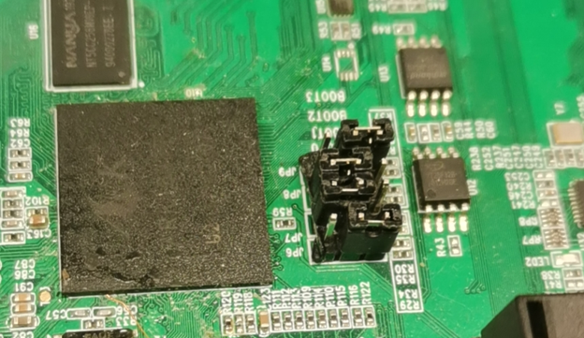
此时设置的是：
[EN] The current setting is:
编译要编译emmc设备的分支;
[EN] Compile the eMMC device branch.

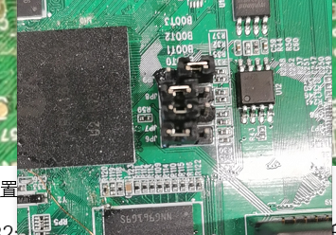
此时设置的是：
[EN] The current setting is:
编译要编译emmc设备的分支;
[EN] Compile the eMMC device branch.

