Day -0

Step -1 Setting up an account

URL to be followed for this step: <https://cloud.google.com/>

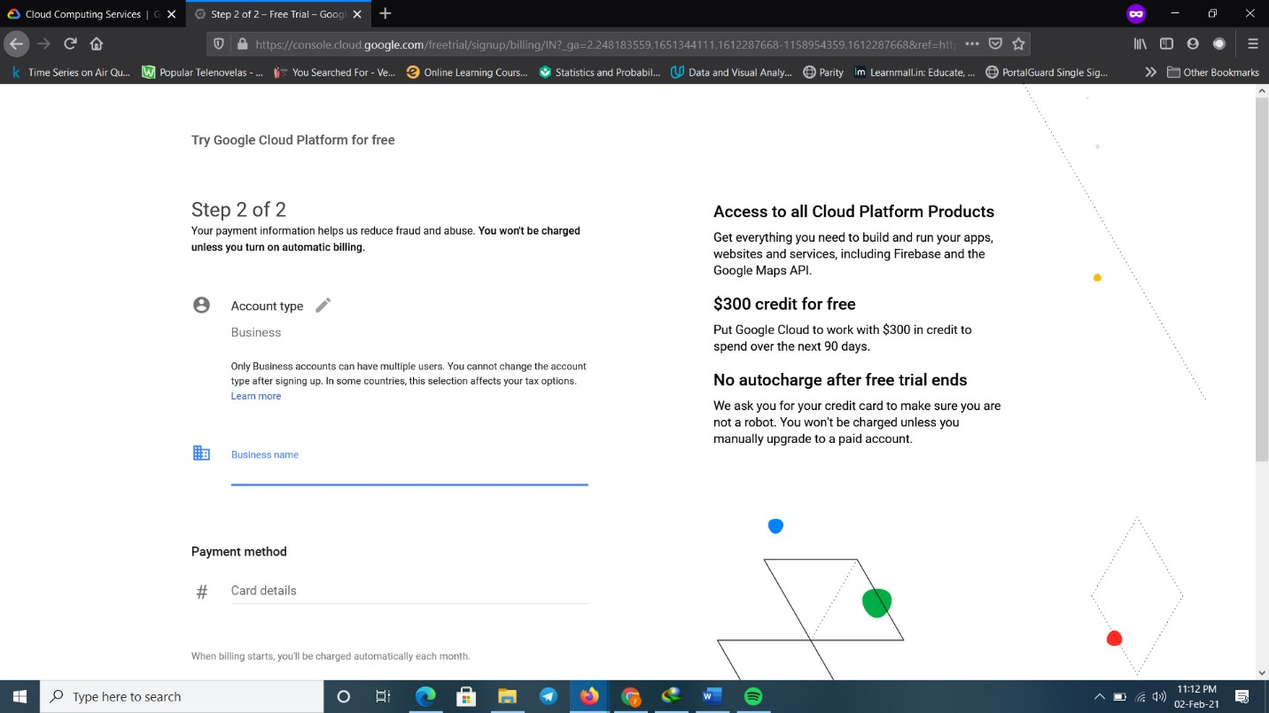

After adding the credit card number and info, the user is good to go and google giving 3 months free tails and worth of 300 USD

\

Step: 2

At the upper corner burger menu, user can find the different features of GCP and user can find Billing option and if he wants then he can bin it at the top

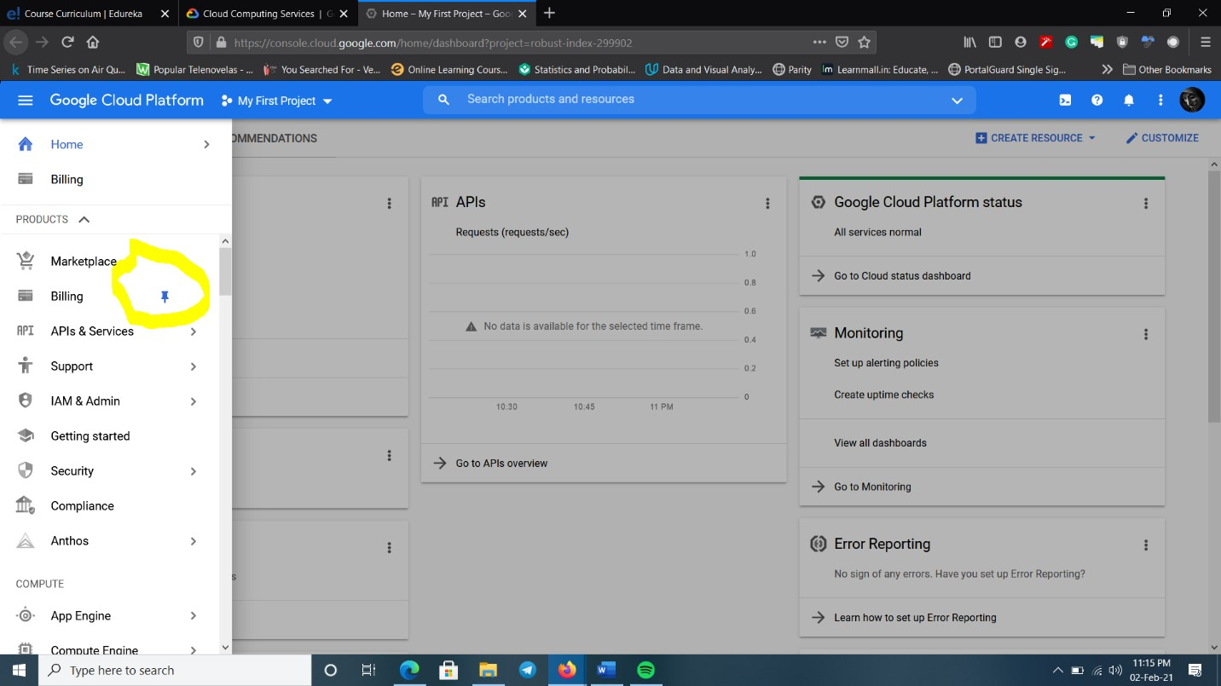

Step – 3

To analyze the price and usage, user can find the option called Pricing and also for more details analysis proposed user can download that usage details as CSV file

Step – 4

As a new user, he can use the Getting Stated colum and there can find the “Take a

VM quickstart” and deploy, in that deploy option he can change the os according

to his platform of usability.

