Opportunities and Difficulties in Gold Export Performance: Obstacles to Ghana and Nigerian Economic Factors

Presented by :

|  |  |
| --- | --- |
| Dani Chehayeb (Leader) | 26328363 |
| Khushi Gujar (Co – Leader) | 45151371 |
| Ashfaq Ali Anees Ali | 40406560 |
| Naveen Kumar Raju | 87474061 |
| Wesley Gonzales | 72552269 |
| Beining Tang | 40846789 |
| Efe Eşref Derinçay | 84649790 |
| Victor Gitahi | 61494514 |
| Yogika | 77471085 |
| Vighnesh Gajula | 76218399 |

Submitted to: Prof. Talha Ali Khan

Table of Contents

**Title Page1**

**Executive Summary4**

Purpose5

Key Insights6

* Economic Impact
* Market Dynamic and infrastructure
* Policy and Regulatory Environment

Recommendations………………………………………………………………………..7

**Introduction4**

Background5

Objective6

Scope………………………………………………………………………………………………………………..7

**Data and Methodology4**

Data Sources5

Data Preprocessing6

Methodology……………………………………………………………………………………………………..

Assumptions………………………………………………………………………………………………….

**Analysis and Insights4**

Export Volume and Value Trends5

Regional Performance6

Global Demand Correlation……………………………………………………………………………………………………..

Challenges and Risks……

**Recommendations4**

Policy Interventions5

Trade Partnerships6

Infrastructure Development…………………………………………………………………………………..

Diversification……

Investment Opportunities

**Conclusion4**

**Appendices4**

Data Visuals5

Technical Details6

Glossary……………………………………………………………………………………………………..

**References4**

# Executive Summary

-Purpose:

The purpose of this report is to undertake a comprehensive examination of the determinants of the gold export performance of Ghana and Nigeria, two leading players in Africa's gold industry that exhibit very different characteristics. In Ghana, which is one of the largest exporters of gold on the continent, the gold industry has been instrumental in driving GDP growth, generating foreign exchange earnings, and creating jobs. The economy of Nigeria remains predominantly reliant on oil exports, while the gold export sector within the country is still at a nascent stage of development. With increasing importance placed on economic diversification, however, Nigeria's untapped gold reserves offer a way forward and a chance at transformation. This report seeks to explore the main factors that influence both nations' performance in the global gold market, how can Ghana and Nigeria enhance their gold export performance by addressing key economic, infrastructure, and regulatory challenges, and leveraging trade partnerships.

This analysis investigates the challenges faced by Nigeria, including limited access to international markets and difficulties in integrating into global value chains. In contrast, it highlights how Ghana's established trade networks and its ability to respond to global demand have allowed it to maintain a competitive advantage. Additionally, the study explores the effects of price fluctuations and global market trends on the performance of gold exports from both countries, emphasizing the importance of adaptable strategies to maximize economic benefits. This report highlights the important role that regulatory and policy frameworks can play in either positively or negatively affecting performance. Ghana has had a consistent mining policy, favorable to foreign direct investment, and encouraged export growth.

In contrast, Nigeria's regulatory framework is characterized by inefficiencies in the form of complex licensing processes and erratic policy implementation that discourages both domestic and international investment in the country's gold sector. Any attempt to address the problems facing Nigeria and ensure that Ghana continues to develop needs an appreciation of these policy differences. It will also examine the broader implications for economic growth and trade competitiveness beyond the analysis of the factors that explain gold export success. This article evaluates the role of gold exports in ensuring that Ghana achieves continued economic development and stability in foreign exchange, besides pointing out ways that Nigeria can use its gold endowment as a base for diversification. The study also provides implementable suggestions to assist both countries in improving their positions in the global gold market, sustainable mining practices, and gold export sectors.

# Key Insights

## Economic Impact

#### Ghana:

* Ghana's trading economy has been faced with challenges due to external factors such as global financial conditions and the war in Ukraine. Growth in real GDP fell from 3.8% in 2022 to 2.9% in 2023. Inflation rose to 40.3% in 2023, driven by higher food prices and exchange rate depreciation. However, fiscal policies helped improve public debt ratios from 92.4% to 84.9% of GDP and reduced the current account deficit from 2.1% to 1.8%. [NACCIMA](https://naccima.com/ghana-nigeria-sign-mou-to-boost-bilateral-trade/) , [African Development Bank Group](https://www.afdb.org/en/countries/west-africa/ghana/ghana-economic-outlook)
* Gold is the backbone of Ghana's trade and represents a substantial contributor to its export earnings. Improved fiscal consolidation and trade balances show that commodities are very important in stabilizing the economy of Ghana. [African Development Bank Group](https://www.afdb.org/en/countries/west-africa/ghana/ghana-economic-outlook)

#### Nigeria:

* Nigeria has undergone significant transformations in its trade and economic landscape. The oil and gas sectors continue to play a vital role in the economy, representing a predominant share of export earnings. Nonetheless, dependence on these industries renders Nigeria vulnerable to fluctuations in global market prices. Consequently, the government has prioritized diversifying into non-oil exports, such as agriculture and manufacturing. [NACCIMA](https://naccima.com/ghana-nigeria-sign-mou-to-boost-bilateral-trade/)
* These include recent efforts, as enshrined in the MoU established with Ghana, for improving bilateral trade with an aim to promote regional integration for overall economic growth in West Africa. This agreement is envisioned to strengthen trade activities between the two economies to easily achieve sustainable development. [NACCIMA](https://naccima.com/ghana-nigeria-sign-mou-to-boost-bilateral-trade/)

#### Comparative Insights:

* Both countries are facing acute economic challenges; however, they are utilizing trade pacts and fiscal policies to buttress their economic stability.
* Ghana is more dependent on gold exports, and the reliance of Nigeria on oil increases the requirement for diversification. The two countries are actively engaged in regional cooperation to solidify economic resilience. [NACCIMA](https://naccima.com/ghana-nigeria-sign-mou-to-boost-bilateral-trade/) , [African Development Bank Group](https://www.afdb.org/en/countries/west-africa/ghana/ghana-economic-outlook)

## Market Dynamic and infrastructure

#### Ghana:

**Largest producer of gold:** Ghana became the leading producer of gold in Africa after gold mining had contributed 48.4% to its gross merchandise exports in 2020. [TRADE COMMISSIONER SERVICE](https://www.tradecommissioner.gc.ca/ghana/market-reports-etudes-de-marches/0006583.aspx?lang=eng)

**Infrastructure Developments:** Under this, the country has invested in modernizing the infrastructure of its transport systems, water, sanitation, and energy sectors. Infrastructural projects like the Eastern Corridor Road and the Accra-Tema motorway expansion significantly improve connectivity, making faster and more efficient movement, including goods and services circulating within the mining sector, possible. [OXFORD BUSINESS GROUP](https://oxfordbusinessgroup.com/reports/ghana/2024-report/)

**Value Addition Initiatives:** In August 2024, Ghana inaugurated its first commercial gold refinery, the Royal Ghana Gold Refinery, in Accra. The facility has a capacity to process 400 kg of gold daily and aims at adding value to the country's gold exports, reducing smuggling, and retaining more economic benefits domestically. [REUTERS](https://www.reuters.com/markets/commodities/ghana-opens-first-gold-refinery-after-centuries-mining-2024-08-08/)

**Prospects:** Ghana will commission the first large-scale greenfield mine in over a decade, the Cardinal Namdini mine, which should produce over 350,000 ounces of gold per year. The move is part of a broader strategy aimed at increasing mineral production to help the economy recover from the shock of the coronavirus pandemic. [REUTERS](https://www.reuters.com/markets/commodities/ghana-launch-monster-mines-boost-gold-production-2024-08-29/)

#### Nigeria:

**Emerging Production:** The rise in gold production in Nigeria stands at a huge 3,048 kilograms in the year 2022. [Statista](https://www.statista.com/statistics/1271274/production-volume-of-gold-in-nigeria/)**First, infrastructure:** The increase in gold production notwithstanding, infrastructural challenges have been the bane to the effective development of the mining sector in Nigeria. The construction sector is projected to grow by 3% in 2024 and 3.5% in 2025; however, high inflation and low fiscal capacity may limit the growth. [Oxford Business Group](https://oxfordbusinessgroup.com/reports/ghana/2024-report/construction-real-estate/constructive-initiatives-infrastructure-development-recognised-as-an-important-driver-of-economic-growth-for-the-country-overview/)**Efforts at Economic Diversification:** The government of Nigeria has been in the forefront of the campaign to wean the economy off dependence on oil through investment in the mining sector, specifically in gold mining. Nevertheless, inadequate infrastructure—epileptic power supply and poor transportation systems—is the major hindrance to such effort.

*Comparative Analysis:*  
**Market Position:** Ghana has a pre-eminent position in the African gold market, supported by heavy investment in infrastructure and value-addition initiatives such as the establishment of a gold refinery. On the other hand, Nigeria is still at the early stages of developing its gold sector and faces infrastructural challenges that slow rapid development.  
  
**Infrastructural Role:** Proactive infrastructural development has facilitated the lead in gold production in Ghana, while Nigeria, with its infrastructural deficits, has seen slower growth of its mining sector.  
  
**Economic Impact:** Ghana's developments in the gold sector have contributed meaningfully to its economy; gold is one of its major export commodities. A related opportunity for Nigeria, on the path of increasing production of gold, is diversification of the economy through infrastructural improvements.

## Policy and Regulatory Environment

Ghana:  
**Minerals and Mining Act, 2006 (Act 703):** This act is the backbone of mining legislation in Ghana, which provides the legal framework for the exploration, extraction, and processing of minerals. It requires licensing, sets out rights and obligations of mining companies, and calls for environmental protection measures. [ICLG](https://iclg.com/practice-areas/mining-laws-and-regulations/ghana)**Minerals and Mining (Local Content and Local Participation) Regulations, 2020 (L.I. 2431):** These regulations require mining companies to give first preference to Ghanaian goods and services and promote local employment and economic participation. The companies are supposed to submit their localization programs, indicating how they would employ and train Ghanaians with the intention of eventually replacing expatriate workers. [ICLG](https://iclg.com/practice-areas/mining-laws-and-regulations/ghana)**Environmental Regulations:** Environmental Impact Assessments are required of mining companies, along with the submission of Environmental Management Plans to reduce ecological impacts. In any case, despite the latter requirements, challenges still arise with regard to effective implementation because of institutional weaknesses. [Aura](https://aura.antioch.edu/cgi/viewcontent.cgi?article=1481&context=etds)**Combating Illegal Mining ("Galamsey"):** The government of Ghana has stepped up efforts to halt illegal artisanal mining, locally referred to as "galamsey," on account of its devastating environmental and social effects. The initiatives include military interventions and community mining programs aimed at regulating small-scale mining and conducting responsible mining practices. [ISS Africa](https://issafrica.org/iss-today/ghana-must-stop-galamsey-before-it-sinks-the-country)

Nigeria:  
**Minerals and Mining Act, 2007:** The Act provides the legal framework and regulations toward the exploration and exploitation of minerals in Nigeria, among them gold. It outlines mechanisms with regards to licenses, environmental concerns, and host community interests.  
  
**Enforcement Challenges:** Despite the law, Nigeria remains very far from fully implementing its mining regulations, given illegal mining operations. Poor governmental capacity, coupled with limited funding, results in an inability to manage environmental degradation or the loss of revenue. [WIKIPEDIA](https://en.wikipedia.org/wiki/Illegal_mining?utm_source=chatgpt.com#Nigeria)**Illegal Mining Containment:** The government has started taking some steps to stop the illegal mining, including setting up task forces and offering alternative livelihoods in agriculture. However, the vastness of the country and remote mining locations complicate enforcement efforts. [WIKIPEDIA](https://en.wikipedia.org/wiki/Illegal_mining?utm_source=chatgpt.com#Nigeria)

Comparative Insights:  
  
**Regulatory Frameworks**: Both countries have instituted legal frameworks to govern gold mining, focusing on licensing, environmental protection, and community involvement. Ghana has newer regulations that include clearly stated local content requirements, while Nigeria still faces challenges in terms of enforcement.  
  
**Local Content Policy:** Ghana has clearly stipulated local content policies to increase the level of national participation in the mining industry, while in Nigeria, the policies are not so well spelled out, with implications for local economic benefit.  
  
**Illegal Mining:** The two countries have big problems with illegal mining activities. Ghana has been more aggressive, even using military interventions to control "galamsey," while enforcement in Nigeria is restricted by resource constraints and wide areas of remote mining.

## Recommendations

### For Ghana:

1. **Sustain and Diversify Export Base:**

* Take advantage of the success of gold mining by encouraging value addition through efforts such as the Royal Ghana Gold Refinery.
* Invest in other commodities such as cocoa and new industries such as renewable energy to de-risk over-dependence on gold.

1. **Strengthen Anti-Illegal Mining Efforts:**

* Expand community mining schemes and invest in sophisticated monitoring gear to promote sustainable mining and fight "galamsey."

1. **Focus on Infrastructure Development:**

* Increase transport and energy infrastructure development (e.g., expansion of Accra-Tema highway) to improve logistics and facilitate wider economic activity.

1. **Fiscal Policies to Combat Inflation:**

* The institute targeted subsidies or fiscal interventions to stabilize food prices and moderate inflation.

1. **Expand Regional Cooperation:**

* Enhance cooperation with neighboring nations such as Nigeria under current trade agreements to increase regional growth and stability.

### For Nigeria:

1. **Prioritize Infrastructure Investment:**

* Prioritize filling infrastructural gaps in transportation and energy to facilitate the manufacturing and mining industries.
* Redouble investment in public-private partnerships to fill gaps.

1. **Accelerate Economic Diversification:**

* Promote non-oil industries like agriculture, mining, and manufacturing to mitigate economic exposure to external oil price shocks.
* Provide incentives to local businesses and foreign investors in gold and other non-oil industries.

1. **Strengthen Enforcement of Mining Laws:**

* Increase investment and capacity development for institutions responsible for enforcing the mining acts to avoid illegal mining operations.
* Utilize technology such as satellite tracking and engage local stakeholders to patrol hard-to-reach regions.

1. **Invest in Local Content Development:**

* Formulate clear-cut policies requiring local involvement in mining programs, basing it on Ghana's model success.

1. **Enhance Bilateral Agreements:**

* Use the MoU with Ghana as a platform to exchange best practices in gold mining and trade policy, promoting a symbiotic relationship in economic and trade development.

# Introduction

## Background:

This study focuses on the gold trade statistics of Ghana and Nigeria from 2017 to 2023, assessing their export efficiency in terms of both quantity and monetary value. Gold is one of the important commodities that help these countries enhance their economies and trade connections. The dataset provides in-depth analysis of the export patterns, contributions of major trading partners, and the global context of gold trade. This research applies methodologies of exploratory data analysis, data visualization, and predictive modeling to understand past performance and identify the determinants that affect the results of trade.

## Objective:

The overall objective of this research is to evaluate and analyze the historical performance of gold exports emanating from Ghana and Nigeria, and establish the prevailing trends, principal contributors, and possible avenues for expansion. It seeks to compare the export performance as well of these two countries; delineate their most important trading partnerships; and assess the economic significance of their gold export. Using predictive analytics, the research seeks to forecast future trends and provide actionable insights, which will confer on stakeholders the ability to make informed decisions. Ultimately, the research seeks to enhance trading practices and improve the economic outcomes of the gold export sector.

## Scope:

The scope is to carry out a more holistic review of the trends and patterns pertaining to gold export in Ghana and Nigeria. It considers the annual performance of the two countries in outlining their main trading partners, together with the products that influence the trade value. Further, this research analyzes the global tendencies for the commodity-specific values in trade and appraises contributions from the trading partners. Using statistical methods, regression analysis, and forecasting techniques, it forecasts future trade patterns. The outcome is meant to guide decision-making processes regarding trade development, policy design, and economic planning in the gold export sector.

# Data and Methodology

## Data Source:

This project used UN Comtrade website for gathering data. The website is maintained by united nation and work as trusted source for analyzing trend of gold export. The data collected is from 2017 to 2023 for Ghana and Nigeria. The gold assets considered are 7108, 710812, 710820 etc. The data is available annually and provides various information like – refYear, reporterdesc, partnerdesc etc.

## Methodology Workflow

### Data Collection and Import:

* We collected and imported a dataset with gold trade information from 2017 to 2023 for analysis.
* We used libraries like Pandas, NumPy, and Seaborn to help with data handling and visualization.

### Data Preprocessing:

* We found and fixed missing values, especially in important columns like net weight.
* We made sure data types were the same for numbers and categories, so they would work well with analysis tools.
* Columns were renamed for clarity and grouped together for easier analysis.

### Exploratory Data Analysis (EDA):

* A time-series analysis was performed to examine the trends of gold exports over the years for Ghana and Nigeria.
* The top trading partners were identified by summing up export quantities and their values.
* We investigated specific commodities to illustrate which high-value items are significant in global trade.

### Visualization:

* Line plots, bar charts, and heatmaps to visualize trends in exports, contributions of partners, and performances of different commodities.
* Comparative visuals to look at the trade differences between Ghana and Nigeria side by side.

### Predictive Modeling:

* A linear regression model to establish relationships between quantity, weight, and value of exports.
* Forecasting using Prophet to predict the future trade values over the next five years.

### Result Analysis and Interpretation:

* Insights from EDA and modeling were put together, showing trends, key partners, and chances for future growth.
* A comparison showed the strengths and challenges for Ghana and Nigeria in the global gold trade.

### Conclusions and Recommendations:

Based on what was found, practical recommendations were made for policymakers and stakeholders to improve trade strategies.

# Analysis and Insights

### Gold Export Performance Over Time (Ghana):

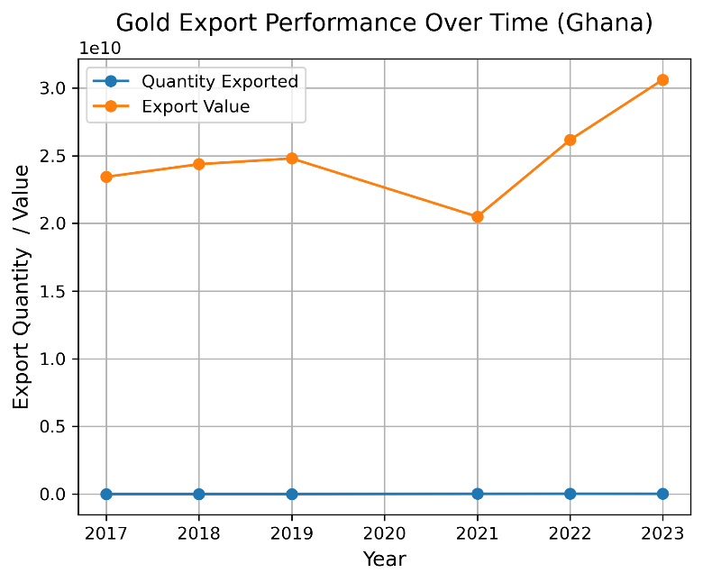

**Figure 1: Ghana Gold Export Performance over Time**

### Observations:

**Export Value (Orange Line):**

* The export value starts high in 2017 and decreases slightly around 2020**.**
* Then, there is a massive increase after 2021, with a peak in 2023.
* This trend might be an indication of changes in gold prices around the world, better ways of production, or increased demand from trading partners.

**Export Quantity (Blue Line):**

* The blue line is almost flat, showing that the amount exported has remained constant over the years.
* This stable quantity is very much different from those of export value change, suggesting that more than likely, it was the gold price (or quality) that influenced the value trends rather than the amount exported.

**Gap Between the Lines:**

* The big gap between the orange and blue lines shows that the money value of exports is much higher compared to the actual amount. This means:
  1. High gold prices.
  2. Ghana is selling higher-quality gold at a higher price.

Insights

**Export Growth:**

* The increase in the value of exports between 2021 and 2023 might be a good trend for Ghana's trade.
* Even with constant export quantities, Ghana could benefit from favorable market conditions or better trade agreements.

**Economic Dependency:**

* Ghana's strong reliance on export value rather than quantity shows how much it depends on global gold prices.

**Potential Investigations:**

* What caused the drop in export value during 2020–2021? Some reasons might be global economic problems, like the COVID-19 pandemic.
* Why did export value go up a lot in 2023? Looking into trading partners, gold prices, or policy changes could help find answers.

### Gold Performance Over Time (Nigeria)

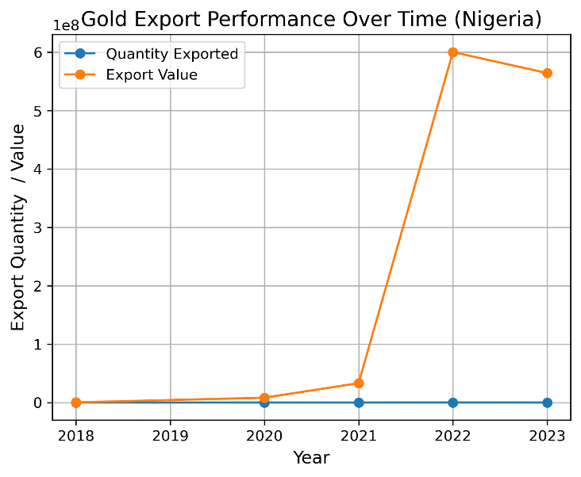

**Figure 2: Nigeria Gold Export Performance over Time**

### Observations And Insights:

**Sharp Increase Around 2021:**

* Both the quantity exported, and export value experience a sharp increase.
* Possible reasons:
  + Increased gold production in Nigeria.
  + Higher global demand for gold during that period.
  + Favorable international gold prices.

**Subsequent Decline (2022):**

* Both metrics show a decline after 2021.
* Possible reasons:
  + Reduction in production/export capacity.
  + Decrease in global gold prices.
  + Policy changes or export restrictions.

**Disconnect Between Quantity and Value:**

* See how the export value does not always correspond to the amount exported.
  + This implies that the price per unit of gold might have varied significantly over that period.

### Top Partner Countries for Gold Exports (Ghana)

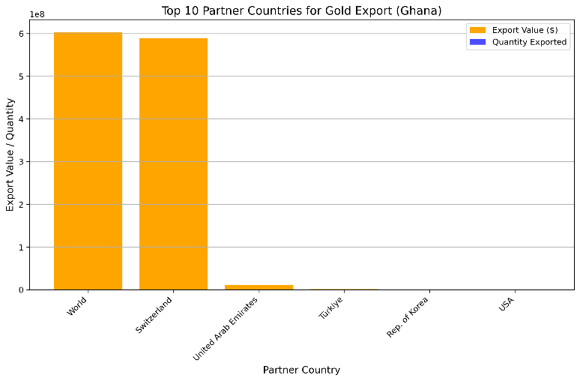

**Figure 3: Ghana Top 10 Gold Export Partners**

### Observations And Insights:

**Major Trading Partner**

* The United Arab Emirates (UAE) is apparently the dominant recipient of Ghana's gold exports in terms of value and quantity.
* Insight:
  + The UAE may be a significant center for gold refining and re-exports.

**Other Nations:**

* Switzerland and India, among others, appear very significant in value.
* Insight:
  + Switzerland is quite noted to basically perform gold refinery, hence the reason it comes out as very significant.
  + India has strong domestic demand for gold, being culturally and economic-driven.

**Quality vs. Quantity:**

* There is a significant gap between the value and volume for specific countries: the number of exports is high, while the value (or vice versa) is small.
* Insight
  + There might be a quality variation in the exported gold, export agreements, or pricing accords established with those countries.

### Top 10 Partner Countries for Gold Export (Nigeria)

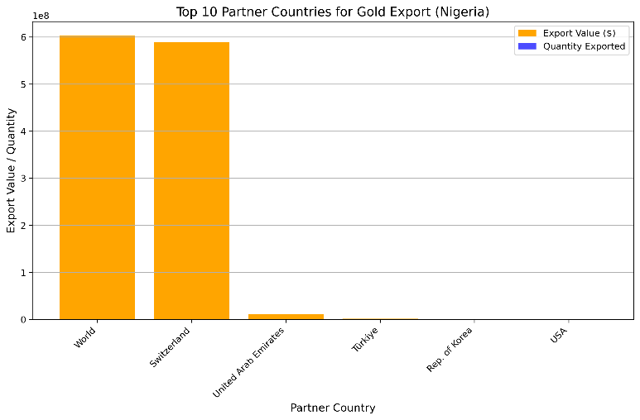

**Figure 4: Nigeria Top 10 Gold Export Partners**

### Observations And Insights:

**Dominant Trading Partner:**

* United Arab Emirates (UAE) and Switzerland: These countries import the largest number of gold exports from Nigeria.
* Insight:
  + UAE likely plays the role of a hub for gold refining and trans-shipment, and Switzerland hosts critical gold refineries worldwide.

**Export Value vs. Volume:**

* For Switzerland and UAE, the export values are high, though their volumes might differ.
* Insight:
  + This could signal variations in the quality or price of the gold shipped to these countries.

**Small Partners:**

* Other countries present very little to the value and volume of the exports, manifesting negligible trade volumes.

### Top Trade Partners by Primary Value for Each Commodity

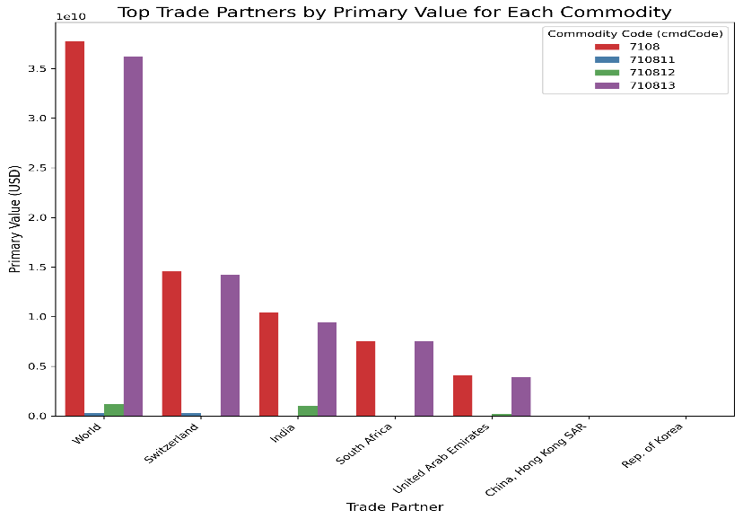

**Figure 5: Top Trading Partners by Primary for each commodity**

### Observations And Insights:

**Commodity Codes and Contribution**

* **Code 7108:** This is a very significant code in this graph, with the UAE and India contributing the most.
* Insight
  + Most likely, Code 7108 refers to high-value gold products exported to these nations, e.g., gold bars or bullion.

**Smaller Contributions for Other Commodities:**

* Dominant values for other commodities such as codes 71012 and 71013 are significantly less, not many nations become major contributors.
* Insight
  + Those might be less processed gold or special pieces of gold.

**India as a Key Player:**

* Probably rich domestic demand makes India a key player in this major value for the commodity 7108.

**Diversity of the UAE's Role:**

* The UAE keeps coming up under many commodities, proving it is an important player in the trade of gold.

### Export Quantities vs. Values for Nigeria and Ghana

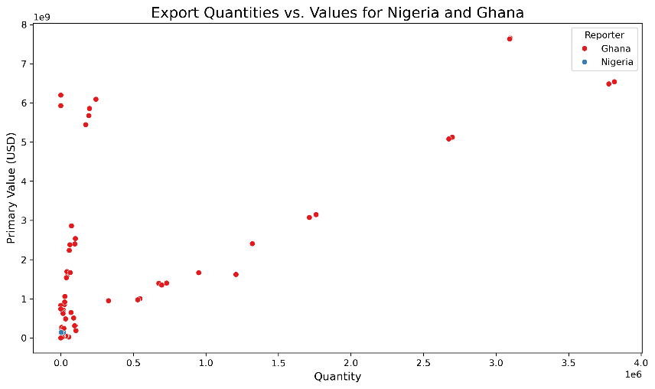

**Figure 6: Export Quantities vs. Values for Nigeria and Ghana**

### Observations And Insights:

**Scatter Plot Insights:**

* Chart showing how much two countries, Nigeria and Ghana export and their values in USD.
* The X axis shows how much is exported whereas the y axis shows the main value in USD.

**Observations:**

* Nigeria:
  + It has a wider range of export amounts and values with larger points on both the axes.
  + Some clusters show that a few of the goods are main exports for Nigeria.
* Ghana:
  + Ghana sends less merchandise and brings in less through exports compared to Nigeria.
  + Ghana's exports are of constant value in nature, but small in quantity.

**Insights:**

* The scale of exportation and export values, however, portray the export structure in Nigeria with big-sized outliers showing extremely high-value commodities.
* Ghana might involve fewer high-value commodities but with controlled and less export quantity.

**Comparison of Nigeria and Ghana:**

* The structure of exports in Nigeria appears to be wide and diversified, imposing greater potential for high-value commodities.
* Ghana's looks specific and concern commodities, maybe targeted to stable markets.

### Global Commodity Trade Values

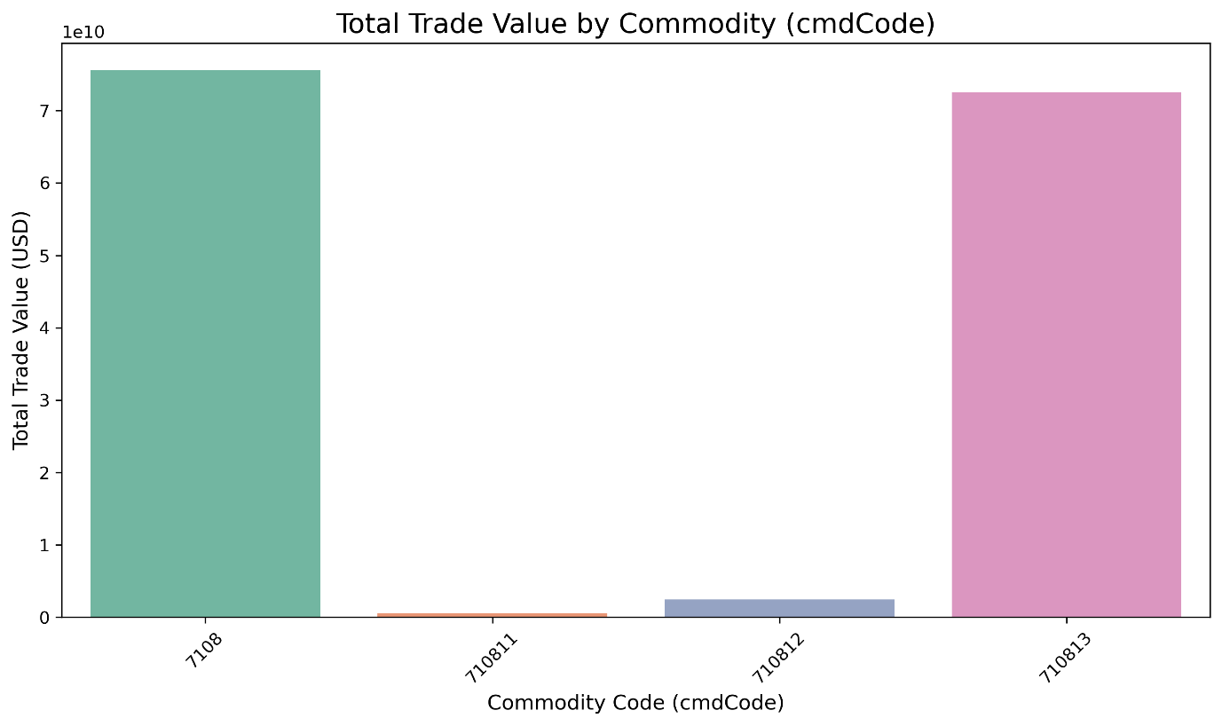

**Figure 7: Total Trade Value by Commodity Codes**

### Observations And Insights:

**Key Observations:**

* The trade values for CmdCode '7108’ and '710813' are exceptionally high and thereby dominate the chart. The ones that have relatively lower trade values with respect to those are CmdCode '710811'.

**Insights:**

* Commodity codes '2709' and '2710' likely cover energy-related goods, such as crude oil and refined petroleum. These goods are incredibly significant in global commerce.
* The huge contrast between codes '2709/2710' and other codes illustrates the degree to which the world relies on some commodities, particularly energy resources.
* Code '8703', typically associated with cars, illustrates the significance of the automobile sector in international trade.

### Heatmap Comparison

### Observations And Insights:

**Heatmap of Ghana:**

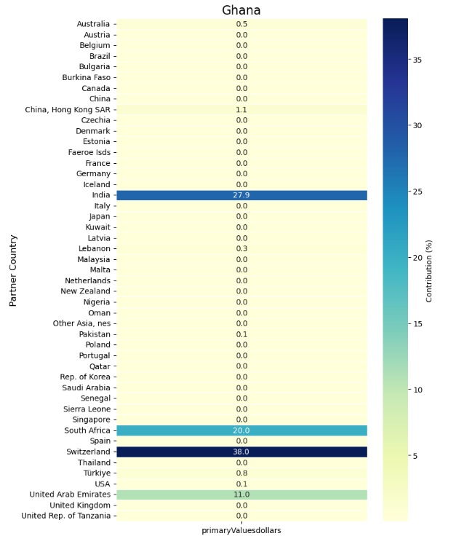

**Figure 8: Ghana Heatmap**

**Overview:**

* The heatmap indicates the distribution of trade values (in USD) across Ghana's trade partners.
* The partner countries are listed on the y-axis, and the color gradient indicates the percentage of trade value, with darker colors indicating larger contributions.

**Key Observations:**

* The most significant trade contribution (approximately 20%) is from South Africa, indicated by a dark bar.
* Other partners in trade have minimal percentages (of around 0%), indicating that Ghana primarily exports to South Africa.
* The low amount of trade from other nations indicates Ghana's heavy dependence on a single country for exports.

**Insights:**

* Ghana's trade strategy appears to rely heavily on South Africa, which might be dangerous if any economic or political shifts influence trade.
* The minimal diversity in trade indicates opportunities for Ghana to establish additional trade collaborations globally.

**Heatmap for Nigeria:**

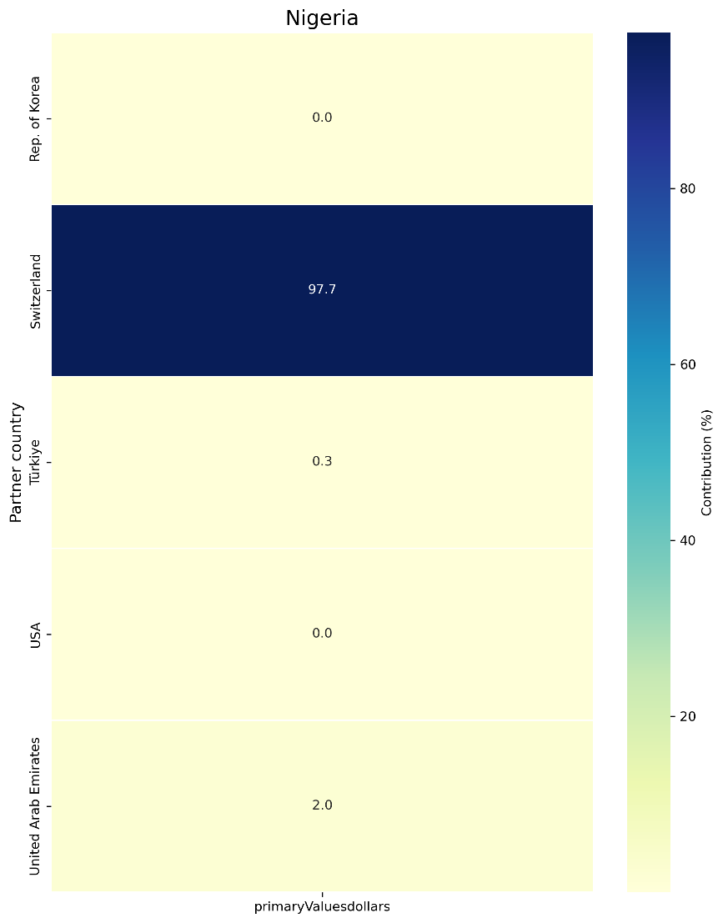

**Figure 9: Nigeria Heatmap**

**Overview:**

* The following heat map also depicts the primary trade values in USD for the trading partners of Nigeria.
* The y-axis represents the partner countries, and the color bar depicts the percent share in the export value of Nigeria.

**Key Observations:**

* Most dominating, as evidenced by the darkest bar, Switzerland captures almost 97.7% of the share in Nigeria's trade value.
* The United States contributes a modest 2.0%, while other countries like Turkey, UAE, and others show 0% trade contributions.

**Insights:**

* Nigeria's export profile is even more centralized than Ghana's, with extreme dependence on a single trading partner, Switzerland.
* This may be related to commodities such as crude oil or precious minerals, but it is a signal of significant risk because of over-dependence on one country.
* An expanded base of trading partners in Nigeria would mean a more resilient and diversified economy.

**Comparison Between Ghana and Nigeria:**

**Trade Concentration:**

* Both countries depend on a single trading partner, with South Africa being the dominant one for Ghana and Switzerland for Nigeria.
* Nigeria's dependence is more extreme, as nearly all its exports are concentrated on Switzerland.

**Risk Factors:**

* This lack of diversification makes both economies vulnerable to geopolitical, economic, or policy changes in their primary trade partner.
* Ghana's portfolio of trade is a little more spread out than Nigeria's, with small contributions from other countries.

**Opportunities:**

* The diversification of trading relations through the identification of new markets and the promotion of other exportable commodities should be emphasized in both countries.

Trade Volume BRICS vs Non-BRICS

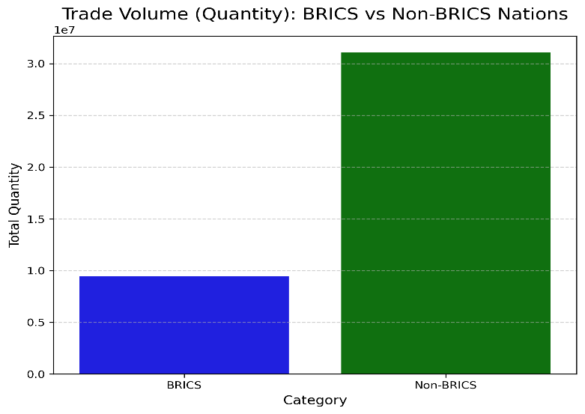

**Figure 10: Trade Volume BRICS vs Non-BRICS**

### Observations:

**Trade Volume Comparison:**

* The combined trade volume of Non-BRICS nations is significantly greater than that of BRICS nations.
* More than three times the trade volume of BRICS countries is represented by Non-BRICS countries within this dataset.

**Proportional Gap:**

* BRICS to Non-BRICS imbalance identifies that Non-BRICS partner trade accounts for overall trade activity depicted in this dataset.

**Possible Regional Bias:**

* The large difference might suggest that the dataset contains a large share of trade with non-BRICS partners, possibly because of geographical, economic, or sectoral biases.

### Insights:

**Economic Impact:**

* Other nations could be adding more to international trade, possibly since they have large economies outside the BRICS nation group.

**Diversification Potential:**

* There could be untapped potential for more trade among BRICS nations, particularly if trade regulations or agreements can solidify relationships within BRICS.

**Strategic Priority:**

* For a business or decision-maker, the priority could be to develop more trade with Non-BRICS nations while maintaining significant relationships within BRICS so as not to be over-dependent on a single group.

Trade Volume Over Time: BRICS vs Non-BRICS

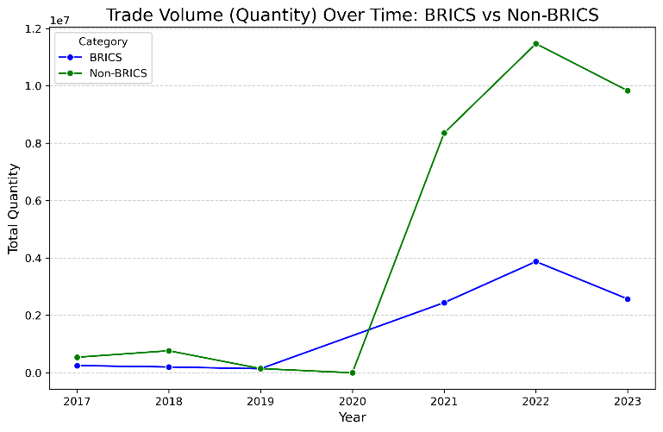

**Figure 11: Trade Volume Over Time: BRICS vs Non-BRICS**

### Observations:

**Overall Trends:**

* Trade with Non-BRICS countries registers a sharp rise from 2019 to 2021, reaching its peak in 2022, before declining marginally in 2023.
* Trade with BRICS countries also rises steadily across the years but, even at its high point in 2022, is much lower than that of Non-BRICS countries.

**2020 Surge:**

* Both BRICS and Non-BRICS countries register significant growth in 2020, with Non-BRICS rising more sharply.

**Gap Between Categories:**

* The trade volume gap between Non-BRICS countries and BRICS countries increases appreciably from 2019 to 2022, signifying the dominance of Non-BRICS partners in trade volumes for the entire duration.

**Fall in 2023:**

* There is a fall in trade volume for Non-BRICS and BRICS countries in 2023, albeit Non-BRICS is much larger.

### Insights:

**Impact of External Factors:**

* The rise in trade volumes since 2020 can be influenced by external economic forces, such as economic recovery from the pandemic or trade patterns, with Non-BRICS nations enjoying more advantages.

**Trade Dependency:**

* The increased trade volumes with Non-BRICS nations reflect a shift towards trade relations outside the BRICS nations, which can reflect broader global trade patterns.

**Prospects for BRICS:**

* Though BRICS trade has been rising consistently, volumes are low. There is possible scope for enhancement of intra-BRICS trade by policy support, regional trade arrangements, or sectoral coordination. Sustainability of Trade Growth:
* The downturn in 2023 for both BRICS and Non-BRICS trade indicates there is a reason to examine whether the peak in 2022 resulted from one-off phenomena or if structural issues exist to sustain the growth.

### Linear Regression Model with Multiple Features

### Code Overview:

1. **Data Splitting:**
   1. train_test_split: Splits the dataset into training and testing sets.
   2. test_size=0.2: 20% of the data is allocated for testing, and 80% for training.
2. **Model Training:**
   1. A LinearRegression model from sklearn is instantiated and trained using the fit() method on the training data (X_train, y_train).
3. **Predictions:**
   1. Predictions for both training and testing datasets are made using the predict() method.
4. **Performance Metrics:**
   1. **R-squared (r2_score):**
      1. A statistical measure that represents the proportion of the variance for the dependent variable explained by the independent variables.
   2. Outputs include Train R2 and Test R2.

### Visualization 1: Actual vs. Predicted Values

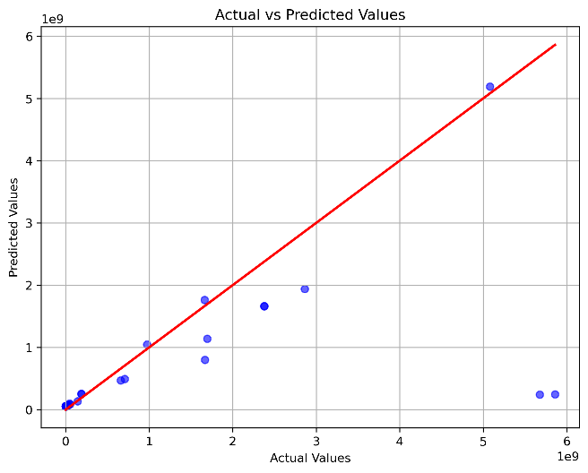

**Figure 12: Actual vs. Predicted Values**

**Description:**

A scatter plot compares the Actual Values of ground truth against Predicted Values from model predictions.

#### **Components:**

1. **X-Axis (Actual Values):**
   1. Represents the true target values (y_test).
2. **Y-Axis (Predicted Values):**
   1. Represents the predicted outputs of the linear regression model (y_pred).
3. **Diagonal Red Line:**
   1. Indicates perfect predictions: if all points fall on this line, the model predictions match the actual values exactly.
4. **Blue Points:**
   1. Represent individual data points comparing actual vs. predicted values.

**Observations:**

**Closeness to Red Line:**

* The closer the dots to the red line, the better the predictions.
* Those points that lie farther from this line indicate errors in prediction, such as underprediction or overprediction by the model.

**Spread of Data Points:**

* Points seem to deviate from the red line for higher values, indicating that the model does not generalize well for higher target values. This could be due to underfitting or nonlinearity in the data.

**Key Insights:**

* The model is performing well for lower target values but may need some improvement for higher values.
* Additional features or transformations may help improve performance.

### Visualization 2: Residuals Plot

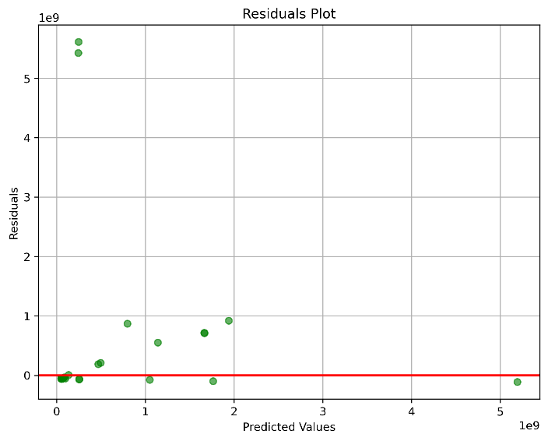

**Figure 13: Residual Plots**

**Description:**

A scatter plot visualizing the residuals (difference between actual and predicted values) against the predicted values.

#### **Components:**

1. **X-Axis (Predicted Values):**
   1. The model's predicted outputs.
2. **Y-Axis (Residuals):**
   1. Calculated as [Equation]Residual=Actual Value−Predicted Value.
3. **Red Horizontal Line:**
   1. Represents a zero residual (perfect prediction).
4. **Green Points:**
   1. Each point corresponds to a residual for a data point.

**Observations:**

**Residual Spread:**

* The residuals are above and below the red line; thus, there is some random error shown.
* However, the residuals are not evenly distributed, and some pattern seems to exist, hence in this case possibly implying that model assumptions may fail to hold-for instance, linearity or homoscedasticity.

**Magnitude of Errors:**

* Some of the residuals have bigger values for high predicted values; from this it can be said that the model performs poorer for high values. Key Insights:

**Insights:**

* A good linear regression should have residuals randomly scattered around zero with no discernible pattern.
* The contour of the above figure may indicate that:
  + Linearity assumption is violated.
  + There is a need for more features/transformations.

**Model Summary:**

**Strengths:**

It appears that, in general, the model fits rather well for the lower values, since many points in the first plot are closely clustered to the red line. For lower predicted values, residuals are small.

**Limitations:**

**Higher Value Predictions:**

Both these visualizations show the weaknesses in the model for higher target values. With higher errors, there are greater deviations from what is considered an ideal line.

**Residual Patterns:**

The residuals are not randomly scattered and may indicate some model deficiencies.

### Time-Series Modeling

* **Time-Series Forecasting:**
  + **Model Used:** Exponential Smoothing from the Holt-Winters method.
    - **Additive Seasonal Model:** Assumes the seasonal variations remain constant over time.
    - **Seasonal Periods = 4:** Indicates you believe the data has a seasonal pattern that repeats every 4 time periods (likely quarters or similar cycles).
* **Forecasting:**
  + A 10-step forecast is generated, extending the series beyond the historical data to predict future values.

### Insights from the Graphs:

##### a. First Graph: Forecasting with Confidence Intervals

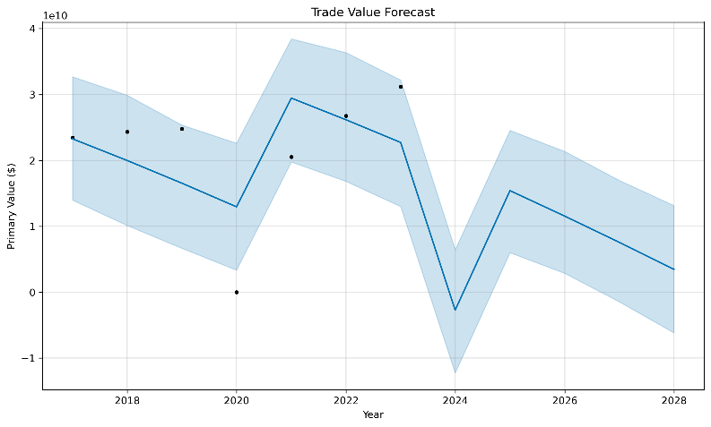

**Figure 14: Forecasting with Confidence Intervals**

**What it shows:**

* The actual historical data are plotted with black dots connected by a line; in contrast, the smooth line shows your forecasted values.
* The blue shading introduces confidence intervals; it's a display indicating that as one gets further away into the future, your forecast becomes less sure.

**Key Observations:**

* There appears to be a downtrend, or negative slope, to this historical data.
* This would then represent that whatever value is generally dropping over time.
* This prediction follows the course of this decline, but the lighter area tapers out; that is, the model is less confident in the further-out predictions.
* **Seasonality captured:** You can see ups and downs in both historical data and forecast - a sign of repeated seasonal patterns aligned with your seasonality of 4.

# Recommendations

Addressing current issues and taking advantage of possibilities are essential to maximizing the gold sector's economic potential and improving Ghana's and Nigeria's gold export performance. Despite being major African producers of gold, both nations struggle with issues including illicit mining, poor infrastructure, and little value addition. They may, however, turn these obstacles into chances for expansion by implementing well-thought-out policies, trade agreements, infrastructure upgrades, and diversification plans. Below are recommendations supported by recent data and developments:

1. Policy Interventions:

- Formalizing the Informal Mining Sector:

Although the informal mining industry makes a substantial contribution to the extraction of gold, illicit operations frequently result in financial losses. For instance, illicit mining in Ghana, known as "galamsey," degrades the environment, costs the government money, and puts people' health at risk. Similar difficulties include a lack of technical know-how, insufficient safety precautions, and restricted market access for Nigeria's artisanal miners. By giving miners access to financing, technical training, and permits, governments may legitimize small-scale and artisanal mining. These programs have the potential to raise tax revenues, decrease environmental harm, and improve productivity. ([The Guardian, 2024](https://www.theguardian.com/world/2024/nov/25/polluted-rivers-taxes-ghana-illegal-gold-mining-boom))

* Addressing environmental and Social Impacts:

Deforestation, water pollution, and habitat destruction are only a few of the serious environmental issues brought on by gold mining in both nations. It is crucial to concentrate on sustainable mining methods, such as reclaiming mined land and upholding environmental laws. To lessen the negative effects of mining, governments and commercial players can work with communities and invest in environmentally friendly mining technology. Social programs such as community development grants can guarantee that local communities directly benefit from mining profits.

* Strengthening Institutional Capacities and Governance:

Long-term success depends on establishing strong institutions to regulate the mining industry. To administer licenses, keep an eye on compliance, and guarantee equitable income distribution, regulatory bodies need to have enough money and employees. To inspire investor and community trust, the Minerals Commission of Ghana and the Ministry of Mines and Steel Development of Nigeria should place a high priority on capacity building, stakeholder engagement, and open revenue management.

2. Trade Partnerships:

- Building Strategic Trade Partnerships:

Nigeria and Ghana should form joint ventures with countries that have dependable gold markets and processing expertise. China, India, the United Arab Emirates, and Switzerland are among the leading importers of gold worldwide. For instance, Ghana may still negotiate beneficial trade agreements that ensure fair pricing and consistent demand even when it already has relations with these countries. Nigeria, a relatively recent participant in major gold exports, should learn from Ghana's achievements and establish comparable alliances.

It is clear that Ghana has developed important trading ties with nations like India, South Africa, Switzerland, and the United Arab Emirates (UAE). The UAE accounted for almost 40.1% of Ghana's gold exports in the third quarter of 2024, making it the top destination. Switzerland, South Africa, and India came in second and third, respectively, with 30.1%, 22.2%, and 6.8% of the shipments, respectively. ([Citi Newsroom](https://citinewsroom.com/2024/12/uae-emerges-top-destination-for-ghanas-gold-exports/))

-Leveraging Technology and Innovation:

The mining industry might undergo a radical transformation thanks to technology. Efficiency may be increased and foreign purchasers looking for gold from ethical sources can be drawn in by using automation, AI-driven research tools, and blockchain for supply chain transparency. Blockchain technology, for example, can verify the provenance of gold and make sure it complies with international norms for ethical sourcing.

3. Infrastructure Development:

- Developing Infrastructure for the Mining Sector:

It is clear that the mining industries in Ghana and Nigeria have been severely hampered by a lack of suitable infrastructure, which includes subpar transportation systems, a restricted energy supply, and ineffective logistics. Infrastructure investments will lower operating costs and increase export efficiency. Examples of these investments include power supplies for processing plants, highways linking mining sites to ports, and sophisticated mining equipment.

Ghana’s Infrastructure Development:

Ghana has prioritized port infrastructure investment to boost trade and support the mining sector. The expansion of the Tema Port, for instance, aims to streamline operations and increase efficiency, aligning with Ghana's broader economic strategies that emphasize infrastructure development as a cornerstone for growth.([Cimaghana](https://cimaghana.org/publications-and-media-relations/the-impact-of-the-tema-port-expansion-on-ghanas-economy))

Nigeria’s Infrastructure Challenges and Initiatives:

Inadequate infrastructure for moving bulk materials from mining sites to processing facilities is a problem for Nigeria's mining industry. The government's emphasis on infrastructure development, which includes calculated expenditures in energy, communication, and transportation, attempts to increase the mining industry's ability to satisfy demands from the worldwide market. ([Delvedatabase](https://www.delvedatabase.org/uploads/resources/MMSD-2016-Nigeria_Mining_Growth_Roadmap_Final-compressed.pdf))

4. Diversification:

- Promoting Value Addition through Gold Refining:

Moving up the value chain by locally processing gold before exporting is a big potential. Higher pricing and job prospects in downstream sectors are two benefits of refined gold.

Ghana has already taken action by building the Royal Ghana Gold Refinery, a cutting-edge establishment in Accra that can refine 400 kg of gold each day. The goal of this project is to preserve economic gains domestically while enhancing the value of the nation's gold exports. ([Reuters](https://www.reuters.com/markets/commodities/ghana-opens-first-gold-refinery-after-centuries-mining-2024-08-08))

By constructing refinery facilities in gold-producing areas like Zamfara, Osun, and Niger states, Nigeria may duplicate similar initiatives. Notably, the first gold refinery in Nigeria is anticipated to open shortly. The majority of the ore will be sourced locally from a variety of sources, including the central states of Kwara and Niger as well as the northwest states of Zamfara, Kebbi, and Kaduna. The expansion of this market can also be fueled by incentives like tax rebates for businesses who engage in value addition.

- Exploring Untapped Mining Regions:

There are still chances for growth as large areas of Ghana and Nigeria have untapped gold riches. Mapping possible gold reserves and carrying out geological studies will yield vital information to draw in investors. Nigeria, for example, has discovered fresh gold deposits through mineral mapping and exploration in states like Zamfara, Osun, and Niger, while Ghana is still searching its rich gold belts for further reserves.

5. Investment Opportunities:

- Encouraging Foreign Direct Investment:

By enhancing the business climate, Ghana and Nigeria can both draw in international capital to their mining industries. Transparent mining laws, stable regulations, and investment security are important considerations for foreign investors. While Ghana's standing as a mining-friendly nation continues to draw international players, Nigeria's recent decision to relax the prohibition on mining in Zamfara State has already aroused interest from investors. Promoting PPPs (public-private partnerships) can increase investment inflows even further.

Nigeria’s Mining Sector:

Citing notable advancements in security, the Nigerian government formally removed a five-year prohibition for mining exploration in Zamfara State in December 2024. It is anticipated that this action would draw both domestic and global investors to the state's wealth of natural resources, which include copper, lithium, and gold. It is projected that the state's economy will grow and job opportunities will be created once mining operations resume.([Reuters](https://www.reuters.com/world/africa/nigeria-resumes-mining-zamfara-state-improved-security-2024-12-23))

Ghana’s Mining Sector:

With over half of all foreign direct investment (FDI) and over one-third of all export earnings, Ghana's mining sector is essential to the country's economy. The nation is a desirable location for foreign investors due to its aggressive policies and stable regulatory framework. The primary regulatory agency that ensures the efficient administration and growth of the industry is the Minerals Commission, which was founded in accordance with Article 269 of the 1992 Constitution and the Minerals Commission Act 1993, Act 450. ([Trade.gov](https://www.trade.gov/country-commercial-guides/ghana-mining-industry-equipment))

Both nations can increase their attractiveness to global investors and support their mining industries and general economic growth by creating a stable and open business environment.

# Conclusion

The possibilities and difficulties Ghana and Nigeria have encountered in their gold export performance have been examined in this paper, which also offers insights into the infrastructure, market dynamics, regulatory environment, and economic effect of their respective gold industries. According to our study, both countries have a lot of potential in the global trade, but they also confront different possibilities and obstacles.

Ghana’s economy has historically been based on the export of gold, which boosts GDP growth, generates employment, and makes a substantial contribution to foreign exchange profits. Nigeria has the chance to diversify its economy by developing its unexplored gold deposits, even if it is still mostly dependent on oil exports. In order to encourage sustainable growth and lessen reliance on outside shocks in other areas, both countries must take advantage of the financial gains from gold exports.

Ghana has effectively formed trade alliances with important international gold importers, such as the United Arab Emirates, Switzerland, and India-all of which are important members of the BRICS (Brazil, Russia, India, China, and South Africa) alliance. These countries control the world’s refining gold consumption markets, giving Ghana and Nigeria the chance to strengthen their economic ties within this group. Furthermore, a bottleneck still exits in both nations due to inadequate infrastructure, including inadequate transportation system, limited refining capacity, and unstable energy supplies. To fully realize the potential of the gold sectors, improve operational effectiveness, and increase export performance, infrastructure investments will be essential

One important factor influencing the performance of gold exports is the regulatory environment. Ghana has retained its competitive edge and promoted growth through stable and investor-friendly policies. On the other hand, Nigeria experiences inefficiencies in the application of policies and licensing procedures, which discourage investment. Nonetheless, recent developments—like the repeal of Zamfara State's mining ban—indicate that efforts are being made to create a more welcoming economic climate. To draw in foreign direct investment (FDI) and promote sectoral growth, both countries must prioritize sustainable mining practices, enforce compliance, and fortify institutional structures.

The BRICS countries—China, India, and South Africa in particular—are essential to the world's gold trade. Ghana and Nigeria have strategic prospects due to China's supremacy as a worldwide importer, South Africa's position as a significant participant in gold production and refining, and India's cultural and investment-driven need for gold. Both countries can stabilize demand, negotiate better prices, and integrate into global value chains by establishing stronger trade ties and obtaining long-term agreements with these countries. Furthermore, greater links might assist Ghana and Nigeria in reducing their reliance on Western markets and mitigating currency concerns as BRICS nations look for alternatives to the dollar for trade payments.

This paper highlights how Ghana and Nigeria may establish themselves as major participants in the global gold market by resolving infrastructural deficiencies, enhancing regulatory frameworks, and fortifying trade ties, particularly with BRICS countries. Nigeria has to step up efforts to diversify its economy and take use of its gold riches, while Ghana needs to keep innovating and adjusting to shifting global dynamics in order to keep its competitive edge.

To put these suggestions into practice, cooperation between governments, foreign partners, and the corporate sector will be crucial. By doing this, both countries may turn their gold export industries into growth-promoting enterprises, paving the road for more sustained growth and robust inclusion into the world economy.

# Appendices

- List of Figures:

Figure 1 .................................................................................................................................. 11

Figure 2 ................................................................................................................................... 13

Figure 3 ................................................................................................................................... 14

Figure 4 ................................................................................................................................... 15

Figure 5 ................................................................................................................................... 16

Figure 6 ................................................................................................................................... 17

Figure 7 ................................................................................................................................... 18

Figure 8 ................................................................................................................................... 19

Figure 9 ................................................................................................................................... 20

Figure 10................................................................................................................................... 21

Figure 11................................................................................................................................... 22

Figure 12................................................................................................................................... 24

Figure 13................................................................................................................................... 25

Figure 14................................................................................................................................... 27

- Glossary:

Galamsey: Illegal small-scale mining operations for gold. Word comes from the phrase “Gather them and sell”.

CmdGold: Which is known as the commodity gold, refers to the type of gold.

7108: Gold (including gold plated with platinum)

710811: Metals; gold, non-monetary, powder.

710812: Metals; gold, non-monetary, unwrought.

710813: Metals; gold, semi-manufactured

# References

- Amosu, C. O., & Adeosun, T. A. (2021). Curtailing illegal mining operation in Nigeria. International Journal of Physical and Human Geography, 9(1), 13–24.- Ghana reclaims position as

–Asuemah Yeboah, S. (2023). Digging deeper: The impact of illegal mining on economic growth and development in Ghana.

-Azubuike, S. I., Nakanwagi, S., & Pinto, J. (2023). Mining resource corridor development in Nigeria: Critical considerations and actions for a diversified and sustainable economic future. Mineral Economics, 36(1), 59–75.

-Citi Newsroom. (2024, December). UAE emerges top destination for Ghana’s gold exports. *Citi Newsroom.* Retrieved from <https://citinewsroom.com/2024/12/uae-emerges-top-destination-for-ghanas-gold-exports/>

-Cimaghana. (n.d.). The impact of the Tema Port expansion on Ghana’s economy. *Cimaghana.* Retrieved from <https://cimaghana.org/publications-and-media-relations/the-impact-of-the-tema-port-expansion-on-ghanas-economy>

-Delvedatabase. (n.d.). *Nigeria mining growth roadmap.* Retrieved from <https://www.delvedatabase.org/uploads/resources/MMSD-2016-Nigeria_Mining_Growth_Roadmap_Final-compressed.pdf>

-Ghana reclaims position as Africa's largest gold producer. (2023, June 10). *GhanaWeb.* Retrieved from <https://www.ghanaweb.com/GhanahlomePage/business/Ghana-reclaims-position-as-Africa-s-largest-gold-producer-1783568>

-Granberg, R., & Singogo, F. K. (2021). *African gold.* Springer International Publishing.

-Onuoha, C. F., Emelury, A. U., Afolaly, S. A., Abiri-Franklin, S. O., & Olarinde, E. S. (2024, April). Regulatory frameworks and enforcement mechanisms in Nigerian mining laws: Challenges and solutions. In *2024 International Conference on Science, Engineering and Business for Driving Sustainable Development Goals (SEBASDG)* (pp. 1–6). IEEE.

- Reuters. (2024, December 23). Nigeria resumes mining in Zamfara state with improved security. *Reuters.* Retrieved from <https://www.reuters.com/world/africa/nigeria-resumes-mining-zamfara-state-improved-security-2024-12-23/>

-The Guardian. (2024, November 25). Polluted rivers and lost taxes: Ghana’s illegal gold mining boom. *The Guardian.* Retrieved from <https://www.theguardian.com/world/2024/nov/25/polluted-rivers-taxes-ghana-illegal-gold-mining-boom>

-Trade.gov. (n.d.). Ghana mining industry equipment. *Trade.gov.* Retrieved from <https://www.trade.gov/country-commercial-guides/ghana-mining-industry-equipment>

-World Gold Council. (2020, April 29). Q1 gold demand supported as COVID-19 fueled safe-haven investment. *World Gold Council.* Retrieved from <https://www.gold.org/news-and-events/press-releases/q1-gold-demand-supported-covid-19-fuelled-safe-haven-investment>

-Wikipedia contributors. (n.d.). *Illegal mining.* Wikipedia. Retrieved January 25, 2025, from <https://en.wikipedia.org/wiki/Illegal_mining?utm_source=chatgpt.com#Nigeria>

-ISS Africa. (n.d.). Ghana must stop galamsey before it sinks the country. Retrieved January 25, 2025, from https://issafrica.org/iss-today/ghana-must-stop-galamsey-before-it-sinks-the-country

-Antioch University Repository and Archive. (2025). The economic and social effects of illegal gold mining in Ghana. Retrieved from <https://aura.antioch.edu/cgi/viewcontent.cgi?article=1481&context=etds>

-ICLG. (n.d.). Mining laws and regulations: Ghana. Retrieved January 25, 2025, from <https://iclg.com/practice-areas/mining-laws-and-regulations/ghana>

-African Development Bank Group. (n.d.). *Ghana economic outlook.* Retrieved January 25, 2025, from <https://www.afdb.org/en/countries/west-africa/ghana/ghana-economic-outlook>

-Nigerian Association of Chambers of Commerce, Industry, Mines, and Agriculture (NACCIMA). (n.d.). Ghana and Nigeria sign MoU to boost bilateral trade. Retrieved January 25, 2025, from <https://naccima.com/ghana-nigeria-sign-mou-to-boost-bilateral-trade/>

-IPPG Africa. (n.d.). Ghana's economic outlook: Opportunities and challenges in trade and policy. Retrieved January 25, 2025, from https://www.ippgafrica.org/ippg-working-paper-ghanas-economic-outlook%EA%9E%89-opportunities-and-challenges-in-trade-and-policy/

-Trade Finance Global. (n.d.). Nigeria, Ghana, and South Africa: Challenges and opportunities for Sub-Saharan giants. Retrieved January 25, 2025, from <https://www.tradefinanceglobal.com/posts/nigeria-ghana-south-africa-challenges-opportunities-sub-saharan-giants/>

-NASS Publishing. (n.d.). The regulatory and welfare effects of mining laws in Africa. Research in World Agricultural Economics, 5(3), 1172. Retrieved January 25, 2025, from https://journals.nasspublishing.com/index.php/rwae/article/view/1172