Design and Implementation of a Web-Based Integrated Reservation and Ticketing System for Superlines Transportation Co. Inc.

A Capstone Project Presented to the Faculty of the
College of Computing and Multimedia Studies
Camarines Norte State College
Daet, Camarines Norte

In Partial Fulfillment of the Requirements
for the Degree in Bachelor of Science
in Information Technology

By
Asis, Leslie Ann B.
Mago, Phoebe Margaret V.
Rasco, Eugene A.
Sabanal, Lordaragon

2026

Chapter 1
INTRODUCTION
Background of the Study
In today’s fast-paced world, the demand for efficient, convenient, and user-friendly transportation services is increasing. Online Bus Reservation System provides bus transportation system, a facility to reserved seats, cancellation of seats and different types of enquiries which need an instant and quick reservation. This system can be used by the users in performing online reservation via the internet for their all-business purposes. Users can use this program directly on their websites and there is no need to install it. (Oloyede, M. O., Alaya, S. M., & Adewole, K. S. (2014). Development of an online bus ticket reservation system for a transportation service in Nigeria. Development, 5(12), 40-42.)
Superlines Transportation Co. Inc. is one of the leading bus transportation companies in Luzon, Philippines. Established in 1975, the company has built a strong reputation for safety, reliability, and customer satisfaction. Despite its long-standing presence in the transportation industry, the company continues to rely heavily on manual processes for reservation and ticketing operations. Currently, customers are required to make walk-in reservations and complete over-the-counter payments to secure tickets. The existing system depends on handwritten logs and manual record-keeping. These procedures are time-consuming and prone to human error. Managing seat availability, tracking reservations, and maintaining accurate customer records become cumbersome for staff. Moreover, customers often experience long queues and waiting times, resulting in reduced convenience and satisfaction.
With the rapid advancement of information and communication technology, organizations across various industries are adopting digital systems to enhance operational efficiency, accuracy, and service delivery. In the transportation sector, web-based reservation and ticketing systems provide a more efficient alternative to traditional manual processes. Such systems allow customers to book tickets online, check real-time seat availability, select preferred seats, and receive digital tickets instantly.
Integrating online payment functionality further enhances the system by enabling secure and immediate financial transactions. Customers can pay through digital platforms without visiting physical terminals, reducing congestion and operational bottlenecks. Online payments also ensure real-time confirmation of bookings, minimize the risk of double booking, and improve revenue monitoring and tracking.
For administrators and staff, a web-based system centralizes reservation, ticketing, and payment processes into a single platform. It enables efficient schedule management, real-time monitoring of seat availability, automated ticket generation, and organized storage of customer records. Secure authentication mechanisms protect sensitive information, while administrative controls ensure that only authorized personnel can access critical system functions. Additionally, the system can generate digital reports that support informed decision-making and operational planning.
In response to these operational challenges, this study proposes the design and implementation of a Web-Based Integrated Reservation and Ticketing System with Online Payment for Superlines Transportation Co. Inc. The proposed system aims to streamline ticket booking procedures, reduce manual workload, enhance transaction accuracy, and improve customer convenience. By integrating reservation, ticketing, and payment processes into a unified platform, the company can deliver faster, more reliable, and customer-oriented services.
Ultimately, this study addresses the limitations of the current manual system and leverages modern web technologies to provide a secure, efficient, and comprehensive solution that strengthens the company’s competitiveness in the transportation industry.
Research Objectives
The main objective of this study is to design, develop, and implement a robust, web-based integrated reservation and ticketing system specifically engineered for Superlines Transportation Co. Inc. This research aims to revolutionize the company’s current operational framework by transitioning from traditional, paper-based methods to a high-performance digital ecosystem featuring secure online payment functionality. Specifically, the study aims to:
- To determine the existing reservation and ticketing process of Superlines Transportation Co. Inc. and identify its limitations and challenges.
- To determine the system features of Web-Based integrated online bus reservation and passenger management system for superlines transportation inc.
3. To determine the level of usability of Web-Based integrated online bus reservation and passenger management system for superlines transportation inc. in terms of:
- Usefulness;
- Satisfaction;
- Ease of Use; and
- Ease of Learning.
Research Questions
The Design and Implementation of a Web-Based Integrated Reservation and Ticketing System for Superlines Transportation Co. Inc. aims to modernize the company’s current manual booking operations by providing a secure, automated, and real-time digital platform. The study seeks to answer the following questions:
1. What is the existing reservation and ticketing process of Superlines Transportation Co. Inc. and identify its limitations and challenges?
2. What are the system features of Web-Based integrated online bus reservation and passenger management system for Superlines Transportation Inc?
3. What is the level of usability of Web-Based integrated online bus reservation and passenger management system for Superlines Transportation Inc. in terms of:
a.Usefulness;
b.Satisfaction;
c.Ease of Use; and
d.Ease of Learning?

Scope and Delimitation of the Study
The primary focus of this study is the design and implementation of a comprehensive, web-based integrated reservation and ticketing system specifically engineered for Superlines Transportation Co. Inc. The system is designed to modernize traditional transit operations by allowing customers to book tickets online, select specific seats through an interactive layout, and process payments securely via integrated digital platforms. Upon successful transaction, the system facilitates a seamless user experience by issuing auto-generated digital e-tickets, complete with unique QR codes for rapid verification and boarding.
From an administrative perspective, the system serves as a centralized management hub where authorized staff can efficiently oversee the entire booking lifecycle. This includes functionalities to manage bus schedules, track digital payment statuses, and maintain organized, retrievable customer records. A critical component of the system’s architecture is the real-time seat availability engine, which synchronizes data across all platforms to ensure operational efficiency and strictly prevent the occurrence of overbooking. Furthermore, to maintain the integrity of these operations, the system employs a robust user authentication framework that utilizes secure, role-based access to protect sensitive financial and personal data from unauthorized interference.
However, the study is governed by several specific delimitations to ensure a focused and achievable research outcome. The system is a bespoke solution designed specifically for the unique business rules of Superlines Transportation Co. Inc.; consequently, the software architecture may not be directly applicable to other transportation providers without undergoing significant modification. While the system provides modern online payment functionality, it is technically delimited by its requirement for active internet connectivity and the use of internet-enabled devices by both customers and administrative personnel.
Additionally, high-level computational features—such as advanced analytics for passenger demand forecasting or the implementation of dynamic pricing algorithms—are considered beyond the current scope of this study. The research does not extend to the integration of physical hardware on buses, such as GPS tracking or onboard kiosks, but remains dedicated to providing a secure, accurate, and efficient software-based reservation and ticketing process. Ultimately, the study is limited to addressing the specific operational bottlenecks of manual processing to establish a reliable digital foundation for the company.
This study is limited in the condition where the system is specifically developed for Superlines Transportation Co. Inc. and is not readily adaptable to other transportation companies without modification. The system requires a stable internet connection and internet-enabled devices for access. Advanced features such as demand forecasting, predictive analytics, and dynamic pricing are not included. Integration with physical hardware (e.g., GPS tracking systems or onboard ticketing devices) is excluded. The study is limited to reservation and ticketing processes and does not cover broader operational management such as fleet maintenance or driver management.
Significance of the Study
The study benefits multiple stakeholders. For Superlines Transportation Co. Inc., the system reduces manual workload, minimizes errors, improves record-keeping, and ensures efficient and secure ticketing operations. The integration of online payment enhances revenue tracking and reduces dependency on cash transactions. This study is significant to the following:
Customers. The system provides convenience to the customers by allowing them to book tickets online, select preferred seats, and make secure payments, eliminating the need to queue at terminals. Immediate digital ticket confirmation improves reliability and customer satisfaction.
Staff and administrators. The system offers a centralized platform for managing reservations, payments, and customer records efficiently, while secure user authentication protects sensitive data.
Future researchers and developers. The study will provide a foundation for enhancing reservation systems, incorporating mobile applications, advanced analytics, or expanding features for other transportation services.

Chapter 2
REVIEW OF RELATED STUDIES AND LITERATURE
Review of Related Literature and Studies
The transportation industry has undergone significant digital transformation due to the continuous advancement of information and communication technologies. One of the most important innovations introduced in public transportation is the development of web-based integrated reservation and ticketing systems. These systems provide transportation companies with efficient tools for handling reservations, ticket sales, customer records, payment processing, and operational monitoring through centralized digital platforms. Modern passengers increasingly demand fast, secure, accessible, and user-friendly services capable of providing real-time booking, online payment, and instant ticket confirmation.
Despite these technological developments, many transportation companies still rely on manual or semi-computerized reservation systems. Traditional reservation methods usually involve physical ticket counters, handwritten records, manual scheduling, and paper-based monitoring processes. According to Martinez (2022), manual reservation systems contribute to congestion, delays, scheduling conflicts, and service inefficiencies in transportation terminals. Lee (2022) further emphasized that traditional scheduling operations heavily depend on manual estimation and intuition, resulting in poor fleet utilization and ineffective operational planning.
Several researchers highlighted the operational weaknesses associated with conventional transportation systems. Arka Jain University (2021) explained that manual bus reservation systems consume excessive time, increase operational errors, and often create disputes between transportation staff and passengers. Similarly, Legowo and Kaharmies (2023) observed that many transportation terminals continue to operate using outdated business processes and conventional operational systems that negatively affect organizational efficiency. Their study recommended the implementation of Enterprise Architecture (EA) and Business Process Improvement (BPI) to modernize transportation operations.
The limitations of traditional transportation systems became more evident during the COVID-19 pandemic. Jr et al. (2023) explained that manual transportation processes created difficulties in implementing transportation restrictions and passenger capacity limitations. Their study introduced the Viajeros web application to modernize ticket reservations and fare payments while minimizing physical interactions. Vinodhkumar et al. (2024) also noted that traditional booking methods often require lengthy forms, physical queues, and complicated procedures that frustrate users and increase ticketing costs.
In addition, several studies emphasized that outdated transportation systems negatively affect passenger satisfaction and operational performance. Baharum et al. (2024) identified the lack of real-time information, weak data security, and inefficient booking procedures as major issues in conventional ticketing systems. Freitas et al. (2023) further observed that declining service quality and poor transportation experiences encourage commuters to shift toward private vehicles and ride-hailing services. Hosseini et al. (2025) similarly identified long waiting times, limited route accessibility, and safety concerns as major contributors to declining public transportation ridership.
Researchers also highlighted the lack of real-time monitoring and tracking technologies in many transportation companies. Nivaan et al. (2021) explained that many public transportation systems still lack real-time mobile tracking systems capable of accurately monitoring vehicle locations and transportation activities. Their study proposed a wireless sensor network system capable of improving route tracking and operational monitoring.
These studies collectively demonstrate that traditional reservation and ticketing systems suffer from inefficient booking methods, inaccurate data management, delayed services, poor monitoring capabilities, and low customer satisfaction. The literature strongly supports the need for a modernized and integrated reservation and ticketing system for Superlines Transportation Co. Inc. to address the operational limitations of manual transportation processes.
The reviewed literature is highly relevant to the present study because it identifies the common operational challenges experienced by transportation companies that still rely on manual or outdated reservation systems. Similar to the problems discussed by Martinez (2022), Lee (2022), and Arka Jain University (2021), Superlines Transportation Co. Inc. experiences inefficiencies in reservation processing, passenger management, and ticket monitoring. The findings of these studies provide a strong foundation for analyzing the company’s current reservation and ticketing processes and identifying areas that require digital transformation. The reviewed studies also justify the need for developing a web-based integrated reservation and ticketing system capable of improving operational efficiency, minimizing human errors, reducing waiting time, and enhancing customer satisfaction.
The increasing demand for digital services and online transactions has encouraged transportation companies to adopt web-based reservation systems that improve both operational efficiency and passenger convenience. Modern reservation systems are designed to provide real-time booking, centralized passenger management, online payment processing, automated scheduling, and operational monitoring within a single digital platform.
According to Oleyede et al. (2014), online reservation systems allow passengers to reserve seats, cancel bookings, and access travel information instantly through internet-based platforms. Shimomba et al. (2025) also emphasized that integrated online bus ticketing systems improve convenience for both transportation providers and passengers by simplifying ticket sales and reservation management. Sari et al. (2024) further explained that website-based reservation systems strengthen communication between customers and transportation companies while simplifying booking and payment procedures.
Several studies emphasized the importance of integrating intelligent technologies into transportation systems. Subramaniyan et al. (2021) introduced a smart ticketing system integrating RFID, GSM, infrared sensors, and facial recognition technologies to automate passenger identification and fare calculation. Kuncara et al. (2021) explained that QR-code-based electronic ticketing systems simplify payment transactions and improve booking convenience for transportation users.
Modern transportation systems also benefit from real-time monitoring and cloud-based technologies. Vadivel et al. (2024) proposed the integration of cloud computing and Random Forest algorithms into transportation ticketing systems to optimize route planning and dynamic pricing. Hoang (2025) similarly emphasized that transportation providers should transition toward AI-integrated platforms capable of improving operational efficiency and customer experiences.
Researchers also explored transportation systems capable of optimizing dispatching and reservation management. Zhou et al. (2021) proposed a customized transportation dispatching model using passenger reservation data to optimize route planning, reduce operational costs, and minimize passenger waiting time. Qiu et al. (2025) further discussed Urban Customized Bus (UCB) systems that support flexible passenger pick-ups and drop-offs for both pre-booked and real-time reservations.
In addition, Fadeev and Alhusseini (2023) emphasized the importance of big data analytics and urban computing technologies in transportation demand management. Aggarwal et al. (2025) further explained that Marketing Information Systems (MIS) integrated with advanced technologies improve transportation data visualization and support better operational decision-making.
These studies collectively indicate that modern web-based transportation systems should incorporate online booking, passenger management, real-time scheduling, cloud integration, digital payment systems, QR-code ticketing, and intelligent operational monitoring to improve transportation efficiency and customer convenience.
The reviewed literature is directly relevant to the proposed Web-Based Integrated Reservation and Ticketing System for Superlines Transportation Co. Inc. because it identifies the essential system features necessary for modern transportation management. The studies of Oleyede et al. (2014), Shimomba et al. (2025), and Sari et al. (2024) support the implementation of online reservation, digital payment, and centralized passenger management functions that are included in the proposed system. Likewise, the findings of Subramaniyan et al. (2021), Vadivel et al. (2024), and Zhou et al. (2021) provide guidance for integrating modern technologies such as real-time monitoring, cloud computing, and intelligent scheduling into the system. These studies serve as a foundation in determining the functional and technical requirements of the proposed web-based reservation and passenger management platform for Superlines Transportation Co. Inc.
The success of web-based reservation systems largely depends on system usability, customer satisfaction, ease of use, and user acceptance. Transportation platforms must provide intuitive interfaces, reliable performance, and accessible features to encourage continuous user adoption and improve customer experience.
Davis (2020), through the Technology Acceptance Model (TAM), explained that users are more likely to adopt technologies that they perceive as useful and easy to use. Martins and Oliveira (2021) supported this theory by concluding that perceived usefulness and ease of use significantly influence customer adoption of mobile ticketing applications. Similarly, Alalwan et al. (2021), through the Unified Theory of Acceptance and Use of Technology 2 (UTAUT2), emphasized that usability, trust, and perceived benefits are major factors influencing user acceptance of digital transportation systems.
Several studies highlighted the importance of mobile accessibility and convenience in reservation systems. Tan and Tan (2020) observed that mobile integration improves customer adoption because users can access transportation services anytime and anywhere. Valencia et al. (2024) also emphasized that usability problems negatively affect customer satisfaction and motivation in online bus booking systems. Using Design Thinking methodology, their study improved usability and customer experience in the RedBus platform.
Hisbulloh et al. (2025) evaluated the user experience of Tiket.com users and found that although passengers appreciated real-time booking convenience, users still experienced difficulties in identifying reliable bus operators and evaluating travel comfort. Putri and Liu (2024), using the System Usability Scale (SUS), concluded that continuous usability improvements are necessary to maintain customer satisfaction in online reservation systems.
Accessibility and ease of learning were also emphasized in transportation applications. Nadila and Islami (2025) explained that elderly users often face usability barriers due to limited digital experience and cognitive limitations. Their study stressed the importance of designing accessible and user-friendly interfaces suitable for different user groups. Hsiao and Tang (2025) further concluded that system quality and user expectations strongly influence customer satisfaction and continued use of self-service technologies.
Moreover, Jati et al. (2025) observed that recurring login failures, delayed responses, and transaction errors negatively affect user satisfaction and overall usability. Their findings emphasized the importance of system reliability, efficient performance, and proper feedback mechanisms in transportation applications.
These studies collectively demonstrate that usefulness, satisfaction, ease of use, and ease of learning are critical factors in evaluating the usability of transportation reservation systems. User-centered design and reliable system performance significantly contribute to positive customer experiences and successful system implementation.
The reviewed studies are highly relevant to the present research because they provide theoretical and practical foundations for evaluating the usability of the proposed Web-Based Integrated Reservation and Ticketing System for Superlines Transportation Co. Inc. The Technology Acceptance Model (TAM) by Davis (2020) and the UTAUT2 framework by Alalwan et al. (2021) support the study’s usability evaluation criteria, particularly usefulness, satisfaction, ease of use, and ease of learning. The studies conducted by Valencia et al. (2024), Putri and Liu (2024), and Nadila and Islami (2025) also emphasize the importance of user-friendly interfaces and accessible system design in achieving customer satisfaction and technology acceptance. These findings guide the development and evaluation of the proposed system to ensure that it meets user expectations and provides an efficient, convenient, and reliable reservation experience for passengers and administrators of Superlines Transportation Co. Inc.
The reviewed literature and studies consistently demonstrate that web-based integrated reservation and ticketing systems provide significant advantages for transportation companies and passengers. Traditional transportation systems often suffer from inefficient booking methods, manual operations, poor data management, long waiting times, operational delays, and declining customer satisfaction. Researchers such as Martinez (2022), Lee (2022), and Arka Jain University (2021) emphasized the limitations of manual reservation systems and the need for digital transformation in transportation services.
The literature also highlighted the importance of integrating modern technologies such as online booking systems, cloud computing, QR-code ticketing, real-time monitoring, intelligent scheduling, and passenger management systems into transportation platforms. Studies conducted by Subramaniyan et al. (2021), Vadivel et al. (2024), Zhou et al. (2021), and Qiu et al. (2025) concluded that intelligent transportation systems improve operational efficiency, passenger convenience, and service quality.
Modern Backend-as-a-Service (BaaS) and Database Management. While traditional systems often struggle with server-side maintenance and data synchronization, recent studies emphasize the shift toward Backend-as-a-Service (BaaS) for rapid and scalable deployment. Williams (2023) demonstrated that utilizing BaaS platforms like Supabase significantly enhances development efficiency by providing an integrated ecosystem for real-time database management and secure authentication. Furthermore, the core reliance on PostgreSQL ensures high data integrity and the ability to execute complex queries, which are essential for managing real-time bus seat availability and dynamic passenger manifests. By adopting this architecture, the researchers ensure that the Superlines system remains resilient under high-concurrency booking requests. Web Development Frameworks and Real-time Processing. The choice of a front-end framework determines the responsiveness and speed of the user interface. As noted by Smith and Doe (2024), Next.js and the use of modern ES6+ JavaScript enable asynchronous operations, allowing the system to process ticket reservations and payment updates in real-time without the need for manual page refreshes. This technology directly addresses the latency issues identified in legacy manual systems. The implementation of server-side rendering (SSR) within Next.js further optimizes the system’s performance, providing Superlines passengers with a seamless, "app-like" experience across different web browsers. Automated Identification through QR Code Technology. Beyond the web interface, the transition from digital reservation to physical boarding requires a reliable bridge. Garcia (2024) argued that QR Code Technology is a superior alternative to RFID in developing regions due to its low implementation cost and high compatibility with existing mobile devices. By generating unique, encrypted QR codes for every successful booking, the proposed system automates the validation process at the terminal. This integration reduces the administrative burden on ticketing clerks and ensures that passenger boarding is both secure and instantaneous.
Modern Backend-as-a-Service (BaaS) and Database Management. The reviewed literature emphasizes the critical role of data architecture in ensuring the scalability of transportation systems. Williams (2023) demonstrated that the transition toward Backend-as-a-Service (BaaS) platforms, specifically Supabase, provides a significant advantage in rapid application development by offering an integrated suite for real-time database management and secure authentication. Furthermore, the reliance on PostgreSQL as its core engine ensures superior data integrity and the ability to process complex relational queries. This is essential for the researchers to maintain accurate, real-time bus seat availability and synchronized passenger manifests, effectively eliminating the risk of overbooking often found in manual systems. Development Frameworks and Real-time Processing. The responsiveness of a web application is largely determined by the efficiency of its front-end framework. According to Smith and Doe (2024), the implementation of modern frameworks like Next.js and the use of ES6+ JavaScript enable asynchronous operations that allow system updates to occur without page refreshes. This is a direct technological solution to the latency issues identified in traditional web systems. By utilizing Next.js, the proposed system provides a seamless and high-speed interface for Superlines passengers, ensuring that ticket reservations and payment confirmations are processed instantaneously, thereby meeting modern user expectations for efficiency. Automated Identification: QR Code vs. RFID Technology. While various tracking technologies exist, the choice of hardware integration must consider cost-effectiveness and accessibility. Garcia (2024) argued that QR Code Technology remains a more viable and efficient method for public transportation in developing regions compared to the high implementation costs associated with Radio Frequency Identification (RFID). Since QR codes can be generated digitally and scanned using standard mobile devices or low-cost scanners, they provide a flexible bridge between digital ticketing and physical boarding. This allows the researchers to implement a rapid validation process that reduces terminal congestion and automates the boarding manifest without requiring expensive infrastructure upgrades for Superlines.
Furthermore, several researchers emphasized that usability, customer satisfaction, system reliability, and accessibility are essential factors in ensuring the success of web-based reservation systems. Studies by Davis (2020), Alalwan et al. (2021), Valencia et al. (2024), and Putri and Liu (2024) demonstrated that usefulness, ease of use, satisfaction, and ease of learning strongly influence technology acceptance and customer adoption.
Overall, the reviewed literature strongly supports the development of a Web-Based Integrated Reservation and Ticketing System for Superlines Transportation Co. Inc. The findings indicate that implementing a secure, reliable, user-friendly, and technologically advanced reservation platform can improve operational efficiency, passenger management, customer satisfaction, and transportation service quality. The reviewed studies also provide valuable guidance in analyzing the current transportation processes, identifying appropriate system features, and evaluating the usability of the proposed system based on recognized usability criteria.

Chapter 3
RESEARCH METHODOLOGY
This chapter outlines the research methodology used to design and implement the Web-Based Integrated Reservation and Ticketing System for Superlines Transportation Co., Inc. The chapter explains the research approach, system design, data collection techniques, development tools, testing methods, and the overall implementation process. It aims to provide a clear framework for how the project was executed and how the objectives outlined in Chapter 1 were achieved.
Research Design
Developmental research was employed in the creation of the proposed web-based system, which involved. The research adopts a descriptive and developmental research design. Descriptive research was used to examine existing reservation and ticketing systems in the transportation, the design, development, testing, and implementation of the software solution.
System Design and Development
The development of the proposed web-based ticketing and reservation system for Superlines Transportation Co., Inc. follows the Rational Unified Process (RUP), a structured and iterative software development methodology that ensures high-quality system delivery through continuous refinement and validation. RUP divides the system development lifecycle into four key phases: Inception, Elaboration, Construction, and Transition. During the Inception phase, the project scope, objectives, and key system requirements are identified, focusing on understanding the current issues in Superlines’ manual ticketing operations such as long queues, booking inefficiencies, and data inaccuracies.
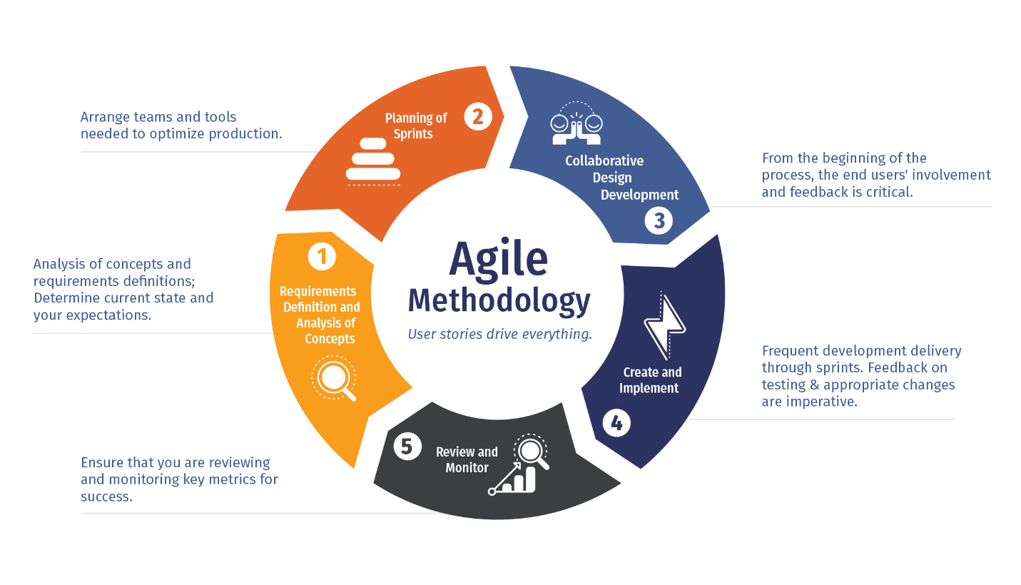
Figure 1. Agile Methodology
The development of the Superlines Bus Ticketing and Reservation Web System may also utilize the Agile software development methodology, an iterative and flexible approach that focuses on continuous improvement, collaboration, and rapid delivery of system functionalities. Agile methodology divides the development process into smaller phases called iterations or sprints, allowing the development team to build, test, and improve the system incrementally. This approach is highly suitable for the proposed system because it enables continuous feedback from users such as passengers, ticketing clerks, and administrators throughout the development process. Through regular evaluation and testing, necessary changes and improvements can be implemented immediately, ensuring that the system effectively addresses operational issues such as long queues, manual booking errors, and inefficient reservation management.
Using Agile methodology allows the developers to prioritize essential features of the Superlines system, including online reservation, real-time seat availability, payment integration, and ticket generation, while maintaining flexibility for future enhancements. The methodology also promotes close communication between developers and stakeholders, ensuring that the system aligns with the operational needs and expectations of Superlines Transportation Co., Inc. Furthermore, Agile supports faster problem identification and resolution through continuous testing and iterative development, resulting in a more reliable, user-friendly, and efficient web-based reservation and ticketing system. Overall, the Agile methodology provides a practical and adaptive framework that supports the successful development and continuous improvement of the proposed transportation management system.

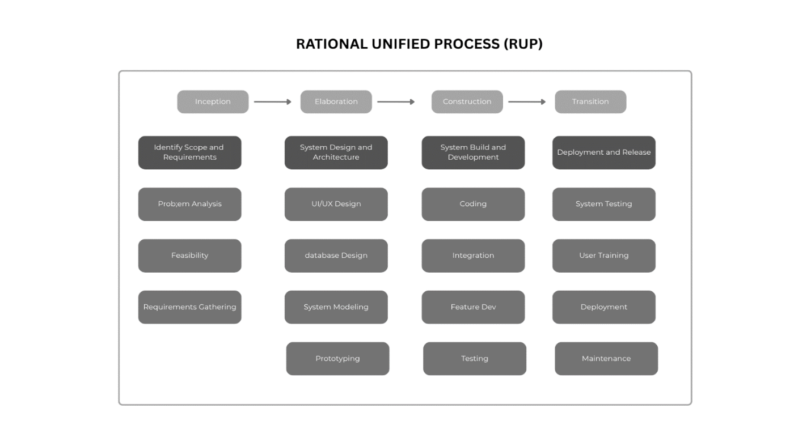
Figure 2. Rational Unified Process

The Elaboration phase involves detailed system analysis and design, where system architecture, database structures, and user interface prototypes are developed to ensure that the platform meets both functional and non-functional requirements. In the Construction phase, the actual development of the system takes place, including the implementation of core features such as online booking, real-time seat availability, secure payment integration, and administrative dashboards, using appropriate front-end and back-end technologies. Finally, the Transition phase ensures the successful deployment of the system, including user training, system testing, and gradual rollout to ensure usability and reliability in real-world operations. By adopting RUP, the development process becomes iterative and user-centered, allowing continuous feedback and improvements, ultimately resulting in a robust, scalable, and efficient web-based reservation system tailored to the operational needs of Superlines Transportation Co., Inc.
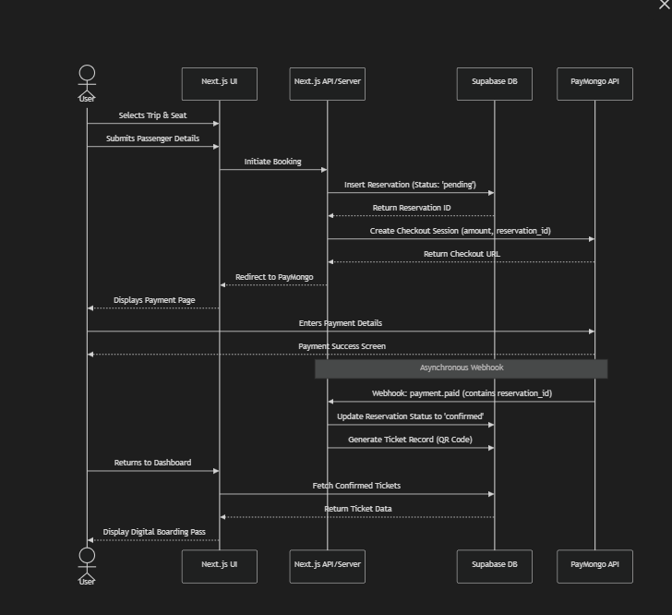
Figure 3. Data flow Diagram
The Data Flow Diagram (DFD)shown in Figure 2 illustrates how data moves within the Superlines Bus Ticketing and Reservation Web System, highlighting the interaction between users, system processes, and data storage. At the context level, the system serves as the central platform that connects customers, administrators, and external payment gateways. Customers interact with the system by submitting booking details, making payments, and receiving electronic tickets, while administrators manage schedules, reservations, and system reports. At a more detailed level, the system is composed of several core processes. The reservation process handles user input, checks seat availability from the bus schedule database, and records booking information in the reservation database. The payment processing module communicates with an external payment gateway to validate transactions and confirm successful payments. Once payment is verified, the ticket generation process creates and stores electronic tickets, which are then sent to the customer as confirmation. Meanwhile, the administrative module allows system managers to update trip schedules, monitor bookings, and generate operational reports using stored data. Overall, the DFD demonstrates a streamlined and integrated data flow that supports efficient booking operations, secure payment handling, and real-time information management, ensuring improved service delivery for Superlines Transportation Co., Inc.
The Entity-Relationship Diagram (ERD) of the Superlines Bus Ticketing and Reservation Web System presents the logical structure of the database by identifying key entities, their attributes, and relationships as shown in Figure 3.
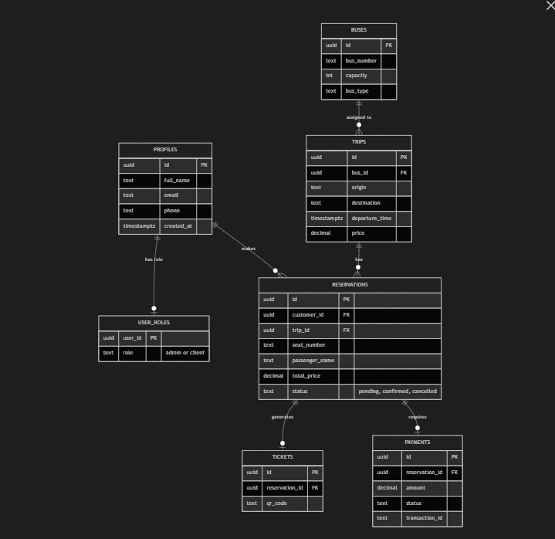
Figure 4. Entity Relationship Diagram
The system primarily revolves around the Customer entity, which is linked to the Reservation entity in a one-to-many relationship, indicating that a single customer can create multiple reservations. Each reservation contains essential booking details and is associated with exactly one payment and one ticket, ensuring proper transaction tracking and ticket issuance. The Reservation entity is also linked to the Trip entity, where multiple reservations can correspond to a single trip, reflecting real-world bus operations. Furthermore, each trip is assigned to a specific bus, establishing a many-to-one relationship between trips and buses. The Bus entity stores details such as bus number and seating capacity, which are essential for managing availability. Additionally, the system includes administrative control over trips, buses, and reservations to ensure efficient operations. Overall, the ERD demonstrates a well-structured relational database design that supports accurate data management, minimizes redundancy, and enables efficient processing of reservations, payments, and ticket generation within the system.
The Construction phase of the Rational Unified Process (RUP) focuses on the actual development and implementation of the Superlines Bus Ticketing and Reservation Web System. During this phase, all system components identified in the earlier stages are translated into a fully functional application through coding, integration, and iterative testing. The development team builds core modules such as user registration and authentication, online reservation, real-time seat availability, payment processing, and ticket generation. Front-end technologies are utilized to create an intuitive and responsive user interface, while back-end technologies handle business logic, database operations, and system integration. Each feature is developed incrementally, allowing continuous testing and refinement to ensure that defects are identified and resolved early. Integration of external services, such as payment gateways, is also carried out to enable secure and seamless financial transactions. Additionally, unit testing, system testing, and performance testing are conducted to verify that the system meets functional and non-functional requirements, including usability, reliability, and efficiency. By the end of the Construction phase, the system reaches a level of completeness where it is ready for deployment and user evaluation in the Transition phase, ensuring that the final product aligns with the operational needs of Superlines Transportation Co., Inc.
The Transition phase of the Rational Unified Process (RUP) focuses on deploying the Superlines Bus Ticketing and Reservation Web System into a real-world operational environment and ensuring its readiness for end users. In this phase, the developed system undergoes final testing, including user acceptance testing (UAT), to validate that it meets the functional and performance requirements defined in earlier stages. Necessary adjustments and bug fixes are implemented based on user feedback to enhance system reliability and usability. The deployment process involves installing the system on a production server, configuring databases, and integrating live services such as payment gateways. Additionally, training sessions are conducted for administrators and staff to familiarize them with system functionalities, including managing schedules, monitoring reservations, and generating reports. Documentation, such as user manuals and technical guides, is also provided to support system usage and maintenance. Furthermore, data migration from existing manual records to the digital system may be performed to ensure continuity of operations. After deployment, the system is closely monitored to address any issues that may arise and to ensure smooth performance. Overall, the Transition phase ensures that the system is fully operational, user-ready, and capable of delivering efficient and reliable services to both customers and Superlines Transportation Co., Inc.
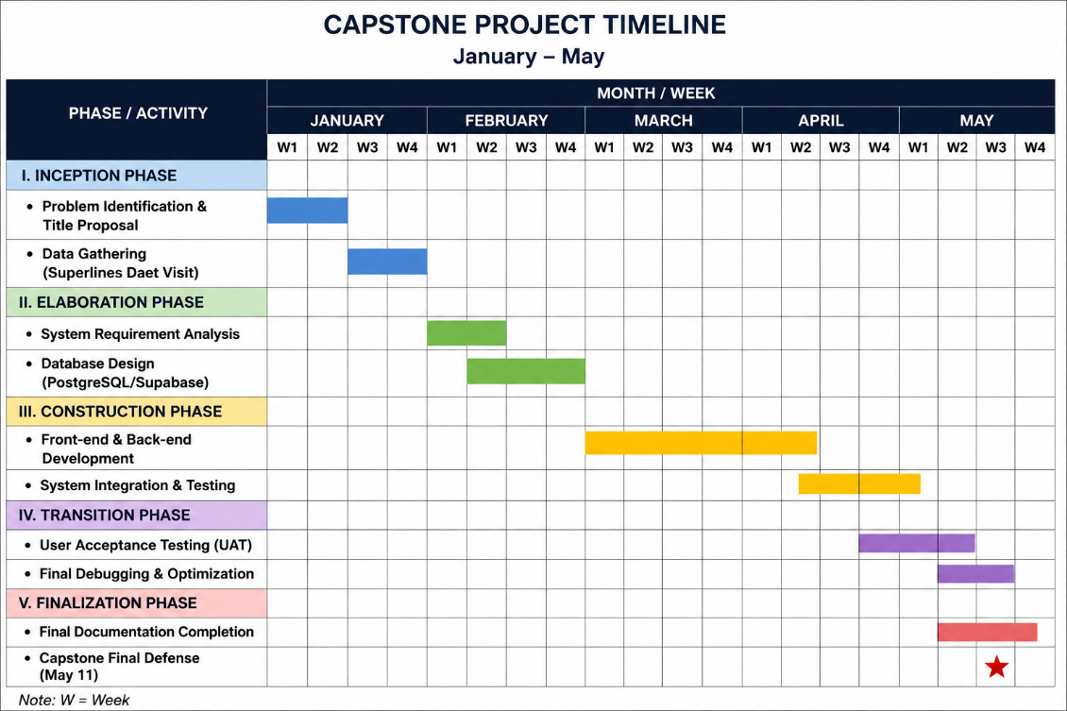
Figure 5. Schedule of Activities
The development of the Superlines Bus Ticketing and Reservation Web System follows a structured schedule of activities aligned with the Rational Unified Process (RUP) to ensure systematic and efficient project execution. The project begins with the Inception phase, where the research problem is identified, and system requirements are gathered and analyzed within the first two weeks. This is followed by the Elaboration phase, which focuses on system design, including the development of user interface prototypes and database structures, typically completed by the fourth week. The Construction phase occupies the majority of the timeline, spanning several weeks dedicated to coding, integration, and comprehensive testing of system functionalities such as booking, payment processing, and administrative controls. Finally, the Transition phase involves deploying the system, conducting user training, and performing user acceptance testing to ensure readiness for real-world application. Maintenance and refinement activities are also included to address any issues encountered after deployment. This structured schedule ensures that each phase is completed efficiently while allowing flexibility for iterative improvements, ultimately contributing to the successful development and implementation of the system.
Source of Data
The data used in the development of the Superlines Bus Ticketing and Reservation Web System were obtained from both primary and secondary sources to ensure accuracy, reliability, and completeness of information. Primary data were collected directly from stakeholders involved in the current ticketing and reservation process, including passengers, ticketing staff, and administrative personnel of Superlines Transportation Co., Inc. Data gathering methods included interviews, surveys, and direct observation. Interviews were conducted to understand the existing workflow, common issues such as long queues and booking inefficiencies, and user expectations for an improved system. Surveys were distributed to passengers to gather insights on user preferences, such as ease of booking, payment options, and desired system features. Additionally, observation of the current manual ticketing process was carried out to identify bottlenecks, inefficiencies, and areas for automation.
Secondary data were gathered from existing literature, including academic journals, books, and online resources related to web-based reservation systems, transportation management, and electronic ticketing technologies. These sources provided theoretical and technical foundations for the system design, including best practices in user interface design, database management, and system security. Furthermore, related studies and case analyses of existing online ticketing platforms were reviewed to identify successful features and strategies that could be adapted to the proposed system. Documentation such as sample booking records, schedules, and reports from transportation operations were also examined to guide the design of the database and system functionalities.
By combining primary and secondary data sources, the study ensures a comprehensive understanding of both user requirements and technological considerations. This approach supports the development of a system that is not only technically sound but also responsive to the actual needs of its users, thereby enhancing the effectiveness and usability of the proposed web-based ticketing and reservation system.
Population of Data
The population of the study consists of individuals directly involved in or affected by the current ticketing and reservation process of Superlines Transportation Co., Inc. Specifically, the respondents include passengers who regularly utilize Superlines bus services, ticketing clerks responsible for handling reservations and payments, and administrative staff who manage schedules, operations, and records. These groups were selected because they represent both end-users and system operators, providing comprehensive insights into the existing manual system and the requirements for a web-based solution.
Passengers were included in the study as they are the primary users of the reservation system and can provide valuable feedback regarding convenience, accessibility, and overall user experience. Ticketing clerks were chosen due to their direct involvement in processing bookings and handling customer transactions, allowing them to identify operational challenges such as delays, errors, and queue congestion. Administrative staff were also included as they oversee scheduling, fleet management, and system coordination, making their input essential for understanding backend operational needs.
By including these key stakeholder groups, the study ensures that the system development is grounded on real operational needs and user expectations. This population selection allows for a balanced perspective between customer experience and administrative efficiency, ensuring that the proposed web-based reservation and ticketing system effectively addresses the limitations of the current manual process and improves overall service delivery for Superlines Transportation Co., Inc.
The respondents of the study are carefully selected to represent the key stakeholders involved in the current ticketing and reservation process of Superlines Transportation Co., Inc.

Respondent Category | Frequency | Percentage
Passengers(End User) | 35 | 70%
Ticketing Clerks (System Operators) | 10 | 20%
Adminitrative Staff/Management (Management) | 5 | 10%
Total | 50 | 100%

Table 1. The Distribution of Respondents
The total respondents are composed of passengers, ticketing clerks, and administrative staff, each group chosen based on their direct interaction with or responsibility in the existing manual system. Passengers comprise 70% or 35 respondents because they are the primary users of the transportation service and the direct beneficiaries of the proposed web-based reservation system. Their inclusion is essential in evaluating user experience, convenience, accessibility, and satisfaction, which are critical factors in assessing the effectiveness of the system.
Ticketing Clerks account for 20% of the sample, or 10 respondents, as they are directly responsible for processing ticket reservations, handling payments, and managing customer inquiries at the terminals. They were selected because they have first-hand experience with the operational limitations of the current manual system, such as long queues, booking errors, and time-consuming processes. Their insights are crucial in identifying inefficiencies and determining how automation can improve daily operations.
Administrative Staff represent 10% or 5 respondents, as they oversee overall operations including scheduling, fleet management, and record-keeping. They were included because they provide a managerial and system-level perspective on how ticketing operations affect business efficiency, resource allocation, and decision-making. Their input is essential in ensuring that the proposed system aligns with organizational goals and operational requirements.
Overall, this distribution ensures that the study captures a comprehensive range of perspectives from end-users to system operators and decision-makers. By selecting these 50 respondents, the study effectively gathers relevant and reliable data necessary for the development of a user-centered and efficient web-based ticketing and reservation system for Superlines Transportation Co. Inc.
Data Collection Method
The study employed a combination of qualitative and quantitative data collection methods to gather comprehensive and reliable information for the development of the Superlines Bus Ticketing and Reservation Web System. These methods include surveys, interviews, and direct observation, which were used to capture the needs, experiences, and challenges of the respondents involved in the current manual ticketing system.
Survey questionnaires were distributed to passengers, ticketing clerks, and administrative staff to gather quantitative data regarding their experiences, preferences, and perceptions of the existing reservation process. The survey focused on key aspects such as ease of booking, waiting time, system efficiency, and satisfaction with current services. This method allowed the researchers to obtain measurable data that can be statistically analyzed to identify common issues and user requirements.
The study utilized a mixed-method approach, combining both quantitative and qualitative data collection methods to obtain comprehensive and reliable information for the development of the Superlines Bus Ticketing and Reservation Web System. This approach is essential in ensuring that both measurable user data and in-depth operational insights are gathered, allowing for a more complete understanding of the existing manual ticketing system.
The quantitative method was primarily used through survey questionnaires distributed to passengers, ticketing clerks, and administrative staff. This method focuses on collecting numerical data that can be statistically analyzed to identify patterns, trends, and levels of satisfaction regarding the current reservation system. The survey included structured questions related to waiting time, booking convenience, system efficiency, and overall user satisfaction. The quantitative data gathered from these responses provide measurable evidence of the problems encountered in the existing manual system and help determine the level of need for a web-based solution.
On the other hand, the qualitative method was used through structured interviews and direct observation. This method focuses on gathering detailed and descriptive information about the experiences, challenges, and suggestions of the respondents. Interviews were conducted with selected ticketing clerks and administrative personnel to gain deeper insights into operational processes such as scheduling, reservation handling, and payment transactions. Meanwhile, direct observation at Superlines terminals allowed the researchers to study the actual workflow in real time, identifying inefficiencies such as long queues, manual encoding errors, and delays in processing transactions. These qualitative insights provide contextual understanding that complements the numerical data collected from surveys.
By integrating both qualitative and quantitative methods, the study ensures a balanced and holistic analysis of the current system. The quantitative data provides statistical support for identifying common issues, while the qualitative data offers deeper explanations of those issues from the perspective of users and system operators. This mixed-method approach strengthens the validity and reliability of the findings and supports the development of a more efficient, user-friendly, and effective web-based reservation and ticketing system for Superlines Transportation Co., Inc.
In addition, structured interviews were conducted with selected ticketing clerks and administrative personnel to obtain in-depth qualitative information about operational challenges, workflow inefficiencies, and suggestions for system improvement. Interviews provided detailed insights that could not be captured through surveys alone, particularly regarding internal processes such as scheduling, payment handling, and record management.
Furthermore, direct observation was conducted at Superlines terminals to examine the actual ticketing process in real time. This method helped the researchers identify bottlenecks such as long queues, manual encoding errors, and delays in transaction processing. Observation also provided a clearer understanding of how the system functions in a real-world environment.
By combining these three data collection methods, the study ensures a more accurate and holistic understanding of the current system. This multi-method approach strengthens the validity of the findings and supports the development of a more efficient, user-friendly, and reliable web-based reservation and ticketing system for Superlines Transportation Co., Inc.

Data Collection Procedure

The data collection process was systematically designed to address the research gaps identified in the literature review in Chapter 2. The procedure followed a three-phased approach to ensure that the proposed system directly solves the operational inefficiencies of Superlines Transportation Co. Inc.
Phase I: Qualitative Observation and Gap Analysis. To address the issues regarding terminal congestion and manual bottlenecks, the researchers conducted direct observations at the Superlines terminal in Daet. This phase focused on measuring the "Transaction Lead Time"—the total time it takes for a passenger to book a ticket manually. This provided the baseline data needed to compare the efficiency of the manual system against the proposed web-based solution.
Phase II: Technical Requirement Validation. Following the technical standards for Cloud-based Databases and Backend-as-a-Service (BaaS) discussed in Chapter 2, the researchers gathered system requirements focused on Supabase and PostgreSQL integration. This ensured that the data collection for system features remained aligned with the construction of the QR-code generation and real-time manifest modules.
Phase III: Quantitative Usability Testing. To conclude the data collection, the researchers administered a survey questionnaire based on the Technology Acceptance Model (TAM) by Davis (2020). The collection focused on two primary metrics: Perceived Usefulness and Perceived Ease of Use. By utilizing the System Usability Scale (SUS) framework by Putri and Liu (2024), the researchers ensured that the feedback collected from passengers and staff could be statistically analyzed using the Weighted Mean to determine the system's final success rate.
Research Instrument
The primary data collection tool utilized in this study is a researcher-designed survey questionnaire, which was meticulously structured to ensure a comprehensive evaluation of the system’s requirements, operational efficiency, and user acceptance. To maintain a high level of theoretical consistency and academic rigor, the instrument was developed based on the conceptual frameworks of system usability and technology adoption discussed in the Review of Related Literature. The questionnaire is organized into three distinct sections, each designed to capture specific data points necessary to fulfill the study's research objectives.
The first section of the instrument focuses on the Demographic Profile of the respondents. This part gathers essential background information, primarily categorizing the participants based on their role within the Superlines ecosystem—whether they are passengers, ticketing clerks, or administrative staff. Collecting this information is vital for the researchers to analyze how different user groups perceive the system’s utility, as a passenger’s need for ease of booking may differ significantly from an administrator’s need for data management and reporting.
The second section is dedicated to the Assessment of the Current Manual System. This part consists of descriptive questions aimed at quantifying the frequency and severity of issues encountered in the existing manual process, such as extended queuing times, manual encoding errors, and the lack of real-time seat availability updates. By including this section, the researchers aim to provide empirical evidence for the operational bottlenecks identified by Martinez (2022). The data gathered here serves as a baseline to demonstrate the necessity of transitioning from a traditional logbook-based method to a modernized web-based integrated platform.
The final and most critical section of the instrument pertains to System Usability and Acceptance. This part was adapted from the Technology Acceptance Model (TAM) by Davis (2020) and the System Usability Scale (SUS) by Putri and Liu (2024), both of which were established in Chapter 2 as the gold standards for evaluating software success. Using a 5-point Likert Scale, this section measures two primary variables: Perceived Usefulness (PU) and Perceived Ease of Use (PEOU). By utilizing these validated frameworks, the researchers can scientifically determine if the proposed Superlines system is perceived as a productive tool that simplifies the reservation process and if the user interface is intuitive enough to be navigated by users with varying levels of technical proficiency.
Data Analysis
The data gathered in this study were analyzed using both quantitative and qualitative data analysis techniques to ensure a comprehensive interpretation of findings related to the development of the Superlines Bus Ticketing and Reservation Web System. The combination of these methods allows the researchers to evaluate both measurable trends and descriptive insights from respondents.1.
Quantitative Data Analysis
Quantitative data obtained from survey questionnaires were analyzed using descriptive statistical methods. The responses from passengers, ticketing clerks, and administrative staff were organized, tabulated, and interpreted using frequency distribution and percentage calculations. This method was used to determine the level of satisfaction, frequency of issues encountered, and user perception of the current manual ticketing system.
The formula used for percentage distribution is:

x̄=∑(f⋅w)
N
Where:

xˉ = Weighted Mean
f = Frequency of each response
w = Weight assigned to each response (Likert Scale)
N = Total number of respondents

The calculated mean scores were then interpreted using the following SUS-based qualitative scale to determine the system's overall acceptance and usability:
Weighted Mean | Adjective Rating | Usability Description
4.51 – 5.00 | Excellent | Highly Usable and Satisfactory
3.51 – 4.50 | Good | Usable with minor suggestions
2.51 – 3.50 | Fair | Acceptable but needs improvement
1.00 – 2.50 | Poor | Not Usable/Difficult to use

Likert-scale questions (e.g., Strongly Agree to Strongly Disagree) were also used to measure user satisfaction and system usability. The weighted mean was computed to determine the overall interpretation of responses, helping identify the most significant issues and user needs that the proposed system must address.
Qualitative Data Analysis
Qualitative data gathered from interviews and direct observation were analyzed using thematic analysis. This method involves identifying, categorizing, and interpreting recurring themes and patterns from respondent responses. Interview transcripts from ticketing clerks and administrative staff were carefully reviewed to extract common issues such as delays in manual processing, data redundancy, and difficulties in managing reservations.
Observation data from Superlines terminals were also analyzed to support and validate interview findings. The researchers documented operational inefficiencies such as long queues, manual encoding errors, and lack of real-time seat availability updates. These findings were grouped into major themes such as operational inefficiency, system limitations, and user inconvenience.
Integration of Quantitative and Qualitative Results
After separate analyses, both quantitative and qualitative findings were integrated to provide a complete understanding of the current system. Quantitative data provided measurable evidence of system inefficiencies, while qualitative data explained the underlying causes of these issues. This integration helped establish a strong basis for designing the proposed web-based reservation and ticketing system.
Interpretation of Results
The interpreted data served as the foundation for identifying system requirements and design specifications. High levels of dissatisfaction in quantitative results, combined with recurring operational issues identified in qualitative findings, indicate a strong need for an automated and integrated reservation system. These results directly support the development of a web-based solution that improves efficiency, accuracy, and user experience for Superlines Transportation Co., Inc.
Ethical Considerations
The development and conduct of this study on the Superlines Bus Ticketing and Reservation Web System adhered to strict ethical standards to ensure the protection, dignity, and rights of all participants involved. Ethical considerations were observed throughout the data gathering, analysis, and system development processes to maintain integrity, transparency, and reliability of the study.
First, informed consent was obtained from all respondents, including passengers, ticketing clerks, and administrative staff of Superlines Transportation Co., Inc. Participants were properly informed about the purpose of the study, the nature of their participation, and how the collected data would be used. They were also assured that their participation was voluntary and that they had the right to withdraw from the study at any time without any negative consequences.
Second, confidentiality and anonymity were strictly maintained. Any personal information provided by respondents was kept confidential and was not disclosed in any form that could identify individuals. Data collected from surveys and interviews were used solely for academic purposes and were securely stored to prevent unauthorized access. In reporting findings, responses were generalized to ensure that no participant could be personally identified.
Third, the study ensured data protection and security, especially since the proposed system involves sensitive information such as personal details and payment-related data. Ethical handling of information was observed in both the research phase and system design considerations, emphasizing the importance of secure data storage and transmission.
Fourth, the study practiced honesty and integrity in data reporting. All findings were accurately represented without fabrication, manipulation, or misinterpretation of data. Proper acknowledgment and citation of all secondary sources were also observed to avoid plagiarism and respect intellectual property rights.
Lastly, the study considered the beneficence principle, ensuring that the results of the research would ultimately benefit both the organization and its users. The proposed system aims to improve efficiency, reduce inconvenience, and enhance customer satisfaction without causing harm to any stakeholder.
Overall, these ethical considerations ensured that the research was conducted responsibly, respectfully, and in accordance with accepted academic and professional standards, thereby strengthening the credibility and validity of the study.

References
Aditya, R., et al. (2024). Automatic bus ticketing system with optimized payment and ticket selection modules.
Aggarwal, S., et al. (2025). Marketing information systems integrated with advanced signal processing technologies for transportation management.
Alalwan, A. A., et al. (2021). Factors affecting adoption of digital transportation systems under UTAUT2.
Arka Jain University. (2021). Automated bus reservation system for efficient passenger and schedule management.
Arzoumanidis, I., et al. (2022). Online booking platforms and sustainability in tourism and transportation industries.
Baharum, N., et al. (2024). IoT-based online ticketing systems for transportation reliability and efficiency.
Bakka, K., et al. (2023). RFID-based smart transportation systems for passenger identification and monitoring.
Davis, F. D. (2020). Technology Acceptance Model (TAM) and user adoption of information systems.
Deng, X., et al. (2023). Customized transportation services integrated into traditional bus systems.
Fadeev, A., & Alhusseini, M. (2023). Big data analytics and urban computing in transportation demand management.
Frederico, G., et al. (2021). Passenger-controlled bus operation model using mobile applications.
Freitas, J., et al. (2023). Transportation service quality and commuter preference analysis.
Hermawati, R., et al. (2026). Assessment of Bus Rapid Transit accessibility, punctuality, and sustainability.
Hisbulloh, M., et al. (2025). User experience evaluation of Tiket.com transportation booking platform.
Hoang, T. (2025). AI-integrated transportation booking platforms and operational optimization.
Hosseini, S., et al. (2025). Transportation safety, accessibility, and service efficiency improvements.
Hsiao, C., & Tang, K. (2025). Self-service technology adoption and customer satisfaction in digital systems.
Jati, P., et al. (2025). System reliability, login failures, and performance optimization in transportation applications.
Jr, R., et al. (2023). Viajeros web application for modern transportation reservations and fare payments.
Kuncara, D., et al. (2021). QR-code-based electronic ticketing systems for transportation services.
Lee, J. (2022). Limitations of traditional scheduling systems in transportation operations.
Legowo, N., & Kaharmies, R. (2023). Enterprise architecture and business process improvement for transportation modernization.
Li, Y., et al. (2023). Reservation-based transportation systems and traffic management strategies.
Martinez, A. (2022). Operational inefficiencies in manual reservation systems.
Martins, C., & Oliveira, T. (2021). Perceived usefulness and ease of use in mobile ticketing adoption.
Nadila, R., & Islami, F. (2025). Usability barriers among elderly users in digital reservation systems.
Nguyen, H., & Tran, P. (2025). System analysis and software testing for transportation booking systems.
Nivaan, S., et al. (2021). Wireless sensor network systems for real-time bus tracking and monitoring.
Oleyede, T., et al. (2014). Online reservation systems for transportation services.
Pal, S., et al. (2021). Travel Vogue: A web-based travel reservation platform.
Putri, A., & Liu, Y. (2024). System Usability Scale evaluation of Tiket.com online booking services.
Qiu, X., et al. (2025). Urban Customized Bus systems with flexible reservation services.
Sari, D., et al. (2024). Website-based reservation systems and customer communication improvement.
Shimomba, K., et al. (2025). Integrated online bus ticketing systems and e-commerce growth.
Sogbe, M., et al. (2025). Digital transformation and sustainable public transportation systems.
Sreekrishna, P., et al. (2021). Machine learning applications for passenger occupancy prediction and mobility management.
Subramaniyan, R., et al. (2021). Smart ticketing systems integrating RFID, GSM, and facial recognition technologies.
Sujatha, M., et al. (2025). Web-based Metropolitan Transport Corporation booking management system.
Susilawati, R., & Susilawati, D. (2025). Consumer preferences for digital transportation services.
Tan, W., & Tan, C. (2020). Mobile integration and customer adoption of reservation systems.
Tran, L. (2025). Digital booking systems and operational efficiency in transportation companies.
Vadivel, R., et al. (2024). Cloud computing and Random Forest algorithms in transportation ticketing systems.
Valencia, P., et al. (2024). User experience evaluation of RedBus online booking applications.
Van, T., et al. (2025). Bloom-filter hashing techniques for automatic bus ticketing systems.
Vinodhkumar, S., et al. (2024). Challenges in traditional transportation booking methods.
Zhao, L., et al. (2022). Online reservation systems during the COVID-19 pandemic.
Zhou, H., et al. (2021). Customized transportation dispatching models using reservation data.
Zhou, Y., et al. (2023). Real-time reservation systems for transportation scheduling optimization.

