Set A
- mkdir ~/ansible-project
- cd ~/ansible-project

- nano ansible.cfg

[defaults]
inventory = ./inventory.ini
host_key_checking = False
remote_user = ubuntu
private_key_file = ~/.ssh/ass4.pem

- nano inventory.ini

[managed]
node1 ansible_host=13.220.50.40
node2 ansible_host=98.88.27.146

[all:vars]
ansible_python_interpreter=/usr/bin/python3

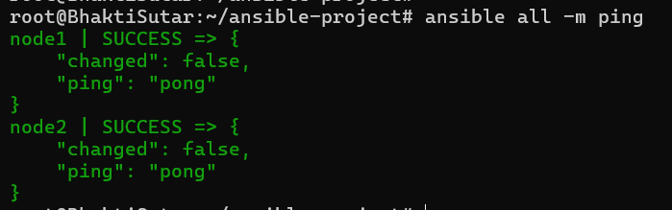

- nano create_user.yml
---
---
- name: Create users with variables and show debug info
hosts: managed
become: yes
tasks:
- name: Create user
user:
name: "{{ username }}"
comment: "{{ comment }}"
state: present
create_home: yes

- name: Show debug message
debug:
msg: "Created user {{ username }} with comment: {{ comment }}"

- mkdir -p host_vars group_vars

- nano host_vars/node1.yml

username: "alice"
comment: "Alice - specific to node1"

- nano host_vars/node2.yml

username: "bob"
comment: "Bob - specific to node2"

- nano group_vars/all.yml

username: "global_user"
comment: "Default comment for all nodes"

- nano group_vars/managed.yml

username: "managed_group_user"
comment: "Group-wide comment for managed nodes"

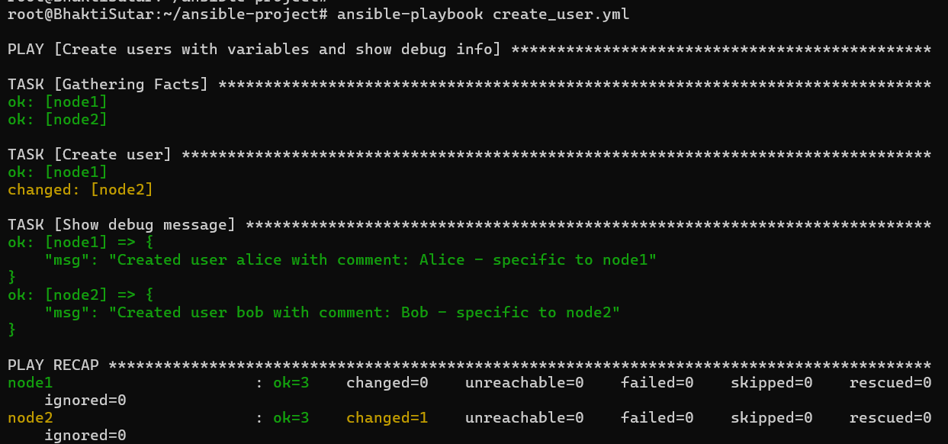

Set B

- nano ansible.cfg

[defaults]
inventory = inventory.ini
host_key_checking = False
- nano inventory.ini
[webservers]
node1 ansible_host=13.233.131.201 ansible_user=ubuntu ansible_ssh_private_k>
node2 ansible_host=3.111.40.50 ansible_user=ubuntu ansible_ssh_private_key_>

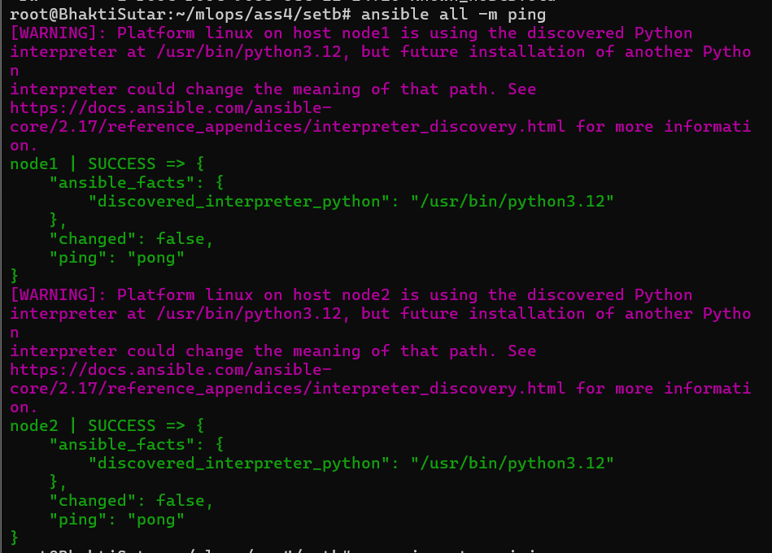

- mkdir -p templates
- cd templates

- nano index.html.j2
<!DOCTYPE html>
<html>
<head>
<title>Welcome to {{ ansible_hostname }}</title>
</head>
<body>
<h1>Hostname: {{ ansible_hostname }}</h1>
<h2>IP Address: {{ ansible_default_ipv4.address }}</h2>
</body>
</html>

- nano nginx.conf.j2
server {
listen 80;
server_name example.com;

root /var/www/html;
index index.html;

location / {
try_files $uri $uri/ =404;
}
}

- nano install_nginx.yml
---
- name: Install Nginx on all hosts
hosts: all
become: yes
tasks:
- name: Update apt cache
apt:
update_cache: yes

- name: Install Nginx
apt:
name: nginx
state: present

- name: Ensure Nginx is running
service:
name: nginx
state: started
enabled: yes

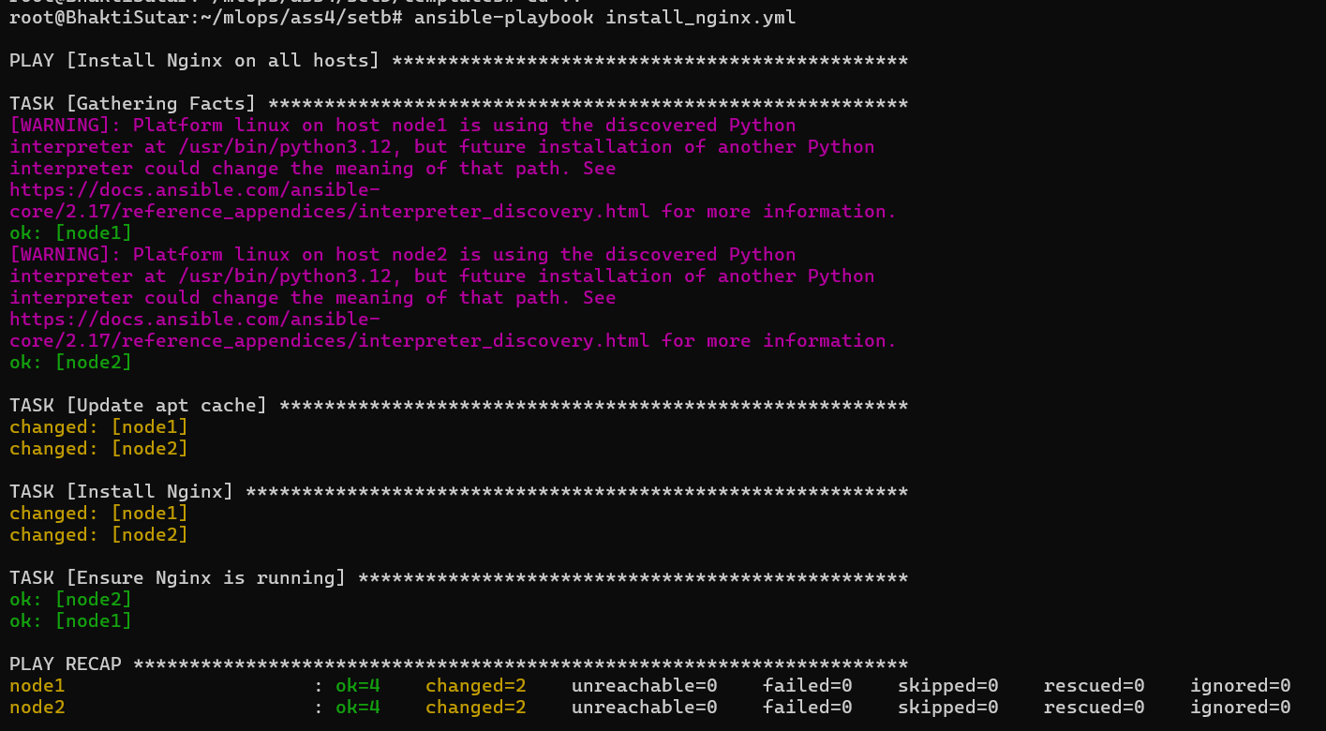

- nano deploy_nginx_conf.yml
---
- name: Deploy Nginx configuration
hosts: all
become: yes
tasks:
- name: Copy nginx.conf.j2 to /etc/nginx/sites-available/example.com.conf
template:
src: templates/nginx.conf.j2
dest: /etc/nginx/sites-available/example.com.conf

- name: Enable site by creating symlink
file:
src: /etc/nginx/sites-available/example.com.conf
dest: /etc/nginx/sites-enabled/example.com.conf
state: link

- name: Test Nginx configuration
command: nginx -t

- name: Reload Nginx
service:
name: nginx
state: reloaded
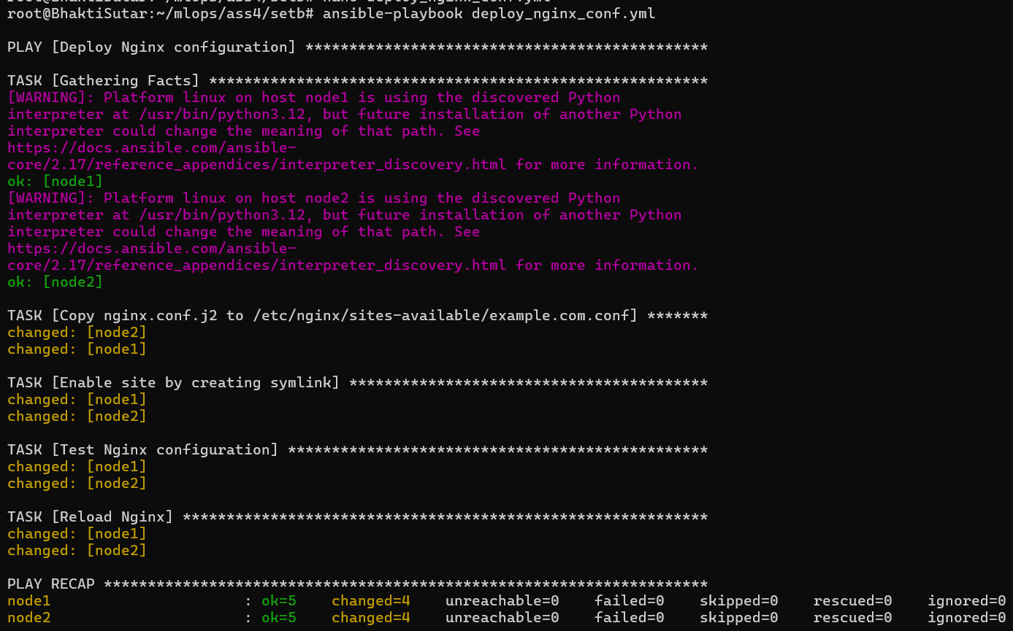

- nano deploy_index_html.yml
---
- name: Deploy custom index.html
hosts: all
become: yes
tasks:
- name: Replace default index.html with Jinja2 template
template:
src: templates/index.html.j2
dest: /var/www/html/index.html
owner: www-data
group: www-data
mode: '0644'

- name: Restart Nginx to apply changes
service:
name: nginx
state: restarted

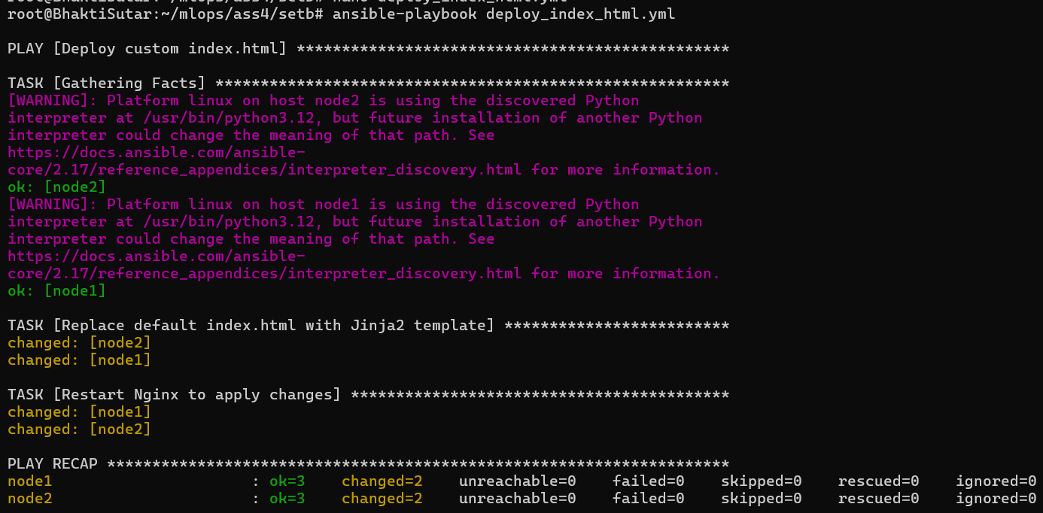

Set c
- nano inventory.ini

[debian]
ubuntu1 ansible_host=3.108.51.70 ansible_user=ubuntu ansible_ssh_private_ke>

[redhat]
amzn1 ansible_host=3.110.118.101 ansible_user=ec2-user ansible_ssh_private_>

- nano ansible.cfg

[defaults]
inventory = inventory.ini
host_key_checking = False

- ansible all -m ping
- ansible debian -m ping
- ansible redhat -m ping
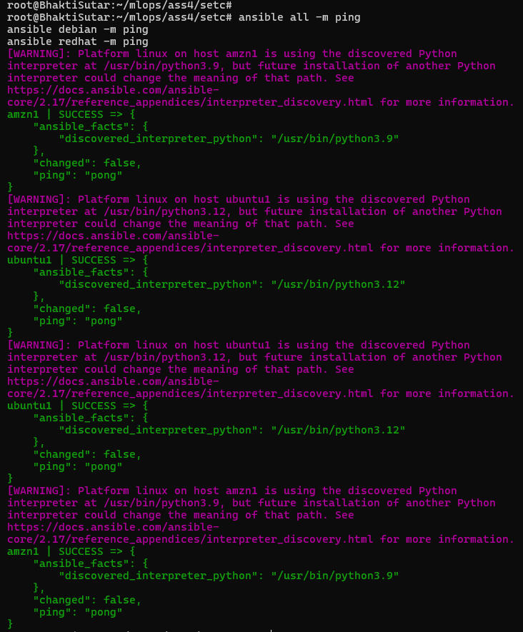

- nano ubuntu.yml

---
- hosts: debian
become: yes
roles:
- apache
- nano amazon.yml
---
- hosts: redhat
become: yes
roles:
- httpd

