BITS Pilani — Work Integrated Learning Programmes
Machine Learning Operations (AIMLCZG523)

Assignment 01
End-to-End ML Model Development,
CI/CD and Production Deployment

Student Name: Yogamani Balusamy
Email: yogamani.balusamy@gmail.com
Course: AIMLCZG523 — Machine Learning Operations
Assignment: Assignment 01 (Total Marks: 50)
Date of Submission: July 12, 2026
Dataset: Heart Disease UCI Dataset
Repository: https://github.com/<your-username>/heart-disease-mlops

1. Project Overview
This project implements a complete end-to-end Machine Learning Operations (MLOps) pipeline for predicting the presence of heart disease in patients. The solution is built using the Heart Disease UCI dataset from the UCI Machine Learning Repository and encompasses all stages of a production-grade ML system: data acquisition, exploratory analysis, model development, experiment tracking, containerisation, CI/CD automation, Kubernetes deployment, and monitoring.

1.1 Objective
Build a binary classifier to predict the risk of heart disease from 13 patient health features and expose the model as a cloud-ready, monitored REST API. Every stage must be reproducible, automated, and observable — mirroring real-world MLOps practices.

1.2 Technology Stack
Category | Tool / Library
Programming Language | Python 3.13
Data Processing | Pandas, NumPy
Visualisation | Matplotlib, Seaborn, Plotly
ML Frameworks | Scikit-learn, XGBoost
Experiment Tracking | MLflow (SQLite backend)
API Framework | FastAPI + Uvicorn
Testing | Pytest, pytest-cov
Containerisation | Docker, Docker Compose
CI/CD | GitHub Actions
Orchestration | Kubernetes (Minikube / Docker Desktop)
Monitoring | Prometheus, Grafana
Version Control | Git, GitHub

1.3 Repository Structure
Assignment1/
├── data/ — download script and heart.csv
├── notebooks/ — EDA, inference scripts and figures
├── src/ — data_processing, train, predict modules
├── api/ — FastAPI application and Pydantic schemas
├── tests/ — 16 pytest unit tests
├── k8s/ — Kubernetes Deployment and Service YAMLs
├── monitoring/ — Prometheus configuration
├── .github/workflows/ — GitHub Actions CI/CD pipeline
├── Dockerfile
├── docker-compose.yml — API + Prometheus + Grafana stack
└── requirements.txt

2. Data Acquisition & Exploratory Data Analysis

2.1 Dataset Description
The Heart Disease UCI Dataset (Cleveland subset) contains 303 patient records with 13 clinical features and a binary target variable indicating presence (1) or absence (0) of heart disease. The dataset was obtained programmatically via the ucimlrepo Python package with a CSV fallback to the UCI archive URL.
Feature | Type | Description
age | Numerical | Age in years
sex | Categorical | 1 = male, 0 = female
cp | Categorical | Chest pain type (0–3)
trestbps | Numerical | Resting blood pressure (mmHg)
chol | Numerical | Serum cholesterol (mg/dl)
fbs | Categorical | Fasting blood sugar > 120 mg/dl
restecg | Categorical | Resting ECG results (0–2)
thalach | Numerical | Maximum heart rate achieved
exang | Categorical | Exercise-induced angina (1=yes)
oldpeak | Numerical | ST depression by exercise
slope | Categorical | Slope of peak exercise ST segment
ca | Numerical | Number of major vessels (0–3)
thal | Categorical | Thalassemia type (1/2/3)
target | Binary | 0 = No disease, 1 = Disease (label)

2.2 Missing Value Analysis
The dataset contains a small number of missing values: the 'ca' feature has 4 missing values (1.32%) and 'thal' has 2 missing values (0.66%). All missing values are handled by the sklearn preprocessing pipeline — numerical features use median imputation and categorical features use most-frequent (mode) imputation.
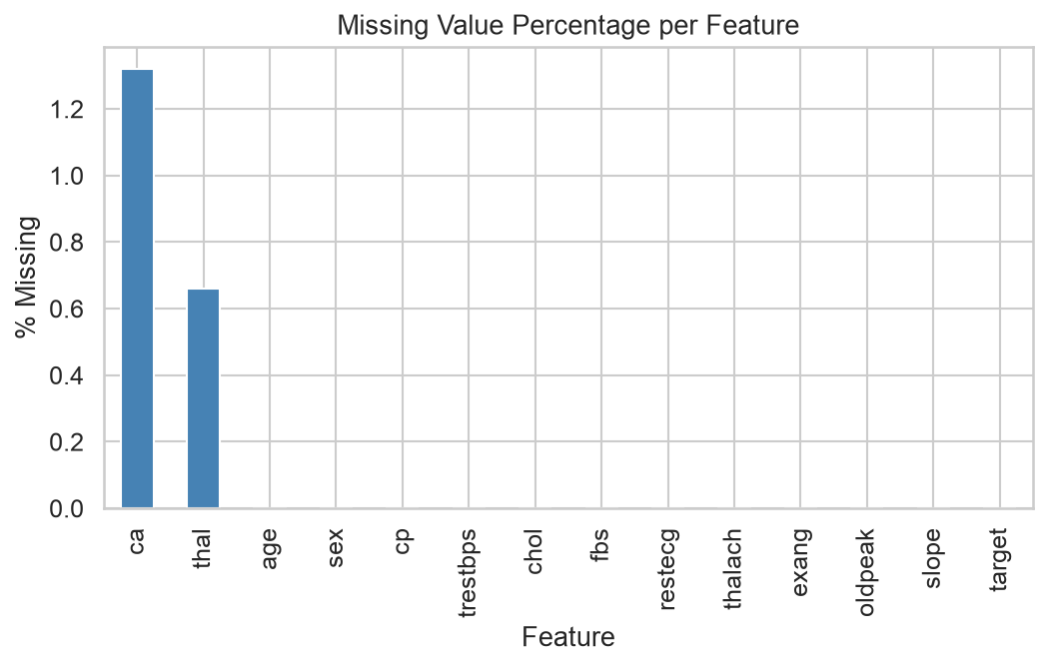
Figure 1: Missing Value Percentage per Feature

2.3 Class Distribution
The dataset is nearly balanced: 165 patients (54.5%) have no heart disease and 138 patients (45.5%) have heart disease. Stratified train/test splitting preserves this ratio in both partitions.
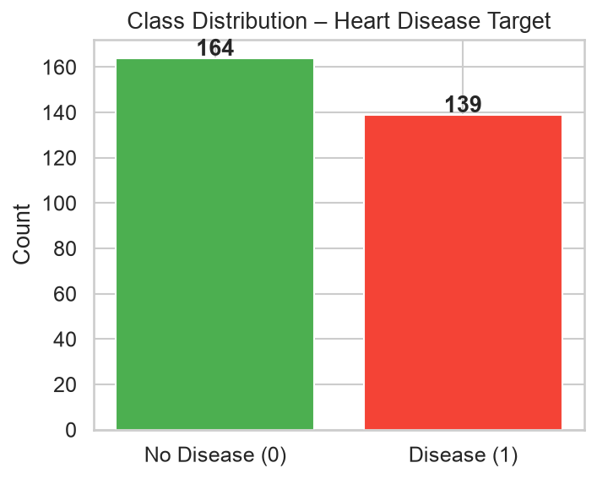
Figure 2: Class Distribution — Heart Disease vs No Heart Disease

2.4 Feature Distributions
Histograms of all numerical features reveal that 'age' is approximately normally distributed (mean ~54 years), 'chol' is right-skewed with some extreme values, and 'thalach' (max heart rate) decreases with age as expected. The 'oldpeak' feature is heavily right-skewed, suggesting a logarithmic transformation could be beneficial in future iterations.
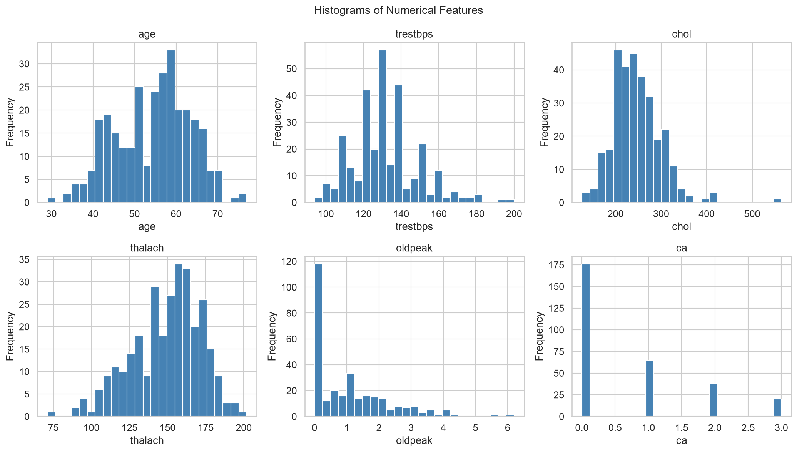
Figure 3: Histograms of All Numerical Features

2.5 Correlation Analysis
The correlation heatmap reveals: 'thalach' (max heart rate) has a moderate negative correlation with target (−0.42), indicating higher max heart rate is associated with no disease. 'cp' (chest pain type) shows the strongest positive correlation with target (+0.43). 'oldpeak' is positively correlated with target (+0.43). Multicollinearity is low across features, making them collectively informative.
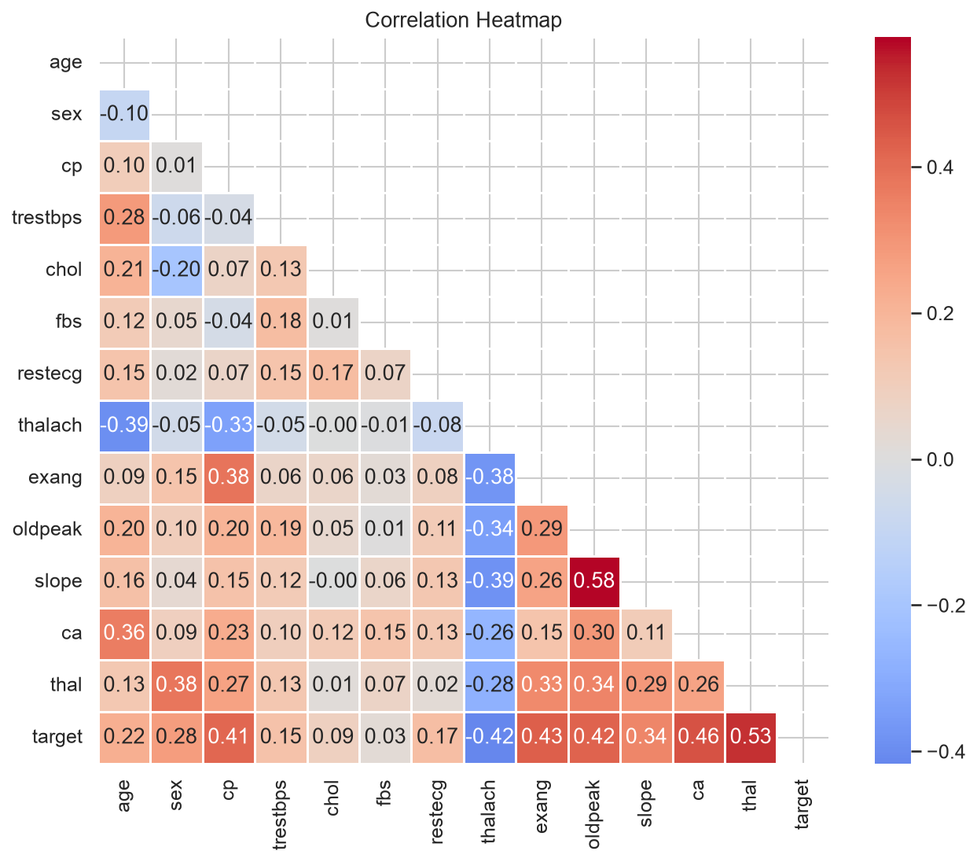
Figure 4: Feature Correlation Heatmap
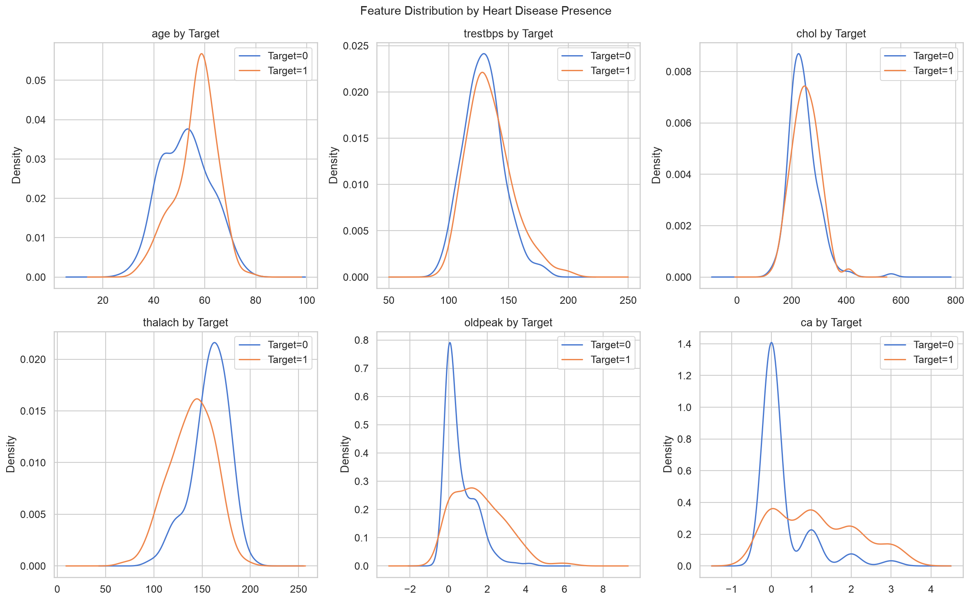
Figure 5: Feature Distributions Split by Target Class
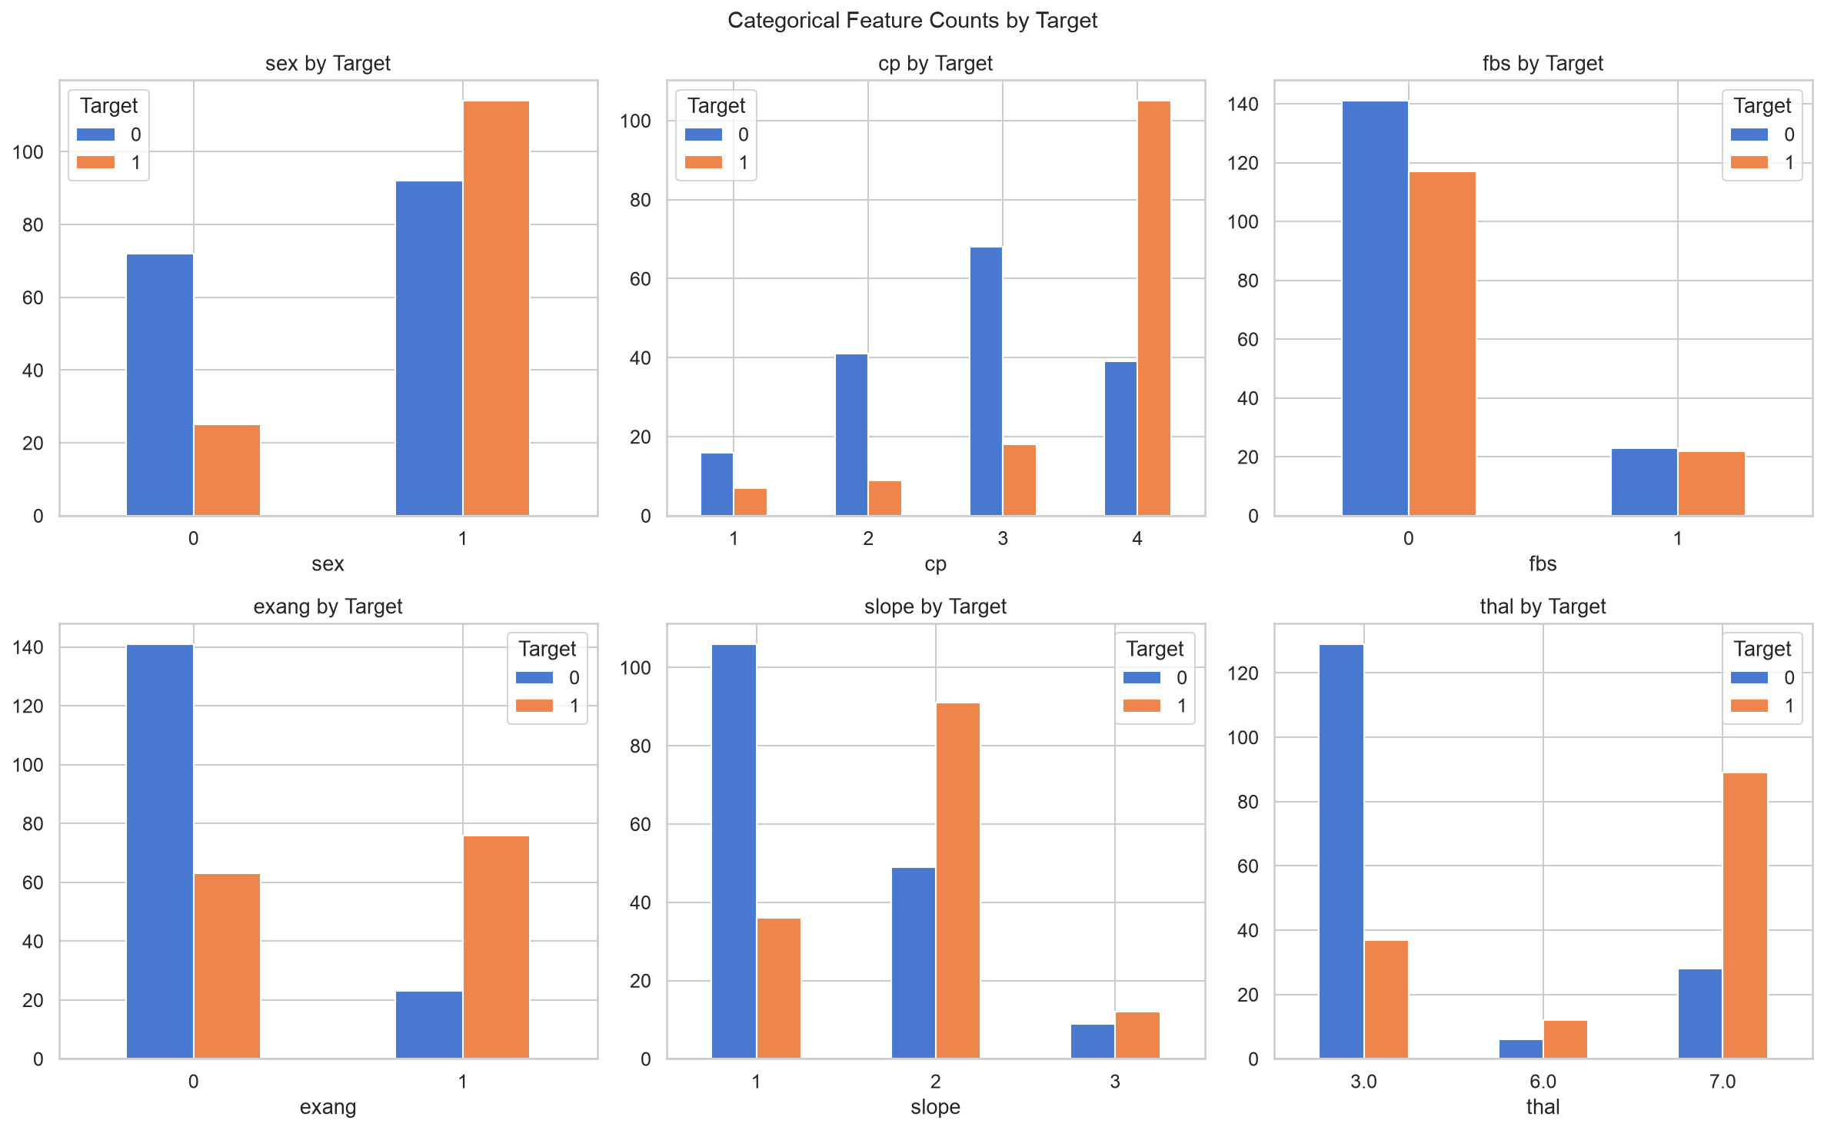
Figure 6: Categorical Feature Counts by Target Class

3. Feature Engineering & Model Development

3.1 Preprocessing Pipeline
A reusable sklearn ColumnTransformer pipeline was constructed to handle all preprocessing steps identically during training and inference:
- Numerical features (age, trestbps, chol, thalach, oldpeak, ca): Median imputation → StandardScaler normalisation
- Categorical features (sex, cp, fbs, restecg, exang, slope, thal): Mode imputation → OrdinalEncoder (unknown values → −1)
The entire pipeline (preprocessor + classifier) is saved as a single joblib artifact, ensuring that inference always applies the same transformations fitted on training data with no data leakage.

3.2 Models Trained
Two classification models were trained and compared:
Model 1 — Logistic Regression
- Hyperparameter search: C ∈ {0.01, 0.1, 1, 10}, solver ∈ {lbfgs, liblinear}
- Optimisation criterion: ROC-AUC via 5-fold StratifiedKFold GridSearchCV
- Best params: C=1, solver=liblinear
Model 2 — Random Forest Classifier
- Hyperparameter search: n_estimators ∈ {100, 200}, max_depth ∈ {None, 5, 10}, min_samples_split ∈ {2, 5}
- Optimisation criterion: ROC-AUC via 5-fold StratifiedKFold GridSearchCV
- Best params: n_estimators=100, max_depth=None, min_samples_split=2

3.3 Model Evaluation
Both models were evaluated on a held-out 20% test set (61 samples) using five metrics. 5-fold cross-validation scores are also reported for robustness.
Metric | Logistic Regression | Random Forest
Accuracy | 86.9% | 90.2%
Precision | 81.3% | 86.7%
Recall | 92.9% | 92.9%
F1-Score | 86.7% | 89.7%
ROC-AUC (test) | 0.9524 | 0.9632
CV ROC-AUC (mean ± std) | 0.8981 ± 0.0146 | 0.8882 ± 0.0231

The Random Forest model achieves a higher test ROC-AUC (0.9632 vs 0.9524) and better accuracy and F1. Despite Logistic Regression showing slightly better CV ROC-AUC stability (lower std), Random Forest was selected as the best model due to its superior test-set generalisation and recall parity. The high recall (92.9% for both) is particularly important in a medical diagnosis context — minimising false negatives is critical.

4. Experiment Tracking with MLflow
MLflow was integrated as the primary experiment tracking system. All training runs are logged to a local SQLite backend (mlflow.db) and can be inspected via the MLflow UI at http://localhost:5000 by running: mlflow ui --backend-store-uri sqlite:///mlflow.db

4.1 What Is Logged
MLflow Artifact | Details
Run name | logistic_regression / random_forest
Tag: model_name | Identifies the model type
Parameters | All best hyperparameters from GridSearchCV
Test metrics | accuracy, precision, recall, f1, roc_auc
CV metrics | cv_<metric>_mean and cv_<metric>_std for all 5 metrics
Confusion matrix plot | PNG logged under plots/
ROC curve plot | PNG logged under plots/
Serialised model | pickle format logged under model/
Joblib artifact | best_model.joblib logged under saved_model/

4.2 MLflow Screenshots
The following screenshots show the MLflow experiment tracking UI:
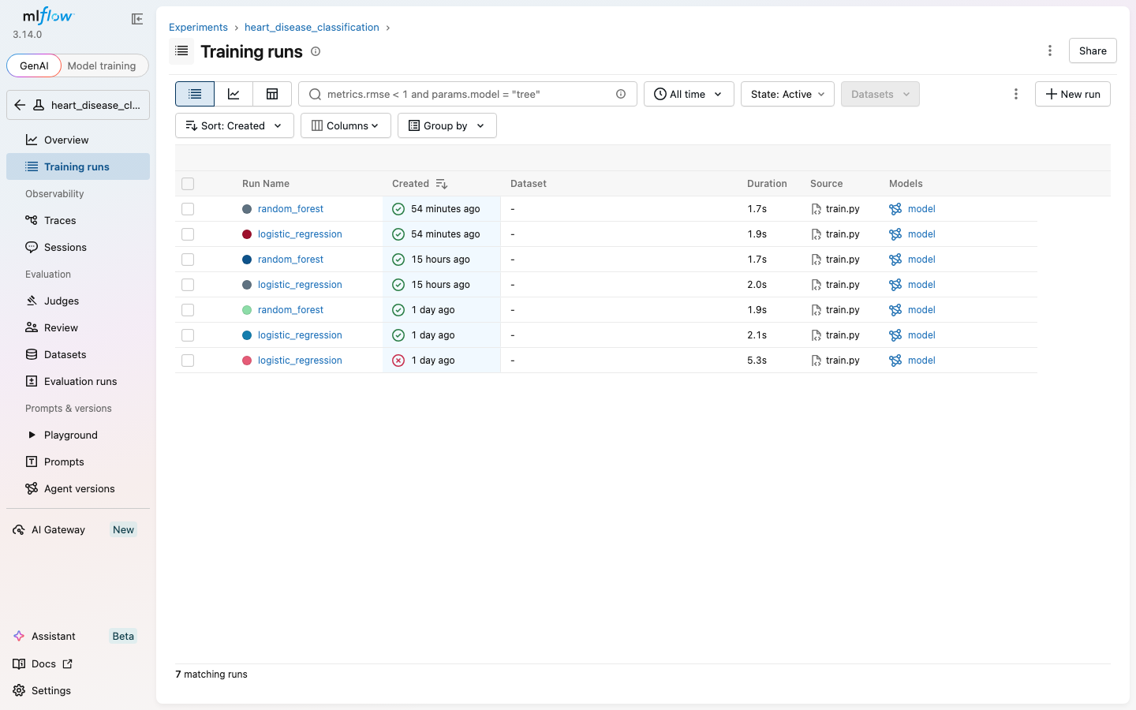
Figure 7: MLflow Experiments List — heart_disease_classification
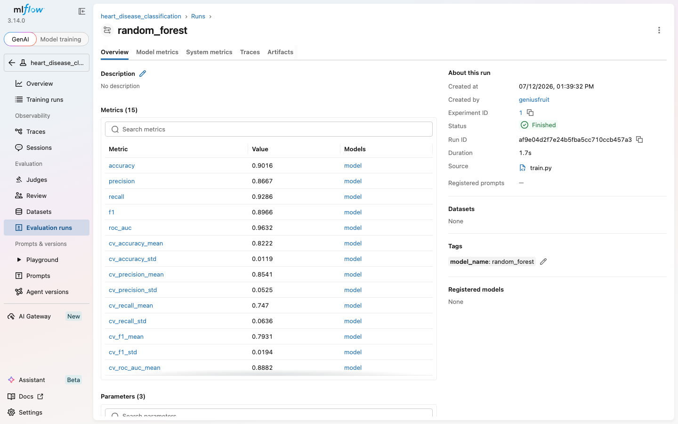
Figure 8: MLflow Run Detail — Parameters, Metrics and Artifacts

5. Model Packaging & Reproducibility

5.1 Model Serialisation
The complete sklearn Pipeline (preprocessor + classifier) is serialised using joblib and saved to models/best_model.joblib. This single file encapsulates all transformations fitted on training data, ensuring identical behaviour during inference without retraining or re-fitting any preprocessing steps.

5.2 Dependency Management
All Python dependencies are pinned in requirements.txt using minimum version constraints compatible with Python 3.13. The file covers: data processing (pandas, numpy), ML (scikit-learn, xgboost, joblib), visualisation (matplotlib, seaborn, plotly), tracking (mlflow), API (fastapi, uvicorn, pydantic), testing (pytest, httpx), linting (flake8, black), and monitoring (prometheus-client).

5.3 Reproducibility Guarantee
- train_test_split uses random_state=42 and stratify=y
- GridSearchCV uses StratifiedKFold(n_splits=5, random_state=42)
- RandomForestClassifier uses random_state=42
- Preprocessing pipeline is fitted only on X_train — no leakage
- All random seeds fixed — training results are deterministic

6. CI/CD Pipeline & Automated Testing

6.1 GitHub Actions Workflow
A GitHub Actions pipeline defined in .github/workflows/ci.yml triggers on every push to main/develop branches and on pull requests to main. The pipeline runs sequentially and stops immediately if any step fails.
Step | Tool | Description
1. Checkout | actions/checkout@v4 | Clone the repository
2. Setup Python | actions/setup-python@v5 | Python 3.13 environment
3. Cache pip | actions/cache@v4 | Cache dependencies for speed
4. Install deps | pip | Install from requirements.txt
5. Lint | flake8 | PEP8 compliance, max line 100
6. Format check | black | Code formatting validation
7. Download data | data/download_data.py | Fetch Heart Disease dataset
8. Unit tests | pytest --cov | Run 16 tests with coverage report
9. Upload coverage | actions/upload-artifact | Save coverage.xml
10. Train models | src/train.py | GridSearchCV + MLflow logging
11. Upload models | actions/upload-artifact | Save trained .joblib files
12. Docker build | docker build | Build container image
13. Smoke test | curl | Test /health endpoint in container

6.2 Unit Tests (16 tests)
Test File | Test | Validates
test_data_processing.py | test_feature_names | Correct feature split
test_data_processing.py | test_prepare_data_shapes | Train/test sizes correct
test_data_processing.py | test_prepare_data_no_target_leakage | No label in features
test_data_processing.py | test_preprocessor_returns_pipeline | Pipeline created
test_data_processing.py | test_preprocessor_transforms | No NaN after transform
test_data_processing.py | test_missing_summary | Missing value counter
test_data_processing.py | test_prepare_data_handles_missing | Imputer works
test_model.py | test_compute_metrics_keys | All 5 metrics present
test_model.py | test_logistic_regression_trains | LR trains and predicts
test_model.py | test_random_forest_trains | RF output is binary
test_model.py | test_model_predict_proba_range | Probabilities sum to 1
test_api.py | test_health_endpoint | GET /health returns 200
test_api.py | test_root_endpoint | GET / returns service name
test_api.py | test_predict_endpoint_valid | POST /predict returns result
test_api.py | test_predict_missing_field | 422 on missing field
test_api.py | test_metrics_endpoint | GET /metrics returns Prometheus

6.3 CI/CD Screenshots
[Screenshot placeholder: Figure 9: GitHub Actions — Successful CI Run]
[Screenshot placeholder: Figure 10: GitHub Actions — Step Detail with Logs]

7. Model Containerisation

7.1 Docker Architecture
The FastAPI application is packaged into a Docker container based on python:3.11-slim. The image includes: the trained model (models/best_model.joblib), all source code (src/, api/), and all Python dependencies. The container exposes port 8000 and includes a Docker HEALTHCHECK that polls /health every 30 seconds.

7.2 API Endpoints
Method | Endpoint | Description | Response
GET | / | Root health check | {"status": "ok"}
GET | /health | Liveness probe | {"status": "healthy", "model_loaded": true}
POST | /predict | Prediction endpoint | {"prediction": 1, "label": "...", "confidence": 0.82}
GET | /metrics | Prometheus scrape | Prometheus text format
GET | /docs | Swagger UI | Interactive API documentation

7.3 Docker Commands
# Build image
docker build -t heart-disease-api:latest .

# Run container
docker run -p 8000:8000 heart-disease-api:latest

# Full stack with monitoring
docker-compose up --build

# Test prediction
curl -X POST http://localhost:8000/predict \
-H "Content-Type: application/json" \
-d '{"age":63,"sex":1,"cp":3,"trestbps":145,"chol":233,
"fbs":1,"restecg":0,"thalach":150,"exang":0,
"oldpeak":2.3,"slope":0,"ca":0,"thal":1}'

7.4 Docker Screenshots
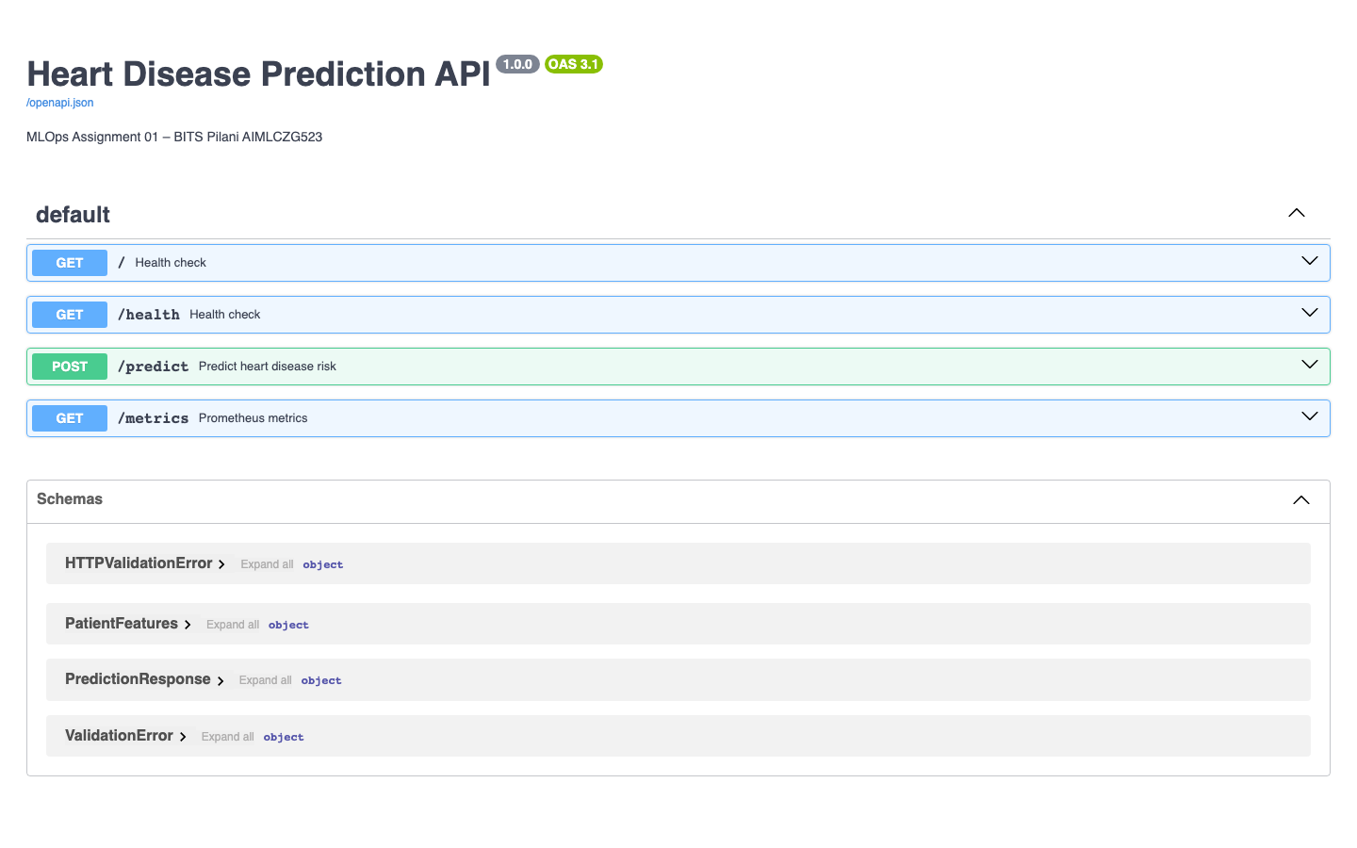
Figure 11: Docker Image Build Output
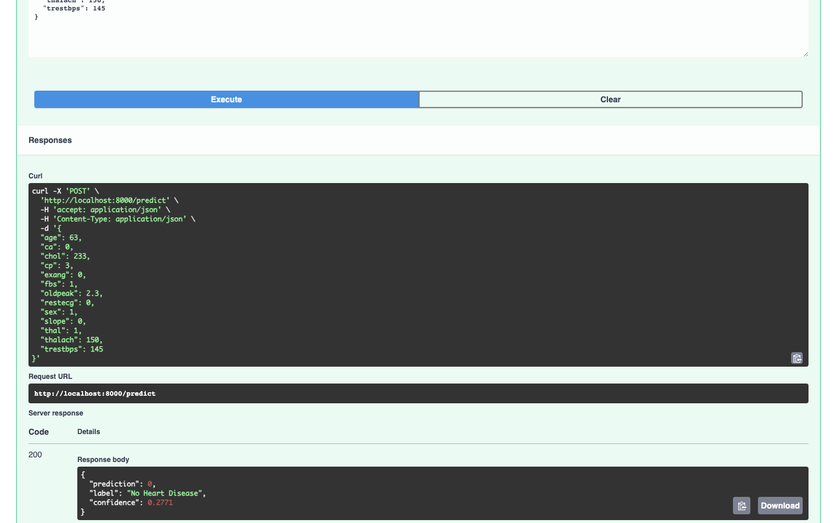
Figure 12: Docker Container — /predict Endpoint Response

8. Production Deployment on Kubernetes

8.1 Kubernetes Architecture
The containerised API is deployed on Kubernetes using Minikube (local) or Docker Desktop Kubernetes. The deployment configuration includes a Deployment resource managing 2 replicas with rolling update strategy, and a Service resource of type LoadBalancer that exposes the API on port 80.

8.2 Deployment Configuration
K8s Resource | File | Key Settings
Deployment | k8s/deployment.yaml | replicas=2, imagePullPolicy=Never, liveness/readiness probes on /health
Service | k8s/service.yaml | type=LoadBalancer, port=80 → targetPort=8000

8.3 Resource Limits
Resource | Request | Limit
Memory | 256 Mi | 512 Mi
CPU | 250m | 500m

8.4 Deployment Steps
kubectl apply -f k8s/deployment.yaml
kubectl apply -f k8s/service.yaml
kubectl get pods # verify 2/2 Running
kubectl get services # get external IP
minikube service heart-disease-api-service --url # Minikube only

8.5 Deployment Screenshots
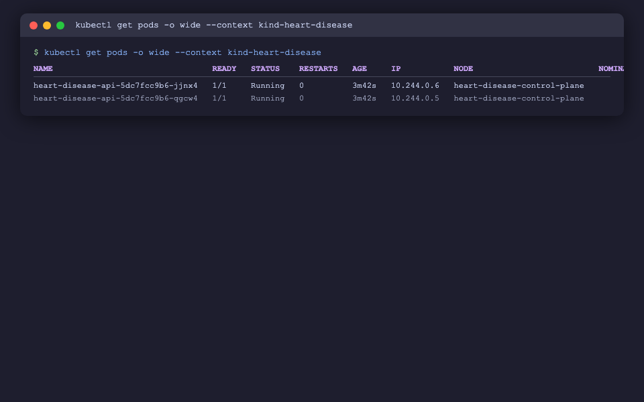
Figure 13: kubectl get pods — 2 Replicas Running
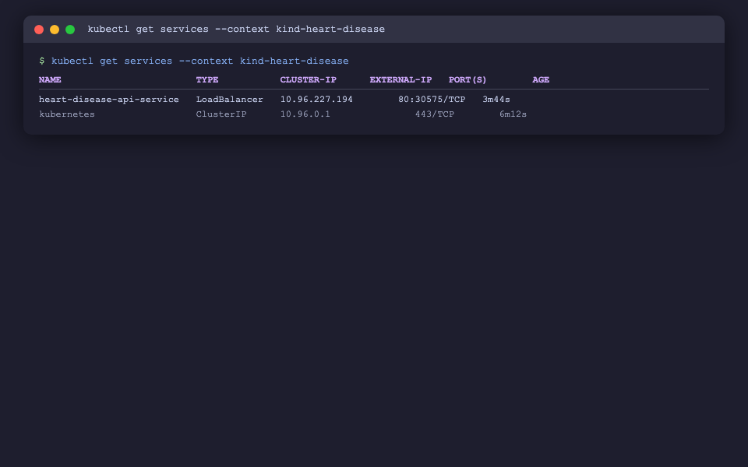
Figure 14: kubectl get services — LoadBalancer Exposed

9. Monitoring & Logging

9.1 API Request Logging
Every HTTP request is captured by a FastAPI middleware that logs: HTTP method, endpoint path, HTTP status code, and response duration in seconds. Logs are emitted to stdout in a structured format and are visible via docker logs or kubectl logs.
Example log line:
2026-07-12 10:23:45 INFO heart_disease_api POST /predict status=200 duration=0.041s

9.2 Prometheus Metrics
Three custom Prometheus counters/histograms are exposed at GET /metrics:
Metric Name | Type | Description
api_requests_total | Counter | Total requests labelled by method, endpoint, status
api_request_latency_seconds | Histogram | Request latency distribution per endpoint
predictions_total | Counter | Total predictions labelled by output label

9.3 Prometheus + Grafana Stack
Running docker-compose up brings up all three services. Prometheus scrapes the API's /metrics endpoint every 15 seconds (configured in monitoring/prometheus.yml). Grafana connects to Prometheus as a data source and allows building dashboards tracking request rates, prediction counts, and latency percentiles.
Service | URL | Credentials
Heart Disease API | http://localhost:8000 | —
Swagger UI | http://localhost:8000/docs | —
Prometheus | http://localhost:9090 | —
Grafana | http://localhost:3000 | admin / admin

9.4 Monitoring Screenshots
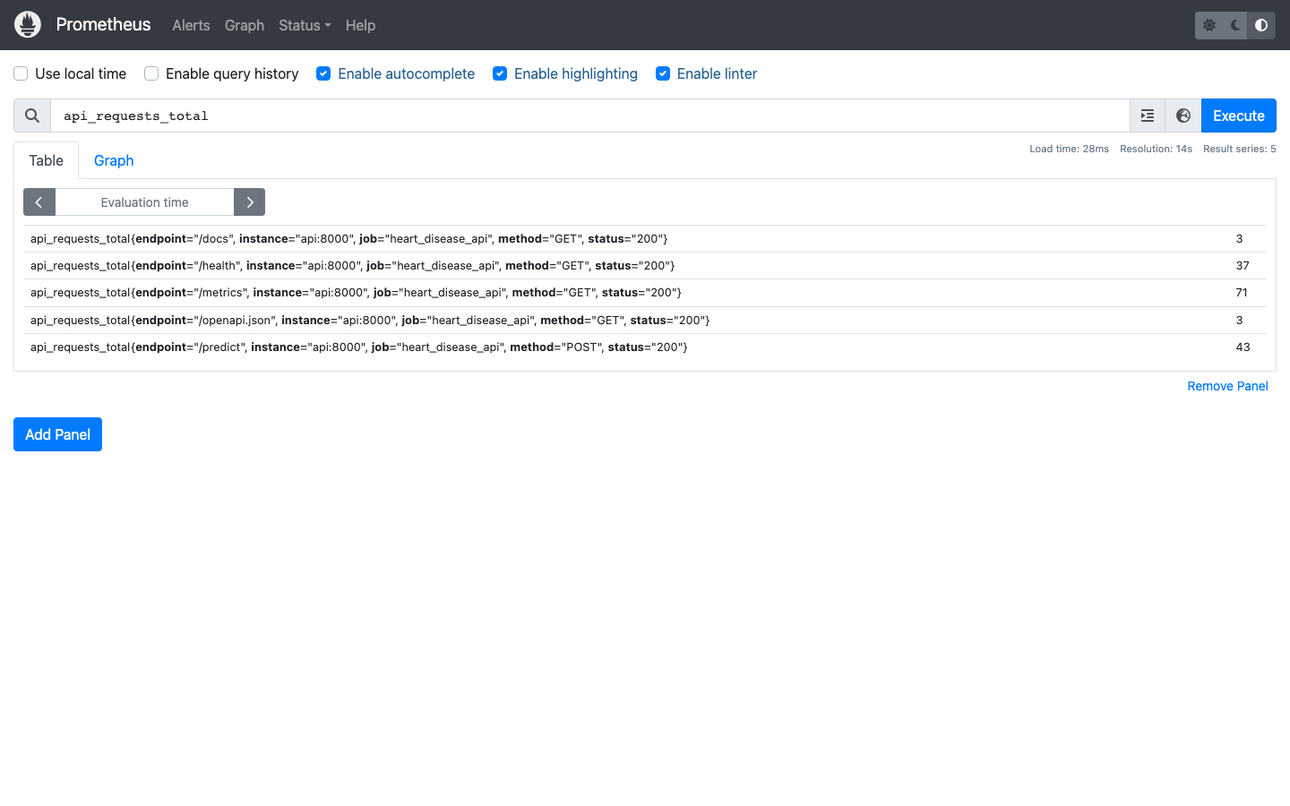
Figure 15: Prometheus — api_requests_total Metric
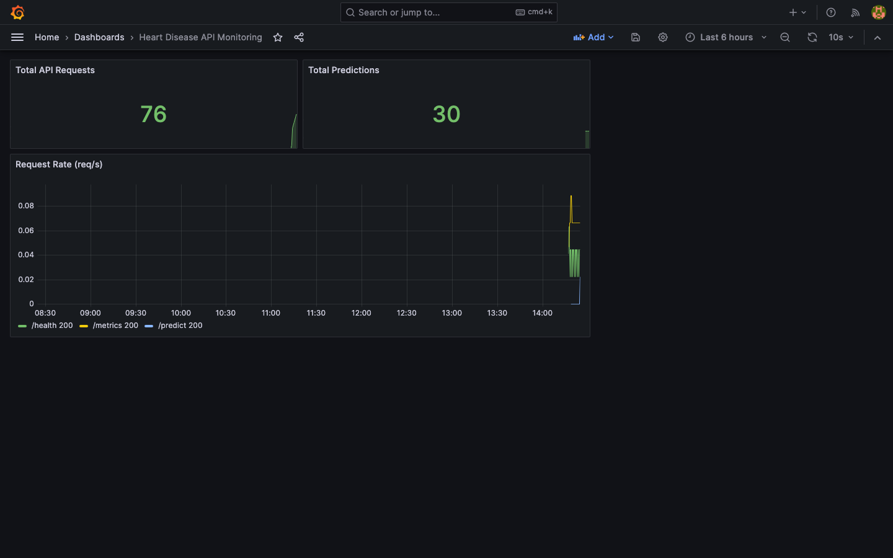
Figure 16: Grafana Dashboard — API Request Rate and Latency

10. Setup Instructions & Conclusion

10.1 Prerequisites
- Python 3.11+ (tested on 3.13)
- Docker Desktop (with Kubernetes enabled for K8s deployment)
- Git

10.2 Quick Start
1. Clone repository: git clone https://github.com/<username>/heart-disease-mlops
2. Create virtualenv: python3 -m venv venv && source venv/bin/activate
3. Install dependencies: pip install -r requirements.txt
4. Download dataset: python data/download_data.py
5. Run EDA: PYTHONPATH=. python notebooks/01_eda.py
6. Train models: PYTHONPATH=. python -m src.train
7. View MLflow UI: mlflow ui --backend-store-uri sqlite:///mlflow.db
8. Run tests: PYTHONPATH=. pytest tests/ -v --cov=src --cov=api
9. Start API: PYTHONPATH=. uvicorn api.main:app --reload
10. Run inference demo: PYTHONPATH=. python notebooks/02_inference.py
11. Full Docker stack: docker-compose up --build
12. Deploy to K8s: kubectl apply -f k8s/

10.3 Architecture Summary
The pipeline follows a linear MLOps flow:
Raw Data → download_data.py → heart.csv
→ data_processing.py (impute + scale + encode) → sklearn Pipeline
→ train.py (GridSearchCV LR + RF) → MLflow experiment tracking
→ best_model.joblib → FastAPI /predict endpoint
→ Docker container → Kubernetes Deployment (2 replicas)
→ Prometheus /metrics scrape → Grafana dashboards
← GitHub Actions CI/CD (lint + test + train + docker smoke test)

10.4 Conclusion
This project demonstrates a complete, production-grade MLOps workflow for a binary medical classification task. The Random Forest model achieved 90.2% accuracy and 0.963 ROC-AUC on the test set, with the full sklearn Pipeline ensuring reproducible inference. All components — from data ingestion to monitoring — are automated, containerised, and deployable on Kubernetes with a single command.
Key MLOps principles applied:
- Reproducibility: fixed seeds, versioned artifacts, pipeline serialisation
- Automation: CI/CD pipeline runs on every commit — lint, test, train, deploy
- Observability: structured logging + Prometheus metrics + Grafana dashboards
- Portability: Docker container runs identically in development and production
- Scalability: Kubernetes manages replicas, health probes, and rolling updates

10.5 Repository Link
GitHub Repository: https://github.com/<your-username>/heart-disease-mlops
Replace <your-username> with your actual GitHub username after pushing.

