**Space Technician**

**Critical Insights into Research: A space technician**

**Introduction:**

ODYSSEY is a website dedicated to space exploration and enthusiasts. It offers a variety of resources, including news articles, educational resources, and a community forum. The website is designed to be easy to use and navigate, and it provides a wealth of information about space science and technology. In this website we are having nav bar and footer and space related sections.

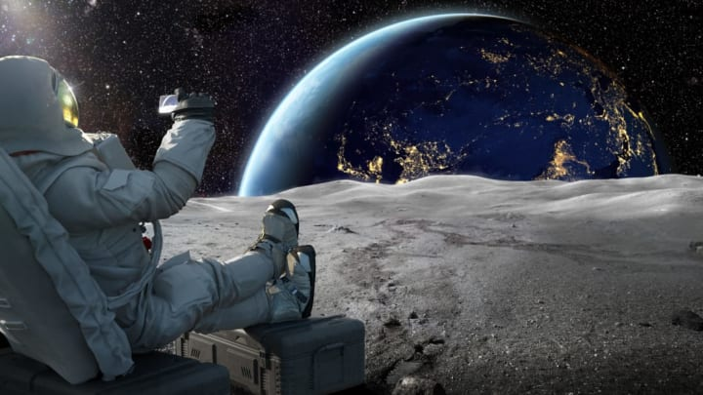

**Purpose and Objectives:**

1. **Information Hub for Space Enthusiasts:**
   * Provide a centralized and accessible source of information for space enthusiasts.=
   * Aggregate and present news articles, educational resources, and updates related to space science and technology.
2. **User-Friendly Design:**
   * Create a website with a user-friendly design that ensures ease of use and navigation for visitors of all backgrounds.
   * Implement an intuitive navigation system, including a navigation bar, to help users quickly find the content they are interested in.
3. **Educational Resources:**
   * Offer a variety of educational resources to cater to different levels of interest and expertise.
   * Provide articles, videos, and other materials that contribute to the understanding of space-related topics.
4. **Community Engagement:**
   * Foster a sense of community among space enthusiasts through the inclusion of a community forum.
   * Encourage users to share their knowledge, experiences, and discussions related to space exploration.
5. **Comprehensive Space Sections:**
   * Design dedicated sections on the website that cover various aspects of space exploration, such as astronomy, space missions, technology, and historical events.
   * Ensure that each section provides in-depth and engaging content to captivate the audience.

.

**Website Development:**

**Project Selection*:***

This project is developed based on the figma file . In this Project we are having a footer header and body sections which has the interactive desgin about webpage.

**Project Objectives:**

1. **Promotion of Scientific Literacy:**
   * Contribute to the promotion of scientific literacy by presenting accurate and up-to-date information about space science.
   * Encourage learning and exploration through engaging content that sparks curiosity.
2. **Regular Updates:**
   * Maintain the website with regular updates to ensure that users are informed about the latest developments in the field of space exploration.
   * Keep the content dynamic and relevant to sustain user interest over time.

**Project Features/Functionalities:**

1. **Space Exploration Courses:**
   * Develop online courses or webinars led by experts in the field, offering in-depth knowledge on specific aspects of space science and technology.
2. **Personalized Newsfeeds:**
   * Implement machine learning algorithms to provide users with personalized newsfeeds based on their interests and browsing history.
3. **Integration with Space Agencies:**
   * Collaborate with space agencies to provide exclusive content, behind-the-scenes insights, and updates on ongoing missions.

**Technology Stack:**

1. **Express.js:**
   * **Role:** Express is a web application framework for Node.js, simplifying the process of building robust and scalable web applications.
   * **Usage:** It is employed to handle routing, middleware, and API endpoints on the server side. Express interacts with MongoDB to fetch and update data.
2. **React.js:**
   * **Role:** React is a JavaScript library for building user interfaces, providing a declarative and efficient way to design interactive UIs.
   * **Usage:** React is utilized for creating the front-end of your application. It allows you to build modular, reusable components that dynamically update based on user interactions. The pie charts and user interface components are likely implemented using React.
3. **Node.js:**
   * **Role:** Node.js is a JavaScript runtime that allows you to execute JavaScript code on the server side.
   * **Usage:** Node.js is the backend runtime for your application. It handles server-side logic, communicates with the database (MongoDB), and serves data to the front end.
4. **HTML:**
   * **Role:** HTML (Hypertext Markup Language) is the standard markup language for creating web pages.
   * **Usage:** HTML is used to structure the content of your web pages. It defines the elements and their hierarchy, including forms, buttons, and other interactive elements.
5. **CSS:**
   * **Role:** CSS (Cascading Style Sheets) is used for styling web pages, defining the presentation and layout.
   * **Usage:** CSS styles are applied to HTML elements to control the visual presentation of your application. It ensures a consistent and visually appealing user interface.
6. **Material-UI (MUI):**
   * **Role:** Material-UI is a popular React UI framework that provides pre-built React components following Google's Material Design principles.
   * **Usage:** MUI components are used to create a consistent and aesthetically pleasing user interface. This includes buttons, forms, and other UI elements.

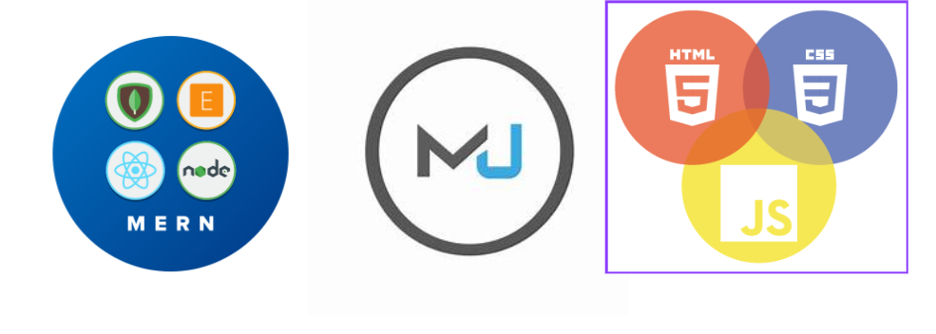

**User Interface (UI) Design:**

### 1. User-Centric Design:

* Understanded users and their needs. Designed with the end-users in mind.
* Conducted user research and gather feedback to inform my design decisions.

**2. Intuitive Navigation:**

* Create a clear and intuitive navigation structure.
* Users can easily find and access essential features and information.

**3. Consistent Design Language:**

* Maintaining consistency in design elements, including colors, fonts, and button styles.

**4. Responsive Design:**

* responsiveness to a seamless experience across various devices and screen sizes.

**Main page of the website:**

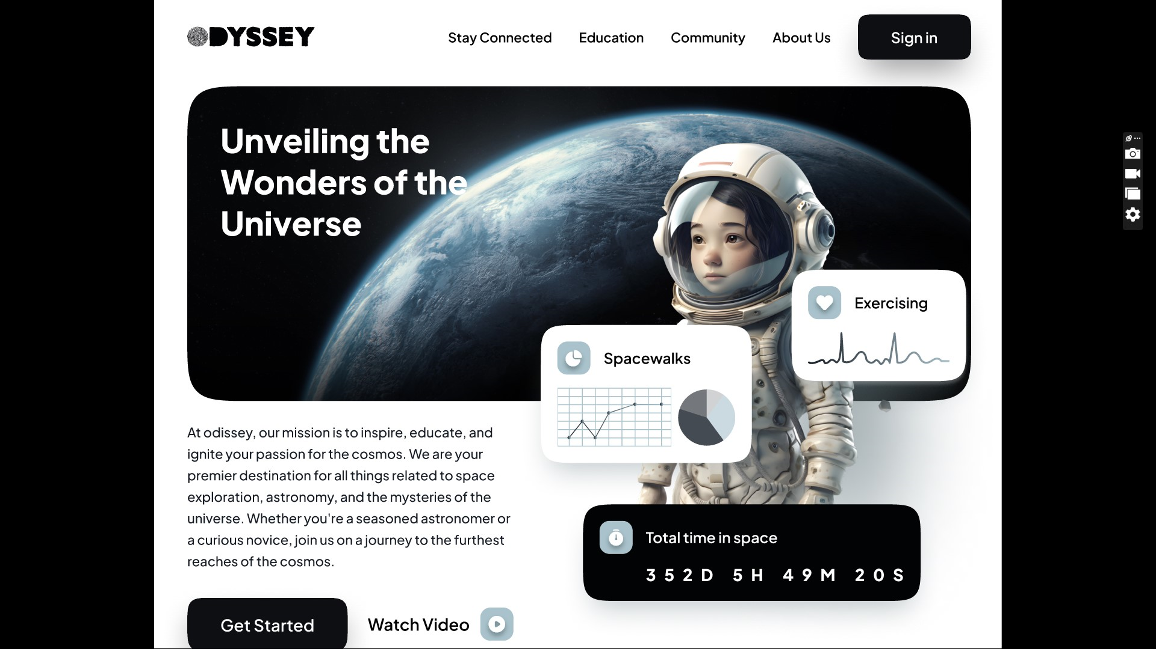

Here is the Main page which contain the nav bar and body and it has the some details about the space.

**Nav bar:**

In this Project Nav Bar contain the stay connected ,Education,Community,About Us and Sign in Options and It had the Odessey Logo Image and it is user friendly website for everyone.

* The navbar is located at the top of the page and includes the ODYSSEY logo, a search bar, and a navigation menu.
* The navigation menu includes links to the following pages: Home, News, Articles, Resources, Forum, and About Us.
* The navbar is designed to be easy to use and navigate, and it helps users find the information they are looking for quickly and easily.
* **Image**:
* The image is located at the top of the page and takes up the full width of the page.
* The image is a high-quality photograph of a galaxy.
* The image is used to capture the attention of users and to create a sense of awe and wonder.
* **Cards** :
* The cards are located in the middle of the page and are used to display news articles.
* Each card includes a headline, a brief summary of the article, and a link to the full article.
* The cards are designed to be visually appealing and to make it easy for users to scan the news headlines.

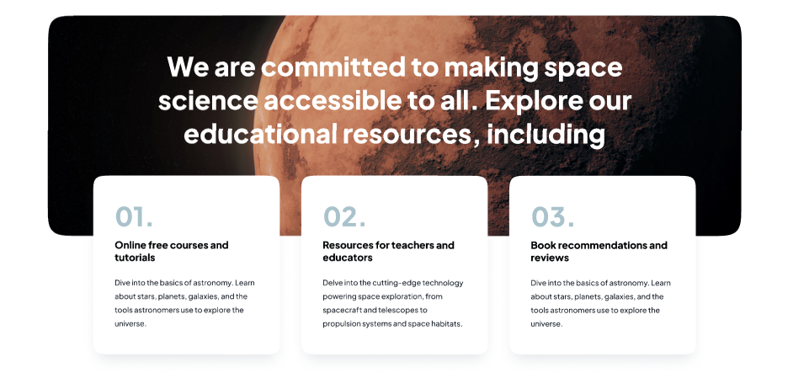

* **Font & Content :**
* The website uses a sans-serif font that is easy to read on screens of all sizes.
* The font size is large enough to be easy to read, but not so large that it makes the page look cluttered.
* The content is written in a clear and concise style that is easy to understand.

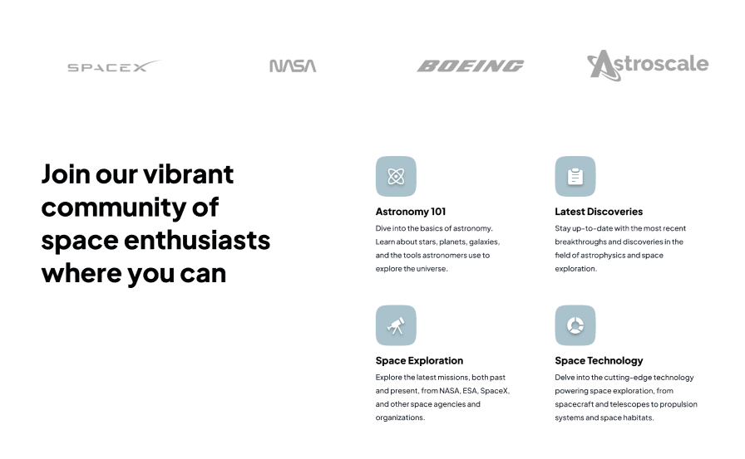

* **Community & Footer:**
* The community section is located at the bottom of the page and includes a forum where users can discuss space exploration and space technology.
* The forum is divided into different categories, such as astronomy, astrophysics, and space exploration.
* The footer includes links to the ODYSSEY social media pages, as well as a copyright notice and a privacy policy.

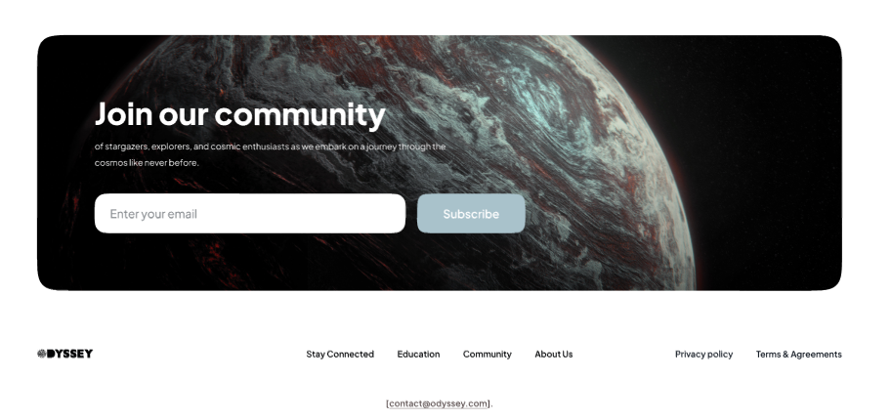

**Responsive**: clear responsive for various screen modes.

Everything is sastisfied as per the task requirements

**Visualization** :

* The website uses a clean and modern design with a focus on white space and large, high-quality images.
* The layout is easy to follow and navigate, with a consistent header, navigation menu, and footer.
* The use of color is minimal and tasteful, with a focus on blue and white to create a sense of calm and professionalism.

**Folder structure:**

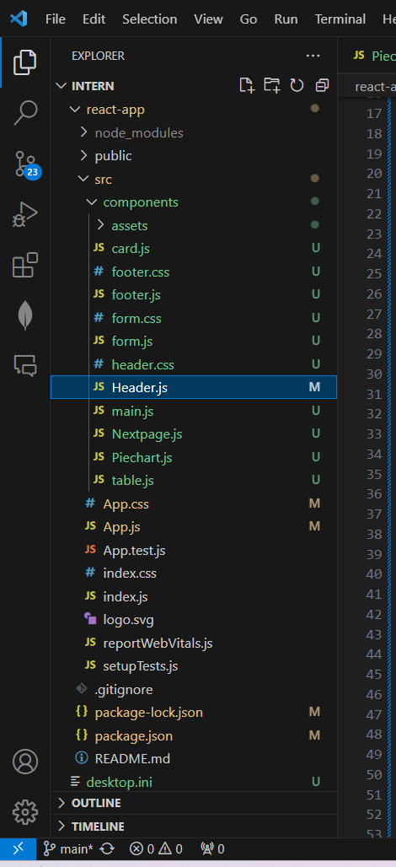

**Code snippest**: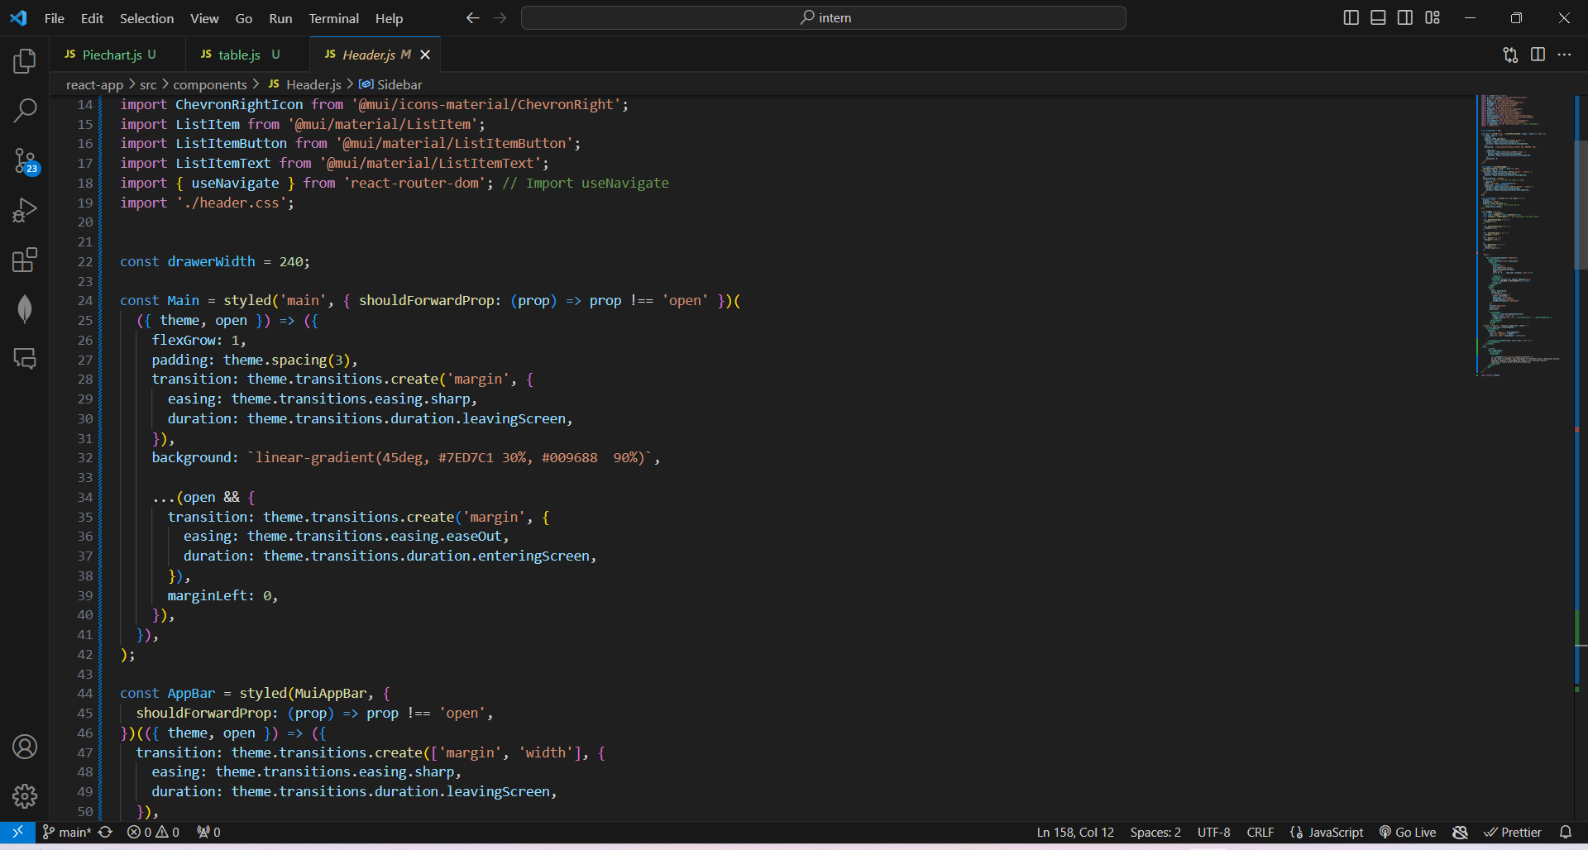

**Model Deployment:**

**GitHub Repository*:***

**Welcome to the Space Technician Project Repository!**

MY GitHub repository serves as the central hub for all resources related to the Space technician , providing a transparent and collaborative space for my project and the wider community. Here, you'll find the source code, documentation, and resources that power space technician.

project. Please follow this ( [https://github.com/yogisay1263](https://github.com/yogisay1263o)) to access the GitHub repository and explore our Space technician.

**LinkedIn Profiles*:***

Please follow this [(https://www.linkedin.com/in/yadla-yogitha-124122229/](https://www.linkedin.com/in/yadla-yogitha-124122229/)) to access my Linkedin for my profile.

**Future Work*:***

Certainly! It sounds like you have some exciting plans for the future development of my space technician . Here's a brief outline of the future work you intend to undertake:

**Main page implementation:**

* **Objective:**
  + Improve the overall accessibility of the application to cater to users with diverse needs.
* **Tasks:**
  + Implement accessibility features, such as screen reader compatibility and keyboard navigation.
  + Conduct usability testing to identify areas for improvement in user-friendliness.

**Conclusion:**

In conclusion, the ODYSSEY project stands as a dynamic and comprehensive platform designed for space exploration enthusiasts. With a user-friendly interface and a wealth of resources, the website successfully achieves its primary objective of providing a hub for space-related information, news, educational content, and community interaction. The combination of a navigable interface, dedicated sections, and a vibrant community forum creates an engaging and informative space for users passionate about the wonders of the cosmos.

The project's success lies in its commitment to accessibility, offering a diverse range of content suitable for both novices and seasoned space enthusiasts. The inclusion of features like a navigation bar, footer, and thematic sections contributes to a seamless user experience, ensuring that visitors can easily navigate and explore the depths of space-related knowledge.

Anomaly