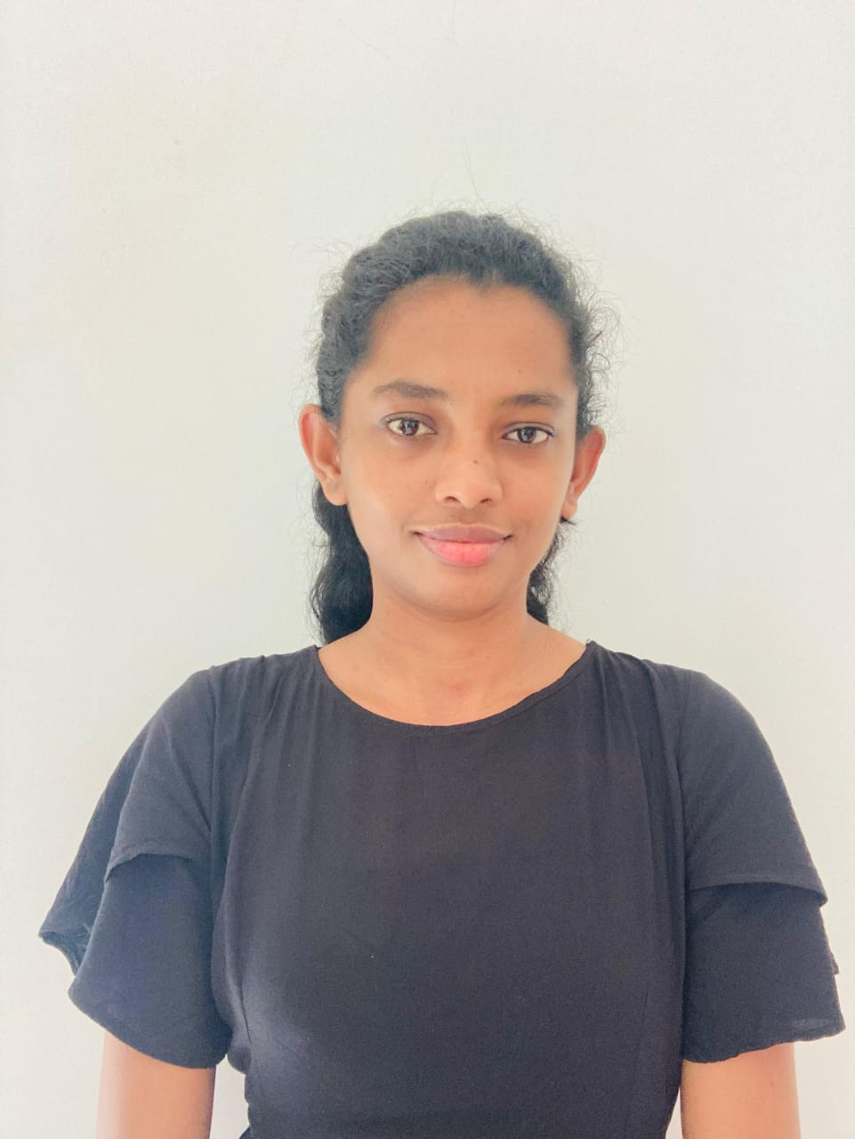



CURICULUM VITAE

**YOGISHA LAKSHMINI**

**PROFILE**

I’m

an

self

-

motivated,

reliable, responsible

and hard

-

working person. I’m able to work

well both in a team environment as well as

using own initiative.

Full Name

-

Ranasinghe Peli Gedara Yogisha Lakshmini

Name With Initials

-

R.P.G.Yogisha Lakshmini

Date Of Birth

-

6

th

June

2000

ID Number

-

20065800713

Gender

-

Female

Civil Status

-

U

nmarried

**Skills**

TEAMWORK

MICROSOFT OFFICE



**CONTACT**

**COURSES**

English Diploma in IMBS Campus Informaton Tecnology in IMBS Campus

Bussiness Management in SITC Campus

Still read Fulstack Developer Course in DP Education

–

**EDUCATION**

OL – 2016

AL - 2021



0763356002

129,Jayasiripura,

Anuradhapura.

.

Yogishalakshmini6

@g

mail.com

0763356002