Q.1.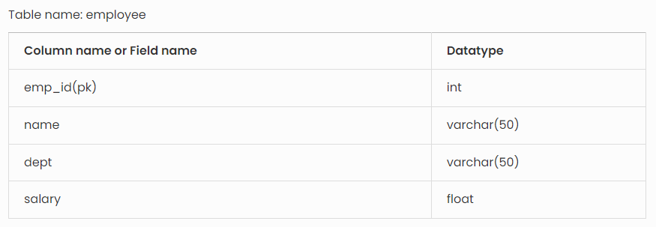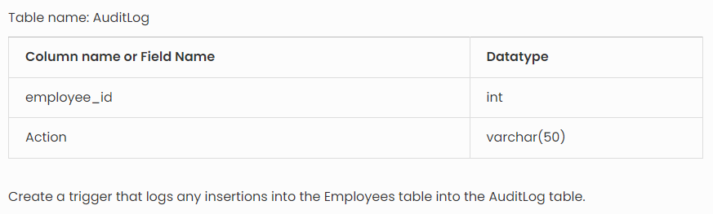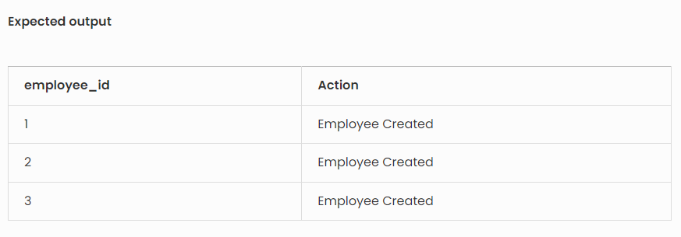

create a trigger that logs insertions into the employee table into the AuditLog table, you can use the following SQL code. This trigger will automatically insert a record into the AuditLog table whenever a new row is added to the employee table.

Here’s how you can define the trigger:

CREATE TRIGGER LogEmployeeInsertion
ON employee
AFTER INSERT
AS
BEGIN
INSERT INTO AuditLog (employee_id, Action)
SELECT emp_id, 'Employee Created'
FROM inserted;
END;

