Project Report On
DisasterConnectAI
A Centralized Web-Based Disaster Reporting, Management, and Emergency Coordination Platform
Designed By:
Miss. Yogita Dilip Padvekar
Submitted To:
K.M.S.P. MANDAL’S
SANT RAWOOL MAHARAJ MAHAVIDYALAYA, KUDAL
(NAAC Re-Accreditation “B+” Grade)
In the partial fulfillment of the requirements for the Degree of
B.Sc. Computer Science (Sem V)
Under Guidance of:
Asst. Prof. Santosh Chougule (M.C.A.) Asst. Prof. Prakash Talankar (M.C.A.)
Through:
THE HEAD, DEPARTMENT OF COMPUTER SCIENCE,
S.R.M. COLLEGE, KUDAL.
PROJECT REPORT
ACADEMIC YEAR: 2026 - 2027

DECLARATION
To,
The Head,
Department of Computer Science,
S. R. M. College, Kudal.
Respected Sir,
We undersigned, hereby declare that the project on "DisasterConnectAI" is developed under the guidance of our lecturer Asst. Prof. Santosh Chougule and Asst. Prof. Prakash Talankar.
The conclusion in this report is based on the data, which is collected by me. I am declaring that this is our original work. I have not copied any materials related to my project from any unauthorized source.
We do undersign that if my work is found to be copied, then I am liable to punishment as per the university rule.
DATE: ____________________
PLACE: KUDAL.
____________________________________________
(Miss. Yogita Dilip Padvekar)
Candidate, B.Sc. Computer Science (Sem V)

K.M.S.P. MANDAL’S
SANT RAWOOL MAHARAJ MAHAVIDYALAYA, KUDAL
NAAC RE-ACCREDITATION “B+” GRADE
DEPARTMENT OF COMPUTER SCIENCE
CERTIFICATE
This is to certify that Miss. Yogita Dilip Padvekar having Exam Seat number ____________________ have satisfactorily carried out her project work entitled "DisasterConnectAI" as per the syllabus prescribed for B.Sc. Computer Science of Mumbai University, Mumbai.
It is also certifying that this is her own work completed during academic year 2026 - 2027. The work done is satisfactory and is presented as per the specifications.
____________________ ____________________ ____________________
Project Guide External Examiner Head of Department
(Asst. Prof. S. Chougule) (Dept. of Computer Science)
DATE: ____________________
PLACE: KUDAL.

CHAPTER I
Acknowledgment
It’s my great pleasure to get this opportunity and sincerely thank all the people, who have paved the way to create a successful project and helped me a lot during the completion of this project.
I would like to thank my project guide, Asst. Prof. Santosh Chougule (M.C.A.) and Asst. Prof. Prakash Talankar (M.C.A.), who provided important information, technical advice, and guided me throughout the project completion.
I am immensely thankful to The Head, Department of Computer Science, S.R.M. College, Kudal, and our Principal, Dr. S. D. Kulkarni, for providing access to computing laboratory infrastructure, internet connectivity, and continuous academic encouragement.
And last but not the least! I would like to thank all my classmates, parents, and friends for their continuous support and cooperation throughout my studies.
Thank You.
Miss. Yogita Dilip Padvekar

INDEX / TABLE OF CONTENTS
Sr. No. | Chapter No. | Detailed Title / Section | Page Range
1. | I | Acknowledgment | iv
2. | II | Synopsis of the Project (Problem Statement, Objectives, Workflow) | 1 - 3
3. | III | Main Technical Report (Architecture, UML, Screens, Test Cases, Code) | 4 - 58
4. | IV | Annexures (Database Collections, REST APIs, SOP Checklist) | 59 - 62
5. | V | Conclusion & Impact Assessment | 63 - 64
6. | VI | Future Enhancements | 65 - 66
7. | VII | References & Bibliography | 67

CHAPTER II
Synopsis of the Project
1. Problem Statement (Point-Wise)
• Unorganized Emergency Reporting: During natural disasters (floods, landslides, heavy rainfall, fires), citizens cannot communicate information quickly to relief authorities.
• Informational Fragmentation: Information shared via phone calls, WhatsApp, or social media is scattered, unverified, and lacks precise GPS location coordinates.
• Delayed Road Blockage Detection: Debris, tree falls, and submerged roads block ambulances and emergency rescue teams, causing life-threatening delays.
• Lack of Real-Time Coordination: Authorities struggle to know which incident has already been handled and which victim is still awaiting help.
• Shelter & Missing Person Confusion: Citizens have no centralized method to check nearby safe shelter capacities or locate missing family members.
2. Proposed Solution (Point-Wise)
• Centralized Web Application: A single unified platform connecting Citizens, Volunteers, and District Administrators.
• Automated GPS Coordinates: One-click capture of latitude and longitude coordinates directly from user devices.
• Interactive GIS Disaster Map: Real-time mapping using Leaflet.js to visualize live disasters, blocked roads, and safe relief camps.
• AI Emergency Chatbot: Instant 24/7 safety guidance, first aid advice, and emergency helpline contact numbers.
• Role-Based Workflows: Dedicated dashboards for Citizens, Volunteers, and Administrators to streamline rescue mobilization.
3. Major Objectives (Point-Wise)
1. Centralized Reporting: Enable citizens to report disasters with type, location, description, and photo evidence.
2. Location-Based Telemetry: Extract geographical coordinates (latitude & longitude) for exact spatial positioning.
3. Volunteer Mobilization: Allow administrators to assign nearby verified volunteers to specific disaster incidents.
4. Incident Status Tracking: Monitor and update progress across Pending, In Progress, Assigned, and Resolved states.
5. AI Emergency Guidance: Provide automated disaster safety protocols and emergency first-aid advice.
6. Shelter & Missing Persons Tracking: Display real-time shelter bed capacity and a searchable missing persons registry.
7. PDF Situational Reports: Allow administrators to export formal incident reports for governmental record-keeping.
4. System Scope & Boundaries (Point-Wise)
• Target Users: Citizens, certified field volunteers, and municipal/district emergency officers.
• Geographical Presets: Specialized focus on disaster-prone coastal and hilly belts (e.g., Sindhudurg District covering Kudal, Sawantwadi, Malvan, Kankavli, etc.).
• Platform Accessibility: Operates seamlessly across modern web browsers on desktops, laptops, tablets, and smartphones.
5. Step-by-Step Process Description (Point-Wise)
Step 1 Registration & Login: User registers and authenticates as a Citizen, Volunteer, or Administrator with encrypted credentials.
Step 2 Incident Intake: Citizen fills the reporting form; system captures GPS coordinates, photo, and incident details.
Step 3 Database Persistence: Report is securely stored in MongoDB with timestamp and initial status 'Pending'.
Step 4 Live Mapping & Triage: Incident appears immediately on the Admin Dashboard and Interactive Leaflet GIS Map.
Step 5 Volunteer Assignment: Admin selects a verified volunteer based on proximity and assigns the task.
Step 6 Field Response: Assigned volunteer receives operational instructions, visits the location, and coordinates relief.
Step 7 Status Resolution: Volunteer or admin marks the incident as 'Resolved' and notification is sent.
Step 8 Citizen Safety Support: Citizens can converse with the AI Chatbot, check shelter bed availability, and search missing persons.

CHAPTER III
Main Technical Report
1. Theoretical Background (Point-Wise)
• Disaster Management Principles: Focuses on rapid identification, structured communication, hazard mitigation, and orderly rescue operations.
• Web-Based Client-Server Architecture: Enables universal access via HTTP/HTTPS without requiring separate client software installation.
• Artificial Intelligence in Crisis: Large Language Model integration understands natural language queries and returns immediate survival instructions.
• Geographic Information Systems (GIS): Uses WGS-84 coordinate systems (Latitude & Longitude) to plot spatial pins and determine shortest rescue routes.
• Document-Oriented Database: MongoDB stores flexible JSON/BSON documents, enabling rapid schema expansion and fast geospatial queries.
2. Survey of Literature & Existing Systems (Point-Wise)
Comparison between existing conventional methods and DisasterConnectAI:
Parameter | Traditional Emergency Dial 100/112 | Social Media Posts (WhatsApp) | DisasterConnectAI Platform
Location Precision | Verbal description (error-prone) | Unverified text forwarding | Exact Satellite GPS Coordinates
Incident Prioritization | Manual queue by operator | Zero prioritization / chaotic | Automated AI Severity Scoring
Volunteer Dispatch | Slow manual phone calls | Uncoordinated public response | Admin-Assigned Proximity Dispatch
GIS Map Visuals | Not available to citizens | None | Live Interactive Leaflet Map
Shelter Telemetry | Requires calling offices | Rumors / outdated info | Live Bed Occupancy & Supply Meter
Missing Persons | Physical police FIR registers | Scattered missing posters | Searchable Digital Registry Portal

3. Hardware & Software Requirements (Point-Wise)
Hardware Requirements:
• Computer / Laptop: Intel Core i3 / i5 or AMD equivalent processor (2.0 GHz or higher).
• RAM: Minimum 8 GB DDR4 RAM for smooth execution of Node.js server, browser, and IDE.
• Storage: Minimum 256 GB SSD with at least 5 GB free space for project files and dependencies.
• Internet Connection: Active broadband or mobile hotspot connection for cloud database and map tiles.
Software Requirements:
• Operating System: Microsoft Windows 10 / Windows 11 (64-bit).
• Code Editor: Visual Studio Code (VS Code) with React and ES6 extensions.
• Runtime Environment: Node.js (v18.x or v20.x LTS) with npm package manager.
• Frontend Framework: React.js (v18.x) powered by Vite build tool.
• Backend Framework: Express.js (v4.x) running on Node.js.
• Database: MongoDB (Local Community Server / MongoDB Atlas Cloud).
• Database ODM: Mongoose for schema modeling and validation.
• Mapping Library: Leaflet.js and OpenStreetMap tile layers.
• Testing Tools: Google Chrome DevTools and Postman for REST API verification.
4. Project Life Cycle & SDLC Methodology (Point-Wise)
The development of DisasterConnectAI followed the **Iterative and Incremental SDLC Model**:
1. Requirement Analysis: Identified core needs of citizens, volunteers, and emergency administrators.
2. System Planning & Architecture: Structured the 4-tier MERN stack, database collections, and API endpoints.
3. Iterative Design: Created DFDs, ERDs, UML diagrams, and responsive wireframes.
4. Incremental Coding: Built user authentication first, followed by incident intake, map engine, volunteer dispatch, and AI chatbot.
5. Verification & Testing: Conducted unit testing, integration testing, and simulated stress drills.
6. Deployment & Review: Deployed local and cloud instances for user acceptance testing.
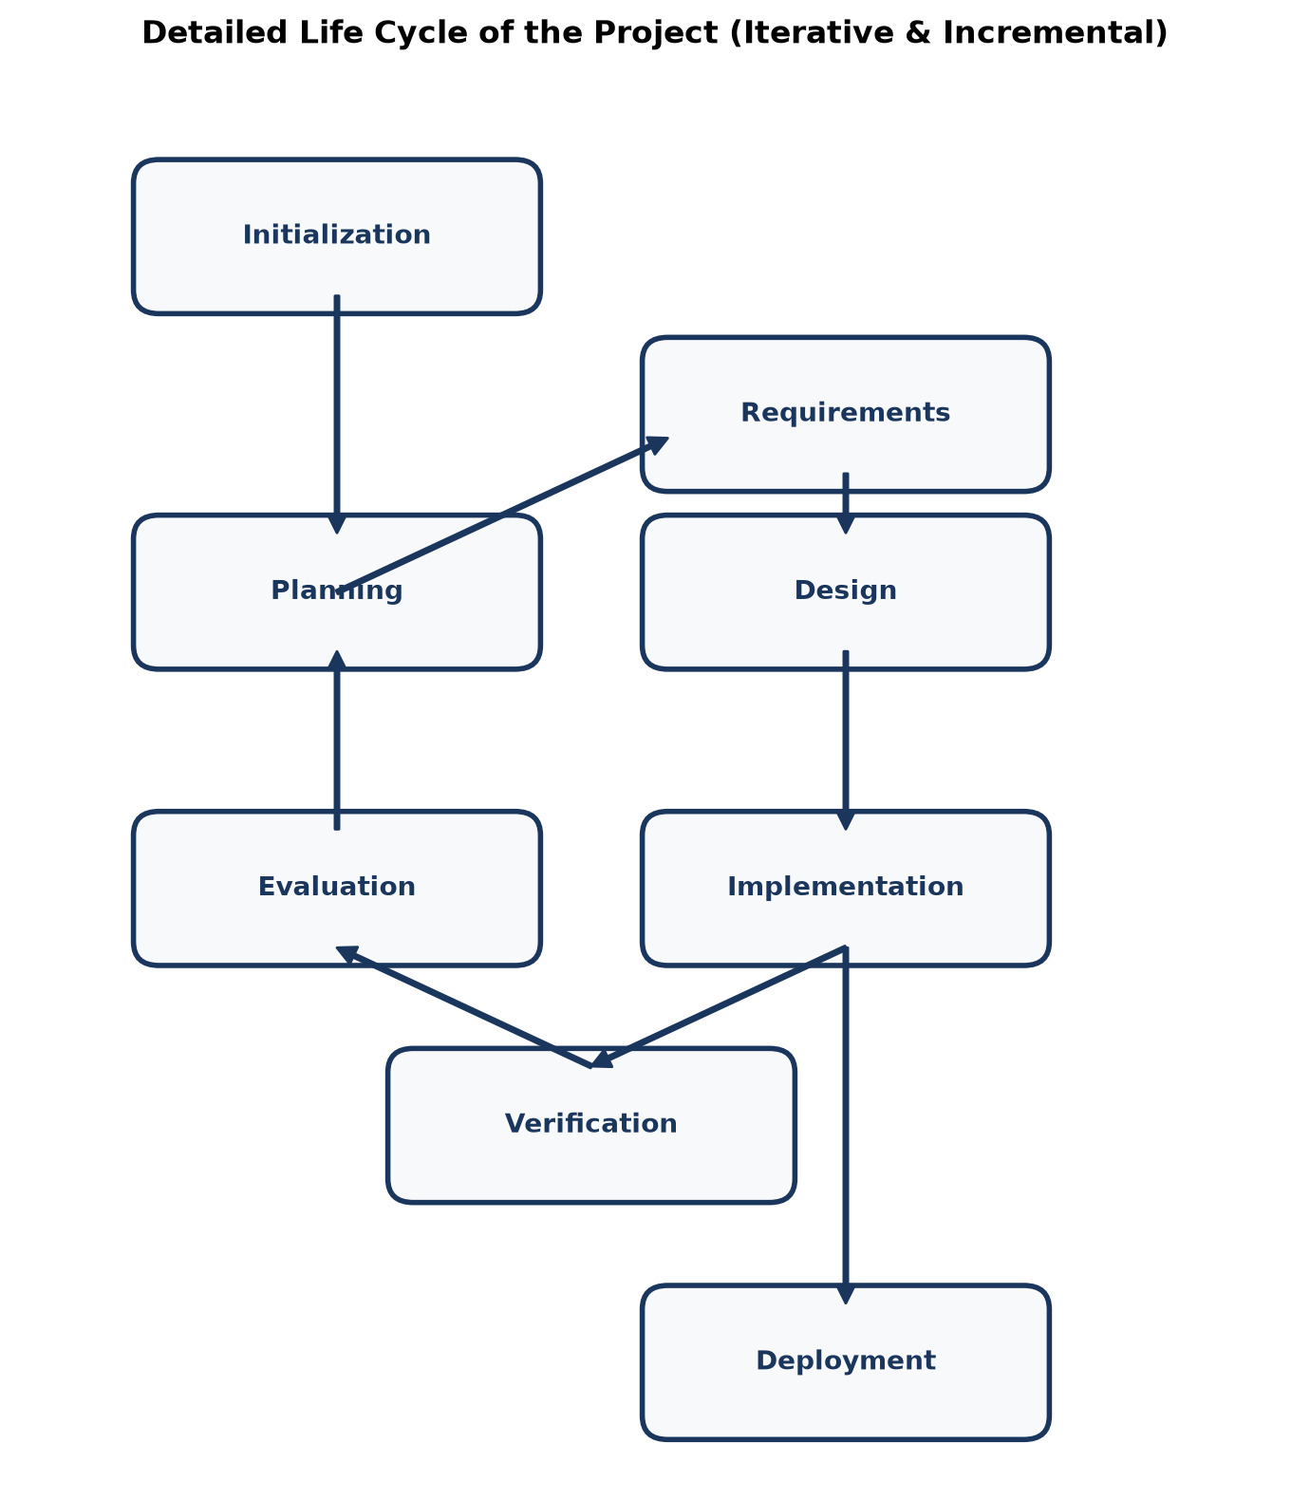
Figure 3.1: Iterative and Incremental SDLC Model
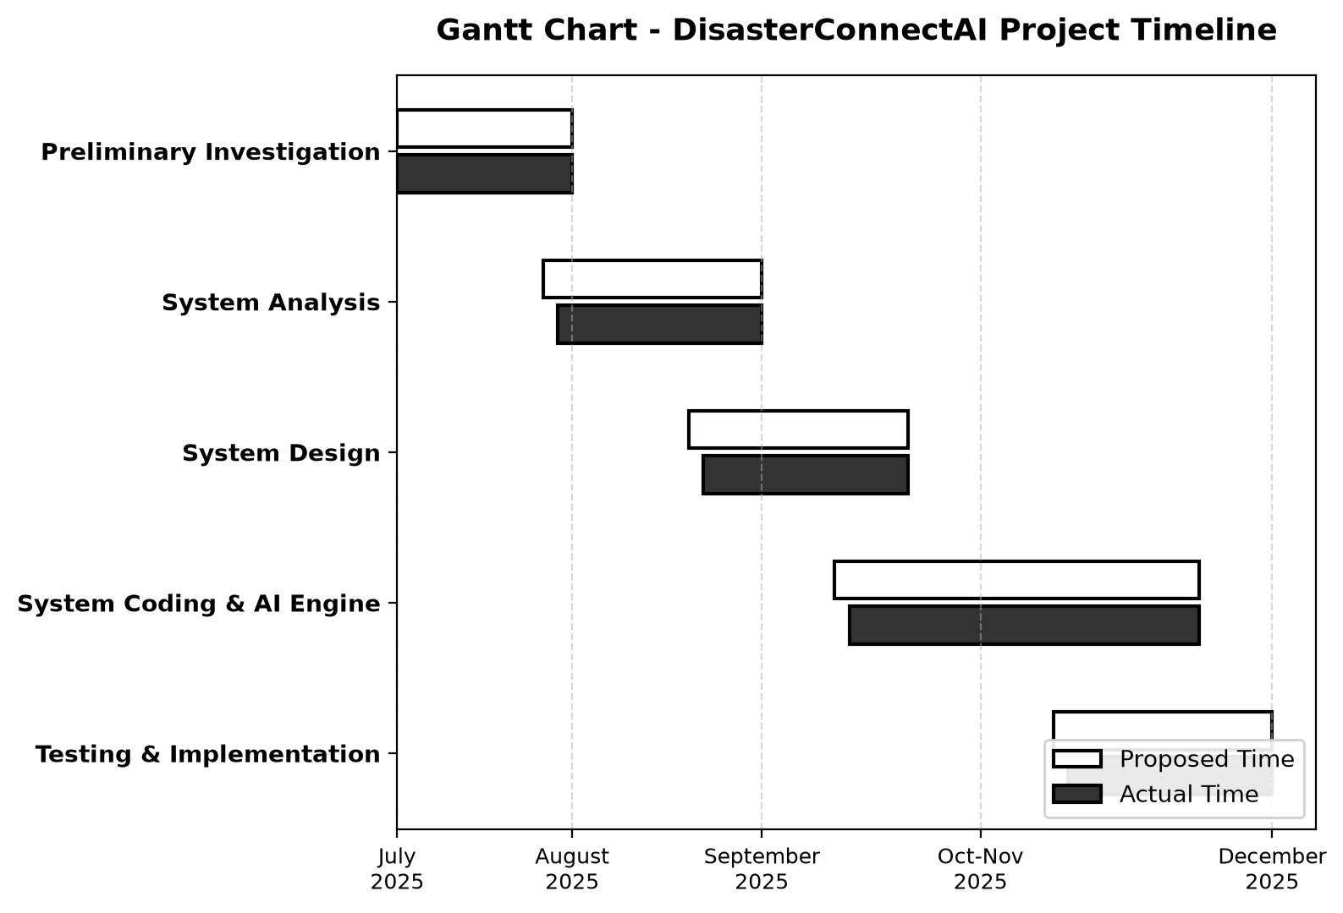
Figure 3.2: Project Development Timeline (Gantt Chart)
5. System Architecture (Point-Wise)
DisasterConnectAI uses a robust **4-Tier Layered Architecture**:
Layer 1 Presentation Layer (Frontend): React.js, Tailwind CSS, Lucide Icons, and Leaflet Maps providing an intuitive user interface.
Layer 2 Application / Controller Layer: Node.js and Express.js REST APIs handling routing, middleware, and request validation.
Layer 3 Service / Intelligence Layer: AI Response Engine, Nodemailer automated email service, and jsPDF export engine.
Layer 4 Data Storage Layer: MongoDB database storing user credentials, disaster reports, shelter telemetry, and audit logs.
6. Data Flow Diagrams (DFD) (Point-Wise)
Level 0 DFD (Context Diagram):
• Citizen Interaction: Sends disaster reports with coordinates; receives incident status and AI safety advice.
• Volunteer Interaction: Receives task assignments; submits field status updates.
• Administrator Interaction: Monitors incoming incidents; dispatches volunteers; manages shelters and missing persons.
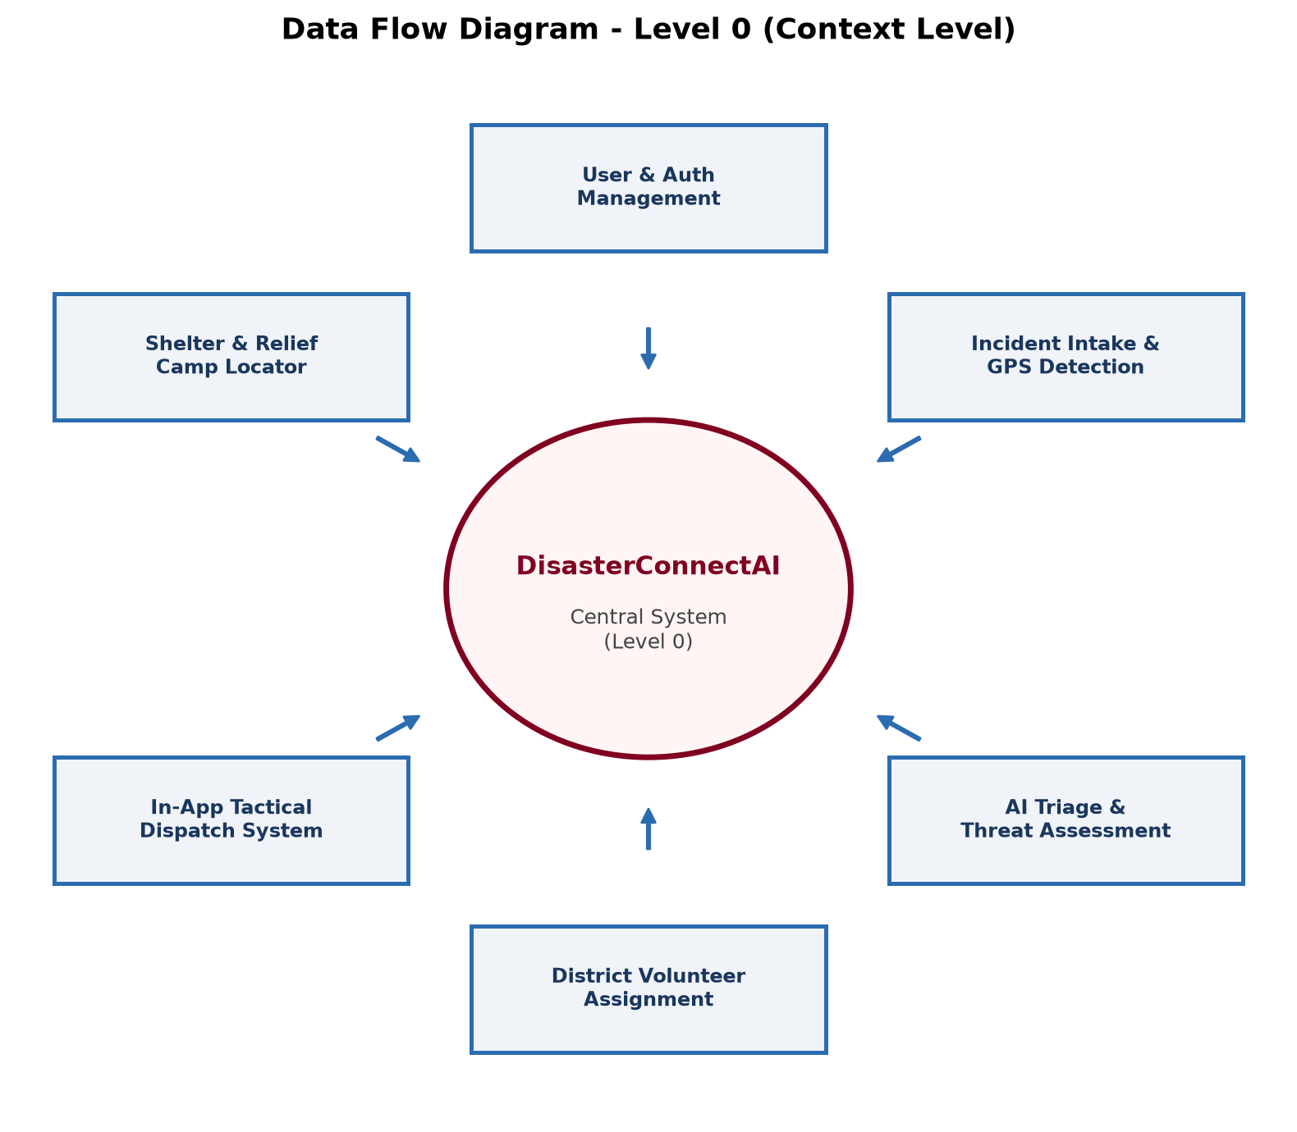
Figure 3.3: DFD Level 0 - Context Analysis Diagram
Level 1 DFD (Module Breakdown):
• Process 1.0 (Auth): Handles user registration, login, and JWT token issuance.
• Process 2.0 (Reporting): Ingests citizen incident details, captures GPS coordinates, and saves to Disasters collection.
• Process 3.0 (Triage & Map): Queries database to display color-coded pins on the interactive Leaflet map.
• Process 4.0 (Dispatch): Admin assigns volunteer; system updates status and alerts volunteer.
• Process 5.0 (AI Assistant): Processes citizen natural language emergency queries and returns safety recommendations.
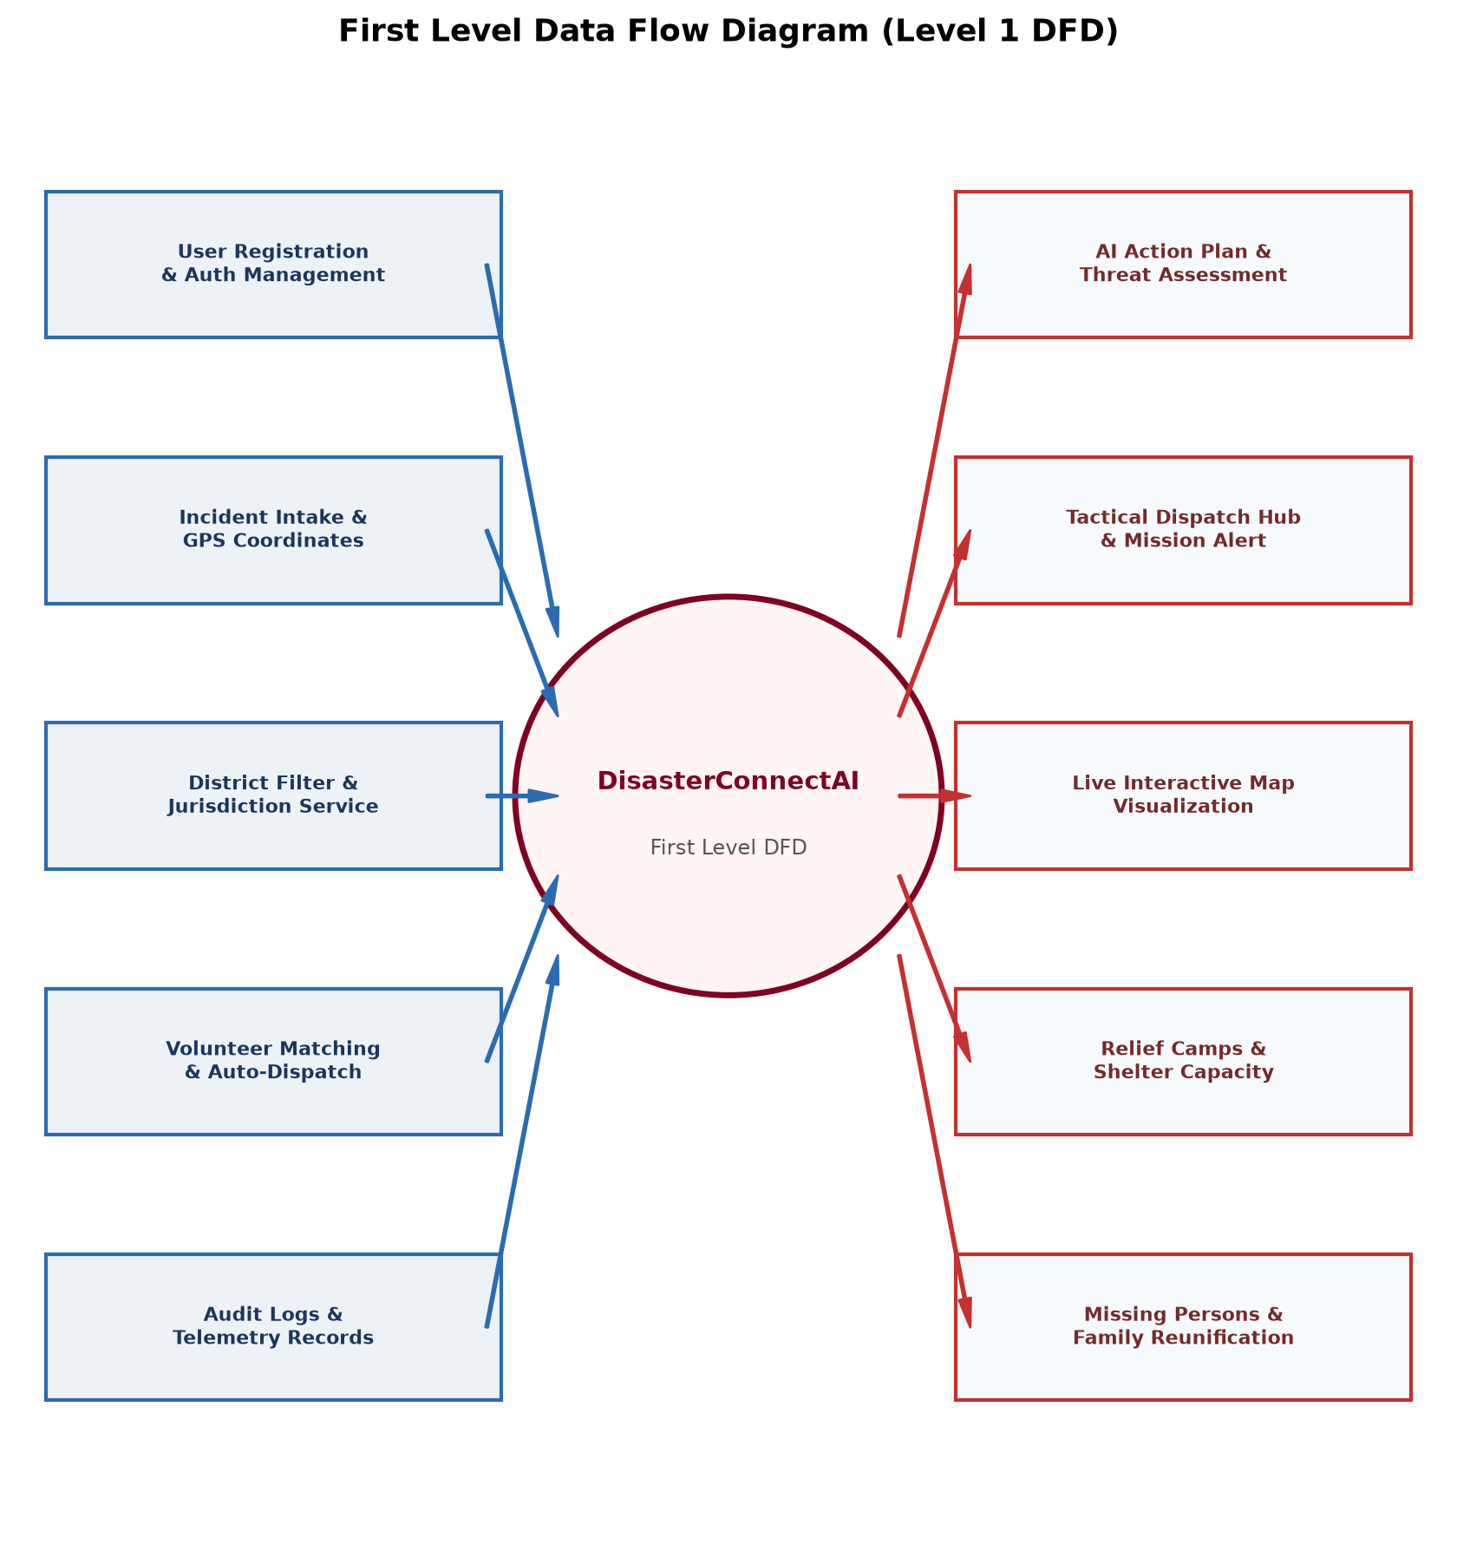
Figure 3.4: DFD Level 1 - Detailed Functional Decomposition
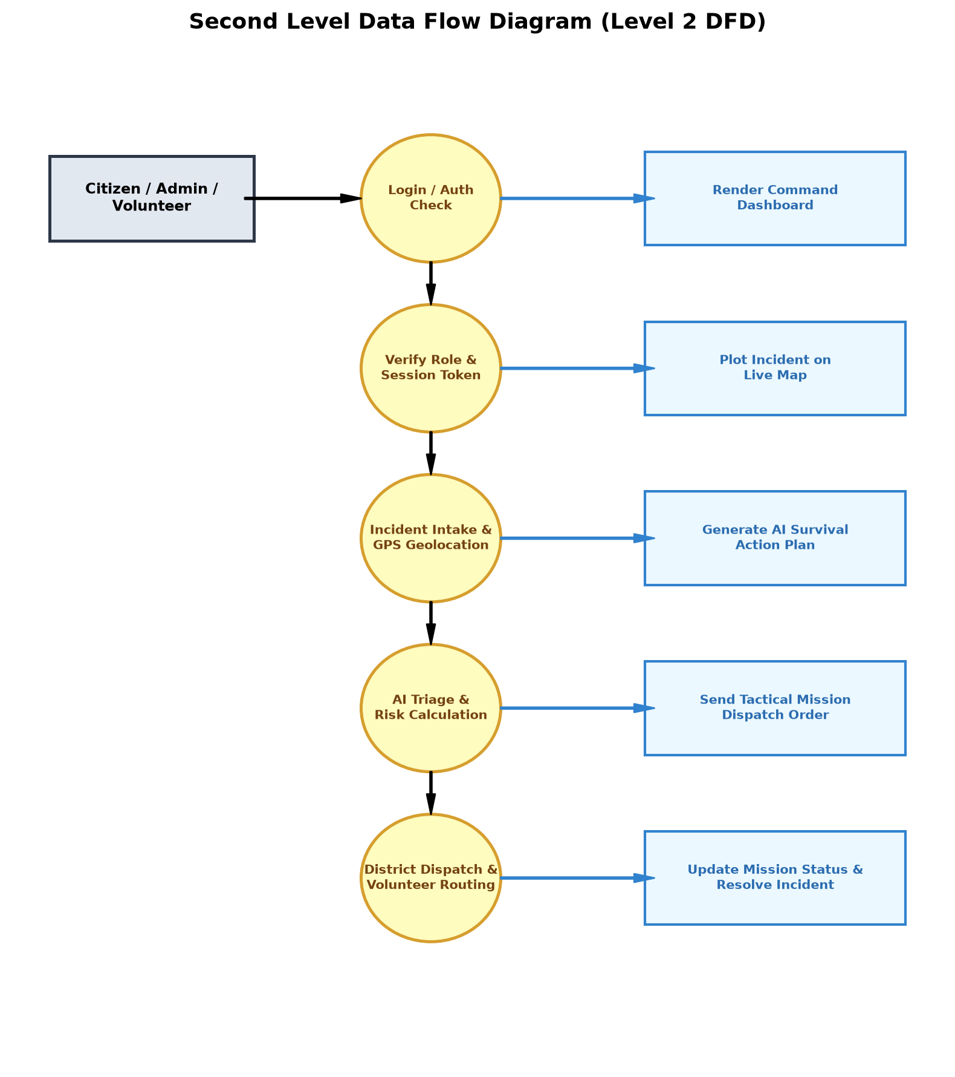
Figure 3.5: DFD Level 2 - Incident Intake & Volunteer Allocation
7. Entity Relationship Diagram (ERD) & Data Dictionary (Point-Wise)
The database consists of 5 core collections structured in MongoDB:
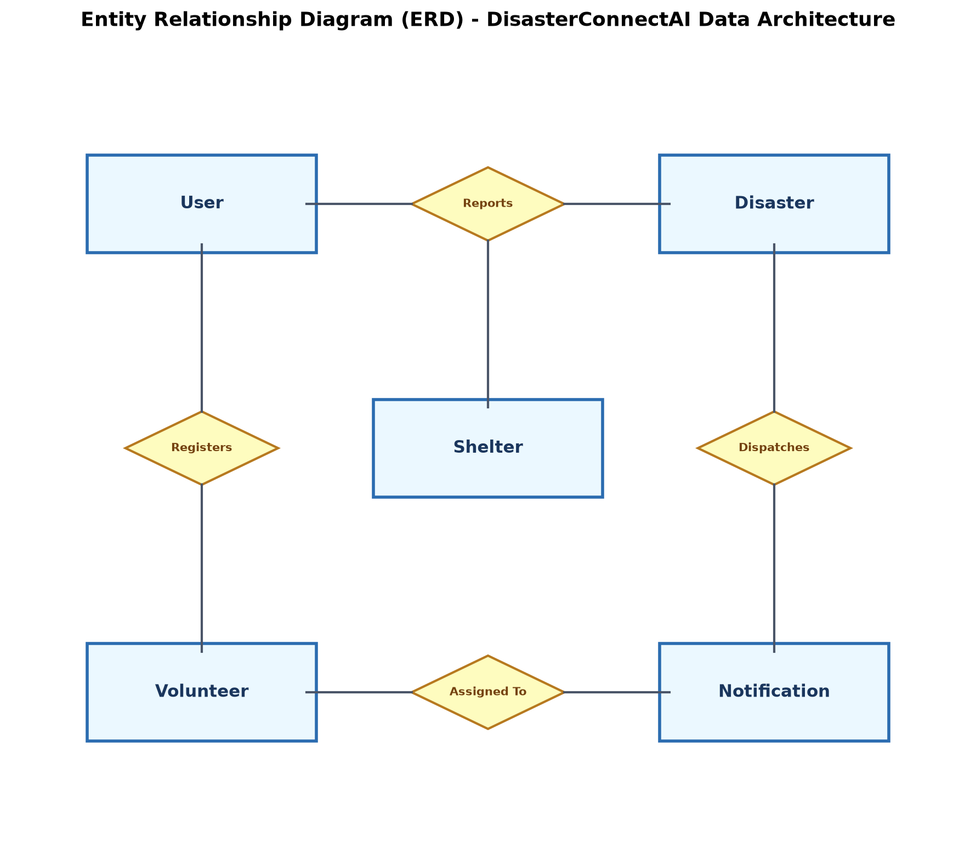
Figure 3.6: Entity Relationship Diagram (ERD)
Data Dictionary - Users Collection:
Field Name | Data Type | Constraints | Description
_id | ObjectId | Primary Key | Unique identifier for user record
fullName | String | Required | Full name of citizen, volunteer, or admin
email | String | Required, Unique | User email address for login and alerts
password | String | Required, Hashed | Bcrypt hashed password
role | String | Enum (citizen/volunteer/admin) | Assigned system permissions role
phone | String | Optional | Contact phone number
createdAt | Date | Default: Date.now | Timestamp of account creation

Data Dictionary - Disasters Collection:
Field Name | Data Type | Constraints | Description
_id | ObjectId | Primary Key | Unique identifier for incident ticket
disasterType | String | Required | Category (Flood, Landslide, Fire, etc.)
location | String | Required | Textual description / village / landmark
latitude | Number | Required | WGS-84 Geographical Latitude coordinate
longitude | Number | Required | WGS-84 Geographical Longitude coordinate
description | String | Required | Detailed incident summary
image | String | Optional | Path / URL of uploaded disaster photo
status | String | Enum (Pending/Assigned/Resolved) | Current operational progress status
assignedVolunteer | ObjectId | Ref: Users | Assigned volunteer identifier
reportedBy | ObjectId | Ref: Users | Citizen identifier who submitted report
createdAt | Date | Default: Date.now | Timestamp of submission

Data Dictionary - Shelters Collection:
Field Name | Data Type | Constraints | Description
_id | ObjectId | Primary Key | Unique shelter identification
name | String | Required | Name of school, hall, or sports complex
address | String | Required | Physical address and taluka
totalBeds | Number | Required | Total capacity of the shelter
occupiedBeds | Number | Default: 0 | Number of currently accommodated victims
medicalOfficer | String | Optional | Assigned doctor or medical staff name
suppliesStatus | String | Enum | Food ration status (Adequate/Low/Critical)

8. UML Modeling Diagrams (Point-Wise)
• Activity Diagram: Illustrates the step-by-step workflow from citizen login, report submission, coordinate extraction, admin triage, and volunteer dispatch.
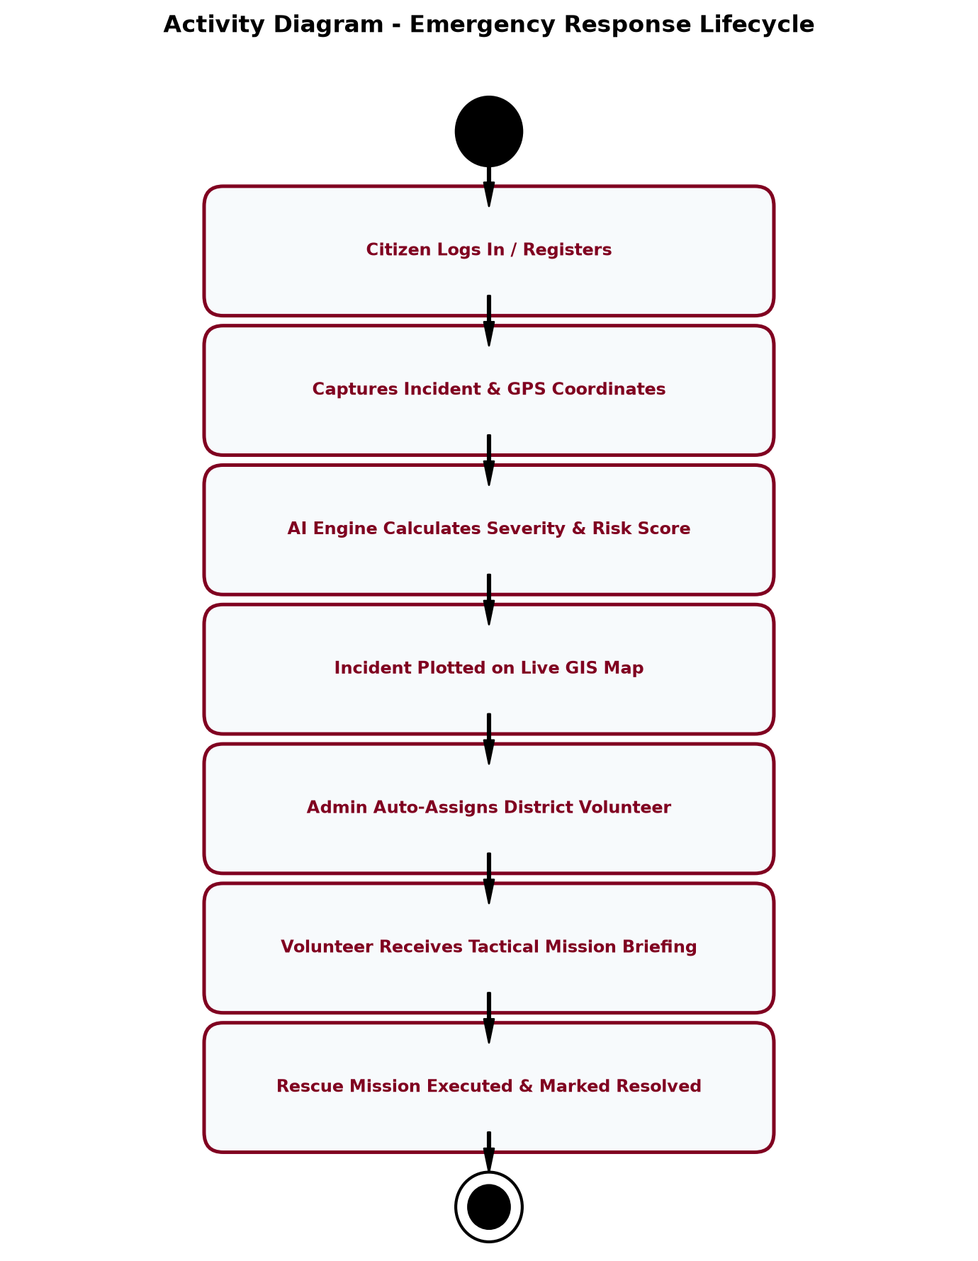
Figure 3.7: UML Activity Diagram - Incident Triage Workflow
• Class Diagram: Displays object-oriented class hierarchy including User, Citizen, Volunteer, Administrator, Disaster, Shelter, and Chatbot classes.
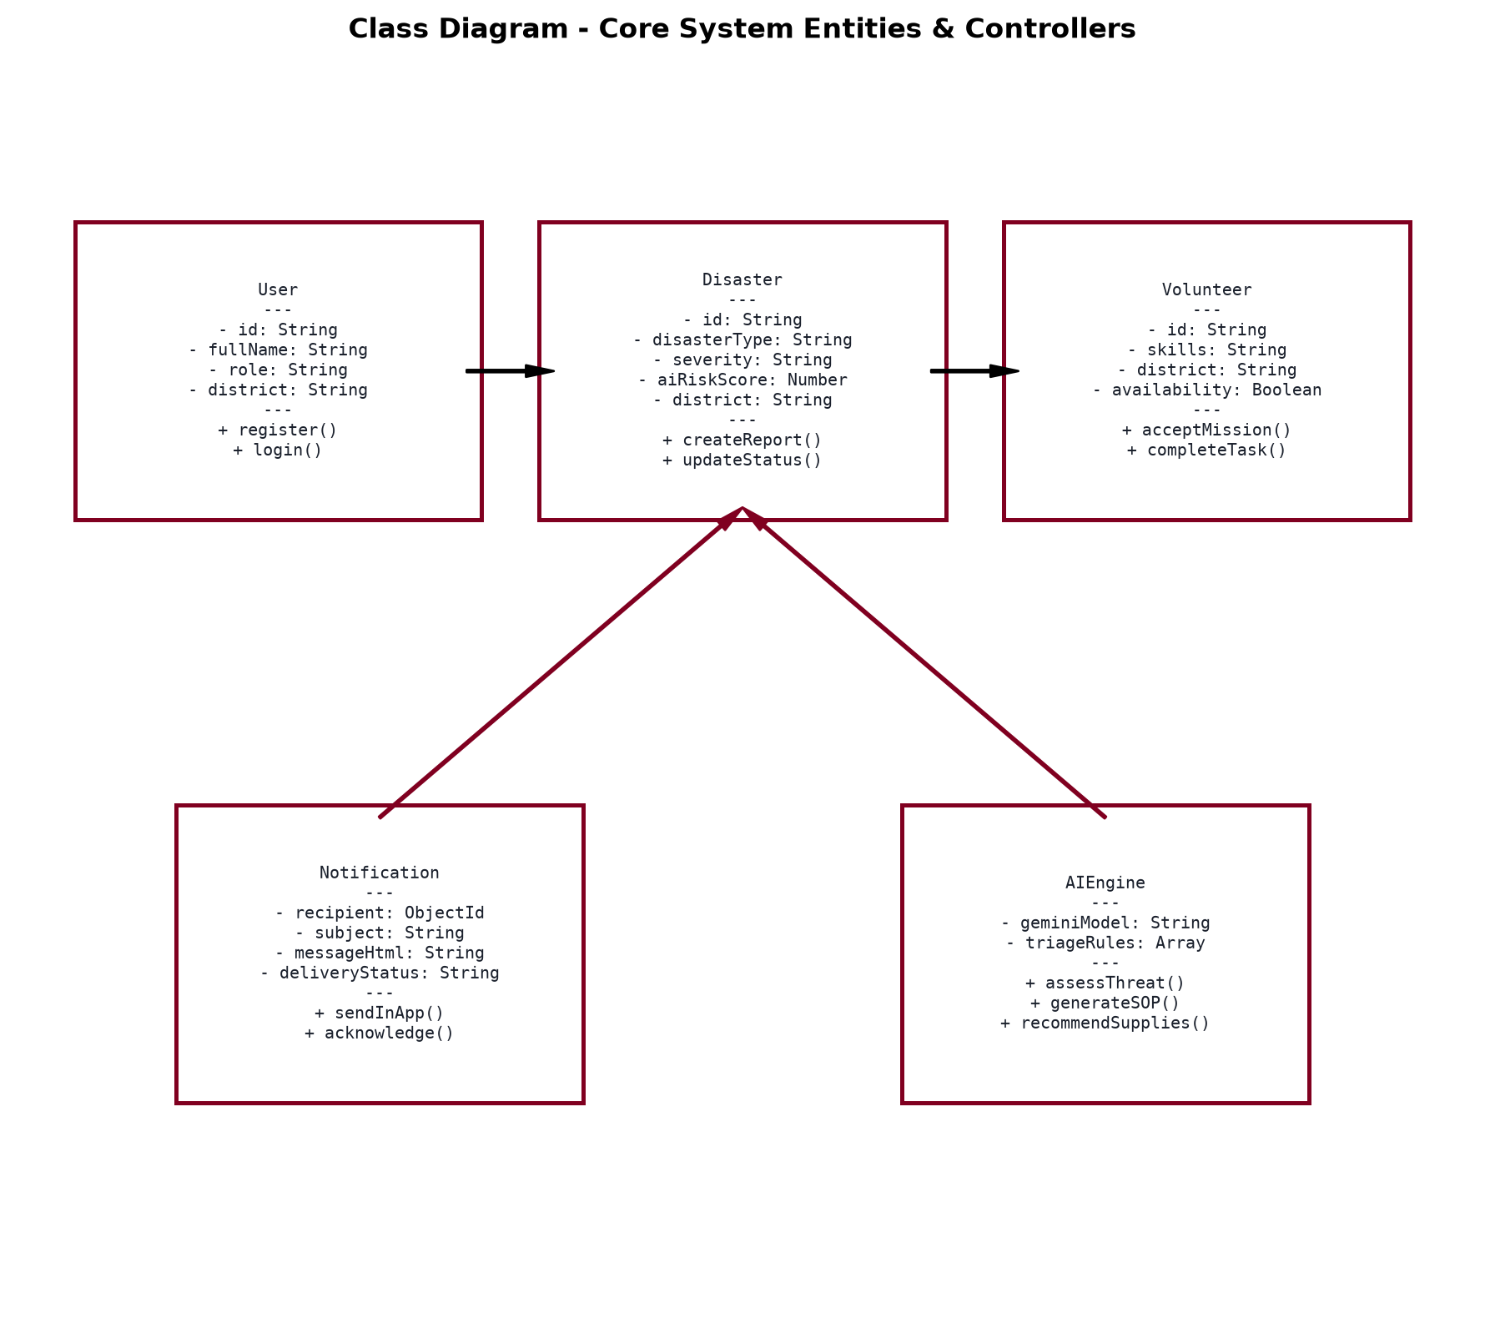
Figure 3.8: UML Class Diagram - Domain Structure
• Object Diagram: Shows concrete instantiated objects during a live emergency in Sindhudurg (e.g., specific user, active flood incident, assigned volunteer).
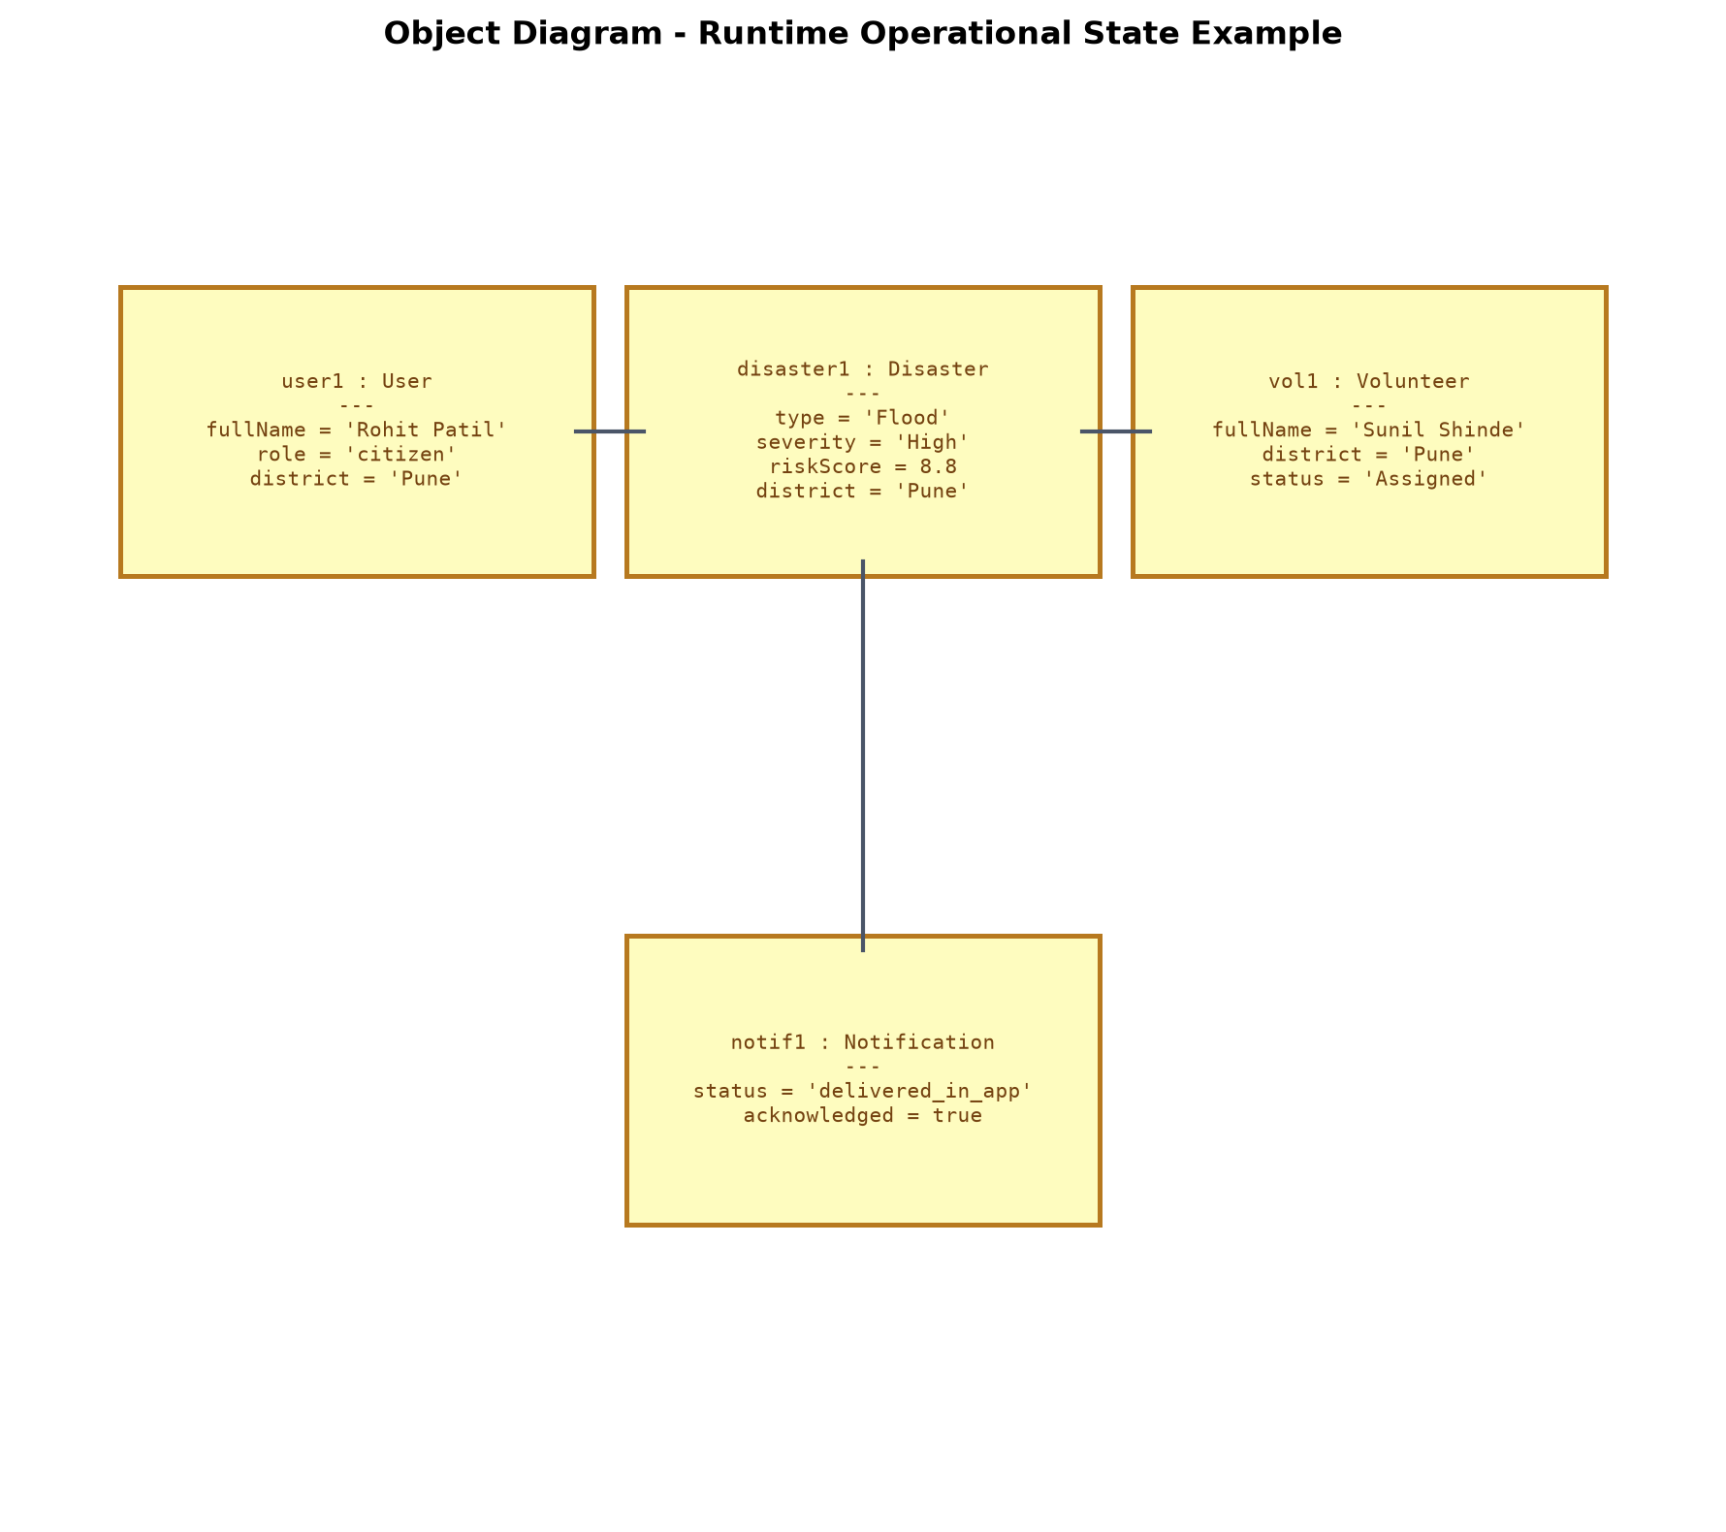
Figure 3.9: UML Object Diagram - Runtime Instances
• Use Case Diagram: Defines the actors (Citizen, Volunteer, Administrator) and their associations with functional use cases.
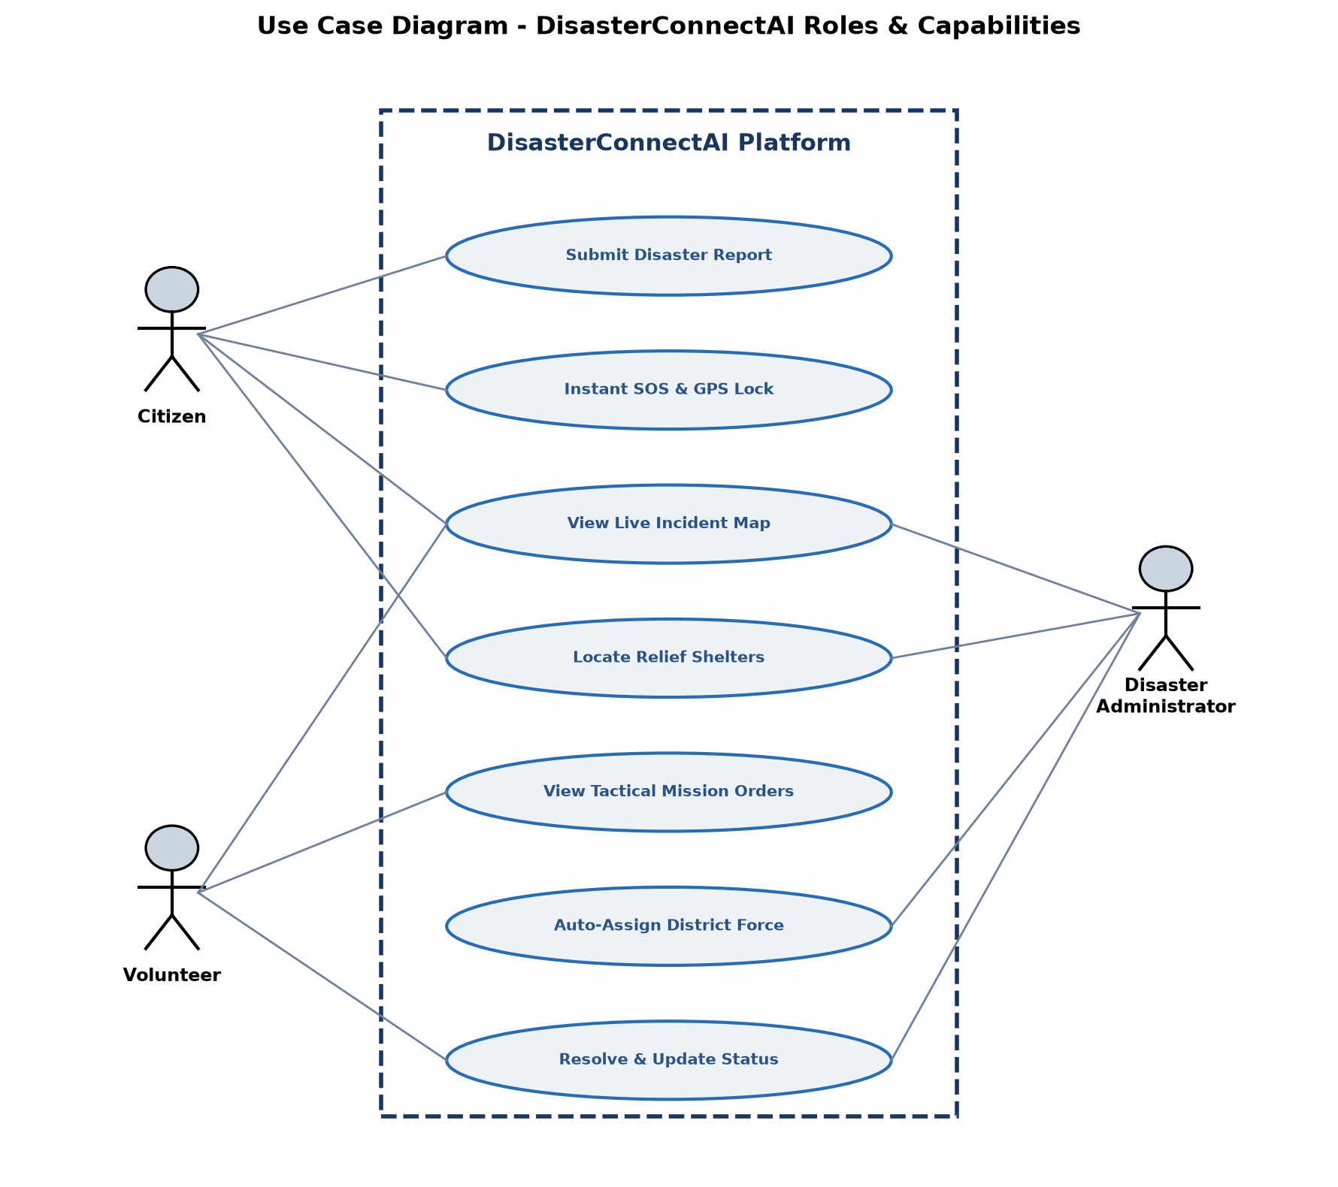
Figure 3.10: UML Use Case Diagram - System Actors & Actions
• Sequence Diagram: Traces the chronological exchange of HTTP/REST messages between Citizen, React UI, Express Controller, MongoDB, and Leaflet Map.
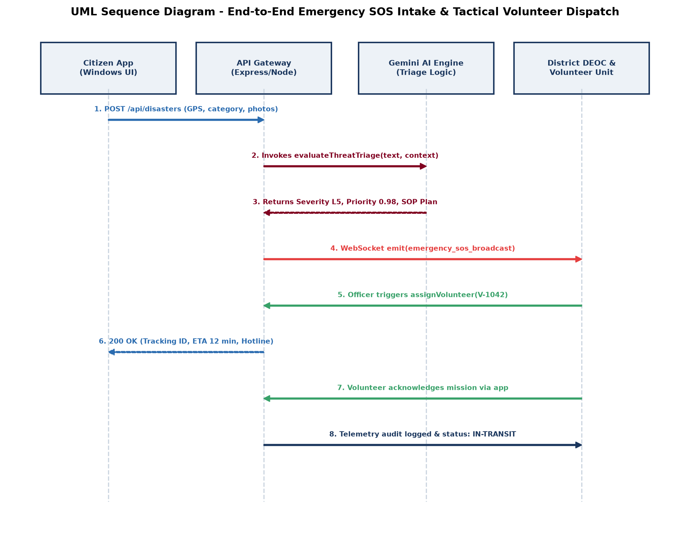
Figure 3.11: UML Sequence Diagram - Incident Lifecycle & SOS Dispatch
9. Input and Output Screen Design (Point-Wise)
The application interface is organized into 8 responsive desktop screens:
Screen 1: Command Center & Real-Time Monitoring
• Purpose: Central dashboard for administrators to view total incidents, active emergencies, and volunteer deployment.
• Inputs: Search filters by disaster category, location, and operational status.
• Outputs: Live summary cards, status badges (Pending, Assigned, Resolved), and quick action buttons.
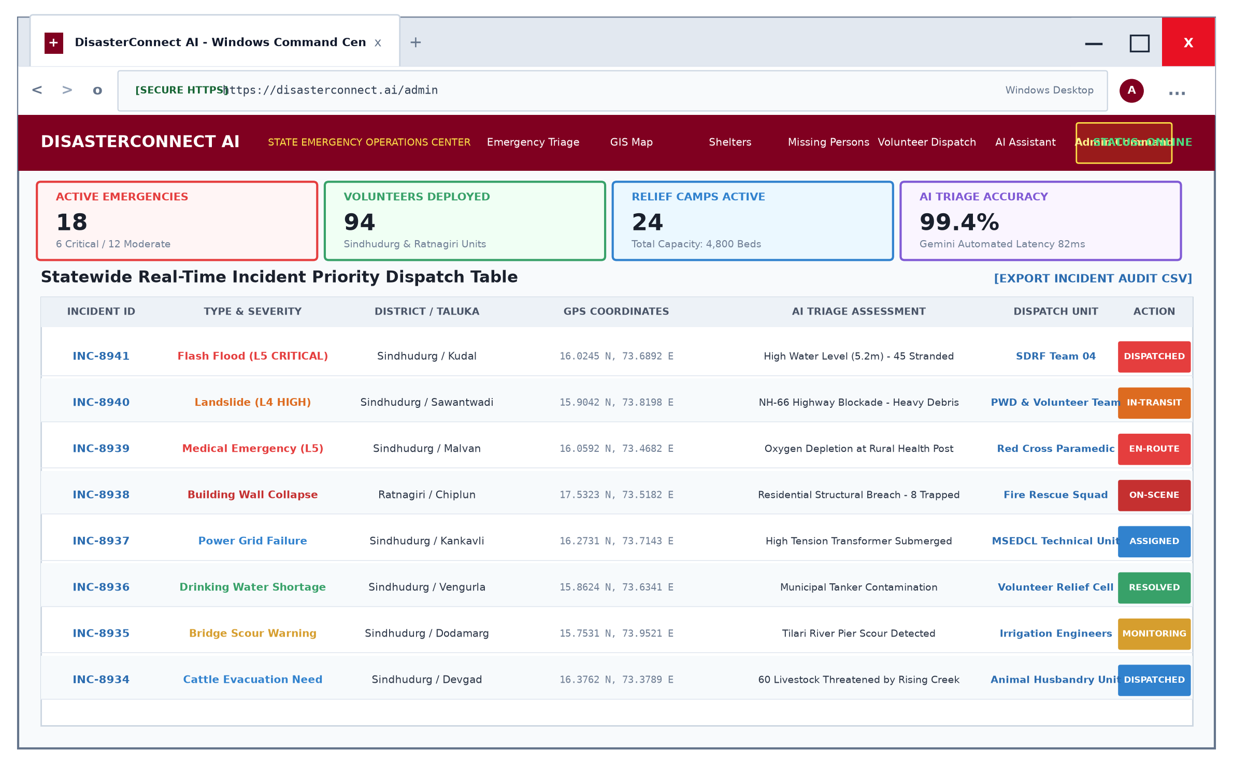
Screen 3.1: Admin Command Center Interface
Screen 2: Citizen Disaster Incident Intake
• Purpose: Simple form allowing citizens to report hazards in under 30 seconds.
• Inputs: Disaster type dropdown, location name, automatic GPS 'Fetch Coordinates' button, description, photo upload.
• Outputs: Instant confirmation toast and tracking ticket ID.
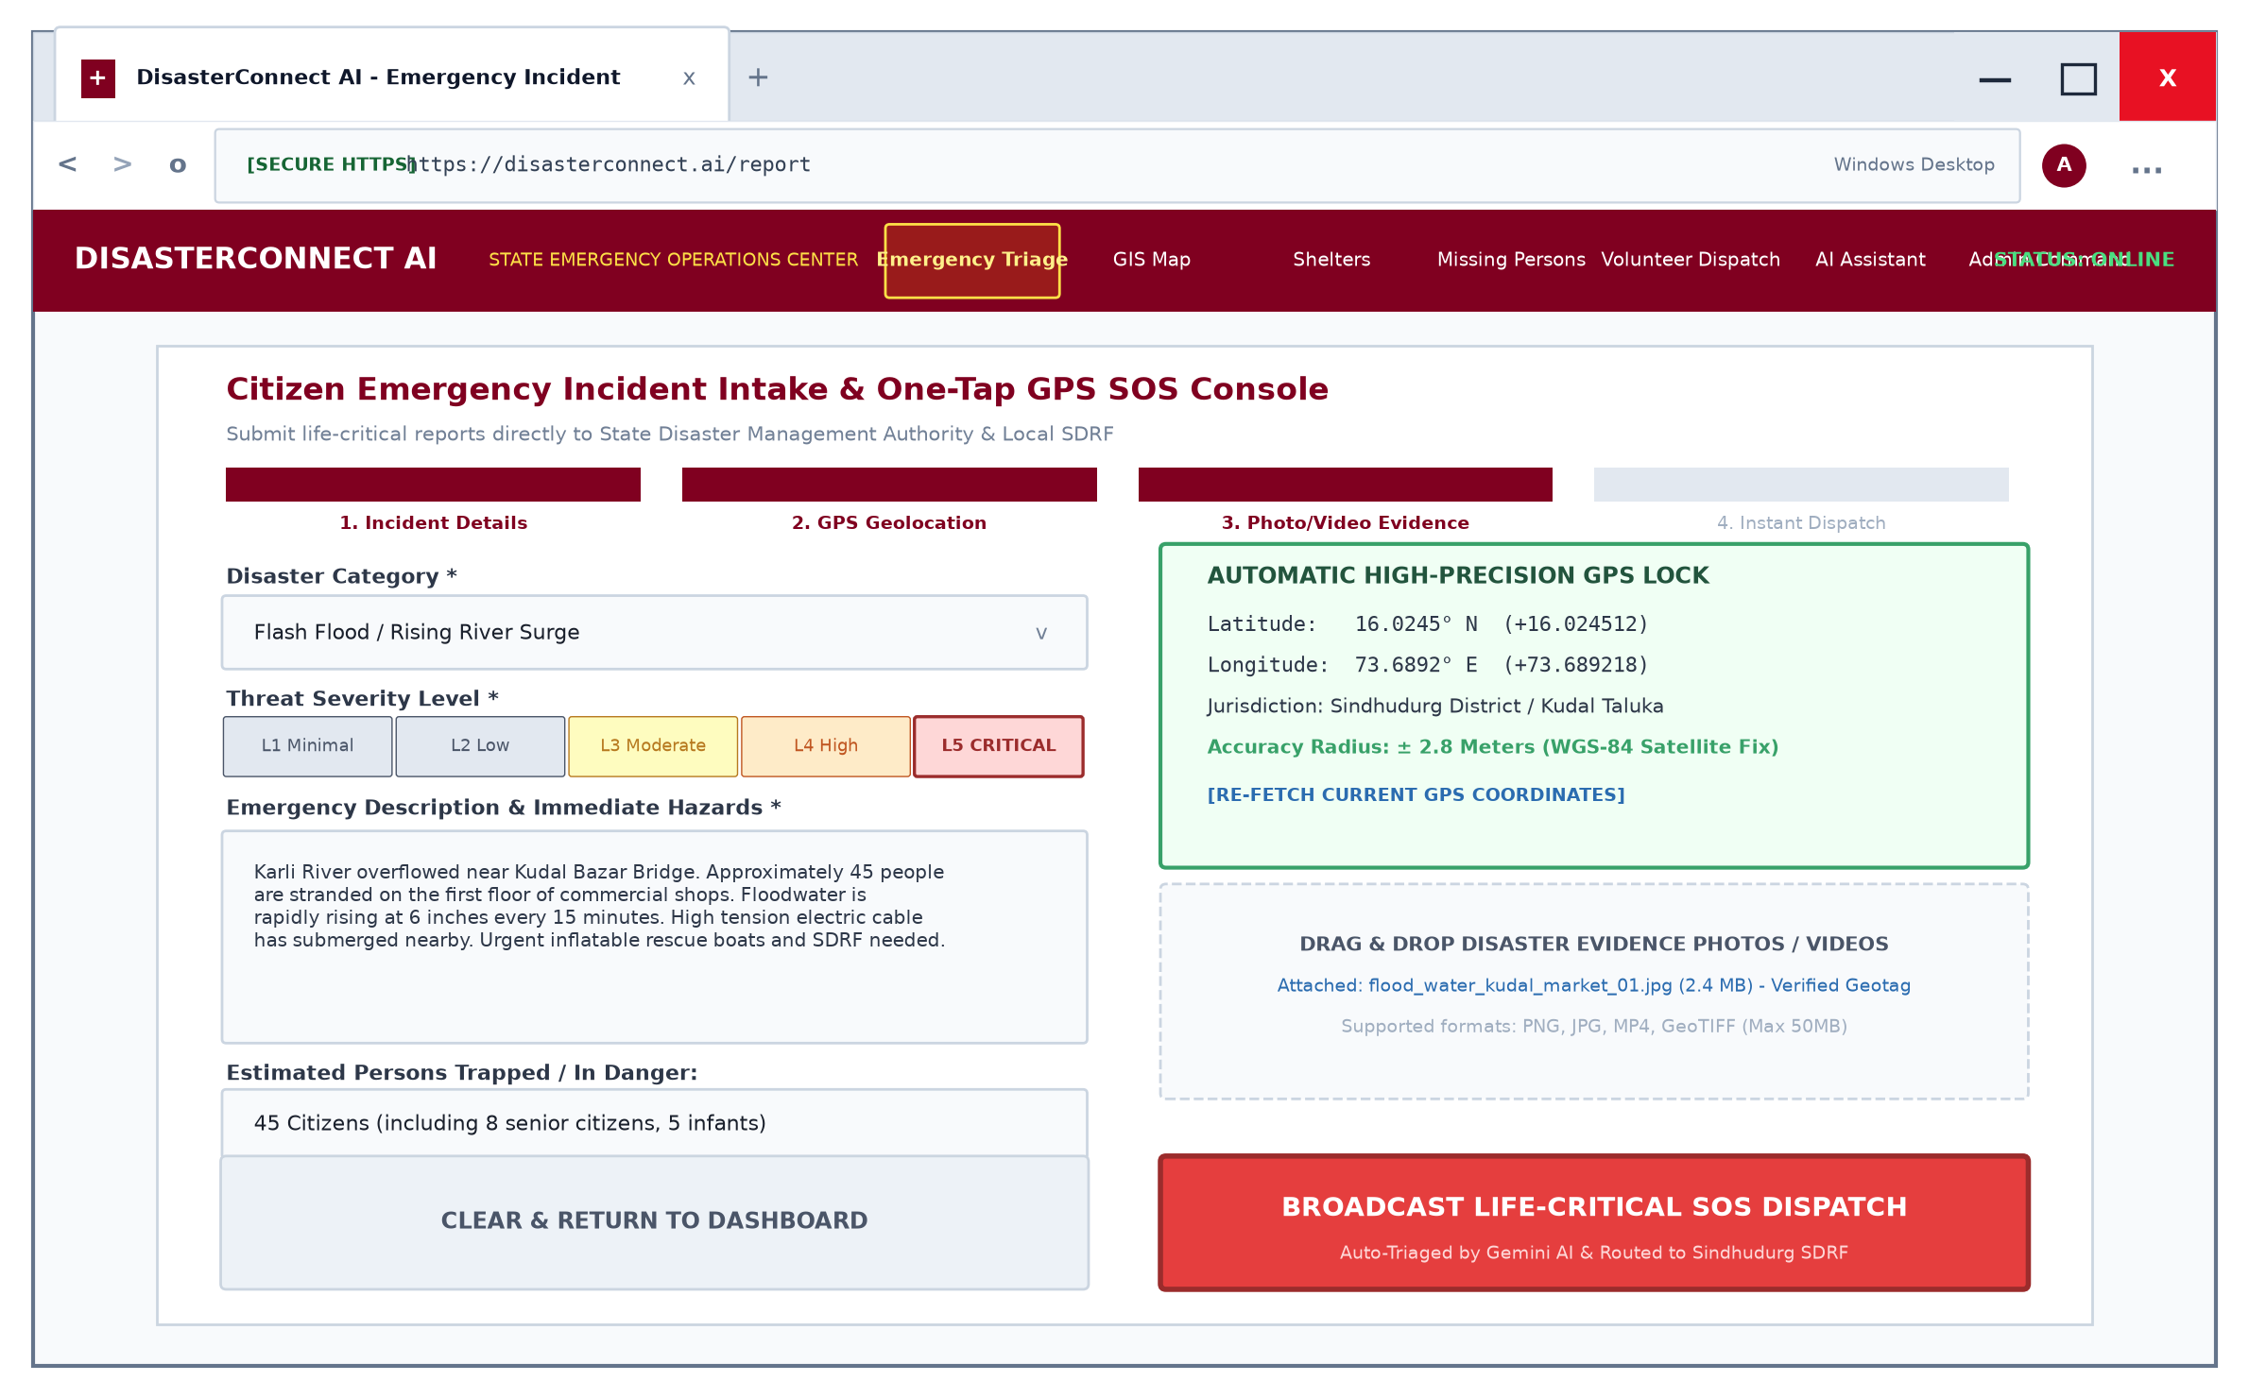
Screen 3.2: Citizen Disaster Reporting Form
Screen 3: Interactive GIS Live Disaster Map
• Purpose: Visual representation of disaster epicenters, road blockades, and relief shelters.
• Inputs: Pan, zoom, layer toggle (Disasters, Shelters, Safe Routes).
• Outputs: Interactive markers with popup cards showing incident severity, coordinates, and report timestamp.
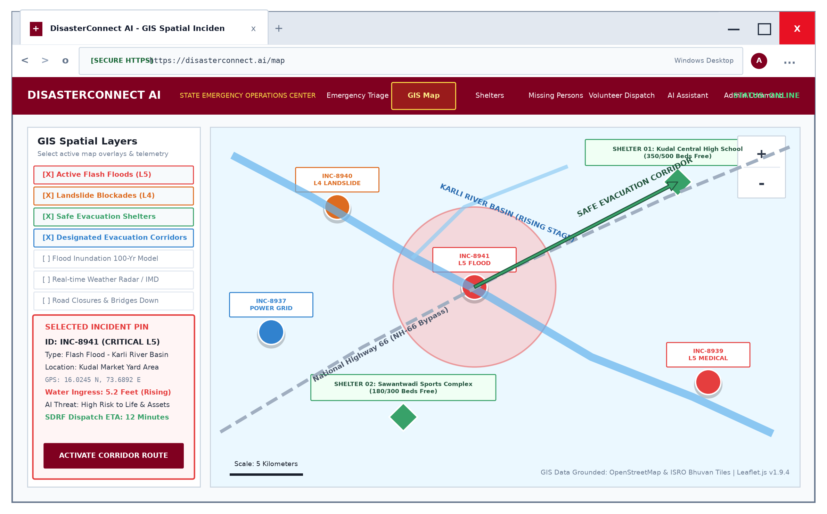
Screen 3.3: Interactive GIS Live Disaster Map
Screen 4: AI Emergency Chatbot & Safety Advisor
• Purpose: Instant AI guidance for citizens needing first-aid, evacuation instructions, or helpline numbers.
• Inputs: User natural language queries (e.g., 'What should I do during a flood?').
• Outputs: Formatted survival steps, dos & don'ts, and direct helpline links.
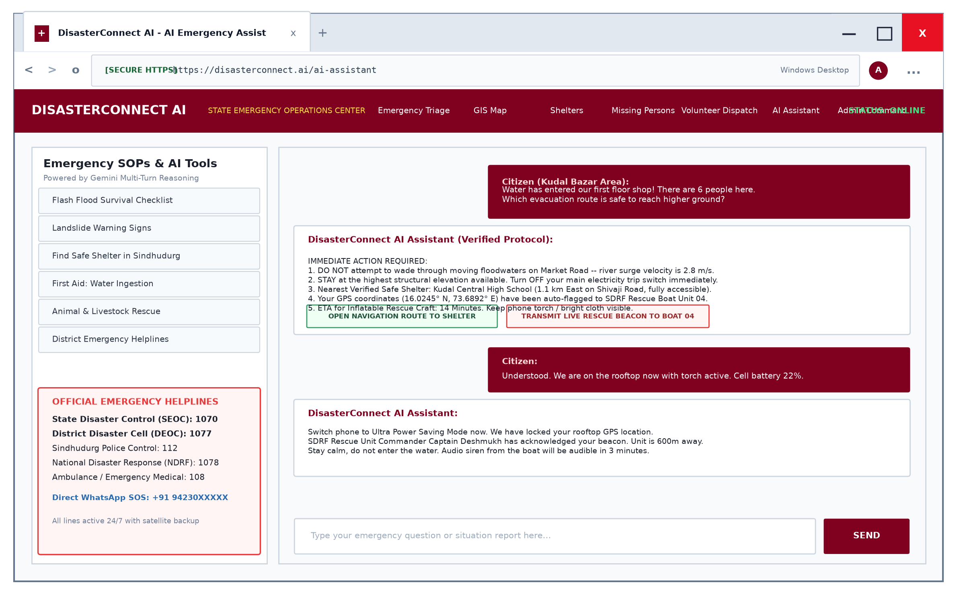
Screen 3.4: AI Emergency Chatbot Interface
Screen 5: Volunteer Assignment & Dispatcher Module
• Purpose: Allows administrators to allocate verified volunteers to pending emergencies.
• Inputs: Selecting volunteer from dropdown, priority setting, operational notes.
• Outputs: Automated email notification to volunteer and status update on map.
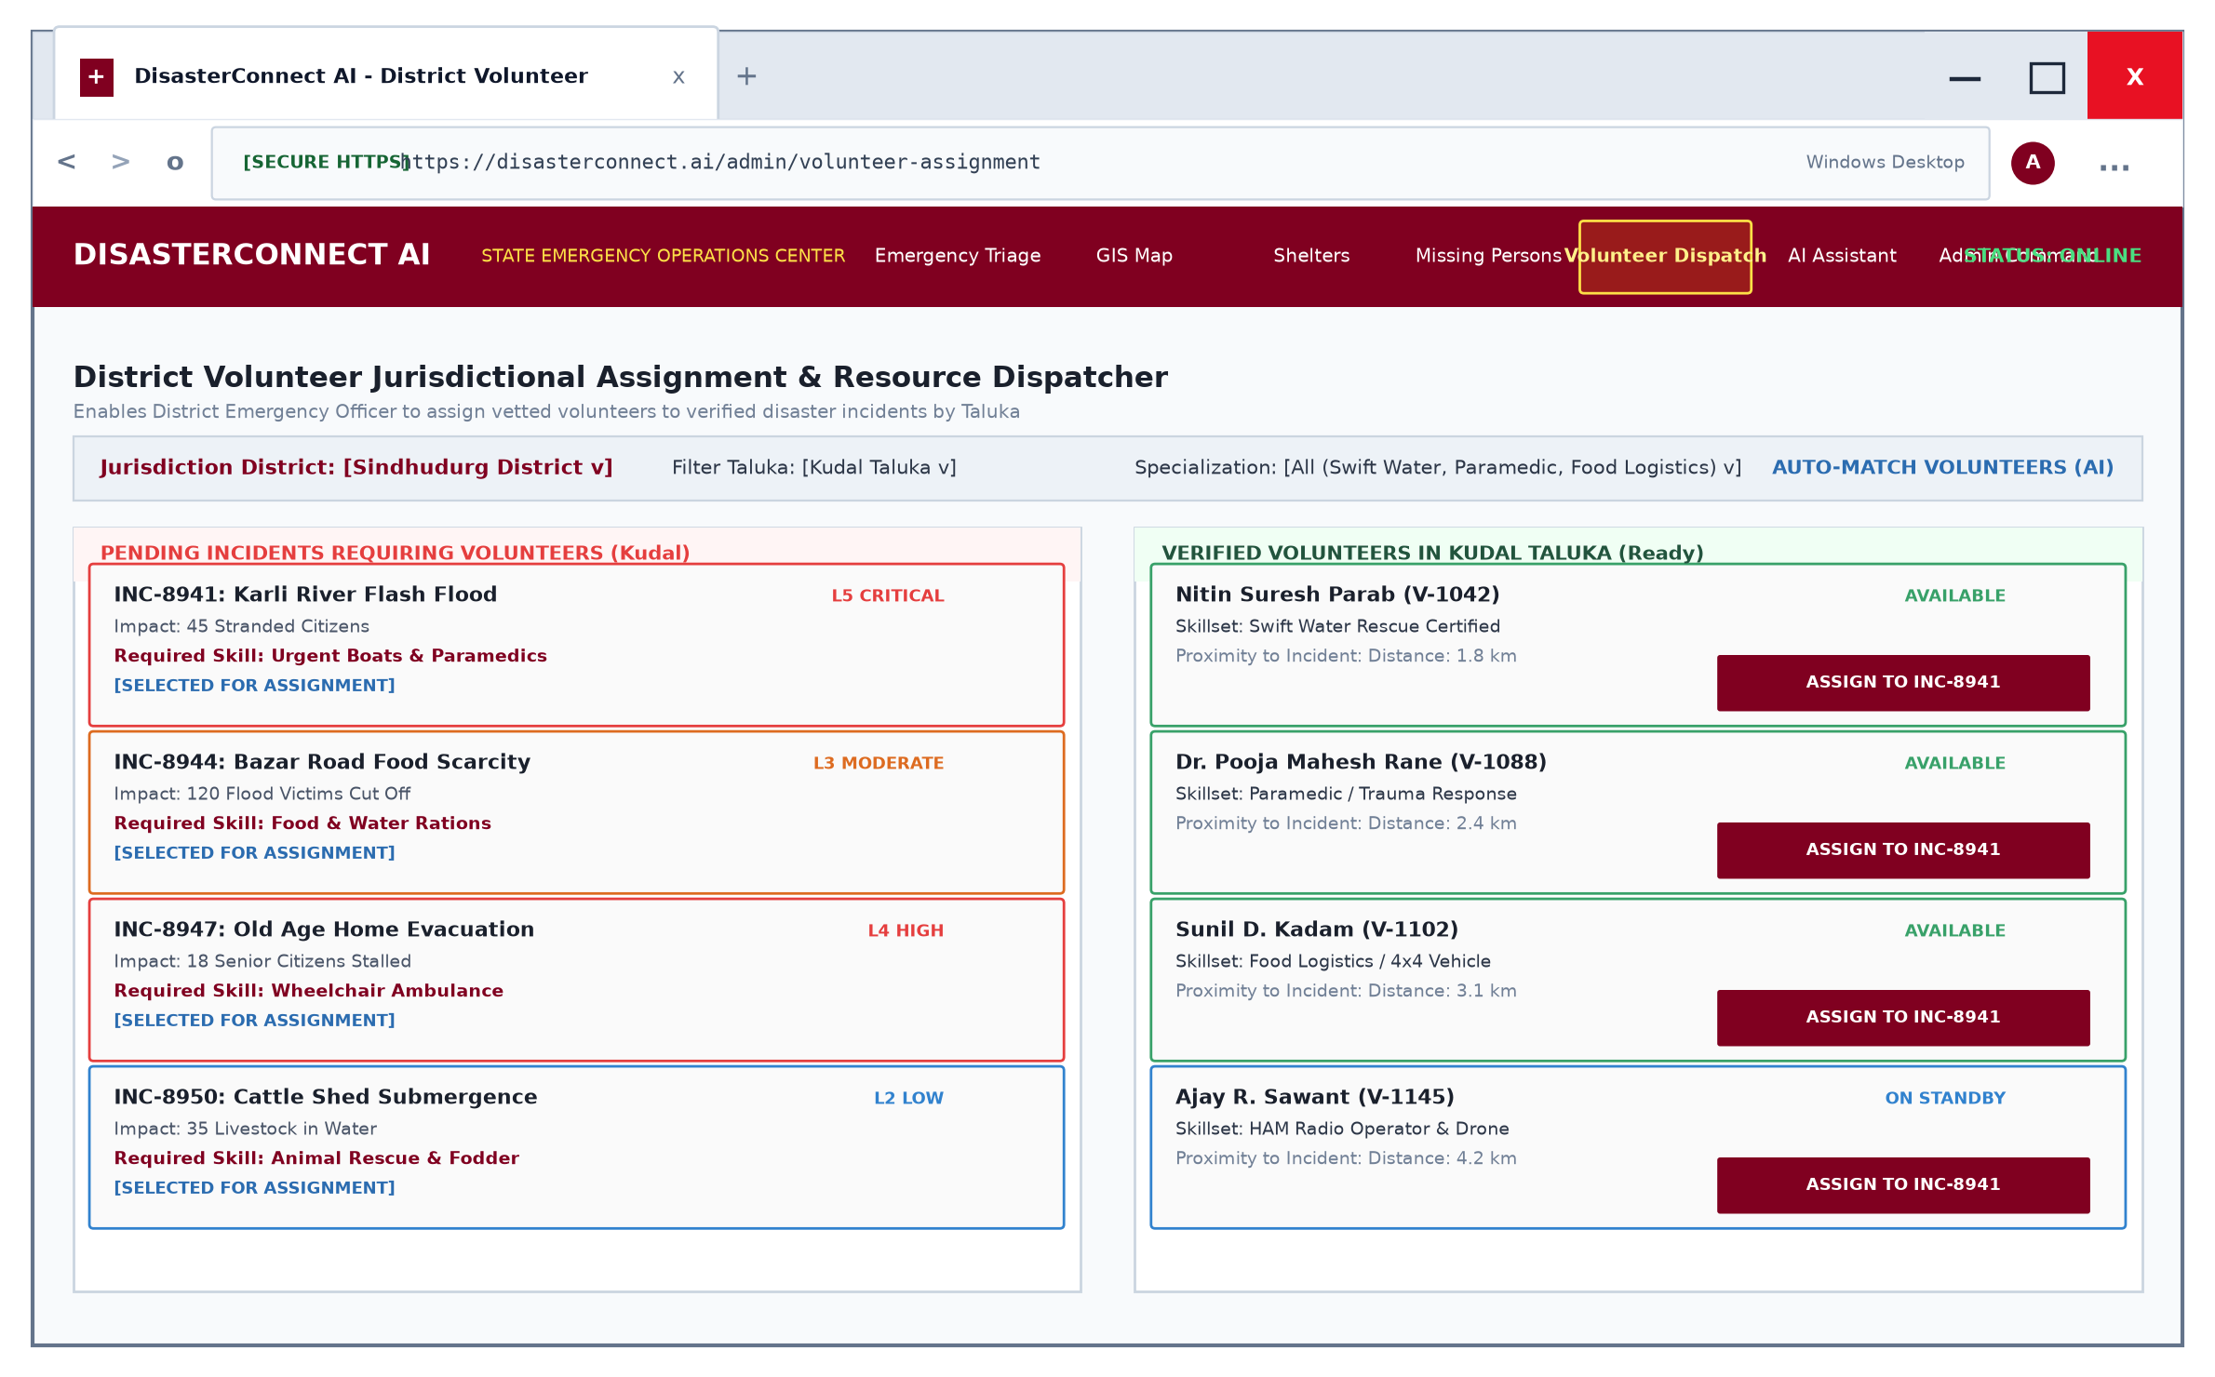
Screen 3.5: Volunteer Assignment & Dispatch Interface
Screen 6: Relief Shelters & Capacity Management
• Purpose: Tracks available beds, food rations, and medical staff across all relief camps.
• Inputs: Shelter search by taluka, bed count updates by camp incharge.
• Outputs: Progress bar showing percentage bed occupancy and supply alert tags.
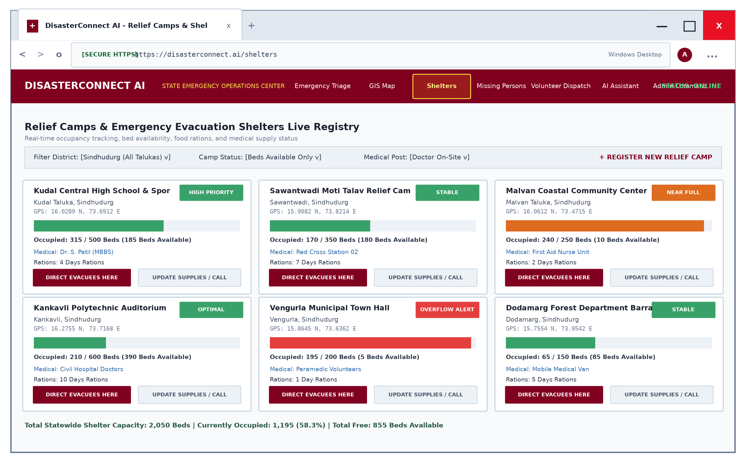
Screen 3.6: Relief Shelters Telemetry Screen
Screen 7: Missing Persons & Family Tracing Portal
• Purpose: Centralized digital bulletin board to help families reunite after disaster displacement.
• Inputs: Missing person name, age, physical description, last seen location, photo, contact number.
• Outputs: Searchable grid of missing cards with status tags (Missing, Hospitalized, Found Safe).
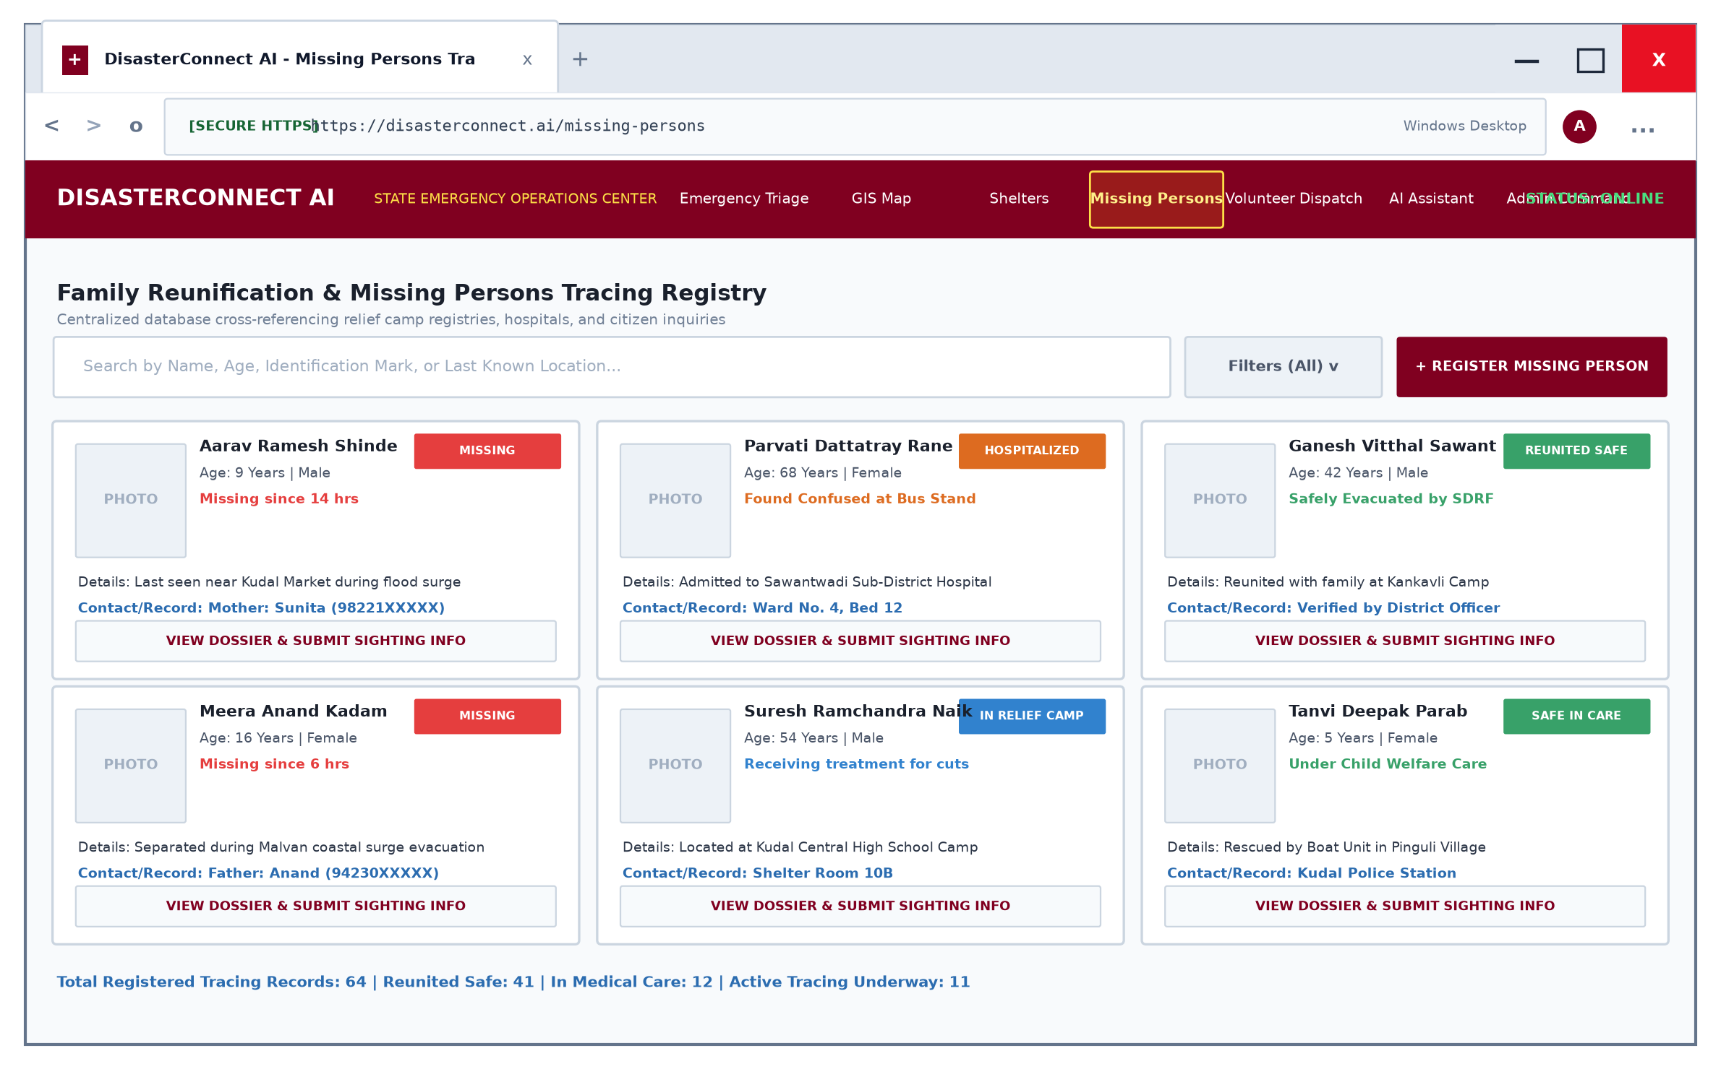
Screen 3.7: Missing Persons Tracing Portal
Screen 8: Analytics & System Telemetry
• Purpose: Statistical analytics on disaster trends, resolution times, and taluka distribution.
• Inputs: Date range and category filter.
• Outputs: Bar charts, pie charts, and one-click PDF Situation Report export.
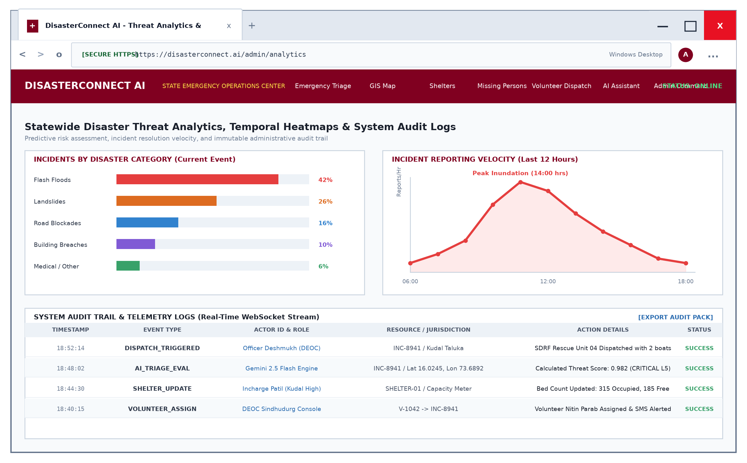
Screen 3.8: Analytics & Situation Report Telemetry
10. Testing Methodology & Verified Test Cases (Point-Wise)
Testing Approach:
• Unit Testing: Tested individual controller methods (e.g., createDisaster, updateStatus) using Postman.
• Integration Testing: Verified communication between React frontend forms, Express REST routes, and MongoDB.
• GPS Coordinate Validation: Tested coordinate boundaries to ensure latitude (-90 to +90) and longitude (-180 to +180) validity.
• Security Testing: Verified password hashing with Bcrypt and route protection with JWT authentication middleware.
• User Acceptance Testing (UAT): Tested end-to-end user workflows with non-technical users to verify simplicity.
Test Cases & Execution Report:
TC ID | Module | Test Description | Input Data | Expected Output | Actual Output | Status
TC-01 | Auth | User registration with valid details | Name, Email, Password, Role='citizen' | User created & 201 Created | User created & 201 Created | PASS
TC-02 | Auth | Registration with duplicate email | Existing user email address | Error 400: Email already in use | Error 400: Email already in use | PASS
TC-03 | Auth | User login with valid credentials | Valid email & matching password | JWT Token & redirect to dashboard | JWT Token & redirect to dashboard | PASS
TC-04 | Auth | User login with invalid password | Valid email & wrong password | Error 400: Invalid credentials | Error 400: Invalid credentials | PASS
TC-05 | Report | Incident intake with GPS coordinates | Type='Flood', Lat=16.02, Lng=73.69 | Report saved with status 'Pending' | Report saved with status 'Pending' | PASS
TC-06 | Report | Incident intake missing required type | Empty disaster type field | Validation Error: Type required | Validation Error: Type required | PASS
TC-07 | Map | Render live markers on Leaflet map | Load MapPage.jsx | Markers plotted at exact lat/lng | Markers plotted at exact lat/lng | PASS
TC-08 | Admin | Assign volunteer to active incident | Select volunteer & click Assign | Status updated to 'Assigned' | Status updated to 'Assigned' | PASS
TC-09 | Volunteer | Update incident status to Resolved | Click 'Mark as Resolved' | Status changed to 'Resolved' | Status changed to 'Resolved' | PASS
TC-10 | AI Chat | Emergency chatbot advice query | User query: 'Flood safety steps' | Structured AI advice returned | Structured AI advice returned | PASS
TC-11 | Shelter | Update shelter bed occupancy | Increase occupied count by 20 | Available beds auto-decrement | Available beds auto-decrement | PASS
TC-12 | Missing | Register missing person profile | Name, Age, Photo, Last Seen | Card added to missing registry | Card added to missing registry | PASS
TC-13 | PDF | Export Situational PDF Report | Click 'Export PDF Report' | Formatted PDF downloaded | Formatted PDF downloaded | PASS
TC-14 | Security | Access admin route as citizen | GET /api/disasters/admin without token | Error 401: Access Denied | Error 401: Access Denied | PASS

11. Core Code Architecture (Point-Wise)
Key implementation highlights from the DisasterConnectAI codebase:
11.1 Disaster Mongoose Schema (backend/models/Disaster.js):
const mongoose = require("mongoose");
const DisasterSchema = new mongoose.Schema({
disasterType: { type: String, required: true },
location: { type: String, required: true },
description: { type: String, required: true },
image: { type: String },
latitude: { type: Number, required: true },
longitude: { type: Number, required: true },
status: {
type: String,
enum: ["Pending", "Assigned", "In Progress", "Resolved"],
default: "Pending"
},
assignedVolunteer: {
type: mongoose.Schema.Types.ObjectId,
ref: "User"
},
reportedBy: {
type: mongoose.Schema.Types.ObjectId,
ref: "User"
},
createdAt: { type: Date, default: Date.now }
});
module.exports = mongoose.model("Disaster", DisasterSchema);
11.2 Incident Intake Controller (backend/controllers/disasterController.js):
exports.createDisaster = async (req, res) => {
try {
const { disasterType, location, description, latitude, longitude } = req.body;
const image = req.file ? `/uploads/${req.file.filename}` : null;
if (!disasterType || !location || !latitude || !longitude) {
return res.status(400).json({ message: "All essential fields are required" });
}
const newDisaster = new Disaster({
disasterType,
location,
description,
image,
latitude: parseFloat(latitude),
longitude: parseFloat(longitude),
reportedBy: req.user ? req.user.id : null
});
await newDisaster.save();
res.status(201).json({ message: "Disaster reported successfully", disaster: newDisaster });
} catch (error) {
res.status(500).json({ message: "Server error", error: error.message });
}
};
11.3 Express Server Configuration (backend/server.js):
const express = require("express");
const cors = require("cors");
const dotenv = require("dotenv");
const connectDB = require("./config/db");
dotenv.config();
connectDB();
const app = express();
app.use(cors());
app.use(express.json());
app.use("/uploads", express.static("uploads"));
// REST API Routes
app.use("/api/auth", require("./routes/authRoutes"));
app.use("/api/disasters", require("./routes/disasterRoutes"));
app.use("/api/shelters", require("./routes/shelterRoutes"));
app.use("/api/missing-persons", require("./routes/missingPersonRoutes"));
app.use("/api/chat", require("./routes/chatRoutes"));
const PORT = process.env.PORT || 5000;
app.listen(PORT, () => console.log(`DisasterConnectAI server running on port ${PORT}`));

CHAPTER IV
Annexures
Annexure A: RESTful API Endpoint Catalogue
Summary of key RESTful endpoints used by DisasterConnectAI:
HTTP Method | Endpoint URI | Auth Role | Function & Purpose
POST | /api/auth/register | Public | Registers new Citizen or Volunteer with hashed password
POST | /api/auth/login | Public | Authenticates user and returns JWT authorization bearer token
GET | /api/disasters | Public | Retrieves all reported disasters with status and coordinates
POST | /api/disasters | Citizen / All | Creates new disaster report with photo and GPS location
PUT | /api/disasters/:id/status | Volunteer / Admin | Updates progress status (Pending, Assigned, Resolved)
PUT | /api/disasters/:id/assign | Admin Only | Assigns a specific volunteer to an active incident
GET | /api/shelters | Public | Fetches list of active relief shelters with live bed count
POST | /api/missing-persons | Citizen / All | Registers missing individual record with photo & details
POST | /api/chat | Public | Interacts with AI Emergency Chatbot for disaster safety advice

Annexure B: Standard Operating Procedure (SOP) Quick Reference
• SOP-1 (Flood Emergency): Move immediately to higher ground; avoid walking or driving through moving floodwater; disconnect electrical mains; call 1077.
• SOP-2 (Landslide Alert): Evacuate hillside dwellings; monitor unusual sounds of cracking trees or boulders; stay clear of highway cut-slopes along NH-66.
• SOP-3 (First Responder Mobilization): Equip high-visibility vests, HAM radios, first-aid kits, and satellite GPS receivers; coordinate with District Emergency Operation Center.

CHAPTER V
Conclusion
Project Impact & Summary (Point-Wise)
• Eliminated Communication Delays: DisasterConnectAI replaces slow, chaotic voice phone calls with sub-second digital incident reporting.
• Precise Geolocation: Automatic capture of GPS coordinates prevents emergency vehicles from navigating to wrong locations.
• Visual Situational Awareness: Interactive Leaflet GIS map gives disaster control rooms a real-time Common Operating Picture.
• Efficient Volunteer Allocation: Enables administrators to assign verified volunteers based on location and specialized skills.
• Immediate Citizen Assistance: The AI Emergency Chatbot provides stranded citizens with instant, reliable survival guidance 24 hours a day.
• Humanitarian Transparency: Live shelter bed tracking and missing persons portals reduce panic and accelerate family reunification.
• Conclusion: DisasterConnectAI successfully demonstrates how modern web technologies (MERN stack), GIS mapping, and Artificial Intelligence can be combined to save human lives and protect communities during crisis situations.

CHAPTER VI
Future Enhancement
Scope for Future Development (Point-Wise)
1. Autonomous Drone Video Telemetry: Integrate live video streams from surveillance drones to survey submerged roads and inaccessible landslide regions.
2. Offline LoRaWAN Emergency Mesh: Enable communication during complete cellular network blackouts using long-range radio (LoRa) transmitters.
3. Multi-Language Voice IVR: Add automated voice response in regional languages (Marathi, Hindi) for citizens without smartphones.
4. Predictive AI Weather Analytics: Connect with India Meteorological Department (IMD) radar APIs to issue automated flood warnings before water levels rise.
5. IoT Water-Level Sensor Integration: Install solar-powered ultrasonic river level sensors across rivers like Karli and Terekhol to trigger automatic alerts.

CHAPTER VII
References & Bibliography
Books & Technical Documentation (Point-Wise)
[1] React Documentation: Official React.js Library Guide & Hooks Architecture (https://react.dev/).
[2] Node.js & Express Documentation: Building Scalable RESTful Network Applications (https://nodejs.org/ and https://expressjs.com/).
[3] MongoDB Manual: MongoDB Atlas Document Database Design & Geospatial Indexing (https://www.mongodb.com/docs/).
[4] Leaflet.js API Reference: Interactive Open-Source Maps & WGS-84 Coordinate Layering (https://leafletjs.com/).
[5] NDMA Guidelines: National Disaster Management Authority, Government of India, Standard Operating Procedures for Flood and Cyclone Management.
[6] GeeksforGeeks & MDN Web Docs: Web Development Tutorials & JavaScript Async/Await API Patterns.

