**High-Level Design (HLD)**

**Stores Sales Prediction**

|  |  |
| --- | --- |
| Written By | Yogita Manoj Patil |
| Version | 1.0 |
| Date | 05-07-2023 |

|  |  |  |  |
| --- | --- | --- | --- |
| **Version** | **Date** | **Author** | **Comments** |
|  |  |  |  |
|  |  |  |  |
|  |  |  |  |
|  |  |  |  |
|  |  |  |  |
|  |  |  |  |
|  |  |  |  |
|  |  |  |  |
|  |  |  |  |
|  |  |  |  |
|  |  |  |  |
|  |  |  |  |
|  |  |  |  |
|  |  |  |  |
|  |  |  |  |

**Document Change Control Record**

Review

|  |  |  |  |
| --- | --- | --- | --- |
| **Version** | **Date** | **Reviewer** | **Comments** |
|  |  |  |  |

**Approval**

|  |  |  |  |  |
| --- | --- | --- | --- | --- |
| **Version** | **Review date** | **Reviewed By** | **Approved By** | **Comments** |
|  |  |  |  |  |

**Abstract**

The project is about building a system that can predict future customer demand for particular products in stores. By analyzing past selling records of a particular product. Big Shopping malls are kept records of selling their product to forecast future demand. It helps to manufacture and product warehouse for storing a quantity of products. The main goal here is to analyze the past record and find a meaningful relationship between different attributes and build a system that is capable of doing predictions of how much a particular product will be in demand. This system will help to manage to store capacity of warehouses.

1. Introduction

**1.1 Why these High-Level Design Documents?**

The purpose of this High-Level Design(HLD) Documents is to add necessary details to the current project description to represent a suitable for coding. This document is also intended to help detect contradictions before coding. And can be used as a reference manual for how the modules interact at a high level.

The HLD will be :

* Present all of the design aspects and define them in detail.
* Describe the user interface being implemented.
* Describe the needed Python libraries for the coding.
* Describe the performance requirements.
* Include design features and the architecture of the project.
* List and describe the non-functional attributes like:
  + Security
  + Reliability
  + Maintainability
  + Portability
  + Reusability
  + Application Compatibility
  + Resource Utilization
  + Serviceability

**1.2 Scope**

The HLD documentation presents the structure of the system, such as the database architecture, application architecture(layers), application flow (Navigation), and technology architecture, The HLD uses non-technical and mildly-technical terms which should be understandable to the administrators of the system

**1.3 Definition**

|  |  |
| --- | --- |
| TERM | Description |
| DB | Database, the cloud platform where the data will be stored. Can be considered  cloud storage. |
| ML | Machine Learning |
| API or APIs | Application Programming Interface can be considered a website link from there we can extract information. |

**2. General Description**

**2.1 Product Perspective**

The Store Salse Prediction is an ML-based Web Application that Is able to predict future product demand by analyzing past records. It will give the number that will be the measure of product sales.

**2.2 Problem Statement**

Tu builds a system the will be able to take information about a product and can predict how much it will be demanded in the future. We have to build an application and that will be able to produce results.

**2.3 Proposed Solution**

We will use performe EDA to find the important relation between different attributes and will use a machine-learning algorithm to predict the future sales demand. The client will be filled the required feature as input and will get results through the web application. The system will get features and it will be passed into the backend where the features will be validated and preprocessed and then it will be passed to a hyperparameter tuned machine learning model to predict the final outcome.

**2.4 Data Requirements**

The data is required for the building of the project is already available on the dashboard. The Store Sales Prediction data is recorded many product descriptions along with past sales quantity. For building the ml model we will use the dataset that is given. The data is consist of 8523 rows and various information about products like product id, product category, store id, store location, e.t.c

**2.5 Tool Used**

The programming language is Python that is used here, also we will use some other python-based libraries like, for ml, we will use Scikit-Learn library, for data manipulation we will use pandas, for numerical computation Numpy, for custom APIs creation Flask web frameworks. Visual Studio Code is used as python IDE for all modular coding and custom APIs creation. And storing all code files for publically available we will use GitHub.





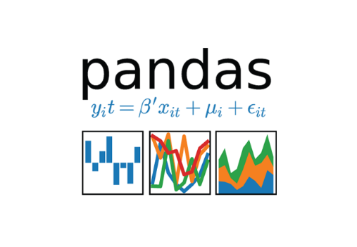





**2.6 Constraints**

The System should be user-friendly, the user should get all proper messages while using the web app. He/she also should get a proper error message if he/she has done something wrong On the web-app page. All the errors and results should be delivered in the easiest possible way and all the buttons are going to insert on the webpage should be labeled properly, so the user did not get confused to use the system.

**2.7 Assumptions**

The main objective is to implement a system that will produce approximate future demand for a product in stores.

**3. Design Details**

**3.1 Process Flow**

We will be using following process flow for this project. The process will be based on modular coding i.e. use of oops concepts to build the entire project from start to end.

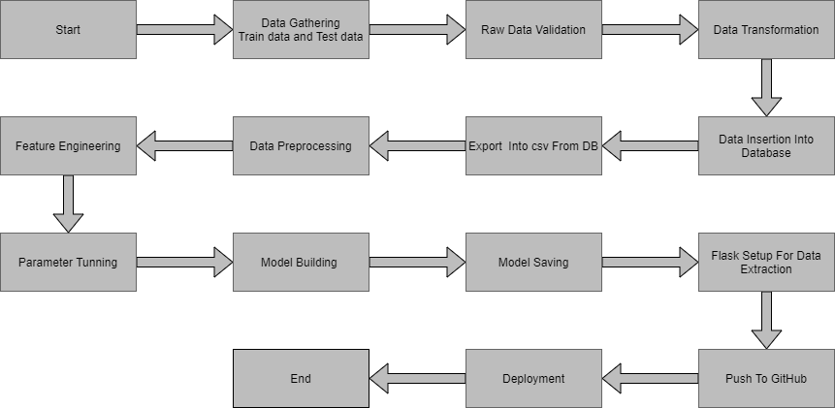

**3.2 Deployment Process**

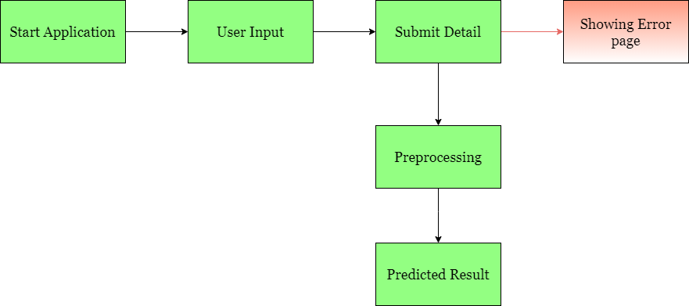

**3.3 Error Handling**

If any error occurred in the processing way then the error message should be shown to the user in a completely non-technical way that can be understandable by any person. And Meaningful error message should be shown, so the user can spot his mistake and rerun the process with improvement. All the errors that are will occur should be handled properly. And we have to log every error for our application and have to manage the same.

**4. Performance**

The Salse Price Prediction is dependent on machine-learning algorithms. We will train various ml algorithms and will find the best fitting algorithm for predicting the target. Our system performance will be based on the data we are going to feed to the algorithms. And the performance will depend on the finalized model. and the web application and the deployment server. With all of these components, our program should run properly.

**4.1 Reusability**

The code and the module are created during the time of building the project should maintain all coding guidelines and full project code is written in a Modular fashion. Our system should have the flexibility to work properly from any location. And it should handle any improper input value from the user and should give a meaningful error message so the user can correct his/her mistake and enter valid input to get the result. And the system should be reusable in every manner with different types of inputs values that are all are it has been trained.

**4.2 Application Compatibility**

The different libraries and python programming languages are used to build the system. Every library has its own functionality and it should work properly with our fluctuate system. Flask will be used for making the web APIs and HTML/CSS will be used to make the web application. All the components of the application should work properly and it should produce a result without any interpretation.

**4.3 Resource Utilization**

Our application should utilize the given resource properly and it should use a minimal amount of internet to work and call the APIs on the Web page. Our system should not use much amount of computational resources hence it will make the application slow. Our application will be deployed cloud platform and it should utilize the resource given on the cloud and work properly.

**5. Deployment**

For the deployment process, we will using Heroku cloud platforms for hosting our application. The cloud platform will run the system and it will give the flexibility to use our application globally.



**6. Conclusion**

The Sales Store Prediction is about to help business owners and manufacturing companies can predict of there product demand in the future. It can help them to grow the business also it will help the supply chain for products. We have a past record about products, product sales records along with store information. We will analyze the past data and will build an ml model that can identify the internal pattern and be able to predict the target value or the sales demand of the product in the future.

**7. Reference**

Google image for collection the logos and images.

Sketch diagram for drawing the diagrams.