Create Azure Database for PostgresSQL for storing details of the job run

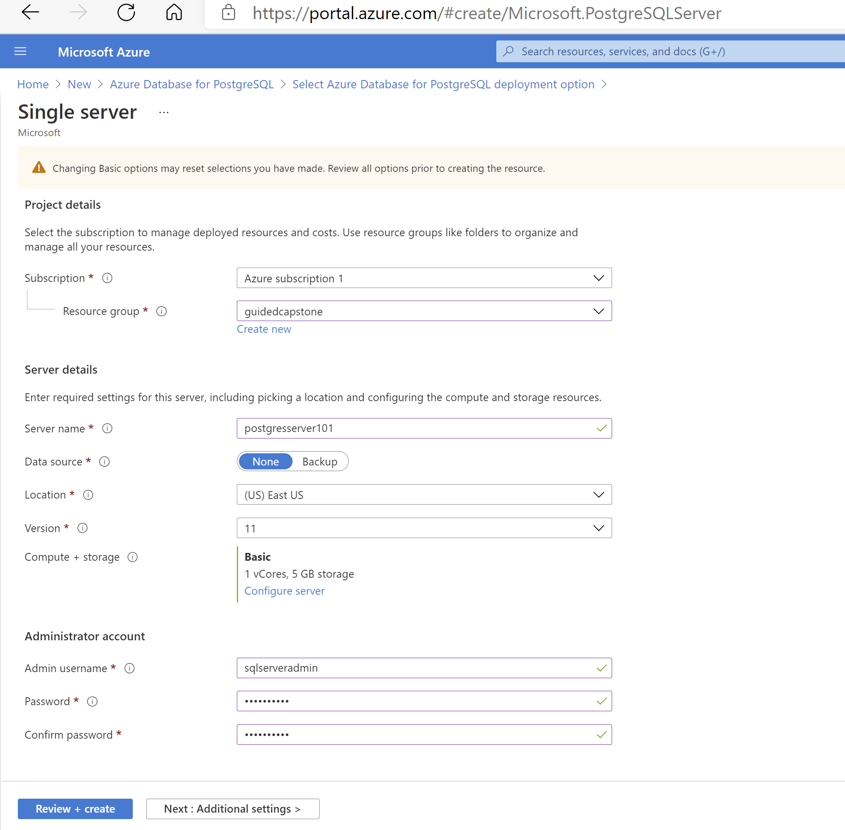

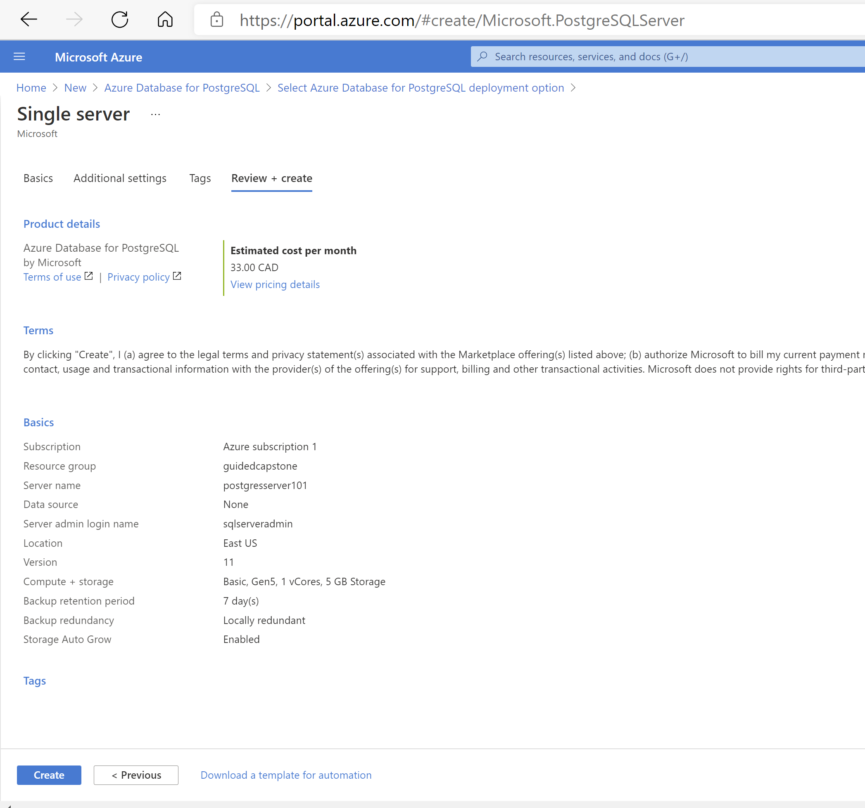

Local execution log. Job execution status is inserted into a job tracking postgres table

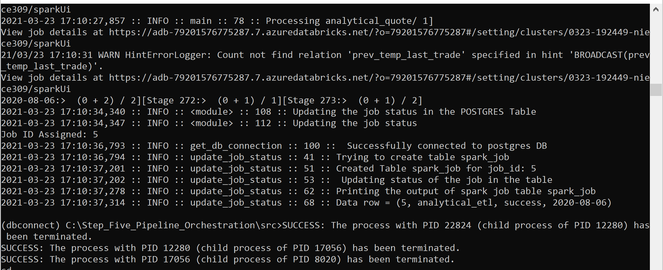

Execute the below commands to create a .whl package file using setup.py

(base) C:\Pipelineorchestration>python setup.py sdist bdist_wheel

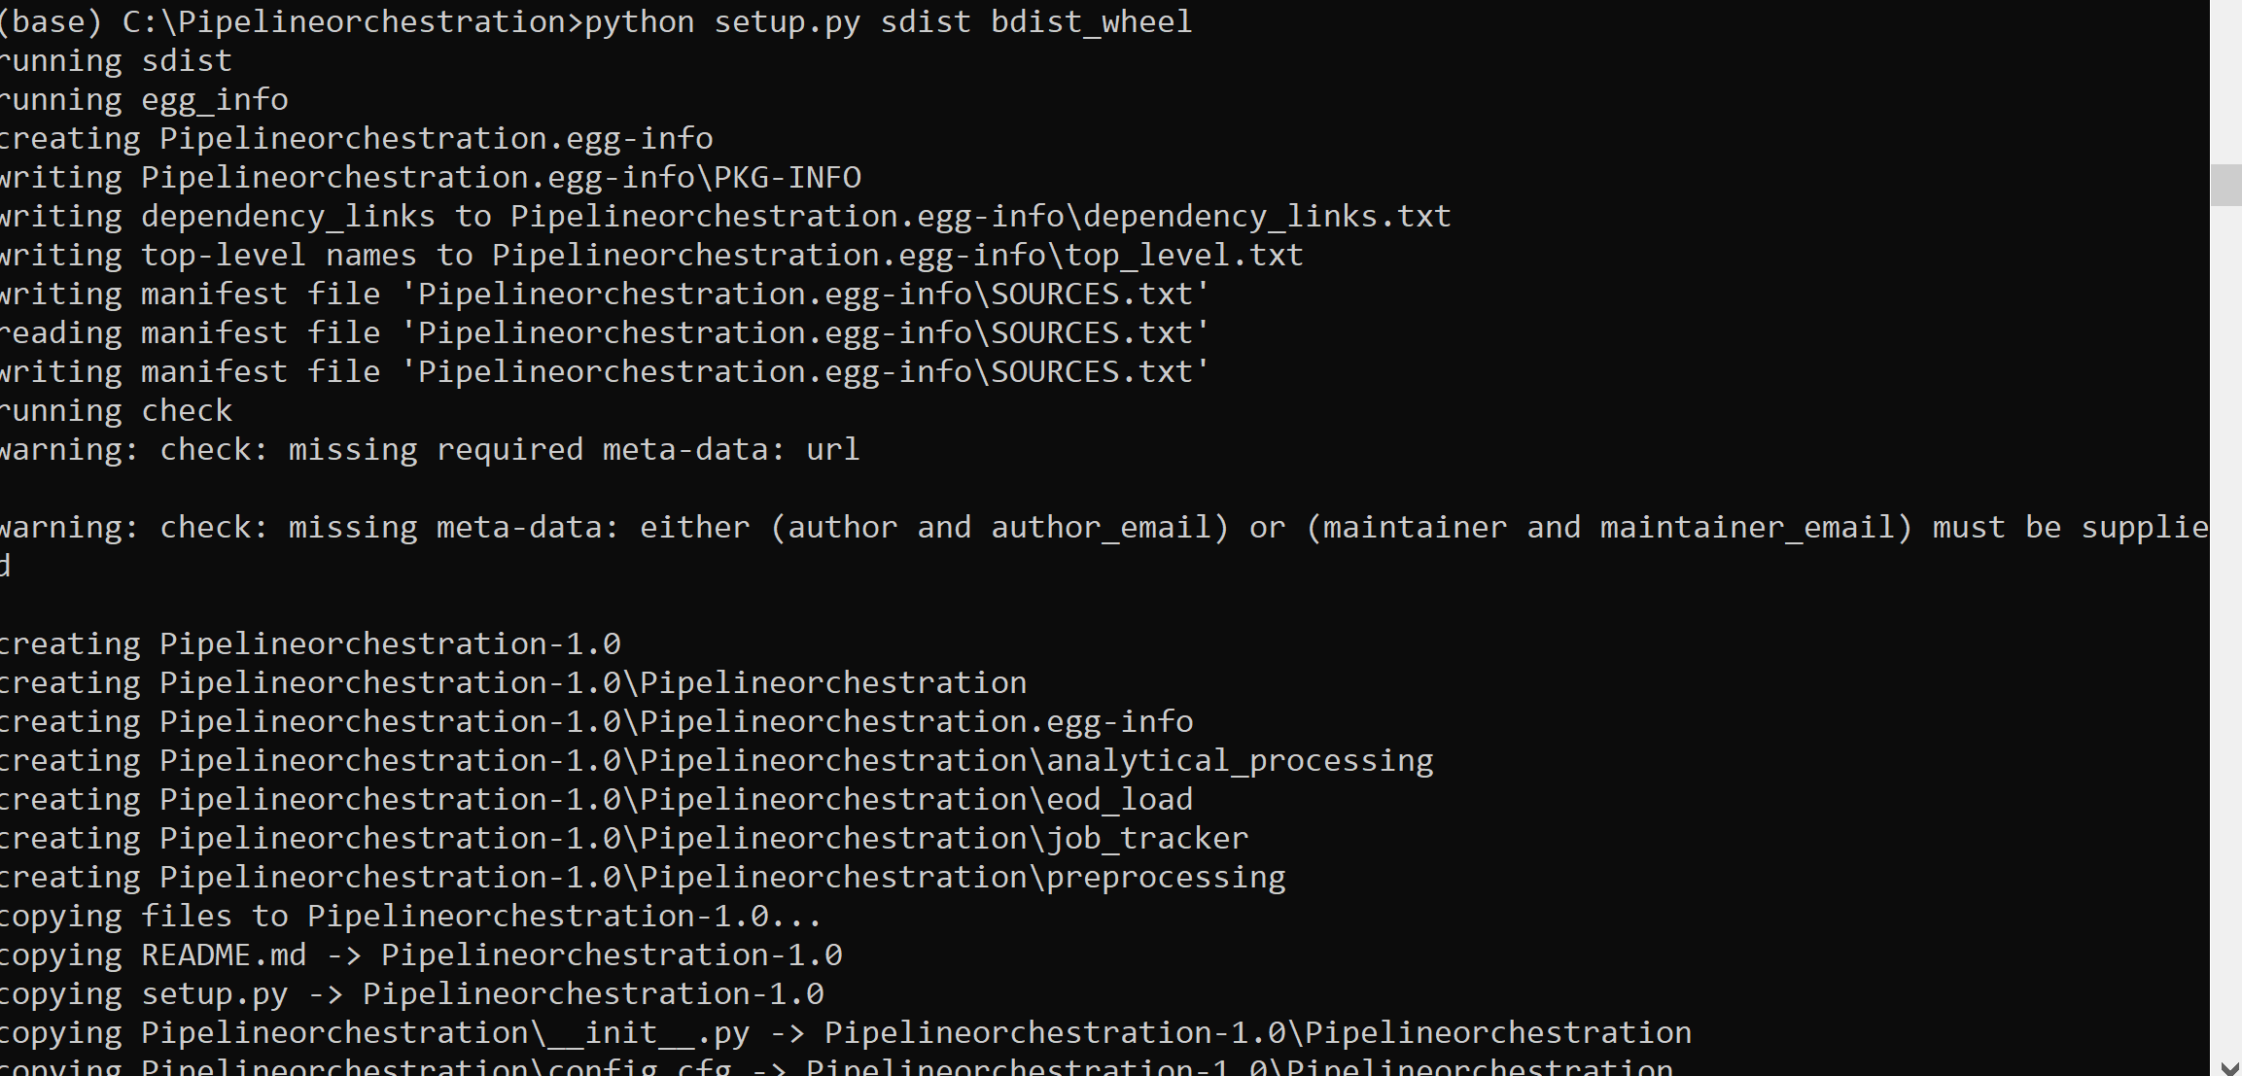

Install the .whl file to the cluster

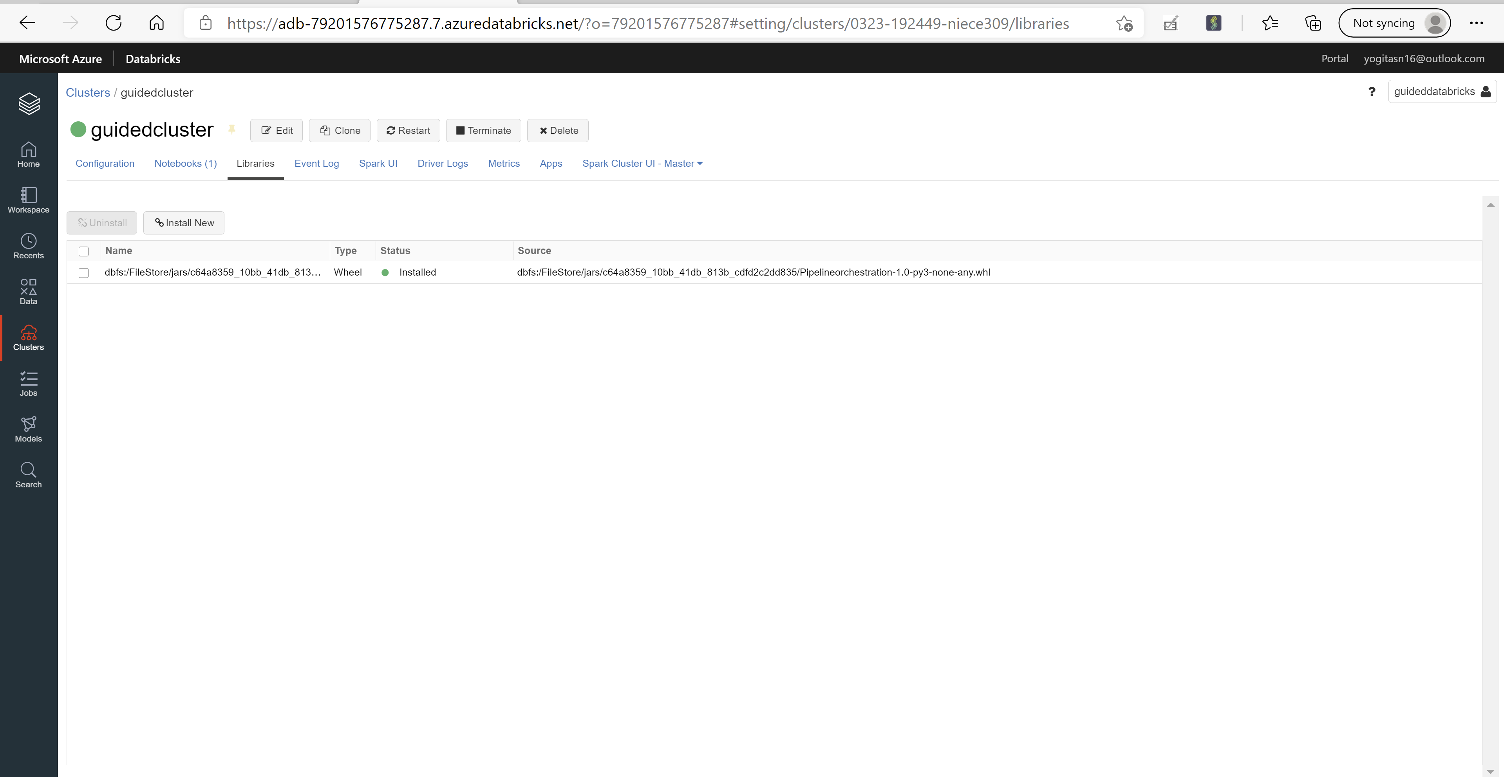

Import the driver file from the installed library, pass parameters and execute the command

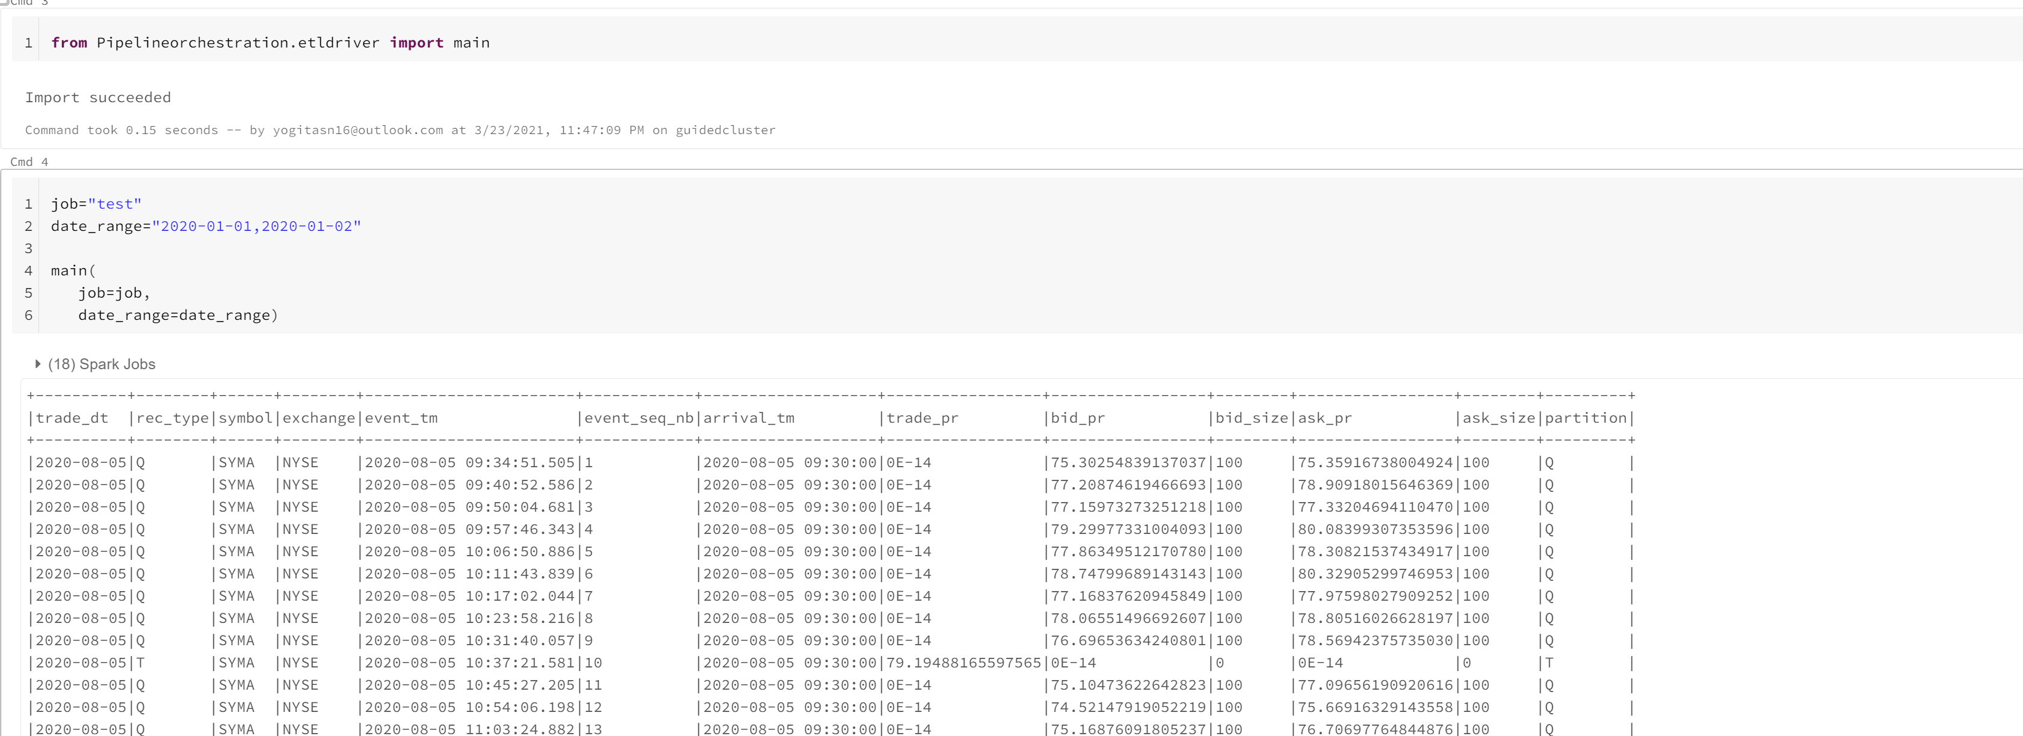

Spark jobs are executed successfully

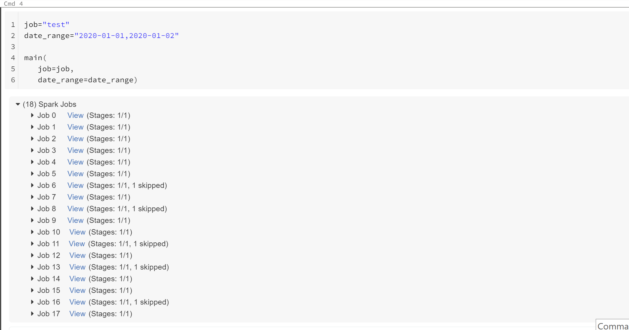

Create a spark job and select the Notebook containing the script

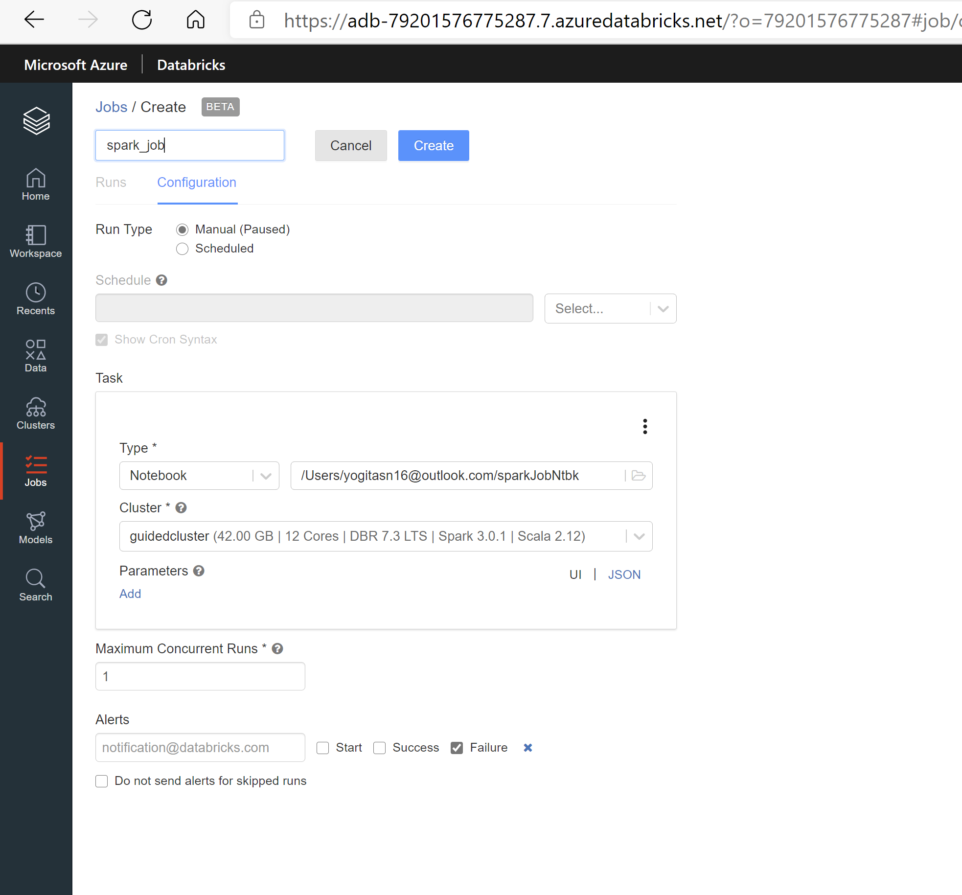

Run the job

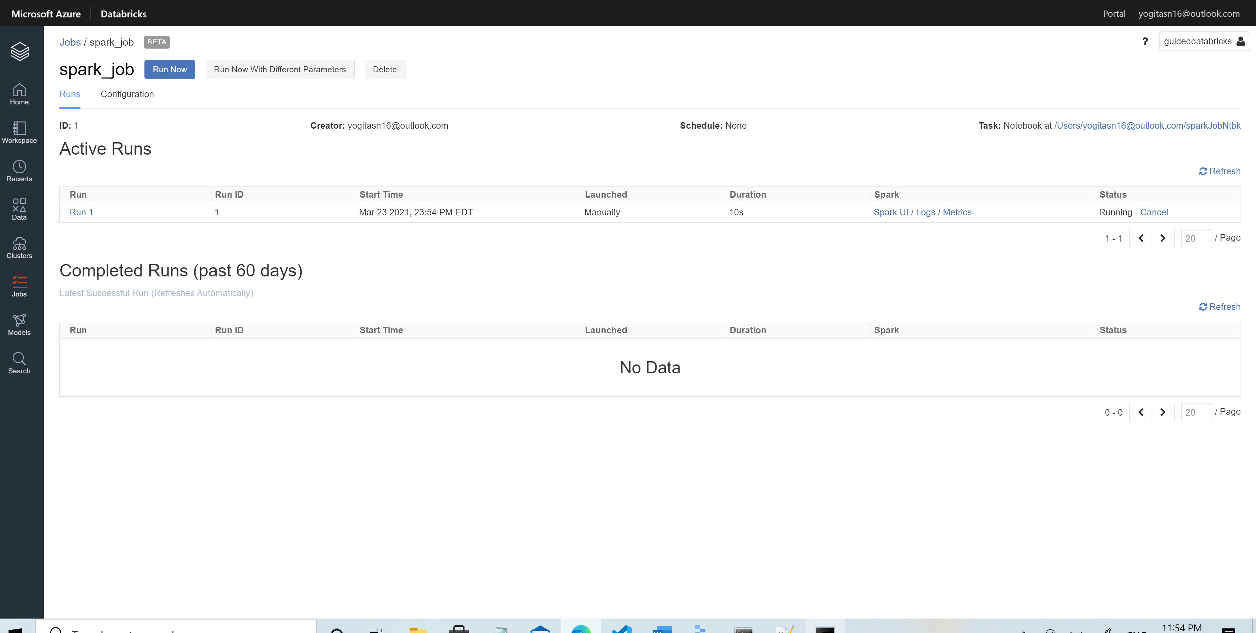

Job is successfully executed

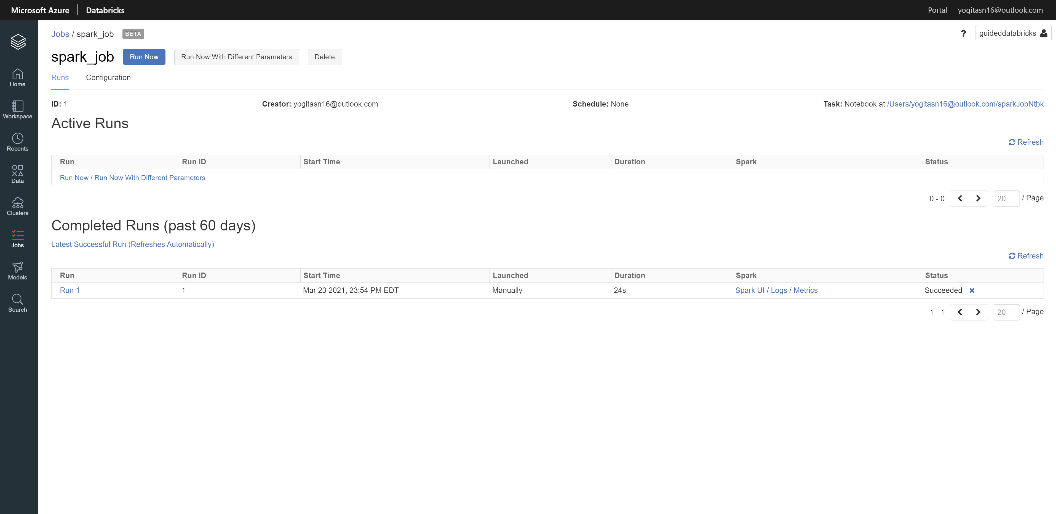

Below is output of the job execution run

