Register an application

Add Redirect URL to be used later to retrieve access code

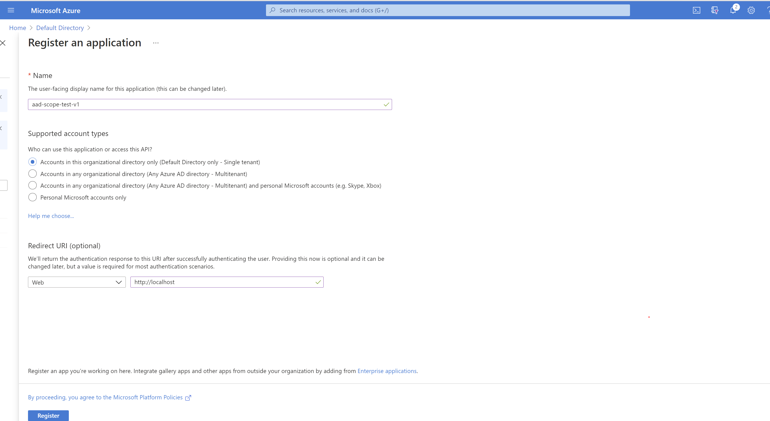

Add Azure Databricks permissions

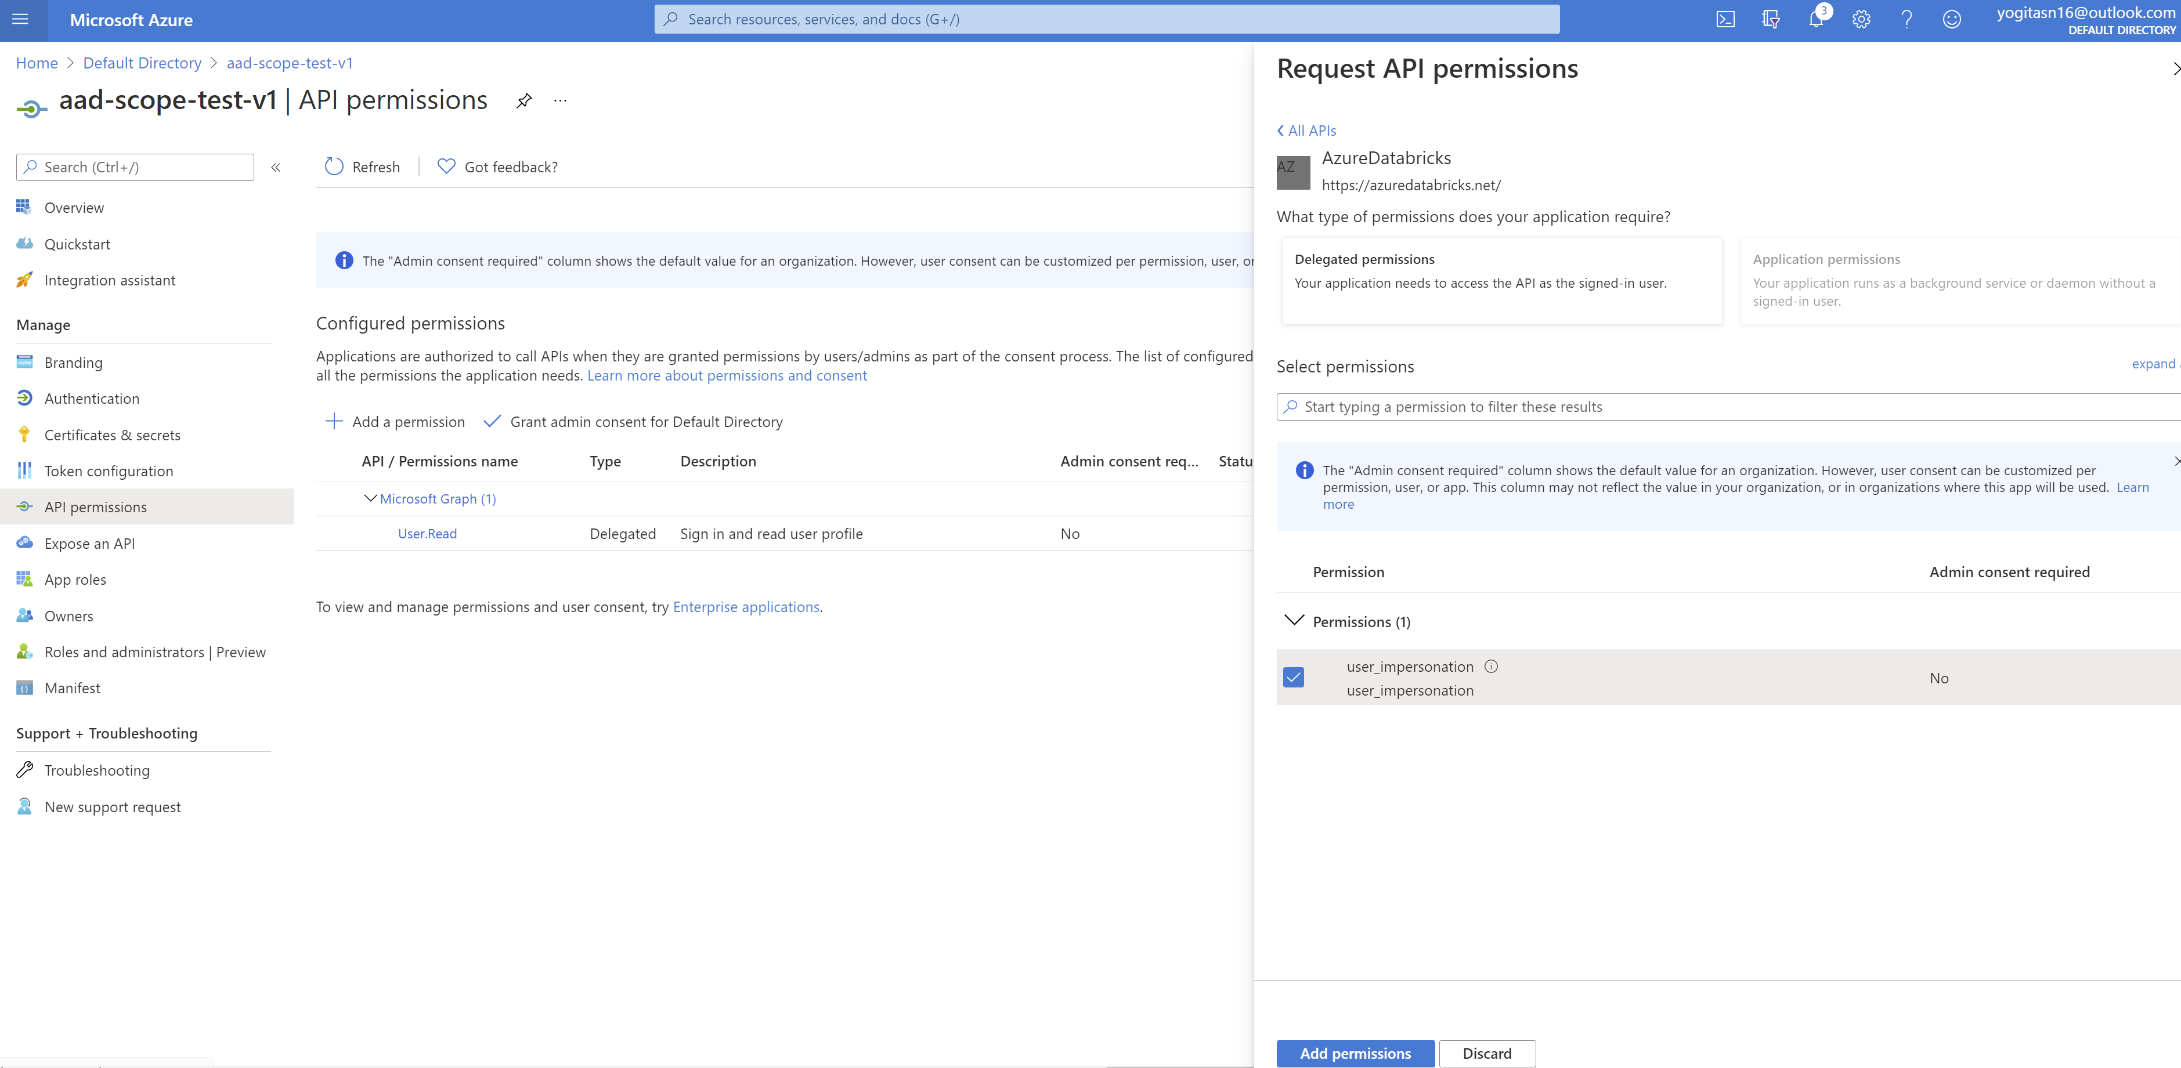

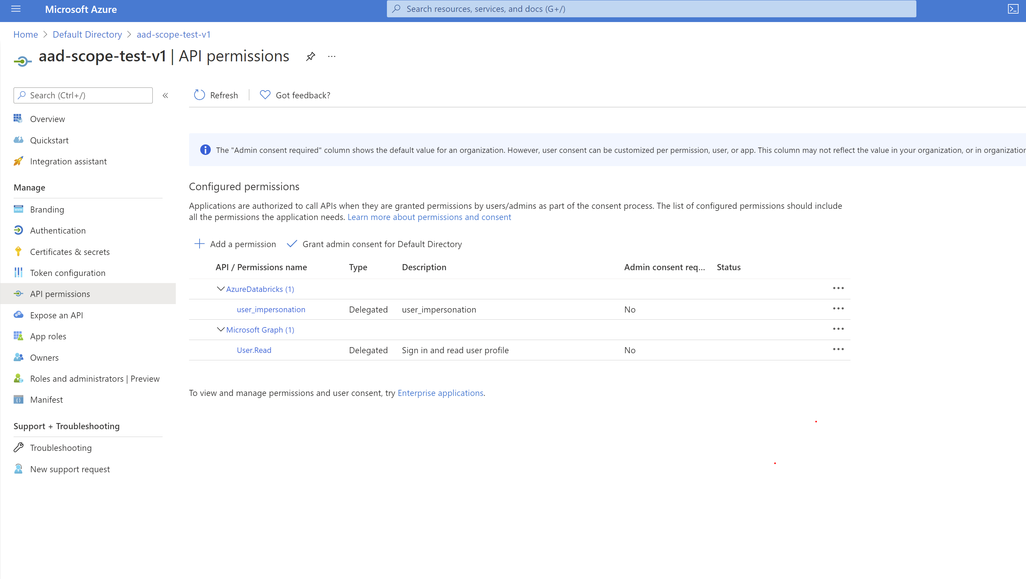

Create a client secret to be used for creating token

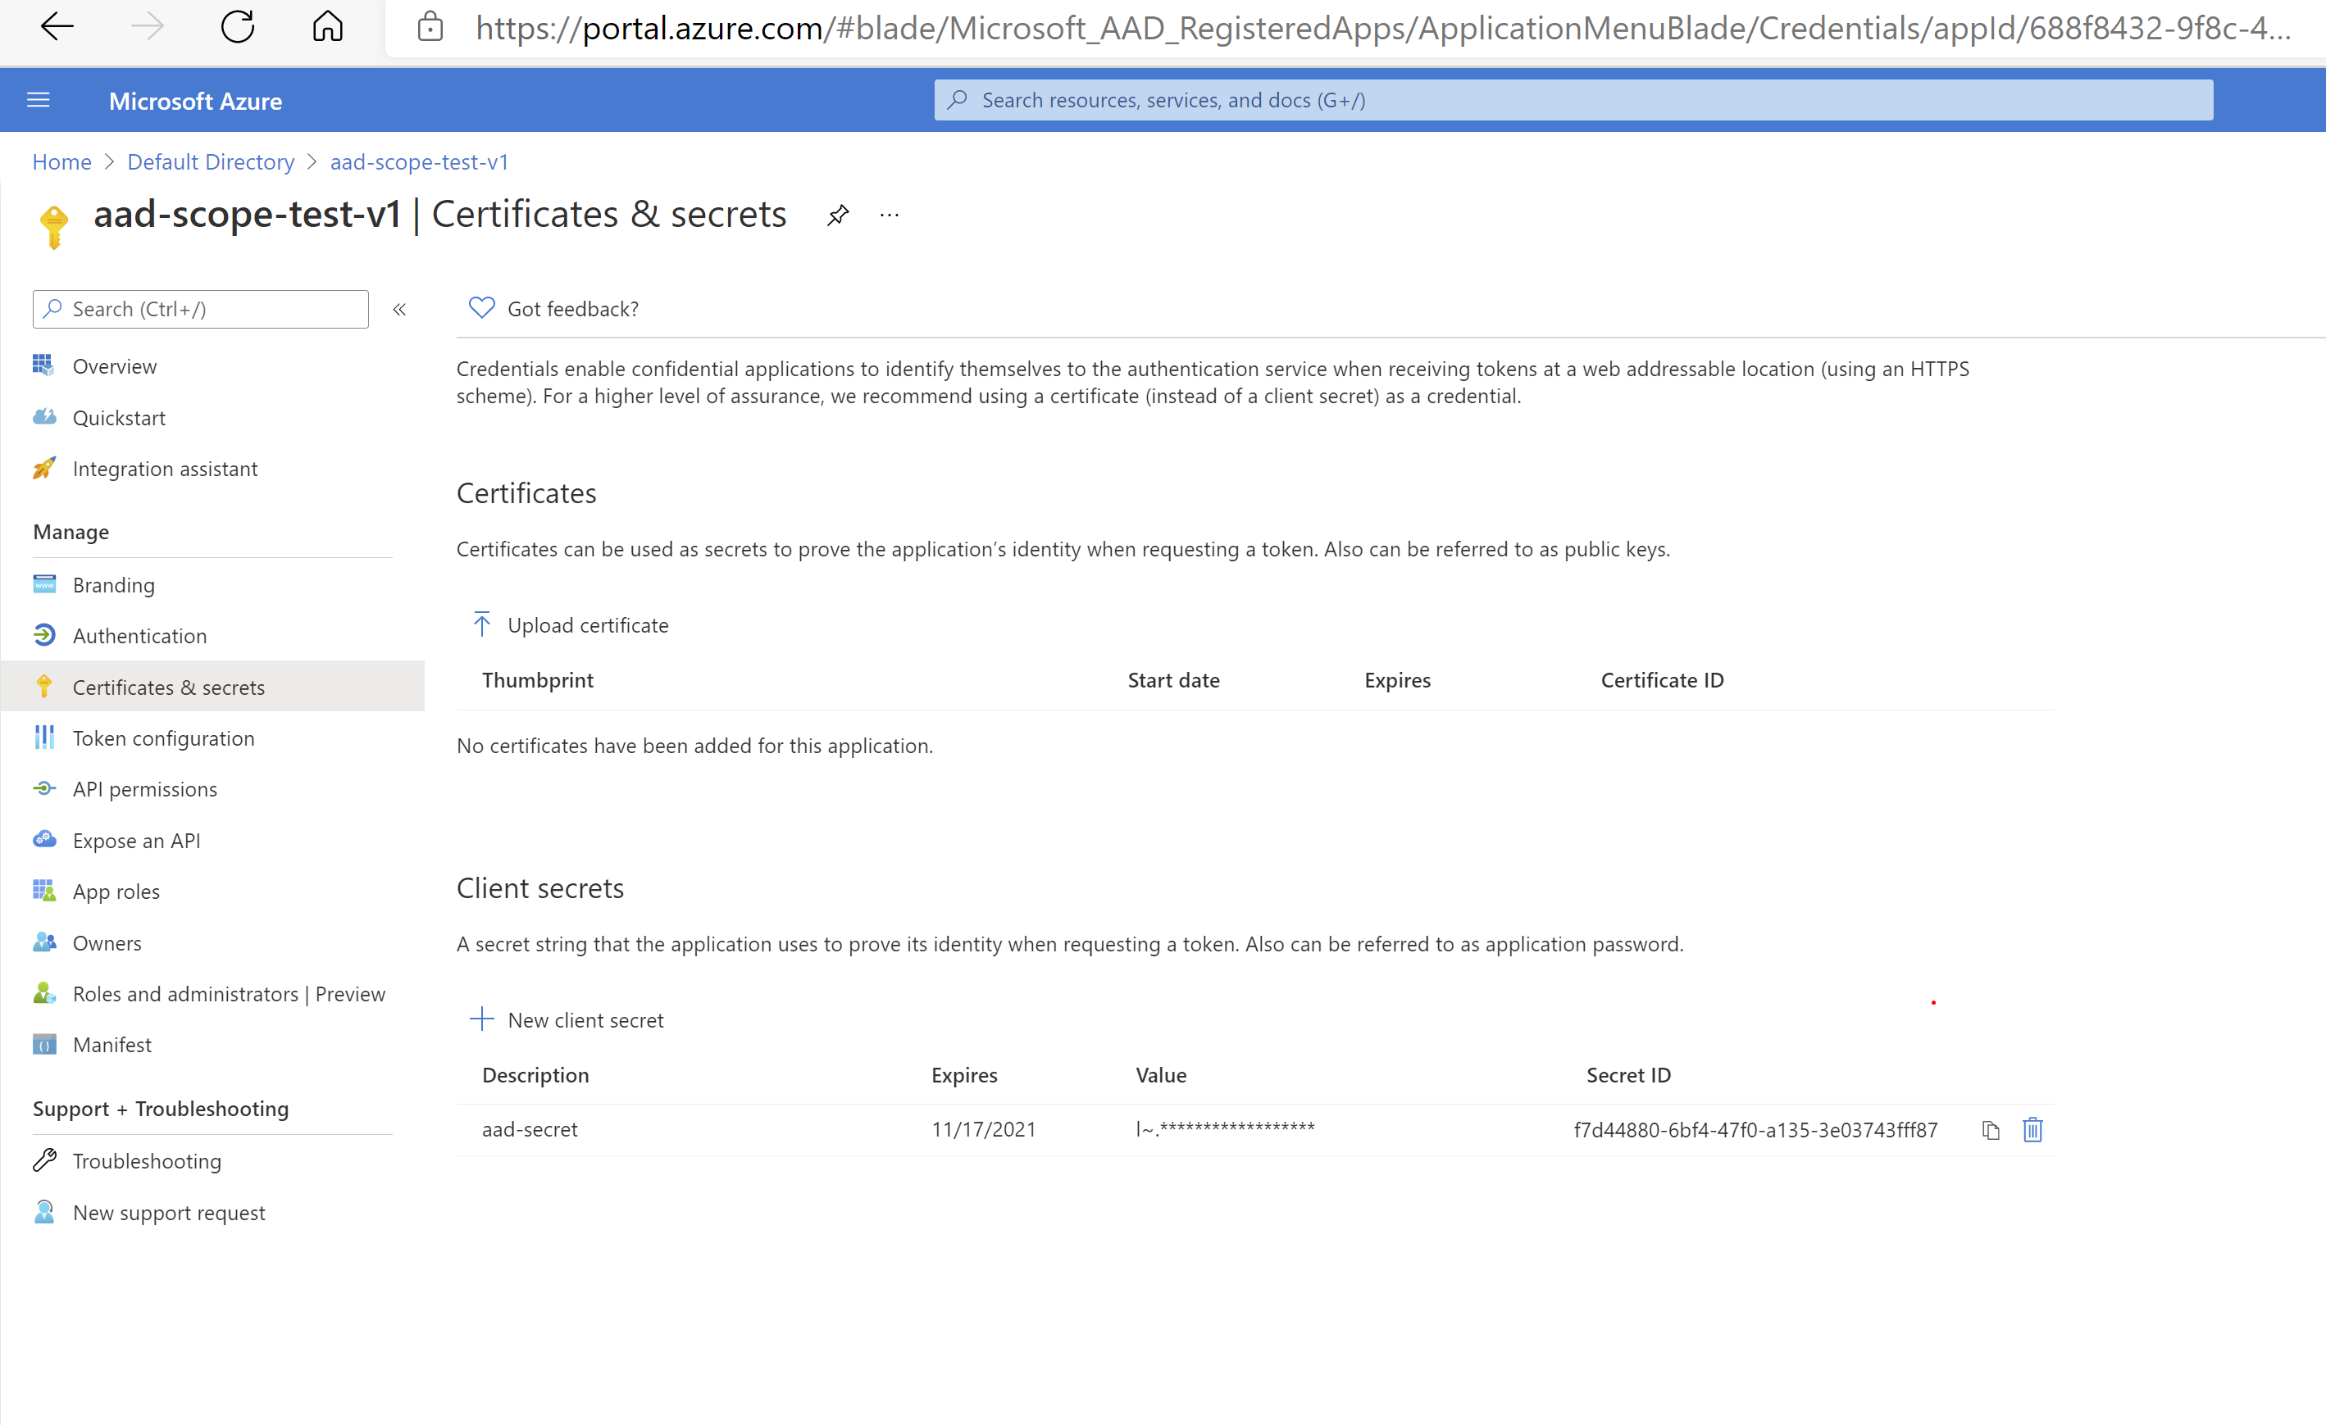

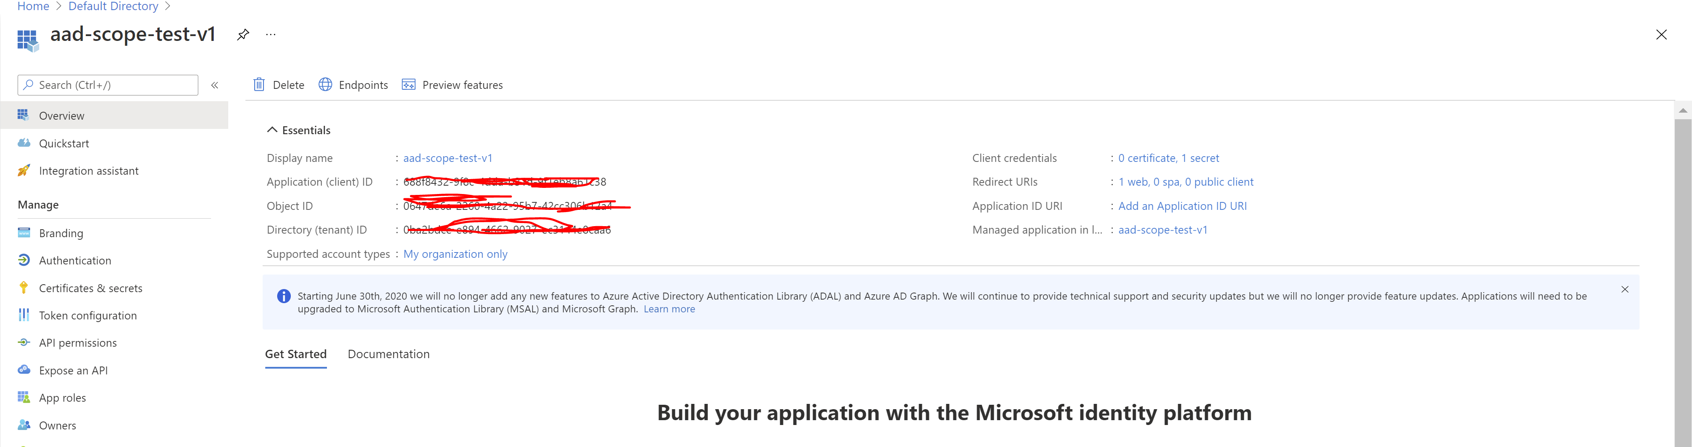

Get Tenant and client ID and retrieve Authorization code by pasting below URL in the browser

Note: redirect_uri: <http://localhost>

State=12345( any random number)

// Line breaks for legibility

https://login.microsoftonline.com/<tenant>/oauth2/authorize?client_id=<client-id>

&response_type=code

&redirect_uri=<redirect URI in encoded format: e.g., http%3A%2F%2Flocalhost>

&response_mode=query

&resource=2ff814a6-3304-4ab8-85cb-cd0e6f879c1d

&state=<a random number or some encoded info>

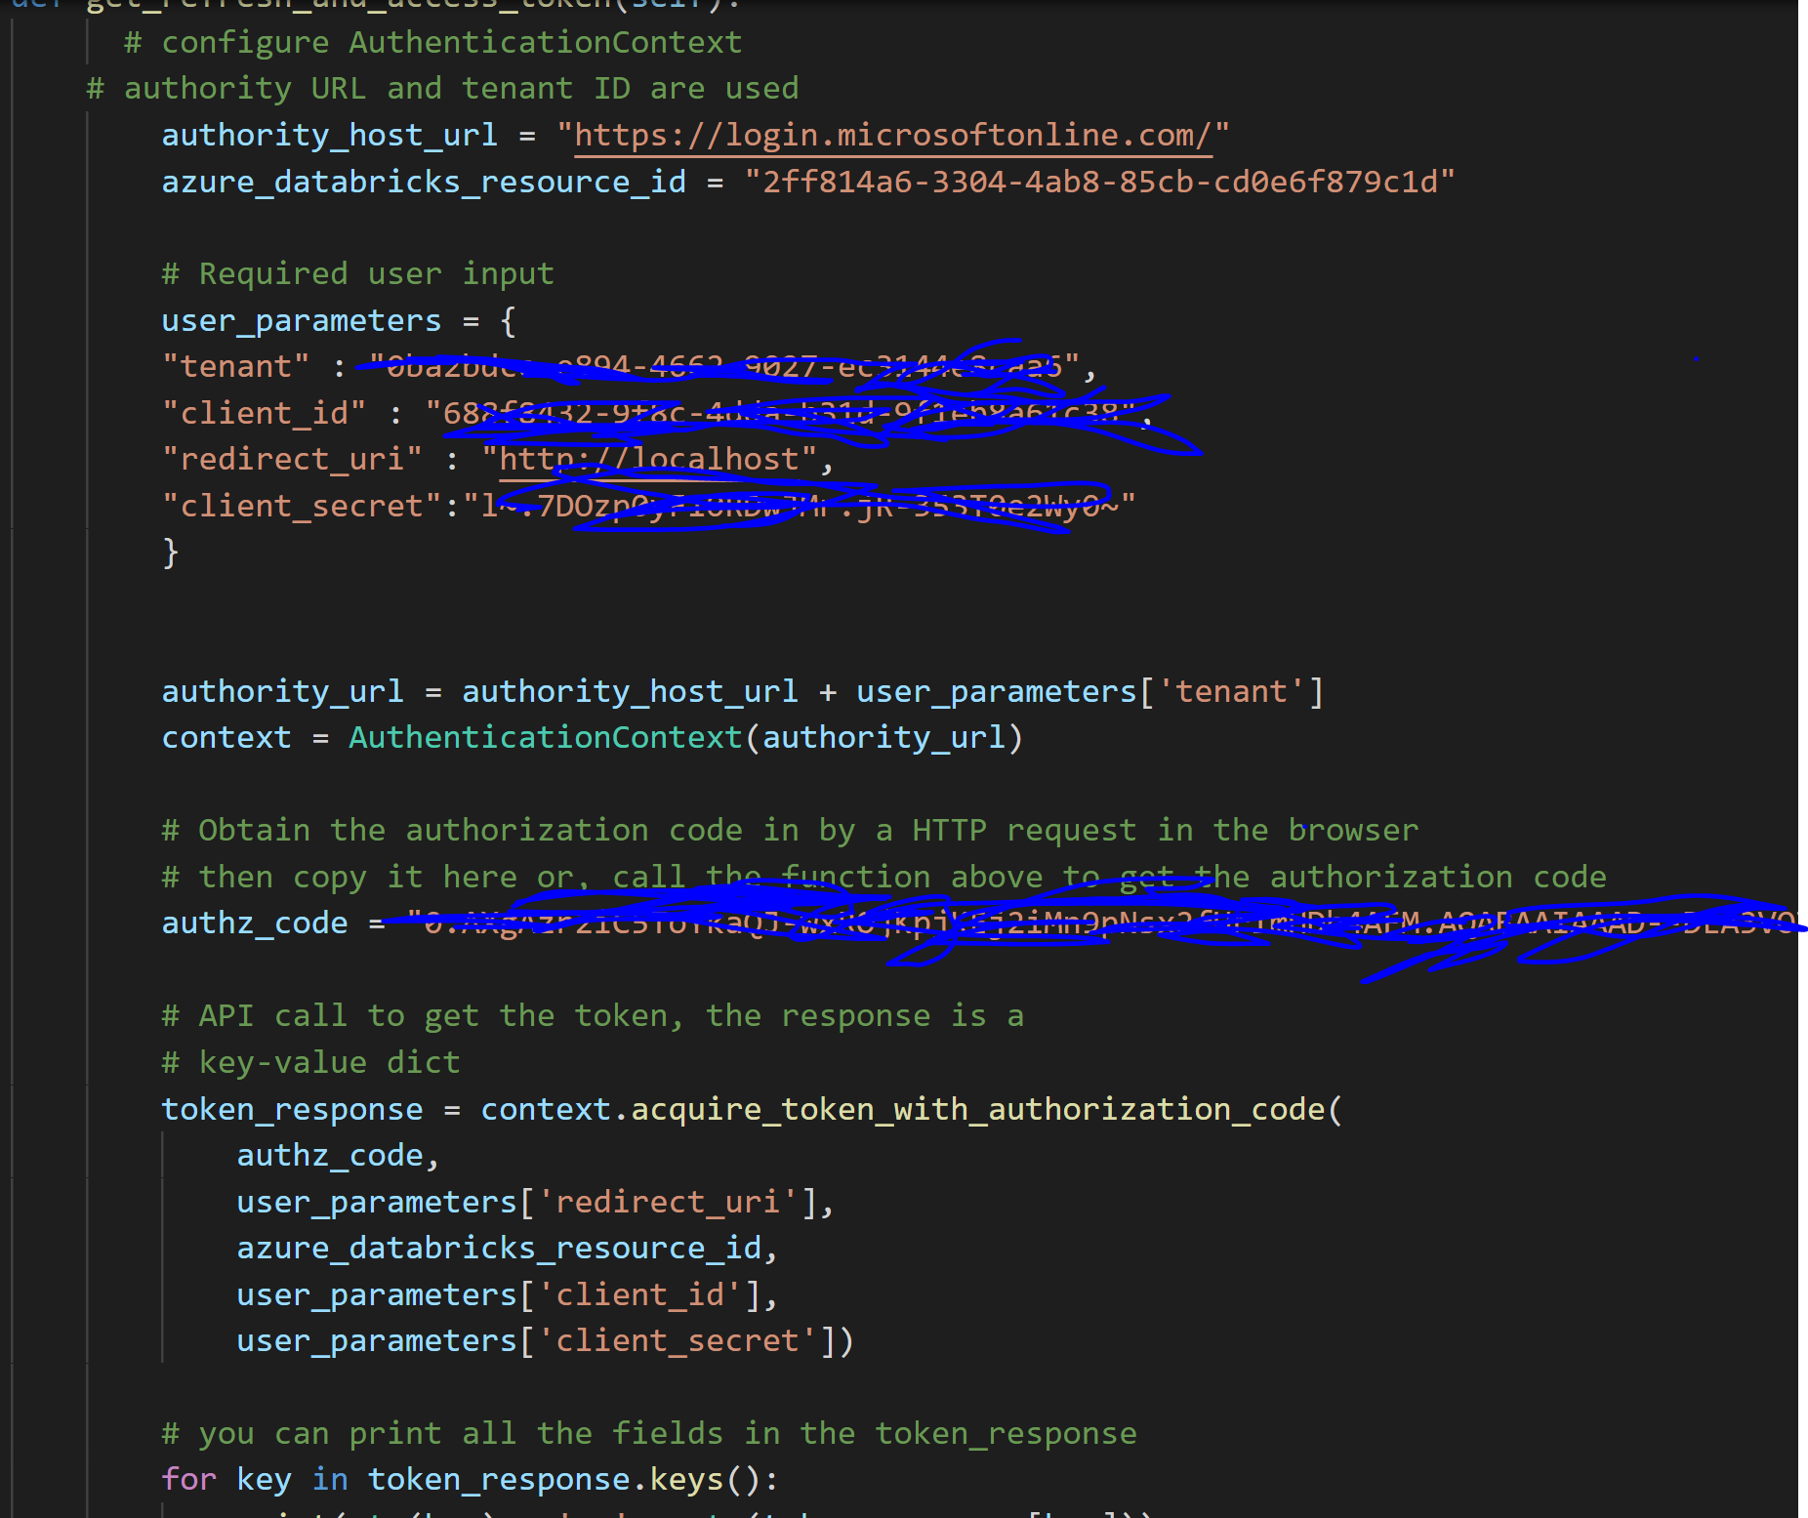

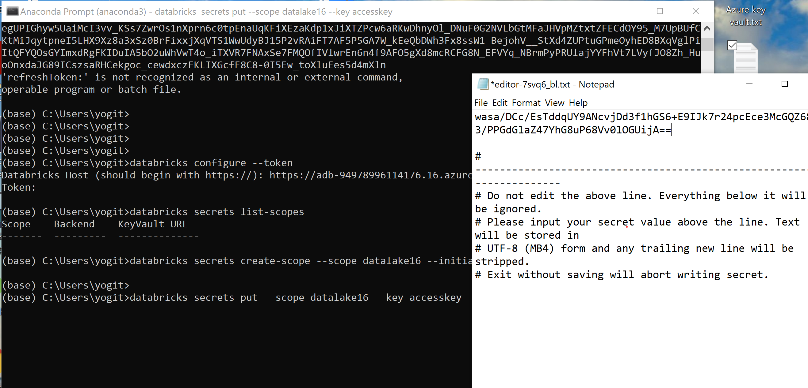

To access data lake

[Mounting & accessing ADLS Gen2 in Azure Databricks using Service Principal and Secret Scopes | by Dhyanendra Singh Rathore | Towards Data Science](https://towardsdatascience.com/mounting-accessing-adls-gen2-in-azure-databricks-using-service-principal-and-secret-scopes-96e5c3d6008b)

Create an application for Data Lake

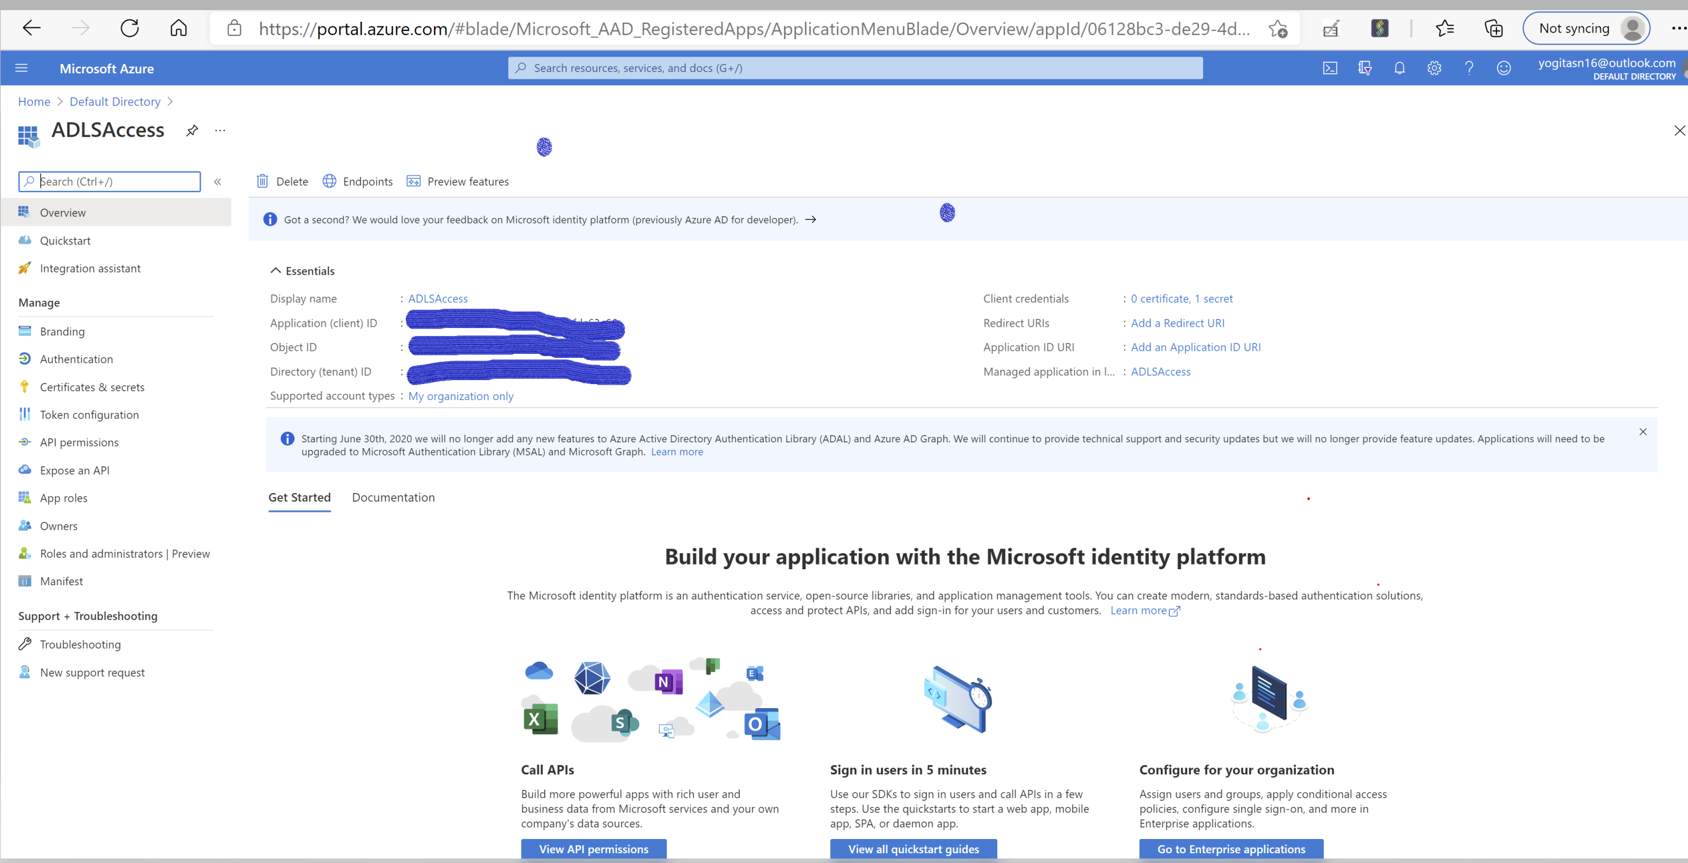

Create application secret

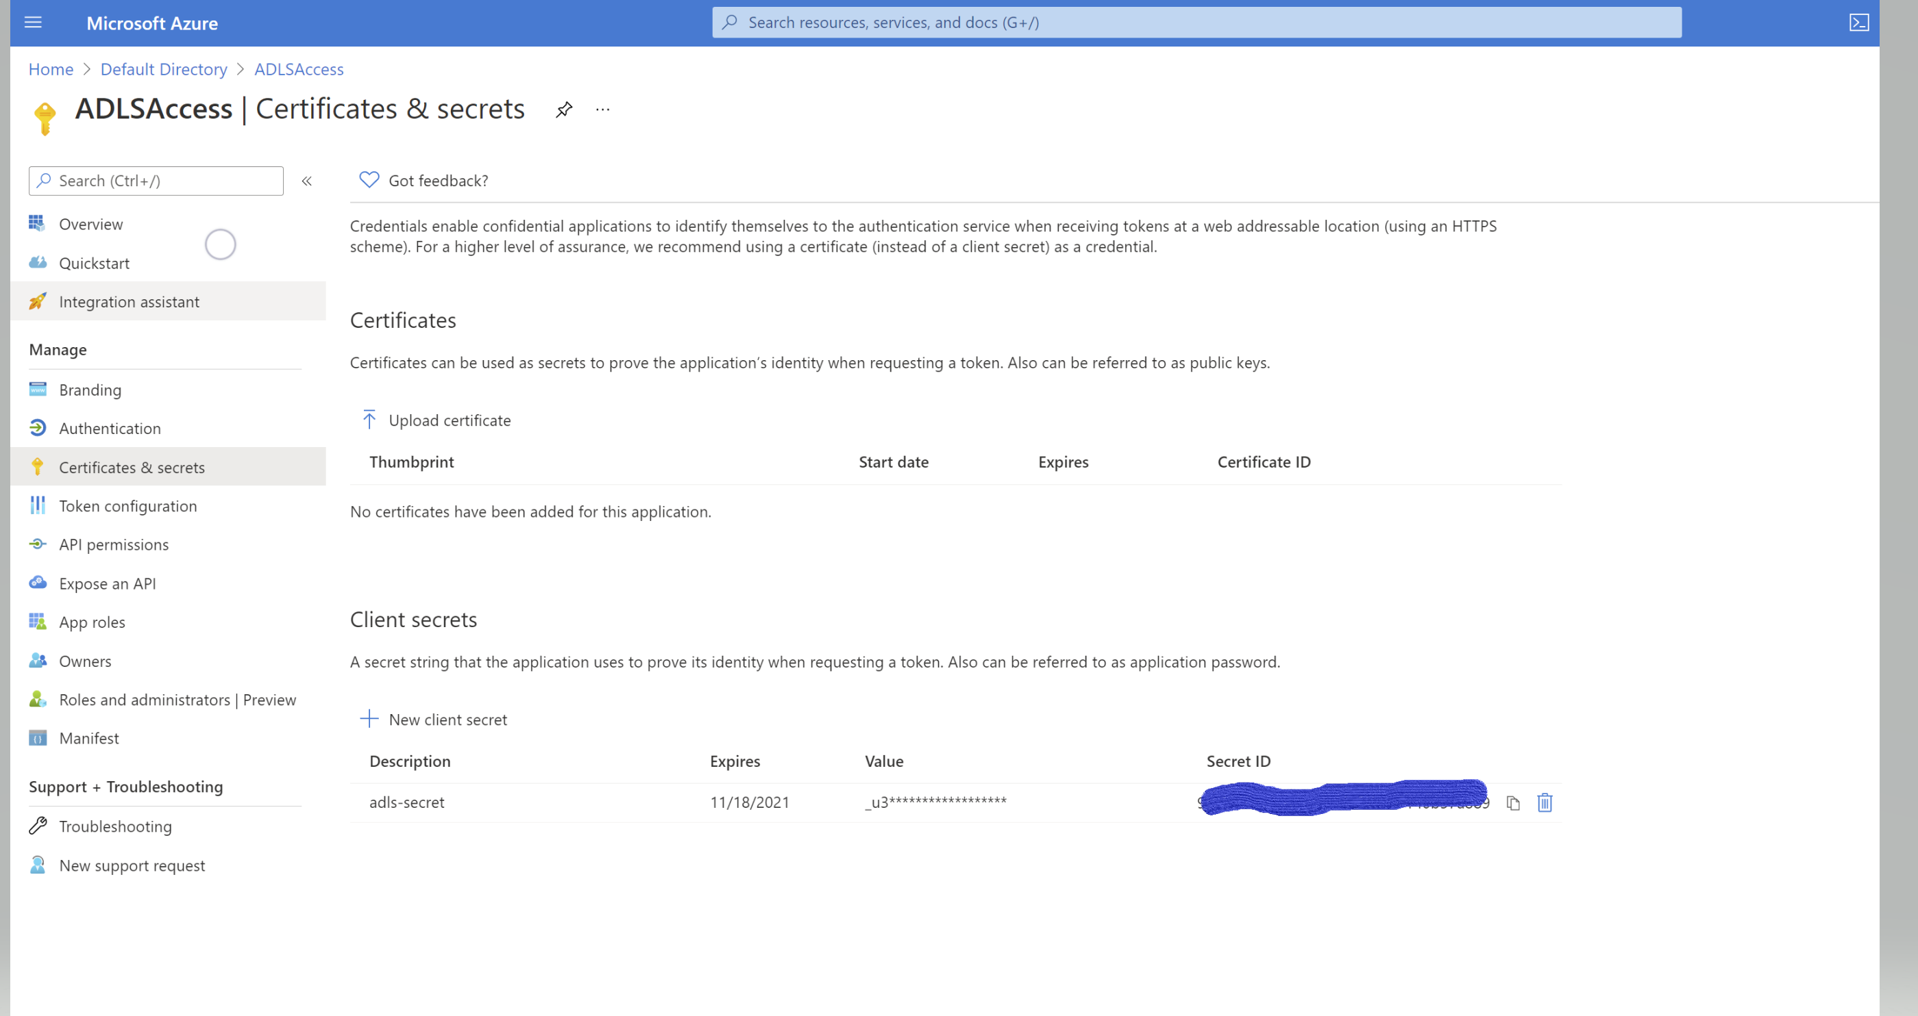

Grant service principal access to ADLS account

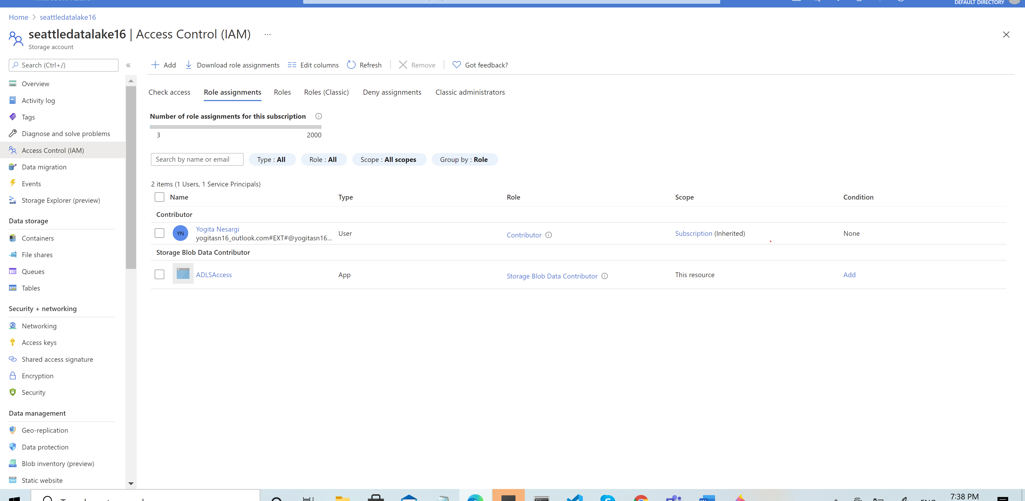

Create Azure key vault backed secret scopes using databricks cli

1. Generate access code using below link

https://login.microsoftonline.com/<tenant>/oauth2/authorize?client_id=<client-id>

&response_type=code

&redirect_uri=<redirect URI in encoded format: e.g., http%3A%2F%2Flocalhost>

&response_mode=query

&resource=2ff814a6-3304-4ab8-85cb-cd0e6f879c1d

&state=<a random number or some encoded info>

1. Generate access code and use that to execute the code to generate the token

