Update Kafka folder path in server.properties

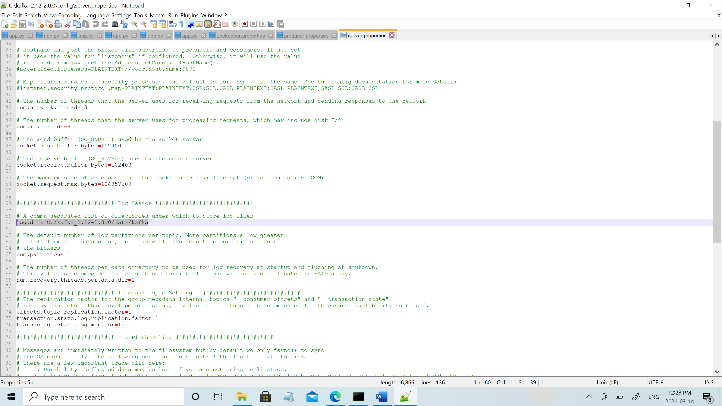

Update zookeeper properties in server.properties

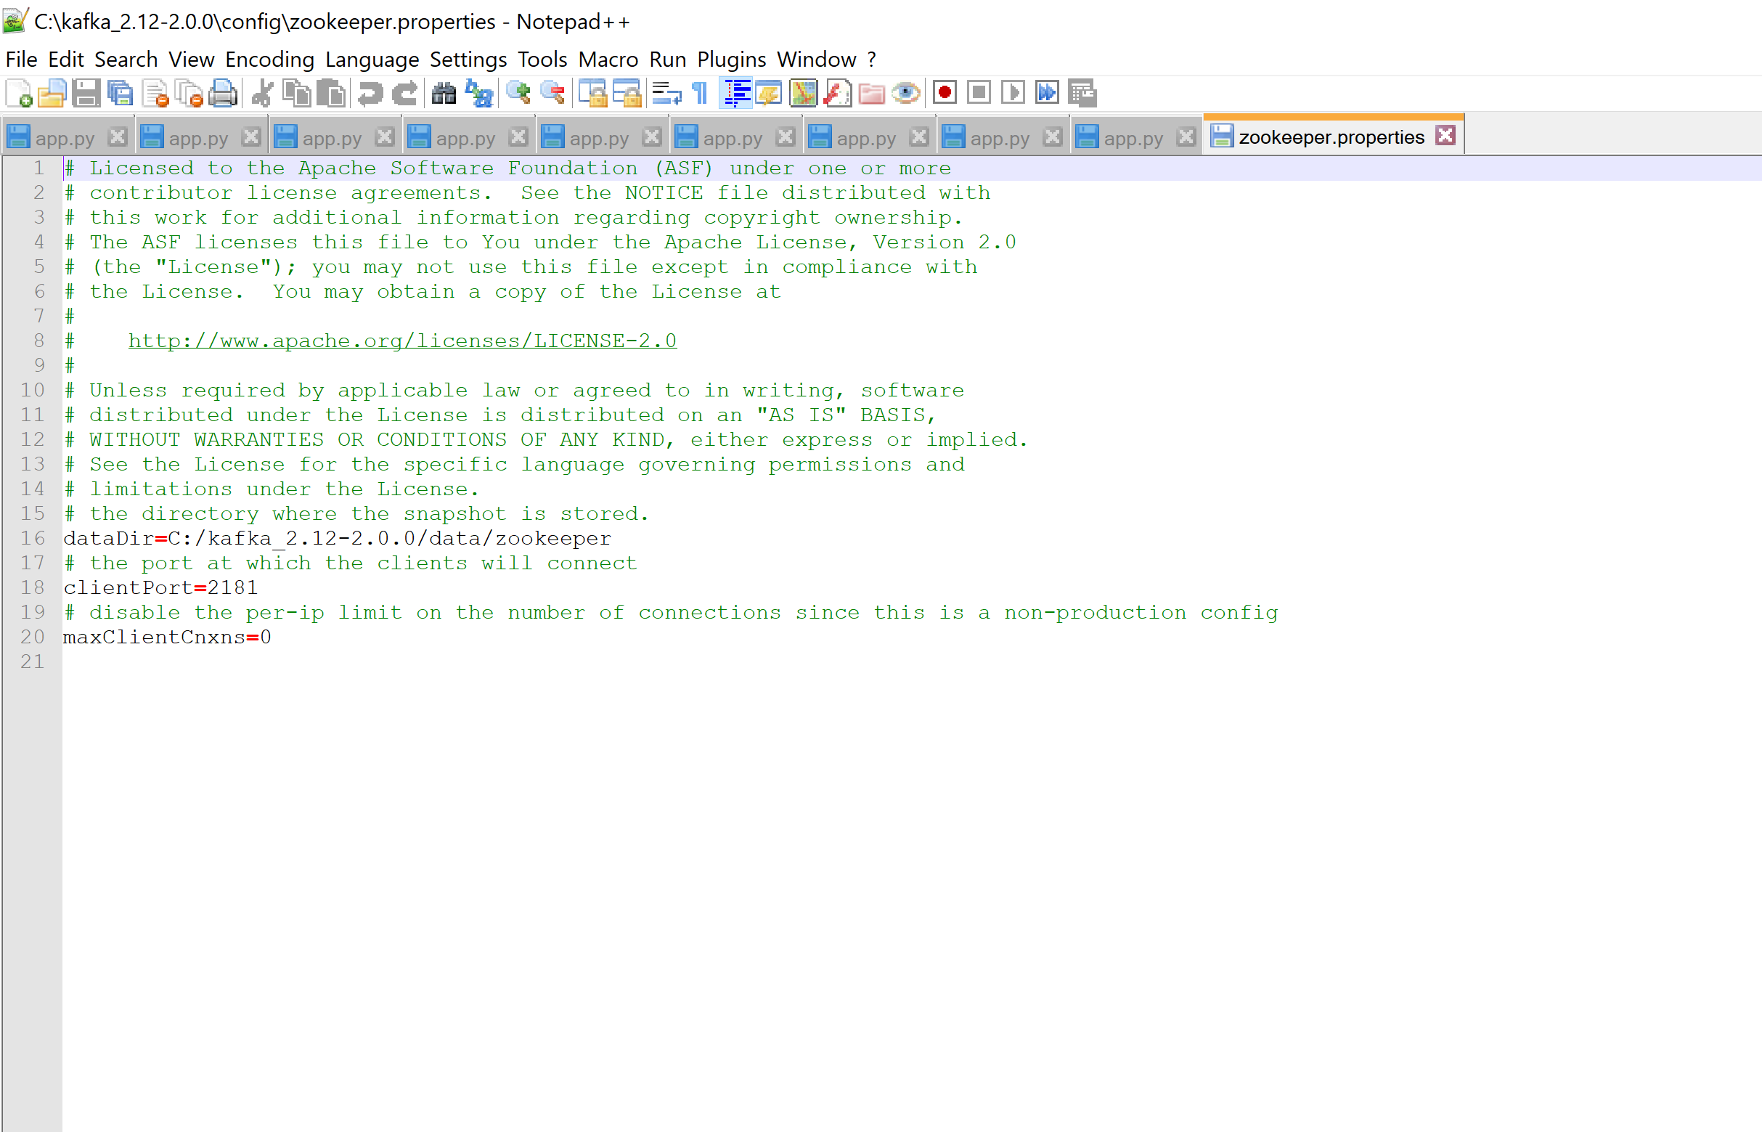

Start Zookeeper: zookeeper-server-start.bat config\zookeeper.properties

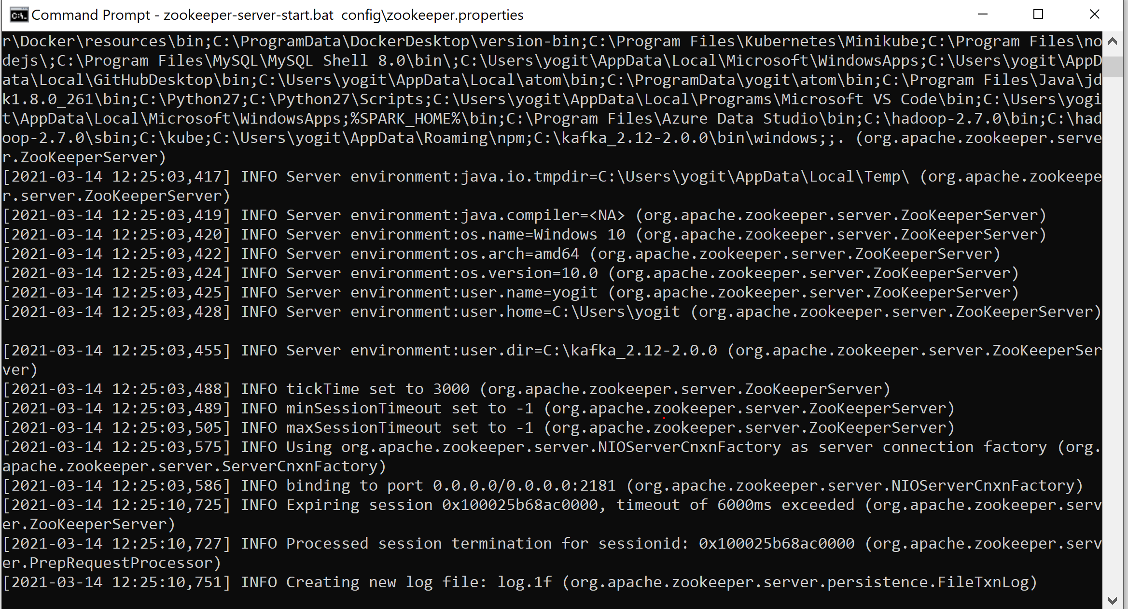

Start Kafka:

kafka-server-start.bat config\server.properties

kafka-topics --zookeeper 127.0.0.1:2181 --topic first_topic --create --partitions 3 --replication-factor 1

kafka-topics --zookeeper 127.0.0.1:2181 –list

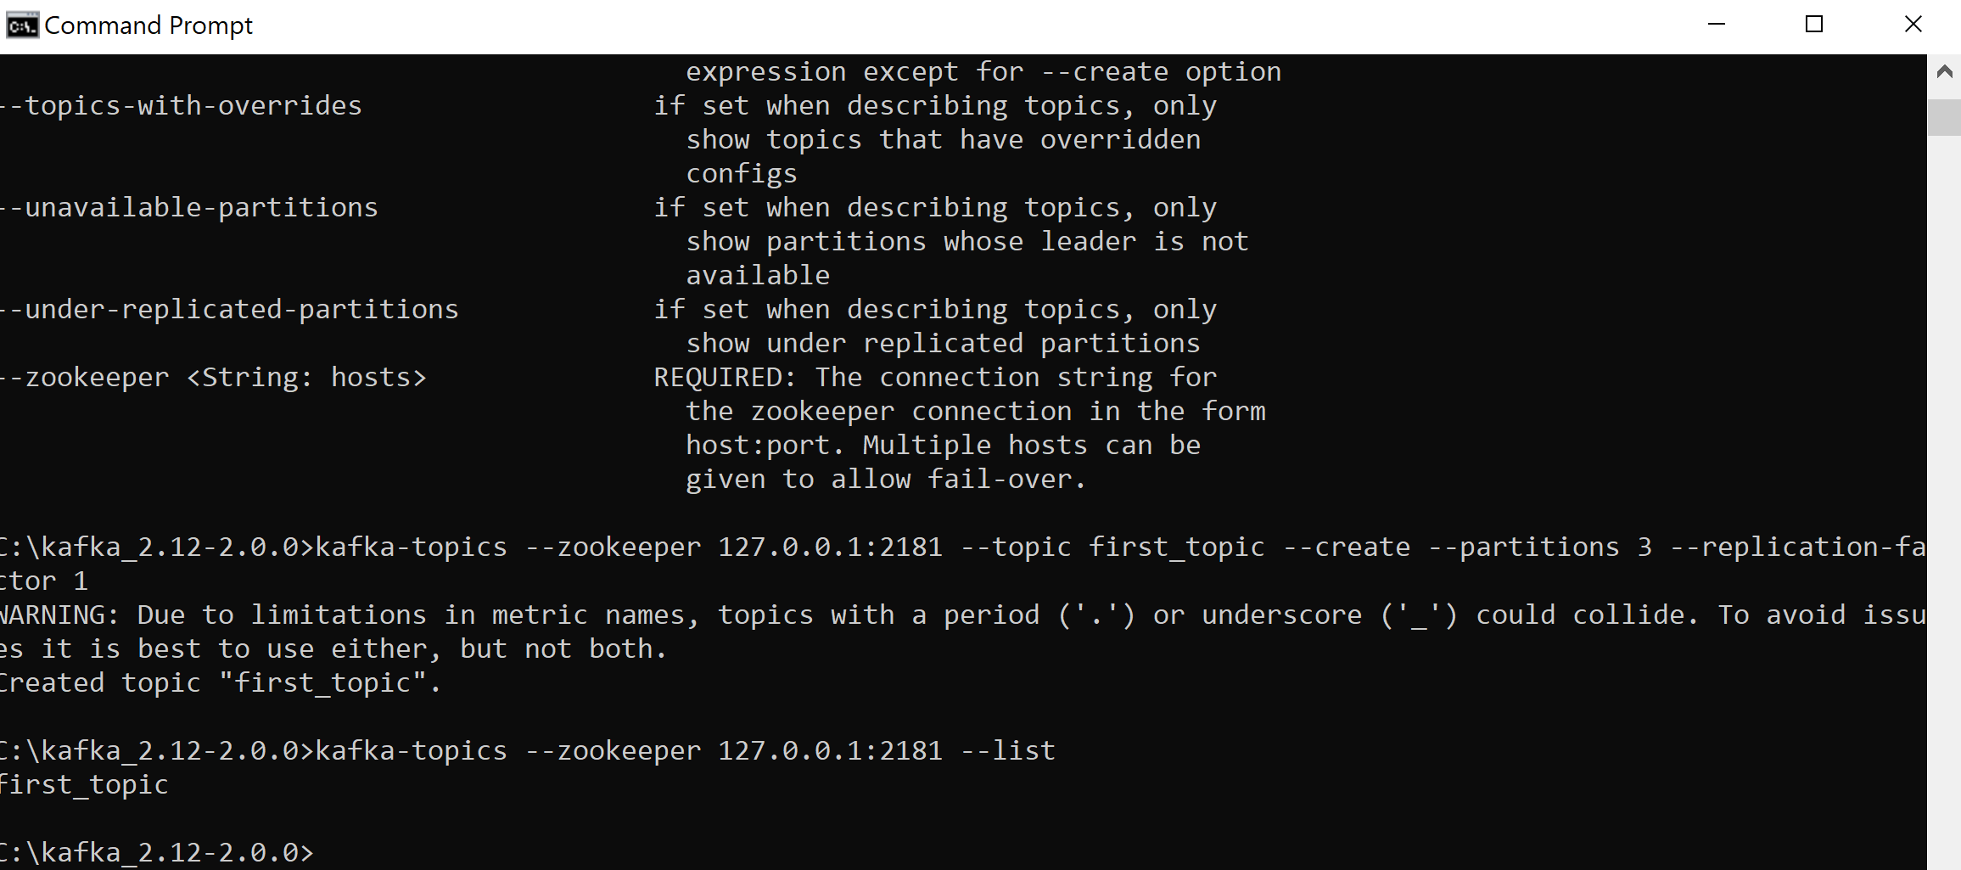

kafka-topics --zookeeper 127.0.0.1:2181 --topic first_topic –describe

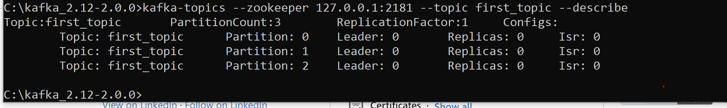

kafka-topics --zookeeper 127.0.0.1:2181 --topic second_topic --create --partitions 6 --replication-factor 1C:\kafka_2.12-2.0.0>kafka-topics --zookeeper 127.0.0.1:2181 --topic second_topic --delete

Topic second_topic is marked for deletion.

Note: This will have no impact if delete.topic.enable is not set to true.

kafka-console-producer --broker-list 127.0.0.1:9092 --topic first_topic

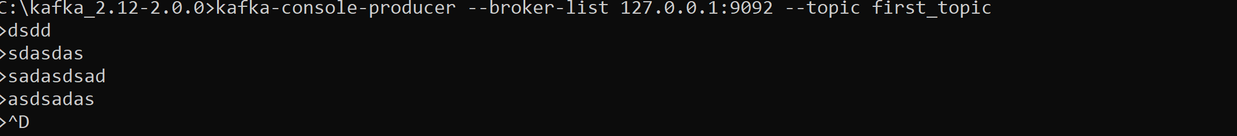

kafka-console-producer --broker-list 127.0.0.1:9092 --topic first_topic --producer-property acks=all

Starting producer for a topic that doesn’t exists

kafka-console-producer --broker-list 127.0.0.1:9092 --topic new_topic



Start consumer for a topic kafka-console-consumer --bootstrap-server 127.0.0.1:9092 --topic first_topic



Consumer group

>kafka-console-consumer --bootstrap-server localhost:9092 --topic first_topic --group my-first-application

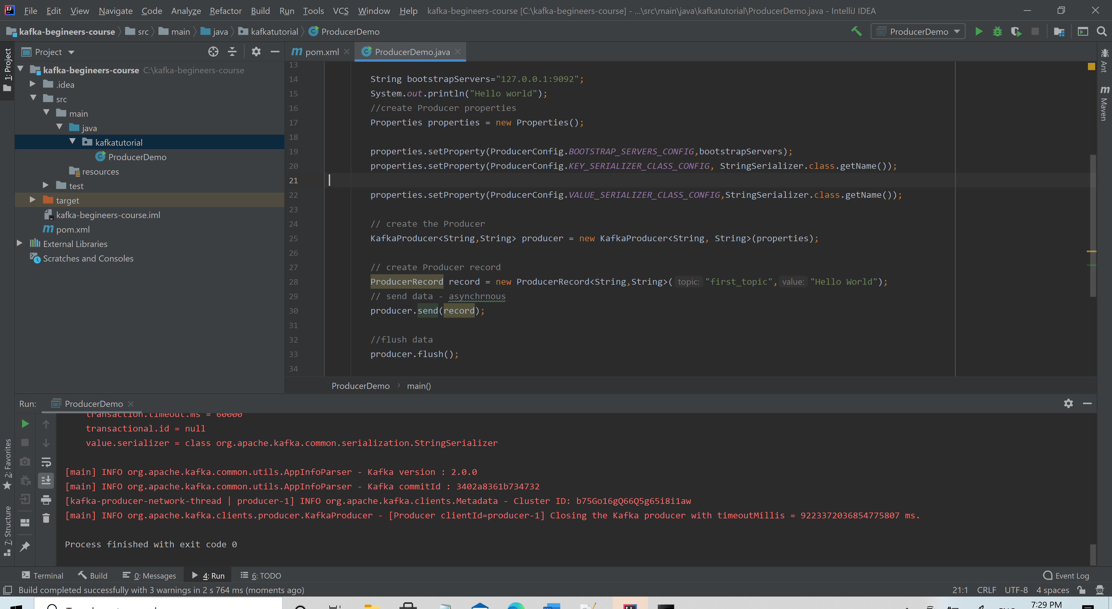

kafka-console-consumer --bootstrap-server localhost:9092 --topic first_topic --group my-third-application

