

Project Overview
Objective:
Design and implement a Data Engineering pipeline for an organization to generate actionable business insights from job application campaigns and associated event data.
Background:
The organization aims to analyze its job application campaign data alongside recipient interactions—including opens, sends, replies, clicks etc. Insights derived from this data will help optimize marketing spend, evaluate campaign conversion rates, and design more targeted campaigns to improve engagement and response rates.

Step-by-Step Plan
Step 1: Data Sourcing
Task:
- Access the Mailshake API documentation at https://api-docs.mailshake.com/.
- Review the Resources section to identify API calls related to:
  - Campaigns
  - Event activities (e.g., opens, sends, replies, clicks, created leads)
- Examine input parameters required for each API request and the corresponding JSON output format.
Step 2: Initial Data Analysis
Task:
- Manually analyze JSON datasets for campaigns and event activity to determine the relevant input fields.
- Identify key JSON elements that define the structure of the tables for each layer of the data pipeline:
  - Bronze Layer: Raw, unprocessed campaign and event activity data
  - Silver Layer: Cleaned and transformed data, ready for analysis
  - Gold Layer: Aggregated business insights and metrics for decision-making
Data Hierarchy & Identification
- Understand how data flows from the API (using POST method calls) through the layers of the pipeline.
- Determine relationships between campaigns and recipient activities to build a normalized, analytics-ready data model.
Campaign data: List all of a team’s campaigns.
https://api.mailshake.com/2017-04-01/campaigns/list

Activity data:
Open: Obtains the most recent emails opened.
https://api.mailshake.com/2017-04-01/activity/opens

Sent: Obtains the most recent emails you have sent
https://api.mailshake.com/2017-04-01/activity/sent

Reply: Obtains the most recent replies to your sent emails. Pay special attention to replyType because you can use this endpoint to look at bounces, out-of-office replies, etc.
https://api.mailshake.com/2017-04-01/activity/replies

Clicks: Obtains the most recent links clicked.
https://api.mailshake.com/2017-04-01/activity/clicks

Created-leads: Obtains the most recently created leads. Usually leads are automatically created from the rules you’ve set up in Lead Catcher, but Mailshake users can also manually turn recipients into leads.
https://api.mailshake.com/2017-04-01/activity/created-leads

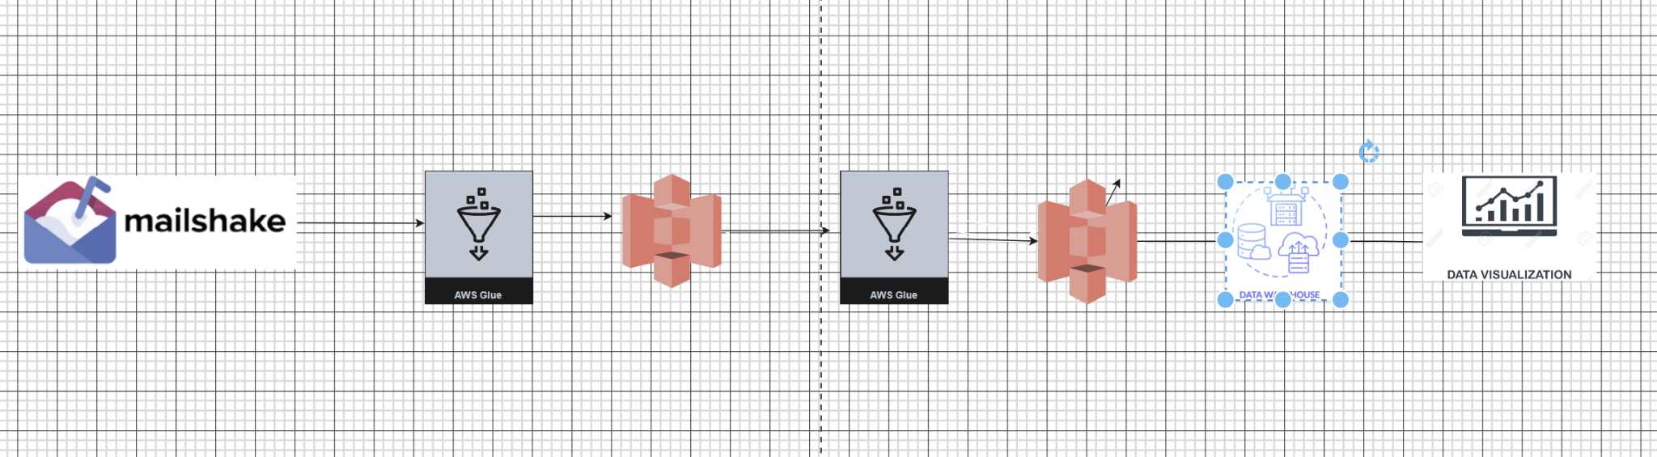
Proposed ETL architecture for mailshake analytics

The ingestion script will be executed in AWS Glue to pull raw data from the Mailshake API and store it in Amazon S3. Once the raw data is ingested, a transformation script in Glue will process, clean, and structure the data, saving it in a clean, analytics-ready format in S3. This cleaned dataset can then be loaded into any data warehouse solution, such as Snowflake or Redshift, and subsequently used to feed data visualization tools for business insights.

We have 36 teams, each managing multiple clients, and we need actionable insights into their email activity, including metrics such as sent emails, open rates, and click rates.

The current dashboard is difficult to navigate, so we aim to build an in-house data solution that streamlines analytics generation and provides clearer, more accessible insights.

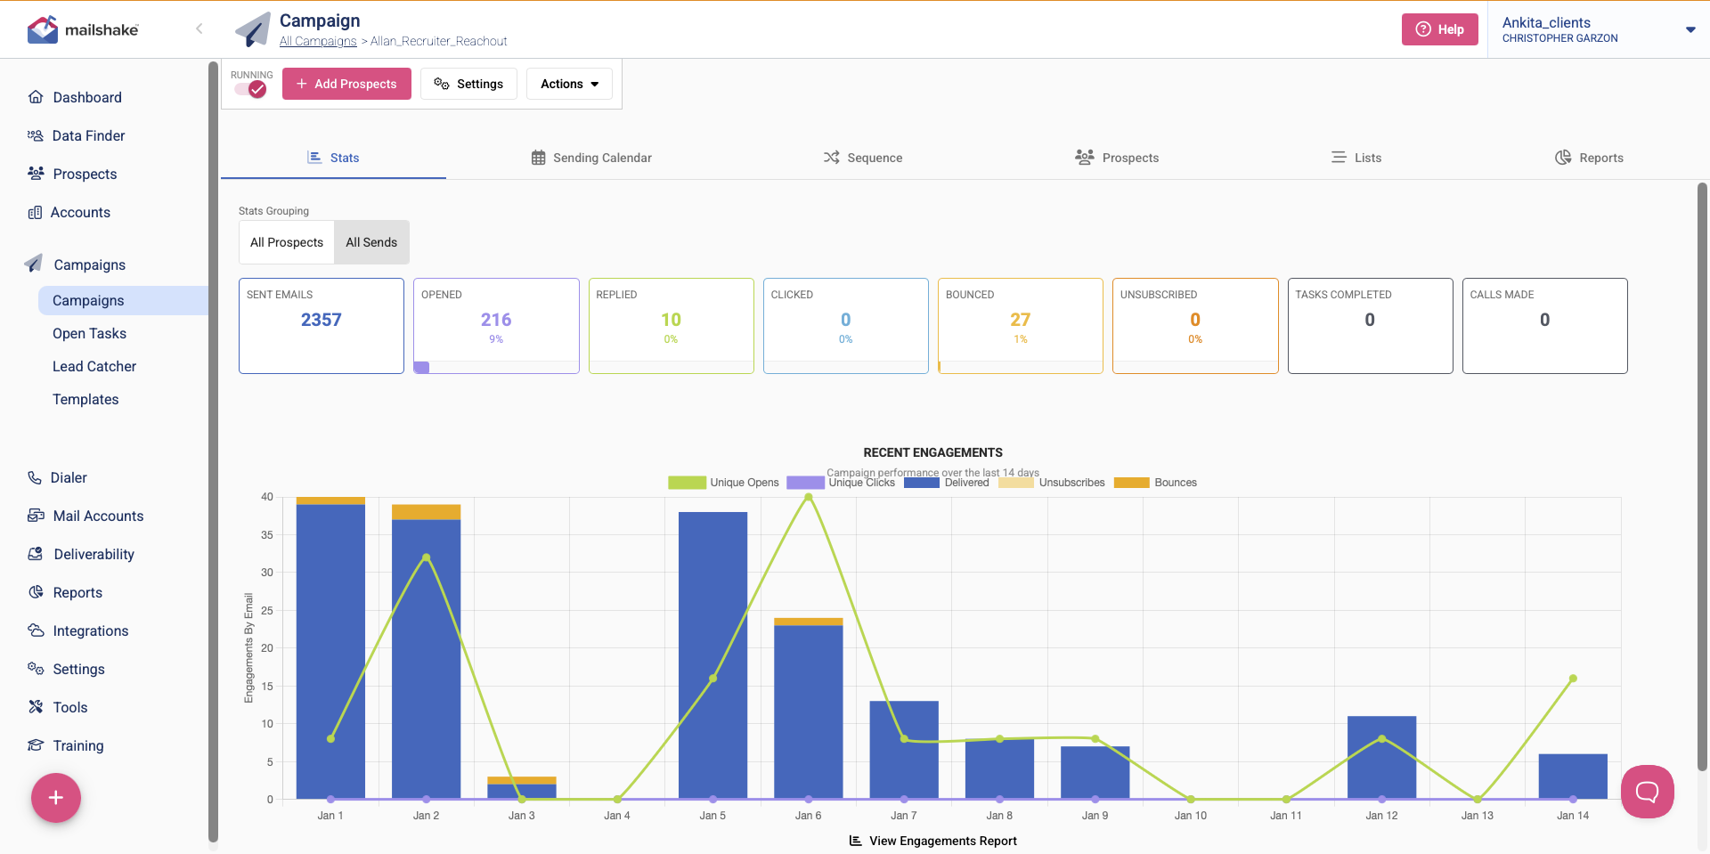

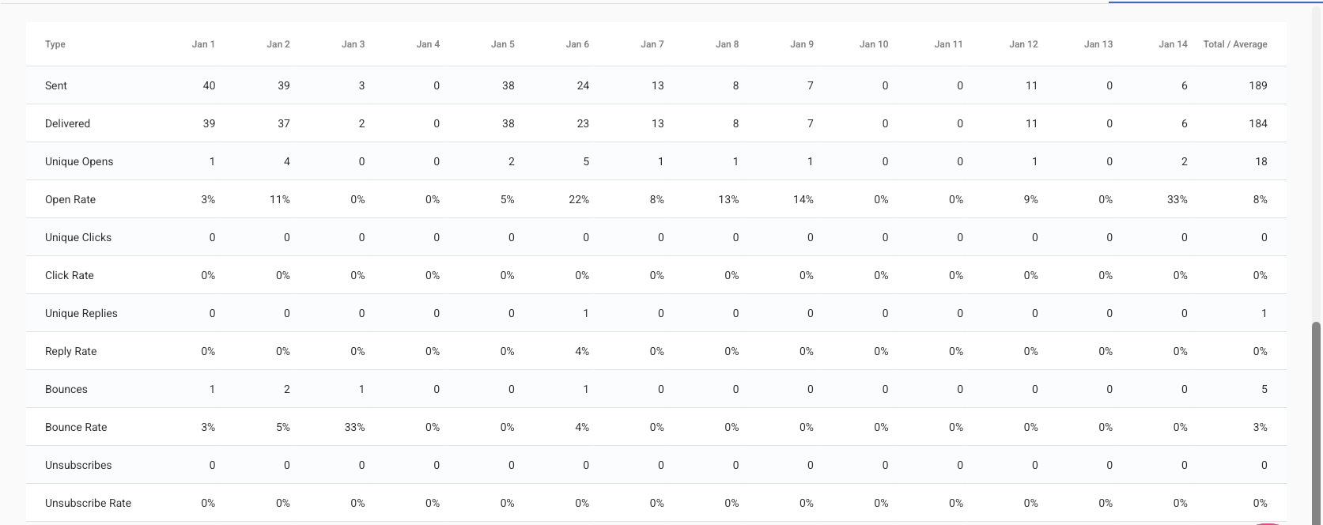

Step 4: Build the Data Pipeline
Define and Calculate Metrics as per Business Requirement:
Metrics
The metrics below will be calculated per team/client/campaign

1.1 Daily Emails Sent
- Goal: Count of total emails sent per day.
- Why it matters: Tracks daily campaign volume and ensures campaigns are sending as expected.
- How to do it:
- Metric: COUNT(id)
- Group by: date_col, team_id/client_id/campaign_id

1.2 Daily Unique Opens
- Goal: Count of unique recipients who opened emails per day.
- Why it matters: Measures actual engagement and filters multiple opens by the same recipient.
- How to do it:
  - Metric: COUNT(DISTINCT CONCAT(recipient_id, ':', parent_message_id))
  - Group by: date_col, team_id/client_id/campaign_id

1.3 Daily Unique Clicks
- Goal: Count of unique recipients who clicked any links in the email per day.
- Why it matters: Measures recipient action beyond opening, showing deeper engagement.
- How to do it:
  - Metric: COUNT(DISTINCT CONCAT(recipient_id, ':', parent_message_id))
  - Group by: date_col, team_id/client_id/campaign_id

1.4 Daily Unique Replies
- Goal: Count of unique recipients who replied to emails per day.
- Why it matters: Captures actionable engagement from the recipient.
- How to do it:
  - Metric: COUNT(DISTINCT CONCAT(recipient_id, ':', parent_message_id))
  - Group by: date_col, team_id/client_id/campaign_id

1.5 Daily Bounces (Not verified)
- Goal: Count of bounced emails per day.
- Why it matters: Measures deliverability issues and identifies invalid or inactive emails.
- How to do it:
  - Metric: COUNT(*) WHERE bounced = TRUE
  - Group by: date_col

1.6 Daily Unsubscribes (Not verified)
- Goal: Count of recipients who unsubscribed per day.
Why it matters: Helps track engagement fatigue and maintain list health.
- How to do it:
  - Metric: COUNT(*) WHERE unsubscribed = TRUE
  - Group by: date_col

1.7 Engagement Summary Table
- Goal: Combine all above metrics into one view for daily campaign reporting.
Why it matters: Provides a single source of truth for engagement analysis.
- How to do it:
  - Group by: date_col, team_id/client_id/campaign_id
  - Metrics: sent, unique opens, unique clicks, unique replies, bounces, unsubscribes

Step 5: Build the Dashboard using Streamlit:
Please go through this link for working on Streamlit for Visualization:
Streamlit Tutorial
1. Task:
Design an interactive dashboard showcasing the calculated metrics and insights.
Deliverable:
1.1 Daily Emails Sent
Goal: Count of total emails sent per day.
Why it matters: Monitors daily campaign activity and ensures campaigns are sending as expected.
Visualizations:
- Bar chart: Date vs Number of Emails Sent, color-coded by team/client/campaign
- Optional: Daily comparison table by team/client/campaign
Data Requirements:
date_col, team_id/client_id, campaign_id, parent_message_id

1.2 Daily Unique Opens
Goal: Count of unique recipients who opened emails per day.
Why it matters: Measures actual engagement and filters multiple opens by the same recipient.
How to do it:
- Metric: COUNT(DISTINCT CONCAT(recipient_id, ':', parent_message_id))
- Group by: date_col, team_id/client_id, campaign_id
Visualizations:
- Bar chart: Date vs Unique Opens, color-coded by team/client/campaign
- Optional: Heatmap showing daily opens per campaign
Data Requirements:
date_col, team_id/client_id, campaign_id, recipient_id, parent_message_id
1.3 Daily Unique Clicks
Goal: Count of unique recipients who clicked links in emails per day.
Why it matters: Measures deeper engagement beyond opening emails.
How to do it:
- Metric: COUNT(DISTINCT CONCAT(recipient_id, ':', parent_message_id))
- Group by: date_col, team_id/client_id, campaign_id
Visualizations:
- Bar chart: Date vs Unique Clicks, color-coded by team/client/campaign
- Optional: Heatmap showing clicks per campaign
1.4 Daily Unique Replies
Goal: Count of unique recipients who replied to emails per day.
Why it matters: Captures actionable engagement from recipients.
How to do it:
- Metric: COUNT(DISTINCT CONCAT(recipient_id, ':', parent_message_id))
- Group by: date_col, team_id/client_id, campaign_id
Visualizations:
- Bar chart: Date vs Unique Replies, color-coded by team/client/campaign
1.5 Daily Bounces (Not Verified)
Goal: Count of bounced emails per day.
Why it matters: Measures deliverability issues and invalid email addresses.
How to do it:
- Metric: COUNT(*) WHERE bounced = TRUE
- Group by: date_col
Visualizations:
- Bar chart: Date vs Bounces
1.6 Daily Unsubscribes (Not Verified)
Goal: Count of recipients who unsubscribed per day.
Why it matters: Tracks engagement fatigue and helps maintain list health.
How to do it:
- Metric: COUNT(*) WHERE unsubscribed = TRUE
- Group by: date_col
Visualizations:
- Bar chart: Date vs Unsubscribes
1.7 Engagement Summary Table
Goal: Combine all metrics into a single daily reporting table.
Why it matters: Provides a single source of truth for engagement analysis.
How to do it:
- Group by: date_col, team_id/client_id, campaign_id
- Metrics: sent, unique opens, unique clicks, unique replies, bounces, unsubscribes
Visualizations:
- Bar chart: Date vs Metrics (stacked or color-coded by campaign/team)
- Optional: Daily comparison table per campaign

Step 6: Submission and Review
1. Task:
○ Submit all deliverables, including:
■ Pipeline documentation.
■ Code files (ETL scripts).
■ Setup Configurations (if any)
■ Final dashboard.
■ Create a CI/CD pipeline using github.
2. Instructions:
○ Ensure all files are properly named and documented.
○ Include a short video or presentation explaining the work.
○ Explain ‘WHY’ behind each tech stack used in your design

