SELECT
COUNT(DISTINCT st.message_id) as total_sent_messages,
COUNT(DISTINCT op.parent_message_id) AS count_opened_messages,
COUNT(DISTINCT rp.parent_message_id) AS count_replied_messages,
st.client_id_col
FROM activity_sent_event st
LEFT JOIN activity_open_event op
ON st.message_id = op.parent_message_id
AND st.client_id_col = op.client_id_col
LEFT JOIN activity_reply_event rp
ON st.message_id = rp.parent_message_id
AND st.client_id_col = rp.client_id_col
GROUP BY st.client_id_col
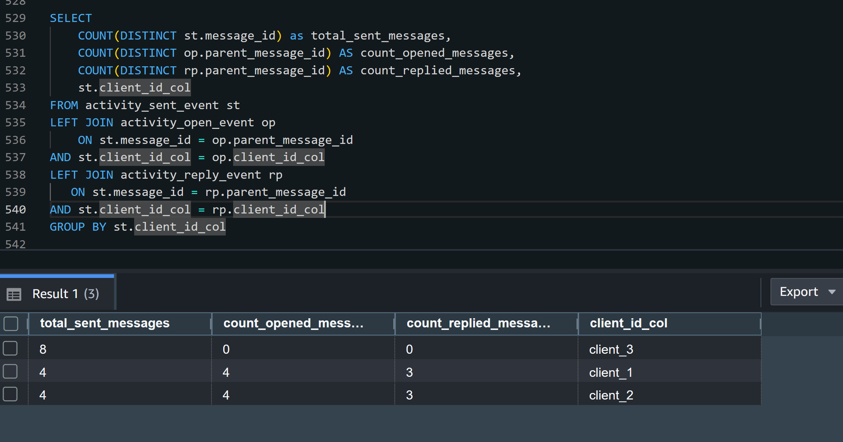
SELECT
COUNT(DISTINCT st.message_id) as total_sent_messages,
COUNT(DISTINCT op.campaign_id) AS count_opened_messages,
COUNT(DISTINCT rp.campaign_id) AS count_replied_messages,
st.campaign_id, st.client_id_col
FROM activity_sent_event st
LEFT JOIN activity_open_event op
ON st.message_id = op.parent_message_id
AND st.client_id_col = op.client_id_col
LEFT JOIN activity_reply_event rp
ON st.message_id = rp.parent_message_id
AND st.client_id_col = op.client_id_col
GROUP BY st.campaign_id, st.client_id_col
ORDER BY client_id_col;
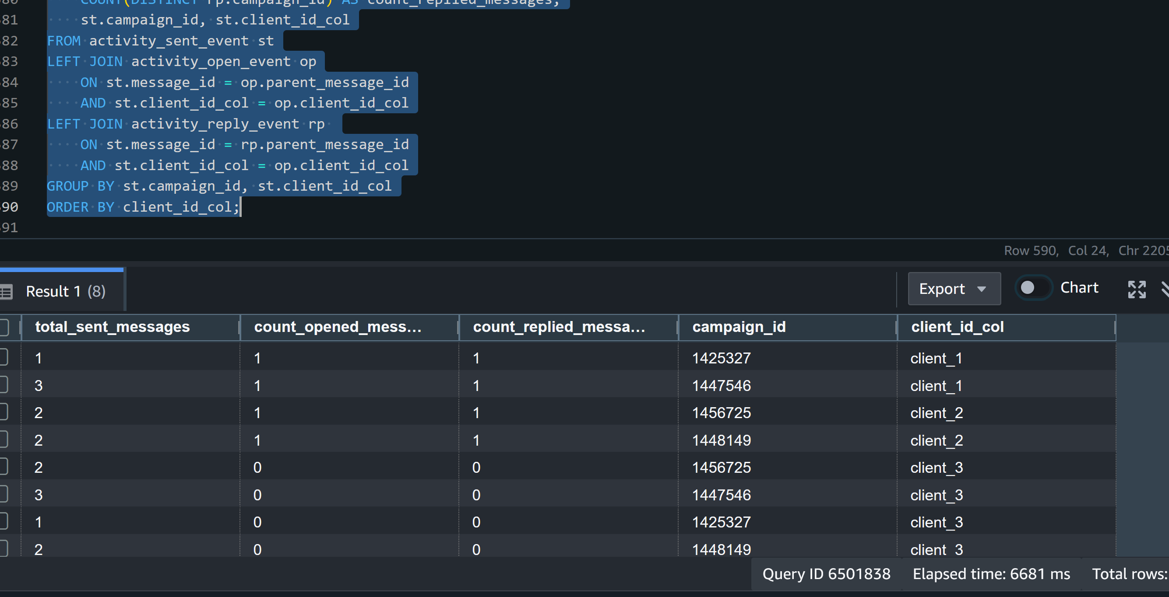
SELECT
COUNT(DISTINCT st.message_id) as total_sent_messages,
COUNT(DISTINCT op.campaign_id) AS count_opened_messages,
COUNT(DISTINCT rp.campaign_id) AS count_replied_messages,
st.campaign_id,
st.campaign_title,
st.client_id_col
FROM activity_sent_event st
LEFT JOIN activity_open_event op
ON st.message_id = op.parent_message_id
AND st.client_id_col = op.client_id_col
LEFT JOIN activity_reply_event rp
ON st.message_id = rp.parent_message_id
AND st.client_id_col = op.client_id_col
GROUP BY st.campaign_id,st.campaign_title, st.client_id_col
ORDER BY client_id_col;
