Clone the repo with the ETL code: https://github.com/yogitasn/mailshake-analytics-project.git
Buildspec file: https://github.com/yogitasn/mailshake-analytics-project/blob/main/buildspec.yml
GitHub → CodePipeline → CodeBuild → S3 → Glue update-job
When you push to GitHub:
- Pipeline triggers
- CodeBuild runs buildspec.yml
- Scripts upload to S3
- Glue job gets updated

✅ STEP-BY-STEP: Create the Pipeline

🔹 STEP 1 — Create S3 bucket (for Glue scripts)
Go to S3 → Create bucket
Example name:
mailshake-glue-scripts-dev
Inside it, your pipeline will upload to:
glue_jobs/
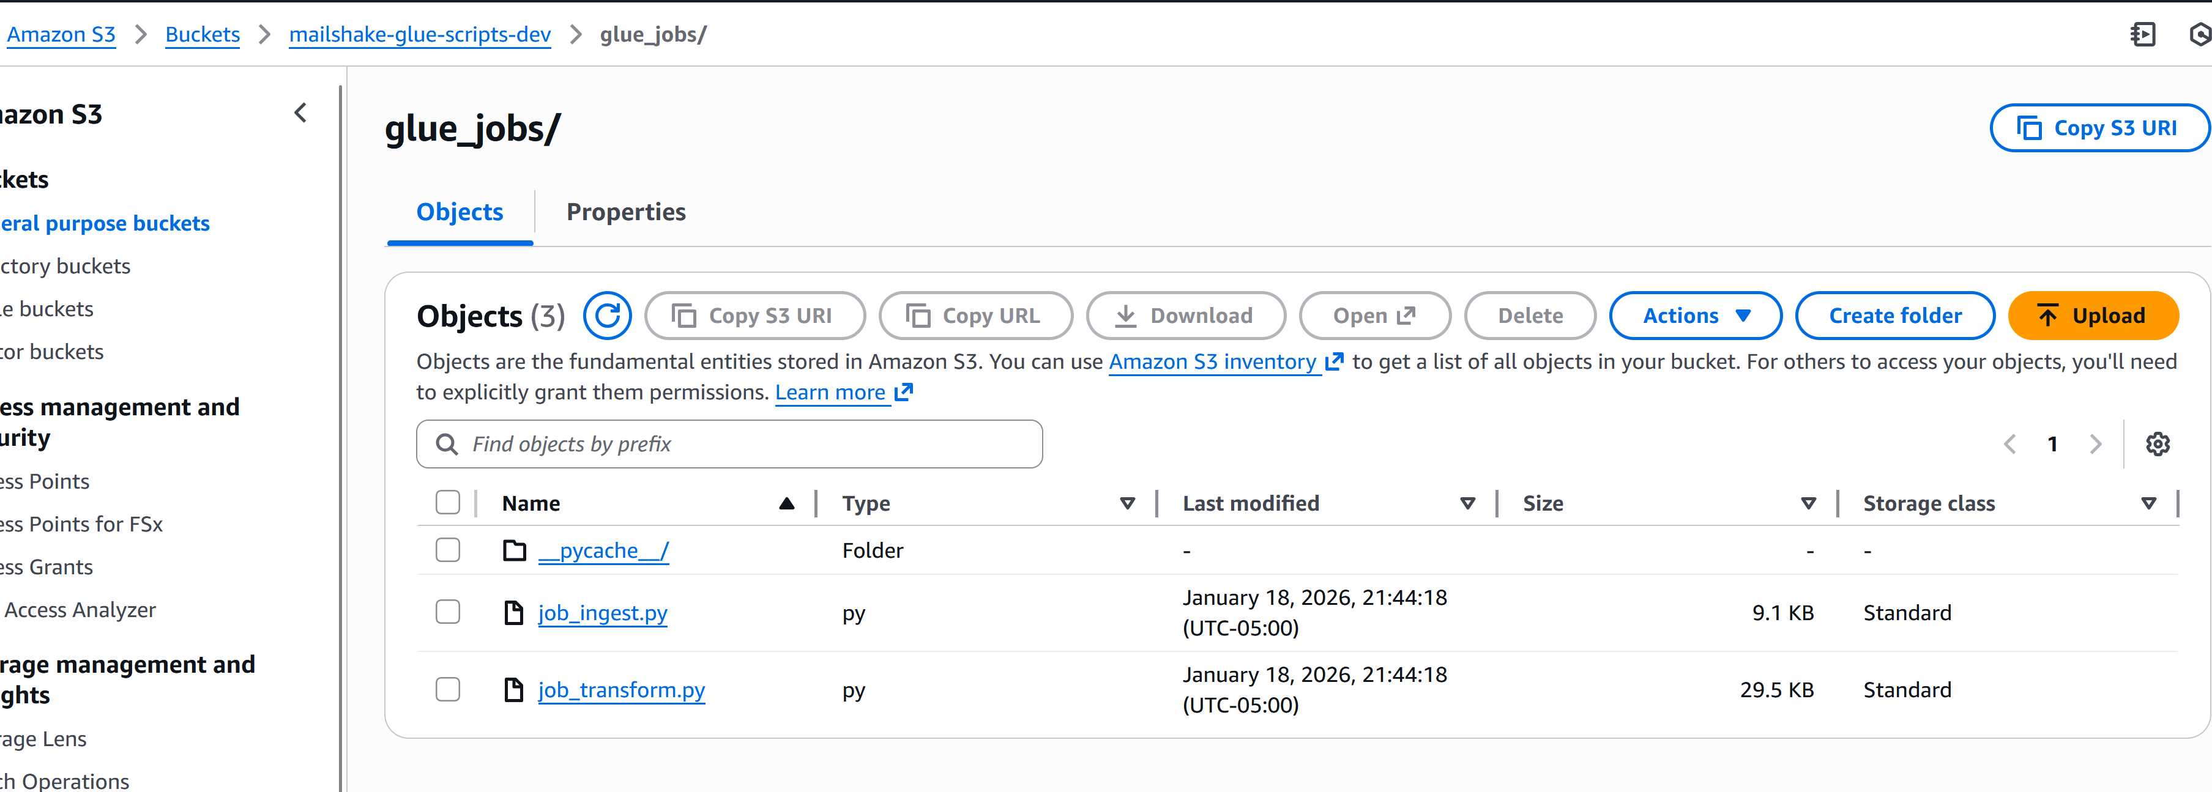

🔹 STEP 2 — Create CodeBuild Project
Go to:
👉 AWS CodeBuild → Create project
Configure:
1️⃣ Source
- Source provider: GitHub
- Choose CodeConnections
- Select your GitHub connection
- Repository: yogitasn/mailshake-analytics-project
- Branch: main

2️⃣ Environment
- Environment image: Managed image
- OS: Ubuntu
- Runtime: Standard
- Image: latest
- Privileged mode: ❌ OFF

3️⃣ Service Role
Let AWS create a new service role OR use existing.
Then attach this policy to the role:
Required permissions:
{
"Effect": "Allow",
"Action": [
"s3:PutObject",
"s3:GetObject",
"s3:ListBucket"
],
"Resource": [
"arn:aws:s3:::mailshake-glue-scripts-dev",
"arn:aws:s3:::mailshake-glue-scripts-dev/*"
]
}
AND
{
"Effect": "Allow",
"Action": [
"glue:UpdateJob"
],
"Resource": "*"
}

1. Create a IAM role that allows Glue service full access to S3 and copy the ARN.

{
"Version": "2012-10-17",
"Statement": [
{
"Effect": "Allow",
"Action": [
"s3:*",
"s3-object-lambda:*"
],
"Resource": "*"
}
]
}
2. Navigate to the Codebuild service role from the UI and then add a Customer inline policy, Replace the ARN below from the IAM role created in step 1
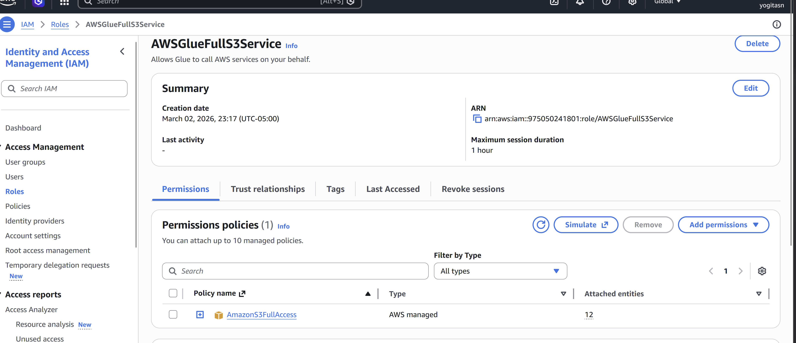
{
"Version": "2012-10-17",
"Statement": [
{
"Effect": "Allow",
"Action": "iam:PassRole",
"Resource": "arn:aws:iam::123333:role/service-role/AWSGlueFullS3Service",
"Condition": {
"StringEquals": {
"iam:PassedToService": "glue.amazonaws.com"
}
}
}
]
}
Save project.
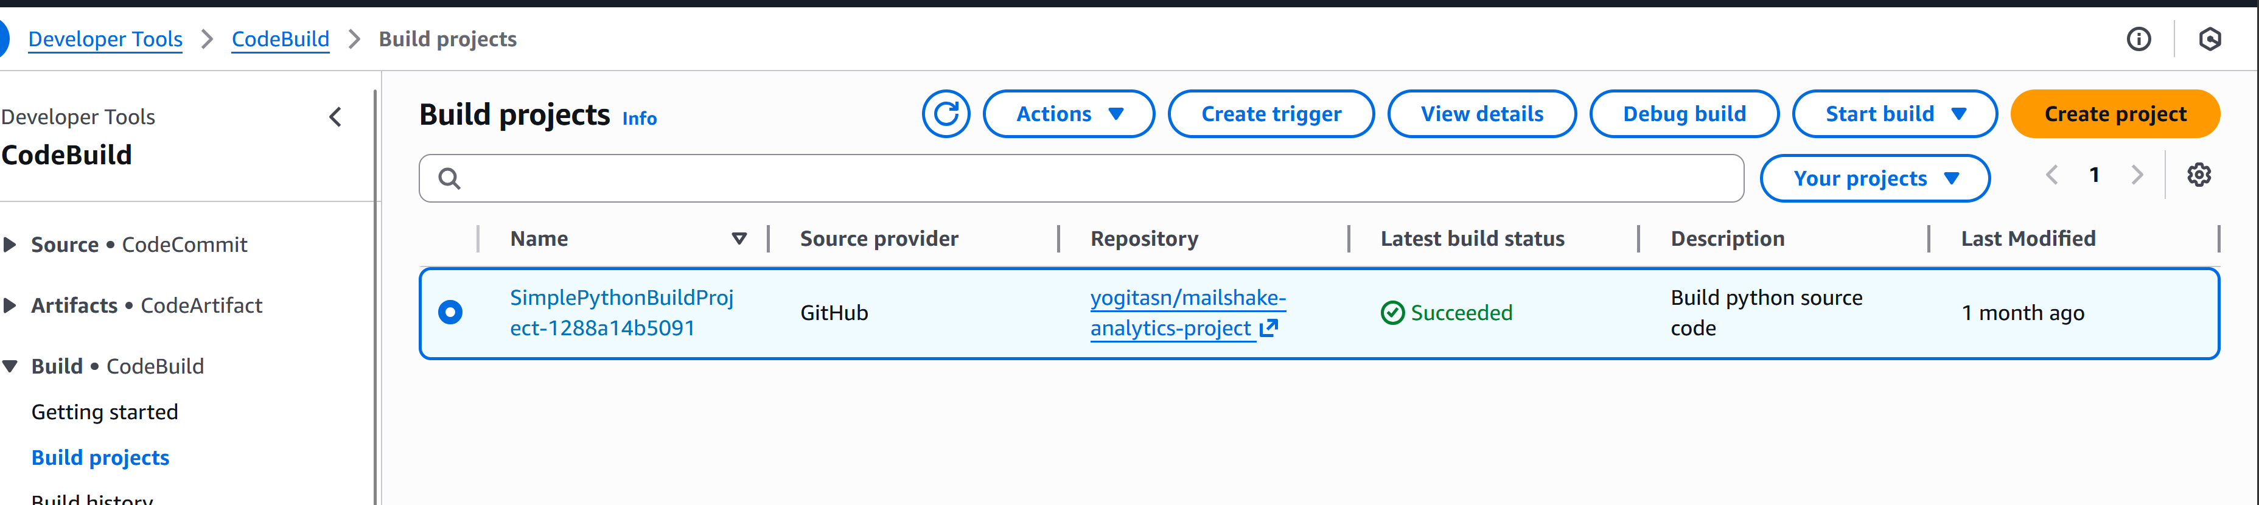
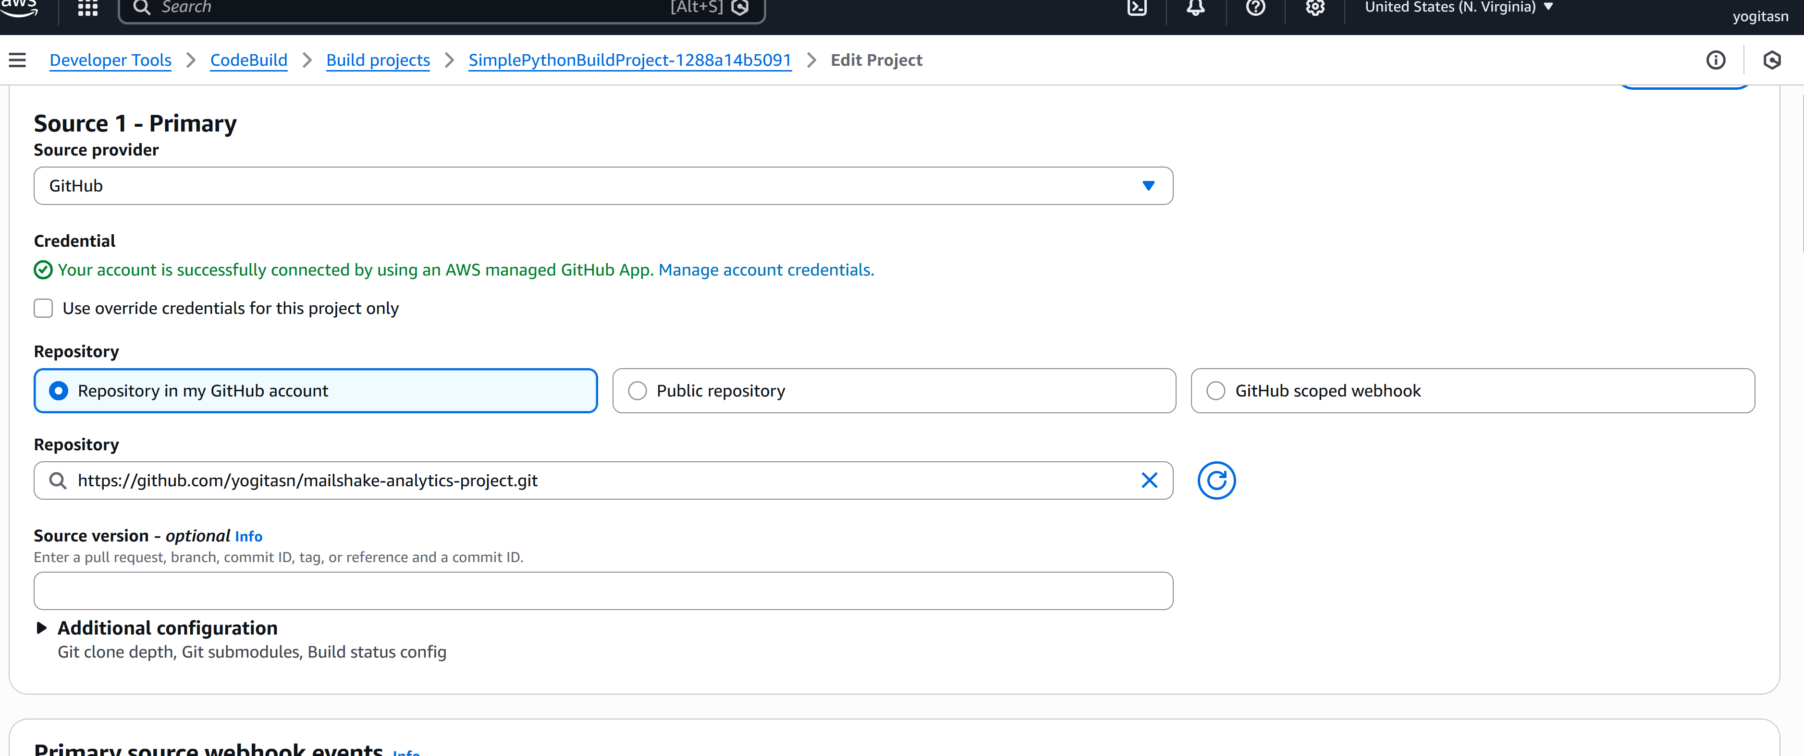

🔹 STEP 3 — Create CodePipeline
Go to:
👉 AWS CodePipeline → Create pipeline

1️⃣ Pipeline Settings
- Name: mailshake-glue-pipeline
- Service role: create new
- Artifact store: default S3 bucket (auto-created)

2️⃣ Source Stage
- Source provider: GitHub (CodeConnections)
- Select your connection
- Repository: yogitasn/mailshake-analytics-project
- Branch: main
- Detect changes: ✅ Yes

3️⃣ Build Stage
- Provider: CodeBuild
- Select project you created earlier

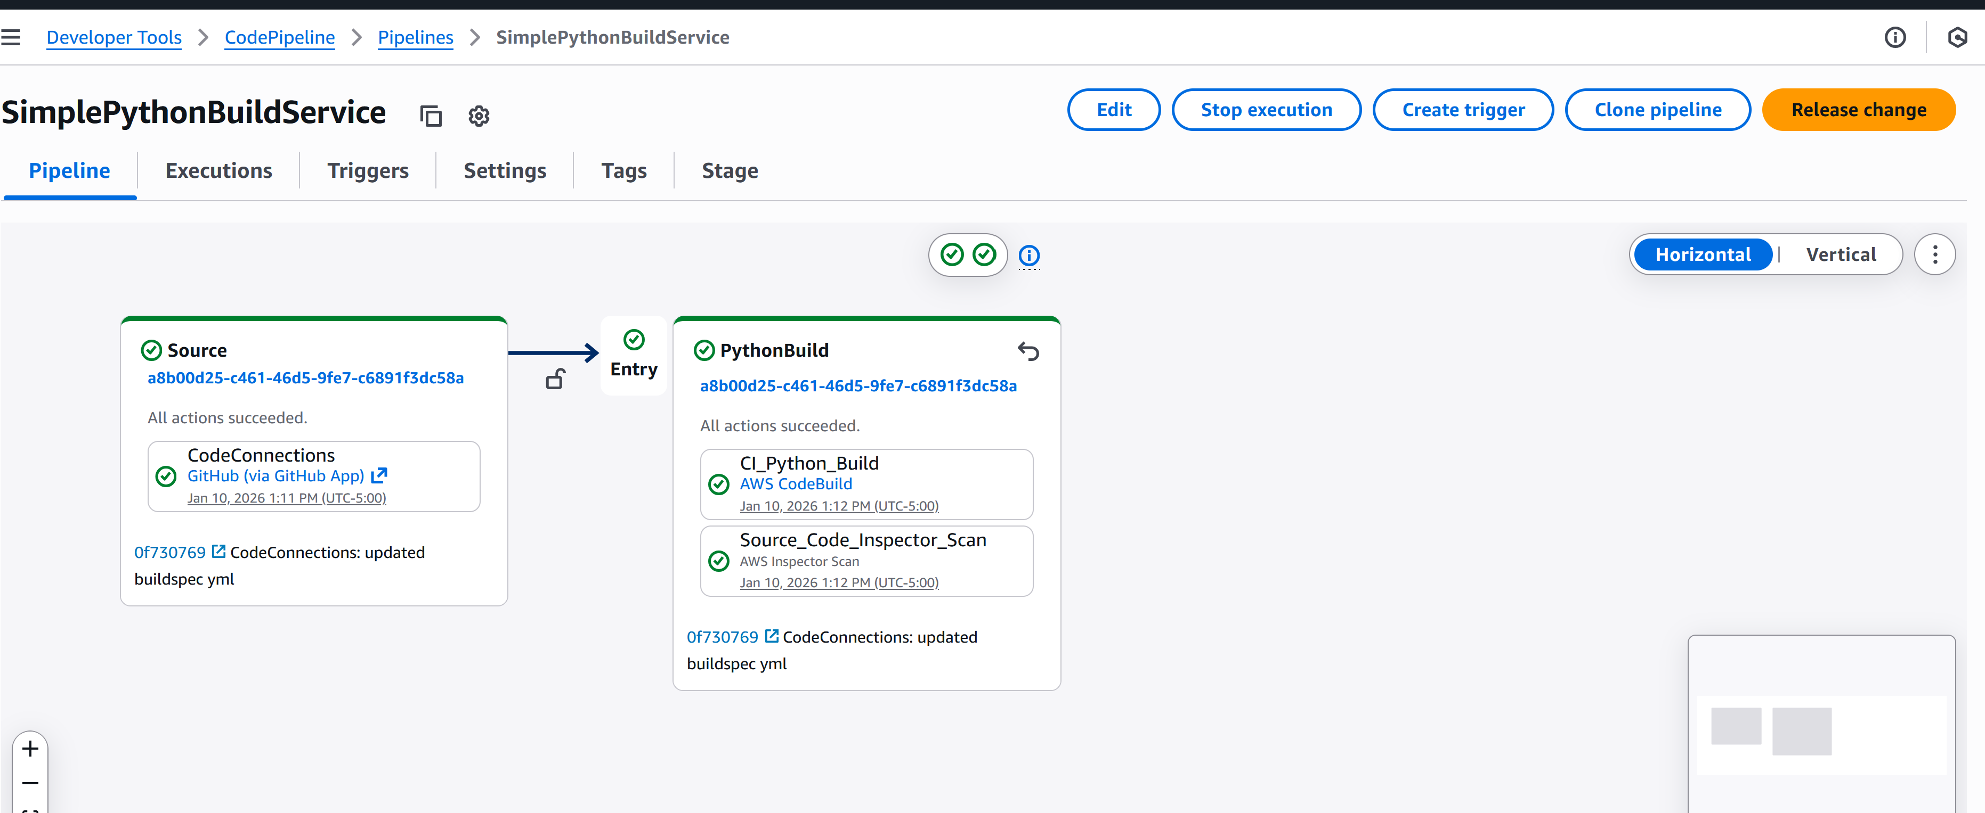

Click Create Pipeline

Pipeline will:
- Pull repo from GitHub
- Run CodeBuild
- Execute your buildspec.yml
- Upload scripts to S3
- Update Glue jobs
- Finish
Before executing Glue scripts, create folders : raw, config, and clean
