PROJECT HANDBOOK AND TECHNICAL USER MANUAL
Blockchain-Based Digital Evidence
Chain of Custody System
Using Python, SHA-256 Cryptographic Hashing and a Private Blockchain
A complete 20-chapter guide to the actual source code, written in beginner-friendly language
for study, reference, demonstration and viva preparation
Student | Yogita Vohra
Degree | BTech Computer Science Engineering — Cybersecurity and Forensics
Project type | Academic minor project (working prototype)
Domain | Blockchain · Cybersecurity · Digital Forensics
Platform | Python 3.13 · Django 5.2 (LTS) · SQLite · ReportLab · Bootstrap 5.3.3
Source of truth | The submitted project ZIP (103 files) and its 45 automated tests
Document | Project Handbook and Technical User Manual — 20 chapters

Honest scope statement: this is a local, application-level blockchain prototype. It is tamper-evident, not tamper-proof, and it makes no claim of legal admissibility.

How to read this handbook
Chapters 1–3 build the background (project, forensics, blockchain). Chapters 4–7 explain the architecture, the technology stack, the setup commands and the folder structure. Chapter 8 walks through the important real code, and Chapter 9 lists the five formulas the project actually uses. Chapters 10–12 cover the database, the chain of custody and verification. Chapters 13–15 are the user manual and the PDF reporting. Chapters 16–19 cover testing, security and limitations, troubleshooting and future work. Chapter 20 is a glossary with 25 viva questions and revision checklists.
Throughout, code excerpts are copied from the submitted project, and every function or class is identified by its exact file path. Where something is deliberately absent (roles, encryption, a public blockchain, an evidence download feature), the text says so rather than pretending otherwise.

Figures and tables
Figures: 3.1 hash-linked blocks · 4.1 architecture · 4.2 workflow · 10.1 database relationships · 13.1–13.8 interface screenshots · 15.1 the generated PDF. Tables: 1.8 features · 2.5 forensic workflow · 3.2 block fields · 3.5 hashing vs encryption · 4.2 apps · 4.5 step-to-file map · 5.0 technology stack · 6.1 software · 6.6 install errors · 8.x explanations · 9.6 the four hashes · 10.1 models · 10.3 storage · 12.2 verification results · 12.6 what is provable · 16.2 the test suite · 16.4 check types · 17.1 protections · 18.1 troubleshooting · 18.2 FAQ · 20.1 glossary.

Chapter 1 Project Overview

1.1 Project title
Blockchain-Based Digital Evidence Chain of Custody System Using Python — an academic minor project built with Python 3.13, Django 5.2, SHA-256 cryptographic hashing, a custom application-level blockchain and SQLite.

1.2 Introduction in easy language
The files that matter in a cyber-crime investigation are digital: a laptop image, a log export, a photograph, a USB copy. They are extremely easy to change, and a paper or spreadsheet custody register is just as easy to edit afterwards without anyone noticing. This project is a small web application that attacks both problems: it gives every evidence file a cryptographic fingerprint (a SHA-256 hash) at the moment it is registered so any later change to the file is detectable, and it records every custody event as a block in a hash-linked ledger so that editing the history itself becomes visible.

1.3 Problem statement
Digital evidence can be copied and altered silently, and a paper chain-of-custody log can be rewritten after the fact. Investigators therefore need a practical way to show (a) that an evidence file is still byte-for-byte the same as when it was collected and (b) who handled it and when, in a record where later edits are noticeable.

1.4 Why digital evidence needs protection
- Digital files can be modified with a single keystroke and no physical trace is left behind.
- A custody register kept in a spreadsheet has no built-in way to reveal a silent edit.
- If the integrity or the history of evidence cannot be shown, the evidence loses its value in an investigation — even when nothing wrong actually happened.

1.5 Objectives (verified in the source code)
- Register an evidence file and compute its SHA-256 hash automatically.
- Record every custody event and write it into a custom Python blockchain.
- Verify an evidence file against its registered hash at any time.
- Validate the ledger and report any modified or mis-linked block.
- Generate a PDF report from real database records.
- Keep the code small enough to be understood and explained in a viva.

1.6 Scope
In scope: login and logout, dashboard, cases, evidence registration, custody events, blockchain ledger, evidence verification, PDF report, a safe tamper demonstration, and 45 automated tests.
Deliberately out of scope (stated in docs/PROJECT_OVERVIEW.md): AI/ML, cryptocurrency, mining or proof-of-work, Ethereum or any public blockchain, peer-to-peer networking or consensus, Docker, cloud deployment and microservices. None of these exist in the code.

1.7 Intended users
A forensic investigator or lab assistant who registers evidence and records its movements; a supervisor or auditor who checks integrity and reads the ledger; and a student or examiner who studies how the pieces fit together. Every page requires a Django login, and all logged-in users currently share the same permissions (there is no role system — a deliberate simplification).

1.8 Main features
Feature | What it does | Main file
Login / logout | Django authentication, hashed passwords, every page protected by @login_required | config/urls.py, evidence/views.py
Dashboard | Live counts of cases, evidence, custody events and blocks + ledger status | evidence/views.py (dashboard)
Cases | Create, list, search and open an investigation case (CASE-0001 …) | evidence/views.py, evidence/services.py
Evidence registration | Upload a file, hash it, store it privately, create EV-0001 and block #1 | evidence/services.py (register_evidence)
Custody events | Append-only history: transferred, accessed, analysis started/completed, returned, archived | evidence/services.py (add_custody_event)
Blockchain ledger | Shows every block; recalculates every hash and checks every link on each page load | blockchain/views.py, blockchain/services.py
Evidence verification | Re-hashes the stored file and compares it with the original hash | verification/services.py
PDF report | Chain-of-custody report built with ReportLab | reports/pdf_generator.py
Safe tamper demo | Tampers with an in-memory copy of a synthetic chain to prove detection works | blockchain/demo.py
45 automated tests | Hashing, blockchain core, database ledger, views, verification, reports | tests/

1.9 Expected outcome
A working local Django application in which an investigator can register evidence, record its custody, prove that the file is unchanged, show that the history has not been edited and print a PDF summary — plus a codebase small enough to explain line by line.

1.10 How to introduce the project to your teacher (30 seconds)
“Sir, my minor project is a Blockchain-Based Digital Evidence Chain of Custody System built in Python and Django. When an investigator uploads an evidence file, the application computes its SHA-256 hash and stores it as the permanent fingerprint. Every custody action — registered, accessed, transferred, analysis started or completed, returned, archived — is recorded as a new block in a hash-linked ledger where each block stores the hash of the block before it. To check the file I re-hash it and compare; to check the history I recalculate every block hash and verify every link. It also generates a PDF chain-of-custody report. I want to be honest about the scope: it is a local, application-level blockchain prototype, so it is tamper-evident but not tamper-proof, and it makes no claim of legal admissibility.”

Chapter 2 Digital Forensics Fundamentals

2.1 What digital forensics means
Digital forensics is the discipline of finding, collecting, preserving, examining and reporting digital evidence in a way that can be defended later — in everyday language, the careful handling of computer-based clues so that nobody can say the clues were changed.

2.2 What digital evidence is
Digital evidence is any information stored or transmitted in binary form that may be relied on in an investigation: a text note, a system log, a database export, a photograph, a video, a disk image, a memory dump or an e-mail. Here, one such item is registered as an Evidence record and the file itself is stored in a private folder under a random name.

2.3 Why evidence integrity matters
Integrity means the evidence is exactly what it was when it was collected — not one byte different. If integrity cannot be demonstrated, an investigator cannot show that a finding came from the original data rather than from something edited afterwards. A SHA-256 hash detects any change cheaply and reliably, because changing a single bit produces a completely different hash.

2.4 What a chain of custody is
The chain of custody (also called the chain of evidence) is the chronological record of who had the evidence, when, and what they did with it. Formal definition: an unbroken documented history of the seizure, custody, transfer, analysis and disposition of evidence. Everyday version: a signed logbook that answers “where has this item been, and who touched it?”
In this application the logbook is the CustodyEvent table, and each event is also written into a blockchain block. The events offered are: Evidence collected / registered, Evidence transferred, Evidence accessed, Analysis started, Analysis completed, Evidence returned and Evidence archived.

2.5 The forensic workflow and where this project fits
Stage | What happens in real life | How the project supports it
Collection | The item is seized and documented; a working copy is made | Evidence registration with the collector's name and a note
Registration / intake | The item receives a unique identifier | Automatic EV-0001 code plus a SHA-256 hash, and block #1
Storage | The item is stored so that it cannot be changed unnoticed | Private folder, random stored filename, no public URL; the hash is the tripwire
Transfer | The item moves from one person to another | TRANSFERRED event — the application requires different From and To values
Examination | The item is analysed | ANALYSIS_STARTED then ANALYSIS_COMPLETED (completion requires a start first)
Reporting | Findings and the custody history are documented | PDF chain-of-custody report generated with ReportLab

2.6 What can go wrong
- A file is edited, re-saved or overwritten and nobody notices — the project detects this as an INTEGRITY MISMATCH because the re-hashed file no longer equals the original hash.
- A custody entry is inserted, removed or back-dated — the project detects this because the block's recalculated hash no longer matches, or a block no longer agrees with its custody-event row.
- A block is deleted, or an event is created without its block — the validator reports “has no blockchain block”, because a block row and its custody event are written in one database transaction.
- The wrong person's name is typed into the handler field — the application cannot detect this. It records the login name as well and states plainly that a typed name does not prove real-world identity.

2.7 Integrity versus authenticity — an important distinction
Preserving integrity means the content has not changed since registration. Proving authenticity means proving where the content came from, that it is genuine, and that the person who registered it told the truth. A hash match proves only the first. The project states this in its own documentation and repeats it in the PDF report: a match shows the file content is unchanged since registration, and a mismatch is a reason to investigate — not by itself proof of malicious tampering (it could be corruption, an accidental edit, or a restore from the wrong backup).

Chapter 3 Blockchain Fundamentals

3.1 What a blockchain is
A blockchain is an append-only list of records (“blocks”) in which each block contains the hash of the block before it. Because a block's own hash is calculated from data that includes that previous hash, changing an old block changes its hash and breaks the link to the next block. That is what makes the history tamper-evident. In this project the chain is local and stored in SQLite, not spread across a network of computers.

3.2 What a block contains here
The block structure is defined in blockchain/block.py as a dataclass. The exact fields are:
Field | Meaning | In the hash?
index | Position in the chain (0 = genesis, then 1, 2, 3 …) | Yes
timestamp | When the event happened, as a UTC ISO-8601 text string | Yes
evidence_id | For example EV-0001, or GENESIS for block 0 | Yes
custody_event_id | Primary key of the CustodyEvent row (None for genesis) | Yes
event_type | For example REGISTERED, ACCESSED, TRANSFERRED | Yes
actor | Name of the person who handled the evidence | Yes
details | Small dictionary: from, to, remarks, recorded_by (username) | Yes
evidence_hash | SHA-256 of the evidence FILE — never the file itself | Yes
previous_hash | Hash of the block before this one | Yes
hash | This block's own hash (a value cannot be part of its own calculation) | No

3.3 How blocks connect
blockchain/chain.py builds each new block from the previous one: index = previous index + 1 and previous_hash = previous block's hash. Validation walks the chain from the genesis block, checking both the recalculated hash and the link. The diagram below shows four linked blocks.
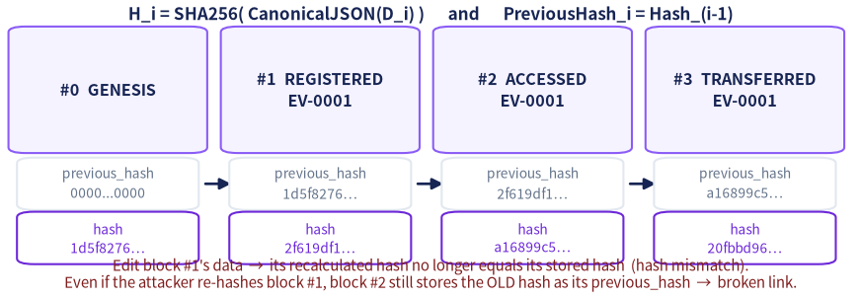
Figure 3.1 — Four hash-linked blocks. Each block stores the previous block's hash inside the data that it hashes, so any edit breaks the link to the following block.

3.4 The genesis block
The genesis block is block #0, the fixed starting point. Its timestamp is a constant (GENESIS_TIMESTAMP = "2026-01-01T00:00:00+00:00") rather than “now”, and both its previous_hash and its evidence_hash are ZERO_HASH ("0" × 64). Because every input is a constant, create_genesis_block() returns an identical block with an identical hash on every computer, and the validator uses that fact to confirm that block 0 in the database really is the genuine genesis block. It is created by the migration and by ensure_genesis_block(), which never creates a second one.

3.5 Hashing versus encryption
 | Hashing (used here) | Encryption
Direction | One way — you cannot get the input back from the output | Two way — with the key you can decrypt
Purpose | Detect change; create a fingerprint | Hide content
Output size | Always 256 bits = 64 hexadecimal characters | Usually the same size as the input
Key needed | No key at all | A secret key
In this project | SHA-256 fingerprints of files and blocks | Not used anywhere

3.6 SHA-256 and its role here
SHA-256 is a member of the SHA-2 family and produces a 256-bit digest, conventionally written as 64 hexadecimal characters. Three properties matter for forensics: the same input always gives the same output; a one-bit change produces a completely different output; and it is practically impossible to work backwards from the digest to the input. Python provides it in hashlib, and the project uses hashlib.sha256() in two places: for evidence files (evidence/hashing.py) and for block data (blockchain/block.py).
import hashlib
hashlib.sha256(b"abc").hexdigest() # ba7816bf8f01cfea414140de5dae2223b00361a396177a9cb410ff61f20015ad
Listing 3.1 — SHA-256 of b'abc', the published test vector asserted in tests/test_hashing.py.

3.7 Why changing an earlier block affects later blocks
One edit produces two independent effects. (1) Hash mismatch: the validator recalculates the block's hash from its current data and compares it with the stored value — they no longer agree. (2) Broken link: even if the attacker also recalculates that block's hash, the next block still stores the OLD hash as its previous_hash, so the link check fails. Only an attacker who rewrites every later block and the matching database rows can rebuild a chain that validates — the honest limit of a single local copy, stated on the ledger page itself.

3.8 Why this is not a distributed public blockchain
- No peer-to-peer network, no nodes, no independent copies — there is exactly one copy in db.sqlite3.
- No consensus protocol and no mining or proof-of-work.
- No digital signatures and no cryptocurrency or tokens.
- It is an application-level, hash-linked ledger: tamper-EVIDENT, not tamper-PROOF.

3.9 Limitations of a custom local blockchain
Because one party controls the database file, that party could, in principle, rewrite every block and every database row and produce a chain that still validates. The project therefore adds extra database cross-checks (each block is compared with its custody-event row and with the evidence's original hash) so that editing database tables directly is also noticed. Practical improvements would be anchoring the latest block hash outside the system or adding digital signatures — both are listed as future work in Chapter 19.

Chapter 4 Project Architecture and Workflow

4.1 The architecture in one picture
The application is a classic Django request/response stack with a thin service layer. Views stay short; the rules live in services, and the cryptographic work lives in small, pure modules that know nothing about the web.
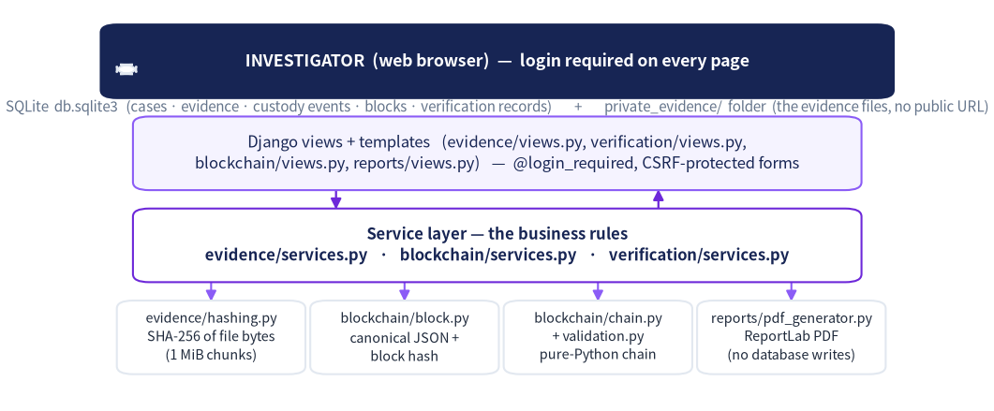
Figure 4.1 — Layered architecture. Requests flow downwards through views and services; only SQLite and the private evidence folder hold state.

4.2 Django apps and their responsibilities
Django app | Responsibility | Key files
config | Settings and the main URL table | config/settings.py, config/urls.py
evidence | Case, Evidence and CustodyEvent models; forms; views; file hashing; business services | evidence/models.py, forms.py, views.py, services.py, hashing.py, storage.py
blockchain | BlockRecord model, block/chain/validation logic, ledger page, safe tamper demo | blockchain/block.py, chain.py, validation.py, services.py, demo.py, views.py
verification | VerificationRecord model and the integrity-verification page | verification/models.py, services.py, views.py
reports | PDF generation and the report page | reports/pdf_generator.py, views.py

4.3 How the components communicate
- A browser sends an HTTP request; Django's URL table (config/urls.py) chooses a view.
- @login_required on every view redirects anonymous visitors to /login/.
- The view validates input through a Django form and then calls a service function — never the other way round. Forms and services deliberately repeat the custody rules, so no code path can skip them.
- The service opens one transaction.atomic() block, writes the CustodyEvent row, updates the evidence status, and appends the block through blockchain/services.py. If any step fails, everything rolls back.
- Before writing anything new, require_valid_ledger() validates the whole stored chain; a damaged ledger raises LedgerInvalidError and the write is refused.
- Evidence bytes go to the private folder; only metadata and hashes go into the database and the blocks.

4.4 The complete workflow
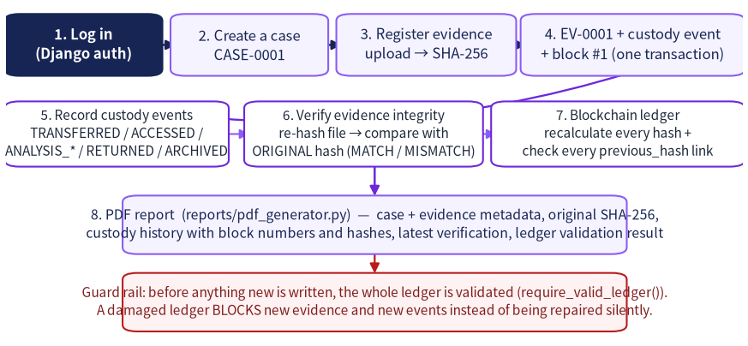
Figure 4.2 — End-to-end workflow, from login to the generated PDF, with the ledger guard rail at the bottom.

4.5 Which file and function does each step
Step | Entry point (URL name) | View / function | Service
Log in | login | auth_views.LoginView with templates/registration/login.html | Django auth
Dashboard | dashboard | evidence.views.dashboard | validate_stored_chain()
Create a case | case_create | evidence.views.case_create | evidence.services.create_case
Register evidence | evidence_register | evidence.views.evidence_register | evidence.services.register_evidence
Record custody event | custody_add | evidence.views.custody_add | evidence.services.add_custody_event
Verify evidence | verify | verification.views.verify_view | verification.services.verify_evidence
Validate the ledger | ledger | blockchain.views.ledger | blockchain.services.get_ledger_rows
Tamper demo | tamper_demo | blockchain.views.tamper_demo | blockchain.demo.run_tamper_demo
Generate a PDF | generate_report | reports.views.generate_report | reports.pdf_generator.build_evidence_report

4.6 What happens when evidence is registered — step by step
- require_valid_ledger() confirms the existing chain is healthy; otherwise the upload is refused.
- calculate_sha256_from_chunks(uploaded_file.chunks()) hashes the uploaded bytes in chunks.
- The Evidence row is created with an auto-generated EV-xxxx id, and the file is saved to private storage under a random UUID name (evidence_upload_path in evidence/models.py).
- The SAVED copy is re-hashed with calculate_sha256_of_path(); if it differs, a ValidationError aborts the transaction and the stored file is deleted.
- The first custody event (action_type = REGISTERED) is created, the evidence status is set, and append_custody_event_block() writes block #1 linked to the genesis block.
- The whole sequence ran inside transaction.atomic(), so a failure anywhere leaves no partial record.

Chapter 5 Technology Stack
Every technology below was confirmed in the project files. Versions come from requirements.txt, the README and static/vendor/README.md; nothing is listed simply because it is popular.
Technology | Version | Purpose here | Where it appears
Python | 3.13.13 (tested; README) | The language of the whole project; hashlib is built in | every .py file
Django | 5.2.18 (LTS) — pinned in requirements.txt | Web framework: routing, ORM, forms, authentication, templates, migrations, admin, test runner | config/settings.py, all apps
SQLite | Ships with Python; engine django.db.backends.sqlite3 | Single-file database holding cases, evidence metadata, custody events, blocks and verification records | config/settings.py (DATABASES)
hashlib (SHA-256) | Python standard library | Fingerprints of evidence files and of block data | evidence/hashing.py, blockchain/block.py
json (canonical JSON) | Python standard library | Deterministic, repeatable serialization before hashing | blockchain/block.py (canonical_json)
ReportLab | 5.0.1 — pinned | Builds the chain-of-custody PDF in memory | reports/pdf_generator.py
HTML5 + Django templates | — | Server-rendered pages; template inheritance via base.html | templates/
Bootstrap | 5.3.3 (MIT, vendored locally, works offline) | Layout, cards, tables, forms, badges | static/vendor/bootstrap/
Bootstrap Icons | 1.11.3 (MIT, vendored) | Sidebar and button icons | static/vendor/bootstrap-icons/
CSS (custom) | — | The “Forensic Violet” theme: navy, violet, lavender, white | static/css/forensic.css
Vanilla JavaScript | — | Show/hide From–To fields, confirm dialogs, prevent double submits | static/js/app.js
asgiref, sqlparse, Pillow, charset-normalizer | 3.12.1 / 0.6.0 / 12.3.0 / 3.5.2 (transitive, pinned) | Pulled in by Django and ReportLab; installed but never imported by the project's own code | requirements.txt

5.1 Beginner-friendly notes
- Python is the language; Django is a library that turns Python functions into web pages. manage.py is the command-line tool that runs migrations, the server and the tests.
- SQLite is a whole database inside one file (db.sqlite3). It needs no server, which is ideal for a project that must run on a student's laptop.
- Bootstrap and Bootstrap Icons are copied into static/vendor/, so the interface looks right even with no internet connection.
- Nothing in the project uses jQuery, React, Docker, Redis or Celery, and there is no external font service.

Chapter 6 Development Environment and Setup
The project targets Windows 11 with PowerShell and Visual Studio Code, using Python 3.13.x. All commands are run inside the folder that contains manage.py.

6.1 Required software
Software | Required? | Why
Python 3.13.x (64-bit) from python.org | Required | Django 5.2 LTS supports Python 3.13; tick “Add python.exe to PATH” and install the py launcher
A terminal (PowerShell) and a browser | Required | To run commands and open http://127.0.0.1:8000/
Visual Studio Code + Python extension | Optional but recommended | Comfortable editing and an integrated terminal
Internet connection | Not needed after setup | Bootstrap and Bootstrap Icons are vendored locally

6.2 Setup commands (PowerShell)
# 1. Open the extracted folder (the one that contains manage.py)
cd C:\path\to\digital_evidence_chain_of_custody
# 2. Create and activate a virtual environment
py -3.13 -m venv venv
.\venv\Scripts\Activate.ps1
# 3. Install dependencies (reads requirements.txt)
python -m pip install --upgrade pip
python -m pip install -r requirements.txt
# 4. Create the database tables (this also creates the genesis block)
python manage.py migrate
# 5. Create your login account (works for the app and for /admin/)
python manage.py createsuperuser
# 6. Start the development server
python manage.py runserver
Listing 6.1 — The complete first-time setup. Steps 1–6 are all required; the optional extras follow.

6.3 What each step actually does
- python -m venv venv creates an isolated folder of packages so this project's Django cannot clash with any other project. The prompt should start with (venv) once activated.
- requirements.txt is a plain list of exact versions: Django 5.2.18 and reportlab 5.0.1 as direct dependencies, plus asgiref, sqlparse, pillow and charset-normalizer pinned to the versions the tests were run with. pip install -r requirements.txt installs all of them.
- python manage.py migrate applies the ready-made migrations in evidence/, blockchain/ and verification/ and creates db.sqlite3. The genesis block is created here (see blockchain/services.py and the blockchain migration).
- python manage.py createsuperuser asks for a username and password and stores the password hashed. The login page itself says accounts are created by the administrator with this command — there is no self-registration page.
- python manage.py runserver starts the development server on port 8000. With DEBUG = True it also serves the /static/ files, which is why the styling works without any extra step.

6.4 Optional commands
python manage.py test # run the 45 automated tests
python manage.py test tests.test_blockchain_core tests.test_ledger_database -v 2
python manage.py tamper_demo --scenario edit_data --block 2
python manage.py demo_modify_file EV-0001 --confirm # DEMO cases only
python manage.py demo_modify_file EV-0001 --confirm --restore
python manage.py changepassword <username> # forgot password
python manage.py runserver 8001 # if port 8000 is busy

6.5 The normal development workflow
- Activate the virtual environment, then start the server.
- Open http://127.0.0.1:8000/ and log in.
- Make code changes in VS Code. With DEBUG = True the server reloads automatically.
- If you change a model, run python manage.py makemigrations then python manage.py migrate.
- Run python manage.py test before recording a demonstration.
- Stop the server with Ctrl + C in the terminal, then leave the virtual environment with deactivate.

6.6 Common installation and startup errors
Message | Cause and fix
'py' is not recognized | The Python launcher was not installed. Reinstall Python and tick the launcher, or use python -m venv venv instead.
running scripts is disabled on this system | PowerShell execution policy. Run Set-ExecutionPolicy -Scope Process -ExecutionPolicy Bypass and activate again.
No module named 'django' / Could not import Django | The virtual environment is not active. The prompt must start with (venv); activate it and re-run pip install -r requirements.txt.
no such table: evidence_case | Migrations were not applied. Run python manage.py migrate in the folder that contains manage.py.
Error: That port is already in use | Another server is running. Use python manage.py runserver 8001.
Pillow or ReportLab fails to install | Use 64-bit Python 3.13, upgrade pip, then re-run pip install -r requirements.txt.
The pages look unstyled | Serve through runserver (it serves /static/ with DEBUG on) and hard-refresh with Ctrl + F5.

6.7 Stopping and deactivating
Press Ctrl + C in the terminal running the server to stop it. Then type deactivate to leave the virtual environment; the (venv) prefix disappears. To start again later, re-activate and run runserver — migrations and the database already exist.

Chapter 7 Project Folder Structure
The tree below is the real structure of the extracted project (103 files). Files created when you run the application — db.sqlite3 and private_evidence/ — are marked.
digital_evidence_chain_of_custody/
manage.py requirements.txt README.md .gitignore
config/ settings.py, urls.py, wsgi.py, asgi.py
evidence/ models.py (Case, Evidence, CustodyEvent), forms.py, views.py, services.py,
hashing.py, storage.py, urls.py, admin.py, apps.py, views_errors.py,
templatetags/forensic_tags.py, migrations/0001_initial.py,
management/commands/demo_modify_file.py
blockchain/ block.py, chain.py, validation.py, services.py, demo.py, models.py, views.py,
urls.py, admin.py, migrations/0001_initial.py,
management/commands/tamper_demo.py
verification/ models.py, services.py, forms.py, views.py, urls.py, admin.py, migrations/
reports/ pdf_generator.py, views.py, urls.py
templates/ base.html, dashboard.html, 404.html, 500.html, registration/login.html,
cases/ (3), evidence/ (5), blockchain/ (2), verification/ (1), reports/ (1),
partials/ _nav_links, _field, _form_errors, _badge, _pagination
static/ css/forensic.css, js/app.js, vendor/ (Bootstrap 5.3.3 + Icons 1.11.3, offline)
tests/ helpers.py + 45 tests in five files
docs/ PROJECT_OVERVIEW.md, BLOCKCHAIN_EXPLAINED.md,
SETUP_AND_TROUBLESHOOTING.md, VIVA_QUESTIONS.md
sample_data/ sample_evidence_note.txt + README (synthetic data only)
db.sqlite3 [created by migrate] private_evidence/ [created on first upload]
Listing 7.1 — Real project tree. Every path shown exists in the submitted ZIP.

7.1 Why the code is split into modules
- Each Django app owns one job, so a change to blockchain logic cannot accidentally break PDF generation.
- blockchain/validation.py is deliberately “pure Python”: it knows nothing about Django or SQLite, which makes it trivial to unit-test by building chains in memory.
- Business rules live in services.py, so a view stays a short request handler and the same rule can be reused by the web form, a management command and a test.
- Templates are separated into pages and reusable partials (_field.html, _badge.html), so a form field or a status badge looks the same everywhere.

Chapter 8 Complete Code Explanation
This chapter explains the code that an examiner is most likely to ask about. Excerpts are copied from the project files; each one is explained immediately afterwards.

8.1 Django settings — config/settings.py
Purpose: one place for every configuration value. The project reads three environment variables with safe local defaults, so no real secret is stored in source code.
SECRET_KEY = os.environ.get(
"DJANGO_SECRET_KEY",
"django-insecure-local-development-key-do-not-use-in-production",
)
DEBUG = _env_flag("DJANGO_DEBUG", True)
ALLOWED_HOSTS = [host.strip() for host in
os.environ.get("DJANGO_ALLOWED_HOSTS", "localhost,127.0.0.1,[::1]").split(",")
if host.strip()]
...
DATABASES = {"default": {"ENGINE": "django.db.backends.sqlite3", "NAME": BASE_DIR / "db.sqlite3"}}
EVIDENCE_STORAGE_ROOT = BASE_DIR / "private_evidence"
MAX_EVIDENCE_UPLOAD_BYTES = 50 * 1024 * 1024
HASH_CHUNK_SIZE = 1024 * 1024
USE_TZ = True
TIME_ZONE = "Asia/Kolkata"
Listing 8.1 — Selected settings (config/settings.py).
- SECRET_KEY signs sessions and CSRF tokens. The fallback value is clearly labelled insecure — it exists only so the project runs locally without any extra configuration.
- DEBUG defaults to True for development, and the settings file itself warns that the server must not be exposed to the internet as-is.
- DATABASES points SQLite at db.sqlite3 in the project root.
- EVIDENCE_STORAGE_ROOT is the private folder. There is deliberately no MEDIA_URL and no URL route serving it, so evidence can never be fetched by typing an address.
- MAX_EVIDENCE_UPLOAD_BYTES (50 MB) and ALLOWED_EVIDENCE_EXTENSIONS (34 safe extensions; executable and script types are excluded) are the upload guard rails; HASH_CHUNK_SIZE (1 MiB) is the read size while hashing.
- USE_TZ = True means timestamps are stored in UTC and displayed in TIME_ZONE. Blocks always store the UTC ISO-8601 text.

8.2 URL routing — config/urls.py and each app's urls.py
urlpatterns = [
path("admin/", admin.site.urls),
path("login/", auth_views.LoginView.as_view(template_name="registration/login.html",
redirect_authenticated_user=True), name="login"),
path("logout/", auth_views.LogoutView.as_view(), name="logout"), # POST only (Django 5)
path("blockchain/", include("blockchain.urls")),
path("verification/", include("verification.urls")),
path("reports/", include("reports.urls")),
path("", include("evidence.urls")),
]
Listing 8.2 — config/urls.py. Evidence's URLs sit at the root because they include the dashboard.
The app routes are: dashboard "", cases/ , cases/new/ , cases/<case_id>/ , evidence/ , evidence/register/ , evidence/<evidence_id>/ , evidence/<evidence_id>/custody/ , custody/add/ , blockchain/ , blockchain/tamper-demo/ , verification/ , reports/ and reports/generate/. The comment in the file states explicitly that there is no route for the evidence storage folder.

8.3 Models — evidence/models.py
def evidence_upload_path(instance, filename):
extension = Path(filename).suffix.lower()
return f"evidence_files/{uuid.uuid4().hex}{extension}"
class Evidence(models.Model):
evidence_id = models.CharField(max_length=20, unique=True)
case = models.ForeignKey(Case, on_delete=models.PROTECT, related_name="evidence_items")
original_filename = models.CharField(max_length=255)
file_extension = models.CharField(max_length=20)
file_size = models.PositiveBigIntegerField(help_text="Size in bytes")
stored_file = models.FileField(upload_to=evidence_upload_path,
storage=PrivateEvidenceStorage(), max_length=255)
sha256_hash = models.CharField(max_length=64) # written once, never updated
registered_by = models.ForeignKey(settings.AUTH_USER_MODEL, on_delete=models.PROTECT,
related_name="evidence_registered")
registered_at = models.DateTimeField(default=timezone.now)
notes = models.TextField(blank=True)
status = models.CharField(max_length=30, choices=Status.choices, default=Status.REGISTERED)
class Meta:
constraints = [models.CheckConstraint(
condition=models.Q(sha256_hash__regex=r"^[0-9a-f]{64}$"),
name="evidence_sha256_is_64_hex_chars")]
Listing 8.3 — evidence/models.py: the upload path helper and the Evidence model.
- evidence_upload_path() never uses the user's filename as the path. A name such as ../../settings.py could try to escape the folder (path traversal), and two identical names would overwrite each other, so a random UUID name is generated and only a cleaned, lower-case extension is kept. The original filename is stored separately for display.
- on_delete=models.PROTECT on every foreign key means a case, evidence item or user cannot be deleted while records depend on it — the database refuses.
- sha256_hash is written once at registration and is never updated by verification, so a mismatch can never silently overwrite the original value.
- The CheckConstraint makes the database itself refuse a hash that is not exactly 64 lower-case hex characters.

8.4 Forms — evidence/forms.py
def clean_evidence_file(self):
uploaded = self.cleaned_data["evidence_file"]
if uploaded.size == 0:
raise ValidationError("The file is empty (0 bytes).")
if uploaded.size > settings.MAX_EVIDENCE_UPLOAD_BYTES:
raise ValidationError(f"The file is larger than the {max_mb} MB limit.")
extension = Path(uploaded.name).suffix.lower().lstrip(".")
if not extension or extension not in settings.ALLOWED_EVIDENCE_EXTENSIONS:
raise ValidationError(f"File type '.{extension}' is not allowed." ...)
return uploaded
Listing 8.4 — Server-side upload validation.
A Django form does two jobs: it draws the HTML inputs and it validates what arrives. Validation runs on the SERVER, so it cannot be bypassed from the browser. CustodyEventForm.clean() calls validate_custody_event() so the user sees friendly messages, and the service layer checks the same rules again so no code path can skip them.

8.5 File hashing — evidence/hashing.py
def calculate_sha256_from_chunks(chunks):
hasher = hashlib.sha256() # an empty calculator
for chunk in chunks: # feed the file one chunk at a time
hasher.update(chunk)
return hasher.hexdigest() # 64 hexadecimal characters
def calculate_sha256_of_path(file_path, chunk_size=None):
chunk_size = chunk_size or settings.HASH_CHUNK_SIZE # 1 MiB
def read_chunks(file_object):
while True:
chunk = file_object.read(chunk_size)
if not chunk:
return
yield chunk
with open(file_path, "rb") as file_object:
return calculate_sha256_from_chunks(read_chunks(file_object))
Listing 8.5 — evidence/hashing.py. Chunking keeps memory use small for very large files.
SHA-256 produces ONE final digest for the complete sequence of bytes whether it is fed in one piece or in many small pieces, so chunking never changes the result — tests/test_hashing.py asserts exactly that with chunk sizes of 7 and 13 bytes.

8.6 Evidence registration — evidence/services.py
def register_evidence(*, case, uploaded_file, notes, user, handler_name):
require_valid_ledger()
# 1. never extend a damaged chain
sha256_hash = calculate_sha256_from_chunks(uploaded_file.chunks())
# 2. hash the bytes
...
with transaction.atomic():
evidence = Evidence(evidence_id=_next_code(Evidence, "evidence_id", "EV"), ...,
sha256_hash=sha256_hash, ...)
uploaded_file.seek(0)
evidence.stored_file.save(uploaded_file.name, uploaded_file, save=False)
# 3. store privately
evidence.save()
stored_hash = calculate_sha256_of_path(evidence.stored_file.path)
# 4. prove it stored intact
if stored_hash != sha256_hash:
raise ValidationError("The stored copy does not match the uploaded file.")
_create_event_and_block(evidence=evidence, action_type=CustodyEvent.ActionType.REGISTERED,
user=user, handler_name=handler_name, remarks=notes or "...")
# 5. event + block
return evidence
Listing 8.6 — register_evidence(): five steps inside one transaction.
Inputs are the case, the validated upload, notes, the logged-in user and the handler name; the output is the saved Evidence object. Step 4 is easy to miss but important: it re-reads the file that was just written to disk and hashes it again, so the system proves the stored copy is byte-identical to what the investigator uploaded. _next_code() builds the next EV-xxxx value from the highest existing one, and the unique constraint in the database is the real protection — if two requests ever pick the same number, the IntegrityError is caught and the loop retries (up to five attempts).

8.7 Custody-event rules — evidence/services.py
STATUS_AFTER_ACTION = {
CustodyEvent.ActionType.REGISTERED: Evidence.Status.REGISTERED,
CustodyEvent.ActionType.TRANSFERRED: Evidence.Status.TRANSFERRED,
CustodyEvent.ActionType.ANALYSIS_STARTED: Evidence.Status.IN_ANALYSIS,
CustodyEvent.ActionType.ANALYSIS_COMPLETED: Evidence.Status.ANALYSIS_COMPLETED,
CustodyEvent.ActionType.RETURNED: Evidence.Status.RETURNED,
CustodyEvent.ActionType.ARCHIVED: Evidence.Status.ARCHIVED,
} # ACCESSED is missing on purpose: viewing evidence does not move it in the workflow
def validate_custody_event(*, evidence, action_type, handler_name, from_party, to_party, remarks):
problems = []
if action_type == A.REGISTERED: problems.append("...created automatically; choose another action.")
if not handler_name.strip(): problems.append("Handler name is required.")
if not remarks.strip(): problems.append("Purpose / remarks are required.")
if evidence.status == Evidence.Status.ARCHIVED:
problems.append("This evidence is archived; no further custody events can be recorded.")
if action_type == A.TRANSFERRED:
if not from_party.strip() or not to_party.strip():
problems.append("A transfer needs both 'From' and 'To'.")
elif from_party.strip().lower() == to_party.strip().lower():
problems.append("'From' and 'To' must be different people for a transfer.")
if action_type == A.RETURNED and not to_party.strip():
problems.append("A return needs the 'To' field (who receives the evidence).")
if action_type == A.ANALYSIS_STARTED and evidence.status == Evidence.Status.IN_ANALYSIS:
problems.append("Analysis has already started for this evidence.")
if action_type == A.ANALYSIS_COMPLETED and evidence.status != Evidence.Status.IN_ANALYSIS:
problems.append("Analysis can only be completed after it has been started.")
if problems:
raise ValidationError(problems)
Listing 8.7 — The custody rules, enforced in the service layer and reused by the form.
Why these rules exist: a transfer with no receiver, or analysis completed before it started, would make the chain of custody meaningless. Notice that add_custody_event() re-reads the evidence inside the transaction (Evidence.objects.get(pk=evidence.pk)) so the rules are checked against its CURRENT status rather than a stale copy from the web form.

8.8 Block hashing — blockchain/block.py
GENESIS_TIMESTAMP = "2026-01-01T00:00:00+00:00"
ZERO_HASH = "0" * 64
def canonical_json(data):
return json.dumps(data, sort_keys=True, separators=(",", ":"), ensure_ascii=True)
def sha256_text(text):
return hashlib.sha256(text.encode("utf-8")).hexdigest()
@dataclass
class Block:
index: int; timestamp: str; evidence_id: str; custody_event_id: int | None
event_type: str; actor: str; details: dict; evidence_hash: str; previous_hash: str
hash: str = field(default="")
def data_for_hashing(self):
return {"index": self.index, "timestamp": self.timestamp, "evidence_id": self.evidence_id,
"custody_event_id": self.custody_event_id, "event_type": self.event_type,
"actor": self.actor, "details": self.details, "evidence_hash": self.evidence_hash,
"previous_hash": self.previous_hash} # note: no "hash" key
def serialize(self):
return canonical_json(self.data_for_hashing())
def calculate_hash(self):
return sha256_text(self.serialize())
Listing 8.8 — blockchain/block.py: canonical serialization and the block hash.
canonical_json() exists because SHA-256 hashes BYTES, and if the same data could be written in two different ways (keys in another order, extra spaces) the same block would produce two different hashes and validation would fail by accident. sort_keys=True fixes the key order, separators=(",", ":") removes spaces, and ensure_ascii=True escapes non-English characters so the bytes are identical on every computer. The block's own hash is excluded from its input because a value cannot be part of its own calculation.

8.9 Chain validation — blockchain/validation.py
def validate_blocks(blocks):
checks = []
genuine_genesis = create_genesis_block()
for position, block in enumerate(blocks):
check = BlockCheck(index=block.index)
if block.index != position: # rule 4: 0, 1, 2 ... no gaps
check.problems.append(f"expected block number {position} but found {block.index} ...")
recalculated_hash = block.calculate_hash() # rule 1: never trust the stored hash
if recalculated_hash != block.hash:
check.problems.append("hash mismatch - the block data no longer produces the stored hash ...")
if position == 0: # rule 3: genuine genesis
if block.hash != genuine_genesis.hash or block.serialize() != genuine_genesis.serialize():
check.problems.append("block 0 is not the genuine genesis block")
else: # rule 2: the link must be intact
previous_block = blocks[position - 1]
if block.previous_hash != previous_block.hash:
check.problems.append("broken link - previous_hash does not equal the hash of block ...")
checks.append(check)
result = ChainValidationResult(block_checks=checks)
if not blocks:
result.general_problems.append("The chain is empty (the genesis block is missing).")
return result
Listing 8.9 — The four rules the validator applies to every block.
This module is pure Python: it knows nothing about Django or the database, which is why the tests can build chains in memory and tamper with copies. It only READS — it never repairs or rewrites anything. ChainValidationResult exposes is_valid, message, all_problems and check_for(index) so the ledger page can show a per-block VALID/INVALID badge.

8.10 Storing blocks in SQLite — blockchain/services.py
class LedgerInvalidError(Exception): ...
def append_custody_event_block(custody_event):
ensure_genesis_block() # 1. make sure block 0 exists
last_record = BlockRecord.objects.order_by("-block_index").first() # 2. newest block
new_block = create_next_block(block_from_record(last_record), # 3. index+1, previous_hash
timestamp=format_block_timestamp(custody_event.timestamp), # = newest block's hash
evidence_id=custody_event.evidence.evidence_id,
custody_event_id=custody_event.pk, event_type=custody_event.action_type,
actor=custody_event.handler_name, details=build_event_details(custody_event),
evidence_hash=custody_event.evidence_hash)
return _save_block(new_block, custody_event) # 4. one BlockRecord row
def require_valid_ledger():
result = validate_stored_chain()
if not result.is_valid:
raise LedgerInvalidError(result.message)
return result
Listing 8.10 — The bridge between the pure blockchain code and the database.
The block is stored as one BlockRecord row containing the canonical JSON text plus two duplicated columns (block_index and previous_hash) that make the table readable and queryable. The duplication is intentional and safe because the validator checks that the copies agree. _cross_check_record() then compares every block against its CustodyEvent row and against the evidence's original hash, so editing the database tables directly is detected too. If the stored JSON cannot be parsed, block_from_record() returns a placeholder block whose recalculated hash cannot match — validation reports it instead of crashing.

8.11 Evidence verification — verification/services.py
def verify_evidence(evidence, user):
current_hash = ""; error_details = ""
try:
file_path = evidence.stored_file.path # never a user-typed path
current_hash = calculate_sha256_of_path(file_path)
if current_hash == evidence.sha256_hash:
result = VerificationRecord.Result.MATCH
else:
result = VerificationRecord.Result.MISMATCH
error_details = ("The current file content differs from the registered version. "
"This does not by itself prove malicious tampering.")
except FileNotFoundError:
result = VerificationRecord.Result.FILE_MISSING
error_details = "The registered evidence file could not be found in storage."
except (OSError, ValueError) as error:
result = VerificationRecord.Result.ERROR
error_details = f"The file could not be read: {error}"
return VerificationRecord.objects.create(evidence=evidence, verified_by=user,
original_hash=evidence.sha256_hash, current_hash=current_hash,
result=result, error_details=error_details)
Listing 8.11 — Verification, with all four outcomes.

8.12 PDF generation — reports/pdf_generator.py
build_evidence_report() takes real records (evidence, its custody events, the latest verification, the chain-validation result, the validation time and the generating user) and lays them out in memory with ReportLab's SimpleDocTemplate. Two details make it robust: table cells are Paragraph objects so long text wraps inside the column instead of running off the page, and hash cells use wordWrap="CJK" so a 64-character unbroken string can be broken at any character. Tables use repeatRows=1 so the header repeats when a table spans pages, and _header_footer() draws a navy top band and a “Page N” footer on every page.

8.13 Management commands and tests
demo_modify_file appends (or with --restore removes) a marker to the STORED COPY of a demo evidence file; it refuses to run unless the case title starts with “DEMO” and --confirm is given, and it never touches the database, the blockchain or the original hash. tamper_demo prints the validation result of a synthetic in-memory chain before and after tampering with a copy. The tests/ package holds helpers.py plus 45 tests across five files (see Chapter 16).

Chapter 9 Evidence Hashing and Important Formulas
Five formulas are actually used by the code. Every symbol below is defined, and each formula is followed by the real Python that implements it. No formula is included that the source does not use.

9.1 Formula 1 — SHA-256 evidence hash
H_evidence = SHA256(F) where F is the complete byte content of the evidence file.
- H_evidence — the 64-hex-character fingerprint stored in Evidence.sha256_hash and copied into each custody event's evidence_hash.
- F — every byte of the file, read in 1 MiB chunks (HASH_CHUNK_SIZE).
- SHA256 — the Python function hashlib.sha256, fed chunk by chunk with hasher.update(chunk).
Worked idea: SHA-256 of b"abc" is ba7816bf8f01cfea414140de5dae2223b00361a396177a9cb410ff61f20015ad. Change the input to b"abd" and roughly half of the 256 output bits flip — nothing like a small, local change. That avalanche property is exactly why a hash is a good tripwire. The project's own sample file, sample_data/sample_evidence_note.txt, produced c92deded8b7ddc258e92bc479ef3b9bfdaf9df7dd0aa6bc08e55888471a02e51 when registered in the demonstration, and the documentation suggests checking it with PowerShell: Get-FileHash sample_data\sample_evidence_note.txt -Algorithm SHA256.
import hashlib
from django.conf import settings
def calculate_sha256_from_chunks(chunks):
hasher = hashlib.sha256()
for chunk in chunks:
hasher.update(chunk)
return hasher.hexdigest()
Listing 9.1 — evidence/hashing.py implements Formula 1.
Why it matters in forensics: the digest is recorded once, at intake. Any later re-hash that differs is objective evidence that the bytes changed. It is also cheap — a few seconds even for a large disk image — and needs no secret key, so anyone can repeat the check independently.

9.2 Formula 2 — block hash
H_i = SHA256( CanonicalJSON( D_i ) ) where D_i is the block's data WITHOUT its own hash.
- D_i — the dictionary returned by Block.data_for_hashing(): index, timestamp, evidence_id, custody_event_id, event_type, actor, details, evidence_hash, previous_hash.
- CanonicalJSON — json.dumps(data, sort_keys=True, separators=(",", ":"), ensure_ascii=True), so the same data always becomes exactly the same bytes.
- H_i — the 64-hex-character digest stored in BlockRecord.current_hash and shown in the ledger table.
def canonical_json(data):
return json.dumps(data, sort_keys=True, separators=(",", ":"), ensure_ascii=True)
def serialize(self):
return canonical_json(self.data_for_hashing())
def calculate_hash(self):
return sha256_text(self.serialize()) # sha256_text = hashlib.sha256(text.encode("utf-8")).hexdigest()
Listing 9.2 — blockchain/block.py implements Formula 2.
The three keyword arguments each remove a way for the same data to be written differently: sort_keys fixes the order of keys, separators removes optional whitespace, and ensure_ascii escapes non-English characters. Without them, {"a":1,"b":2} and {"b":2,"a":1} would be the same data but hash differently, and validation would fail for no real reason. tests/test_blockchain_core.py asserts that key order does not matter.

9.3 Formula 3 — previous-hash linking
PreviousHash_i = Hash_(i-1) and Index_i = Index_(i-1) + 1
def create_next_block(previous_block, *, timestamp, evidence_id, custody_event_id,
event_type, actor, details, evidence_hash):
block = Block(index=previous_block.index + 1, timestamp=timestamp, evidence_id=evidence_id,
custody_event_id=custody_event_id, event_type=event_type, actor=actor,
details=details, evidence_hash=evidence_hash,
previous_hash=previous_block.hash) # <- the link
return block.seal() # seal() calculates and stores self.hash
Listing 9.3 — blockchain/chain.py implements Formula 3 for both the in-memory chain and the database.
Because previous_hash is INSIDE the data that is hashed, block i's hash depends on the entire history before it. This is the property that turns a list of records into a chain: a change anywhere in the past propagates into every later link.

9.4 Formula 4 — blockchain integrity validation
For every block i, all of the following must hold:
- RecalculatedHash_i == StoredHash_i — the data still produces the stored hash (no silent edit).
- block_i.previous_hash == block_(i-1).hash — the link is intact.
- Block 0 equals the genuine, deterministic genesis block.
- Block numbers run 0, 1, 2, 3 … with no gap, duplicate or reordering (block.index == position).
On top of these, the database bridge adds cross-checks: the duplicated columns must agree with the stored JSON; every block must still agree with its CustodyEvent row (custody event id, evidence id, event type, actor, timestamp, details, evidence hash); the block's evidence hash must equal the evidence's original sha256_hash; and every custody event must HAVE a block, otherwise the validator reports “has no blockchain block”. The result is reported as BLOCKCHAIN VALID or BLOCKCHAIN INVALID with a numbered list of problems.

9.5 Formula 5 — file integrity comparison during verification
VerificationResult = MATCH if OriginalHash == CurrentHash, else MISMATCH — plus the explicit states FILE_MISSING (the stored file is gone) and ERROR (it exists but cannot be read).
current_hash = calculate_sha256_of_path(evidence.stored_file.path)
if current_hash == evidence.sha256_hash:
result = VerificationRecord.Result.MATCH
else:
result = VerificationRecord.Result.MISMATCH
Listing 9.5 — verification/services.py implements Formula 5.

9.6 The four hashes are NOT the same thing
Name | Formula | What it answers
Original evidence hash | SHA256(F) at registration | Is the FILE unchanged since intake?
Block hash (current_hash) | SHA256(CanonicalJSON(D_i)) | Is this block's own data unmodified?
Previous block hash | Hash_(i-1) | Does this block still point at the real previous block?
Recomputed hash | SHA256(CanonicalJSON(D_i)) recalculated at validation time | Does the stored hash still match the stored data? (the actual tamper test)

A common viva trap is to confuse these. A file hash and a block hash are different values computed from different inputs, and the original evidence hash is never overwritten by anything — not by verification, not by the demo command, and not by the application.

Chapter 10 Database Models and Data Storage
The database is SQLite (a single file, db.sqlite3). Five models hold all structured data; the evidence files themselves live outside the database in the private folder.
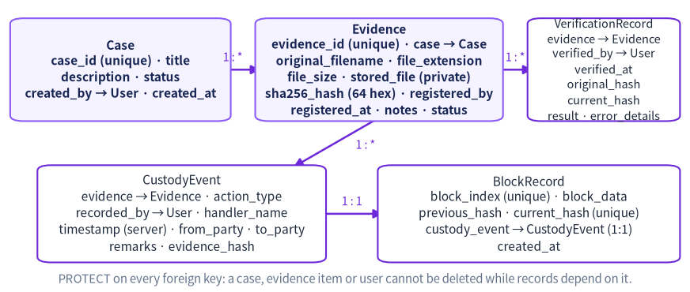
Figure 10.1 — Model relationships. Case 1→* Evidence 1→* CustodyEvent 1→1 BlockRecord, and Evidence 1→* VerificationRecord.

10.1 The models in beginner-friendly language
Model (table) | Important fields | What it means
Case (evidence_case) | case_id (unique, e.g. CASE-0001), title, description, status (OPEN / UNDER_REVIEW / CLOSED), created_by → User (PROTECT), created_at | One investigation. Evidence items are grouped under it. The Case ID is generated automatically.
Evidence (evidence_evidence) | evidence_id (unique, e.g. EV-0001), case → Case, original_filename, file_extension, file_size, stored_file (private storage), sha256_hash (64 hex, check-constrained), registered_by → User, registered_at, notes, status | One registered evidence item: metadata plus a reference to the file. The hash is the permanent fingerprint.
CustodyEvent (evidence_custodyevent) | evidence → Evidence, action_type (REGISTERED, TRANSFERRED, ACCESSED, ANALYSIS_STARTED, ANALYSIS_COMPLETED, RETURNED, ARCHIVED), recorded_by → User, handler_name, timestamp (set by the server), from_party, to_party, remarks, evidence_hash | One line in the chain of custody. Append-only: there is no page to edit or delete these rows.
BlockRecord (blockchain_blockrecord) | block_index (unique), block_data (canonical JSON text), previous_hash, current_hash (unique), custody_event → CustodyEvent (OneToOne, empty only for block 0), created_at | One block of the ledger, stored as a row. This is the only stored copy of block data.
VerificationRecord (verification_verificationrecord) | evidence → Evidence, verified_by → User, verified_at, original_hash, current_hash, result (MATCH / MISMATCH / FILE_MISSING / ERROR), error_details | The verification history. Rows are never edited: they show what was checked, when, by whom, and the outcome.

10.2 Keys, relationships and timestamps
- Primary keys: Django adds an automatic BigAutoField id to every model. The human-friendly codes (case_id, evidence_id) are separate unique columns, so two cases can never share CASE-0001.
- Foreign keys with on_delete=PROTECT mean the database refuses to delete a case, evidence item or user while other records depend on it. This prevents dangling references in a custody history.
- The one-to-one field BlockRecord.custody_event ties each custody event to exactly one block, and a check constraint enforces that only block 0 (the genesis block) may have no custody event.
- Timestamps use default=timezone.now — set by the server, never typed by the user, so an event cannot be back-dated from the form. Django stores them in UTC (USE_TZ = True) and the templates display them in TIME_ZONE; blocks always store the UTC ISO-8601 string.

10.3 Database versus file storage
Where | What is kept | Why there
SQLite db.sqlite3 | Case, evidence metadata, custody events, blocks, verification records | Structured data that must be queryable, comparable and validated
private_evidence/ folder | The evidence files themselves, under random UUID names | Large binary content. It is private: no MEDIA_URL and no URL route serves this folder
Not stored anywhere | The file's content inside a block | Only the hash and metadata go into the blockchain — never the file itself (the registration page says so explicitly)

10.4 Migrations
A migration is the written plan that brings the database tables in step with the model classes. Ready-made migration files ship with the project (evidence/migrations/0001_initial.py, blockchain/migrations/0001_initial.py and verification/migrations/0001_initial.py), so a student normally only runs python manage.py migrate. If you change a model, run makemigrations to write a new plan and migrate to apply it. The evidence migration also adds the check constraint evidence_sha256_is_64_hex_chars, and the blockchain migration creates the genesis block.

Chapter 11 Chain of Custody Implementation

11.1 What a custody event represents
A CustodyEvent is one documented action on one evidence item: who performed it, when the server recorded it, which account recorded it, any From/To parties, and a required purpose/remarks note. Each event is written to the blockchain as a new block, and the pair is saved inside a single database transaction.

11.2 How registration creates the initial record
register_evidence() creates the Evidence row, then immediately calls _create_event_and_block() with action_type = REGISTERED. That single function creates the CustodyEvent (copying the evidence's original sha256_hash into evidence_hash), updates the evidence status through STATUS_AFTER_ACTION, and appends the block. So an evidence item can never exist without at least one custody event and one block — the first block of its history.

11.3 How custody history is preserved
- The application provides no page to edit or delete a custody event, and the Django admin shows Evidence, CustodyEvent and VerificationRecord as read-only (ReadOnlyAdmin sets has_add_permission, has_change_permission and has_delete_permission to False).
- Every event carries a COPY of the evidence's original hash at that moment, so the file fingerprint at each step is visible in the history.
- Events are ordered by timestamp then id, and each one displays the block number it was written into.
- If a custody event were edited directly in the database, the validator would report that the block's details/actor/timestamp no longer agree with the database record.

11.4 How events are associated with blocks
BlockRecord.custody_event is a OneToOneField, so the association is 1:1 and enforced by the database. append_custody_event_block() finds the newest block, builds the next one with create_next_block(), and saves it linked to the event. The block stores the evidence id, the event type, the handler name as the actor, a small details dictionary (from, to, remarks, recorded_by username), the event timestamp as UTC text, and the event's evidence_hash.

11.5 How consistency between database and blockchain is checked
comparisons = [
("custody event id", block.custody_event_id, event.pk),
("evidence id", block.evidence_id, event.evidence.evidence_id),
("event type", block.event_type, event.action_type),
("actor", block.actor, event.handler_name),
("timestamp", block.timestamp, format_block_timestamp(event.timestamp)),
("details", block.details, build_event_details(event)),
("evidence hash (event row)", block.evidence_hash, event.evidence_hash),
("original evidence hash (evidence row)", block.evidence_hash, event.evidence.sha256_hash),
]
for label, block_value, database_value in comparisons:
if block_value != database_value:
check.problems.append(f"the {label} in the block differs from the database record")
Listing 11.1 — blockchain/services.py: the database cross-checks that catch direct table edits.

11.6 What happens when a mismatch is found
- The ledger page shows BLOCKCHAIN INVALID with a numbered list of problems, and the affected rows show an INVALID badge (hover to see the reason).
- The dashboard shows the same status in red, stating that new evidence and custody events are blocked until the problem is investigated.
- require_valid_ledger() then raises LedgerInvalidError, so attempts to register evidence or record an event fail with a message instead of being saved.
- Nothing is repaired automatically. The design decision is deliberate: silently “fixing” a damaged ledger would destroy the very evidence of the damage.

11.7 A realistic example, following the real workflow
Case CASE-0001 “DEMO laptop review” is created; sample_evidence_note.txt is registered as EV-0001 with hash c92deded…a02e51, creating a REGISTERED custody event and block #1 (previous_hash = the genesis hash 1d5f8276…). The investigator records “Evidence accessed” — DEMO EVIDENCE ACCESSED — which creates a second event and block #2 (previous_hash = block #1's hash 2f619df1…). The ledger page then shows three blocks, all VALID, and the dashboard shows 1 case, 1 evidence item, 2 custody events and a VALID 3-block chain. The chain-of-custody page lists both events oldest-first with their block numbers and shortened block hashes.

Chapter 12 Evidence Verification and Tamper Detection

12.1 How a file is selected and re-hashed
The Verify evidence page shows a drop-down of all registered evidence, labelled “EV-0001 - original_filename”. Verification changes data (it appends a history row), so it runs only on POST, protected by the CSRF token. verify_evidence() takes the file path from evidence.stored_file.path — built by Django from the stored relative name inside the private folder — never from anything a user typed.

12.2 What each result means
Result | Condition in the code | What it means for the investigator
MATCH — “Integrity verified” | current_hash == evidence.sha256_hash | The stored file is byte-identical to the file registered. Shown with a green banner.
MISMATCH — “Integrity mismatch” | current_hash != evidence.sha256_hash | The content differs from the registered version. Investigate the cause; it does not by itself prove malicious tampering.
FILE_MISSING | FileNotFoundError while opening the stored file | The file was moved or deleted from the private folder. The database record and hash remain.
ERROR — “Verification error” | OSError or ValueError while reading | The file exists but could not be read. error_details records the reason.

12.3 What is saved, and what is never changed
Every run appends a VerificationRecord with the user, the time, a copy of the original hash, the current hash (blank when it could not be computed), the result and any error details. The original sha256_hash on the Evidence row is never modified by verification — tests/test_verification_reports.py asserts this explicitly after tampering with a file. Both hashes are displayed side by side on the page so the difference is visible, and the history table shows the last 15 runs (filtered to one evidence item when you arrive from a link such as ?evidence=EV-0001).

12.4 What blockchain validation checks
Validation is a different question from verification. On every load of the ledger page (and on the dashboard), the application reads every BlockRecord in order, rebuilds Block objects from the stored JSON, recalculates each hash, checks each previous_hash link, confirms block 0 is the genuine genesis block, confirms the indexes run 0,1,2… without gaps, and then runs the database cross-checks from Chapter 11. The result is a per-block VALID/INVALID badge plus a summary banner such as “BLOCKCHAIN VALID - all 3 block(s) passed the hash and link checks.”

12.5 Testing tampering safely
Three safe routes exist, and none of them alters real data:
- The Tamper demo (safe) page or python manage.py tamper_demo: it builds a synthetic chain entirely in memory, tampers with a COPY, and shows validation failing. Scenarios: edit_data (edit a block's data and leave its hash), edit_and_rehash (edit and recalculate that block's hash) and break_link (change previous_hash).
- The automated tests: python manage.py test tests.test_blockchain_core tests.test_ledger_database -v 2.
- The modified-evidence-file route for cases titled DEMO…: python manage.py demo_modify_file EV-0001 --confirm appends a known marker to the stored COPY, verification then reports INTEGRITY MISMATCH, and --restore removes exactly that marker.
One honest finding from the demo code is worth remembering for the viva: if the attacker edits the LAST block and recalculates its hash, no later block points to it, so hash-linking alone cannot detect it. The demo says this in plain English, and it is exactly why the real application adds the database cross-checks.

12.6 What the system can and cannot prove
Question | Answer
Is the file the same as when it was registered? | Yes — a MATCH is strong evidence of this.
Has the custody history been edited? | Detectable if a hash or a link breaks, or if a block and its database row disagree. NOT detectable if an attacker rewrites every block and every database row.
Who created the file, and where did it come from? | Not provable. A hash says nothing about origin or authenticity.
Was the person who typed the handler name really that person? | Not provable. The login name is also recorded, but a typed name does not prove real-world identity.
Is the evidence legally admissible? | No claim is made. The software and its reports state this explicitly.

Chapter 13 User Interface and Navigation
The interface is server-rendered with Django templates and styled with the local Bootstrap build and the custom “Forensic Violet” theme (static/css/forensic.css). Every page shares base.html: a dark navy sidebar, a white top bar showing the project name and the logged-in username with a Log out button, a dismissible message area, and a footer that repeats the honest scope statement. The screenshots in this chapter are genuine captures of the running application.

13.1 Shared navigation
The sidebar (templates/partials/_nav_links.html) is grouped into three sections: INVESTIGATION — Dashboard, Cases, Evidence, Register evidence, Custody event; INTEGRITY — Verify evidence, Blockchain ledger, Tamper demo (safe); OUTPUT — PDF reports. The active item is highlighted in violet, and on narrow screens the whole navigation moves into a Bootstrap offcanvas drawer opened by a menu button.

13.2 Sign in page
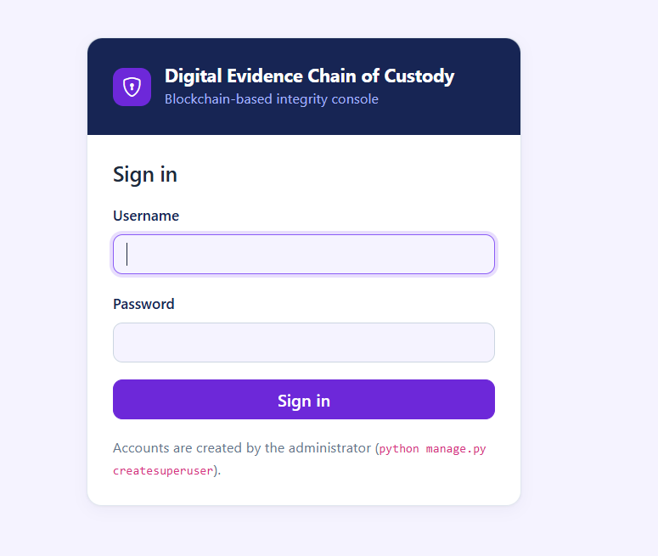
Figure 13.1 — Sign in page (templates/registration/login.html).
Purpose: authentication. Fields: Username and Password. The only button is Sign in. A wrong credential shows “Incorrect username or password. Please try again.” The page states that accounts are created by the administrator with python manage.py createsuperuser — there is no self-registration. Django's LoginView handles the POST; redirect_authenticated_user sends an already-signed-in visitor straight to the dashboard.

13.3 Dashboard
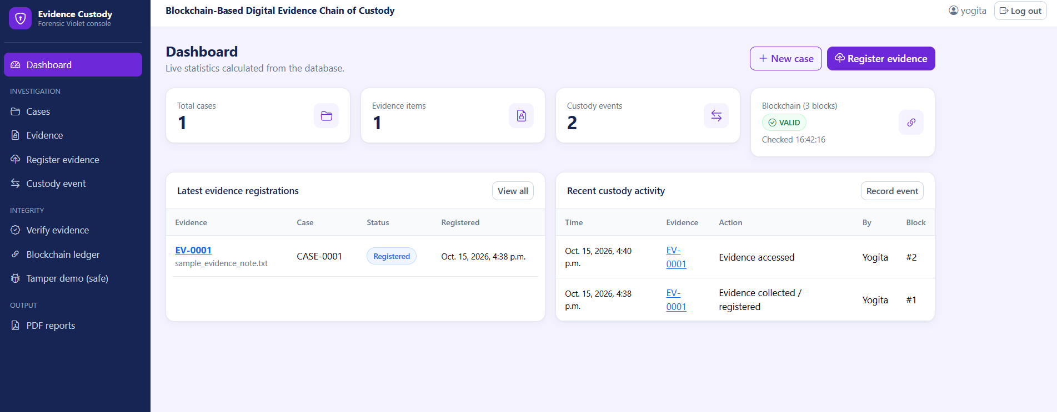
Figure 13.2 — Dashboard with live statistics and a VALID blockchain status.
Purpose: a live overview. Four statistic cards show Total cases, Evidence items, Custody events and the Blockchain status (for example “Blockchain (3 blocks)” with a green VALID badge and the time it was checked). Two panels list the latest evidence registrations and the most recent custody activity; both have an empty state with a call-to-action button (“Register the first item”) when there is no data. The header offers + New case and Register evidence. Every number is counted from the database on each page load by evidence.views.dashboard, which also calls validate_stored_chain() — if the chain were invalid, a red banner would appear here stating that new entries are blocked.

13.4 Register evidence
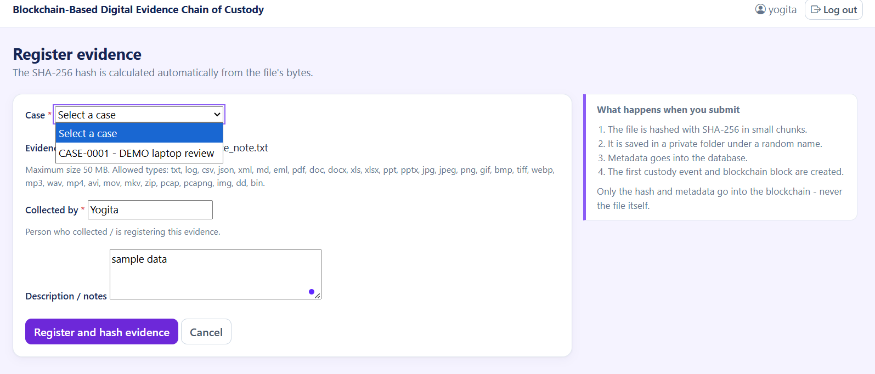
Figure 13.3 — Register evidence form, with the case drop-down open and the helper text listing the allowed file types.
Purpose: upload a new evidence file. Fields: Case (a drop-down of non-closed cases), Evidence file, Collected by and Description / notes. The button is Register and hash evidence. The side callout explains the four things that will happen on submit, and notes that only the hash and metadata go into the blockchain — never the file itself. If there is no open case, a warning tells you to create one first. The form posts with enctype="multipart/form-data" and data-once, which disables the submit button after the first click so a large file cannot be submitted twice. Success redirects to the evidence detail page with the message “Evidence EV-0001 was registered and its first custody block was created.”

13.5 Evidence detail
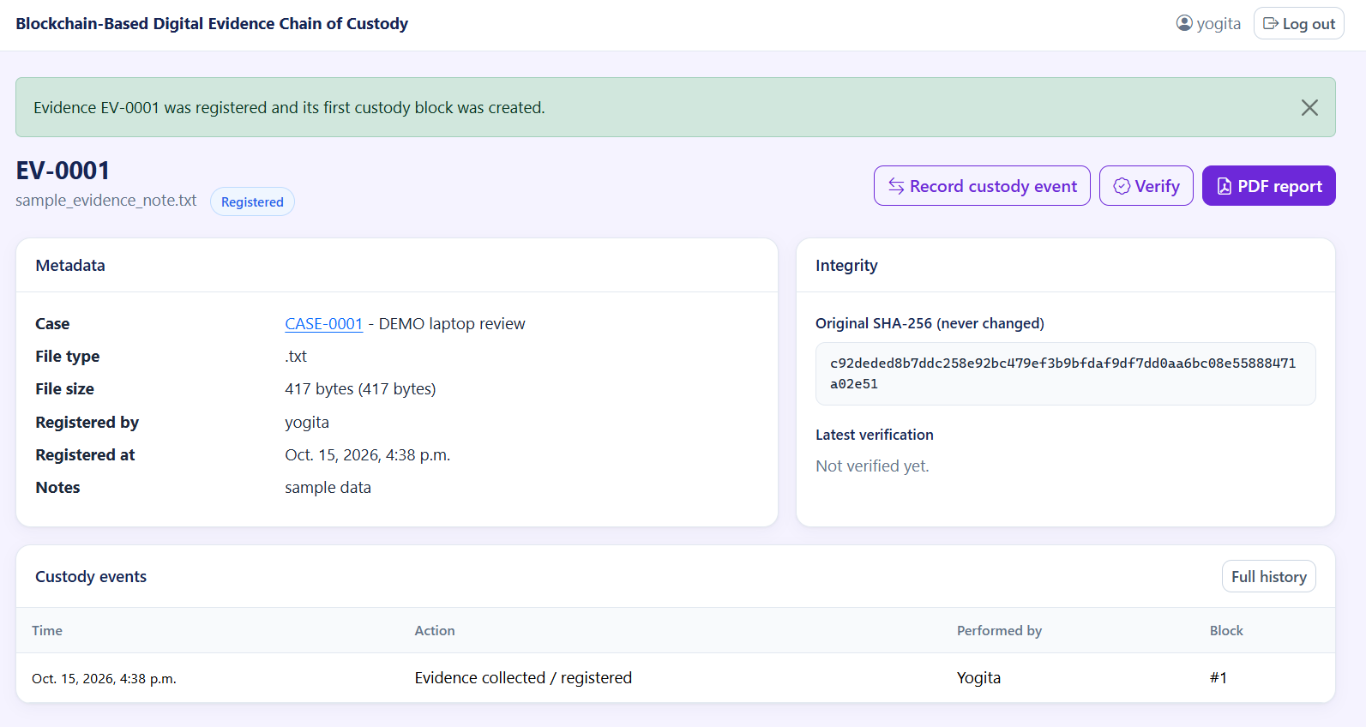
Figure 13.4 — Evidence detail page: metadata, the integrity panel and the custody-event table.
Purpose: everything known about one item. The header shows the Evidence ID, the original filename and a status badge, with three action buttons: Record custody event, Verify and PDF report. The Metadata card lists Case, File type, File size, Registered by, Registered at and Notes. The Integrity card shows the original SHA-256 under the label “Original SHA-256 (never changed)” and the latest verification result (or “Not verified yet.”). The Custody events table shows Time, Action, Performed by and Block, with a Full history button. This page is the natural starting point for demonstrating the project.

13.6 Record custody event
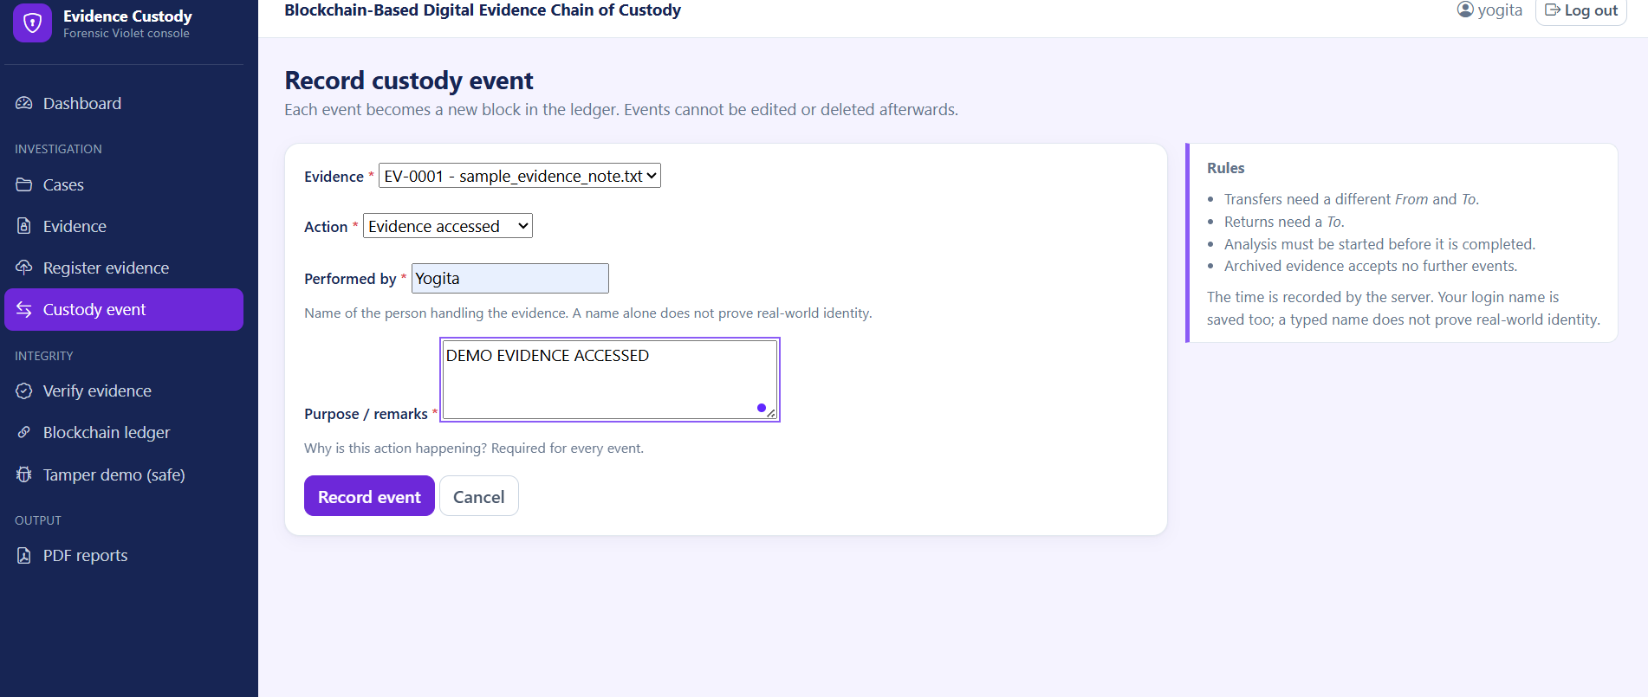
Figure 13.5 — Record custody event, with the Rules panel on the right.
Purpose: append one event to the chain of custody. Fields: Evidence, Action, Performed by, From, To and Purpose / remarks. The From/To pair is shown or hidden by static/js/app.js depending on the chosen action. The Rules panel lists the four enforced rules and states that the time is recorded by the server and that a typed name does not prove real-world identity. The Registration action is deliberately absent from the drop-down because it is created automatically at registration. On success the user is redirected to the custody history with the message “Custody event recorded in block #N.”; on failure the errors appear in the form and nothing is saved.

13.7 Verify evidence
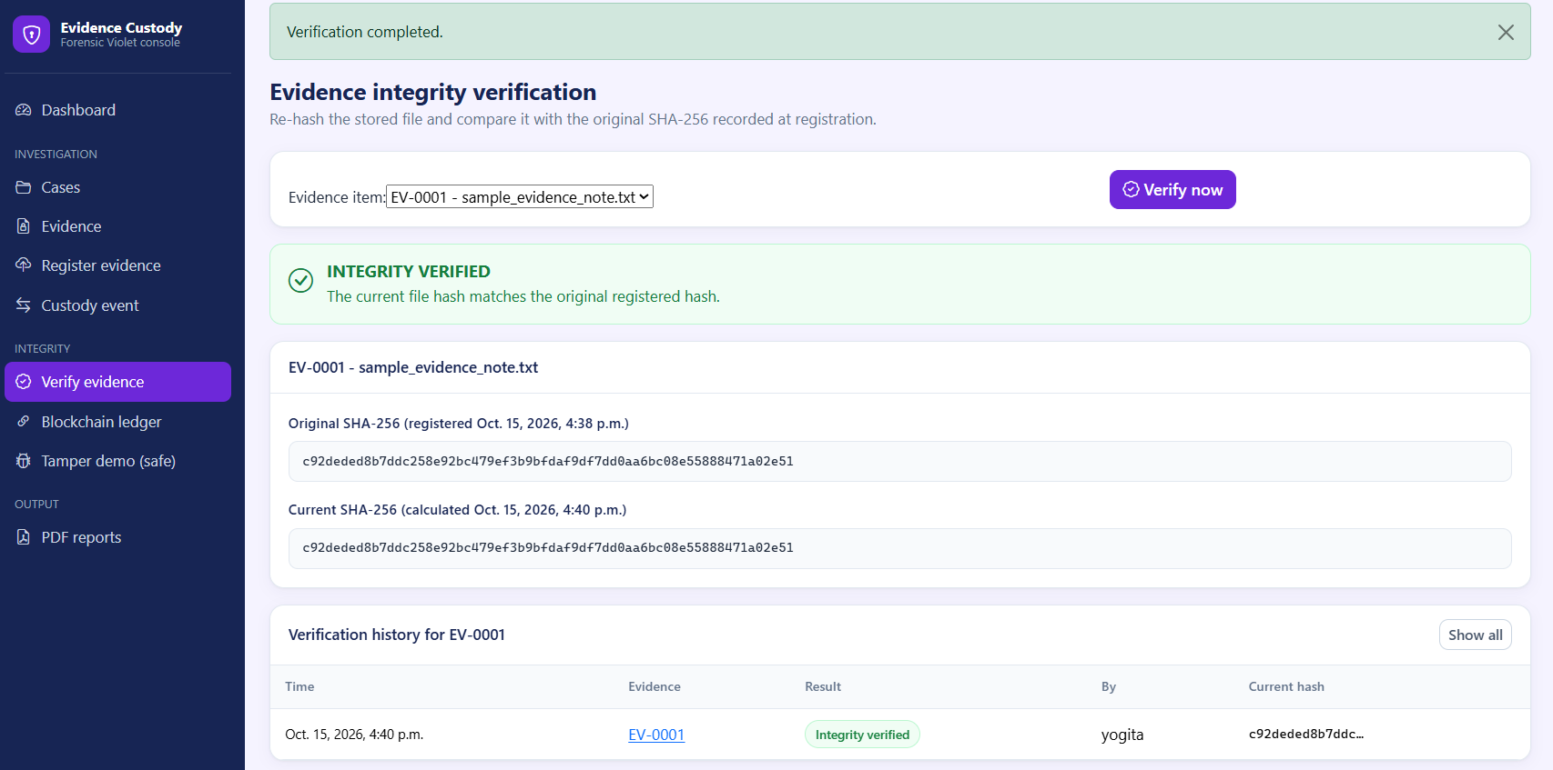
Figure 13.6 — Verification result: both hashes are shown side by side and the run is stored in the history.
Purpose: re-hash a stored file and compare it with the registered hash. The user selects an evidence item and presses Verify now. The result appears as a colour-coded banner — green for INTEGRITY VERIFIED, red for INTEGRITY MISMATCH or FILE MISSING, amber for VERIFICATION ERROR — followed by a card showing the original hash (with the registration time) and the current hash (with the calculation time). The Verification history table lists Time, Evidence, Result, By and Current hash, with a Show all button to clear the filter.

13.8 Blockchain ledger
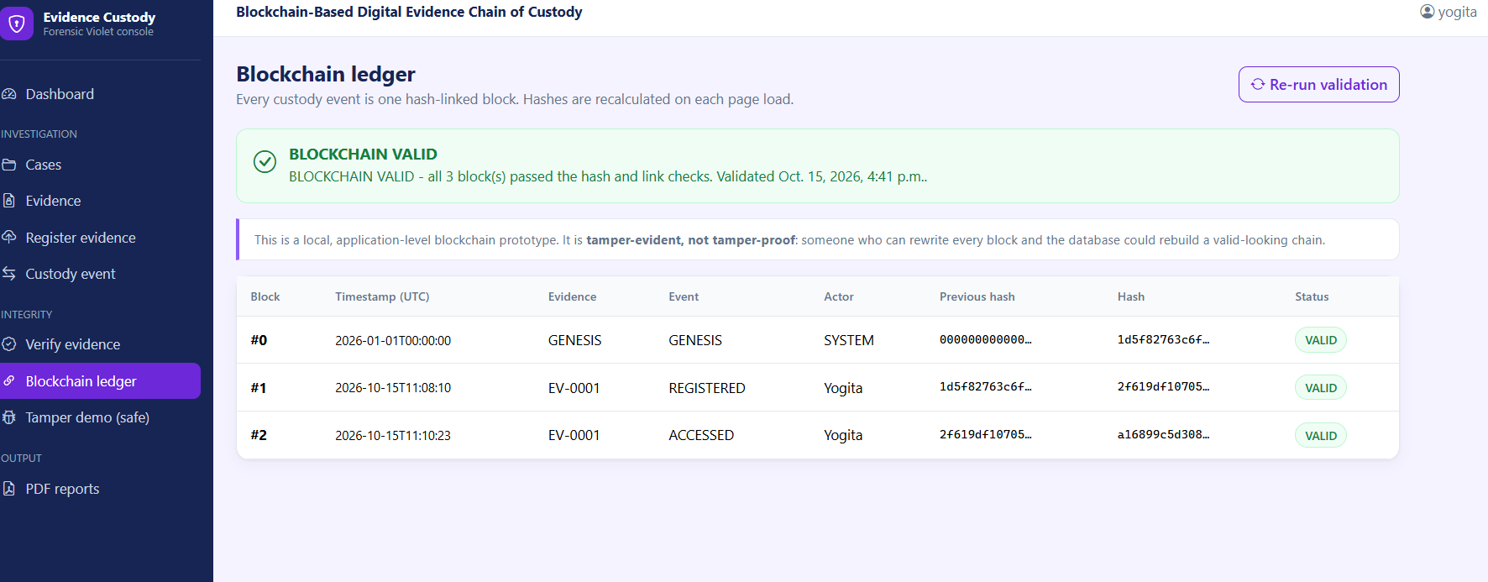
Figure 13.7 — Blockchain ledger: three VALID blocks with their previous hashes and hashes.
Purpose: show every block and prove the chain is intact. The banner reports BLOCKCHAIN VALID with the number of blocks and the validation time, or BLOCKCHAIN INVALID with a numbered list of problems. A callout repeats the honest limitation (“tamper-evident, not tamper-proof”). The table shows Block, Timestamp (UTC), Evidence, Event, Actor, Previous hash, Hash and Status, with long hashes shortened to twelve characters plus an ellipsis and the full value available as a tooltip. Re-run validation simply reloads the page, because validation happens on every load.

13.9 Tamper demo (safe) and PDF reports
The Tamper demo page carries a TEST / DEMO badge and offers a scenario drop-down, a block selector (#1–#4), a mandatory confirmation tick-box and a Run demonstration button. The result shows the original chain as valid, then the tampered copy with its problems and a plain-English explanation, plus a block-by-block table of the tampered copy.
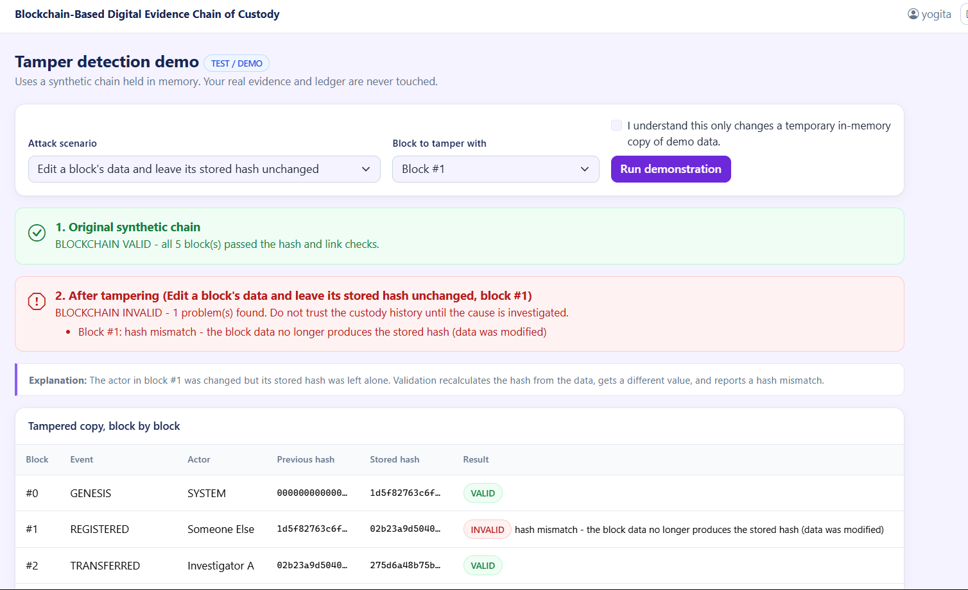

The PDF reports page (Figure 15.1 shows the report it produces) has an evidence drop-down, a checked-by-default box to run a fresh integrity verification first, and a Generate PDF report button; the side callout lists what the report contains and repeats that it does not guarantee legal admissibility.

13.10 Cases, Evidence list and error pages
Cases (/cases/) lists Case ID, title, status and creation details with a search box for Case ID or title and a status filter; /cases/new/ creates a case and /cases/<id>/ shows one case with its evidence items and the custody history of all of them. The Evidence list (/evidence/) shows Evidence ID, Case, File, Size, SHA-256 (shortened), Status and Registered, with filters for Evidence ID or filename, case and status, and pagination at 12 rows. Styled 404 and 500 pages (templates/404.html, 500.html, wired through handler404 and handler500) replace the default error screens when DEBUG is False.

Chapter 14 How to Use the Project
This is the complete user manual, in the order you would demonstrate it. Commands are Windows PowerShell commands run inside the project folder.
- Start the application: activate the virtual environment (.\venv\Scripts\Activate.ps1) and run python manage.py runserver. Open http://127.0.0.1:8000/ — every view is protected by @login_required, so you are redirected to /login/.
- Sign in with the account created by python manage.py createsuperuser (there is no self-registration page).
- Dashboard: check the four statistic cards and the blockchain status badge. On a fresh database you see 0 cases, 0 evidence items, 0 custody events and a VALID chain with 1 block (the genesis block).
- Cases → New case: enter a title (start it with “DEMO” if you plan to run the tamper demonstration) and press Create case. CASE-0001 is generated automatically.
- Register evidence: choose the case, choose a file (try sample_data\sample_evidence_note.txt), enter Collected by, press Register and hash evidence. The hash is computed, the file is stored privately under a random name, and the REGISTERED event plus block #1 are created. You land on the evidence detail page.
- Record custody events: Custody event → choose the evidence and an action, fill Performed by and Purpose / remarks, add From and To for a transfer or return, press Record event. Each event becomes a new block.
- Full history shows the chain of custody oldest-first with From → To, remarks, the block number and a shortened block hash.
- Verify evidence → choose the item → Verify now: read the banner and compare the two hashes. Every run is saved in the history.
- Blockchain ledger: validation runs on every page load (Re-run validation just reloads it); every block should show VALID.
- PDF reports → choose the evidence → leave “Run a fresh integrity verification first” ticked → Generate PDF report. It downloads as custody_report_EV-0001_YYYYMMDD_HHMMSS.pdf.
- Log out from the top bar (a POST form protected by CSRF), stop the server with Ctrl + C, and type deactivate to leave the virtual environment.

14.1 A sample scenario (fictional data, clearly labelled as an example)
Example only — the names, the case and the file are invented. Case “CASE-0001 DEMO laptop review” with the description “reviewing a laptop (demo case)”. The synthetic file sample_evidence_note.txt (417 bytes) is registered by the user yogita with the note “sample data”, becoming EV-0001 with original SHA-256 c92deded8b7ddc258e92bc479ef3b9bfdaf9df7dd0aa6bc08e55888471a02e51. Two custody events follow: “Evidence collected / registered” by Yogita in block #1, then “Evidence accessed” with the remark “DEMO EVIDENCE ACCESSED” by Yogita in block #2. Verification reports INTEGRITY VERIFIED with an identical current hash, and the ledger reports all three blocks VALID. The PDF report then summarises exactly this data.

Chapter 15 PDF Reporting

15.1 Purpose and library
The report turns the database records into a printable, self-contained summary of one evidence item's custody history. It is produced with ReportLab 5.0.1, using SimpleDocTemplate, Table, Paragraph, Spacer and A4 page size — no HTML-to-PDF conversion and no browser is involved. Generation happens in memory (io.BytesIO) and the finished bytes are returned as an application/pdf response with a Content-Disposition attachment filename, so nothing is left on disk.

15.2 What the report contains
- Section 1 — Case details: Case ID, title, status, description and creation time.
- Section 2 — Evidence and registration: Evidence ID, original filename, file type, file size, the original SHA-256, who registered it and when, the current custody status and the notes.
- Section 3 — Chronological custody history: Time, Action, Performed by, From > To, Remarks, Block number and the block hash for every event.
- Section 4 — Latest evidence verification: the outcome (INTEGRITY VERIFIED / INTEGRITY MISMATCH / FILE MISSING / VERIFICATION ERROR), when and by whom, both hashes and any details.
- Section 5 — Blockchain validation: the verdict, the number of blocks checked, the validation time and the summary message (plus the first ten problems if the chain is invalid).
- Section 6 — Important notes: the plain-English disclaimer about what a hash match does and does not prove.
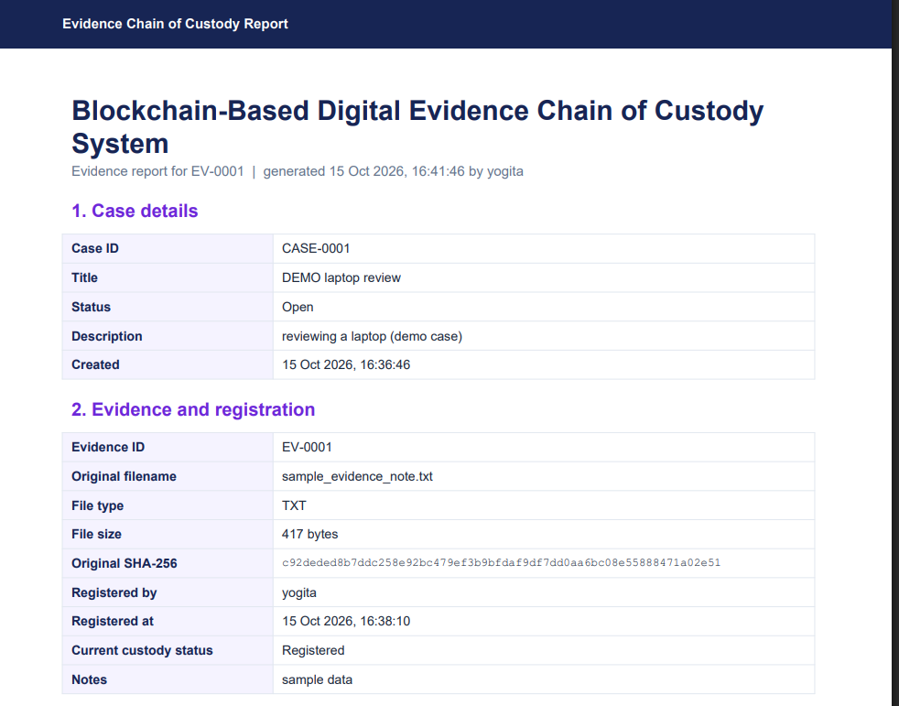
Figure 15.1 — The generated PDF report, showing the navy header band and sections 1 and 2.

15.3 How it is generated and which functions are responsible
reports/views.py:generate_report() loads the evidence, optionally runs verify_evidence() when ?verify_now=1, collects the events and the latest verification, runs validate_stored_chain() so the report contains a FRESH ledger verdict, and calls build_evidence_report(). Inside reports/pdf_generator.py, _styles() defines the paragraph styles (violet headings, Courier hash style with wordWrap="CJK"), _key_value_table() builds the two-column tables with a lavender label column, _p() escapes user text with xml.sax.saxutils.escape so a stray & or < cannot break the PDF, and _header_footer() draws the navy top band, the footer disclaimer and “Page N” on every page.

15.4 How to use it and how it helps auditing
PDF reports → choose the evidence item → leave “Run a fresh integrity verification first” ticked (recommended) → Generate PDF report. The browser downloads the file. Because the report carries the original hash, the full custody history with block numbers and block hashes, the latest verification and the ledger verdict, it gives an auditor one document that can be checked independently: the original hash can be recomputed from the evidence file, and the block hashes can be compared with the ledger page. Section 4 also prints the honest warning that a mismatch means the content differs from the registered version and does not by itself prove malicious tampering.

15.5 Limitations
- The report is a summary of this prototype's data — it is not a signed or certified forensic document.
- It does not guarantee legal admissibility, and it says so on the page and in the footer of every page.
- If no verification has been run, section 4 states that plainly instead of inventing a result.
- The report is generated on demand from live data; it is not archived by the application.

Chapter 16 Testing and Quality Assurance

16.1 What automated testing means here
An automated test is a piece of code that sets up a situation, performs an action, and asserts what must be true. Django's test runner creates a TEMPORARY database and deletes it afterwards, and tests/helpers.py overrides EVIDENCE_STORAGE_ROOT to point at a temporary folder, so running the tests never touches your real db.sqlite3 or your real evidence files.

16.2 The test suite (45 tests, confirmed)
File | Tests | What it proves
tests/test_hashing.py | 4 | SHA-256 of b'abc' equals the published vector; identical files hash identically; one changed byte changes the hash; chunked hashing equals whole-file hashing (chunk sizes 7 and 13).
tests/test_blockchain_core.py | 12 | The genesis block is deterministic; canonical JSON ignores key order; blocks are linked; a valid chain passes; edited data gives a hash mismatch; a wrong previous_hash gives a broken link; edit-and-rehash breaks the NEXT link; a fake genesis is rejected; tampering with a copy leaves the original valid; all three demo scenarios are detected.
tests/test_ledger_database.py | 11 | Genesis exists exactly once; registration creates block #1 linked to block #0; each event gets the next linked block; evidence status follows events; edited block data, edited custody events and an edited original hash are all detected; a deleted block is detected; new events are refused on a damaged ledger (LedgerInvalidError) and nothing is saved; a transfer needs From and To; archived evidence rejects further events.
tests/test_evidence_views.py | 12 | All 14 protected URLs redirect anonymous visitors to the login page; login reaches the dashboard; stored evidence has NO public URL; registration stores the correct hash, size, filename and EV-0001 with a random storage name; IDs are sequential; .exe, oversized and empty files are refused; a valid transfer is saved with block #2 while an invalid one saves nothing; every main page returns HTTP 200; search filters work.
tests/test_verification_reports.py | 6 | An unchanged file gives MATCH; a modified file gives MISMATCH and the original hash is NOT overwritten; a deleted file gives FILE_MISSING; the verification page posts and stores history; the report endpoint returns a real PDF (starts with %PDF, larger than 1500 bytes, Content-Type application/pdf) for a long filename; an unknown evidence ID redirects instead of crashing.

16.3 How to run the tests and read the output
python manage.py test
# Found 45 test(s).
# Creating test database for alias 'default'...
# .............................................
# Ran 45 tests in 11.642s
# OK
# Destroying test database for alias 'default'...
python manage.py test tests.test_blockchain_core tests.test_ledger_database -v 2 # verbose
Listing 16.1 — The real output of the test suite as executed for this handbook.
A line of dots means passing tests; an F means a failure and an E an error, and the traceback below shows exactly which assertion failed. “System check identified no issues (0 silenced)” means Django's own configuration checks passed as well.

16.4 Syntax checks, system checks and tests are different things
Check | Command | What it catches
Syntax / import check | python -m compileall . or python -c "import config.settings" | Typos and syntax errors only — it proves nothing about behaviour
Django system check | python manage.py check (runs automatically with most commands) | Missing migrations, bad settings, broken model definitions
Automated tests | python manage.py test | Actual behaviour: hashes, validation, rules, views, PDF output

Honest statement about execution: the 45 tests were executed for this handbook in a Linux sandbox with Python 3.13 and Django 5.2.18, and the run reported “Ran 45 tests … OK”. The README states they were tested with Python 3.13.13 and Django 5.2.18 on Windows 11; a Windows run was not performed for this handbook, so re-run python manage.py test on your own machine to confirm.

16.5 Testing file tampering safely
Never edit the original evidence file by hand. Use the Tamper demo page, the tamper_demo management command, the automated tests, or — only for a case titled DEMO… — demo_modify_file EV-0001 --confirm followed by --restore. That command appends a fixed marker to the stored copy, refuses to run without --confirm, refuses evidence outside a DEMO case, and never touches the database, the blocks or the original hash.

Chapter 17 Security, Privacy and Limitations

17.1 Protections that ARE implemented
Protection | Where it is implemented
Authentication on every page — anonymous visitors are redirected to the login page | @login_required on all views; asserted for 14 URLs in tests/test_evidence_views.py
Hashed passwords and four password validators | django.contrib.auth + AUTH_PASSWORD_VALIDATORS in config/settings.py
CSRF protection on every POST form | CsrfViewMiddleware + {% csrf_token %} in every form
Server-side validation of uploads (extension allow-list of 34 safe types, 50 MB limit, empty file refused) | evidence/forms.py clean_evidence_file + settings
Private evidence storage with no public URL and no route to the folder | evidence/storage.py (base_url returns None), config/urls.py
Random storage filenames, defeating path traversal and name collisions | evidence/models.py evidence_upload_path()
Only the hash and metadata go into the blockchain — never the file itself | register_evidence(); stated on the registration page
Append-only history: no edit/delete pages, read-only admin for evidence, custody events and verification records | evidence/admin.py (ReadOnlyAdmin), verification/admin.py
A damaged ledger blocks new entries instead of being repaired silently | blockchain/services.py require_valid_ledger()
Tamper detection through recalculated hashes, link checks, a genuine-genesis check and database cross-checks | blockchain/validation.py + _cross_check_record()
No evidence download feature at all | Deliberate design decision, documented in README.md

17.2 Risks and honest limitations
- The ledger is tamper-EVIDENT, not tamper-PROOF. Someone who can rewrite every block and every database row could rebuild a chain that still validates.
- SQLite and a local folder are not high-assurance forensic storage: there is no encryption at rest, no write-once media, no off-site backup and no access logging.
- A hash match proves unchanged CONTENT since registration. It does not prove origin, authorship or authenticity, and a mismatch is a reason to investigate rather than proof of malice.
- A username plus a typed handler name does not independently prove a person's real-world identity.
- All logged-in users have the same permissions — there is no role system (kept simple on purpose).
- SECRET_KEY defaults to a clearly-labelled development key and DEBUG defaults to True, so the server must not be exposed to the public internet as-is.
- No claim of legal admissibility is made anywhere by the software or its reports.
- Because only the hash is stored in the block, the ledger proves that a specific file fingerprint was recorded at a specific time — it does not preserve the file itself.

17.3 Safe handling, backup and future hardening
For real use, evidence files should be copied to write-once or versioned storage with an off-site backup, and the database file should be backed up together with it — a hash without the file proves nothing, and a file without the ledger loses its history. The .gitignore file already prevents db.sqlite3 and private_evidence/ from being committed to version control, which is the right default. Chapter 19 lists the hardening steps (roles, digital signatures, external timestamping, encryption, proper deployment) as future work rather than claiming they exist today.

Chapter 18 Troubleshooting and Frequently Asked Questions

18.1 Problems and fixes
Problem | Likely cause and solution
'python' is not recognized / wrong Python launcher | Python is not on PATH or the py launcher is missing. Reinstall Python 3.13 and tick “Add python.exe to PATH”; then use py -3.13 -m venv venv.
running scripts is disabled on this system | PowerShell execution policy. Run Set-ExecutionPolicy -Scope Process -ExecutionPolicy Bypass, then activate the venv again.
Virtual environment will not activate | Check the path: .\venv\Scripts\Activate.ps1 must exist. If venv/ was created with a different Python, delete it and recreate it.
No module named 'django' (or ReportLab missing) | The venv is not active. The prompt must begin with (venv); activate it and re-run python -m pip install -r requirements.txt.
no such table: evidence_case | Migrations were not applied. Run python manage.py migrate in the folder that contains manage.py.
Migration errors after editing a model | Run makemigrations then migrate; if a model change conflicts, read the message — Django usually names the missing field or the required default.
Error: That port is already in use | Another server is running. Use python manage.py runserver 8001, or stop the other process.
Login fails / permission problems | Accounts are created only with python manage.py createsuperuser. For a forgotten password use python manage.py changepassword <username>.
Upload rejected: “File type '.xxx' is not allowed” | The extension is not in ALLOWED_EVIDENCE_EXTENSIONS in config/settings.py (executable and script types are excluded on purpose).
Upload rejected: “The file is larger than the 50 MB limit” | Raise MAX_EVIDENCE_UPLOAD_BYTES in config/settings.py (also consider FILE_UPLOAD_MAX_MEMORY_SIZE).
FILE MISSING during verification | The stored file was moved or deleted from private_evidence/. Restore it from backup, or re-register the evidence.
INTEGRITY MISMATCH | The stored file's bytes changed. Investigate: it could be corruption, an accidental edit, a restore from the wrong backup, or deliberate tampering. The original hash is kept, so the record is not lost.
Blockchain validation fails | Open Blockchain ledger to see which block is wrong and why. Common causes: a row was edited directly in the database, a block row was deleted, or a custody event has no block. Nothing is repaired automatically; restore from a good backup or rebuild the database if this was a deliberate experiment.
“Evidence was NOT registered … ledger” or “The event was NOT recorded … ledger” | The ledger failed validation, so writes are refused by design. Fix the ledger problem first.
PDF generation fails | Check that ReportLab installed (python -c "import reportlab"). Generation also runs a fresh ledger validation; if the chain is invalid the report shows the problems rather than failing silently. Timestamps that differ from UTC are intentional: Django stores UTC and displays TIME_ZONE (default Asia/Kolkata); blocks always store the UTC text.
Database or configuration problems / starting over | Stop the server, delete db.sqlite3 and the private_evidence folder, then run python manage.py migrate again and recreate the superuser. The database and the evidence files must be reset together.

18.2 Frequently asked questions
Question | Answer
Does this use Ethereum or a real public blockchain? | No. It is a local, application-level, hash-linked ledger written in plain Python and stored in SQLite.
Is the evidence file stored in the blockchain? | No. Only the SHA-256 hash and the event metadata are stored. The file lives in private_evidence/.
Can I download an evidence file from the app? | No — there is deliberately no download feature, so evidence is never served over the web.
Can a custody event be edited or deleted? | Not through the application, and the admin site shows these tables read-only. A direct database edit would be detected by validation.
What happens if the ledger is damaged? | New evidence and new custody events are refused, and the problem is listed on the ledger page and dashboard. Nothing is auto-repaired.
Do I need an internet connection to run it? | No. Bootstrap and its icons are vendored locally, and the database is a local file.
How do I reset the project for a fresh demo? | Stop the server, delete db.sqlite3 and private_evidence/, run migrate, and create the superuser again.

Chapter 19 Future Enhancements
Everything in this chapter is FUTURE WORK. None of it exists in the current source code.

19.1 Most suitable for a university minor project (small, self-contained additions)
- Role-based access control: give investigators, analysts and auditors different permissions using Django groups and permission checks, so not everyone can register evidence.
- An audit log of logins, downloads and failed attempts, stored in its own append-only table.
- More evidence metadata (device, hash of the acquisition tool, collector organisation, seal number) and richer filters and CSV export on the evidence list.
- Backup and restore helpers: a management command that copies db.sqlite3 and private_evidence/ together and verifies every hash after restoring.
- Anchoring the latest block hash outside the system — print it on the PDF report, e-mail it to a supervisor, or publish it in a shared document — so that a full local rewrite becomes detectable.
- More tests: form-level tests for every rule, tests for the tamper-demo edge case where the last block is edited, and a test that the report contains the exact original hash.

19.2 Substantial additional development (a larger project on its own)
- Digital signatures and authenticated collection: sign each block (and optionally the evidence hash) with a per-user private key so identity, not just a typed name, is provable.
- Trusted external timestamping or a public anchor: publish block hashes to a trusted timestamping service or an existing public ledger so that the chain's history is witnessed by a third party.
- A properly designed distributed ledger: multiple independent nodes with a consensus rule, which is the only way to make history rewriting genuinely impractical — and only worth building if a real requirement justifies the complexity.
- Encryption at rest for evidence and the database, plus a key-management plan.
- Production deployment: DEBUG = False, a real secret key from the environment, HTTPS, a production database (for example PostgreSQL), a web server and reverse proxy, static-file serving, and automated backups.
- Write-once or object-locked evidence storage, and integration with a lab's existing case-management system.
- A REST API so that other forensic tools can register evidence and read the ledger programmatically.

19.3 What to prioritise for the viva
For a minor project, the first list is the right scope: roles, an audit log, richer metadata and external anchoring of the latest block hash are each small, demonstrable and clearly valuable. The second list needs significant additional work and should be presented as a roadmap with an honest explanation of why a single local copy cannot be made tamper-proof.

Chapter 20 Glossary and Viva Preparation

20.1 Glossary in very easy language
Term | Meaning
Digital evidence | Any file or data that may be used in an investigation: a note, a log, an image, a video, a disk image.
Chain of custody | The documented history of who had the evidence, when, and what they did with it.
Integrity | The content has not changed — not even by one byte — since it was registered.
Authenticity | Proof of where the content came from and that it is genuine. A hash alone does not prove this.
Hash / digest | A fixed-length fingerprint of data. SHA-256 always gives 64 hexadecimal characters.
SHA-256 / hex | A one-way function from the SHA-2 family producing a 256-bit digest, written as 64 base-16 characters (0–9, a–f). Same input, same output; a one-bit change gives a different output.
Block | One record in the ledger. Here one custody event, plus hashes and the link to the previous block.
Genesis block | Block #0, the fixed starting point with a constant timestamp and an all-zero previous hash.
previous_hash | The hash of the block before this one — the “link” that makes a chain.
Canonical JSON | One exact, repeatable text form of data (sorted keys, no extra spaces) so the same data always hashes the same way.
Validation | Recalculating every block hash and checking every link to detect an edited history.
Verification | Re-hashing a stored file and comparing it with the original hash (MATCH / MISMATCH).
Tamper-evident | Editing becomes visible. This project is tamper-evident.
Tamper-proof | Editing is impossible. This project is NOT tamper-proof — one party owns the database file.
Migration | The written plan that brings the database tables in step with the model classes.
Model / ORM | A Python class describing one database table; Django's ORM reads and writes rows as Python objects. A ForeignKey with PROTECT forbids deleting the referenced row while records depend on it. A transaction (transaction.atomic()) is a group of writes that all succeed or all roll back.
UTC / time zone | Coordinated Universal Time. Stored internally; displayed in TIME_ZONE (default Asia/Kolkata).
CSRF token | A hidden value that stops another website from submitting your forms on your behalf.
@login_required | A Django decorator that redirects anonymous visitors to the login page.
Private storage | A folder with no public URL, so evidence files cannot be fetched from a browser.
Hash mismatch | The recalculated hash differs from the stored one — the data changed.
Broken link | A block's previous_hash no longer equals the previous block's hash.
ReportLab | The Python library used to build the PDF report.
Bootstrap | A CSS framework, vendored locally, used for the layout of the interface.
Forensic Violet | The name of this project's visual theme: navy, violet, lavender, white.

20.2 Viva questions with answers (25)
Q1. What does your project do in one sentence? It registers digital evidence with a SHA-256 fingerprint and records every custody action as a block in a hash-linked ledger, so that changes to the file or to the history can be detected, and it produces a PDF custody report.
Q2. Why did you use hashing instead of encryption? I need to DETECT change, not hide content. A hash is one-way and needs no key, so anyone can re-hash the file and check it. Encryption is for confidentiality and would need key management.
Q3. Why SHA-256 specifically? It gives a fixed 256-bit (64 hex character) digest, is deterministic, has the avalanche property, and is available in Python's standard library as hashlib.sha256. No extra dependency is needed.
Q4. Which formula computes the evidence hash? H_evidence = SHA256(F), where F is the complete byte content of the file, read in 1 MiB chunks in evidence/hashing.py.
Q5. How is a block's hash computed? H_i = SHA256(CanonicalJSON(D_i)), where D_i is every block field except the block's own hash. It is implemented as sha256_text(serialize()) in blockchain/block.py.
Q6. Why do you need canonical JSON? SHA-256 hashes bytes. Without a single exact text form, the same data could be written with keys in a different order and produce a different hash, so validation would fail for no real reason. sort_keys, separators and ensure_ascii fix the text.
Q7. What exactly is inside the block hash? index, timestamp, evidence_id, custody_event_id, event_type, actor, details, evidence_hash and previous_hash. The block's own hash is excluded because a value cannot be an input to its own calculation.
Q8. Why is the evidence file itself not in the blockchain? Only the hash and metadata are stored, which keeps the ledger small and avoids duplicating sensitive content. The file lives in the private folder.
Q9. What is the genesis block and why is its timestamp fixed? It is block #0, the starting point. Its timestamp is a constant (2026-01-01T00:00:00+00:00) so that it is identical on every machine; the validator uses that to confirm block 0 is genuine.
Q10. How does validation detect tampering? For every block it recalculates the hash and compares it with the stored value, checks that previous_hash equals the previous block's hash, checks that block 0 is the genuine genesis block, and checks that the indexes run 0,1,2,… without gaps. It then cross-checks each block against its custody event and the evidence's original hash.
Q11. Why do you recalculate hashes instead of trusting the stored ones? A stored hash is only a claim. If someone edits the data and leaves the old hash in place, the stored value still looks fine — only recalculating from the data reveals the disagreement.
Q12. If an attacker edits a block AND recalculates its hash, is the attack still detected? Yes, for any block that has a successor: the next block still stores the OLD hash as its previous_hash, so the link check fails. If the attacker also rewrites every later block and the matching database rows, the chain validates again — that is the honest limit of a single local copy.
Q13. What is the difference between evidence verification and ledger validation? Verification re-hashes one evidence FILE and compares it with its original hash. Ledger validation recalculates the BLOCK hashes and checks the links and the database cross-checks. One answers “is the file unchanged?”, the other “is the history unchanged?”
Q14. What are the possible verification results? MATCH (integrity verified), MISMATCH (content differs), FILE_MISSING (the stored file is gone) and ERROR (the file exists but could not be read).
Q15. Does a mismatch prove tampering? No. It proves the content differs from the registered version. It could be corruption, an accidental edit, a wrong restore, or deliberate tampering. It is a signal to investigate.
Q16. Is the original hash ever overwritten? Never. Verification writes only a new VerificationRecord row. A test asserts that the original hash is unchanged after a file is modified.
Q17. Why are the custody event and the block saved in one transaction? So an event is never reported as recorded without its block. If appending the block fails, the whole transaction rolls back and nothing is saved.
Q18. What are the custody rules? Transfers need different From and To; returns need a To; analysis must be started before it is completed; archived evidence accepts no further events; handler name and remarks are required. The rules are enforced in the form AND in the service layer.
Q19. Why is the timestamp set by the server? So an event cannot be back-dated from the form. The field uses default=timezone.now and the login name is recorded as well.
Q20. Which Django models does your project define? Case, Evidence and CustodyEvent in the evidence app, BlockRecord in the blockchain app, and VerificationRecord in the verification app — plus Django's own User.
Q21. How are evidence files stored and why is that safe? In private_evidence/ under a random UUID name with only the extension kept, using a custom PrivateEvidenceStorage whose base_url is None. There is no MEDIA_URL and no URL route for the folder, so files cannot be fetched from a browser, and there is deliberately no download feature.
Q22. What security features are implemented? Django authentication with hashed passwords, @login_required on every page, CSRF protection, server-side validation, an upload extension allow-list and a 50 MB size limit, private storage, random filenames, read-only admin for history tables, and a rule that refuses new entries when the ledger is invalid.
Q23. What are the main limitations? The ledger is tamper-evident, not tamper-proof; there is no role system; SQLite and a local folder are not high-assurance storage (no encryption at rest, no write-once media, no off-site backup); a hash proves unchanged content, not authenticity; a typed handler name does not prove identity; and no claim of legal admissibility is made.
Q24. Why is this not a real distributed blockchain? There is no peer-to-peer network, no independent copies, no consensus protocol, no mining and no digital signatures. It is a single hash-linked ledger in one SQLite file — deliberately, to stay explainable and honest in scope.
Q25. How is the PDF report generated? reports/pdf_generator.py builds it in memory with ReportLab's SimpleDocTemplate and A4 pages: case details, evidence and registration, the chronological custody history with block numbers and hashes, the latest verification, the fresh blockchain validation result, and the disclaimers.

20.3 One-minute project explanation
“My project is a Blockchain-Based Digital Evidence Chain of Custody System built with Python, Django and SQLite. An investigator logs in, creates a case, and registers an evidence file. The application computes its SHA-256 hash in 1 MiB chunks, stores the file in a private folder under a random name, saves the metadata, and creates the first custody event together with block #1 in one database transaction. Every later action — accessed, transferred, analysis started or completed, returned, archived — becomes another block, and each block stores the hash of the block before it. To check the file I re-hash it and compare it with the original hash; to check the history I recalculate every block hash, verify every link and cross-check each block against its database row. Finally, it generates a PDF chain-of-custody report with ReportLab. It is a local, application-level prototype — tamper-evident but not tamper-proof — and it makes no claim of legal admissibility.”

20.4 Two-minute project explanation
“The problem is that digital evidence is trivial to modify and a paper or spreadsheet custody log is trivial to edit afterwards. My project attacks both problems. First, integrity: when evidence is registered, the file's bytes are hashed with SHA-256 in 1 MiB chunks and the digest is stored permanently — 64 hexadecimal characters. Verification re-hashes the stored file and compares; the result is MATCH, MISMATCH, FILE_MISSING or ERROR, and every run is appended to a history table. The original hash is never overwritten. Second, history: every custody event is written into a custom Python blockchain. A block holds the index, a UTC timestamp, the evidence id, the custody event id, the event type, the actor, a small details dictionary, the evidence hash and the previous block's hash. Its own hash is SHA-256 of the canonical JSON of those fields — canonical meaning sorted keys, no extra spaces, so the same data always hashes identically. Validation recalculates every hash, checks that each block's previous_hash equals the previous block's hash, confirms block 0 is the genuine deterministic genesis block, checks the indexes are sequential, and then cross-checks each block against its custody-event row and the evidence's original hash. If anything is wrong, the ledger page lists the problems and the application REFUSES new evidence and new events instead of repairing the chain silently. The stack is Django 5.2 with SQLite, hashlib, ReportLab for the PDF, and vendored Bootstrap for the interface. There are 45 automated tests covering hashing, the in-memory blockchain, the database ledger, the views and the reports, and they all pass. I am careful about scope: this is a hash-linked log in one file, so it is tamper-evident but not tamper-proof, and a hash match proves unchanged content rather than authenticity.”

20.5 The most important formulas in one place
1) Evidence hash H_evidence = SHA256(F) F = all bytes of the file
2) Block hash H_i = SHA256(CanonicalJSON(D_i)) D_i = block data without its own hash
3) Linking PreviousHash_i = Hash_(i-1) and Index_i = Index_(i-1) + 1
4) Validation RecalculatedHash_i == StoredHash_i AND previous_hash_i == hash_(i-1)
AND block 0 == genuine genesis AND indexes 0,1,2,... with no gap
(+ cross-checks against the custody-event row and the original evidence hash)
5) Verification MATCH if OriginalHash == CurrentHash else MISMATCH
(plus FILE_MISSING and ERROR when the hash cannot be computed)
SHA-256 output: 256 bits = 64 hexadecimal characters. CanonicalJSON = json.dumps(
data, sort_keys=True, separators=(",", ":"), ensure_ascii=True)

20.6 Final revision checklist
- Can you state the difference between hashing and encryption, and between integrity and authenticity?
- Can you write Formula 1 and Formula 2 from memory and say exactly which fields are hashed?
- Can you explain why canonical JSON is needed, with the {"a":1,"b":2} example?
- Can you explain the two attacks (hash mismatch, broken link) and the honest limit of a single local copy?
- Can you name the four validation rules and the extra database cross-checks?
- Can you name all five models and the relationships between them?
- Can you list the custody rules and say where they are enforced (form AND service)?
- Can you explain transaction.atomic() and why the event and its block are written together?
- Can you explain why require_valid_ledger() refuses writes on a damaged chain?
- Can you describe the four verification results and state that the original hash is never overwritten?
- Can you explain the upload guard rails (extension allow-list, 50 MB limit, random stored name, private folder, no download route)?
- Can you say how many tests exist, what they cover, and what the honest scope statement is?
- Can you run the demo safely — Tamper demo page, tamper_demo command, or demo_modify_file for a DEMO case only?
- Can you state three realistic future improvements and one that would need substantial extra work?

