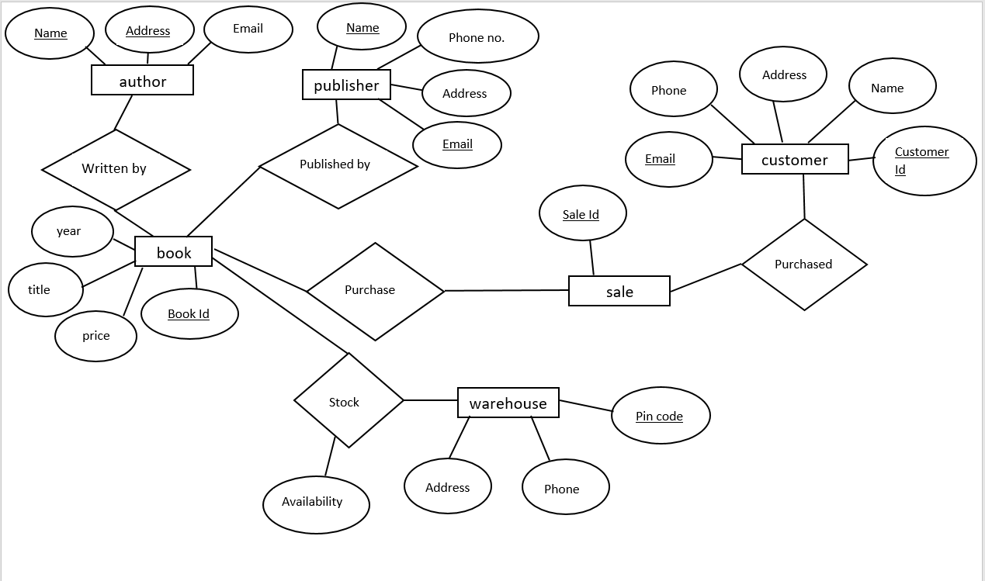

CUSTOMER: PUBLISHER: BOOK:

|  |  |  |  |  |  |  |  |  |  |  |
| --- | --- | --- | --- | --- | --- | --- | --- | --- | --- | --- |
| **COLUMN** | **DATA TYPE** | **CONSTRAINT** |  | **COLUMN** | **DATA TYPE** | **CONSTRAINT** |  | **COLUMN** | **DATA TYPE** | **CONSTRAINT** |
| CUSTOMER ID | NUMERIC | PRIMARY KEY | NAME | VARCHAR(30) | NOT NULL | BOOK ID | NUMERIC | PRIMARY KEY |
| NAME | VARCHAR(30) | NOT NULL | PHONE NO. | NUMERIC | NOT NULL | TITLE | VARCHAR(20) | NOT NULL |
| ADDRESS | VARCHAR(60) | NOT NULL | ADDRESS | VARCHAR(60) | NOT NULL | PRICE | NUMERIC | NOT NULL |
| PHONE | NUMERIC |  | EMAIL | VARCHAR(25) | PRIMARY KEY | YEAR | DATE |  |
| EMAIL | VARCHAR(25) |  |  |  |  |  |  |  |

AUTHOR: WAREHOUSE: STOCK:

|  |  |  |  |  |  |  |  |  |  |  |
| --- | --- | --- | --- | --- | --- | --- | --- | --- | --- | --- |
| **COLUMN** | **DATA TYPE** | **CONSTRAINT** |  | **COLUMN** | **DATA TYPE** | **CONSTRAINT** |  | **COLUMN** | **DATA TYPE** | **CONSTRAINT** |
| BOOK ID | NUMERIC | PRIMARY KEY | PIN CODE | NUMERIC | PRIMARY KEY | AVAILABILITY | NUMERIC | NOT NULL |
| TITLE | VARCHAR(20) | NOT NULL | ADDRESS | VARCHAR(60) | NOT NULL |  |  |  |
| PRICE | NUMERIC | NOT NULL | PHONE | NUMERIC | NOT NULL |  |  |  |

SALE:

|  |  |  |
| --- | --- | --- |
| **COLUMN** | **DATA TYPE** | **CONSTRAINT** |
| SALE ID | NUMERIC | PRIMARY KEY |