Experiment 6: Apply DML commands:

* Insert
* Update
* Delete
* Select

Command: Insert command

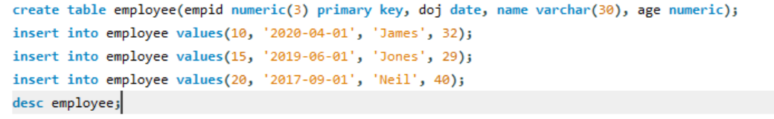

Output:

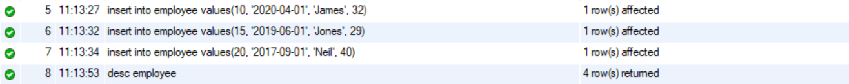

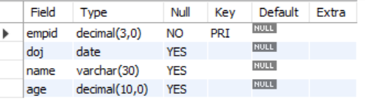

Command: Update command

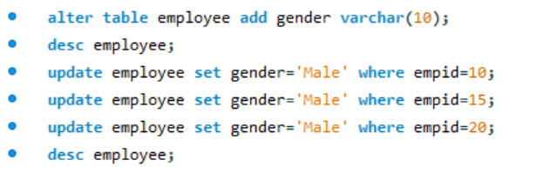

Output:

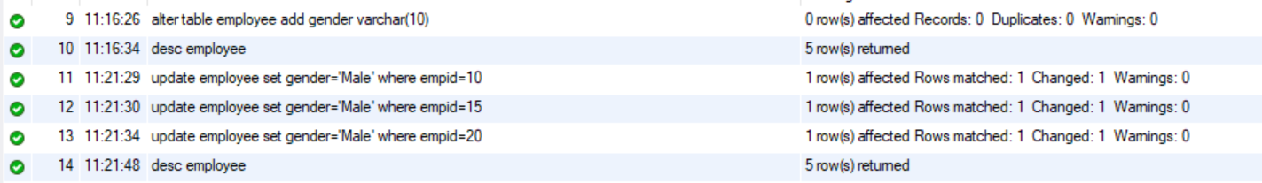

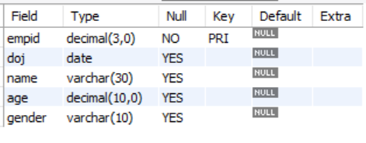 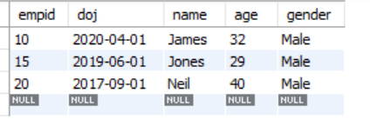

Command: Delete command



Output:



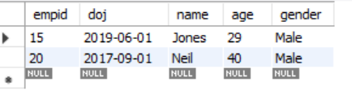

Command: Select command



Output:



