Quiz Manager

Functional Specification Document



BY

YOGITHASATYASAI PANTHAM

FUNDAMENTAL JAVA PROJECT -- QUIZ

# Purpose:

* The purpose of this document is to give a brief description about the end to end specifications of the project.
* The main aim of this project is to develop an application (API Oriented , Web-based) that deals with quiz management.

# Introduction:

This project helps to do CRUD operations and get the questions based on the difficulty level. This project is a console application and execution.

Overview:

In the project user can login as a student and take the test. User can get their results at the end of the exam. In addition to this user can add questions.

Scope of the project:

* It gives automatic quiz with the help of open questions and mcq questions.
* It gives grades automatically for the quiz.
* It creates data access with CRUD methods.
* It creates a configurable file for application.
* Exports quiz to plain text.

Definitions:

To run the program, the following steps are used:

* Install h2
* Install java 8
* Install html
* Install spring boot
* Create tables in database
* Add questions
* Export questions in a text file

Software requirements:

|  |  |
| --- | --- |
| FRONT END | Css , HTML , JSP |
| BACKEND | Java 8, spring-boot, TOMCAT |
| DATABASE | H2 |
| VERSION | GIT |

System Requirements:

🡪 Main source code:

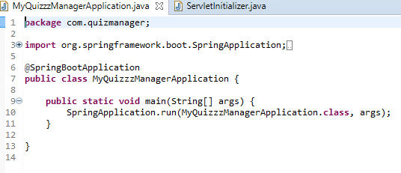

🡪 List of topics:

For example,

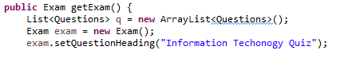





🡪 Add Question:

User can add the questions

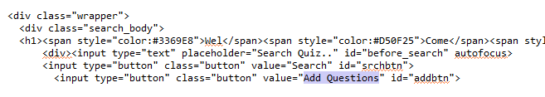

🡪 Preparing Questions:

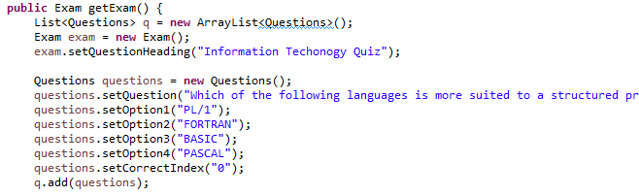

🡪 Save, search & send:

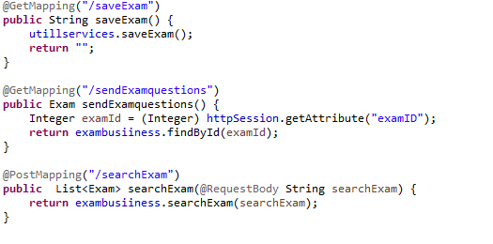

Please find the welcome screen below

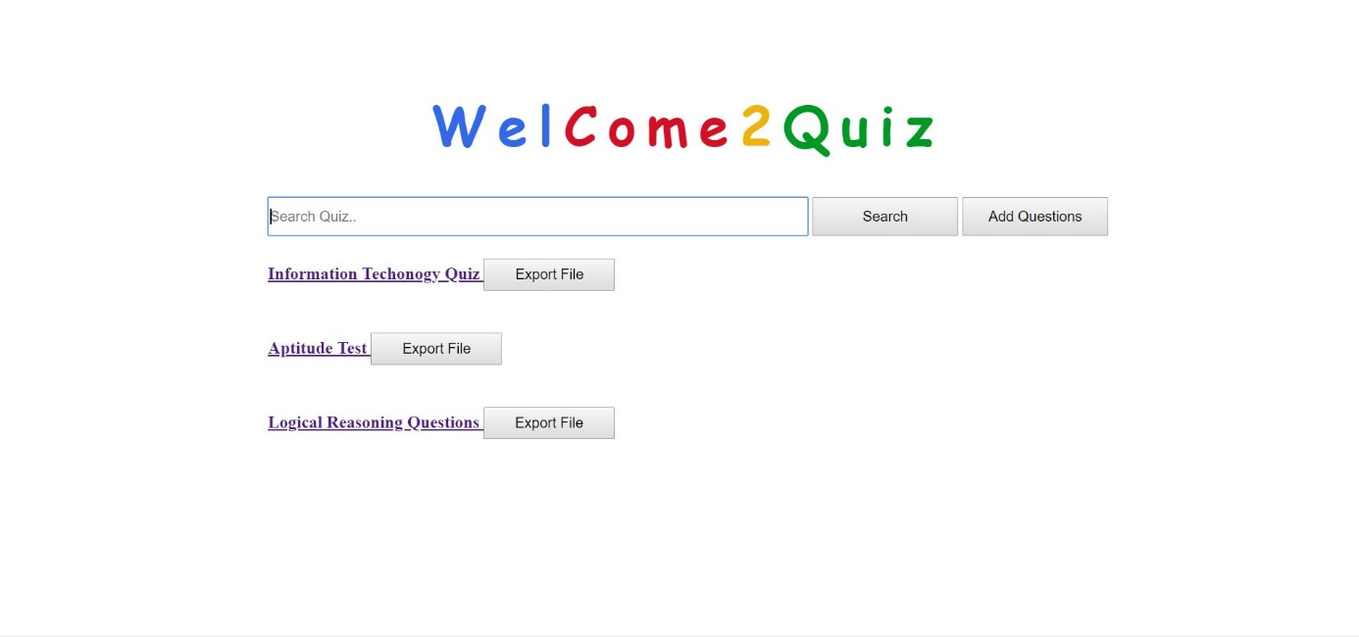

🡪 Hardware Requirements:

|  |  |  |
| --- | --- | --- |
| **#** | **HARDWARE** | **REQUIREMENT** |
| 1. | Operating System | Compatible with Windows, Mac OS X, Linux |
| 2. | RAM | Minimum required 124MB |
| 3. | Disk Space | Minimum required 124MB |
| 4. | Processor | 64-bit, four-core, 2.5 GHz minimum per core |

**UML DIAGRAM:**

**Class diagram**

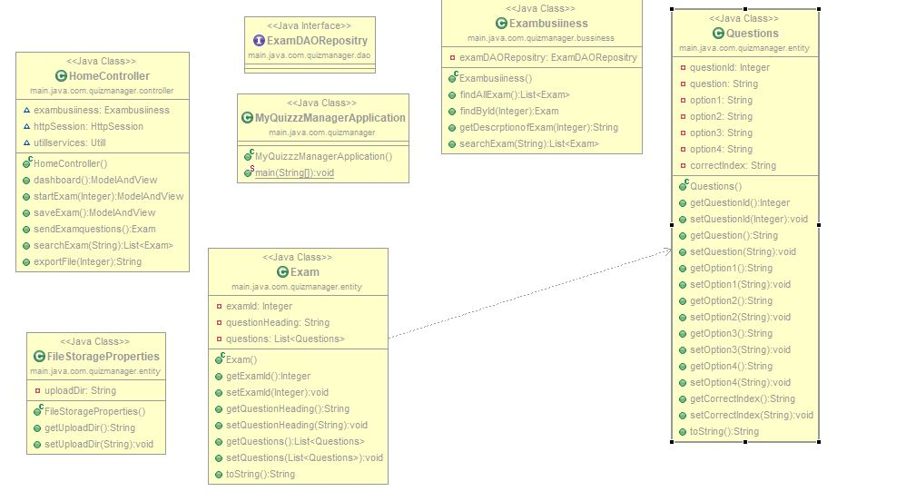

BIBILIOGRAPHY:

<https://thomas-broussard.fr/work/java/courses/project/fundamental.xhtml>