**GIT HANDSON-1**

**Step 1: Setup your machine with Git Configuration**

1. check if Git client is installed properly

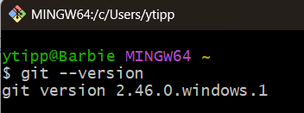

1. configure user level configuration of user ID and email ID

1. check if the configuration is properly set

**Step 2: Integrate notepad++.exe to Git and make it a default editor**

1. check if notepad++.exe

Set environment variables

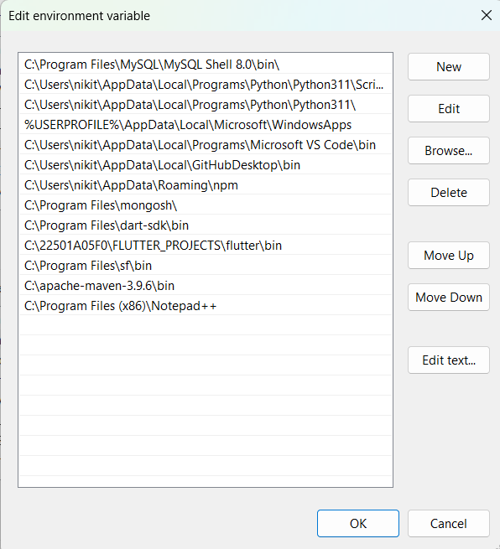

1. Check again:

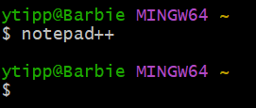

1. create an alias command for notepad++.exe

1. configure the editor

1. verify if notepad++ is the default editor



**Step 3: Add a file to source code repository**

1. create a new project “**GitDemo**”

1. Git bash initializes the “**GitDemo**” repository

1. create a file **“welcome.txt”** and add content to the file

1. verify if the file “welcome.txt” is created

1. Verify the content and move to the initialized repository

1. Check the status

1. make the file to be tracked by Git repository



1. add multi line comments

1. check if local and “Working Directory” git repository are same

1. Signup with GitLab and create a remote repository **“GitDemo”**

1. pull the remote repository

1. push the local to remote repository

**Final Gitlab - GitDemo project:**

