**ABSTRACT**

Many fans of celebrities admire their sense of style and aspire to wear the same clothes and accessories their idols showcase in public appearances, photoshoots, or on social media. However, these items are often out of reach for the average consumer due to their high prices and exclusivity. Luxury brands frequently collaborate with celebrities, resulting in unique or limited-edition items that quickly sell out or are not widely available. Additionally, some pieces worn by celebrities are custom-made, further limiting access to the general public. These challenges leave fans feeling disappointed and unable to replicate the style of their favourite icons.

Another factor complicating this is that celebrities rarely wear the same outfit more than once, adhering to the unspoken rules of the fashion and entertainment industries. As a result, many of these high-end outfits end up sitting unused in their closets. At the same time, fans continue to seek out affordable ways to own similar pieces or authentic items that hold a connection to the celebrity they admire. This creates a significant gap between demand and accessibility in the world of celebrity fashion.

To address this issue, we are developing an innovative platform that bridges the gap between fans and celebrity wardrobes. This website will allow celebrities to resell outfits and accessories they no longer wish to keep. The items will be offered at discounted prices, making them accessible to a broader audience, including fans who may not typically afford high-end or exclusive fashion. Through this platform, we aim to democratize access to celebrity fashion while promoting sustainability in the fashion industry.

Table of contents

|  |  |
| --- | --- |
| Chapters | Page Numbers |
| 1.Introduction   * 1. Web Development   2. Problem Statement   3. Objectives |  |
| 2.Literature Survey |  |
| 3.System Architecture  3.1 System Architecture  3.2 Reference Images |  |
| 4.Technologies Used |  |
| 5.Future Enhancement |  |
| 6.Source Code |  |
| 7.Reference |  |
| 8.Conclusion |  |

*Chapter 1: Introduction*

* 1. Web Development

Web development refers to the process of creating and maintaining websites or web applications. It involves several aspects, including:

1. **Frontend Development**: Focuses on the part of a website that users interact with directly, such as layout, design, and interactivity. It uses languages like HTML, CSS, and JavaScript.
2. **Backend Development**: Handles the server-side logic, databases, and application functionality. It involves programming languages like Python, PHP, Ruby, or Java, and frameworks like Django, Flask, or Node.js.
3. **Full-Stack Development**: Combines both frontend and backend development, allowing developers to work on all parts of a website or application.
4. **Database Management**: Ensures that data is stored, retrieved, and managed efficiently using databases like MySQL, MongoDB, or PostgreSQL.
5. **Web Hosting and Deployment**: Involves making a website accessible on the internet through servers and services like AWS, Heroku, or Netlify.

Web development powers the internet, enabling businesses, entertainment, and communication through interactive, user-friendly, and secure websites and applications.

* 1. Problem Statement

Many fans of celebrities aspire to replicate their idols' style by purchasing the clothes and accessories they showcase in public appearances, photoshoots, or on social media. However, these items are often inaccessible to the general public due to their high prices, exclusivity, and limited availability. Luxury brands and custom-made designs further compound the issue, leaving fans disappointed and unable to connect with their favourite celebrities through fashion. At the same time, celebrities rarely reuse their outfits, resulting in high-end clothing sitting idle in their closets while fans struggle to find affordable ways to own similar or authentic pieces. This creates a significant gap between the demand for celebrity fashion and its accessibility, leaving fans and celebrities with untapped opportunities.

There is a lack of a sustainable, affordable platform that addresses this gap, connecting fans with celebrity-owned fashion items in a way that benefits both parties.

* 1. Objectives of the project
* Bridge the Gap Between Fans and Celebrity Fashion:

Create a platform that enables fans to purchase authentic celebrity-owned clothing and accessories at affordable prices, making celebrity fashion more accessible to the general public.

* Promote Sustainability in the Fashion Industry:

Encourage the reuse of high-end clothing by extending its lifecycle, thereby reducing waste and contributing to a circular economy.

* Provide Celebrities with a Platform for Wardrobe Resale:

Offer celebrities an opportunity to declutter their wardrobes while monetizing items they no longer wear, aligning them with sustainable and ethical practices.

* Enhance Affordability Without Compromising Quality:

Allow fans to own premium or luxury fashion items at significantly discounted prices compared to their original cost.

* Build a Community of Fashion Enthusiasts:

Foster a space where fans and celebrities can interact indirectly through fashion, creating a sense of connection and mutual benefit.

* Ensure Transparency and Authenticity:

Implement a system to verify the authenticity of the items being sold, ensuring buyers receive genuine celebrity-owned pieces.

* Provide a User-Friendly Platform:

Develop an intuitive and engaging website interface to simplify the buying and selling process for both fans and celebrities.

*Chapter 2: Literature Survey*

Celebrities have a significant impact on consumer behavior, particularly in fashion. Research indicates that celebrity endorsements positively influence consumer purchasing decisions. Social media platforms like Instagram further amplify this effect, making celebrity fashion more accessible. Platforms like *The RealReal* and *Poshmark* have successfully created markets for resale of celebrity-owned fashion, showing the demand for such services.  
The second-hand fashion market has experienced exponential growth due to increasing demand for sustainable fashion. Online resale platforms like *Depop* and *Poshmark* promote the reuse of clothing, contributing to a circular economy. This model not only makes fashion more affordable but also reduces environmental waste, making it a significant driver for *CelebStore*.  
The fashion industry has a substantial environmental impact, responsible for a large portion of global carbon emissions and wastewater. Platforms promoting resale, like *CelebStore*, align with circular economy principles, extending the lifecycle of luxury fashion and reducing waste.  
User experience is critical in e-commerce success. A clean, intuitive design increases user satisfaction and engagement. Research shows that personalization and mobile-friendly design are key elements for retaining customers. For *CelebStore*, easy navigation and a responsive design will enhance user experience. Ensuring the authenticity of luxury fashion is crucial in the resale market. Using blockchain technology or other verification systems will help authenticate items, building trust and credibility for *CelebStore*. Collaborating with influencers and celebrities for product endorsements is an effective marketing strategy. Promoting *CelebStore* through celebrity social media channels will increase its visibility and attract more customers.

*Chapter 3: System Architecture*

**3.1 System Architecture**

**1. Homepage**

The homepage serves as the entry point and provides an overview of the store's offerings.

**Features:**

* **Dynamic Hero Banners:**
  + Carousel showcasing promotions, discounts, or seasonal events.
  + Dynamically populated based on backend data (e.g., CMS).
* **Featured Categories:** 
  + Display top-level categories with icons/images.
  + Quick links for easier navigation.
* **Trending Products/Best Sellers:**
  + Dynamically fetched based on user preferences, sales data, or manually curated lists.
* **Personalization:**
  + "Recommended for You" section using machine learning algorithms or user activity history.
  + Seasonal recommendations based on location or trends.
* **Call-to-Actions (CTAs):**
  + Clear CTAs for signing up, exploring deals, or starting a search.

**2. Search and Filtering**

This module helps users find products quickly and efficiently.

**Features:**

* **Search Bar with Autosuggestions:**
  + Predictive suggestions based on keywords and popular searches.
  + Autocomplete functionality.
* **Advanced Filters:**
  + Filters by price, brand, ratings, availability, etc.
  + Multi-select options for filters.
* **Sorting Options:**
  + Sort by popularity, price (low-to-high/high-to-low), or ratings.
* **Search Results:**
  + Display matching products with pagination or infinite scrolling.
  + Highlight searched keywords for better visibility.

**3. Product Listing Pages (PLP)**

These pages display products within a category or search results.

**Features:**

* **Grid/List View Toggle:**
  + Allow users to switch between grid or list views for product layouts.
* **Pagination or Infinite Scrolling:**
  + Load more products dynamically to enhance performance.
* **Product Card Components:**
  + Key details like product image, title, price, rating, and quick actions (e.g., "Add to Wishlist").
* **Performance Optimizations:**
  + Lazy load images and use placeholders for better page performance.

**4. Product Details Page (PDP)**

The PDP provides in-depth information about a product to assist purchasing decisions.

**Features:**

* **High-Resolution Images:**
  + Image gallery with zoom-in, 360-degree view, or video support.
* **Product Information:**
  + Title, detailed description, key features, and specifications.
* **Pricing and Availability:**
  + Display current price, discounts, and stock status.
* **Reviews and Ratings:**
  + User-generated reviews, average ratings, and a breakdown by stars.
* **Related Products:**
  + "You May Also Like" or "Frequently Bought Together" recommendations.
* **Add to Cart/Buy Now:**
  + Buttons for adding the product to the cart or proceeding directly to checkout.
* **Q&A Section:**
  + Customers can ask questions about the product, and sellers or previous buyers can answer.

**5. Cart and Checkout**

The cart and checkout module manages the order process.

**Cart Features:**

* **Dynamic Cart Updates:**
  + Real-time updates to the cart UI when products are added/removed.
* **Mini-Cart:**
  + Accessible cart summary on all pages for quick access.
* **Price Summary:**
  + Display itemized costs (subtotal, discounts, shipping fees, taxes).
* **Promo Code Application:**
  + Input field to apply discount codes with real-time validation.

**Checkout Features:**

* **Multi-Step Process:**
  + **Step 1**: Shipping Information (address, contact).
  + **Step 2**: Payment Method (credit card, PayPal, etc.).
  + **Step 3**: Order Review and Confirmation.
* **Guest Checkout:**
  + Allow users to complete purchases without account registration.
* **Security:**
  + Use secure payment gateways (e.g., Stripe) and SSL for encrypted data transfer.
* **Order Confirmation:**
  + Display an order summary with tracking details after a successful transaction.

**6. User Account**

This module provides users with tools to manage their profiles and track orders.

**Features:**

* **Profile Management:**
  + Users can update their name, email, phone number, and password.
* **Order History:**
  + View past orders with detailed statuses (shipped, delivered, etc.).
  + Option to reorder or download invoices.
* **Saved Addresses:**
  + Manage multiple shipping addresses for quick checkout.
* **Wishlist:**
  + Save favourite products for later consideration.
  + Persistent wishlist stored in the backend.
* **Account Security:**
  + Two-factor authentication (optional) and secure password resets.

7. Selling page

The Selling Page enables sellers to perform the following core activities:

* Add and manage product listings.
* Track orders and inventory.
* Analyze sales and performance metrics.
* Manage shipping and fulfillment options.

3.2 Reference Images:

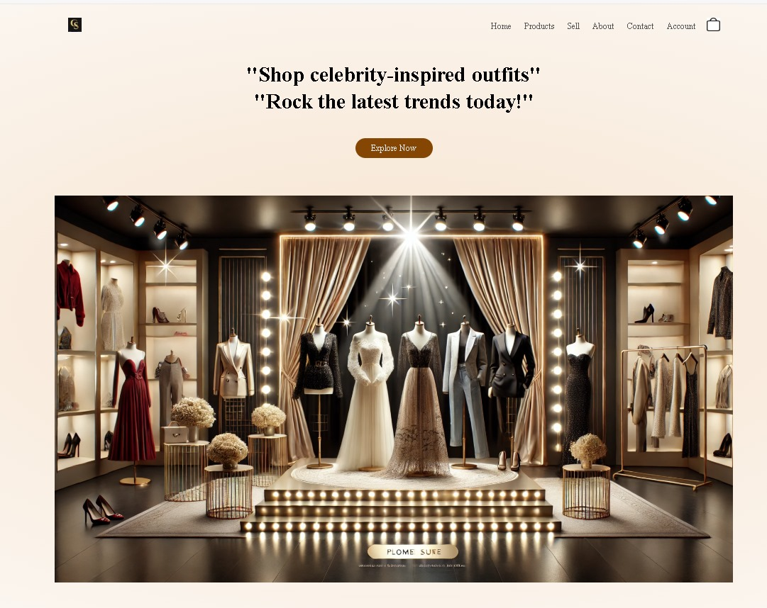

Fig 1: Home Page

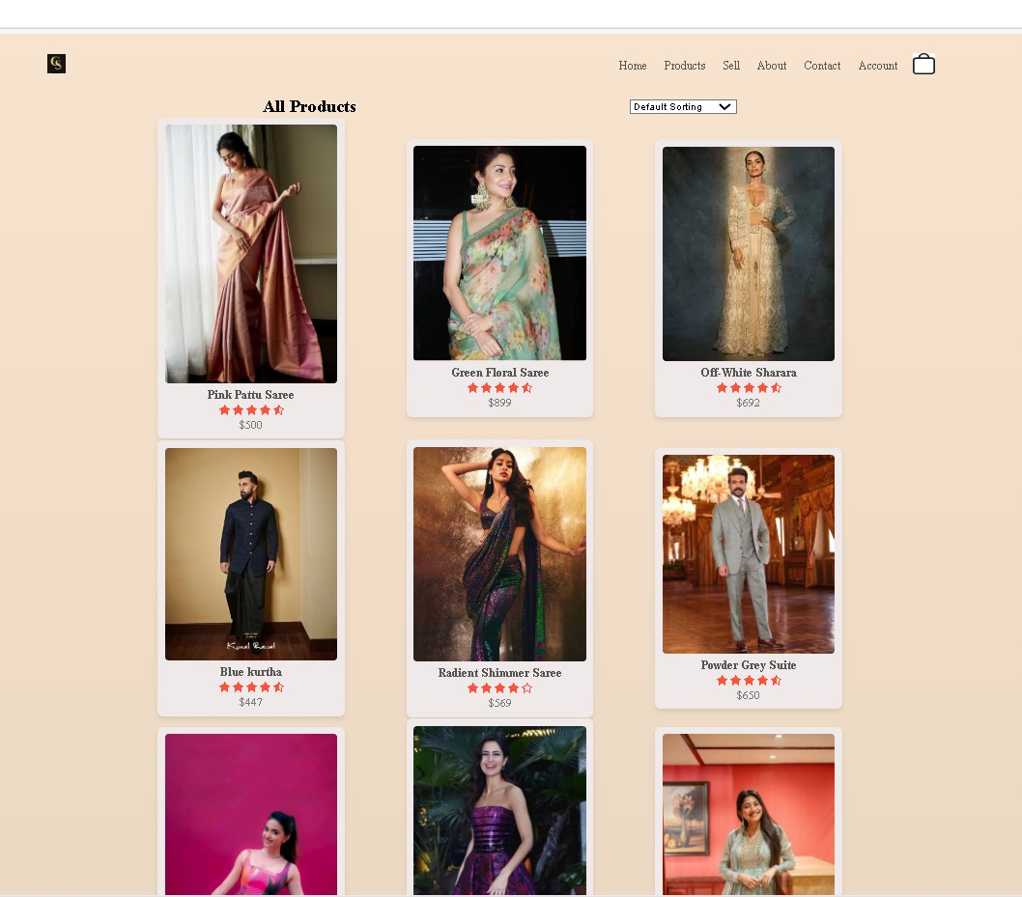

Fig 2: Product Page

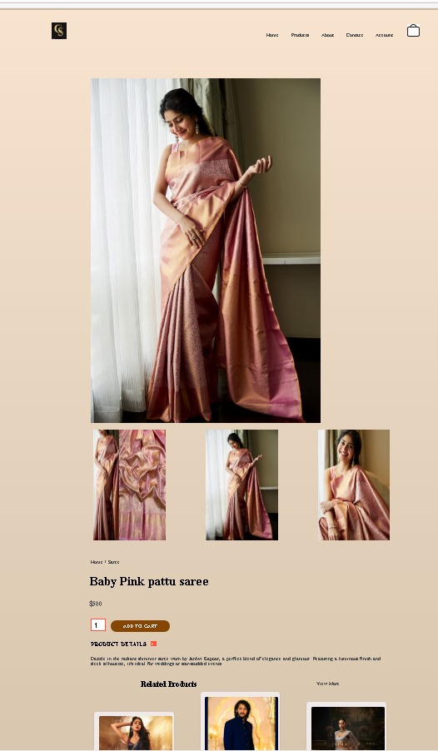 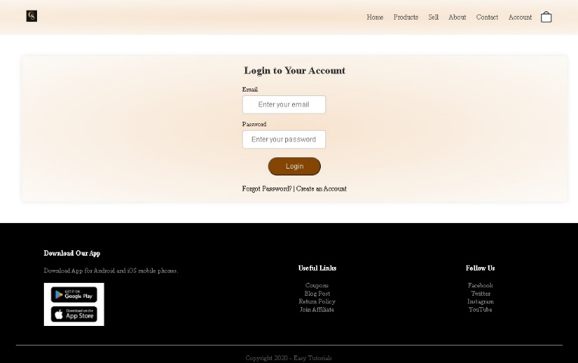

Fig 3:Product Details page Fig 4: Login Page

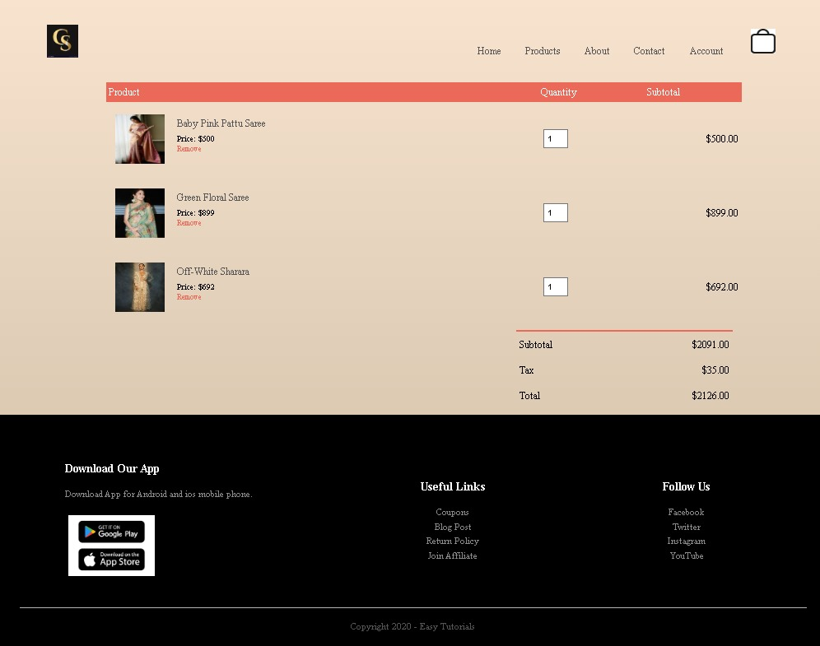

Fig 5: Cart Page

*Chapter 4: Technologies Used*

**1.HTML in an eCommerce Website:**

HTML (HyperText Markup Language) is essential in the development of e-commerce websites, as it forms the foundational structure of these online platforms. It is responsible for organizing and displaying content such as product listings, descriptions, and images in a user-friendly format. HTML tags like <div>, <ul>, and <table> are used to structure product grids, while <h1>, <h2>, and <p> tags define headings and paragraphs for product names and descriptions. Call-to-action buttons like "Add to Cart" or "Buy Now" are created using the <button> or <a> tags to encourage user interaction. The visual presentation of these elements is enhanced by CSS, but HTML ensures the correct structure of navigation menus, images, videos, and buttons, improving the user experience and making the site easy to navigate. Furthermore, HTML supports SEO by incorporating meta tags and semantic elements such as <article>, <section>, and <header>, which help search engines better understand and rank the content. Alt attributes in image tags also contribute to accessibility and image search optimization. HTML also enables seamless integration with JavaScript, which adds dynamic features like product image sliders, interactive shopping carts, and checkout forms. These forms are essential for customer interaction, such as providing contact information, entering payment details, or submitting reviews. Moreover, HTML ensures that e-commerce websites are responsive and adaptable across various devices, making the shopping experience seamless whether viewed on a desktop, tablet, or smartphone. By adhering to accessibility standards and compliance guidelines, HTML ensures that e-commerce sites are inclusive, catering to all users, including those with disabilities. In conclusion, HTML is a critical component of an e-commerce website, enabling a well-organized, functional, and visually appealing online store that drives customer engagement and business success.

1. Structuring the Website

HTML defines the overall structure of the eCommerce website. It organizes content into sections such as the header, main content, and footer. This ensures that every page is logically arranged, making it easier for users to navigate.

* Header Section: Includes the website logo, navigation menus, search bars, and user account options.
* Main Content Section: Displays dynamic content like product listings, product details, shopping cart, and user account details.
* Footer Section: Contains links to company information, policies, FAQs, and social media accounts.

2. Displaying Product Listings

HTML structures the product listing pages by defining how each product is displayed. It organizes product images, names, prices, descriptions, and action buttons (e.g., "Add to Cart") in a clear and consistent layout. This structure makes browsing products intuitive for customers.

3. Product Details Page (PDP)

The Product Details Page uses HTML to present all critical information about a specific product, such as:

* High-resolution images or videos of the product.
* A detailed description of the product.
* Pricing details, discounts, and availability.
* Interactive elements like "Add to Cart" or "Buy Now" buttons.

4. Forms for User Interaction

HTML forms are crucial for collecting user input in an eCommerce website. They facilitate actions such as:

* Searching for products using keywords.
* Registering or logging in to the website.
* Filling out shipping and billing details during checkout.
* Submitting feedback or reviews about products.

These forms include input fields, dropdowns, checkboxes, and submit buttons to collect and process data efficiently.

5. Navigation and Menus

HTML structures navigation menus that allow users to explore different categories or sections of the website. This includes:

* Category-based menus (e.g., Electronics, Clothing, Home Decor).
* Breadcrumb navigation to show the user’s current location on the site and allow easy backtracking.
* Footer navigation links for policies, help pages, and customer support.

6. User Reviews and Ratings

HTML organizes the review and rating section where customers can read other users' feedback or submit their own. It includes user-generated comments, star ratings, and a form to leave reviews. This section helps build trust and provides insights into product quality.

7. Sell Page

The Sell Page is designed for sellers to list their products on the platform. It includes sections for sellers to input product details, upload images, and manage their inventory.

* Forms: For sellers to enter product details, such as name, description, price, quantity, and category.
* File Upload Inputs: To upload product images or videos.
* Dropdown Menus: To select product categories, subcategories, or shipping options.
* Buttons: To submit the listing or save it as a draft.
* Text Areas: For detailed product descriptions or additional instructions.
* Error Handling: To display messages if required fields are missing or if the upload fails.
* Tables/Lists: For sellers to view and manage their existing product listings.

8. Login Page

The Login Page allows users to authenticate their accounts, either as customers or sellers. It typically includes fields for entering credentials and additional options for password recovery or sign-up.

* Forms: To capture user login credentials, such as email/username and password.
* Input Fields: For email/username, password, and possibly CAPTCHA verification.
* Buttons: For submitting login details, signing up, or recovering a password.
* Hyperlinks: For redirecting to the "Forgot Password" or "Sign-Up" page.
* Checkboxes: For options like "Remember Me" for keeping users logged in.
* Error Messages: To alert users if login fails due to incorrect credentials.

9. Contact Page

The Contact Page enables users to get in touch with the website's customer support team for queries, feedback, or complaints. It’s an essential page for improving user trust and engagement.

* Forms: For users to submit their name, email, subject, and message.
* Text Input Fields: For capturing basic user information, such as name and email address.
* Text Area: For detailed messages or inquiries.
* Dropdown Menus: To categorize the query type (e.g., order-related, feedback, technical issues).
* Contact Information: Static HTML content to display phone numbers, email addresses, and office addresses.
* Interactive Maps: To embed a map (e.g., using an iframe for Google Maps) showing the company’s location.

10. About Page

The About Page provides information about the eCommerce platform, including its history, mission, team, and values. It helps build trust and credibility with users.

* Static Content: Structured text to describe the company’s vision, mission, and history.
* Headers and Subheaders: For organizing sections like "Our Story," "Our Team," or "Our Values."
* Images and Videos: To showcase the team, office spaces, or milestones.
* Lists: For presenting achievements, key statistics, or a timeline of milestones.
* Hyperlinks: For linking to related pages, such as the Careers or Blog section.
* Team Members: HTML sections for showcasing profiles, names, roles, and social media links of team members.
* SEO Elements: Meta tags, alt attributes for images, and semantic headings to improve search engine visibility.

***CSS ***

CSS in an E-commerce Website

CSS (Cascading Style Sheets) is a cornerstone technology for e-commerce websites, playing a vital role in creating a visually appealing and functional online shopping experience. While HTML is responsible for the structure of a website, CSS is the tool that enhances its design by controlling the layout, color scheme, fonts, and overall visual appearance. For e-commerce platforms, CSS is crucial not only for aesthetic appeal but also for user experience (UX), responsiveness, and accessibility, which directly impact sales, customer satisfaction, and brand identity.

The primary function of CSS in an e-commerce website is to control its layout and presentation. E-commerce platforms typically have complex page structures, with product listings, detailed product pages, shopping carts, and category navigation. CSS enables the creation of flexible and well-organized layouts that improve how these elements are displayed. Modern CSS techniques like Flexbox and CSS Grid are often used to create responsive and dynamic layouts that automatically adjust based on the screen size or device. This is particularly important for e-commerce sites, as more users are shopping on mobile devices. CSS ensures that the website’s design looks and functions flawlessly on desktop, tablet, and smartphone screens, providing a consistent experience for customers across all platforms.

Beyond layout, CSS is essential for styling the visual components that define the brand identity of an e-commerce website. Typography, color schemes, and images are all controlled through CSS to create a unique visual language that aligns with the brand’s message. For instance, an online store specializing in luxury goods might use elegant fonts, subdued colors, and high-quality images to convey sophistication, while a children’s toy store might employ vibrant colors, playful fonts, and whimsical graphics. By using CSS, e-commerce websites can customize fonts, text sizes, colors, and backgrounds to create an aesthetically pleasing and cohesive design that reflects the company’s branding. This consistency helps build trust with customers and reinforces the brand’s identity.

Interactivity is another area where CSS shines in e-commerce. Online shopping sites rely on user engagement, and CSS enhances interactivity by allowing designers to create hover effects, animations, and transitions that make the website feel dynamic and responsive. For example, hovering over a product image can trigger a zoom effect, allowing customers to see more details of the product. Buttons like “Add to Cart” or “Buy Now” can be animated to change colors or size when hovered over, signaling to the user that they are interactive elements. These effects help guide the user through the shopping process, improving the overall customer experience.

CSS also plays a significant role in accessibility, which is critical for e-commerce websites to reach a broad audience. Proper use of CSS ensures that the website is visually legible, even for users with visual impairments. High contrast between text and background colors, appropriate font sizes, and sufficient spacing between elements all contribute to making the site more readable. Additionally, CSS ensures that navigation elements like buttons, links, and forms are easily clickable and accessible to users with disabilities, complying with web accessibility standards like WCAG (Web Content Accessibility Guidelines).

Moreover, CSS contributes to the performance and speed of an e-commerce website. A website that loads quickly is crucial for retaining customers and improving conversion rates. CSS optimizations, such as combining stylesheets and minimizing CSS code, can help reduce loading times. Additionally, CSS can be used to implement techniques like lazy loading, which ensures that images and content are only loaded when needed, improving page load speed and user experience.

Finally, CSS enables customization of user interface (UI) elements, such as navigation bars, product filters, and shopping carts, ensuring a seamless and enjoyable shopping experience. Customizable elements allow customers to find what they need quickly, enhancing their ability to navigate through the site and complete purchases with ease.

In conclusion, CSS is indispensable in e-commerce web design. It shapes the visual design, ensures a responsive and interactive experience, and contributes to the accessibility and performance of the site. By effectively using CSS, e-commerce websites can create a visually appealing, user-friendly, and functional platform that attracts and retains customers, ultimately driving sales and business growth.Top of Form

Bottom of Form

1. Layout Design

CSS is used to define the overall layout of the website, ensuring proper organization and alignment of elements.

* Grid and Flexbox Layouts: Used to create responsive and flexible layouts for product listings, navigation menus, and content sections.
* Positioning: CSS helps position elements like headers, footers, sidebars, and modals (e.g., login pop-ups or cart summaries).
* Spacing: Margin, padding, and spacing utilities ensure proper whitespace between elements, improving readability.

2. Typography

CSS styles text content to make it visually appealing and easy to read.

* Font Styling: Custom fonts are applied to headings, body text, and buttons using @font-face or Google Fonts.
* Font Sizes and Weights: CSS controls text size, weight (e.g., bold, light), and letter spacing for better readability and emphasis.
* Colors: Text colors are chosen to align with the brand's theme, ensuring contrast and accessibility.

3. Colors and Themes

CSS defines the color scheme of the website, maintaining brand identity and enhancing the visual experience.

* Primary and Secondary Colors: Used for buttons, links, and call-to-action elements.
* Hover and Active States: CSS styles hover effects (e.g., button color changes) to improve interactivity.
* Backgrounds: Solid colors, gradients, or images are applied to various sections for aesthetic appeal.

4. Product Listings

CSS is crucial for styling product cards and grids on listing pages.

* Card Design: CSS styles each product card with borders, shadows, and hover effects.
* Responsive Grids: Products are displayed in grid layouts that adjust dynamically on different screen sizes.
* Hover Effects: Interactive effects like zooming product images or changing button colors enhance user engagement.

5. Product Details Page (PDP)

The PDP uses CSS to present detailed product information attractively.

* Image Gallery: CSS enables image zoom, carousel effects, and alignment of thumbnails.
* Tabs and Sections: For styling product descriptions, reviews, and specifications in separate tabs or sections.
* Call-to-Action Buttons: Buttons like "Add to Cart" or "Buy Now" are styled prominently to grab attention.

6. Navigation and Menus

CSS styles navigation bars and menus to improve usability and design.

* Sticky Headers: Keep navigation bars fixed at the top while scrolling.
* Dropdown Menus: CSS handles the appearance and transitions of dropdown menus for categories or account settings.
* Hover Effects: Visual feedback for menu items, such as color changes or underlining.

7. Forms and Inputs

Forms are styled with CSS to enhance user experience.

* Input Fields: CSS adds borders, shadows, and focus states for input fields like search bars, login forms, and checkout details.
* Buttons: Styled with rounded corners, gradients, or shadows to make them visually appealing and interactive.
* Validation Feedback: CSS displays error or success messages for form submissions, such as incorrect passwords or successful registrations.

8. Images and Media

CSS ensures media elements (e.g., product images and banners) are responsive and well-aligned.

* Responsive Images: CSS adapts image sizes to different screen resolutions using properties like max-width and height.
* Image Effects: Adds hover effects like zoom-in, grayscale, or opacity changes.
* Hero Banners: Large promotional banners are styled using background properties and text overlays.

9. Responsive Design

CSS ensures the website is fully responsive and works across all devices (mobile, tablet, desktop).

* Media Queries: CSS uses media queries to apply different styles based on screen size.
* Fluid Layouts: CSS frameworks like Flexbox and Grid make layouts automatically adjust to screen dimensions.
* Hamburger Menus: Mobile-friendly menus styled for easy navigation on smaller screens.

10. Animations and Transitions

CSS adds subtle animations to enhance user interaction and engagement.

* Button Animations: Smooth color or size changes when hovered or clicked.
* Page Transitions: Fade-ins or slide-ins for content as users navigate.
* Loading Indicators: Spinners or progress bars styled with CSS.

11. Shopping Cart

CSS styles the shopping cart to make it user-friendly.

* Item Display: Products in the cart are displayed in a visually appealing layout.
* Sticky Cart Summaries: CSS ensures cart summaries are fixed while users scroll through the cart.
* Quantity Controls: Buttons for increasing/decreasing product quantities are styled for usability.

12. Checkout Page

CSS is used to make the checkout process smooth and visually appealing.

* Form Design: Input fields for billing, shipping, and payment details are styled for clarity.
* Step Indicators: Progress bars or step indicators are styled to guide users through the checkout process.
* Order Summary: CSS ensures the summary is well-organized with proper spacing and alignment.

13. Footer Design

CSS is used to style the footer, ensuring it’s visually consistent with the website’s theme.

* Column Layout: Social links, policies, and contact information are arranged in columns.
* Hover Effects: Links in the footer respond to hover actions for better interactivity.
* Icons: Social media or payment method icons are styled to fit the website’s design.

*Chapter 5: Future Enhancement*

**Future Enhancements for CelebStore E-commerce Website**

1. **AI-Powered Personalization**

Implement AI algorithms to analyze user behaviour, preferences, and purchase history. This can help in offering tailored product recommendations, creating personalized shopping experiences, and increasing customer satisfaction. By predicting what products users might be interested in, CelebStore can enhance its sales and customer retention.

1. **Automated Pricing and Inventory Management**

Use AI to optimize pricing strategies based on market trends, competitor pricing, and user behaviour. This dynamic pricing system ensures that products are priced competitively while maximizing profit margins. AI can also manage inventory in real-time, adjusting stock levels and alerting when it’s time to restock or offer discounts.

1. **Fraud Detection and Security**

Incorporate AI-powered fraud detection mechanisms to analyze patterns of transactions and identify suspicious activities. This system would instantly flag potential fraud, such as account takeovers or counterfeit products, protecting both buyers and sellers. The platform will offer enhanced security for financial transactions, ensuring trust and confidence in the system.

1. **Voice Search and Navigation**

Implement voice search features, allowing users to search for celebrity fashion or specific items via voice commands. This enhancement will improve accessibility and user experience, especially for mobile users, making the shopping process more interactive and hands-free.

1. **Augmented Reality (AR) Integration**

Integrate AR technology to allow users to virtually try on clothes or accessories before purchasing. This feature would enhance user engagement by helping customers visualize how products will look on them, increasing conversion rates.

1. **AI-Driven Chatbots**

Introduce AI-driven chatbots to provide real-time customer support, guiding users through the shopping process, answering queries, and even assisting with product recommendations based on user preferences.

1. **Predictive Analytics for Fashion Trends**

Utilize predictive analytics to forecast upcoming fashion trends based on data from social media, influencer collaborations, and fashion shows. CelebStore can then curate exclusive collections ahead of time, tapping into emerging trends early and maintaining relevance in the market.

By adopting these future enhancements, CelebStore can stay competitive in the evolving e-commerce landscape while ensuring a seamless, secure, and personalized shopping experience for its users.

*Chapter 6: Source Code*

HTML Source Code for Home Page:

<!DOCTYPE html>

<html lang="en">

<head>

<meta charset="UTF-8">

<meta name="viewport" content="width=device-width, initial-scale=1.0">

<title>CelebStore | Ecommerce Website Design</title>

<link rel="stylesheet" href="style.css">

<link rel="stylesheet" href="https://stackpath.bootstrapcdn.com/font-awesome/4.7.0/css/font-awesome.min.css">

</head>

<body>

<div class="header">

<div class="container">

<div class="navbar">

<div class="logo">

<img src="logo.jpg" width="25px">

</div>

<nav>

<ul>

<li><a href="index.html">Home</a></li>

<li><a href="samp2.html">Products</a></li>

<li><a href="sell.html">Sell</a></li>

<li><a href="about.html">About</a></li>

<li><a href="contact.html">Contact</a></li>

<li><a href="login.html">Account</a></li>

</ul>

</nav>

<a href="cart_page.html"><img src="cart.png" width="25px" height="25px"></a>

</div> <div class="row">

<div class="col-2">

<h1>"Shop celebrity-inspired outfits"<br>"Rock the latest trends today!"</h1>

<a href="" class="btn">Explore Now</a>

</div>

<div class="col-2">

<img src="home.webp">

</div>

</div>

</div>

</div>

<!---featured categories---->

<div class="categories">

<div class="small-container">

<div class="row">

<div class="col-3">

<img src="p2.1.avif" alt="">

<h2>MEN</h2>

</div>

<div class="col-3">

<img src="cat1.avif" alt="">

<h3>WOMEN</h3>

</div>

</div>

</div>

</div>

<!----featured products-->

<div class="small-container">

<h2 class="title" >Featured Products</h2>

<div class="row">

<div class="col-4">

<img src="p1.1.avif" alt="">

<h4>Lehanga</h4>

<div class="rating"> <i class="fa fa-star"></i>

<i class="fa fa-star"></i>

<i class="fa fa-star"></i>

<i class="fa fa-star"></i>

<i class="fa fa-star-half-o"></i>

</div>

<p>$800</p>

</div>

<div class="col-4">

<img src="c1.1.avif">

<h4>Gown</h4>

<div class="rating">

<i class="fa fa-star"></i>

<i class="fa fa-star"></i>

<i class="fa fa-star"></i>

<i class="fa fa-star"></i>

<i class="fa fa-star-o"></i>

</div>

<p>$650.00</p>

</div>

<div class="col-4">

<img src="p2.1.avif">

<h4>Sherwani</h4>

<div class="rating">

<i class="fa fa-star"></i>

<i class="fa fa-star"></i>

<i class="fa fa-star"></i>

<i class="fa fa-star"></i>

<i class="fa fa-star-half-o"></i>

</div>

<p>$450.00</p>

</div>

<div class="col-4">

<img src="c3.1.avif"> <h4>Men Kurta</h4>

<div class="rating">

<i class="fa fa-star"></i>

<i class="fa fa-star"></i>

<i class="fa fa-star"></i>

<i class="fa fa-star"></i>

<i class="fa fa-star"></i>

</div>

<p>$750.00</p>

</div>

<div class="col-4">

<img src="c2.1.avif">

<h4>Saree</h4>

<div class="rating">

<i class="fa fa-star"></i>

<i class="fa fa-star"></i>

<i class="fa fa-star"></i>

<i class="fa fa-star"></i>

<i class="fa fa-star-half-o"></i>

</div>

<p>$500.00</p>

</div>

<div class="col-4">

<img src="c4.1.avif">

<h4>kurta</h4>

<div class="rating">

<i class="fa fa-star"></i>

<i class="fa fa-star"></i>

<i class="fa fa-star"></i>

<i class="fa fa-star"></i>

<i class="fa fa-star-half-o"></i>

</div>

<p>$650.00</p>

</div> <div class="col-4">

<img src="c5.avif">

<h4>Saree</h4>

<div class="rating">

<i class="fa fa-star"></i>

<i class="fa fa-star"></i>

<i class="fa fa-star"></i>

<i class="fa fa-star"></i>

<i class="fa fa-star-half-o"></i>

</div>

<p>$500.00</p>

</div>

<div class="col-4">

<img src="c7.avif">

<h4>Couple Outfits</h4>

<div class="rating">

<i class="fa fa-star"></i>

<i class="fa fa-star"></i>

<i class="fa fa-star"></i>

<i class="fa fa-star"></i>

<i class="fa fa-star-half-o"></i>

</div>

<p>$800.00</p>

</div>

</div>

<!----brands-->

<div class="brands">

<div class="small-container">

<div class="row">

<div class="col-5">

<img src="b1.jpg">

</div>

<div class="col-5">

<img src="b2.png"> </div>

<div class="col-5">

<img src="b3.png">

</div>

<div class="col-5">

<img src="b4.jpg">

</div>

<div class="col-5">

<img src="b5.jpg">

</div>

</div>

</div>

</div>

<!-----footer-->

<div class="footer">

<div class="container">

<div class="row">

<div class="footer-col1">

<h3>Download Our App</h3>

<p>Download App for Android and ios mobile phone.</p>

<div class="app-logo">

<img src="app_img.png">

</div>

</div>

<div class="footer-col3">

<h3>Useful Links</h3>

<ul>

<li>Coupons</li>

<li>Blog Post</li>

<li>Return Policy</li>

<li>Join Affiliate</li>

</ul>

</div>

<div class="footer-col4">

<h3>Follow Us</h3>

<ul>

<li>Facebook</li>

<li>Twitter<li>

<li>Instagram</li>

<li>YouTube</li>

</ul>

</div>

</div>

<hr>

</div

</div>

</body>

</html>

CSS Source Code:

*{

margin: 0;

padding: 0;

box-sizing:border-box;

}

.navbar{

display: flex;

align-items: center;

padding: 25px;

}

nav{

flex: 1;

text-align: right;

}nav ul{

display: inline-block;

list-style-type: none;

}

nav ul li{ display: inline-block;

margin-right: 20px;

}

a{

text-decoration: none;

color:#555;

}

p{

color:#555;

}

.container{

max-width: 1300px;

margin:auto;

padding-right: 25px;

}

.row{

display: flex;

align-items: center;

text-align: center;

flex-wrap: wrap;

justify-content: space-around;

}

.col-2 img{

max-width: 100%;

padding: 50px 0;

}

.col-2 h1{

font-size: 40px;

line-height: 50px;

margin: 25px 100px;

}

.btn{

display: inline-block; background: #864603;

color: #ebecf1;

padding: 8px 30px;

margin: 20px 500px;

border-radius: 300px;

align-items: center;

transition: background 0.5s;

}

.btn:hover{

background:#9b6a6a;

}

.header{

background: radial-gradient(#f7e3ce,#fcfaf7);

}

.categories{

margin: 70px 0;

}

.col-3{

flex-basis: 30%;

min-width:250px;

margin-bottom: 30px;

}

.col-3 img{

width: 100%;

}

.small-container{

max-width: 1080px;

margin:auto;

padding-left: 25px;

padding-right: 25px;

}

/features/

.title{

text-align: center;

margin: 0px auto 80px;

position: relative;

line-height: 60px;

color: #555;

}

.title::after{

content: '';

background: #ff523b;

width: 80px;

height: 5px;

border-radius: 5px;

position: absolute;

bottom: 0;

left: 50%;

transform: translateX(-50%);

}

.col-4{

flex-basis: 25%;

padding: 10px;

min-width: 200px;

margin-bottom: 50px;

transition: transform 0.5s;

}

.col-4 img{

width: 100%;

}

h4{

color: #555;

font-weight: normal;

}

.col-4 p{

font-size: 14px;

}

.rating .fa{

color: #ff523b;

}

.col-4:hover{

transform: translateY(-5px);

}

/*----offer

.offer{

background: radial-gradient(#f7e3ce,#fcfaf7);

margin-top: 80px;

padding: 30px 30px;

}

.col-2 .offer-img{

padding: 50px;

}

small{

color: #f7e3ce;

}*/

/brand/

.brands{

margin: 100px auto;

}

.col-5{

width: 160px;

}

.col-5 img{

width: 100%;

cursor: pointer;

filter: grayscale(100%);

}

.col-5 img:hover{

filter: grayscale(0);

}

.footer{

background: #000;

color: #8a8a8a;

font-size: 14px;

padding: 60px 0 20px;

}

.footer p{

color: #8a8a8a;

}

.footer h3{

color: #fff;

margin-bottom: 20px;

}

.footer-col1,.footer-col2,.footer-col3,.footer-col4{

min-width: 250px;

margin-bottom: 20px;

}

.footer-col1{

flex-basis: 30%;

}

.footer-col2{

flex: 1;

text-align: center;

}

.footer-col2 img{

width: 180px;

margin-bottom: 20px;

}

.footer-col3,.footer-col4{

flex-basis: 12%;

text-align: center;

}

.app-logo{

margin-top: 20px;

}

.app-logo img{

width: 140px;

}

.footer li{

display: block;

}

.footer hr{

border: none;

background: #b5b5b5;

height: 1px;

margin: 20px 0;

}

.copyright{

text-align: center;

}

/* login page*/

/* Styling for the login page */

*Chapter 7: References*

1. Welling, Luke, and Laura Thomson. PHP and MySQL Web development. Sams publishing, 2003.
2. Ullah, Syed Emdad, Tania Alauddin, and Hasan U. Zaman. "Developing an E-commerce website." *2016 International Conference on Microelectronics, Computing and Communications (MicroCom)*. IEEE, 2016.
3. Huang, Y.H., 2019. *Developing a design system for an e-commerce website* (Master's thesis).
4. Hoffman, Leslie, and J. P. Frenza. "Building Your Web Site: HTML Basics." *Nonprofit World* 16 (1998): 22-24.
5. AbdAlameer, E. M. T. (2014). Building and developing E-commerce website. *International Journal of Science and Research (IJSR)*, *3*(9), 1419-1425.
6. Smashing Magazine. *How to Create Selling eCommerce Websites*. Smashing Magazine, 2012.
7. AbdAlameer, Elham Mohammed Thabit. "Building and developing E-commerce website." *International Journal of Science and Research (IJSR)* 3, no. 9 (2014): 1419-1425.
8. Tyagi, Shivanshu, Shashwat Yadav, Utkarsh Singhal, and Himanshi Chaudhary. "Analysis and development of e-commerce web application." In *2022 Fifth International Conference on Computational Intelligence and Communication Technologies (CCICT)*, pp. 65-72. IEEE, 2022.

*Chapter 7: Conclusion*

In conclusion, the innovative platform designed to bridge the gap between celebrity fashion and fans offers a revolutionary solution to address the challenges of high-priced and limited-access celebrity outfits. By providing a space for celebrities to resell their clothing and accessories at discounted prices, the platform allows fans to acquire iconic, luxury items that they may otherwise never afford. This not only democratizes access to exclusive fashion but also promotes sustainability by encouraging the reuse and recycling of high-end garments.

The website is designed with user experience at its core, offering a variety of intuitive features such as personalized recommendations, advanced search and filtering capabilities, and a seamless checkout process. Dynamic elements, including a carousel of promotions and trending products, will ensure that the site remains engaging and relevant to its audience. With robust product listing pages, high-resolution images, detailed product descriptions, and a variety of payment and shipping options, the platform ensures a smooth, informative, and enjoyable shopping experience.

Additionally, the selling page empowers celebrities and sellers to manage their inventories and sales efficiently while tracking performance metrics, ultimately fostering a sustainable ecosystem of resale and celebrity-driven fashion.

Through these features and the integration of advanced technology, this platform sets the stage to transform the fashion industry by connecting fans with the wardrobes of their favorite celebrities. Not only does it promote accessibility, but it also supports a more eco-friendly approach to fashion, ensuring the continued relevance and success of the platform in the years to come.