Community Service Project

Name of the Students: B. Maithreya, D. Abhilash, J. Mounika, K. Yogitha
Name of the College: Vignan's Institute of Information Technology (A)
Registration Numbers: 24L31A4318, 24L31A4340, 24L31A4357, 24L31A4359
Period of Community Service Project: 11 May 2026 – 20 June 2026
Year: II B. Tech
Name and Address of the Habitation for Community Service Project (CSP): Dungalavanipalem, NAD Junction, Visakhapatnam, Andhra Pradesh.

Community Service Project Report
on
SachiSeva — Welfare Eligibility Platform
Submitted in partial fulfilment of the requirements for the award of the Community Service Project of
Bachelor of Technology
in
Department of Computer Science Engineering – Artificial Intelligence
By
24L31A4318
24L31A4340
24L31A4357
24L31A4359

Under the Faculty Guidance of
Mrs. K. Swathi
Assistant Professor

Department of Computer Science Engineering – Artificial Intelligence
Vignan's Institute of Information Technology (A)
Duvvada, Visakhapatnam
June 2026

Vignan's Institute of Information Technology (A)
Department of Computer Science Engineering – Artificial Intelligence
STUDENT DECLARATION
We, B. Maithreya (Reg. No.: 24L31A4318), D. Abhilash (Reg. No.: 24L31A4340), J. Mounika (Reg. No.: 24L31A4357) and K. Yogitha (Reg. No.: 24L31A4359), are II B. Tech students of Bachelor of Technology in the Department of Computer Science Engineering – Artificial Intelligence, Vignan's Institute of Information Technology (A), Duvvada, Visakhapatnam. We hereby declare that the presented report of the Community Service Project titled "SachiSeva — Welfare Eligibility Platform" is uniquely prepared by us after the successful completion of a summer Community Service Project from 11th May 2026 to 20th June 2026 at Dungalavanipalem, NAD Junction, Andhra Pradesh, under the faculty guidance of Mrs. K. Swathi, Assistant Professor, Dept. of CSE-AI, Vignan's Institute of Information Technology (A), Duvvada, Visakhapatnam, during the academic year 2025–26.
We also confirm that the report is only prepared for our academic requirement, not for any other purpose. It might not be used in the interest of the opposite party of the corporation.

Names of Students: B. Maithreya, D. Abhilash, J. Mounika, K. Yogitha
Regd. Nos.: 24L31A4318, 24L31A4340, 24L31A4357, 24L31A4359

Department of Computer Science Engineering – Artificial Intelligence
CERTIFICATE
This is to certify that B. Maithreya (Reg. No.: 24L31A4318), D. Abhilash (Reg. No.: 24L31A4340), J. Mounika (Reg. No.: 24L31A4357) and K. Yogitha (Reg. No.: 24L31A4359) have completed the Community Service Project titled "SachiSeva — Welfare Eligibility Platform" at Dungalavanipalem, NAD Junction, Andhra Pradesh, from 11th May 2026 to 20th June 2026 under the faculty guidance of Mrs. K. Swathi, Assistant Professor, Dept. of CSE-AI. The batch submitted the Community Service Project report to the department during the academic year 2025–26, in partial fulfilment of the requirements for the award of the Community Service Project of Bachelor of Technology in the Department of Computer Science Engineering – Artificial Intelligence, Vignan's Institute of Information Technology (A), Duvvada, Visakhapatnam.

Signature of Guide Signature of Head of the Department
Mrs. K. Swathi Mrs. K. Swathi

ABSTRACT
SachiSeva is a bilingual (Telugu and English) web application developed as a Community Service Project for the citizens of Andhra Pradesh. It brings the major state and central welfare schemes and the common Grama/Ward Sachivalayam services into one place, and lets a family find out, in one click, every scheme it qualifies for, the benefit it would receive and the documents it needs.
The app addresses a significant gap in welfare outreach: many eligible citizens are unaware of, or unable to access, benefits because of language barriers, limited digital literacy and a lack of guidance on documents. SachiSeva resolves this with a Telugu/English interface, a family profile that is answered only once, an eligibility engine based on the government's six-step validation, one combined document checklist, an "Apply for all" option, voice read-out and voice input, and an assistant (SachiBot) that answers in Telugu or English.
The application is built with React, TypeScript and Tailwind CSS, uses Supabase (a PostgreSQL database with row-level security, sign-in, document storage and live updates) as its backend, and is hosted on Vercel, where server functions run the SachiBot assistant. It covers 21 welfare schemes and 16 Sachivalayam services in 14 categories. Every page needs a login. Citizens can apply online, upload each document once, track every application and message Sachivalayam staff; staff review applications in a separate panel that needs a staff key, and when an application is approved or rejected the applicant is automatically asked to visit their nearby Sachivalayam for the next steps. The system was validated with 65 automated database checks covering every role and workflow, and with automated browser tests of every screen in Telugu and English on phone and desktop layouts.
Keywords: Welfare Eligibility, AP Sachivalayam, Telugu Language, Bilingual Interface, React, Supabase, Row-Level Security, Community Service.

ACKNOWLEDGEMENTS
We express our sincere thanks to Mrs. K. Swathi, Head of the Department, CSE-AI, Vignan's Institute of Information Technology (A), Visakhapatnam, for her valuable guidance and encouragement for the completion of this project.
We express our sincere thanks to Dr. J. Sudhakar, Principal, Vignan's Institute of Information Technology (A), Visakhapatnam, for his co-operation and encouragement on this project.
We express our sincere thanks to Dr. V. Madhusudhan Rao, Rector, and Mr. N. Srikanth, CEO, Vignan Vizag Group, Visakhapatnam, for their co-operation and encouragement for the completion of this project.
We express our sincere thanks to Dr. L. Rathaiah, Chairman, Vignan Group of Institutions, for his co-operation and for providing facilities for doing this project.
Lastly, we extend our gratitude to all our Teaching and Non-Teaching staff and all our friends, who directly or indirectly helped us in this endeavour.

B. Maithreya, D. Abhilash, J. Mounika, K. Yogitha
24L31A4318, 24L31A4340, 24L31A4357, 24L31A4359

TABLE OF CONTENTS
S.No. | Title | Page No.
1 | Executive Summary | 1
2 | Overview of the Community | 2
3 | Community Service Part | 3
4 | Activity Log – Week 1 | 4
5 | Weekly Report – Week 1 | 5
6 | Activity Log – Week 2 | 6
7 | Weekly Report – Week 2 | 7
8 | Activity Log – Week 3 | 8
9 | Weekly Report – Week 3 | 9
10 | Activity Log – Week 4 | 10
11 | Weekly Report – Week 4 | 11
12 | Outcomes Description | 12
13 | Mini-Project Report: SachiSeva — Welfare Eligibility Platform | 14
14 | Recommendations and Conclusions | 24
15 | References | 25
16 | Annexure A: Field Photographs | 26
17 | Annexure B: CSP Completion Certificate | 28

LIST OF FIGURES
Figure No. | Title | Page No.
Figure 13.1 | System Architecture of SachiSeva | 17
Figure 13.2 | Welfare Scheme Catalogue Screen (Telugu) | 18
Figure 13.3 | Family Questionnaire (Answered Once) | 19
Figure 13.4 | My Schemes: Eligibility Results and Combined Document Checklist | 20
Figure 13.5 | Apply for All Screen | 20
Figure 13.6 | Staff Panel: Application Review | 21
Photo A.1 – A.4 | Field Photographs at Dungalavanipalem, NAD Junction | 26
Annexure B | Community Service Project Completion Certificate | 28

LIST OF TABLES
Table No. | Title | Page No.
Table 2.1 | Survey Respondent Summary | 2

CHAPTER 1: EXECUTIVE SUMMARY
The Community Service Project aimed to design and build a self-service digital tool that helps citizens of Andhra Pradesh check their eligibility for State and Central welfare schemes delivered through the Sachivalayam network. A survey at Dungalavanipalem, NAD Junction, Andhra Pradesh showed that most citizens lack a single, simple way to check which schemes they qualify for.
To address this challenge, SachiSeva, a bilingual web application, was designed and developed. A citizen answers a short set of family questions once and instantly sees every welfare scheme the family is eligible for, with the benefit amount and the documents required, in Telugu and English with a voice read-out. The citizen can then apply for all of those schemes together, upload each document only once, and follow every application until Sachivalayam staff decide on it.
The project involved studying the Sachivalayam welfare-scheme system, surveying citizens, designing the eligibility engine and scheme catalogue, building the application and its staff panel, and creating community awareness about SachiSeva.

1.1 Learning Objectives
- To design a single, bilingual (Telugu and English) self-service tool that allows a citizen to check, in one pass, which of the State's welfare schemes they are eligible for.
- To encode accurate, current eligibility rules for the 21 welfare schemes and 16 Sachivalayam services modelled in the application, grouped under 14 categories.
- To provide one combined document checklist for all the schemes a family qualifies for, with a Telugu/English voice read-out, so that citizens with limited reading ability can use the tool independently.
- To let citizens apply online for all their eligible schemes at once and track each application, while Sachivalayam staff review, request documents and decide in one panel.

1.2 Learning Outcomes
- Acquired practical knowledge of the AP Sachivalayam welfare-scheme ecosystem and the barriers citizens face in accessing it.
- Understood how a bilingual web application backed by a secure cloud database can bridge the digital-literacy and awareness divide.
The project showed how a simple, bilingual digital tool can close the gap between citizens and the welfare schemes they are entitled to.

CHAPTER 2: OVERVIEW OF THE COMMUNITY
The Community Service Project survey was conducted at Dungalavanipalem, NAD Junction, Andhra Pradesh, a settlement served by a local Grama/Ward Sachivalayam in Andhra Pradesh. Before finalising the scope of the SachiSeva application, an informal survey was carried out among residents and visitors at the local Sachivalayam, to confirm that the welfare-scheme awareness gap was a genuine, everyday problem and not only an assumption.
Respondents were asked four simple questions: (i) how many AP welfare schemes they could name that they were personally eligible for; (ii) which language they were most comfortable reading scheme information in; (iii) whether they had ever made a repeat visit to the Sachivalayam because they were missing a document; and (iv) whether they would use a phone-based tool to check eligibility if one were available in Telugu.
Respondent | Age Group | Schemes Correctly Named | Preferred Language
Ramya | 18–29 | 3 | English
Vinay | 30–45 | 2 | Telugu
Raju | 46–60 | 4 | Telugu
Prem | 60+ | 1 | Telugu
Table 2.1 Survey Respondent Summary
The survey indicated that respondents could typically name far fewer schemes than they were actually eligible for, that a majority preferred Telugu for reading scheme information, and that a notable share reported a repeat Sachivalayam visit caused by a missing document. This finding directly justified the design objectives of the SachiSeva application.
From a socio-economic perspective, Dungalavanipalem, NAD Junction, Andhra Pradesh faces challenges common to communities served by the Sachivalayam system: dependence on staff and notice boards for scheme information, limited awareness of eligibility rules that change whenever a scheme is revised, and difficulty navigating formal or bureaucratic Telugu/English terminology. Mobile phone ownership among respondents was high, though comfort with reading detailed government notices was uneven, particularly among older citizens.

CHAPTER 3: COMMUNITY SERVICE PART
As part of the Community Service Project, a survey and awareness programme were conducted at Dungalavanipalem, NAD Junction, Andhra Pradesh. A short questionnaire asked citizens how many schemes they could name, their preferred reading language, whether missing documents had caused repeat visits, and whether they would use a phone-based eligibility tool. Data was collected by talking directly with citizens and Sachivalayam visitors.
Based on the findings, SachiSeva was built as a bilingual web application, and awareness sessions showed citizens how to answer a few family questions once and see their eligible schemes, benefits and documents.

3.1 Values Acquired
- Social responsibility towards citizens underserved by existing scheme-information channels.
- Commitment to bridging the awareness and digital-literacy divide through inclusive technology.
- Respect for citizens' privacy: only the last four digits of Aadhaar are collected, and each citizen can see only their own data.
- Ethical use of technology to empower rather than exploit citizens seeking welfare benefits.

3.2 Life Skills Acquired
- Communication and interaction skills through citizen surveys and awareness sessions.
- Teamwork and collaboration in designing and building the application.
- Problem-solving and critical thinking in addressing real-world eligibility and documentation challenges.
- Leadership and presentation skills during community awareness demonstrations.
- Data collection and analysis through the citizen survey.

3.3 Technical Skills Acquired
- Full-stack web development with React, TypeScript, Vite and Tailwind CSS.
- Database design with PostgreSQL on Supabase, including row-level security.
- Use of the Web Speech API for Telugu/English voice read-out and voice input.
- Bilingual interface design for low-literacy users.
- Deployment on Vercel, with the source code on GitHub.

ACTIVITY LOG FOR WEEK – 1
Day | Date | Brief Description of Daily Activity | Learning Outcome | Signature
Day-1 | 11-05-2026 | Team formation and project ideation; identified the welfare-scheme awareness gap in the AP Sachivalayam system as the focus area for the Community Service Project. | Understanding project objectives and teamwork.
Day-2 | 12-05-2026 | Studied the AP Sachivalayam welfare-scheme ecosystem and the challenges citizens face in identifying schemes they qualify for. | Awareness of real-world governance problems.
Day-3 | 13-05-2026 | Conducted a literature review on bilingual e-governance tools and web-based welfare-eligibility services. | Research and analytical skills.
Day-4 | 14-05-2026 | Identified project requirements: bilingual (Telugu/English) interface, eligibility engine, online applications and a staff review panel. | Project planning skills.
Day-5 | 15-05-2026 | Studied React, Supabase (database, sign-in, file storage) and Web Speech API concepts. | Understanding technology fundamentals.
Day-6 | 16-05-2026 | Finalized project scope, objectives and the overall development roadmap for SachiSeva. | Requirement analysis and documentation skills.

WEEKLY REPORT — WEEK 1
(From Date: 11-05-2026 to Date: 16-05-2026)

Objective of Activity
To initiate the SachiSeva project, understand the problem domain of welfare-scheme awareness, and define project objectives and requirements.

Detailed Report
In the first week, the team studied the difficulties citizens face in finding the AP welfare schemes they are eligible for and the documents they need. Existing e-governance applications were reviewed to choose a suitable architecture, and the project objectives, technologies and design plan were finalized.

Key Activities Carried Out
- Formed the project team, divided roles (research, design, development and field work) and agreed on a weekly working schedule.
- Studied how citizens currently find out about AP welfare schemes through the Grama / Ward Sachivalayam, and listed the main difficulties they face.
- Reviewed existing government portals and e-governance applications to understand what information they provide and where citizens get stuck.

Outcomes of the Week
By the end of the week the team had a clear problem statement, an agreed list of features and a technology plan. The main goal was fixed as helping a family see, in one place and in their own language, every scheme they are likely eligible for together with the documents they need.

Challenges Faced and Solutions
- Scheme rules are spread across many separate government notices. The team decided to keep all scheme data in a single structured catalogue so that it can be checked and updated easily.

Plan for the Next Week
Design the system architecture, the scheme data model, the eligibility-matching engine and the bilingual screens of the application.

ACTIVITY LOG FOR WEEK – 2
Day | Date | Brief Description of Daily Activity | Learning Outcome | Signature
Day-7 | 18-05-2026 | Designed the system architecture: React web application, Supabase backend (database, sign-in, storage, live updates) and Vercel server functions. | System architecture design skills.
Day-8 | 19-05-2026 | Modelled scheme data fields: eligibility rules, benefits, documents, steps, fees and time limits in Telugu and English. | Data modelling skills.
Day-9 | 20-05-2026 | Identified and catalogued welfare schemes and citizen services across multiple categories. | Data source analysis.
Day-10 | 21-05-2026 | Designed the eligibility-matching engine logic (profile comparison against scheme rules). | Rule-engine design skills.
Day-11 | 22-05-2026 | Designed the bilingual (Telugu/English) UI screens and navigation flow. | UI/UX design skills.
Day-12 | 23-05-2026 | Planned data security: row-level security so that citizens see only their own applications, and a separate staff role. | Database security skills.

WEEKLY REPORT — WEEK 2
(From Date: 18-05-2026 to Date: 23-05-2026)

Objective of Activity
To design the SachiSeva platform: system architecture, data model, eligibility engine and bilingual UI flows.

Detailed Report
The second week focused on platform design. The architecture (a React web application, a Supabase backend and Vercel server functions) was finalized. Scheme data fields (eligibility rules, benefit amounts, document checklists, application steps, fees and time limits) were modelled for 21 schemes and 16 services across 14 categories. The eligibility-matching engine and the bilingual UI screens were designed, and the database security model was planned.

Key Activities Carried Out
- Prepared the architecture: a React single-page application hosted on Vercel, Supabase for the database, sign-in, document storage and live updates, and small Vercel server functions for the AI assistant and centre search.
- Designed the scheme record: name in Telugu and English, category, benefit, eligibility rules, required documents, application steps, fees and time limits.

Outcomes of the Week
The design of SachiSeva was completed. Each scheme is described once in a single catalogue that drives the eligibility check, the document checklist and the application form, so that updating one entry updates every screen that uses it.

Challenges Faced and Solutions
- Some eligibility rules cannot be decided from a short questionnaire. The engine was designed to give three results — eligible, likely eligible and not eligible — so that citizens are not wrongly turned away.

Plan for the Next Week
Prepare the survey questionnaire, visit Dungalavanipalem, NAD Junction, and introduce the SachiSeva idea to citizens.

ACTIVITY LOG FOR WEEK – 3
Day | Date | Brief Description of Daily Activity | Learning Outcome | Signature
Day-13 | 25-05-2026 | Prepared a survey questionnaire for Dungalavanipalem, NAD Junction, Andhra Pradesh, covering scheme awareness, language preference and document issues. | Survey design and research skills.
Day-14 | 26-05-2026 | Visited Dungalavanipalem, NAD Junction, Andhra Pradesh and conducted preliminary interactions with citizens and Sachivalayam visitors. | Community engagement and communication.
Day-15 | 27-05-2026 | Collected survey responses from citizens on welfare-scheme awareness and access. | Data collection and field research skills.
Day-16 | 28-05-2026 | Conducted awareness sessions explaining the SachiSeva eligibility-checking tool to citizens. | Public awareness and presentation skills.
Day-17 | 29-05-2026 | Demonstrated the SachiSeva application on mobile devices to citizens. | Technical demonstration and user education.
Day-18 | 30-05-2026 | Analyzed initial survey responses and identified key awareness gaps in the community. | Data analysis and problem identification.

WEEKLY REPORT — WEEK 3
(From Date: 25-05-2026 to Date: 30-05-2026)

Objective of Activity
To conduct the community survey at Dungalavanipalem, NAD Junction, Andhra Pradesh and create awareness about the SachiSeva platform among citizens.

Detailed Report
The third week was dedicated to community engagement. The team visited Dungalavanipalem, NAD Junction and surveyed citizens and Sachivalayam visitors on scheme awareness, preferred language and repeat visits caused by missing documents. Awareness sessions showed how a citizen can answer a few family questions once and see all their eligible schemes, and were well received.

Key Activities Carried Out
- Prepared a short survey on scheme awareness, preferred language, source of scheme information and repeat visits caused by missing documents.
- Visited Dungalavanipalem, NAD Junction and spoke with citizens and Sachivalayam visitors about how they currently learn about schemes.
- Recorded survey responses and noted common questions about pensions, rice cards, certificates and education support.

Outcomes of the Week
The survey confirmed the problem identified in the first week: citizens usually learn about schemes one at a time and often make extra trips because of missing documents. Citizens responded well to seeing all their schemes and the combined document checklist on a single screen in Telugu.

Challenges Faced and Solutions
- Some citizens were hesitant to share personal details. The team explained that the app asks only for the last four digits of Aadhaar and that family answers are used only for the eligibility check.

Plan for the Next Week
Test the complete application, verify scheme information against current government sources, gather feedback in a follow-up session and prepare the final community report.

ACTIVITY LOG FOR WEEK – 4
Day | Date | Brief Description of Daily Activity | Learning Outcome | Signature
Day-19 | 01-06-2026 | Implemented and tested the eligibility engine against representative citizen profiles. | Testing and validation skills.
Day-20 | 02-06-2026 | Verified scheme names, benefit amounts and document checklists against current government sources. | Data verification skills.
Day-21 | 03-06-2026 | Conducted functional testing of online applications, document upload, the staff panel, voice read-out and the SachiBot assistant. | Quality assurance skills.
Day-22 | 04-06-2026 | Conducted a follow-up awareness session and gathered citizen feedback on the application. | Leadership and awareness creation.
Day-23 | 05-06-2026 | Deployed the application and demonstrated the final SachiSeva tool to the community. | Technical presentation skills.
Day-24 | 06-06-2026 | Compiled all survey findings and prepared the final community analysis report. | Data synthesis and reporting skills.

WEEKLY REPORT — WEEK 4
(From Date: 01-06-2026 to Date: 06-06-2026)

Objective of Activity
To complete functional testing of the SachiSeva application, gather citizen feedback, and prepare the final community analysis report.

Detailed Report
During the fourth week, the team completed functional testing of the eligibility engine, online applications, document upload, the staff review panel and the Telugu voice read-out. Scheme names, benefit amounts and document checklists were verified against current government sources, and the application was demonstrated to the community.

Key Activities Carried Out
- Tested the eligibility engine with sample family profiles covering farmers, students, elderly citizens, widows and auto drivers.
- Checked scheme names, benefit amounts and document lists against current official AP government sources and corrected outdated entries.
- Tested the full application flow: sign-up, the family questionnaire, applying online, uploading documents, tracking by application number and staff review.

Outcomes of the Week
SachiSeva was deployed online and demonstrated to the community. Citizens could answer the family questions, see their eligible schemes with combined document lists, apply online and track the status of their applications, while staff could review applications and update their status from the staff panel.

Challenges Faced and Solutions
- Benefit amounts and scheme status change over time. Each scheme was marked as open, announced or not currently accepting applications, so that citizens are not misled.

Plan for the Next Week
Prepare the outcomes chapter, the mini-project report and the recommendations, and submit the final Community Service Project report.

CHAPTER 4: OUTCOMES DESCRIPTION

4.1 Details of the Survey
As part of the Community Service Project, a survey was conducted at Dungalavanipalem, NAD Junction, Andhra Pradesh to understand citizens' awareness of AP government welfare schemes, the barriers they face in accessing entitlements, and their preferred language for scheme information (see Chapter 2, Table 2.1). The survey involved interactions with citizens and visitors at the local Sachivalayam.
The survey revealed that respondents could typically name far fewer schemes than they were actually eligible for. Citizens reported learning about schemes mainly by asking Sachivalayam staff about one scheme at a time, rather than seeing all schemes they qualify for in one place. A notable share of respondents reported having made a repeat visit to the Sachivalayam because they were missing a required document, and a majority indicated a preference for receiving scheme information in Telugu. These findings highlight the need for a bilingual, phone-friendly, self-service eligibility tool like SachiSeva.

4.2 Problems Identified in the Community
- Citizens typically learn about a scheme only by asking Sachivalayam staff about one scheme at a time, rather than seeing all schemes they qualify for in one place.
- Eligibility rules (income ceilings, age limits, caste/category criteria, asset limits) are spread across multiple notices and change whenever a scheme is revised, making it hard for citizens to stay up to date.
- Government scheme information is often presented in formal Telugu or English, not always accessible to citizens with limited literacy or limited familiarity with bureaucratic terms.
- Citizens frequently make repeat visits to the Sachivalayam because they are missing a required document.
- No single, simple place exists for a citizen to check, in their own language, exactly which schemes they qualify for.

4.3 Short-Term Action Plan
- Demonstrate the SachiSeva application to citizens visiting the Dungalavanipalem, NAD Junction Sachivalayam and help them add it to their phones.
- Conduct digital-literacy sessions to help citizens use the family-profile eligibility check independently.
- Display awareness material with the SachiSeva link/QR code at the local Sachivalayam.
- Collect citizen feedback to refine the wording of eligibility questions and document checklists.
- Train interested citizens/volunteers to act as local champions who help their neighbours use the platform.

4.4 Long-Term Action Plan
- Extend the scheme catalogue as new schemes are announced, and periodically re-verify benefit amounts and thresholds against official sources.
- Add push notifications (where supported) to tell citizens about application updates and upcoming renewals.
- Conduct a formal, larger-scale user study with Sachivalayam staff and citizens to measure time saved per enquiry.
- Connect to official government data sources, with permission, so that eligibility and application status can be confirmed automatically.

4.5 Community Awareness Programmes Conducted
Awareness programmes were conducted at Dungalavanipalem, NAD Junction, Andhra Pradesh to address the identified gaps in welfare-scheme awareness, particularly the lack of a single place to check eligibility and the frequency of repeat Sachivalayam visits caused by missing documents. The programmes included interactive sessions, live demonstrations of the SachiSeva application, and discussions about the documents required for common schemes.
Citizens were shown how to answer the family questions once, view their personalised list of eligible schemes with benefit amounts, use the voice read-out to hear the required documents, and apply for all their eligible schemes together.

4.6 Outcomes of the Awareness Programme
- Citizens gained a better understanding of the welfare schemes they were personally eligible for.
- Awareness of document requirements for common schemes improved, which can help reduce repeat Sachivalayam visits.
- Citizens with limited reading ability expressed interest in the Telugu voice read-out feature.
- Community members understood the value of a bilingual, phone-friendly tool for checking entitlements.
- The SachiSeva application was well received as a practical and accessible solution for the community.

REPORT OF THE MINI-PROJECT WORK

SACHISEVA — WELFARE ELIGIBILITY PLATFORM

13.1 Introduction
The Government of Andhra Pradesh delivers a large share of its welfare benefits through the Grama/Ward Sachivalayam (village/ward secretariat) system. Over the past few years the number of active welfare schemes has grown steadily, and currently spans pensions, education support, agriculture support, household and housing assistance, transport benefits, support for weavers, fishermen, women, youth, SC/ST/BC/minority communities, health insurance, and a range of citizen document services such as caste, income and residence certificates. Under the present TDP–JSP–BJP alliance government led by Chief Minister N. Chandrababu Naidu, several of these schemes were re-branded or re-launched, including six flagship welfare promises that the government refers to as the "Super Six".
While information about these schemes exists in government circulars, notice boards at the Sachivalayam, and on portals such as the Navasakam Beneficiary Management (NBM) system, an ordinary citizen rarely has a single, simple place to check, in their own language, exactly which schemes they personally qualify for, what benefit they would receive, and what documents they must carry. SachiSeva was built as a Community Service Project to close this gap. It is a free, bilingual Telugu/English web application, which can be added to a phone's home screen, that lets a family answer a few questions once, instantly see every welfare scheme it is eligible for, and apply for all of them together.

13.2 Problem Statement
- Citizens typically learn about a scheme only by asking Sachivalayam staff or volunteers about one scheme at a time, rather than being able to see all schemes they qualify for in one place.
- Eligibility rules (income ceilings, age limits, caste/category criteria, asset limits) are spread across multiple notices and change whenever the scheme is revised by the government, making it hard for an ordinary citizen to stay up to date.
- Government scheme information is often presented in formal Telugu or English, which is not always accessible to citizens with limited literacy or limited familiarity with bureaucratic terms.
- Citizens frequently make repeat visits to the Sachivalayam because they are missing a required document, and must submit the same documents again for each scheme separately.

13.3 Objectives
- To design a single, bilingual (Telugu and English) self-service tool that allows a citizen to check, in one pass, which of the State's welfare schemes they are eligible for.
- To encode accurate, current eligibility rules (income ceiling, land holding, electricity use, four-wheeler ownership, government employment, income tax, urban property, age, gender, caste/category and occupation) for the 21 schemes and 16 Sachivalayam services modelled in the application, grouped under 14 categories.
- To provide one combined document checklist for all the schemes a family qualifies for, with a Telugu/English voice read-out, so that citizens with limited reading ability can still use the tool independently.
- To let a citizen apply for all eligible schemes in one step and follow each application, and to give Sachivalayam staff a protected panel to review applications, request documents and record decisions.

13.4 Scope of the Project
SachiSeva covers 21 welfare schemes and 16 Sachivalayam services across 14 categories, including the schemes behind all six of the government's "Super Six" promises. It provides a one-click eligibility check for the whole family, personalised benefit amounts, a combined document checklist with Telugu/English voice read-out, online applications ("Apply for all"), application tracking with messages from staff, a nearest Sachivalayam/MeeSeva finder, the SachiBot assistant, and a staff panel protected by a staff key. Future scope includes push notifications and connection to official data sources (see Section 13.12).

13.5 Methodology
SachiSeva was developed using an iterative build-and-test approach. The citizen screens and the staff panel were built as a single React web application; data, sign-in, document storage and live updates are handled by Supabase, and the SachiBot assistant runs as a Vercel server function so that its API key never reaches the browser. The scheme and service catalogue is kept in one source file in both languages and is used to generate the database entries and SachiBot's knowledge, so that all three always agree. An AI-assisted development workflow was used to speed up UI scaffolding and code review, while all eligibility rules and scheme data were verified manually against government sources. Every change was checked with automated database tests and browser tests.

13.6 Tools and Technologies Used
- Front end: React 19, TypeScript and Tailwind CSS, built with Vite. Each screen loads separately, so the first page opens quickly on low-end phones.
- Backend: Supabase, a PostgreSQL database with row-level security, email/password sign-in, private storage for document photos, and live updates for application status and messages.
- Server functions: Vercel Functions for the SachiBot assistant (Google Gemini, with a built-in Telugu/English answer list when the AI service is unavailable), nearby-office search and the staff-key check.
- Installability: a Web App Manifest so that the app can be added to a phone's home screen and opened like an app.
- Accessibility: the Web Speech API for Telugu/English voice read-out (a speaker button on every page reads it aloud) and voice input, and a bundled Telugu font (Anek Telugu) so that Telugu text renders correctly on every device.
- Maps: OpenStreetMap data and Leaflet maps to find the nearest Sachivalayam and MeeSeva centre, combining the app’s own list of centres with a live OpenStreetMap search, with directions through Google Maps.
- Hosting: deployment on Vercel, with the source code maintained on GitHub.

13.7 System Architecture
The application follows a three-tier architecture, as shown in Figure 13.1. Citizens and Sachivalayam staff use the same web application in their browser. The application holds the bilingual scheme and service catalogue and the eligibility engine, so a family's eligibility is worked out instantly on the phone. Supabase provides the backend: sign-in with separate citizen and staff roles; a PostgreSQL database whose row-level security rules ensure that each citizen can see only their own profile, applications, messages and documents; private storage for document photos; and live updates that show status changes and staff messages immediately. Vercel server functions connect to external services (Google Gemini for SachiBot and, optionally, Google Places for nearby offices) so that secret keys never reach the browser.
Each of the 37 entries in the catalogue (21 schemes and 16 services in 14 categories: pensions, education, farmers, women, health, housing, workers and livelihood, youth and jobs, family and marriage, certificates, rice card, birth/death/marriage, electricity/water/health card, and land and property) is modelled with: a bilingual name, summary and icon; its status (open, opens in rounds, or announced but not yet open); the benefit amount, including benefits personalised to the family (for example, the NTR Bharosa pension amount by category, from Rs. 4,000 a month for old age or widows to Rs. 15,000 for the fully disabled or bedridden, or Rs. 15,000 × the number of school-going children for Talliki Vandanam); who qualifies; a bilingual document list; application steps; where to apply; the official fee and time limit for services; and a set of machine-checkable rules. Each rule answers yes, no or "not known yet", so a family that skips a question sees a scheme as "likely, confirm at the Sachivalayam" rather than a wrong "not eligible".
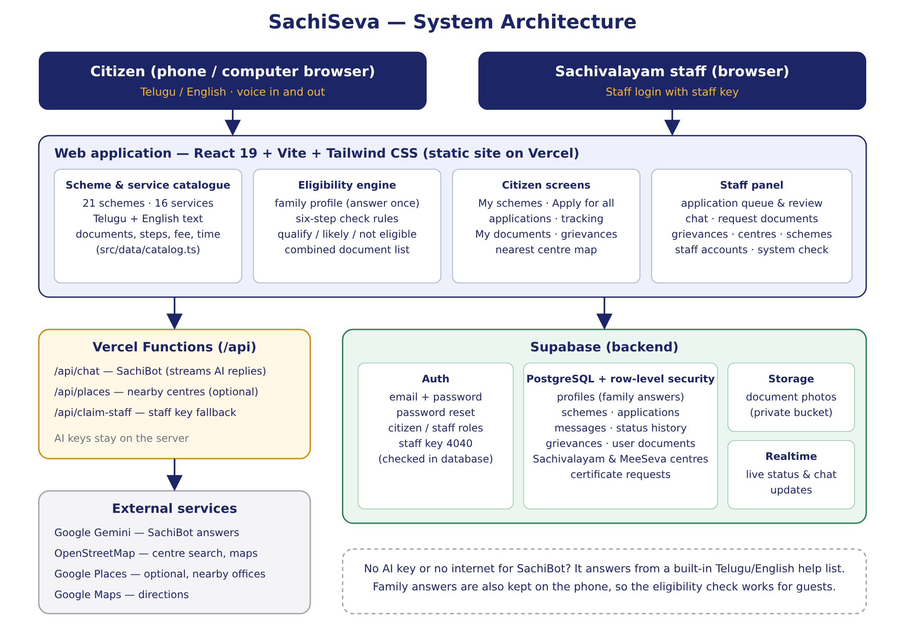
Figure 13.1 System Architecture of SachiSeva
Figure 13.1 shows the overall architecture of SachiSeva: the citizen and staff screens of the web application, the catalogue and eligibility engine, the Supabase backend (sign-in, database, storage and live updates), the Vercel server functions, and the external services they use.

13.8 Key Features
The application works in Telugu and English with a one-tap language switch. Its main features are:
- Login first: the welcome page is a log in / register screen for citizens and staff; every other page needs a login.
- My schemes: the family answers 23 short questions in three steps (about the person, family and home, and the family's income together with the government's six-step check: land, electricity, four-wheeler, government job or pension, income tax and town property). Questions can be skipped. The result lists the schemes the family qualifies for, the ones that are likely (with what to confirm), schemes coming soon, and schemes not eligible with the reason, together with the personalised benefit.
- One combined document list: documents needed for all eligible schemes are merged, so a document such as the Aadhaar card appears once, and ticked against the documents the citizen has already saved.
- Apply for all: one form, each document uploaded once, and a separate application with its own number for every selected scheme; schemes already applied for are skipped.
- Scheme and service pages: for each of the 37 items, who qualifies, documents, steps, where to go, fee and time limit, official links and a "Listen" button.
- Applications and tracking: a progress timeline for each application, messages with staff, an Upload button for every document staff request, attaching a photo or PDF at any time, a grievance option after seven days without an update, and tracking by application number.
- Nearest centre: the closest Sachivalayam and MeeSeva centre in one tap using GPS or a typed village, town or PIN code, with distance, directions and crowd level.
- SachiBot: an assistant that answers in Telugu or English, typed or spoken, using the same catalogue.
- Staff panel: staff log in with the staff key and can review applications, change status, message citizens, ask for several documents at once from a list, handle grievances, update centre crowd levels, edit scheme details and run a system check. When staff approve or reject an application, the applicant automatically gets a message asking them to visit their nearby Sachivalayam, where staff advise on the next steps.
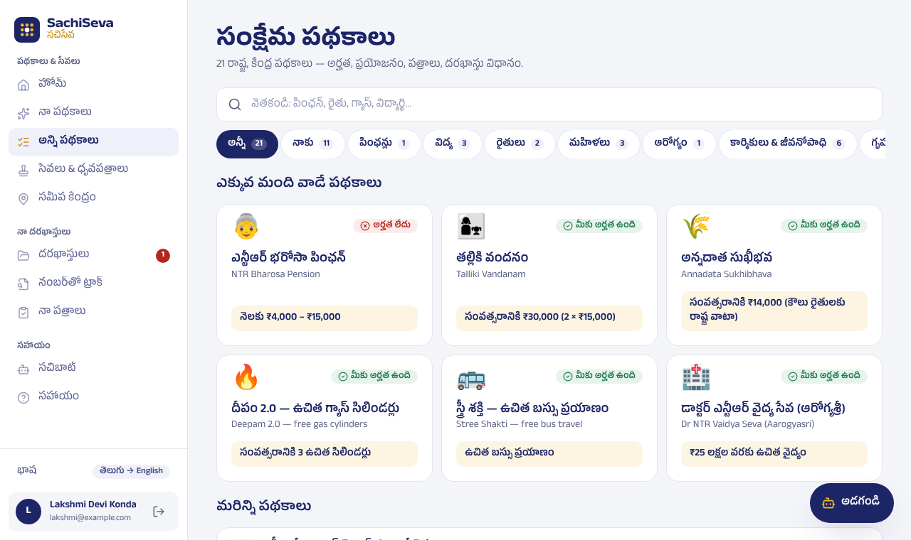
Figure 13.2 Welfare Scheme Catalogue Screen (Telugu)
Figure 13.2 shows the Welfare Scheme Catalogue in Telugu. Each scheme card shows the scheme name in both languages, the family's personalised benefit and an eligibility badge ("You qualify" or "Not eligible"). Citizens can search, filter by category, or choose "For me" to see only the schemes they qualify for.
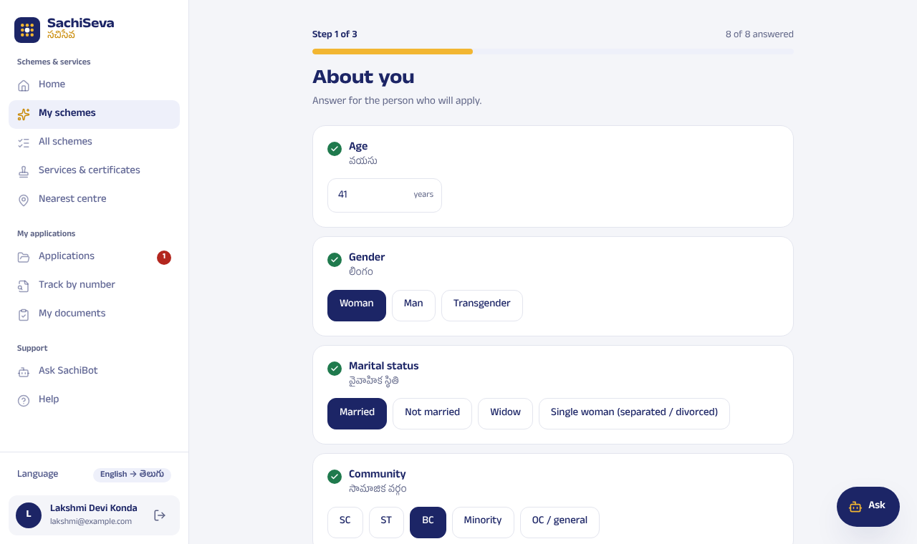
Figure 13.3 Family Questionnaire (Answered Once)
Figure 13.3 shows the first of the three short steps of the family questionnaire. Every question is shown in English with its Telugu translation, can be answered with large buttons, and can be skipped if the citizen is unsure. The answers are saved on the phone and in the citizen's account, so they are asked only once.

13.9 Results and Discussion
The completed application is deployed on Vercel. A citizen can open the link, answer the family questions once, and within seconds see exactly which of the 21 schemes they qualify for, the benefit amount and the documents required, collapsing what would otherwise be several separate enquiries at the Sachivalayam into a single self-service check followed by a single "Apply for all" submission.
The following functional outcomes were verified during development and testing:
- Eligibility results were checked for representative family profiles and matched the expected schemes and benefit amounts. For example, a 67-year-old widow in a village with a family income of Rs. 6,000 a month is shown the NTR Bharosa pension at Rs. 4,000 a month, and a land-owning farmer family with two school-going children is shown Annadata Sukhibhava at Rs. 20,000 a year (Rs. 14,000 from the State and Rs. 6,000 PM-Kisan) and Talliki Vandanam at Rs. 30,000 a year.
- Scheme names and benefit amounts were cross-checked against current government information so that the catalogue uses the present government's scheme names (for example, Nethanna Sevalo and Auto Driver Sevalo).
- 65 automated database checks confirmed that every operation works for the correct role with security switched on: a citizen sees only their own data, cannot approve their own application or post messages as staff, a wrong staff key is refused (and locked out after five wrong tries), tracking by number needs a login, and approving or rejecting an application sends the applicant the visit message.
- Automated browser tests opened all 37 screens on phone and desktop layouts in English and Telugu, using a simulated backend, with no errors. They included answering the questionnaire, "Apply for all", submitting an application, SachiBot replies, and staff login with the correct and an incorrect key.
- The server functions were packaged and run on their own to confirm that they start and respond correctly when deployed.
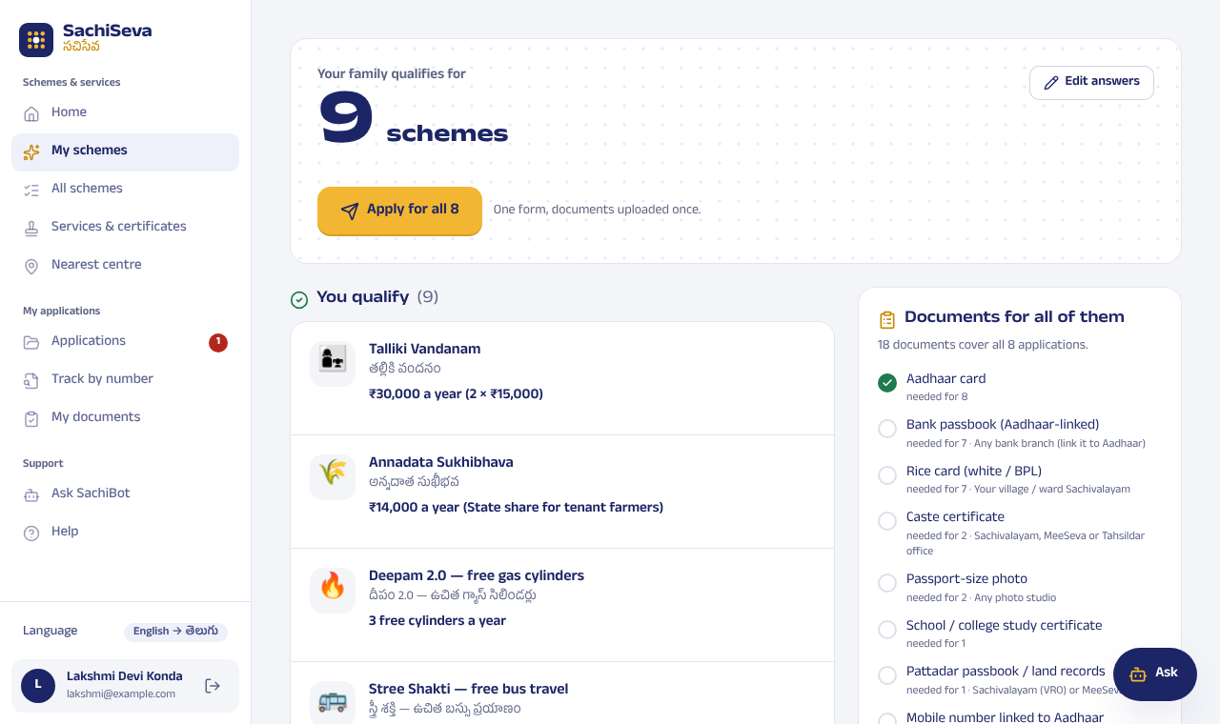
Figure 13.4 My Schemes: Eligibility Results and Combined Document Checklist
Figure 13.4 shows the result of the eligibility check for a family: the number of schemes it qualifies for, each scheme with its personalised benefit, and on the right one combined list of the documents needed for all of them, with documents already saved marked as done. The "Apply for all" button submits an application for every eligible scheme in one step.
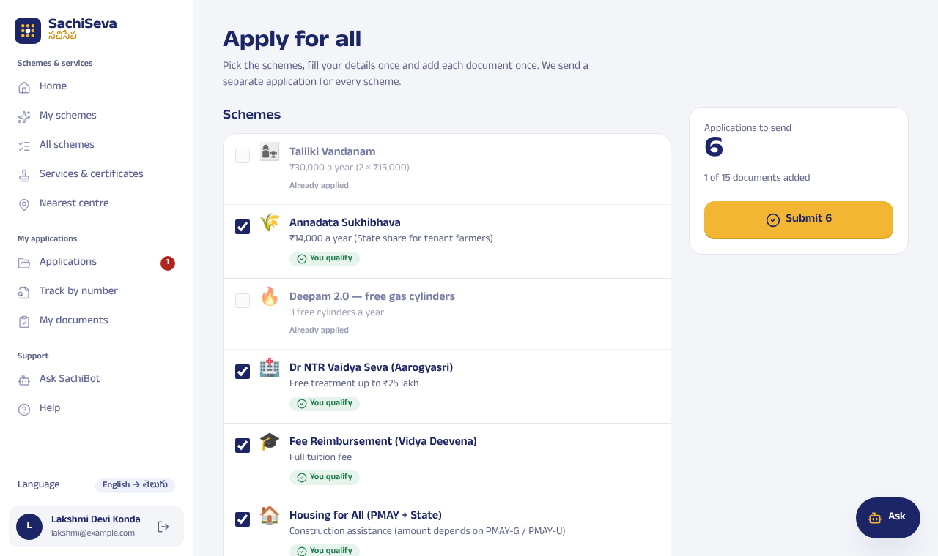
Figure 13.5 Apply for All Screen
Figure 13.5 shows the "Apply for all" screen. Schemes the citizen qualifies for are ticked automatically, schemes already applied for are skipped, and the citizen's details and each document are entered only once; one application with its own number is then created for every selected scheme.
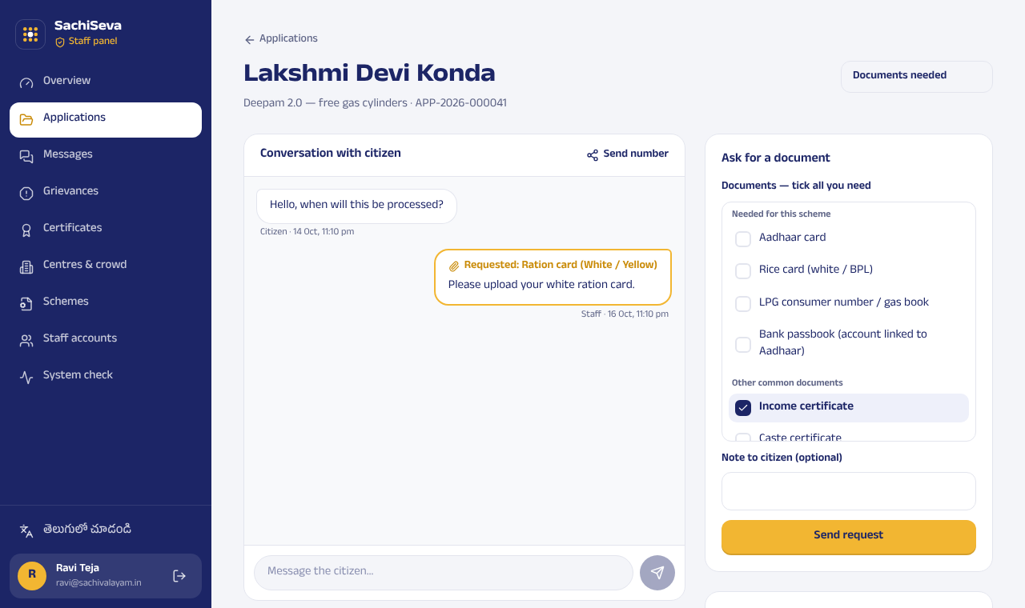
Figure 13.6 Staff Panel: Application Review
Figure 13.6 shows the staff panel, which staff open by logging in with the staff key. A staff member sees the applicant's details and documents, changes the application status, messages the citizen, and ticks one or more missing documents to request, each of which the citizen can upload from the same application screen.

13.10 Benefits of the Project
- Reduces repeat Sachivalayam visits by giving citizens a single, personalised eligibility check instead of several separate enquiries.
- One combined document list and "Apply for all" spare citizens from submitting the same documents again for every scheme.
- Telugu/English voice read-out and voice input extend access to citizens with limited reading ability.
- Personal data is protected by database security rules: each citizen can see only their own profile, applications and documents, and only the last four digits of Aadhaar are collected.
- The staff panel lets Sachivalayam staff review applications, request missing documents and update scheme details without changing any code.
- Scalable design that can be adapted to other States' welfare-scheme catalogues.

13.11 Survey Findings
The survey conducted at Dungalavanipalem, NAD Junction, Andhra Pradesh (see Chapter 2, Table 2.1, and Chapter 4) confirmed that respondents could typically name far fewer schemes than they were actually eligible for, that a majority preferred Telugu for reading scheme information, and that a notable share reported a repeat Sachivalayam visit caused by a missing document. This directly validated the eligibility check, the combined document checklist, "Apply for all" and the Telugu voice read-out built into SachiSeva.

13.12 Future Enhancements
- Extend the scheme catalogue as new schemes are announced, and periodically re-verify benefit amounts and thresholds against official sources.
- Add push notifications (where supported) to tell citizens about application updates and upcoming renewals.
- Conduct a formal, larger-scale user study with Sachivalayam staff and citizens to measure time saved per enquiry and to refine the wording of eligibility questions.
- Connect to official government data sources, with permission, so that eligibility and application status can be confirmed automatically.
- Adapt the same eligibility-engine design to other States' welfare-scheme catalogues, since the architecture is not specific to Andhra Pradesh.

13.13 Challenges Faced

Technical Challenges
- Deployment configuration: the first version was built on a server-rendered framework that did not run correctly on Vercel, so several features failed after deployment. The application was rebuilt as a static React application with Vercel server functions, and a rewrite rule was added so that opening any page link directly works.
- Verifying scheme data accuracy: because scheme names, benefit amounts and eligibility thresholds change whenever the government revises a programme, each catalogue entry had to be checked against real government sources rather than accepted at face value. Schemes that are announced but not yet open are clearly marked so that citizens are not misled.
- Keeping pace with a change of government branding: several scheme names had to be corrected to match the schemes as re-launched by the current TDP–JSP–BJP alliance government, rather than the names used under the previous administration.
- Eligibility accuracy: an early version marked every scheme as "eligible" because the stored rules were empty. The rules were rewritten so that each condition answers yes, no or "not known yet", and similar-sounding documents (for example, "Bank passbook (Aadhaar-linked)" and "Aadhaar card") had to be matched carefully when combining document lists.
- Bilingual rendering and voice support: Telugu text did not render consistently across devices until the Telugu font was bundled with the app, and not every browser ships a Telugu text-to-speech voice by default, which required testing on multiple devices.
- Security: testing showed that a citizen could have created an application already marked as approved, or posted messages as staff. Database triggers and row-level security rules now prevent this, and staff accounts need a staff key that is checked inside the database.

Non-Technical Challenges
- Collecting accurate, current eligibility criteria for 37 different schemes and services from scattered government sources was time-consuming and required cross-verification.
- Explaining technical eligibility conditions (for example, the limit of 1,000 sq ft of property in a town, or the 300-unit electricity limit) in plain Telugu, in a way a non-technical citizen would understand, needed several rounds of wording revision.

13.14 Conclusion
SachiSeva shows that a citizen-facing e-governance tool can be both simple and complete: a bilingual catalogue, a small eligibility engine based on the government's six-step check and a secure cloud database give an Andhra Pradesh family one place to discover every scheme it qualifies for, prepare its documents, apply for all of them together and follow each application to a decision. The project met its objectives: it covers 21 schemes and 16 services in 14 categories, including all six "Super Six" promises, offers a combined document checklist with Telugu voice read-out, and gives Sachivalayam staff a protected panel to review applications and keep scheme details up to date.

CHAPTER 5: RECOMMENDATIONS AND CONCLUSIONS

5.1 Recommendations
- Expand Scheme Coverage: New schemes and citizen services should be added to the catalogue as they are announced, with benefit amounts and thresholds periodically re-verified against official government sources.
- Government Partnership: Educational and government institutions should partner with the platform so that scheme updates can be synced directly from official Sachivalayam or NBM notifications rather than by manual entry alone.
- Enhance Telugu Voice Quality: The Web Speech API voice read-out should be tested and tuned across more devices and browsers to ensure consistent Telugu pronunciation for all citizens.
- Promote Digital Literacy: Sachivalayam field staff and volunteers should be trained to demonstrate the SachiSeva application to visiting citizens as part of routine service delivery.
- Regular Data Verification: The scheme catalogue should be reviewed whenever the government revises a scheme. Because the catalogue is kept in one file, a single update regenerates both the database script and SachiBot's knowledge.
- Monitor and Evaluate: The number of applications, approvals, grievances and repeat-visit trends should be tracked to evaluate the platform's impact and guide future improvements.

5.2 Conclusion
SachiSeva — Welfare Eligibility Platform was successfully designed to address the problem of welfare-scheme awareness gaps among citizens served by the AP Sachivalayam system. The project demonstrated the effective use of modern web technology (a bilingual React application, a secure Supabase database and server functions) to deliver personalised welfare-scheme information and online applications to citizens regardless of their literacy level or device.
The Community Service Project survey conducted at Dungalavanipalem, NAD Junction, Andhra Pradesh highlighted the urgent need for a bilingual, self-service eligibility-checking tool for the community. The project not only provided a technological solution but also helped create awareness about available government welfare schemes and the documents citizens need before visiting the Sachivalayam.

CHAPTER 6: REFERENCES
- Government of Andhra Pradesh. (n.d.). Village and Ward Secretariats Department. https://gramawardsachivalayam.ap.gov.in
- Government of Andhra Pradesh. (n.d.). Official portal of the Government of Andhra Pradesh. https://www.ap.gov.in
- Government of Andhra Pradesh. (n.d.). NTR Bharosa pensions (Social Security Pensions). https://sspensions.ap.gov.in
- Government of India. (n.d.). Pradhan Mantri Kisan Samman Nidhi (PM-KISAN). https://pmkisan.gov.in
- The Week. (2025, June 11). Andhra govt to disburse Rs 8,745 cr under 'Talliki Vandanam' scheme on Jun 12. https://www.theweek.in/wire-updates/national/2025/06/11/mes8-ap-scheme-cm.html
- The Hans India. (2026, September 12). 'Super Six' bill mounts as AP expands free travel, farm, education support. https://www.thehansindia.com/news/cities/amaravati/super-six-bill-mounts-as-ap-expands-free-travel-farm-education-support-1121009
- Bhatnagar, S. (2014). Public service delivery: Role of information and communication technology in improving governance and development impact (ADB Economics Working Paper Series No. 391). Asian Development Bank. https://www.adb.org/publications/public-service-delivery-role-information-and-communication-technology-improving-governance
- Biørn-Hansen, A., Majchrzak, T. A., & Grønli, T.-M. (2017). Progressive web apps: The possible web-native unifier for mobile development. In Proceedings of the 13th International Conference on Web Information Systems and Technologies (WEBIST 2017) (pp. 344–351). SciTePress. https://doi.org/10.5220/0006353703440351
- Meta Open Source. (n.d.). React documentation. https://react.dev
- Supabase. (n.d.). Row level security. Supabase Docs. https://supabase.com/docs/guides/database/postgres/row-level-security
- Vercel. (n.d.). Vercel Functions. Vercel Docs. https://vercel.com/docs/functions
- MDN Web Docs. (n.d.). Web Speech API. Mozilla. https://developer.mozilla.org/en-US/docs/Web/API/Web_Speech_API
- W3C. (n.d.). Web application manifest. World Wide Web Consortium. https://www.w3.org/TR/appmanifest/
- WHATWG. (n.d.). HTML living standard. https://html.spec.whatwg.org

ANNEXURE A: FIELD PHOTOGRAPHS
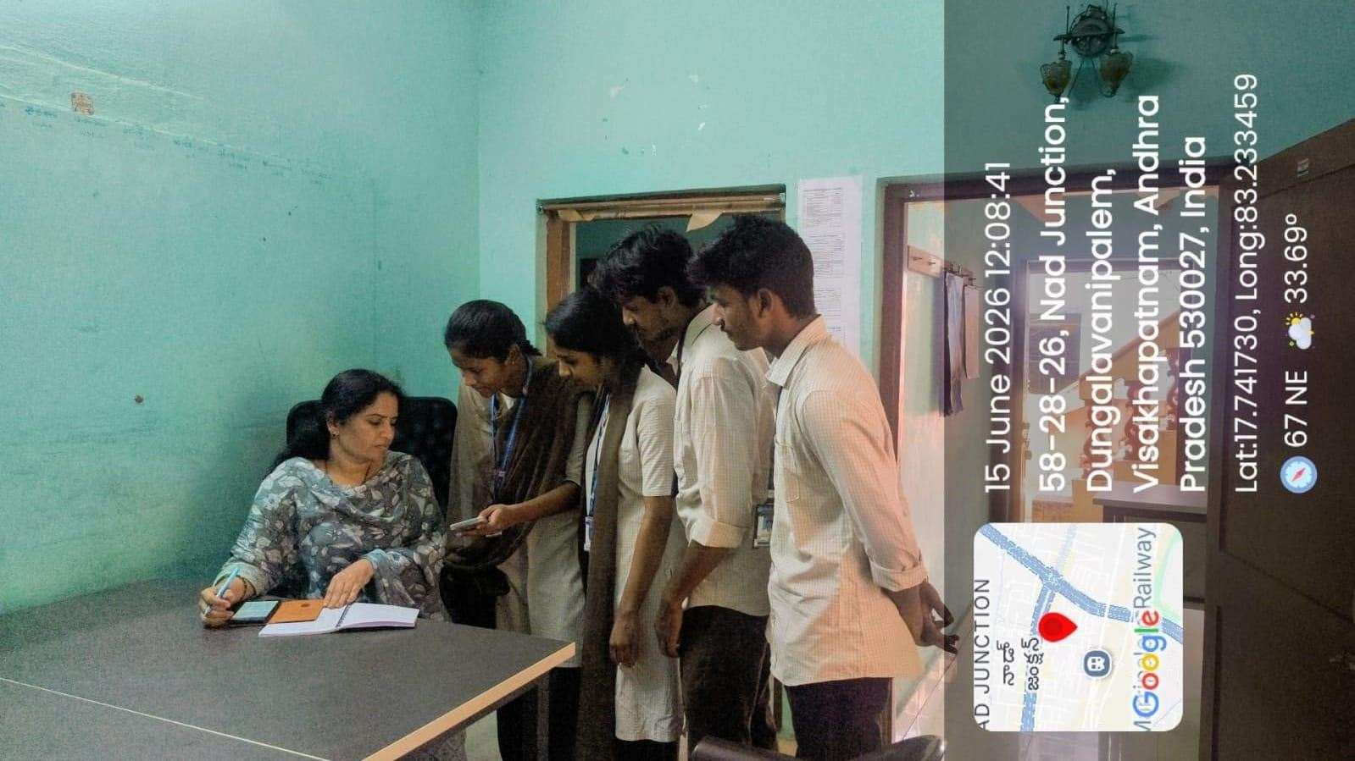
Photo A.1 The team discussing the project with a Sachivalayam official (15 June 2026)
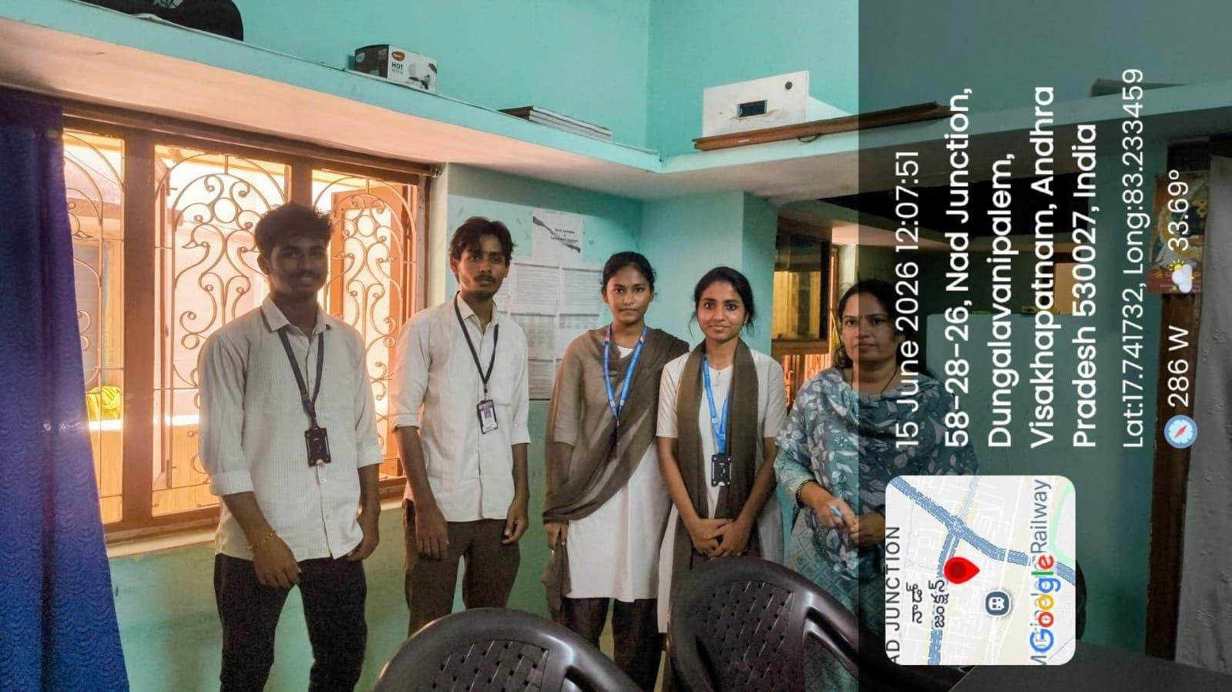
Photo A.2 The team at the Sachivalayam, Dungalavanipalem, NAD Junction (15 June 2026)

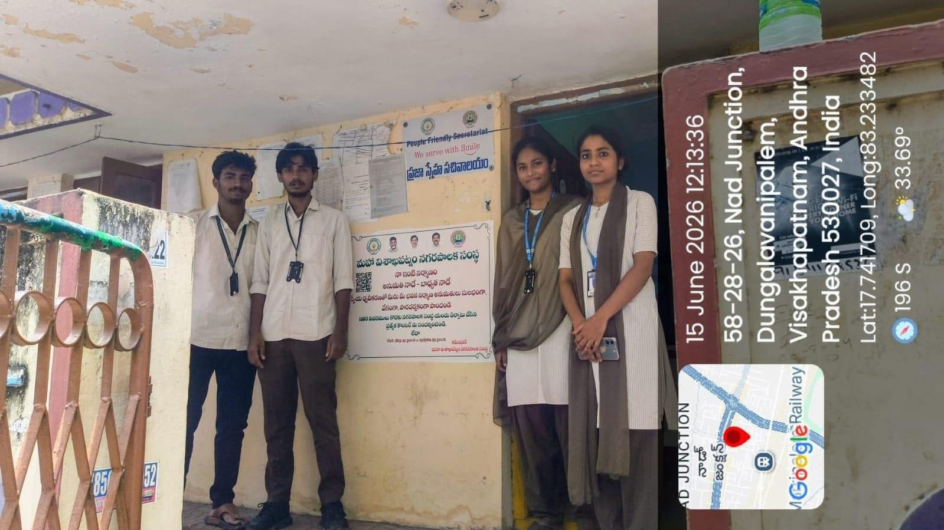
Photo A.3 The team outside the Sachivalayam, Dungalavanipalem, NAD Junction (15 June 2026)
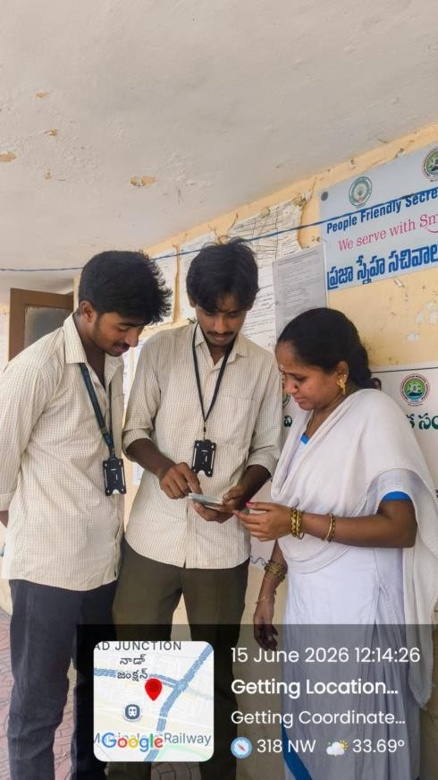
Photo A.4 Demonstrating SachiSeva to a citizen on a phone (15 June 2026)

ANNEXURE B: CSP COMPLETION CERTIFICATE
The following certificate was issued by the Secretary, Grama/Ward Sachivalayam, Dungalavanipalem (NAD), Visakhapatnam, on 15 June 2026, confirming the completion of the Community Service Project "SachiSeva" by the team during the academic year 2025–2026.
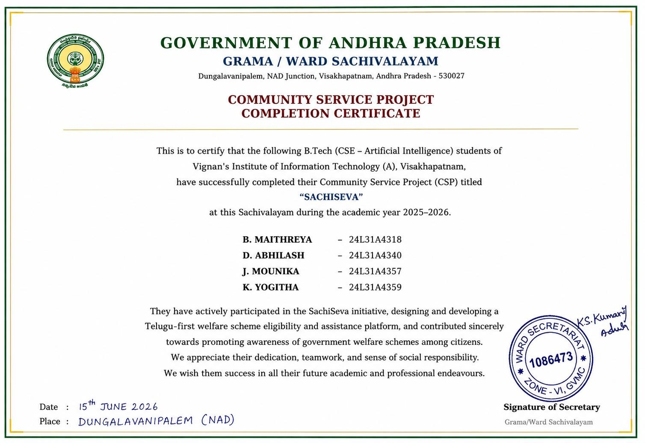
Community Service Project Completion Certificate issued by the Grama/Ward Sachivalayam

