**RM 07**

|  |  |  |
| --- | --- | --- |
| H:\FORM EDIT\Logo kota malang jawa timur.png | PEMERINTAH KOTA MALANG  DINAS KESEHATAN  **PUSKESMAS RAMPAL CELAKET**  Jl. Simpang Kasembon No.5 Telp. (0341) 356380  [www.puskrampalcelaket.malangkota.go.id](http://www.puskrampalcelaket.malangkota.go.id) e-mail : [puskrampalcelaket@malangkota.go.id](mailto:puskrampalcelaket@malangkota.go.id)  MALANG Kode Pos : 65111 | H:\FORM EDIT\logo-puskesmas (1).png |

**RUANG PEMERIKSAAN GIGI DAN MULUT**

# No RM : ${no_rm}

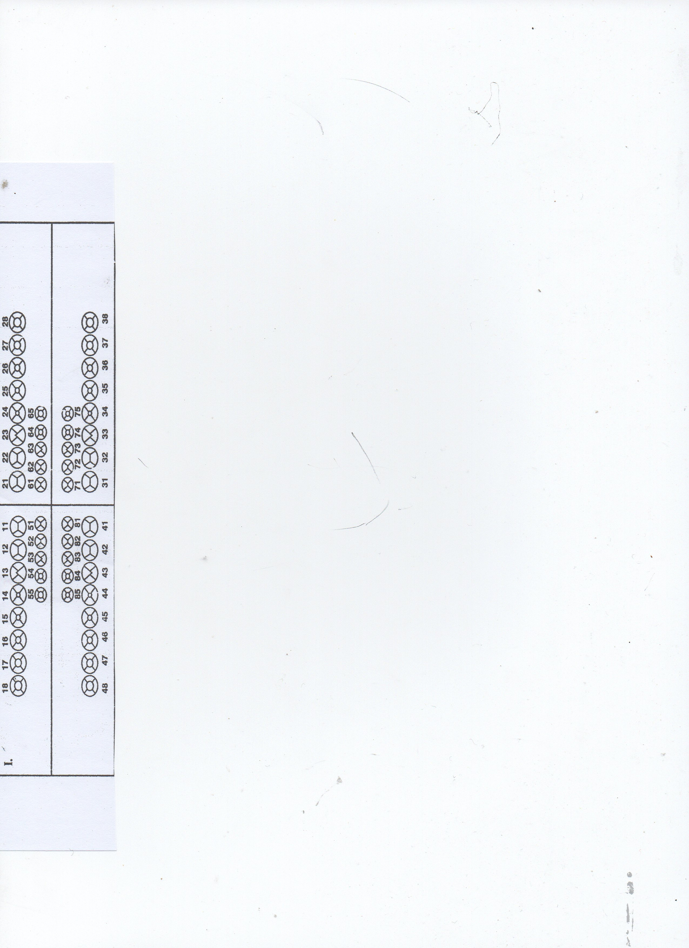**IDENTITAS PASIEN**

|  |  |  |  |
| --- | --- | --- | --- |
| NAMA | : | ${nama_pasien} | |
| TANGGAL LAHIR | : | ${tgl_lahir} | UMUR : ${umur} |
| JENIS KELAMIN | : | ${jk} | AGAMA : ${agama} |
| ALAMAT | : | ${alamat} | |
| PEKERJAAN | : | ${pekerjaan} | |
| KEPESERTAAN | : | ${cara_bayar} | |
| NO. TELP | : | ${telepon} | |
| RIWAYAT ALERGI | : |  | |

**ODONTOGRAM (FDI)**

| **TGL & JAM** | **S** | **O** | **A** | **P** | **NAMA &**  **TTD DOKTER** |
| --- | --- | --- | --- | --- | --- |
|  |  |  |  |  |  |