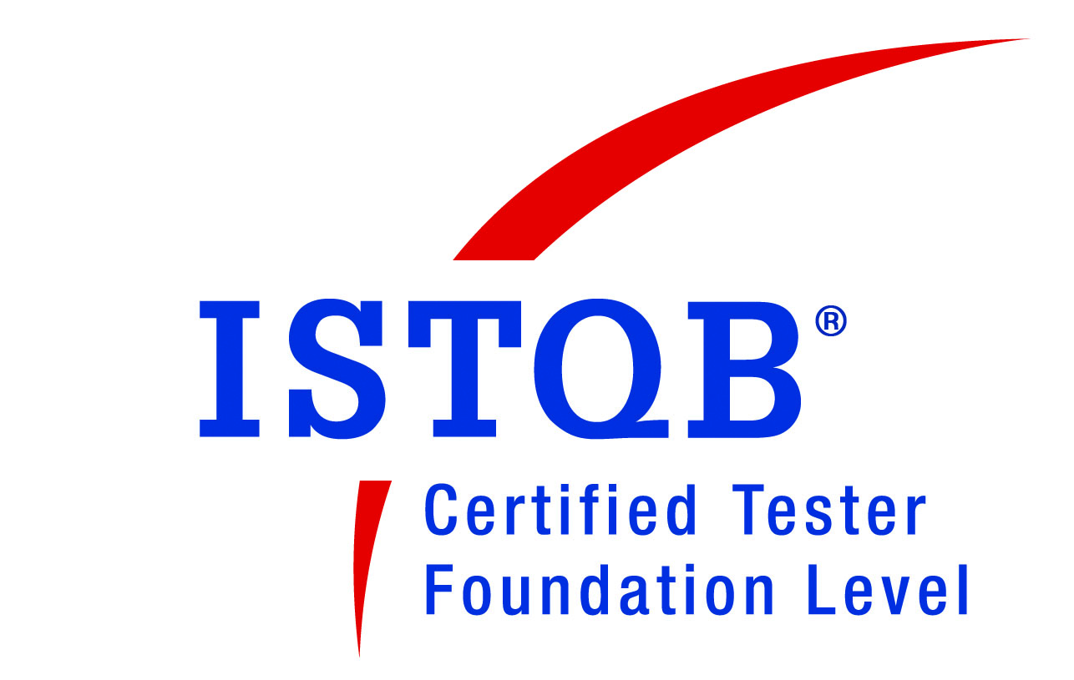
Name: Yogesh Shivaji Salunke
E-mail: yogsalunke@yahoo.com
Contact No.: +91-8898478863

Professional summary:
Experienced Test Team Lead with a proven track record of successfully managing and leading testing efforts for software development project. Strong leadership and communication skills with the ability to effectively manage cross- functional teams to achieve project goals.

Domain Knowledge: | Insurance, Banking, Telecom, E- Learning, Localization,  Health and safety, Windows Application.  Professional Experience – 13+ yrs (Selenium 2 yrs + SOAPUI 1.3 yrs)

Work Experience:-

- Company-: Capgemini India.
Senior Consultant Jul. 2021 – Till Date

Projects Worked on: - Merlin Cloud (Abbott)

Merlin.net Patient Care Network (PCN) is a remote follow up system that imports and manages cardiac information for patients who have Abbott implanted devices. The system lets you and other clinicians upload and manages patient device data via web interface.
Roles :-
- Managing the testing team, which includes assigning work, setting goals and providing guidance and support to team members.
- Led the migration project and team of 5.
- Review Test cases to ensure that they are of high quality.
- Monitoring testing progress, identifying defects and ensuring they are documented and resolved in timely manner.
- Identify opportunities to automate the testing process and guide the team.
- Provide regular reports on testing progress, defects and issues to the stakeholders and senior management.
- Identifying opportunities to improve the testing process and implementing changes.
Tools Used –
- Doors, ClearQuest, Selenium, Putty, Jira, WinSCP, Postman
- Have experience in medical devices.

- Company-: Accenture Services PVT.LTD.
Team Lead Aug. 2016 – Jul. 2021

Projects Worked on: -

1) Three (Insurance domain) (Agile) – US based Client

Three basically it’s insurance project which deals with different LOB such as Auto, WC, General liability and Property. This is web based application whose backend is DUCK creek, where user can buy a policy, make endorsement and apply for claims. It covers different modules such as policy creation, Billing, claims and settlement.
Roles:-
- Leading a team of 4 members, currently responsible for Planning, Test preparation and execution for the new requirement’s and defects.
- Coordinating with onshore PO for the requirement analysis and estimations.
- Coordinating with different teams for the regression planning and creating a regression scope based on the requirement’s from different teams.
- Participated for UAT testing.
- Allocating work items within onshore/offshore team members and assisting them in any requirement clarification and reviewing the same.

2) Wi-Fi Ready Zone Services (Agile) – ATNT

Wi-Fi Services enables client a very detail analysis of the services and products they are using with the help of reporting API’s, which are consume by the Portal team.
Working on Big data analysis project which involves technologies like Spark, UNIX, Casandra and web API’s.
Roles:-
- Leading a team of 4, currently responsible for spark Jobs execution, business requirement validation, it involves executing the Job and analyzing the response.
- Spark job testing which involves requirement validation, database validation in Cassandra DB & analyzing web service API response using postman/SOAPUI
- Assisted business users in defining UAT test cases and plans; Maintained test cases and test data.
- Preparing deployment checklist and validating the artifacts for deployment. Monitoring pre and post deployment activities.
- Introduced the automation environment (SOAPUI) for regression and led the team to test the JAVA WEB API’s with various Testing Levels.
- Coordinated resource allocations, created work assignments for team, maintained timelines / milestones, and ensured compliance with quality standards.
- Client interaction for the Requirements and working with onshore team.

- Company-: Efkon India Pvt. Ltd. (Vikhroli)
Sr. Test Engineer. April. 2015 – Aug.2016

Projects Worked on: -

1) FASTAG –Electronic Toll Collection (Axis Bank)

The ETC CCH is a robust, fully automated, Back Office Solution for the Tolling Industry. The product is built on a solid foundation using the latest technology architecture and standards.
The modules Includes Concessionaire, POS, TAG issuance and TAG operations, Road user, Back Office Module, Audit Process, Service Request Management .

Roles:-
- Working closely with development team to understand the application workflow.
- Responsible for Functional testing of developed software against specified requirements.
- Preparation of Test Plan, Workflow document and Test Scenario documents.
- Accurately monitoring and recording results in JIRA.
- Analyzing, writing reports & communicating results to colleagues & managers.
- Responsible for Regression and smoke Testing, also maintaining the test environment.
- Involved in UAT testing in Axis Environment.
- Responsible for Creating and execution of Automation Scripts in existing framework using selenium web driver.

(Selenium Web driver)
Responsible for Testing the Functionality of Mobile Application.

NHAI App – Incident Management app.
Total Visible – Employee Attendance management and Tasks Management App.

- Company-: Mindgate Solutions Pvt. Ltd. (Vikhroli)
Test Engineer. Sep. 2013 – Mar 2015

Projects Worked on: -

1) ezeClick Payment gateway (Amex)

ezeClick solution coupled with the SafeKey and VPOS process provides a safe and secure payment authentication and authorization process.
ezeClick offers a virtual wallet, termed as ezeClick e-Wallet for Card members. They can add and store multiple Card details, and re-use the same for a transaction.

2) Reliance Jio HSE&F (Reliance)
This application is design to capture the incident and enable the HSE&F related processes, procedures & information to be accessible across all R4G locations. Also to compliment and co-ordinate HSE&F related activities across the business.

Other Projects -:
1) NAREGA
2) Converter applications for different banks, Windows based application.
3) CBTR (SCB bank)

Roles:-
- Working closely with development team to understand the application workflow.
- Responsible for Test Scenario and Test case Preparation.
- Test case Execution and Defect Reporting.
- Responsible for End to End Functional Testing of application.
- Involve in preparation of Test plan document.
- Reporting and monitoring the defects to Dev. Team and manager.

- Company-: Praxis Interactive Technology.
Test Engineer. June 2012 – Aug 2013

Projects Worked on: -

PLATO (Web based E-learning system)

Campus Management Corp. is a private company that provides software solutions and services to more than 1,700 colleges, universities, foundations, and other companies. It unites academics and administration on a single platform.

- Company-: LionBridge Technology.
Localization Test Engineer. May 2010 – Jan. 2012

Technical Skills:

Automation Tools: Selenium 2.0, Bugzilla, TFS, JIRA, SOAPUI
Databases: SQL Server 2005/2008, Casandra
Testing methodologies: Agile, V model, Black Box Testing, UAT
Other: UNIX, WinSCP, Putty, Spark Testing

Educational Qualification:
Degree | College |  | University | Year | Class.
PG Diploma-IT Project Management | LN Welingkar Institute of Management |  | Mumbai | 2017 | First Class
ISTQB Certification | ISTQB |  | - | 2014 | First Class
BCS | N.G. Acharya College  (Chembur) |  | Mumbai University | 2009 | Second Class

Personal Information:
Date of Birth: | 2nd Sep 1987
Address: | Yogesh Shivaji Salunke  Flat 103, Plot No 30, Sector 15, Shri Vishnu CHS,  Koper Khairane – 4007090
Nationality: | Indian
Languages: | English, Hindi, Marathi

Extra Curricular Activities
Co-Curricular Activities | 1. Participation in interschool Drawing and quiz competitions.  2. Participation in annual social gatherings.  3.Trekking
Hobbies | 1. Analyzing Stock market  2. Swimming

