DEDICATION
THIS WORK IS DEDICATED
TO MY HARDWORK

ACKNOWLEDGEMENTS
The accomplishment of this great project won’t have been a success without out the important contributions of a good number of people who gave me a huge support academically, professionally, financially and even spiritually. I then direct my appreciations to:
- Mr. Armand Claude ABANDA, the Resident Representative of AICS Cameroon for creating the Anglophone section offering the software engineering field and also for his encouragements and follow-ups. Also, for permitting us carry our internship at his institute AICS Cameroon.
- My Academic Supervisor Mr. TCHOUA NGATCHOU NANA Samory for his time, advices, and follow-up throughout these periods.
- My Professional Supervisor Mr. TCHOUA NGATCHOU NANA Samory for his time, advices, and follow-up throughout these periods
- To my teachers (lecturers) for their words of encouragement, trust and time invested during this period.
- To my lovely family YOGO, my mum and dad must especially, thanking them for their continuous prayers, blessings, support (spiritual and financial support) and encouragements. A special thanks to my uncles and aunts.
- Mr. AGBOR ANDERSON for his time, advices, and follow-up throughout these periods.
- Mr. MESSIO for his time, advices, and follow-up throughout these periods.

SUMMARY
DEDICATION I
ACKNOWLEDGEMENTS II
SUMMARY III
LIST OF FIGURES IV
LIST OF TABLES VI
LIST OF ABBREVIATIONS VII
ABSTRACT 1
RÉSUMÉ 2
GENERAL INTRODUCTION 3
CHAPTER I : INSERTION PHASE 4
CHAPTER II: EXISTING SYSTEM 17
PRESENTATION OF THEME 20
DESCRIPTION OF THE EXISISTING SYSTEM 21
CRITICISM OF THE EXISTING SYSTEM 23
LIMITATIONS OF THE EXISTING SYSTEM AND PROPOSED SOLUTIONS 24
PROBLEMATIC 26
PROPOSED SOLUTION 26
CHAPTER III : SPECIFICATION BOOK 28
29
CHAPTER IV: ANALYSIS PHASE 47
a. METHODOLOGY 50
CHAPTER V: CONCEPTION PHASE 81
CHAPTER VI: REALIZATION PHASE 95
CHAPTER VII: FUNCTIONALITY TESTING 110
CHAPTER VII: INSTALLATION GUIDE AND USER GUIDE 117
GENERAL CONCLUSION 125
BIBLIOGRAPHY xiv
WEBOGRAPHY xv
ANNEXES xvi
Table of content xvii

LIST OF FIGURES
Figure 1localisation of smart-tech 2
Figure 2 Organisation chart of SMART-TECH 5
Figure 3: Gantt chart 38
Figure 4 : UML hirarchy 45
Figure 5:Representation of 2-TUP 47
Figure 6 : Use case formalism 50
Figure 7 : General use case of the system 54
Figure 8: manage books specific use case 54
Figure 9 : Manage users specific use case 54
Figure 10 : manage Courses specific use case 55
Figure 11 Manage courses specific use case 56
Figure 12: Communication diagrame formalism 61
Figure 13 :Communication diagram of authentication 63
Figure 14 Communication Diagram create user 63
Figure 15 : Communication diagram of set availability 64
Figure 16:Sequence Diagram formalism 65
Figure 17: Sequence Diagram Authentication 67
Figure 18: sequence diagram create user 68
Figure 19: sequence diagram of send availability 68
Figure 20: activity diagram formalism 69
Figure 21 activity diagram authenntication 71
Figure 22: create user activity diagram 72
Figure 23 : Activity diagram of set availability 73
Figure 24:System physical architecture 77
Figure 25: MVC illustration diagram 78
Figure 26: Class diagram formalism 79
Figure 27:System class diagram 81
Figure 28: State machine formalism 82
Figure 29 Payment state machine 84
Figure 30:Package diagram formalism 85
Figure 31: System package diagram 87
Figure 32: Component diagram formalism 91
Figure 33 : System deployment diagram 93
Figure 34: Component diagram formalism 94
Figure 35 : Component Diagram of ESSTIC 97
Figure 36 : Login screen 106
Figure 37: chat visualisation 106
Figure 38: recover user info screen 107
Figure 39:Unit test register 108
Figure 40: login unit test 108
Figure 41:login page 115
Figure 42:dashbord interface 116
Figure 43: view timetable 116
Figure 44:validate entrance exam result 117
Figure 45:manage profile interface 117

LIST OF TABLES
Table 1 : software resources needed 31
Table 2 : Hardware resources needed source mercurial 2024 33
Table 3 : Human resource needed 33
Table 4: Estimated cost table 34
Table 5 : project Planning 36
Table 6: table of participant 37
Table 7: Comparative study between UML and Merise 46
Table 8 : Component of use case Diagram 51
Table 9: Authentication textual description 57
Table 10 : Textual description create course 58
Table 11 : set availability textual description 59
Table 12 : Generate timetable textual description 59
Table 13 : Component of communication diagram 61
Table 14:Components of a Sequence Diagram 65
Table 15:Component of an activity diagram 70
Table 16 : Component of a class diagram 80
Table 17 : Component of state machine diagram 83
Table 18: Component package diagram 86
Table 19: Component of a deploment diagram 92
Table 20: Component of a component diagram 95
Table 21: Hardware materials used for the development of the ESSTIC Smart System 98
Table 22:Software materials used for the development of the ESSTIC Smart System 99

LIST OF ABBREVIATIONS
2TUP: Two Track Unified Process
API: Application programming Interface
AICS: African institute of Computer Science
CD-ROM: Compact Disk- Read Only Memory
CRUD: Create Read Update Delete;
DBMS: Database Management System
ICT: Information and Communication Technology
IOT: Internet of things
SDLC: System Development Life Cycle

ABSTRACT
Humanity has stopped evolving. In fact, it has evolved at an exponential rate over the pass few centuries, driven by innovations in technology. From the agricultural revolution to the industrial revolution then to information and communication technology revolution, we have developed new tools that has allowed us transform our world in ways that were unimaginable. Thus, we cannot see the future without technology. These new technological advances have had a profound impact on our lives changing the way we work, the way we communicate and the way we interact with the world around us. For this reason, the African Institute of computer sciences is committed to making Cameroon a key player in the information and communication technology revolution. To archive this, AICS offers its students practical trainings through academic internship. This internship gives students the opportunity to apply their theoritical knowledge to real world problems. In line with these perspectives, we approach INTERLINK, which is an enterprise that host our internship. During our induction phase, we were assigned the theme” Design and Implementation of an Intelligent House System Based on Light Intensity Control and Security Monitoring. “. Following our theme, we conducted feasibility studies, followed by analysis, then via conception and realization phases. The application was developed using Nodejs, Vue.js and in order to obtain a flexible and secure solution.
Keywords:
  - ARTIFICIAL ITELIGENCE
  - IOT
  - SCHEDULING
  - COMMUNICATION

RÉSUMÉ
L'humanité n'a pas cessé d'évoluer, bien au contraire, elle a évolué à un rythme exponentiel au cours des derniers siècles, stimulée par les innovations technologiques. De la révolution agricole à la révolution industrielle, puis à la révolution des technologies de l'information et de la communication, nous avons développé de nouveaux outils qui nous ont permis de transformer notre monde de manière inimaginable. Ainsi, nous ne pouvons pas concevoir l'avenir sans technologie. Ces avancées technologiques ont eu un impact profond sur nos vies, changeant la façon dont nous travaillons, communiquons et interagissons avec le monde qui nous entoure. Pour cette raison, l'Institut Africain d'Informatique (IAI) s'est engagé à faire du Cameroun un acteur clé de la révolution des technologies de l'information et de la communication. Pour atteindre cet objectif, l'IAI offre à ses étudiants des formations pratiques à travers des stages académiques. Ce stage donne aux étudiants l'opportunité d'appliquer leurs connaissances théoriques à des problèmes du monde réel. Dans cette optique, nous nous sommes adressés à SMART-TECH, une entreprise qui accueille notre stage. Lors de notre phase d'induction, nous avons été assignés au thème " Conception et mise en œuvre d’un système de maison intelligente basée sur le control de luminosité et surveillance ". Suivant notre thème, nous avons effectué des études de faisabilité, suivies d'une analyse, puis des phases de conception et de réalisation. L'application a été développée en utilisant Nodejs, Vue.js afin d'obtenir une solution flexible et sécurisée.
Mots-clés :
- Intelligence artificielle
- Internet des Object
- Planification
- communication

GENERAL INTRODUCTION
In today’s educational landscape, institutions face growing challenges in managing academic activities efficiently while providing personalized support to students. Traditional school management systems focus mainly on administrative tasks such as scheduling, grading, and data storage, often neglecting performance analysis and individualized learning guidance. This gap limits timely interventions and hinders continuous academic improvement. To overcome these limitations, this project presents the conception and implementation of an intelligent school management system that leverages artificial intelligence to analyze student performance and provide personalized learning orientation. The system seeks to combine administrative efficiency with AI-driven decision support, offering real-time insights and data-based recommendations to enhance subject mastery and overall academic success. The project’s analysis and design adopt the 2TUP (Two-Track Unified Process) methodology, emphasizing both business and system modeling for a comprehensive understanding of user needs and system functionalities. Using UML (Unified Modeling Language) diagrams—such as use case, class, sequence, and activity diagrams—the system is modeled to represent its behavior, user interactions, and data structures. This structured analytical approach establishes a solid foundation for subsequent design and implementation phases.
Project Phases:
- Insertion Phase: Defines project context, objectives, and overall purpose.
- Existing System: Manual, slow, decentralized, and prone to information gaps.
- Specification Book: Lists system requirements and development guidelines.
- Analysis Phase: Identifies user needs and system functionalities.
- Conception Phase: Designs system architecture and component interactions.
- Realization Phase: Develops and integrates the designed system modules.
- Functionality Testing Phase: Verifies system performance and requirement compliance.
- The user guide: Explains registration, navigation, and application process clearly

CHAPTER I : INSERTION PHASE

Preamble

The insertion phase document presents the internship environment, the structure of the organization, the conditions in which the interns were received, as well as the project to be realized during the internship.

Content :
INTRODUCTION
- WELCOME AND INTERGRATION
- GENERAL PRESENTATION OF SMART-TECH
- HARDWARE AND SOFTWARE RESOURCES OF WELLD OF SMART-TECH
- ORGANIZATION OF SMART-TECH
- BRIEF PRESENTATION OF PROJECT
CONCLUSION

INTRODUCTION
Social and professional integration refers to the process by which an individual is integrated into the social and economic context by adopting the norms and rules that govern it. In the following sections, we will begin by describing our reception and integration within the company INTERLINK. Then, we will explain its overall structure as well as its organizational chart.

WELCOMING AND INTERGRATION

Welcome
Upon our arrival at INTERLINK, the reception was very simple. We were first taken to the meeting room, introduced to each team member, and then each of us introduced ourselves with our name, class, school, reason for being there, duration of the internship, and how we were admitted.
The Director then gave a welcome speech and instructed the intern coordinator to give us a full tour of the company. Finally, based on our academic fields, we were assigned to different departments

Integration
At first, adjusting was quite intense due to the workload and pressure of meeting tight deadlines. However, after three days, adaptation was achieved.

GENERAL PRESENTATION OF SMART-TECH

History
INTERLINK is a company specializing in software development, online presence management, digital marketing, tech consulting, systems maintenance, IT training and consultancy, network design and implementation, and surveillance camera installation.
It was founded in 2025 by Mr. TCHOU NGATCHOU NANA Samory and Mr. BANGOUP Rufin, who had a futuristic vision for digital transformation in businesses. Today, INTERLINK supports and works with over 10 companies aiming to align with digital standards. Its headquarters is in Yaounde, with a branch office in Douala.

Geographical location
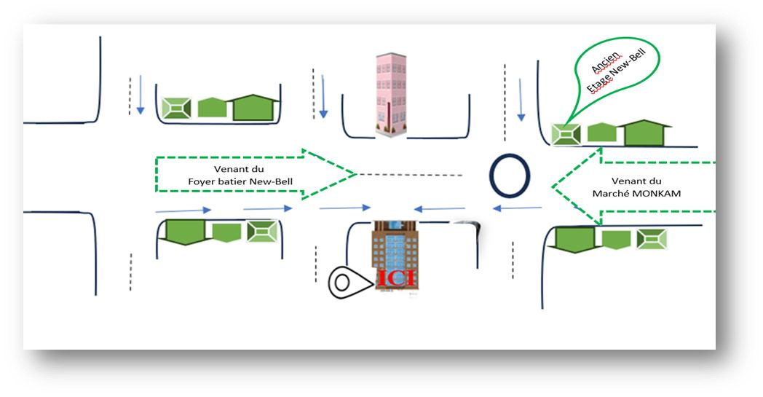
INTERLINKis located at Abang, 3 kilo meters from AWAE Escalier.
Figure 1localisation of smart-tech

Mission
INTERLI main mission is to promote digital transformation for individuals and businesses. Its objectives include:
- Providing a new image of Africa (especially Cameroon) to the world by helping businesses move from analog to digital to improve performance.
- Creating software, logos, flyers, websites, and network installations.
- Offering quality training to company staff and individuals, believing every African should master digital tools.

Activities, Achievements and Partners.

ACTIVITIES
INTERLINKis a key player in digital transformation across various business sectors. Its solutions include:
- System Integration: Helping companies adapt to digital tools.
- IT Strategy and Organization Consulting: Advising on IT service organization and strategies.
- Project Management: Supporting businesses throughout project execution.
- Communication & Digital Marketing: Handling online presence, including web design and content.
- Web & Mobile Application Development: Building websites and apps with attention to quality.

ACHIEVEMENTS
- Design and implementation of a Travel Management System (TMS) for GHF SARL
- Network deployment and maintenance for SOCADEP, CWORTH ENERGY, and individuals
- Installation of surveillance systems at EMERIX COMPANY and private residences
- Design of logos and flyers for SMARTEKS, LA PETITE BAYAM,
FONDATION PAVI, and individuals
- Online presence management for LA PETITE BAYAM, SMARTEKS,
PENTIUM GSM, and others
- Creation of a professional training center with JPTEKS
- Maintenance of IT equipment for FONDATION PAVI and others.

PARTNERS
INTERLINKas an economic enterprise has the following partners who greatly help in the development of their enterprise.
Tableau 1 Table of partners
PARTNERS
• SOCADEP 
• EMERIX. 
• JPTEKS
• PENTUIM GSM 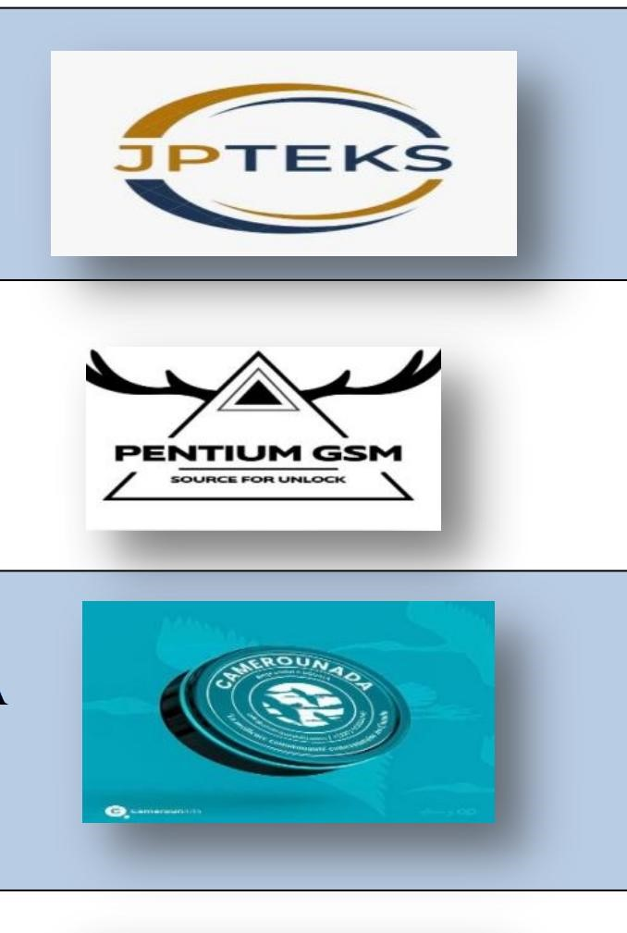

• FONDATION PAVI. 

ORGANIZATIONAL CHART OF SMART-TECH
SMART-TECH has several departments. We were assigned to the Technology
Department.

IV. COMPANY RESOURCES
Figure 2 Organisation chart of INTERLINK

1. Hardware Ressource
Tableau 2 hardware ressource of smart-tech
N | Equipment | Characteristic | Quantity
1. | Computer sever |   Desktop HP | 03
2. | Laptop computer |   Laptop HP | 05
2. | Laptop computer |   Laptop Dell | 05
3. | Routers |   Cisco catalyst 1941 | 01  01
3. | Routers |   Tp-link (wifi) | 01  01
4. | Switch |   Switch cisco catalyst 24 ports | 01
5. | Optic fibre | Camtel | 01
6. | Modem | Modems MTN 4G 01  Modems Toplink 5G | 01  01
7. | Ethernet cable | Twisted pair CAT6 | 01

2. Software Resources
Tableau 3 software resources of smart-tech
N° | Software | Description
01 |   Office suite | Standard Office Suite for creating documents, spreadsheets, presentations, and other professional content.
02 |   Windows 11 | Operating System for computer.
03 |   WPS | Word Processing software.
04 |   Adobe suit | Professional Suite for image editing, illustration creation, video editing, and audio editing.
05 |   Canva | Online Graphic Design Platform for creating professional visuals, presentations, social media publications, etc.
06 |   Visual studio code | IDE (Integrated Development Environment), a free and open-source environment, very popular for web and mobile development.
07 |   Wamp | Local Web Development Environments, including Apache, MySQL, and PHP, for testing and deploying web applications locally before putting them online.
08 |   Cisco ISE | Authentication Management Tools (such as Active Directory) for managing authentications within information systems
09 |   ENSP of HUAWEI | Email Monitoring Software (such as Microsoft Exchange Monitor), a useful tool for monitoring and optimizing mail server operations
10 |   SolarWinds | Email Monitoring Software (such as Microsoft Exchange Monitor), a useful tool for monitoring and optimizing mail server operations
11 |   EVE NG | GNS3 (or other network simulation software), a software for simulating networks through clientless virtualization.
12 |   Eclipse | Open-source Integrated Development Environment (IDE)Used for software development in various languages, including:Java, C++, Python, PHP
 |   GitHub | Source Code Management Platform, used to store, share, and collaborate on software projects.

CONCLUSION

Upon completing our integration, we have gained a thorough understanding of the work environment in which we will be operating during our internship. We have acquainted ourselves with the structure's history, missions, responsibilities, organization, various resources, and organizational chart, enabling us to confidently proceed to the second part of the report, the specifications document.

CHAPTER II: EXISTING SYSTEM
Preamble:
The insertion phase helped us to establish a comprehensive understanding of the host organization. This phase emphasizes on the key characteristics, specificities, and objectives of the designated study subject
Content :
INTRODUCTION
- PRESENTATION OF THEME
- DESCRIPTION OF THE EXISTING SYSTEM
- CRITICISM OF THE EXISTING SYSTEM
- LIMITATIONS OF EXISTING SYSTEM
- PROBLEMATIC
- PROPOSED SOLLUTION
CONCLUSION

INTRODUCTION

Engineers are society's problem-solvers, working to make life easier for everyone. Before proposing solutions, we need to understand the root causes of the problem and how it's currently addressed. Analysing existing systems in our field is key to identifying problems and developing effective solutions. This ensures our proposals improve upon or replace the current system for the better

