**Practical 2:**

**Assignment No. :- Clone the repository at https://github.com/KBCNM-University**

**Roll No. :- 104**

**Name :- Yogesh Pralhad Patil.**

* **Create Repository on github :**

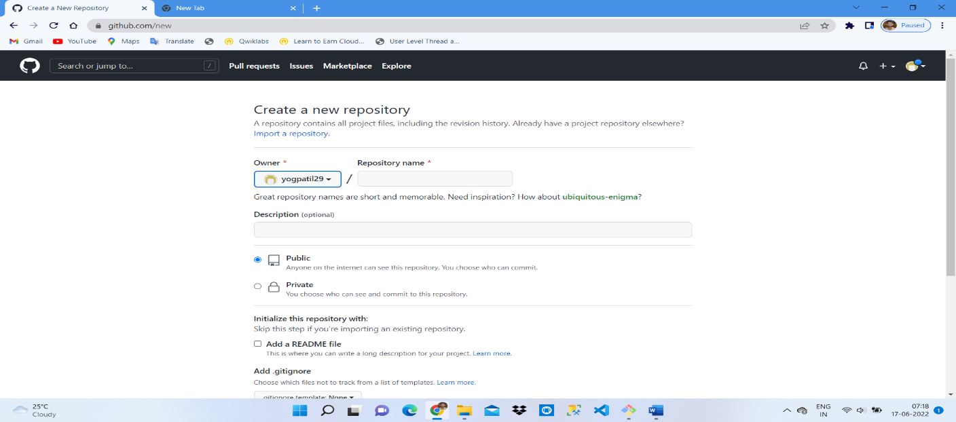

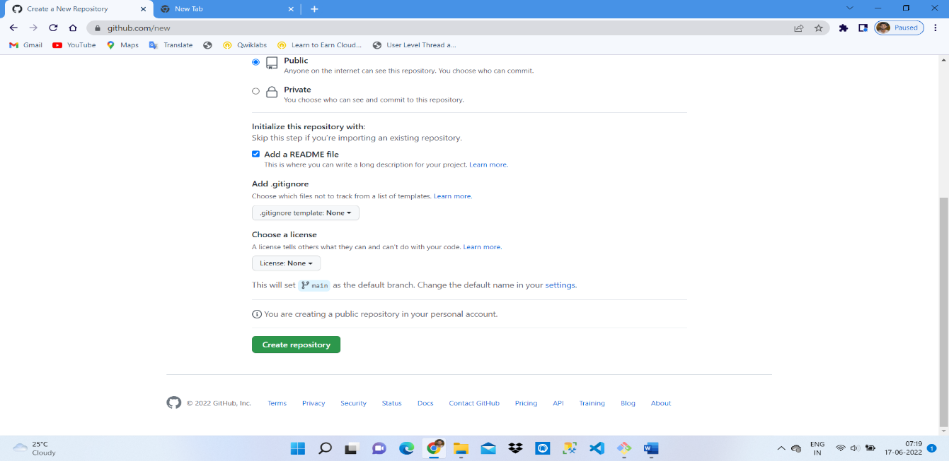

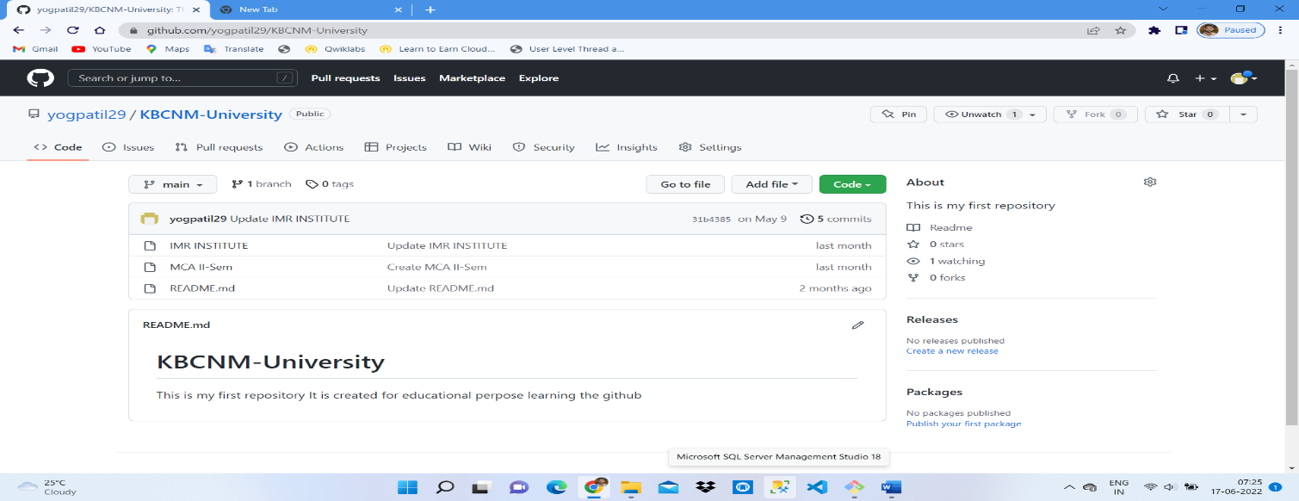

* **Before clone command :**

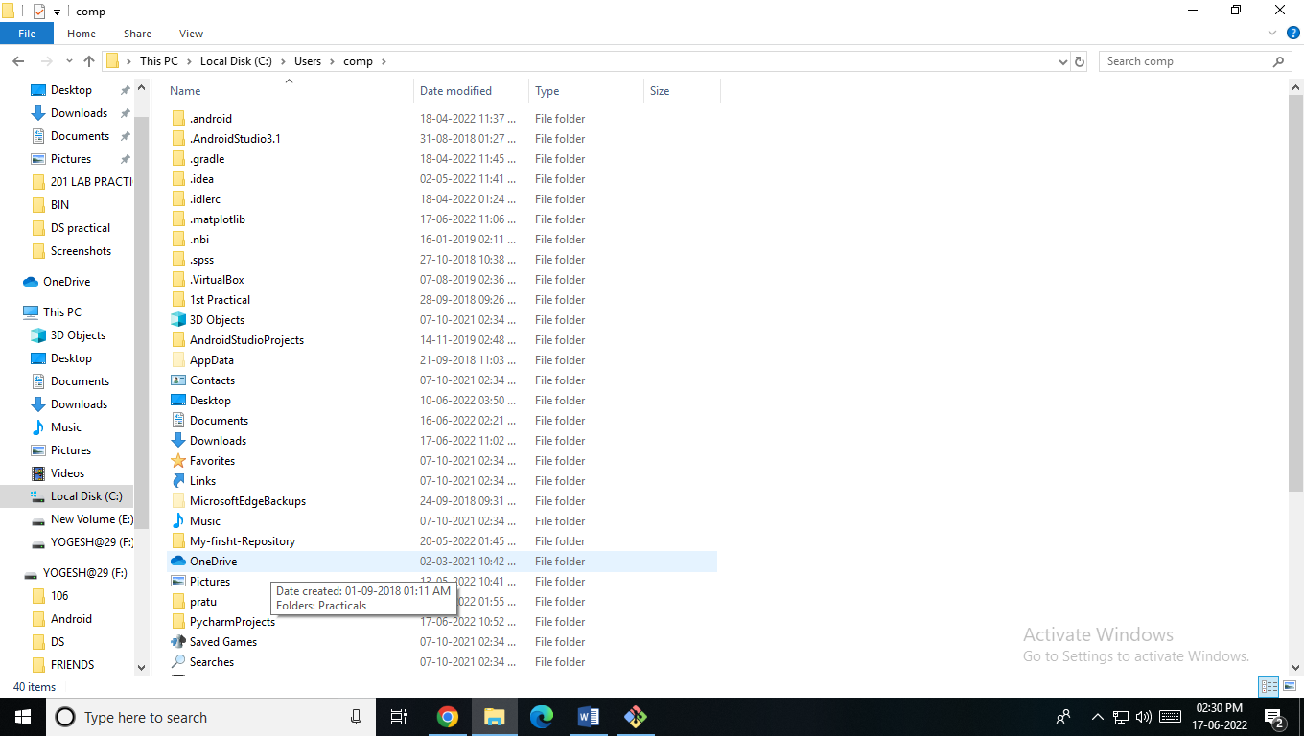

* **Clone it to local machine :**

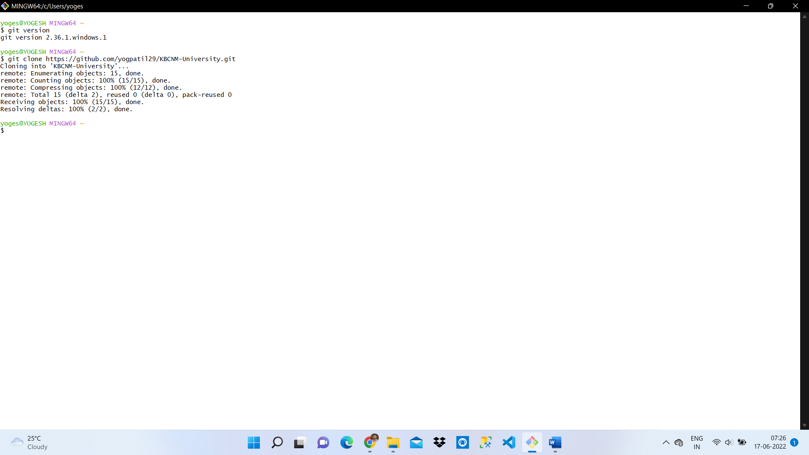

* **Output : After cloning :-**

