**Assignment No. :- 3**

**Assignment Name** :- **Use git add to add that file to the repository. Use git commit to commit your changes.**

**Roll No. :- 104**

**Name : Yogesh Pralhad Patil**

* **Before the commiting changes :-**

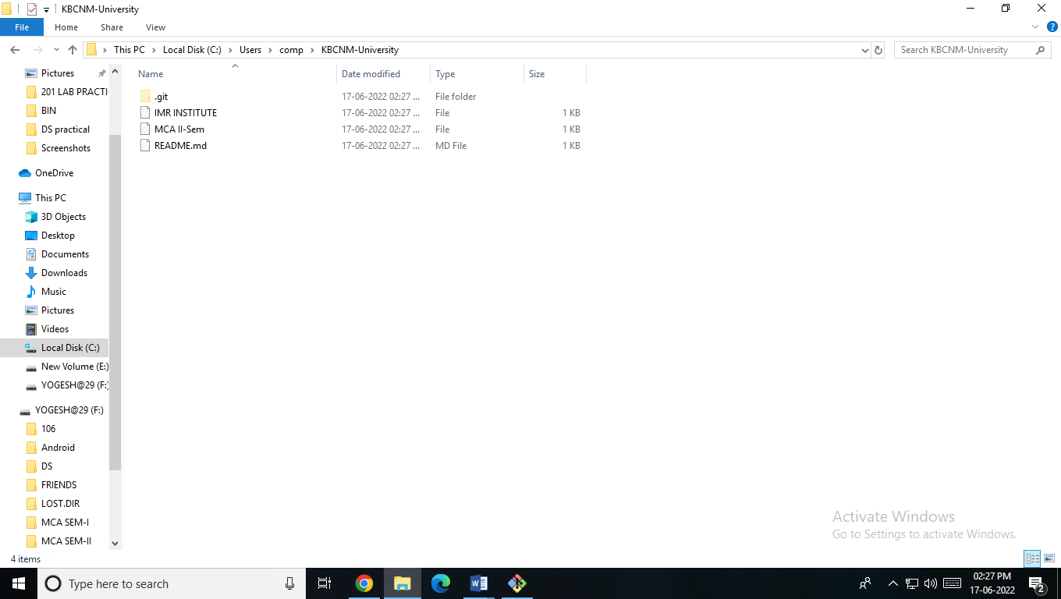

**Step 1: -Go to your local directory and create a file.**

yoges@YOGESH MINGW64 ~

$ cd KBCNM-UNIVERSITY

yoges@YOGESH MINGW64 ~/KBCNM-UNIVERSITY (main)

$ git init KBCNM-UNIVERSITY

Reinitialized existing Git repository in C:/Users/yoges/KBCNM-University/KBCNM-UNIVERSITY/.git/

yoges@YOGESH MINGW64 ~/KBCNM-UNIVERSITY (main)

$ touch file4.txt

**Step 2 : Edit the created file.**

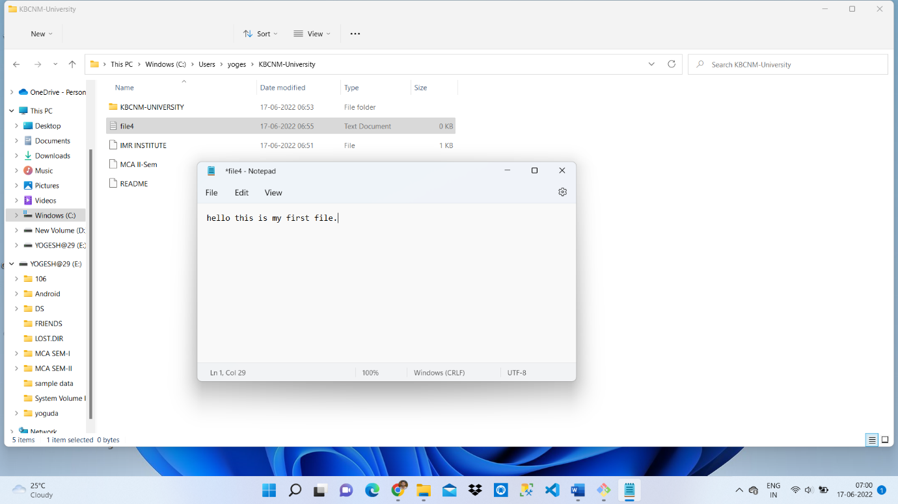

**Step 3 : Add the file in staging area**

yoges@YOGESH MINGW64 ~

$ cd KBCNM-UNIVERSITY

yoges@YOGESH MINGW64 ~/KBCNM-UNIVERSITY (main)

$ git init KBCNM-UNIVERSITY

Reinitialized existing Git repository in C:/Users/yoges/KBCNM-University/KBCNM-UNIVERSITY/.git/

yoges@YOGESH MINGW64 ~/KBCNM-UNIVERSITY (main)

$ touch file4.txt

yoges@YOGESH MINGW64 ~/KBCNM-UNIVERSITY (main)

$ git add file4.txt

**Step 4: Commit the changes.**

yoges@YOGESH MINGW64 ~

$ cd KBCNM-UNIVERSITY

yoges@YOGESH MINGW64 ~/KBCNM-UNIVERSITY (main)

$ git init KBCNM-UNIVERSITY

Reinitialized existing Git repository in C:/Users/yoges/KBCNM-University/KBCNM-UNIVERSITY/.git/

yoges@YOGESH MINGW64 ~/KBCNM-UNIVERSITY (main)

$ touch file4.txt

yoges@YOGESH MINGW64 ~/KBCNM-UNIVERSITY (main)

$ git add file4.txt

yoges@YOGESH MINGW64 ~/KBCNM-UNIVERSITY (main)

$ git commit -m "this is my first commit"

[main 8598aba] this is my first commit

1 file changed, 0 insertions(+), 0 deletions(-)

create mode 100644 file4.txt

yoges@YOGESH MINGW64 ~/KBCNM-UNIVERSITY (main)

$

