**Practical No:-4**

**Practical Name:- Use git push to send your change to the primary repository. Look online to see if your change has been pushed.**

**Roll No: - 104**

**Name :- Yogesh Pralhad Patil.**

* **Command to push changes to remote repository :-**

yoges@YOGESH MINGW64 ~

$ git version

git version 2.36.1.windows.1

yoges@YOGESH MINGW64 ~

$ git clone https://github.com/yogpatil29/KBCNM-University.git

Cloning into 'KBCNM-University'...

remote: Enumerating objects: 15, done.

remote: Counting objects: 100% (15/15), done.

remote: Compressing objects: 100% (12/12), done.

remote: Total 15 (delta 2), reused 0 (delta 0), pack-reused 0

Receiving objects: 100% (15/15), done.

Resolving deltas: 100% (2/2), done.

yoges@YOGESH MINGW64 ~

$ cd KBCNM-UNIVERSITY

yoges@YOGESH MINGW64 ~/KBCNM-UNIVERSITY (main)

$ ls

'IMR INSTITUTE' 'MCA II-Sem' README.md

yoges@YOGESH MINGW64 ~/KBCNM-UNIVERSITY (main)

$ git init KBCNM-UNIVERSITY

Initialized empty Git repository in C:/Users/yoges/KBCNM-University/KBCNM-UNIVERSITY/.git/

yoges@YOGESH MINGW64 ~/KBCNM-UNIVERSITY (main)

$ touch file4.txt

yoges@YOGESH MINGW64 ~/KBCNM-UNIVERSITY (main)

$ git add file4.txt

yoges@YOGESH MINGW64 ~/KBCNM-UNIVERSITY (main)

$ git commit -m "this is my first commit "

[main 8d8519f] this is my first commit

1 file changed, 0 insertions(+), 0 deletions(-)

create mode 100644 file4.txt

yoges@YOGESH MINGW64 ~/KBCNM-UNIVERSITY (main)

$ git push origin main

Enumerating objects: 4, done.

Counting objects: 100% (4/4), done.

Delta compression using up to 4 threads

Compressing objects: 100% (2/2), done.

Writing objects: 100% (3/3), 278 bytes | 139.00 KiB/s, done.

Total 3 (delta 1), reused 0 (delta 0), pack-reused 0

remote: Resolving deltas: 100% (1/1), completed with 1 local object.

To https://github.com/yogpatil29/KBCNM-University.git

31b4385..8d8519f main -> main

yoges@YOGESH MINGW64 ~/KBCNM-UNIVERSITY (main)

$

* **Output :-**
* **Before Push File :-**

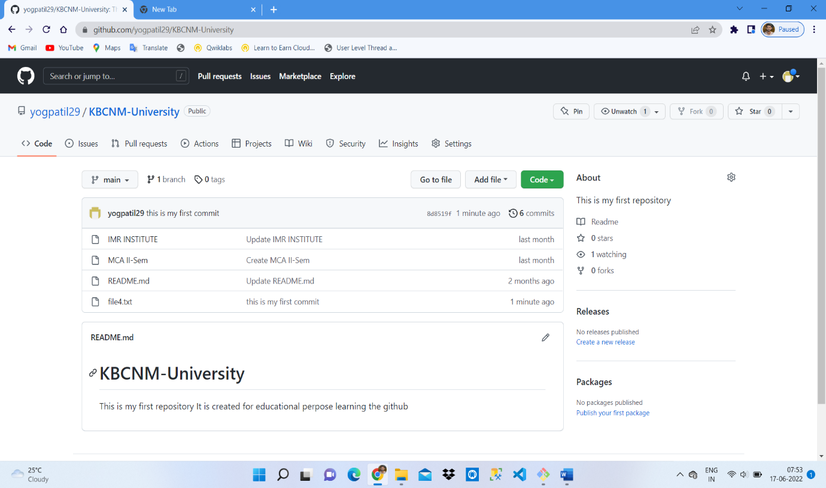

* **Afrer the Push :**

