**Assignment No. :- 5**

**Assignment Name** :- **Use git pull to get your partners change into your repository. Verify that you have the new file.**

**Roll No. :- 104**

**Nmae :- Yogesh Pralhad Patil.**

* **Command for PULL :-**

yoges@YOGESH MINGW64 ~

$ git clone https://github.com/yogpatil29/yogpatil.git

Cloning into 'yogpatil'...

remote: Enumerating objects: 19, done.

remote: Counting objects: 100% (19/19), done.

remote: Compressing objects: 100% (15/15), done.

remote: Total 19 (delta 3), reused 3 (delta 0), pack-reused 0

Receiving objects: 100% (19/19), 962.12 KiB | 737.00 KiB/s, done.

Resolving deltas: 100% (3/3), done.

yoges@YOGESH MINGW64 ~

$ cd yogpatil

yoges@YOGESH MINGW64 ~/yogpatil (main)

$ git init yogpatil

Initialized empty Git repository in C:/Users/yoges/yogpatil/yogpatil/.git/

yoges@YOGESH MINGW64 ~/yogpatil (main)

$ git pull https://github.com/yogpatil29/yogpatil.git

remote: Enumerating objects: 4, done.

remote: Counting objects: 100% (4/4), done.

remote: Compressing objects: 100% (3/3), done.

remote: Total 3 (delta 1), reused 0 (delta 0), pack-reused 0

Unpacking objects: 100% (3/3), 455.98 KiB | 707.00 KiB/s, done.

From https://github.com/yogpatil29/yogpatil

* branch HEAD -> FETCH_HEAD

Updating 17e8ba5..bc6bc75

Fast-forward

MCA Syllabus 2020-2023.pdf | Bin 0 -> 505193 bytes

1 file changed, 0 insertions(+), 0 deletions(-)

create mode 100644 MCA Syllabus 2020-2023.pdf

yoges@YOGESH MINGW64 ~/yogpatil (main)

$

* **Output :-**
* **Before Pull changes :-**

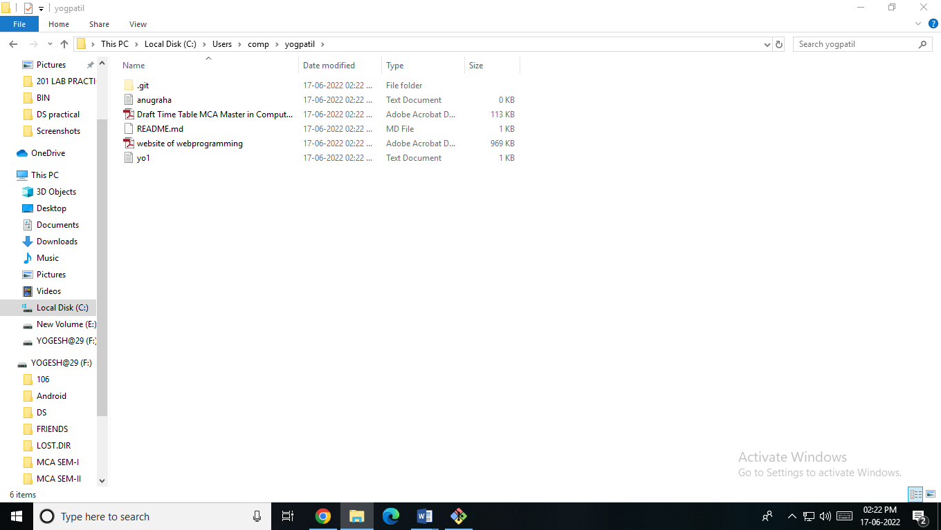

* **File added in remote repository :-**

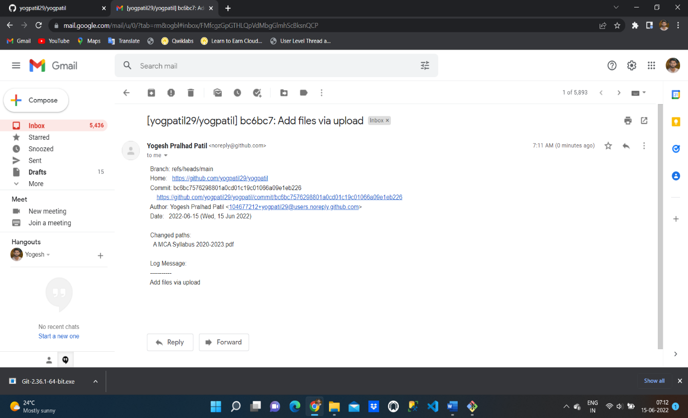

* **File Pull in local machine :-**

