**Assignment no. :- 09**

**Assignment Name :- Demonstrate the use of git diff command.**

**Name :- Yogesh Pralhad Patil.**

**Roll No. :- 104**

* **Command for diff :-**

comp@comp235 MINGW32 ~

$ git clone https://github.com/yogpatil29/yogpatil.git

Cloning into 'yogpatil'...

remote: Enumerating objects: 24, done.

remote: Counting objects: 100% (24/24), done.

remote: Compressing objects: 100% (19/19), done.

remote: Total 24 (delta 5), reused 7 (delta 1), pack-reused 0

Receiving objects: 100% (24/24), 1.39 MiB | 114.00 KiB/s, done.

Resolving deltas: 100% (5/5), done.

comp@comp235 MINGW32 ~

$ cd yogpatil

comp@comp235 MINGW32 ~/yogpatil (main)

$ git init yogpatil

Initialized empty Git repository in C:/Users/comp/yogpatil/yogpatil/.git/

comp@comp235 MINGW32 ~/yogpatil (main)

$ touch file6.txt

comp@comp235 MINGW32 ~/yogpatil (main)

$ git add file6.txt

comp@comp235 MINGW32 ~/yogpatil (main)

$ git commit -m"this is for diff"

[main 24fc6e3] this is for diff

1 file changed, 0 insertions(+), 0 deletions(-)

create mode 100644 file6.txt

comp@comp235 MINGW32 ~/yogpatil (main)

$ git diff

diff --git a/file6.txt b/file6.txt

index e69de29..fb19422 100644

--- a/file6.txt

+++ b/file6.txt

@@ -0,0 +1,2 @@

+this is for diff ...........

+after commit for diff

\ No newline at end of file

comp@comp235 MINGW32 ~/yogpatil (main)

$

* **Output :-**
* **File before diff :-**

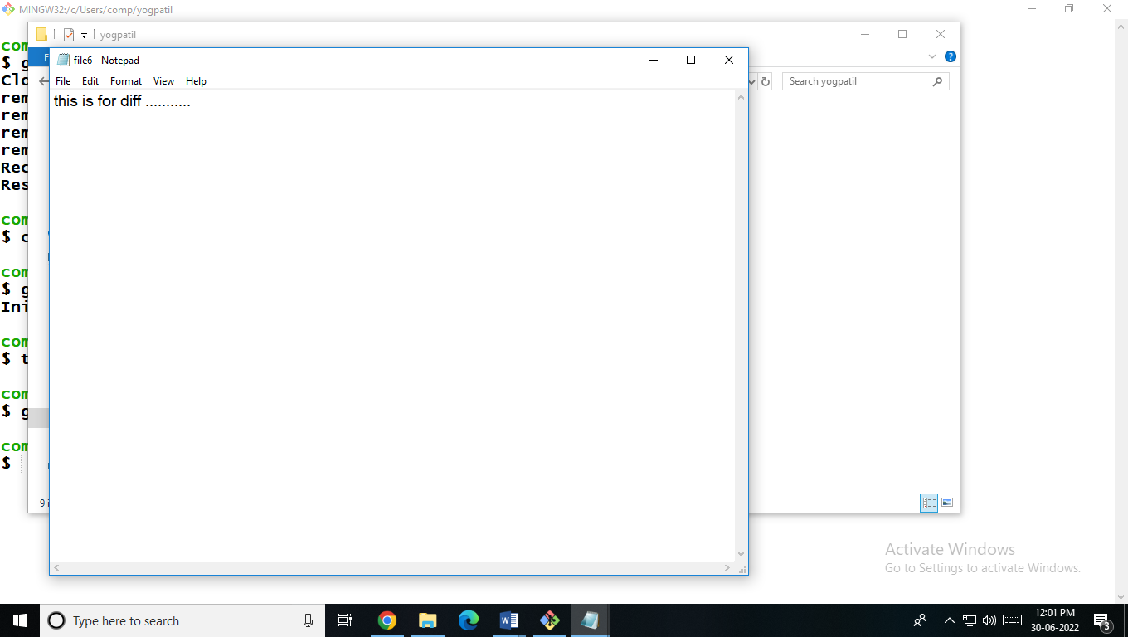

* **After diff commit :-**

