**PRATIKUM SISTEM DATA LINEAR**

**MODUL 2**

**Disusun oleh:**

**JOHANES YOGTAN WICAKSONO RAHARJA (215314105)**

**Kelas D**

**PRODI INFORMATIKA**

**UNIVERSITAS SANATA DHARMA SEMESTER GASAL 2022/2023**

1. Terdapat method rekursif sebagai berikut :

public static int paijo (int x)

{

if (x == 0)

return 0;

return 2 * paijo (x - 1) + x * x;

}

* 1. Input Program

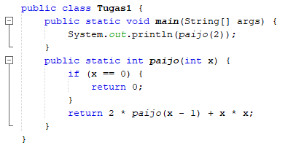

* 1. Output Program

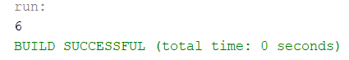

* 1. Apa tujuan method tersebut ? *(5 poin)*

Tujuan method tersebut untuk mengetahui gambaran tentang fungsi rekursif yang memanggil dirinya sendiri “Paijo” tanpa batas dari making progressnya hingga berhenti saat kondisi dari base case terpenuhi.

* 1. Base case (*5 poin*)



* 1. Making progress (*5 poin*)



* 1. Stack untuk setiap langkah (*15 poin*)

Nilai Awal : Paijo(2) atau X = 2

|  |  |  |  |
| --- | --- | --- | --- |
|  |  |  | Paijo(0) |
|  |  | Paijo(1) | Paijo(1) |
|  | Paijo(2) | Paijo(2) | Paijo(2) |
| Main() | Main() | Main() | Main() |
| Time 1 | Time 2 | Time 3 | Time 4 |
|  | Push: paijo(2) | Push: paijo(1) | Push: paijo(0) |
|  |  |  |  |

|  |  |  |
| --- | --- | --- |
|  |  |  |
| Paijo(1) |  |  |
| Paijo(2) | Paijo(2) |  |
| Main() | Main() | Main() |
| Time 5 | Time 6 | Time 7 |
| Pop: paijo(0) | Pop: paijo(1) | Pop : paijo(2) |
| Return 0 |  | Return 6 |

1. Terdapat method rekursif sebagai berikut :

public static void upAndDown (int n)

{

System.out.print ("\nLevel: " + n);

if (n < 4)

upAndDown (n+1);

System.out.print ("\nLEVEL: " + n);

}

* 1. Input Program

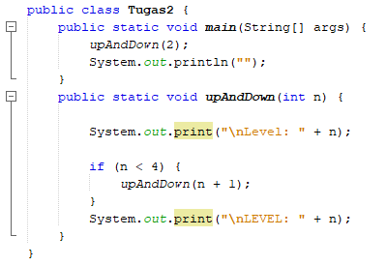

* 1. Output Program

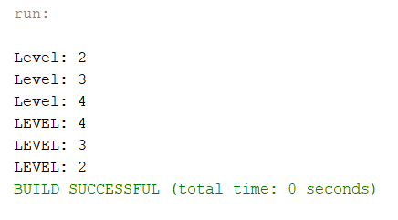

* 1. Apa tujuan method tersebut ? *(5 poin)*

Tujuan method tersebut untuk mengetahui gambaran tentang fungsi rekursif yang memanggil dirinya sendiri “UpAndDown” tanpa batas dari making progressnya hingga berhenti saat kondisi dari base case terpenuhi

* 1. Base case (*5 poin*)





* 1. Making progress (*5 poin*)



* 1. Stack untuk setiap langkah (*15 poin*)

|  |  |  |  |
| --- | --- | --- | --- |
|  |  |  | upAndDown (4) |
|  |  | upAndDown (3) | upAndDown (3) |
|  | upAndDown(2) | upAndDown (2) | upAndDown (2) |
| Main() | Main() | Main() | Main() |

|  |  |  |  |
| --- | --- | --- | --- |
| upAndDown (4) |  |  |  |
| upAndDown (3) | upAndDown (3) |  |  |
| upAndDown (2) | upAndDown(2) | upAndDown (2) |  |
| Main() | Main() | Main() | Main() |

1. **Buatlah stack masing-masing untuk kedua program rekursif fibonacci dibawah ini ketika mencetak bilangan Fibonacci ke-6:**

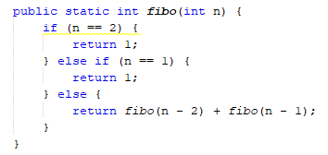

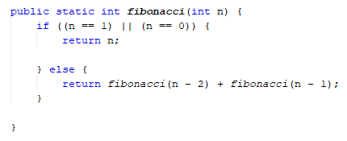

* 1. Input Program
* Stack Fibo

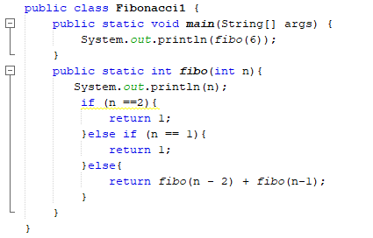

* Stack Fibonacci

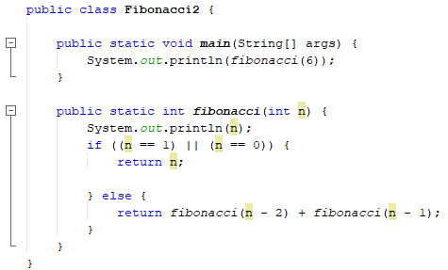

* 1. Output Program
* Stack Fibo

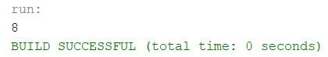

* Stack Fibonacci

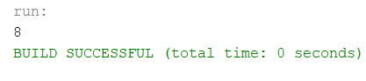

**Stack Fibo :**

|  |  |  |  |  |
| --- | --- | --- | --- | --- |
|  |  |  |  |  |
|  |  |  |  |  |
|  |  |  |  |  |
|  |  |  | Fibo (2) |  |
|  |  | Fibo(4) | Fibo(4) | Fibo (4) |
|  | Fibo(6) | Fibo(6) | Fibo(6) | Fibo(6) |
| Main() | Main() | Main() | Main() | Main() |
| Time 1 | Time 2 | Time 3 | Time 4 | Time 5 |
|  | Push: fibo(6) | Push: Fibo(4) | Push: Fibo(2) | Pop: Fibo(2) |
|  |  |  |  | Return 1 |

|  |  |  |  |  |
| --- | --- | --- | --- | --- |
|  |  |  |  |  |
|  |  |  |  |  |
|  | Fibo(1) |  | Fibo(2) |  |
| Fibo(3) | Fibo(3) | Fibo(3) | Fibo(3) | Fibo(3) |
| Fibo(4) | Fibo(4) | Fibo(4) | Fibo(4) | Fibo(4) |
| Fibo(6) | Fibo(6) | Fibo(6) | Fibo(6) | Fibo(6) |
| Main() | Main() | Main() | Main() | Main() |
| Time 6 | Time 7 | Time 8 | Time 9 | Time 10 |
| Push: Fibo(3) | Push: Fibo(1) | Pop: Fibo(1) | Push: Fibo(2) | Pop: Fibo(2) |
|  |  | Return 1 |  | Return 1 |

|  |  |  |  |  |
| --- | --- | --- | --- | --- |
|  |  | Fibo(1) |  | Fibo(2) |
|  | Fibo(3) | Fibo(3) | Fibo(3) | Fibo(3) |
| Fibo(5) | Fibo(5) | Fibo(5) | Fibo(5) | Fibo(5) |
| Fibo(3) | Fibo(3) | Fibo(3) | Fibo(3) | Fibo(3) |
| Fibo(4) | Fibo(4) | Fibo(4) | Fibo(4) | Fibo(4) |
| Fibo(6) | Fibo(6) | Fibo(6) | Fibo(6) | Fibo(6) |
| Main() | Main() | Main() | Main() | Main() |
| Time 11 | Time 12 | Time 13 | Time 14 | Time 15 |
| Push: Fibo(5) | Push: Fibo(3) | Push: Fibo(1) | Pop: Fibo(1) | Push: Fibo(2) |
|  |  |  | Return 1 |  |

|  |  |  |  |  |
| --- | --- | --- | --- | --- |
|  |  | Fibo(2) |  | Fibo(3) |
|  | Fibo(4) | Fibo(4) | Fibo(4) | Fibo(4) |
| Fibo(3) | Fibo(3) | Fibo(3) | Fibo(3) | Fibo(3) |
| Fibo(5) | Fibo(5) | Fibo(5) | Fibo(5) | Fibo(5) |
| Fibo(3) | Fibo(3) | Fibo(3) | Fibo(3) | Fibo(3) |
| Fibo(4) | Fibo(4) | Fibo(4) | Fibo(4) | Fibo(4) |
| Fibo(6) | Fibo(6) | Fibo(6) | Fibo(6) | Fibo(6) |
| Main() | Main() | Main() | Main() | Main() |
| Time 16 | Time 17 | Time 18 | Time 12 | Time 14 |
| Pop: Fibo(2) | Push: Fibo(4) | Push: Fibo(2) | Pop: Fibo(2) | Push: Fibo(3) |
| Return 1 |  |  | Return 1 |  |

|  |  |  |  |  |
| --- | --- | --- | --- | --- |
| Fibo(1) |  | Fibo(2) |  |  |
| Fibo(3) | Fibo(3) | Fibo(3) | Fibo(3) |  |
| Fibo(4) | Fibo(4) | Fibo(4) | Fibo(4) | Fibo(4) |
| Fibo(3) | Fibo(3) | Fibo(3) | Fibo(3) | Fibo(3) |
| Fibo(5) | Fibo(5) | Fibo(5) | Fibo(5) | Fibo(5) |
| Fibo(3) | Fibo(3) | Fibo(3) | Fibo(3) | Fibo(3) |
| Fibo(4) | Fibo(4) | Fibo(4) | Fibo(4) | Fibo(4) |
| Fibo(6) | Fibo(6) | Fibo(6) | Fibo(6) | Fibo(6) |
| Main() | Main() | Main() | Main() | Main() |
| Time 15 | Time 16 | Time 17 | Time 18 | Time 19 |
| Push: Fibo(1) | Pop: Fibo(1) | Push: Fibo(3) | Pop: Fibo(2) | Pop: Fibo(3) |
|  | Return 1 |  | Return 1 |  |

|  |  |  |  |  |
| --- | --- | --- | --- | --- |
|  |  |  |  |  |
|  |  |  |  |  |
|  |  |  |  |  |
| Fibo(3) |  |  |  |  |
| Fibo(5) | Fibo(5) |  |  |  |
| Fibo(3) | Fibo(3) | Fibo(3) |  |  |
| Fibo(4) | Fibo(4) | Fibo(4) | Fibo(4) |  |
| Fibo(6) | Fibo(6) | Fibo(6) | Fibo(6) | Fibo(6) |
| Main() | Main() | Main() | Main() | Main() |
| Time 20 | Time 21 | Time 22 | Time 23 | Time 24 |
| Pop: Fibo(4) | Pop: Fibo(3) | Pop: Fibo(5) | Pop: Fibo(3) | Pop: Fibo(4) |
|  |  |  |  |  |

|  |  |
| --- | --- |
|  |  |
|  |  |
|  |  |
|  |  |
|  |  |
|  |  |
|  |  |
| Fibo(6) |  |
| Main() | Main() |
| Time 25 | Time 26 |
| Pop: Fibo(4) | Pop: Fibo(6) |
|  | Total Return 8 |

**Stack Fibonacci :**

|  |  |  |  |  |
| --- | --- | --- | --- | --- |
|  |  |  |  |  |
|  |  |  |  |  |
|  |  |  |  | Fibo(0) |
|  |  |  | Fibo (2) | Fibo (2) |
|  |  | Fibo(4) | Fibo(4) | Fibo (4) |
|  | Fibo(6) | Fibo(6) | Fibo(6) | Fibo(6) |
| Main() | Main() | Main() | Main() | Main() |
| Time 1 | Time 2 | Time 3 | Time 4 | Time 5 |
|  | Push: fibo(6) | Push: Fibo(4) | Push: Fibo(2) | Push: Fibo(0) |
|  |  |  |  |  |

|  |  |  |  |  |
| --- | --- | --- | --- | --- |
|  |  |  |  |  |
|  |  |  |  | Fibo(1) |
|  | Fibo(1) |  | Fibo (3) | Fibo (3) |
| Fibo (2) | Fibo (2) | Fibo (2) | Fibo (2) | Fibo (2) |
| Fibo (4) | Fibo (4) | Fibo (4) | Fibo (4) | Fibo (4) |
| Fibo(6) | Fibo(6) | Fibo(6) | Fibo(6) | Fibo(6) |
| Main() | Main() | Main() | Main() | Main() |
| Time 6 | Time 7 | Time 8 | Time 9 | Time 10 |
| Pop: Fibo(0) | Push: Fibo(1) | Pop: Fibo(1) | Push: Fibo(3) | Push: Fibo(1) |
| Return 0 |  | Return 1 |  |  |

|  |  |  |  |  |
| --- | --- | --- | --- | --- |
|  |  | Fibo(0) |  | Fibo(1) |
|  | Fibo(2) | Fibo(2) | Fibo(2) | Fibo(2) |
| Fibo (3) | Fibo (3) | Fibo (3) | Fibo (3) | Fibo (3) |
| Fibo (2) | Fibo (2) | Fibo (2) | Fibo (2) | Fibo (2) |
| Fibo (4) | Fibo (4) | Fibo (4) | Fibo (4) | Fibo (4) |
| Fibo(6) | Fibo(6) | Fibo(6) | Fibo(6) | Fibo(6) |
| Main() | Main() | Main() | Main() | Main() |
| Time 11 | Time 12 | Time 13 | Time 14 | Time 15 |
| Pop: Fibo(1) | Push: Fibo(2) | Push: Fibo(0) | Pop: Fibo(0) | Push: Fibo(1) |
| Return 1 |  |  | Return 0 |  |

|  |  |  |  |  |
| --- | --- | --- | --- | --- |
|  |  |  | Fibo(1) |  |
|  |  | Fibo(3) | Fibo(3) | Fibo(3) |
|  | Fibo(5) | Fibo(5) | Fibo(5) | Fibo(5) |
| Fibo(2) | Fibo(2) | Fibo(2) | Fibo(2) | Fibo(2) |
| Fibo (3) | Fibo (3) | Fibo (3) | Fibo (3) | Fibo (3) |
| Fibo (2) | Fibo (2) | Fibo (2) | Fibo (2) | Fibo (2) |
| Fibo (4) | Fibo (4) | Fibo (4) | Fibo (4) | Fibo (4) |
| Fibo(6) | Fibo(6) | Fibo(6) | Fibo(6) | Fibo(6) |
| Main() | Main() | Main() | Main() | Main() |
| Time 16 | Time 17 | Time 18 | Time 19 | Time 20 |
| Pop: Fibo(1) | Push: Fibo(5) | Push: Fibo(3) | Push: Fibo(1) | Pop: Fibo(1) |
| Return 1 |  |  |  | Return 1 |

|  |  |  |  |  |
| --- | --- | --- | --- | --- |
|  | Fibo(0) |  | Fibo(1) |  |
| Fibo(2) | Fibo(2) | Fibo(2) | Fibo(2) | Fibo(2) |
| Fibo(3) | Fibo(3) | Fibo(3) | Fibo(3) | Fibo(3) |
| Fibo(5) | Fibo(5) | Fibo(5) | Fibo(5) | Fibo(5) |
| Fibo(2) | Fibo(2) | Fibo(2) | Fibo(2) | Fibo(2) |
| Fibo (3) | Fibo (3) | Fibo (3) | Fibo (3) | Fibo (3) |
| Fibo (2) | Fibo (2) | Fibo (2) | Fibo (2) | Fibo (2) |
| Fibo (4) | Fibo (4) | Fibo (4) | Fibo (4) | Fibo (4) |
| Fibo(6) | Fibo(6) | Fibo(6) | Fibo(6) | Fibo(6) |
| Main() | Main() | Main() | Main() | Main() |
| Time 21 | Time 22 | Time 23 | Time 24 | Time 25 |
| Push: Fibo(2) | Push: Fibo(0) | Pop: Fibo(0) | Push: Fibo(1) | Pop: Fibo(1) |
|  |  | Return 0 |  | Return 1 |

|  |  |  |  |  |
| --- | --- | --- | --- | --- |
|  |  | Fibo(0) |  | Fibo(1) |
|  | Fibo(2) | Fibo(2) | Fibo(2) | Fibo(2) |
| Fibo(4) | Fibo(4) | Fibo(4) | Fibo(4) | Fibo(4) |
| Fibo(2) | Fibo(2) | Fibo(2) | Fibo(2) | Fibo(2) |
| Fibo(3) | Fibo(3) | Fibo(3) | Fibo(3) | Fibo(3) |
| Fibo(5) | Fibo(5) | Fibo(5) | Fibo(5) | Fibo(5) |
| Fibo(2) | Fibo(2) | Fibo(2) | Fibo(2) | Fibo(2) |
| Fibo (3) | Fibo (3) | Fibo (3) | Fibo (3) | Fibo (3) |
| Fibo (2) | Fibo (2) | Fibo (2) | Fibo (2) | Fibo (2) |
| Fibo (4) | Fibo (4) | Fibo (4) | Fibo (4) | Fibo (4) |
| Fibo(6) | Fibo(6) | Fibo(6) | Fibo(6) | Fibo(6) |
| Main() | Main() | Main() | Main() | Main() |
| Time 26 | Time 27 | Time 28 | Time 29 | Time 30 |
| Push: Fibo(4) | Push: Fibo(2) | Push: Fibo(0) | Pop: Fibo(0) | Push: Fibo(1) |
|  |  |  |  |  |

|  |  |  |  |  |
| --- | --- | --- | --- | --- |
|  |  | Fibo(1) |  | Fibo(2) |
|  | Fibo(3) | Fibo(3) | Fibo(3) | Fibo(3) |
| Fibo(2) | Fibo(2) | Fibo(2) | Fibo(2) | Fibo(2) |
| Fibo(4) | Fibo(4) | Fibo(4) | Fibo(4) | Fibo(4) |
| Fibo(2) | Fibo(2) | Fibo(2) | Fibo(2) | Fibo(2) |
| Fibo(3) | Fibo(3) | Fibo(3) | Fibo(3) | Fibo(3) |
| Fibo(5) | Fibo(5) | Fibo(5) | Fibo(5) | Fibo(5) |
| Fibo(2) | Fibo(2) | Fibo(2) | Fibo(2) | Fibo(2) |
| Fibo (3) | Fibo (3) | Fibo (3) | Fibo (3) | Fibo (3) |
| Fibo (2) | Fibo (2) | Fibo (2) | Fibo (2) | Fibo (2) |
| Fibo (4) | Fibo (4) | Fibo (4) | Fibo (4) | Fibo (4) |
| Fibo(6) | Fibo(6) | Fibo(6) | Fibo(6) | Fibo(6) |
| Main() | Main() | Main() | Main() | Main() |
| Time 31 | Time 32 | Time 33 | Time 34 | Time 35 |
| Pop: Fibo(1) | Push: Fibo(3) | Push: Fibo(1) | Pop: Fibo(1) | Push: Fibo(2) |
| Return 1 |  |  | Return 1 |  |

|  |  |  |  |  |
| --- | --- | --- | --- | --- |
| Fibo(0) |  | Fibo(1) |  |  |
| Fibo(2) | Fibo(2) | Fibo(2) | Fibo(2) |  |
| Fibo(3) | Fibo(3) | Fibo(3) | Fibo(3) | Fibo(3) |
| Fibo(2) | Fibo(2) | Fibo(2) | Fibo(2) | Fibo(2) |
| Fibo(4) | Fibo(4) | Fibo(4) | Fibo(4) | Fibo(4) |
| Fibo(2) | Fibo(2) | Fibo(2) | Fibo(2) | Fibo(2) |
| Fibo(3) | Fibo(3) | Fibo(3) | Fibo(3) | Fibo(3) |
| Fibo(5) | Fibo(5) | Fibo(5) | Fibo(5) | Fibo(5) |
| Fibo(2) | Fibo(2) | Fibo(2) | Fibo(2) | Fibo(2) |
| Fibo (3) | Fibo (3) | Fibo (3) | Fibo (3) | Fibo (3) |
| Fibo (2) | Fibo (2) | Fibo (2) | Fibo (2) | Fibo (2) |
| Fibo (4) | Fibo (4) | Fibo (4) | Fibo (4) | Fibo (4) |
| Fibo(6) | Fibo(6) | Fibo(6) | Fibo(6) | Fibo(6) |
| Main() | Main() | Main() | Main() | Main() |
| Time 36 | Time 37 | Time 38 | Time 39 | Time 40 |
| Push: Fibo(0) | Pop: Fibo(0) | Push: Fibo(1) | Pop: Fibo(1) | Pop: Fibo(2) |
|  | Return 0 |  | Return 1 |  |

|  |  |  |  |  |
| --- | --- | --- | --- | --- |
|  |  |  |  |  |
|  |  |  |  |  |
|  |  |  |  |  |
| Fibo(2) |  |  |  |  |
| Fibo(4) | Fibo(4) |  |  |  |
| Fibo(2) | Fibo(2) | Fibo(2) |  |  |
| Fibo(3) | Fibo(3) | Fibo(3) | Fibo(3) |  |
| Fibo(5) | Fibo(5) | Fibo(5) | Fibo(5) | Fibo(5) |
| Fibo(2) | Fibo(2) | Fibo(2) | Fibo(2) | Fibo(2) |
| Fibo (3) | Fibo (3) | Fibo (3) | Fibo (3) | Fibo (3) |
| Fibo (2) | Fibo (2) | Fibo (2) | Fibo (2) | Fibo (2) |
| Fibo (4) | Fibo (4) | Fibo (4) | Fibo (4) | Fibo (4) |
| Fibo(6) | Fibo(6) | Fibo(6) | Fibo(6) | Fibo(6) |
| Main() | Main() | Main() | Main() | Main() |
| Time 41 | Time 42 | Time 43 | Time 44 | Time 45 |
| Pop: Fibo(3) | Pop: Fibo(2) | Pop: Fibo(4) | Pop: Fibo(2) | Pop: Fibo(3) |
|  |  |  |  |  |

|  |  |  |  |  |
| --- | --- | --- | --- | --- |
|  |  |  |  |  |
|  |  |  |  |  |
|  |  |  |  |  |
|  |  |  |  |  |
|  |  |  |  |  |
|  |  |  |  |  |
|  |  |  |  |  |
|  |  |  |  |  |
| Fibo(2) |  |  |  |  |
| Fibo (3) | Fibo (3) |  |  |  |
| Fibo (2) | Fibo (2) | Fibo (2) |  |  |
| Fibo (4) | Fibo (4) | Fibo (4) | Fibo (4) |  |
| Fibo(6) | Fibo(6) | Fibo(6) | Fibo(6) | Fibo(6) |
| Main() | Main() | Main() | Main() | Main() |
| Time 46 | Time 47 | Time 48 | Time 49 | Time 50 |
| Pop: Fibo(5) | Pop: Fibo(2) | Pop: Fibo(3) | Pop: Fibo(2) | Pop: Fibo(4) |
|  |  |  |  |  |

|  |  |  |  |
| --- | --- | --- | --- |
|  |  |  |  |
|  |  |  |  |
|  |  |  |  |
|  |  |  |  |
|  |  |  |  |
|  |  |  |  |
|  |  |  |  |
|  |  |  |  |
|  |  |  |  |
|  |  |  |  |
|  |  |  |  |
|  |  |  |  |
|  |  |  |  |
| Main() |  |  |  |
| Time 51 |  |  |  |
| Pop: Fibo(1) |  |  |  |
| Return 8 |  |  |  |

**Apa perbedaan kedua program dalam stack?**

1. *x 15 poin)*
   * + 1. Program Fibonacci (2) membutuhkan waktu penyelesain yang lebih lama. Dilihat dari stack yang lebih banyak.
       2. Program Fibo (1) returnnya sudah ditentukan yaitu 1, sedangkan Program Fibonacci nilai returnnya ‘n’ atau nilai returnya mengikuti nilai base case programnya