Github link: https://github.com/yogurt98/INFO8870_final

EC2 instance:

And ec2 instance security group:

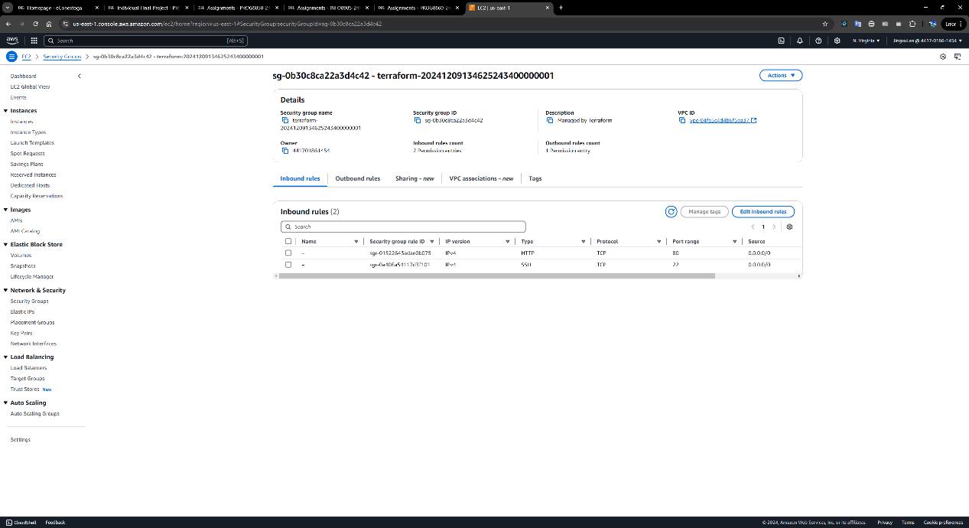

S3 bucket:

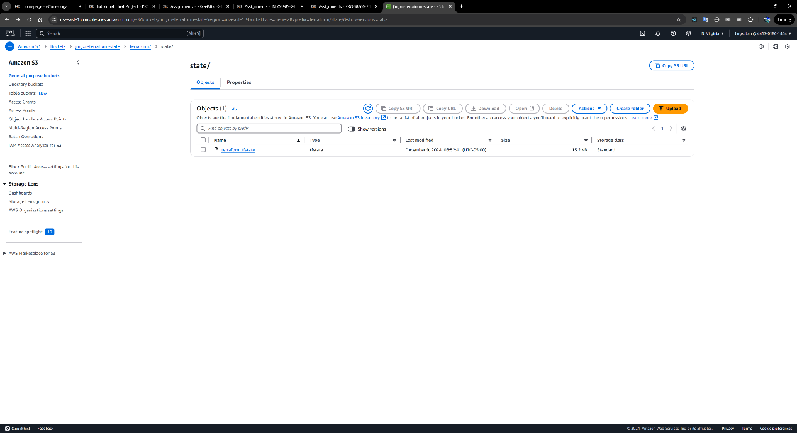

Terraform apply:

