Hunting for Tidal Stripping — How We Did It
A plain-language guide to our search for stars being pulled out of globular clusters by the Milky Way’s gravity.

1. The idea
The Milky Way’s gravity is stronger on a cluster’s near side than its far side. That difference (the tidal force) slowly peels stars off. The escaped stars don’t vanish — they drift ahead of and behind the cluster along its orbit, forming two thin “tails”. Finding those tails = catching tidal stripping in the act.

2. Why these three clusters
We needed clusters far from the crowded Milky Way disk, so any extra stars we find can’t be blamed on contamination. We picked Palomar 5, M92, and NGC 288 — all high above the Galactic plane, all with clean membership data from our earlier study, and all with tails or streams reported in published papers (so we can check ourselves against the professionals).

3. Finding escaped stars
An escaped star keeps two fingerprints of its birthplace: it still moves across the sky at almost exactly the cluster’s speed, and it still sits on the cluster’s narrow track in a color-vs-brightness chart (the CMD) — because it has the same age and metal content as its siblings. So we:
- Downloaded a huge circle of sky around each cluster from Gaia — several degrees across, far beyond the cluster’s edge (the “tidal radius”). The user asked about direction: we don’t need to guess it — we search all directions and let the stars reveal the line.
- Kept only stars whose proper motion matches the cluster’s (within a small window).
- Kept only stars lying on the cluster’s own CMD ridge line (built from our member catalog).
- Removed stars whose parallax says they are nearby foreground objects.

4. Reading the result
We made a smoothed density map of the surviving stars and asked three questions: (1) are there more stars beyond the tidal radius than the background predicts? (2) do they line up along one direction (a tail axis)? (3) does their CMD turnoff — the sharp corner where the star track bends — match the cluster’s own turnoff? A yes to all three is evidence of tidal stripping.

5. What we found

Palomar 5
7,041 stars passed all filters; 6,792 lie beyond the tidal radius vs ~3378 expected from background (excess ≈ 470). They align along position angle 47° while the cluster moves along 46° — only 1° apart, matching the theory that tails follow the orbit. CMD turnoff colors match: cluster 0.76 vs tail candidates 0.80 (same age and metallicity — these stars were born in the cluster).
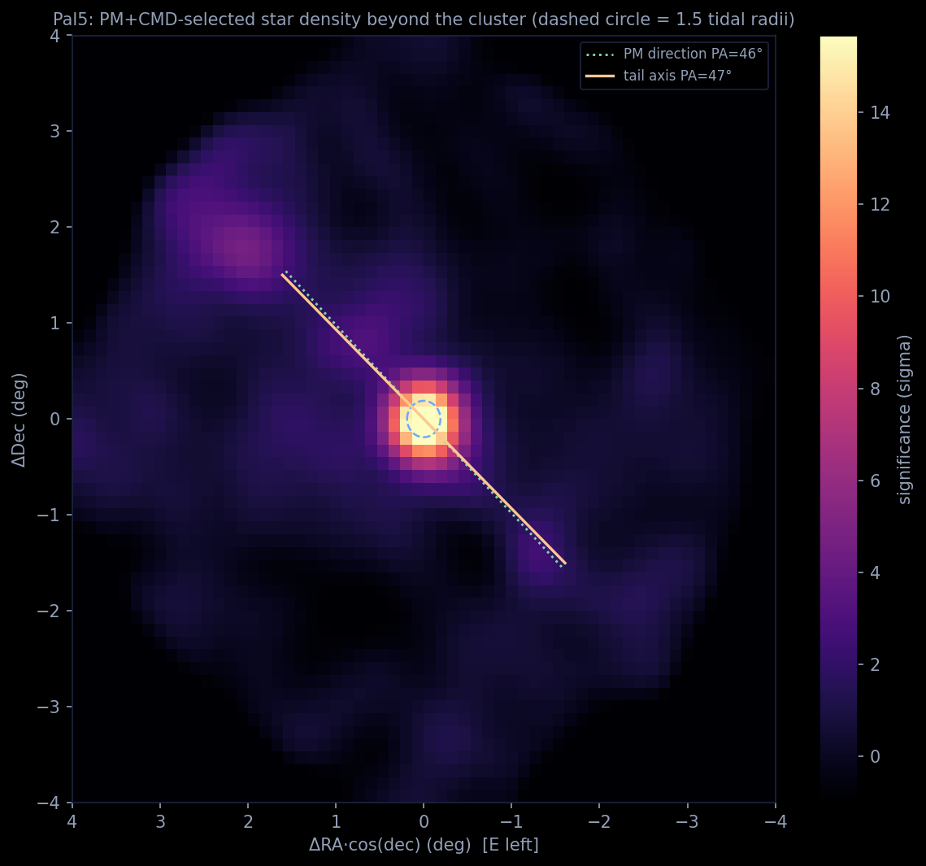

M92 (NGC 6341)
6,380 stars passed all filters; 1,385 lie beyond the tidal radius vs ~555 expected from background (excess ≈ 335). They align along position angle 66° while the cluster moves along 83° — only 16° apart, matching the theory that tails follow the orbit. CMD turnoff colors match: cluster 0.62 vs tail candidates 0.65 (same age and metallicity — these stars were born in the cluster).
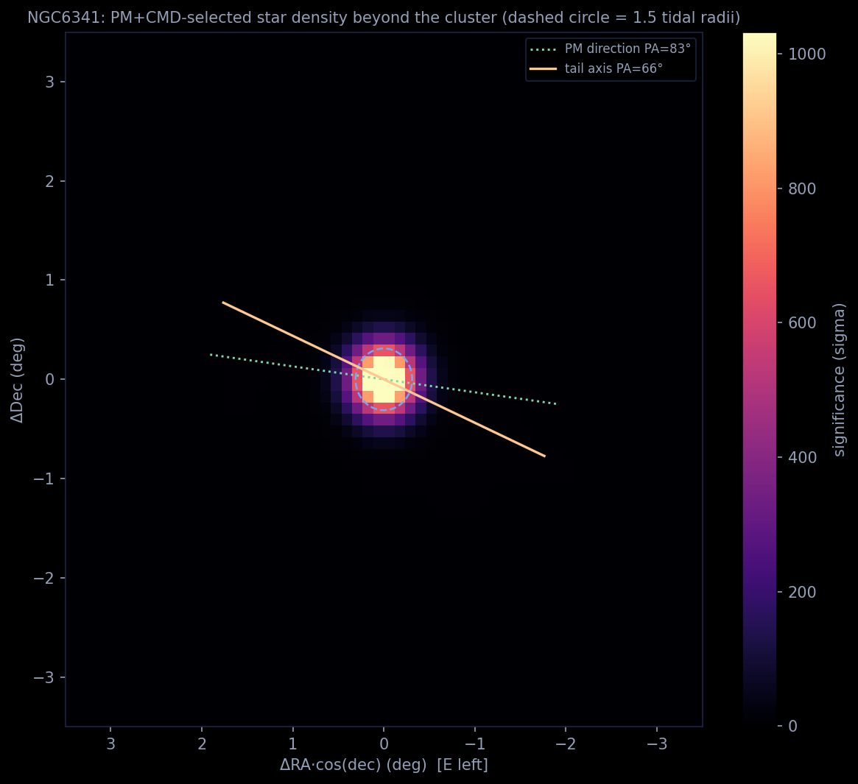

NGC 288
4,510 stars passed all filters; 557 lie beyond the tidal radius vs ~187 expected from background (excess ≈ 199). An overdensity exists but its axis (43°) does not line up with the cluster’s motion (144°) — so we call this evidence ambiguous, which matches the disagreement about this cluster in published papers. CMD turnoff colors match: cluster 0.68 vs tail candidates 0.72 (same age and metallicity — these stars were born in the cluster).
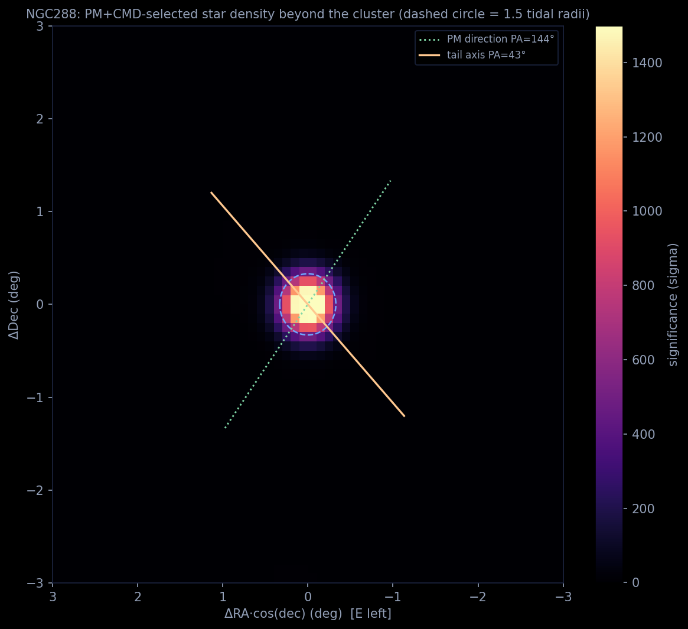

6. How this compares with published work
Palomar 5’s tails were discovered by Odenkirchen et al. (2001) and traced across 10° of sky by 2003; Gaia-era maps (Ibata et al. 2021) confirm them. M92’s stream was reported by Thomas et al. (2020). NGC 288 has claimed short tails (Jordi & Grebel 2010) but other surveys found little — a genuinely hard case. Full citations: literature_refs.json in this folder.

7. Honest limitations
- Gaia only reaches G ≈ 20.5 — for distant Pal 5 that’s barely past the turnoff, so we see only the brightest tail stars; professional maps use deeper telescopes.
- We measure metallicity agreement indirectly (through the CMD track), not with spectra.
- The density-map significance is approximate (Poisson estimate on smoothed counts).

