How We Measured Cluster Rotation (V/σ)
A plain-language guide to our study of 24 globular clusters, using data from the Gaia space telescope.

1. The question
A globular cluster is a ball of hundreds of thousands of stars. Do those stars just buzz around randomly, or does the whole ball also spin? We measure this with one number: V/σ (“V over sigma”). V is how fast the cluster spins in an organized way; σ (sigma) is how fast stars shuffle around randomly. V/σ near 0 means no spin; higher values (0.3–0.6) mean the cluster clearly rotates.

2. Getting the stars
- We downloaded every star Gaia sees toward each cluster (out to the cluster’s edge, its “tidal radius”).
- Cluster members all drift across the sky together (same proper motion), crowd toward the cluster center, and line up on one narrow track in a color-vs-brightness chart (because they were born together). Field stars do none of these.
- Each star got a membership probability from these three tests. For this study we kept only stars above 90% probability.

3. Measuring the spin (V)
For each star we take its sideways drift relative to the cluster’s average motion, and split it into “toward/away from the center” and “around the center”. If the cluster spins, stars all around one ring drift the same way around the center — so we average that “around” motion in rings of increasing radius. The largest ring average is V.
One trap we avoided: if you slightly mismeasure the cluster’s average motion, you get a fake pattern that looks like rotation but flips sign around the ring (a sinusoid). Real rotation is the same all the way around. We tested for the fake pattern separately — it also turned out to be a great detector of contaminated samples.

4. Measuring the shuffle (σ)
σ is the spread of star speeds — but Gaia’s measurement errors add fake spread. We subtracted the known measurement error to recover the true spread. Skipping this step makes σ too big and V/σ misleadingly tiny — for distant clusters this correction changes the answer completely.

5. Honesty checks
- Detection test: a statistical test (chi-squared) asks “could these ring averages be pure noise?” Only clusters passing at 99% confidence count as rotating.
- Quality flags: every cluster is graded good / error-dominated / contaminated / unmeasurable. Two distant clusters (NGC 2419, Pal 5) are honestly “unmeasurable” — Gaia’s errors exceed their entire internal motion.
- Validation: clusters already known to rotate (from published papers) all ranked at the top of our list, and the known non-rotator NGC 288 failed the detection test — exactly as it should.

6. What we found
- Fastest relative rotators: 47 Tuc (V/σ = 0.63) and ω Centauri (0.52) — matching published values.
- Bigger clusters spin faster relative to their shuffle: V/σ rises with cluster size (correlation 0.71, statistically significant). Likely because small dense clusters “forget” their spin faster through star-to-star encounters.
- Metal content ([Fe/H]) showed no correlation with V/σ in our sample.
- NGC 6266 (M62) shows a strong rotation signal that past surveys never tested — our most original result (with a caution: its outskirts are contaminated by bulge stars).
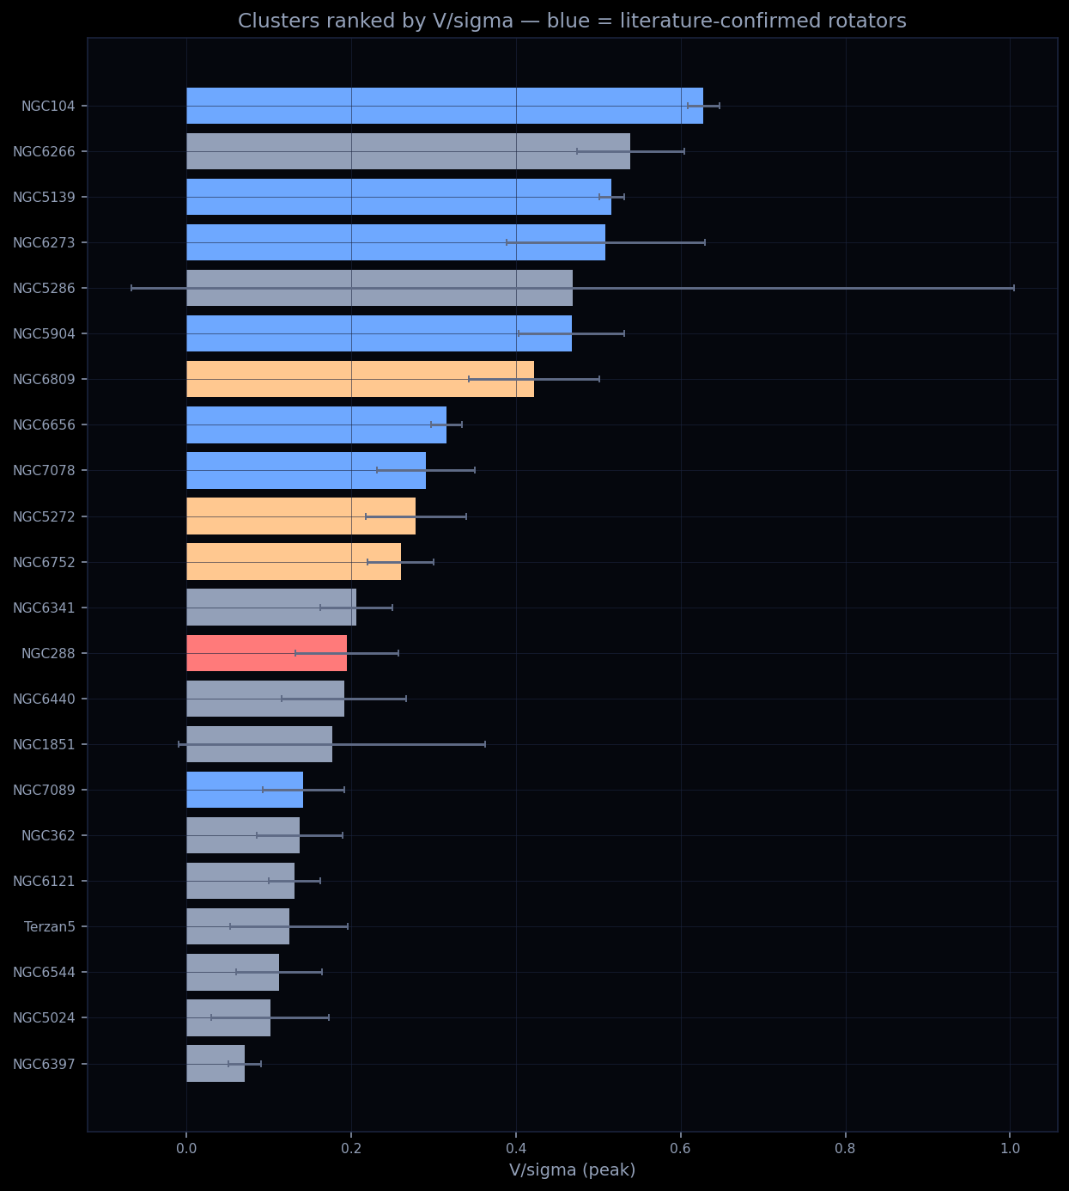
All 24 clusters ranked by V/σ. Blue = confirmed rotators in past papers; they rank high in our measurement too.

7. Where everything lives
Folder “vsigma_study” inside Cluster Analysis HTML: the full technical write-up (METHODS.md), the analysis program (vsigma_pipeline.py), the results table (vsigma_summary.csv), and per-cluster plots. The interactive version is in the app — open the V/σ study screen from the top bar.

