Unemployement Rate Analysis by Sriram Amruthur and Yohana Pandian

Gitlink: [Unemployement Rate Analysis code file](https://github.com/yohana29/Unemployement-rate-analysis.git)

#### The GIT repository has the code file, datasets, README file and the markdown file as well

## Required Libraries

library(dplyr)

##   
## Attaching package: 'dplyr'

## The following objects are masked from 'package:stats':  
##   
## filter, lag

## The following objects are masked from 'package:base':  
##   
## intersect, setdiff, setequal, union

library(tidyr)  
library(ggplot2)

## Creating dummy dataframe to save the compiled single dataframe for later

testing_merge <- data.frame(matrix(ncol = 6, nrow = 0))  
colnames(testing_merge) <- c('Year','Gender','Age','Race', 'Marital.status','Unemployement_Rate')

## Code for dynamic reading of files

file_names<-c('yr_2021_test.csv','yr_2020_test.csv','yr_2019_test.csv'  
 ,'yr_2018_test.csv','yr_2017_test.csv','yr_2016_test.csv'  
 ,'yr_2015_test.csv','yr_2014_test.csv','yr_2013_test.csv'  
 ,'yr_2012_test.csv','yr_2011_test.csv','yr_2010_test.csv'  
 ,'yr_2009_test.csv','yr_2008_test.csv','yr_2007_test.csv'  
 ,'yr_2006_test.csv','yr_2005_test.csv','yr_2004_test.csv'  
 ,'yr_2003_test.csv','yr_2002_test.csv')

## Recurssive function to dynamically read files for data preprocessing

for (val in file_names){  
 #Read the CSV file  
 yr_2021<-read.csv(paste0("D:/Data Science 2021-2023/Spring 2022/Advanced R/Project/Datasets/Excel/Test_CSV/",val))  
   
 #introduce identity column  
 yr_2021 <- tibble::rowid_to_column(yr_2021, "index")  
   
 #create two subsets with the identity   
 #1) identity,men,women   
 yr_2021_gender<-yr_2021%>%  
 select(index,Men,Women)  
   
 #2)identity,Year,Race, Age, Marital.status  
 yr_2021_othercol<-yr_2021%>%  
 select(index,Year,Race, Age, Marital.status)  
   
 ## Pivot the Gender and unemployement rates  
 yr_2021_gender <- yr_2021_gender %>%  
 select(index,Men,Women) %>%  
 gather(key = Gender, value = Unemployement_Rate, -index)  
  
 #join the othercol and gender df wrt to the index column  
 yr_2021_fin<-yr_2021_gender%>%  
 inner_join(yr_2021_othercol, by = c("index" = "index")) %>%   
 select(Year,Gender,Age,Race, Marital.status,Unemployement_Rate)  
   
 #Append all the datasets together  
 testing_merge<-rbind(testing_merge,yr_2021_fin)  
   
}  
View(testing_merge)

## Data validation

#Checking if all the year is read  
testing_merge %>% distinct(Year,Marital.status)

## Year Marital.status  
## 1 2021 Married, spouse present  
## 2 2021 Widowed, divorced, or separated  
## 3 2021 Never married  
## 4 2020 Married, spouse present  
## 5 2020 Widowed, divorced, or separated  
## 6 2020 Never married  
## 7 2019 Married, spouse present  
## 8 2019 Widowed, divorced, or separated  
## 9 2019 Never married  
## 10 2018 Married, spouse present  
## 11 2018 Widowed, divorced, or separated  
## 12 2018 Never married  
## 13 2017 Married, spouse present  
## 14 2017 Widowed, divorced, or separated  
## 15 2017 Never married  
## 16 2016 Married, spouse present  
## 17 2016 Widowed, divorced, or separated  
## 18 2016 Never married  
## 19 2015 Married, spouse present  
## 20 2015 Widowed, divorced, or separated  
## 21 2015 Never married  
## 22 2014 Married, spouse present  
## 23 2014 Widowed, divorced, or separated  
## 24 2014 Never married  
## 25 2013 Married, spouse present  
## 26 2013 Widowed, divorced, or separated  
## 27 2013 Never married  
## 28 2012 Married, spouse present  
## 29 2012 Widowed, divorced, or separated  
## 30 2012 Never married  
## 31 2011 Married, spouse present  
## 32 2011 Widowed, divorced, or separated  
## 33 2011 Never married  
## 34 2010 Married, spouse present  
## 35 2010 Widowed, divorced, or separated  
## 36 2010 Never married  
## 37 2009 Married, spouse present  
## 38 2009 Widowed, divorced, or separated  
## 39 2009 Never married  
## 40 2008 Married, spouse present  
## 41 2008 Widowed, divorced, or separated  
## 42 2008 Never married  
## 43 2007 Married, spouse present  
## 44 2007 Widowed, divorced, or separated  
## 45 2007 Never married  
## 46 2006 Married, spouse present  
## 47 2006 Widowed, divorced, or separated  
## 48 2006 Never married  
## 49 2005 Married, spouse present  
## 50 2005 Widowed, divorced, or separated  
## 51 2005 Never married  
## 52 2004 Married, spouse present  
## 53 2004 Widowed, divorced, or separated  
## 54 2004 Never married  
## 55 2003 Married, spouse present  
## 56 2003 Widowed, divorced, or separated  
## 57 2003 Never married  
## 58 2002 Married, spouse present  
## 59 2002 Widowed, divorced, or separated  
## 60 2002 Never married

#Each year has 48 records  
testing_merge %>% count()

## n  
## 1 960

## Exploratory Analysis

### Visualization using ggplot

#bar chart  
ggplot(data = testing_merge) +  
 geom_col(mapping = aes(x = Age, y = Unemployement_Rate))

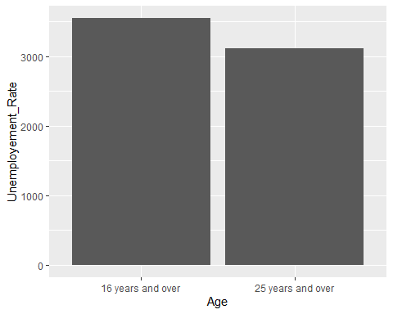

ggplot(data = testing_merge) +  
 geom_col(mapping = aes(x = Gender, y = Unemployement_Rate))

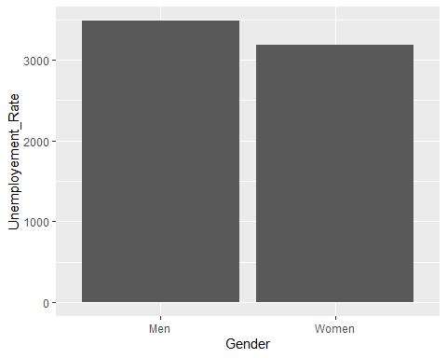

ggplot(data = testing_merge) +  
 geom_col(mapping = aes(x = Marital.status, y = Unemployement_Rate))

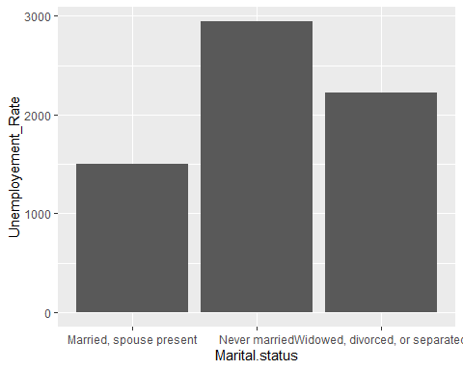

ggplot(data = testing_merge) +  
 geom_col(mapping = aes(x = Race, y = Unemployement_Rate))

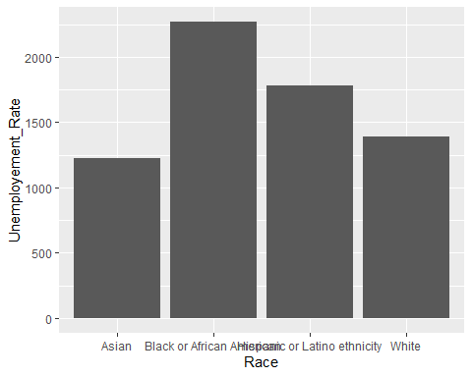

#Coloured point chart  
ggplot(data = testing_merge) +  
 geom_point(mapping = aes(x = Year, y = Unemployement_Rate, color = Race))

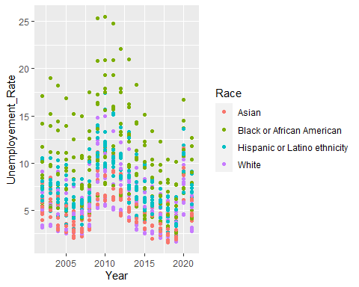

ggplot(data = testing_merge) +  
 geom_point(mapping = aes(x = Year, y = Unemployement_Rate))

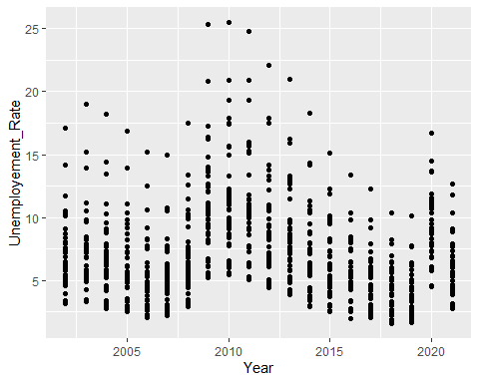

### Analysis of Data using Regression Model

#Building a prediction model  
colnames(testing_merge)

## [1] "Year" "Gender" "Age"   
## [4] "Race" "Marital.status" "Unemployement_Rate"

model1= lm(Unemployement_Rate ~ Gender + Age + Race + Marital.status, data=testing_merge)  
anova(model1)#all the variables are significant (to check significance)

## Analysis of Variance Table  
##   
## Response: Unemployement_Rate  
## Df Sum Sq Mean Sq F value Pr(>F)   
## Gender 1 97.3 97.35 13.974 0.0001964 ***  
## Age 1 198.5 198.47 28.491 1.177e-07 ***  
## Race 3 2695.2 898.39 128.964 < 2.2e-16 ***  
## Marital.status 2 3263.0 1631.50 234.202 < 2.2e-16 ***  
## Residuals 952 6631.8 6.97   
## ---  
## Signif. codes: 0 '***' 0.001 '**' 0.01 '*' 0.05 '.' 0.1 ' ' 1

summary(model1) #to interpret the effect of each factor

##   
## Call:  
## lm(formula = Unemployement_Rate ~ Gender + Age + Race + Marital.status,   
## data = testing_merge)  
##   
## Residuals:  
## Min 1Q Median 3Q Max   
## -5.3897 -1.8415 -0.3936 1.4130 13.0081   
##   
## Coefficients:  
## Estimate Std. Error t value  
## (Intercept) 3.6255 0.2409 15.047  
## GenderWomen -0.6369 0.1704 -3.738  
## Age25 years and over -0.9094 0.1704 -5.338  
## RaceBlack or African American 4.3504 0.2409 18.056  
## RaceHispanic or Latino ethnicity 2.3167 0.2409 9.615  
## RaceWhite 0.6933 0.2409 2.878  
## Marital.statusNever married 4.5159 0.2087 21.643  
## Marital.statusWidowed, divorced, or separated 2.2506 0.2087 10.786  
## Pr(>|t|)   
## (Intercept) < 2e-16 ***  
## GenderWomen 0.000196 ***  
## Age25 years and over 1.18e-07 ***  
## RaceBlack or African American < 2e-16 ***  
## RaceHispanic or Latino ethnicity < 2e-16 ***  
## RaceWhite 0.004096 **   
## Marital.statusNever married < 2e-16 ***  
## Marital.statusWidowed, divorced, or separated < 2e-16 ***  
## ---  
## Signif. codes: 0 '***' 0.001 '**' 0.01 '*' 0.05 '.' 0.1 ' ' 1  
##   
## Residual standard error: 2.639 on 952 degrees of freedom  
## Multiple R-squared: 0.4853, Adjusted R-squared: 0.4816   
## F-statistic: 128.3 on 7 and 952 DF, p-value: < 2.2e-16

## Additonal analysis to analyse the effect of Unemployement on GDP

#reading GDP data  
gdpdata<-read.csv("D:/Data Science 2021-2023/Spring 2022/Advanced R/Project/Datasets/GDP.csv")  
   
#Summarizing unemployement data for each year by taking the means  
yr_groupby<-testing_merge%>%  
 group_by(Year) %>%   
 summarise_at(vars(Unemployement_Rate), list(Unemployement_Rate = mean))  
  
yr_groupby

## # A tibble: 20 x 2  
## Year Unemployement_Rate  
## <int> <dbl>  
## 1 2002 6.97  
## 2 2003 7.21  
## 3 2004 6.59  
## 4 2005 5.91  
## 5 2006 5.09  
## 6 2007 5.09  
## 7 2008 6.55  
## 8 2009 10.5   
## 9 2010 10.9   
## 10 2011 10.4   
## 11 2012 9.11  
## 12 2013 8.11  
## 13 2014 6.94  
## 14 2015 5.93  
## 15 2016 5.38  
## 16 2017 4.75  
## 17 2018 4.18  
## 18 2019 3.84  
## 19 2020 9.32  
## 20 2021 6.18

#Joining the unemployement data with GDP data for analysis  
yr_unemp_gdp<-yr_groupby%>%  
 inner_join(gdpdata, by = c("Year" = "Year")) %>%   
 select(Year,GDP,Unemployement_Rate)  
  
yr_unemp_gdp

## # A tibble: 20 x 3  
## Year GDP Unemployement_Rate  
## <int> <dbl> <dbl>  
## 1 2002 1.7 6.97  
## 2 2003 2.9 7.21  
## 3 2004 3.8 6.59  
## 4 2005 3.5 5.91  
## 5 2006 2.9 5.09  
## 6 2007 1.9 5.09  
## 7 2008 -0.1 6.55  
## 8 2009 -2.5 10.5   
## 9 2010 2.6 10.9   
## 10 2011 1.6 10.4   
## 11 2012 2.2 9.11  
## 12 2013 1.8 8.11  
## 13 2014 2.5 6.94  
## 14 2015 3.1 5.93  
## 15 2016 1.7 5.38  
## 16 2017 2.3 4.75  
## 17 2018 3 4.18  
## 18 2019 2.2 3.84  
## 19 2020 -3.4 9.32  
## 20 2021 5.7 6.18

#Relationship between unemployement and GDP, (HAS A NEGATIVE ESTIMATE)  
model_test= lm(GDP ~ Unemployement_Rate ,data=yr_unemp_gdp)  
summary(model_test)

##   
## Call:  
## lm(formula = GDP ~ Unemployement_Rate, data = yr_unemp_gdp)  
##   
## Residuals:  
## Min 1Q Median 3Q Max   
## -4.3355 -0.8994 0.2289 1.0877 3.3924   
##   
## Coefficients:  
## Estimate Std. Error t value Pr(>|t|)   
## (Intercept) 5.0045 1.4402 3.475 0.0027 **  
## Unemployement_Rate -0.4367 0.1986 -2.199 0.0412 *   
## ---  
## Signif. codes: 0 '***' 0.001 '**' 0.01 '*' 0.05 '.' 0.1 ' ' 1  
##   
## Residual standard error: 1.848 on 18 degrees of freedom  
## Multiple R-squared: 0.2118, Adjusted R-squared: 0.168   
## F-statistic: 4.838 on 1 and 18 DF, p-value: 0.04115

#plots to determine the relationship  
ggplot(data = yr_unemp_gdp) +  
 geom_point(mapping = aes(x = GDP, y = Unemployement_Rate))

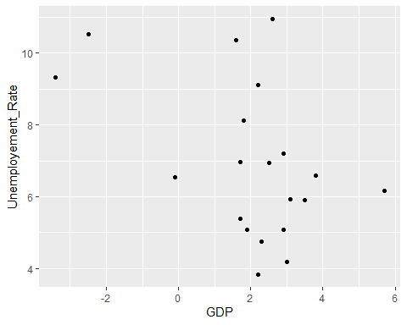

ggplot(data = yr_unemp_gdp) +  
 geom_point(mapping = aes(x = Unemployement_Rate, y =GDP ))

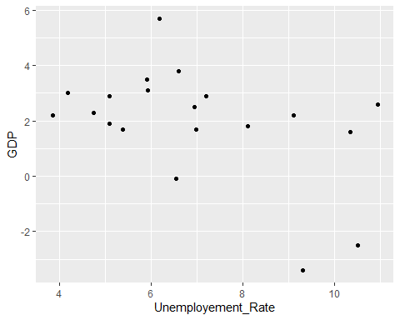

## Additonal analysis to analyse the effect of Unemployement on Crime Rates

crdata<-read.csv("D:/Data Science 2021-2023/Spring 2022/Advanced R/Project/Datasets/CrimeRates.csv")  
  
yr_groupby_cr<-testing_merge%>%  
 group_by(Year) %>%   
 summarise_at(vars(Unemployement_Rate), list(Unemployement_Rate = mean))  
  
yr_groupby_cr

## # A tibble: 20 x 2  
## Year Unemployement_Rate  
## <int> <dbl>  
## 1 2002 6.97  
## 2 2003 7.21  
## 3 2004 6.59  
## 4 2005 5.91  
## 5 2006 5.09  
## 6 2007 5.09  
## 7 2008 6.55  
## 8 2009 10.5   
## 9 2010 10.9   
## 10 2011 10.4   
## 11 2012 9.11  
## 12 2013 8.11  
## 13 2014 6.94  
## 14 2015 5.93  
## 15 2016 5.38  
## 16 2017 4.75  
## 17 2018 4.18  
## 18 2019 3.84  
## 19 2020 9.32  
## 20 2021 6.18

yr_unemp_cr<-yr_groupby_cr%>%  
 right_join(crdata, by = c("Year" = "Year")) %>%   
 select(Year,Crime_Rate,Unemployement_Rate)  
  
yr_unemp_cr

## # A tibble: 18 x 3  
## Year Crime_Rate Unemployement_Rate  
## <int> <dbl> <dbl>  
## 1 2002 5.65 6.97  
## 2 2003 5.7 7.21  
## 3 2004 5.52 6.59  
## 4 2005 5.67 5.91  
## 5 2006 5.81 5.09  
## 6 2007 5.7 5.09  
## 7 2008 5.43 6.55  
## 8 2009 5.03 10.5   
## 9 2010 4.76 10.9   
## 10 2011 4.71 10.4   
## 11 2012 4.73 9.11  
## 12 2013 4.53 8.11  
## 13 2014 4.44 6.94  
## 14 2015 4.95 5.93  
## 15 2016 5.39 5.38  
## 16 2017 5.32 4.75  
## 17 2018 4.96 4.18  
## 18 2019 4.46 3.84

#no significance  
model_test_cr= lm( Crime_Rate ~ Unemployement_Rate ,data=yr_unemp_cr)  
summary(model_test_cr)

##   
## Call:  
## lm(formula = Crime_Rate ~ Unemployement_Rate, data = yr_unemp_cr)  
##   
## Residuals:  
## Min 1Q Median 3Q Max   
## -0.9137 -0.2681 0.0706 0.4000 0.5720   
##   
## Coefficients:  
## Estimate Std. Error t value Pr(>|t|)   
## (Intercept) 5.65366 0.37001 15.280 5.79e-11 ***  
## Unemployement_Rate -0.07294 0.05156 -1.415 0.176   
## ---  
## Signif. codes: 0 '***' 0.001 '**' 0.01 '*' 0.05 '.' 0.1 ' ' 1  
##   
## Residual standard error: 0.4618 on 16 degrees of freedom  
## Multiple R-squared: 0.1112, Adjusted R-squared: 0.05564   
## F-statistic: 2.002 on 1 and 16 DF, p-value: 0.1763

ggplot(data = yr_unemp_cr) +  
 geom_point(mapping = aes(x = Crime_Rate, y = Unemployement_Rate))

