Name yintern.com

student-to-employer internship platform

Essential Core Features
- Student Profiles: A dedicated space for students to list skills, academic majors, coursework, CGPA, and portfolio projects rather than a traditional heavy resume.
- Employer Dashboard: A simple portal for companies to post roles, set minimum academic or skill requirements, and review applicants.
- Matching & Filtering: A search system that lets students filter by remote/in-person status, paid vs. unpaid stipends, and industry.
- Application Tracking: Built-in status updates so students know if their application is viewed, shortlisted, or rejected
. internships conveniently categorized in different fields for Fall 2024, Spring 2025, and Summer 2025 and you can click on the internship link to apply to yoursel

.specifying the place for the intership

.work from home or in office

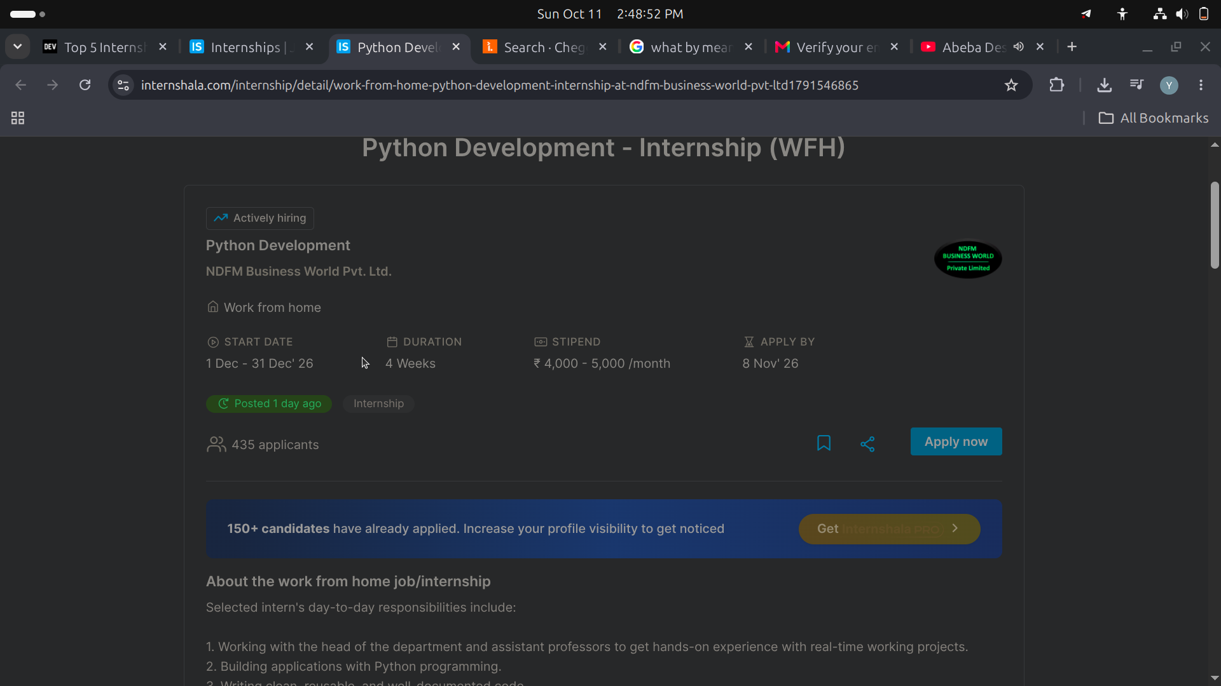
.buiilding trust btwn university and colleges and with student on their
intern grade and performance by showing it is assesement through portal

.
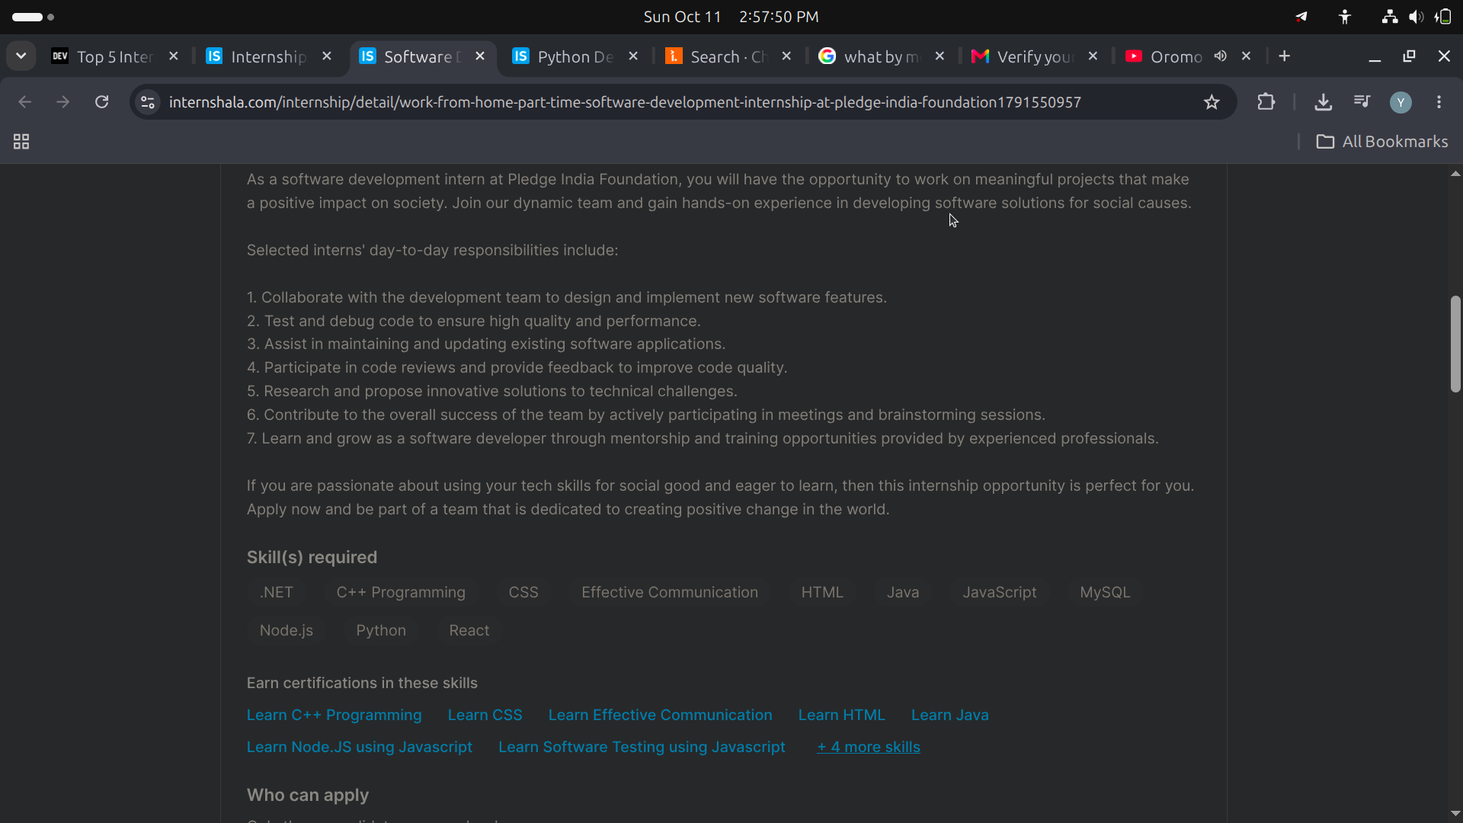
.https://internshala.com/internship/detail/work-from-home-part-time-software-development-internship-at-pledge-india-foundation1791550957
Unclear Job Descriptions: Vague role expectations, lack of transparency about pay or responsibilities, and poor communication from recruiters make it hard to evaluate or target the right positions.

.solving Independent Placement and Lack of Formal Networks

. solving Limited Networking: A general lack of transparent recruitment channels, career fairs, and professional networking platforms makes it difficult for students to connect with corporate employers

,Universities often fail to conduct regular supervision visits or allocate sufficient budgets to support students in the field.

AI Mode conversation: what are the major problems students face while finding internship in ethiopia or africa

supervisors, and company mentors) to log into the same system but see only the information relevant to them.
Implementing a continuous assessment module within this system is highly recommended to solve the "poor supervision" and tracking gaps common in African universities.

1. Platform Architecture: The Three-Dashboard Model
Instead of building isolated student sites, create one portal with three distinct user roles:
User Dashboard | Key Functionalities
Student Dashboard | Submit daily/weekly digital logbooks, request supervisor approvals, view internship openings, and upload final reports.
University Advisor Dashboard | Track assigned student locations, view and score weekly progress, conduct mid-term evaluation forms, and leave feedback.
Company Mentor Dashboard | Log daily attendance, approve student tasks, fill out final industry performance appraisals, and communicate with the university

