Task 1: Create an IAM User

\* Create a new IAM user with Access Key. Ensure you save the access key ID and secret access key provided during the creation process.

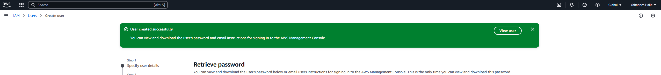

Task 2

A

B

Task 3

a

B

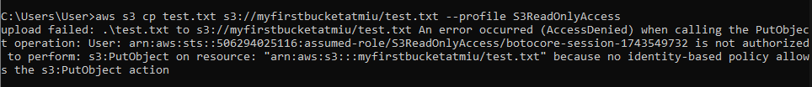

C

