Select the best attacking midfielder in England Premier League

**What are the benefits of my project?**

1. Identifying the best attacking midfielder helps managers build more efficient lineups and game plans based on player strengths and compatibility with the team's style of play.
2. Fans enjoy discussions around which players are the best in specific roles. Creating data-backed player comparisons generates interest and engagement in the football community.
3. Clubs looking to strengthen their squads can use the data and analysis from the project to identify players that fit their tactical needs.
4. Identifying top performers can help clubs and sponsors in marketing campaigns, as the best players attract more attention and commercial interest.

**Who is the attacking midfielder?**

An attacking midfielder in football is a player positioned in the midfield but plays a more advanced and offensive role compared to other midfielders. Their primary job is to create scoring opportunities for their teammates, link play between midfield and attack, and occasionally score goals themselves. They often operate just behind the forwards and are pivotal in orchestrating attacks.

**Priority list of key attributes for an attacking midfielder**

When selecting or analyzing an attacking midfielder, certain attributes are more critical to their success. Below is a priority list of key attributes ranked in order of importance, based on the role's requirements.

1. **Creativity and Vision (High Priority)**

Assists, accurate long balls, and big chances created are excellent indicators of player creativity in football.

1. **Dribbling and Ball Control (High Priority)**

dribbling and free-kick goals scored are strong indicators to measure the effectiveness of an attacking midfielder

1. **Passing Accuracy (High Priority)**

completed passes and crosses accuracy are excellent metrics for evaluating a player's passing accuracy

1. **Shooting Ability (Medium Priority)**

Goals are a key measure of a player's shooting ability. A higher number of goals indicates effective finishing, shot accuracy, and decision-making in front of the goal.

1. **Defending skills (Low-Medium Priority)**

For an attacking midfielder, defensive contributions are important, and tackle accuracy, blocked shots, duels won and aerial battles won are valuable in assessing their defending skills

1. **Individual awards (Medium Priority)**

These awards highlight an attacking midfielder's excellence. Player of the Season and Month awards showcase consistency, while Goal of the Season/Month reflects creativity and finishing ability. Premier League Champion indicates team success, and Playmaker of the Year emphasizes vision and playmaking skills, all essential for a top-tier attacking midfielder.

**Data gathering**

The data required for this project was primarily sourced from three well-known football statistics websites: Transfermarkt, SofaScore, and the Premier League's official website. 28 attacking midfielders are playing in the premier league. Using above websites, create a data set.

1. Player: The name of the football player.
2. Main position: The primary position the player typically plays in (eg: attacking midfielder)
3. Club: The football club that the player is currently associated with.
4. Age: The player’s age.
5. Market value (euro million): The estimated market value of the player in millions of euros.
6. All-time appearance: The total number of matches the player has appeared in throughout their career across all competitions.
7. All-time goals: The total number of goals scored by the player in all competitions throughout their career.
8. All-time assists: The total number of assists the player has provided across all competitions.
9. All-time yellow cards: The total number of yellow cards the player has received in their career.
10. All-time red cards: The total number of red cards the player has received in their career.
11. Premier League appearance: The number of matches the player has appeared in the Premier League.
12. Premier League Goals per match: The average number of goals the player scores per match in the Premier League.
13. Premier League Passes per match: The average number of passes the player makes per match in the Premier League.
14. Premier League Cross accuracy %: The percentage of successful crosses made by the player in the Premier League.
15. Premier League Big Chances Created: The number of "big chances" the player has created in the Premier League. Big chances are opportunities where the player is in a high-probability scoring position.
16. Premier League Accurate long balls: The number of accurate long balls played by the player in the Premier League.
17. Premier League Free kicks scored: The total number of free-kick goals scored by the player in the Premier League.
18. Premier League Tackle success %: The percentage of tackles made by the player that were successful in the Premier League.
19. Premier League Blocked shots: The number of shots blocked by the player in Premier League matches.
20. Premier League Duels won: The total number of duels (one-on-one battles) won by the player in the Premier League.
21. Premier League Successful 50/50s: The number of successful 50/50 challenges (a contested ball situation) won by the player in the Premier League.
22. Premier League Aerial battles won: The number of aerial duels won by the player in Premier League matches.
23. Average successful dribbles in domestic league (last 4 seasons): The average number of successful dribbles made by the player per season in their domestic league over the past four seasons.
24. Times Player of the Season: The number of times the player has won the Player of the Premier league season award.
25. Times Player of the Month: The number of times the player has won the Player of the Month award.
26. Times Goal of the Season: The number of times the player has won the Goal of the Premier league season award.
27. Times Goal of the Month: The number of times the player has won the Goal of the Month award in Premier league season.
28. Times Premier League Champion: The number of times the player has been part of a team that won the Premier League.
29. Times Playmaker of the Year: The number of times the player has won the Playmaker of the Year award.
30. Average rating (last 12 months): The player’s average performance rating over the last 12 months.

To select the best attacking midfielder in the Premier League, I employed two methods:

* **Power BI Visualization:** Visual analysis of player performance data, including assists, passing accuracy, and other key metrics, to identify top performers.
* **Binary Optimization Using Python:** Applied mathematical optimization techniques to select the optimal attacking midfielder based on defined performance criteria and constraints, ensuring data-driven precision.

**Power BI Visualization**

Using Power BI Visualization to analyze Premier League attacking midfielders allows for an intuitive understanding of performance data. The interactive nature of Power BI enhances the ability to identify trends and key players, making it a valuable tool for decision-making in sports analytics.

1. **Creativity and Vision**

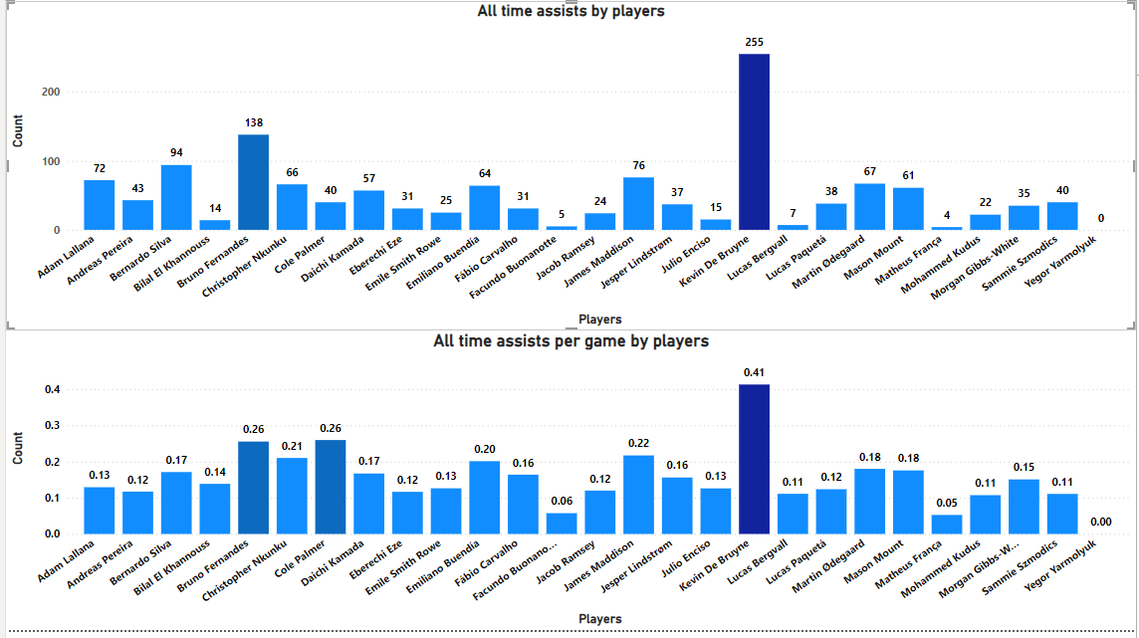

Above charts shows two bar charts related to the number of assists made by players in all time. The first chart shows the total number of assists made by each player. The player with the most assists is **Kevin De Bruyne**, followed by Bruno Fernandes and Bernardo silva. The second chart shows the number of assists per game by each player per game. The player with the highest average assists per game is also **Kevin De Bruyne**, followed by Bruno Fernandes and Cole Palmer. These charts provide a visual representation of the assist-making abilities of the players.

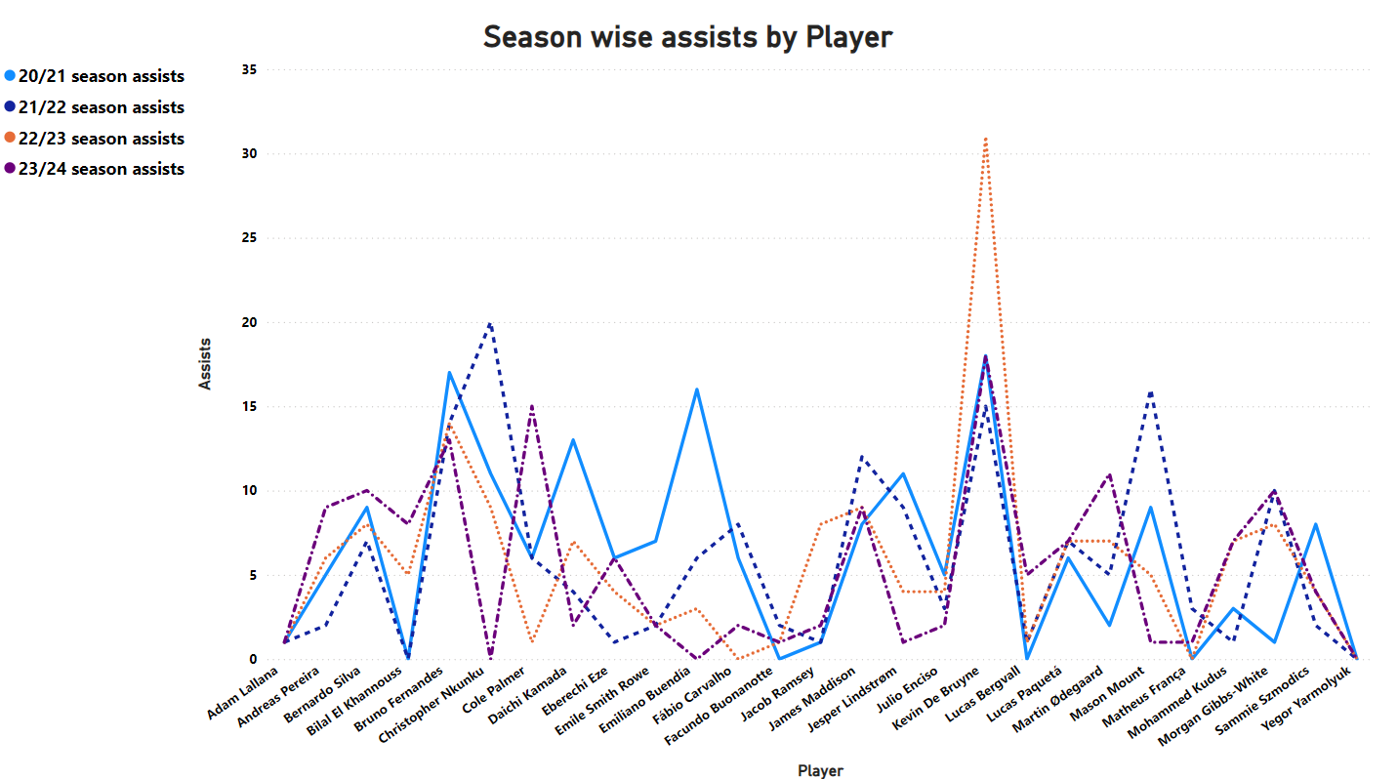

line chart shows a assist-making performance of players across four seasons: 20/21, 21/22, 22/23, and 23/24. like Kevin De Bruyne and Bruno Fernandes, have maintained a consistently high assist-making output across multiple seasons. The chart provides a visual representation of the assist-making trends of these players.

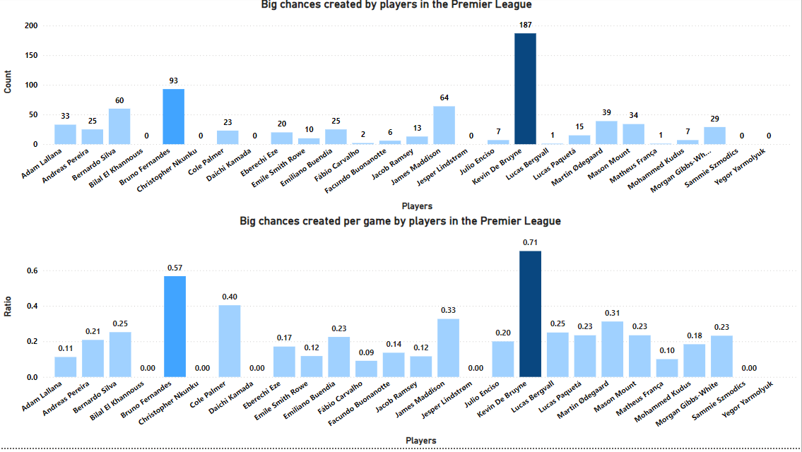

The chart shows two bar charts related to the number of big chances created by players in the Premier League. The first chart shows the total number of big chances created by each player in England Premier league. The player with the most big chances created is **Kevin De Bruyne**, followed by Bruno Fernandes. The second chart shows the average number of big chances created by each player per game. The player with the highest average big chances created per game is also **Kevin De Bruyne**, followed by Bruno Fernandes and Cole Palmer. these charts provide a visual representation of the chance-creating abilities of the players in the league.

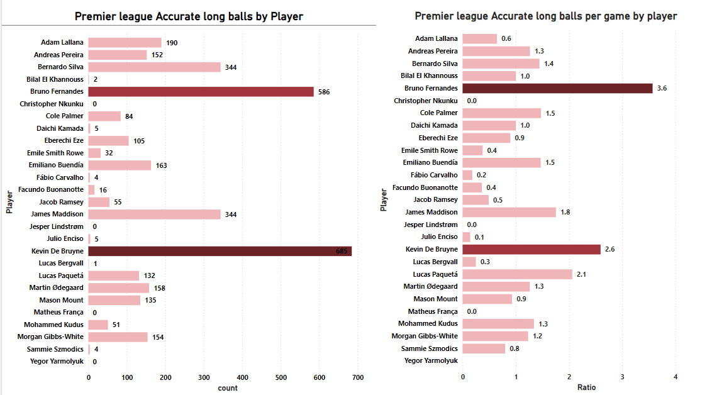

The chart provided shows two bar charts related to the number of accurate long balls played by players in the Premier League. The first chart shows the total number of accurate long balls played by each player. The player with the most accurate long balls is **Kevin De Bruyne**, followed by Bruno Fernandes and Bernardo Silva. The second chart shows the average number of accurate long balls played by each player per game. The player with the highest average accurate long balls per game is also **Bruno Fernandes**, followed by Kevin De Bruyne and Lucas Paquetá.

Analyzing Creativity and Visionarea, **Kevin De Bruyne** excels in creating big chances, assists, and accurate long balls. His ability to contribute in these areas makes him a valuable player. **Bruno Fernandes** consistently ranks high in assists and accurate long balls. Players who create more big chances tend to also have higher assist numbers, suggesting that these skills are interconnected.

1. **Dribbling and Ball Control**

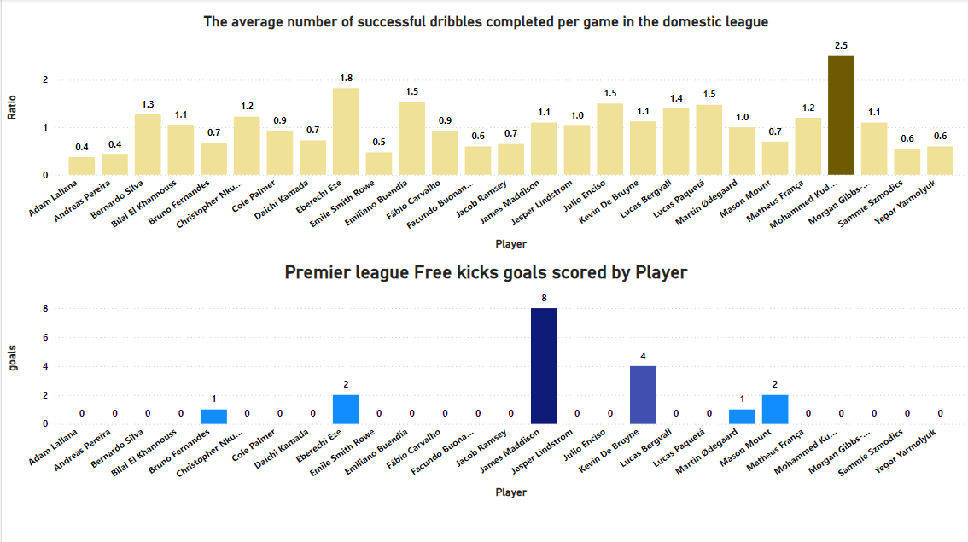

The first chart shows the average number of successful dribbles completed per game in domestic league by each player. Dribbling ability is crucial for breaking through defensive lines and creating opportunities. The player with the highest average number of successful dribbles per game is **Mohammed Kudus**, followed by Eberechi Eze. The second chart shows the number of free-kick goals scored in England Premier league by each player. Free-kick goals showcase a player's capability to capitalize on set pieces, which can be game-changing in tight matches. The player with the most free-kick goals is **James Maddison**, followed by Kevin De Bruyne. While Kudus is excellent in dribbling, Maddison’s set-piece ability combined with his general attacking threat makes him a top choice.

1. **Passing Accuracy**

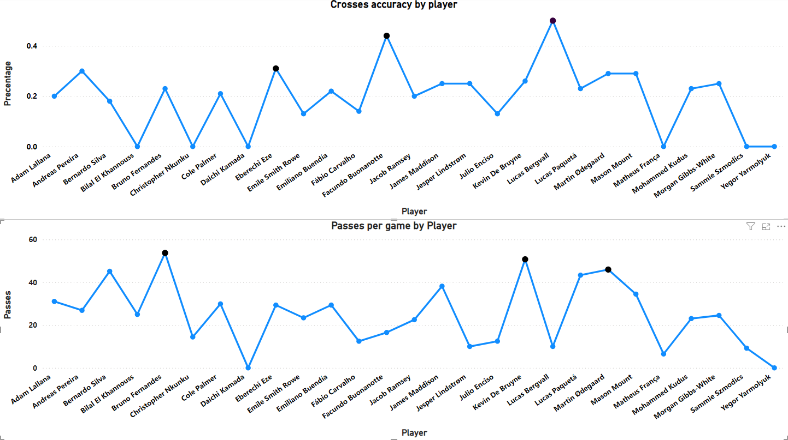

The first chart shows the cross accuracy in England Premier league of each player. Cross accuracy is crucial for delivering effective balls into the box, assisting forwards and creating goal-scoring chances. The player with the highest cross accuracy is **Lucas Bergvall**, followed by Facundo Buonanotte and Eberechi Eze. The second chart shows the number of passes per game in premier league by each player. **Number of passes per game** reflects a player's involvement in the build-up play, their ability to dictate the tempo, and their vision to connect the play between midfield and attack. The player with the highest number of passes per game is **Bruno Fernandes**, followed by Kevin De Bruyne and Martin Ødegaard. Lucas Bergvall leads in cross accuracy, making him an excellent candidate for delivering precise crosses into the box. Bruno Fernandes, with his passing dominance, is a strong candidate.

1. **Goal scoring accuracy**

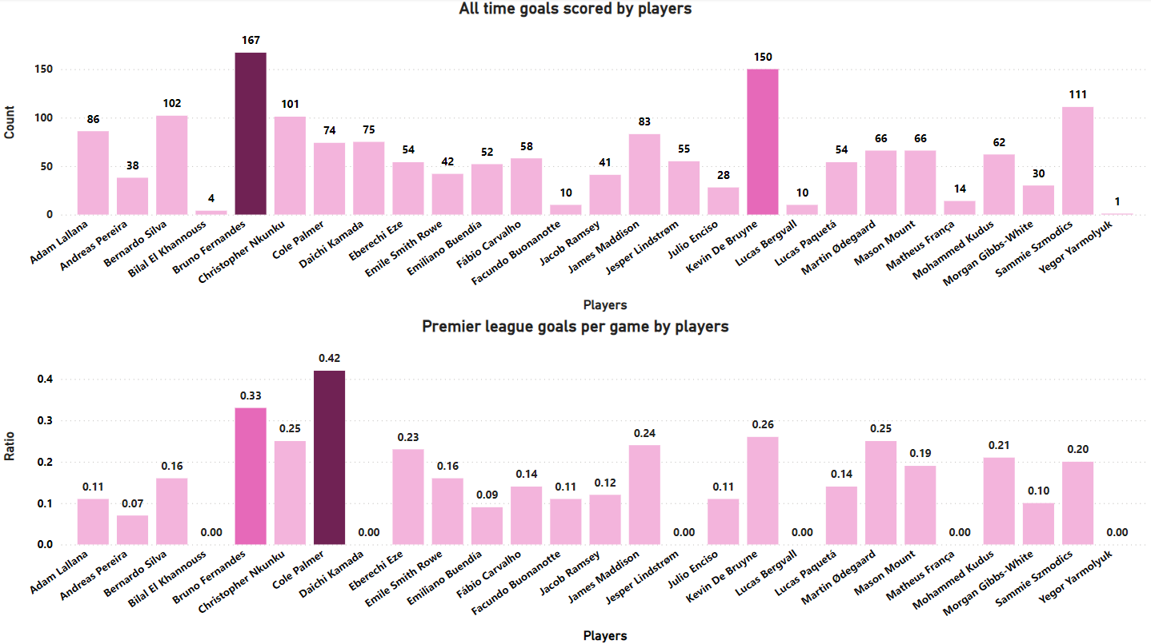

The first chart shows the all-time of goals scored by each player. All-time goals scored reflects a player's overall goal-scoring impact throughout their career. The player with the most goals scored is **Bruno Fernandes**, followed by Kevin De Bruyne. The second chart shows the England Premier league goals per game by each player. Premier League goals per game shows their efficiency in scoring within England’s top competition. Thee player with the highest average number of Premier league goals per game is also **Cole Palmer**, followed by Bruno Fernandes and Kevin De Bruyne. Bruno Fernandes leads in all-time goals scored, showing his consistent contribution as a goal-scoring midfielder. Cole Palmer has the highest Premier League goals per game, showing his strong efficiency when on the field. Bruno Fernandes would be the top choice for an attacking midfielder given his combination of career goals and Premier League efficiency.

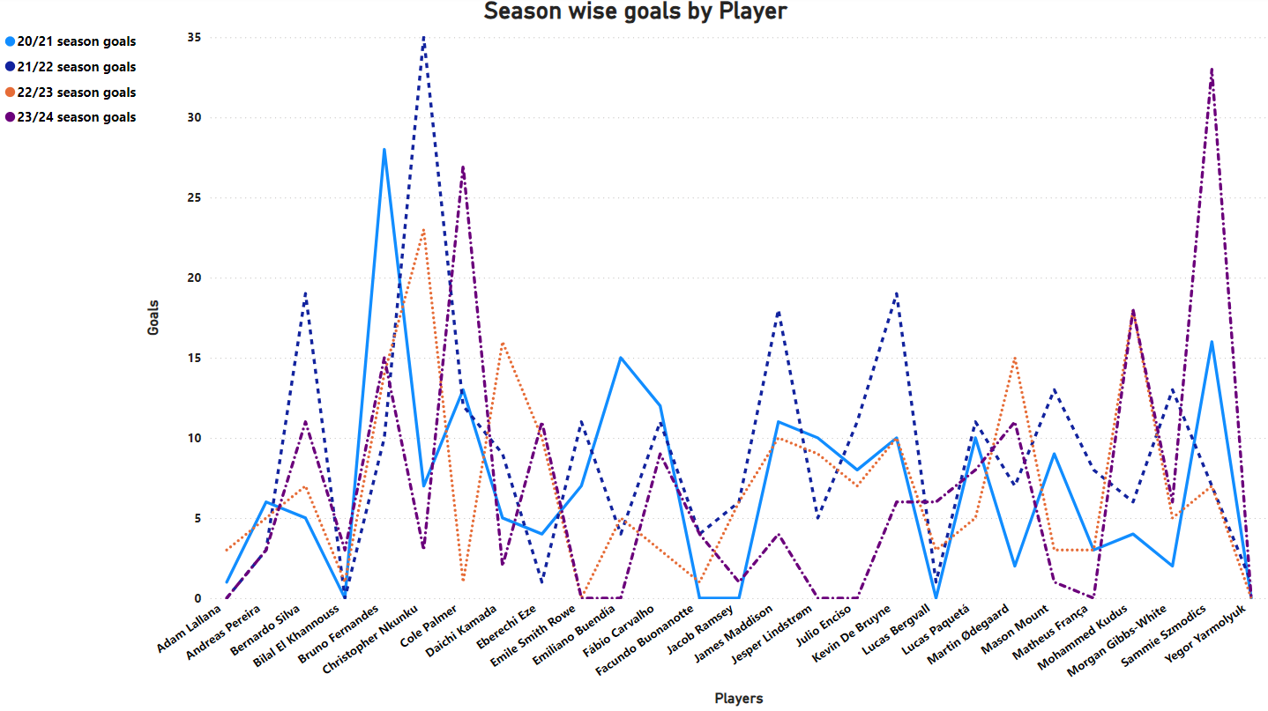

line chart shows a goal-scoring performance of players across four seasons: 20/21, 21/22, 22/23, and 23/24. In highly competitive leagues, goal-scoring consistency is often crucial for success. A midfielder who can consistently contribute goals can significantly impact a team's chances of winning matches. Some players, like **Kevin De Bruyne** and **Bruno Fernandes**, have maintained a consistently high goal-scoring output across multiple seasons. Such as **Cole Palmer** has shown significant improvement in their goal-scoring abilities over time. Younger players like Bilal **El Khannouss** and **Cole Palmer** have shown promising goal-scoring potential, suggesting they could be future stars.

1. **Awards**

Player of the Season, Player of the Month, Goal of the Season, Goal of the Month, Premier League Champion, and Playmaker of the Year are excellent indicators of a player's impact and contribution over a specific period, offering additional context to help select the best attacking midfielder.

Player of the Season - Awarded to the best player for their consistent performance throughout the entire Premier League season.

Player of the Month - This award is given for outstanding performance during a particular month.

Goal of the Season - This award is given for the best goal scored during a Premier League season.

Goal of the Month - This award is similar to Goal of the Season, but it is awarded on a monthly basis.

Premier League Champion - being part of a title-winning team means the player was instrumental in achieving the highest level of success in English football.

Playmaker of the Year - This award is given to the player with the most assists in a season, recognizing their contribution in creating scoring opportunities.

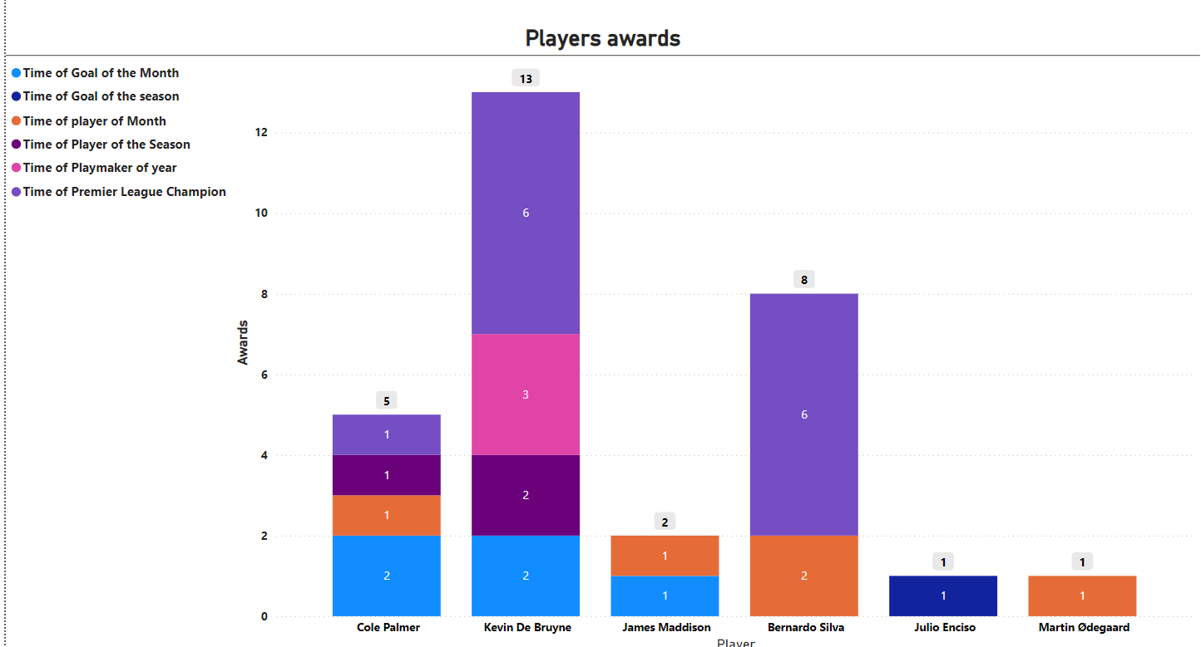

**Kevin De Bruyne** has won the most awards overall, including the prestigious Goal of the Season and Player of the Season. **Cole Palmer** has won multiple awards, suggesting he is a promising young player.

1. **Defensive Skills**

Defensive skills, while not the primary responsibility of an attacking midfielder, are increasingly important in modern football. The role of an attacking midfielder has evolved to require contributions in both attack and defense, making players more versatile and valuable to their teams.

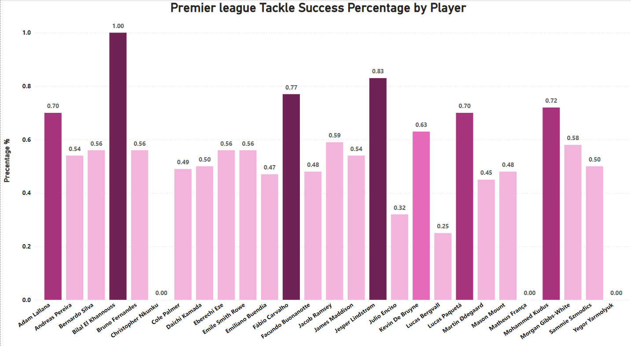

Above chart shows a bar chart representing the tackle success percentage of players in the Premier League. Tackle success in football refers to the percentage of successful tackles a player makes out of the total number of tackles they attempt. Several players have achieved tackle success percentages above 70%, including Fábio Carvalho, Jesper Lindstrøm, Bilal El Khannouss, Lucas Paquetá, and Mohammed Kudus.

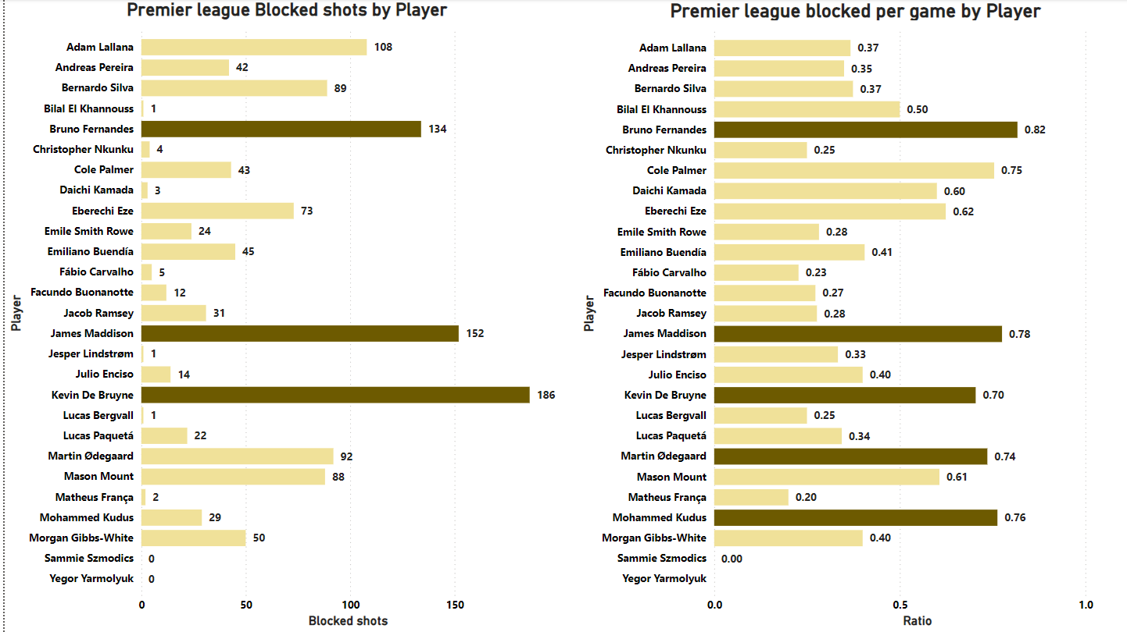

The first chart shows the total number of blocked shots in England Premier League by each player. Blocked shots are generally considered more relevant for defensive players, but they can also be an important indicator when evaluating an attacking midfielder. A blocked shot in football occurs when a player from the defending team successfully obstructs or deflects a shot on goal taken by an attacking player. The player with the most blocked shots is **Kevin De Bruyne**, followed by James Maddison and Bruno Fernandes. The second chart shows the average number of blocked shots by each player per game. The player with the highest average blocked shots per game is also **Bruno Fernandes**, followed by James Maddison and Mohammed Kudus. Blocked shots are not traditionally associated with attacking midfielders, but the data shows that top attacking midfielders like Kevin De Bruyne, Bruno Fernandes, and James Maddison contribute significantly to their team’s defensive efforts.

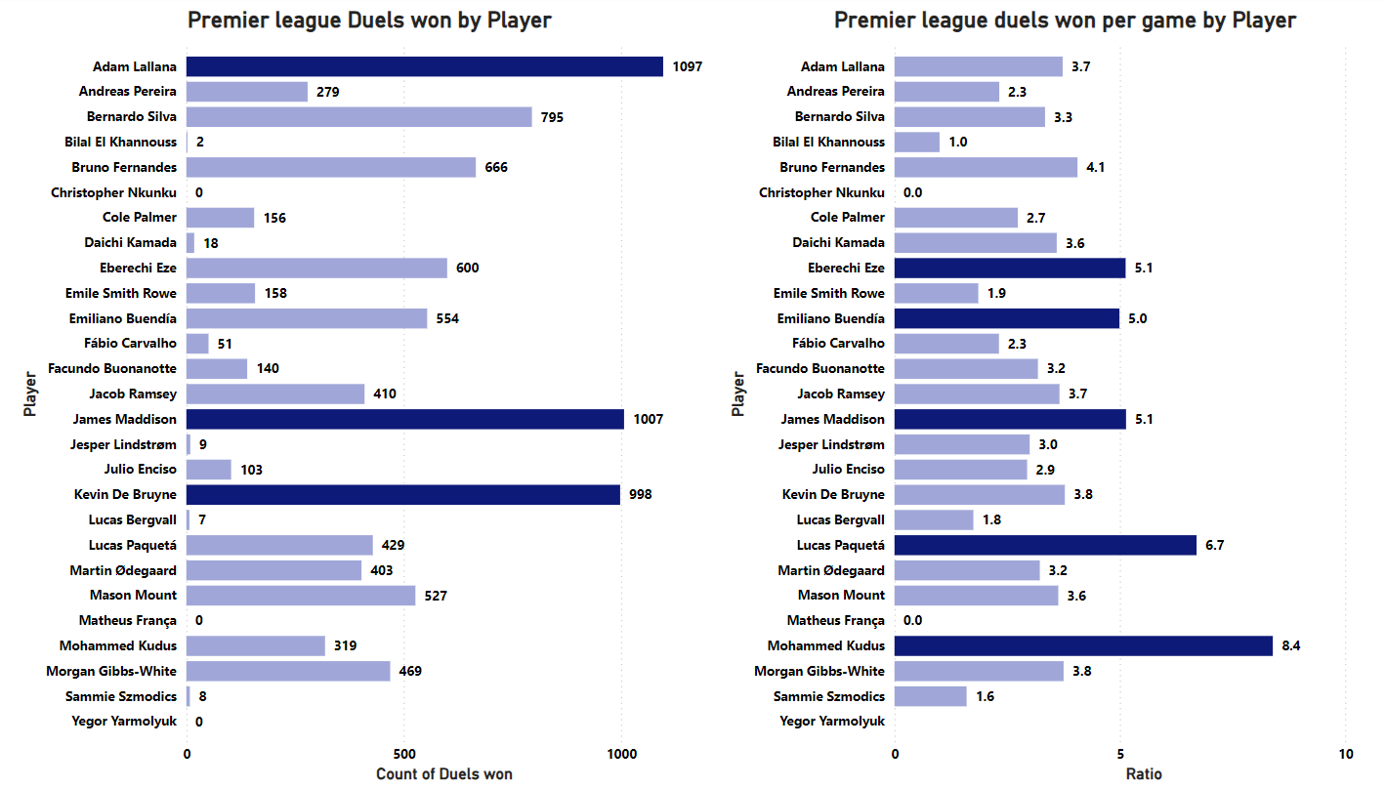

The first chart shows the total number of duels won in England Premier League by each player. A duel won refers to a situation where a player successfully competes against an opponent to gain or retain possession of the ball. A high number of duels won shows an attacking midfielder's ability to win the ball back in pressing situations or to keep possession under pressure. The player with the most duels won is **Adam Lallana,** followed by James Maddison and Kevin De Bruyne. The second chart shows the average number of duels won by each player per game. The player with the highest average duels won per game is **Mohammed Kudus**, followed by Lucas Paquetá and Eberechi Eze. While Adam Lallana leads in total duels won, which reflects his consistency across the season, Mohammed Kudus stands out with the highest average duels won per game, making him the most efficient in this area.

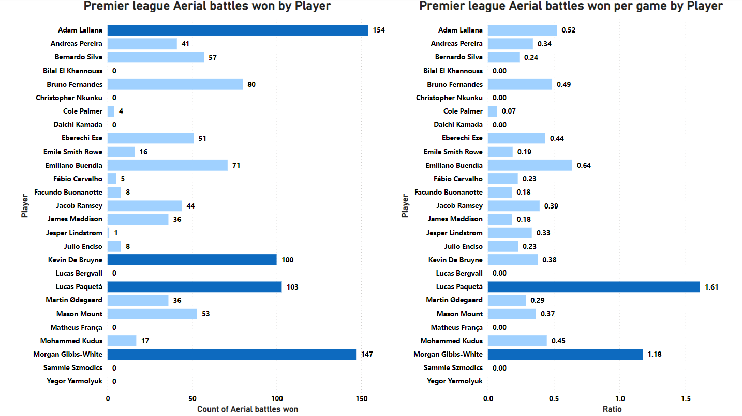

The first chart shows the total number of aerial battles won in England Premier League by each player. aerial battles won refers to instances where a player successfully competes with an opponent to win possession of the ball in the air. An attacking midfielder who wins a significant number of aerial battles adds versatility to their game. The player with the most aerial battles won is **Adam Lallana**, followed by Morgan Gibbs-White and Kevin De Bruyne. The second chart shows the average number of aerial battles won by each player per game. The player with the highest average aerial battles won per game is **Lucas Paquetá**, followed by Morgan Gibbs-White. Lucas Paquetá stands out due to his efficiency in winning aerial battles per game. **Adam Lallana** leads in overall total aerial battles won, indicating his all-around consistency throughout the season.

**Conclusion**

Based on the detailed analysis provided in multiple performance metrics across different dimensions, Kevin De Bruyne and Bruno Fernandes emerge as the two leading candidates for the title of the best attacking midfielder in the Premier League.

Both **Kevin De Bruyne** and **Bruno Fernandes** demonstrate exceptional abilities in key areas for an attacking midfielder, including chance creation, assists, passing accuracy, and goal-scoring consistency. However, **Kevin De Bruyne** edges out as the top choice due to his superior creativity, vision, awards, and overall versatility. His dominance in both offensive playmaking and his contributions across multiple seasons make him the best attacking midfielder. Bruno Fernandes, while not far behind, is a close second, excelling in goal-scoring and passing, but slightly trailing De Bruyne in creativity and accolades.

**Binary Optimization**

The process involved assigning weights to various attributes of attacking midfielders to prioritize their importance, followed by the implementation of optimization using Google OR-Tools.

1. Binary Optimization Approach

The Python code using the OR-Tools library was then employed to refine the selection process. The objective was to maximize the combined weighted performance of the players across selected attributes

1. Data Preparation

Player data was loaded from an Excel sheet and further processed to calculate per-game statistics such as assists, chances created, and duels won. Additional factors like awards won and discipline records (yellow/red cards) were also included to comprehensively evaluate the players.

These attributes were standardized using the StandardScaler to ensure comparability across different metrics

1. Attribute Weights

Each attribute was assigned a weight, reflecting its importance in determining the attacking midfielder’s overall contribution. For example, assists and big chances created were given higher weights (10 and 9), while disciplinary records (yellow/red cards) received negative weights (-2).

1. Optimization Setup

A binary optimization problem was formulated where the solver selected a fixed number of players (10 in this case) to maximize the weighted sum of their attributes. Decision variables were introduced to indicate whether a player was selected (1) or not (0).

1. Results

The solver returned an optimal set of attacking midfielders, ranked by their overall weighted score. Kevin De Bruyne was the highest-ranked player, followed by Bruno Fernandes and James Maddison, among others.

**Conclusion**

The analysis revealed **Kevin De Bruyne** as the standout player, followed by other elite midfielders like **Bruno Fernandes and James Maddison**. This approach provided a comprehensive method to rank players, balancing both offensive contributions and overall influence on the game. Further refinement can involve adjusting the weights based on specific team needs or tactical preferences, as well as expanding the attribute set for a more holistic evaluation.