Improving Loss Recovery in UDP-Based Reliable File Transfer: Adaptive RTO with Selective Repeat over UDT-Style Congestion Control
Computer Networks Lab (BCSE308P) — Final Submission (Template II)

Work Done
A reliable file-transfer protocol was implemented from scratch over UDP in two versions that share all common code (packet framing, simulated lossy channel, DAIMD congestion control, logging). The baseline follows UDT's design: sliding-window flow control, checksum error detection, ACK/NAK feedback, Go-Back-N recovery on loss, and a fixed 200 ms retransmission timeout. The improved version replaces exactly two mechanisms: the fixed timeout becomes an adaptive RTO computed from SRTT/RTTVAR (Jacobson/Karels, with Karn's rule), and Go-Back-N becomes Selective Repeat with per-packet ACKs, an out-of-order receive buffer and SACK-style fast retransmit.
Both versions were run over the same simulated channel (0%, 1%, 5% and 10% random loss, 20 ms ± 5 ms one-way delay, identical random seeds) on a 256 KB file, 10 repeats per point, plus a loss-burst experiment and a packet-reordering experiment. Every transfer was verified byte-for-byte with SHA-256, including edge cases (file smaller than one packet, 2 MB file, 0% loss).

Outputs

Table 1 — Throughput (Mbps, mean ± std over repeats)
Loss | Baseline | Improved | Change
0% | 1.90 ± 0.10 | 1.97 ± 0.07 | —
1% | 1.73 ± 0.17 | 1.72 ± 0.05 | -0%
5% | 1.05 ± 0.14 | 1.24 ± 0.10 | +18%
10% | 0.69 ± 0.12 | 1.02 ± 0.13 | +48%

Table 2 — Retransmission overhead, transfer time and timeouts
Loss | Baseline overhead | Improved overhead | Transfer time (base → impr) | Timeouts (base → impr)
0% | 0.0% | 0.0% | 1.10 s → 1.07 s | 0.0 → 0.0
1% | 8.4% | 2.8% | 1.23 s → 1.22 s | 0.0 → 0.6
5% | 31.8% | 14.0% | 2.02 s → 1.70 s | 0.6 → 7.9
10% | 47.4% | 21.8% | 3.14 s → 2.09 s | 2.9 → 22.1

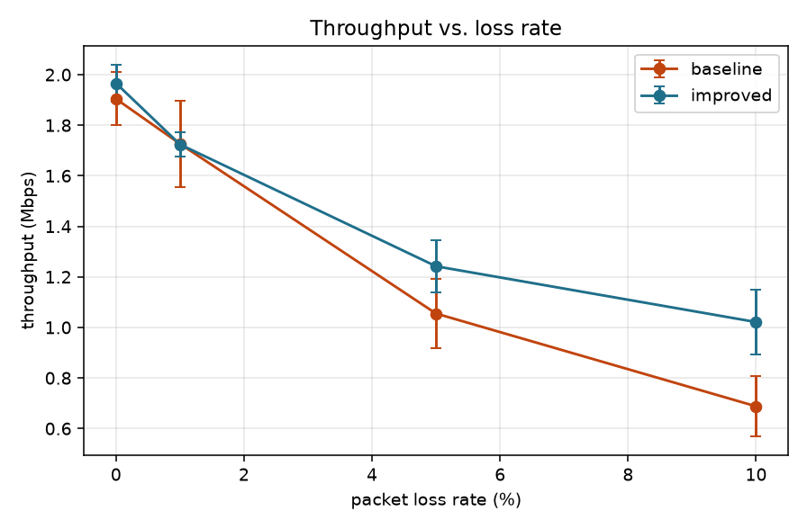
Figure 1 — Throughput vs. loss rate (error bars: std. dev.)
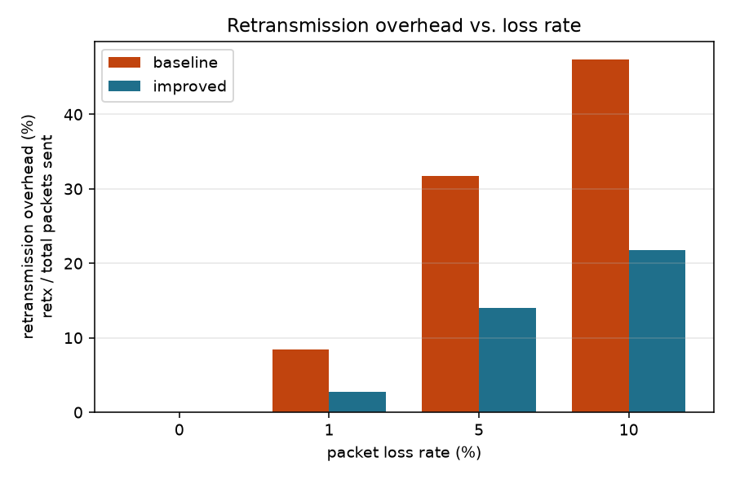
Figure 2 — Retransmission overhead vs. loss rate
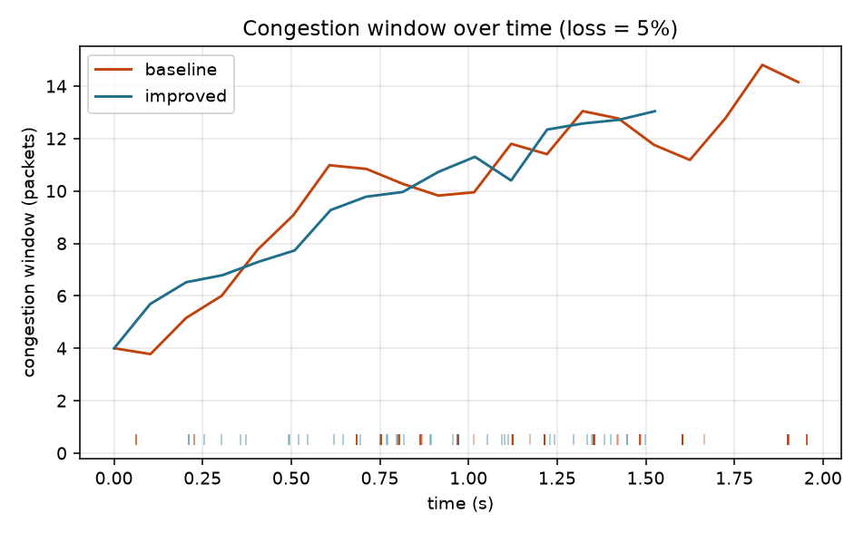
Figure 3 — Congestion window over time, representative run at 5% loss (ticks = retransmissions)
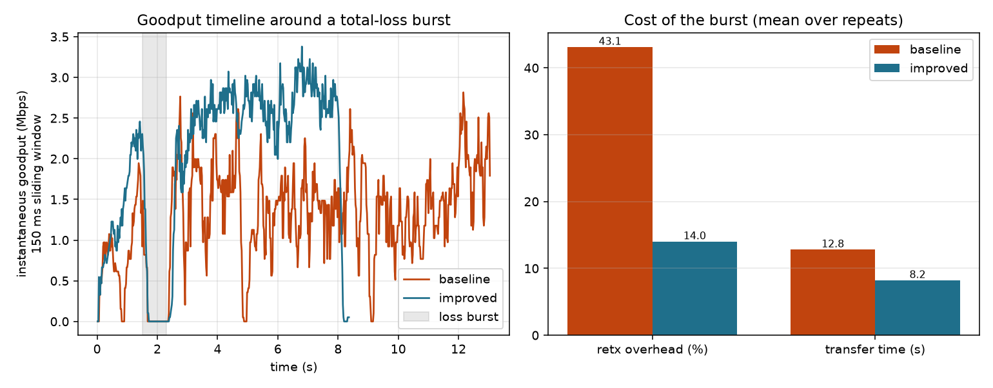
Figure 4 — Goodput around a total-loss burst (left) and cost of the burst (right)
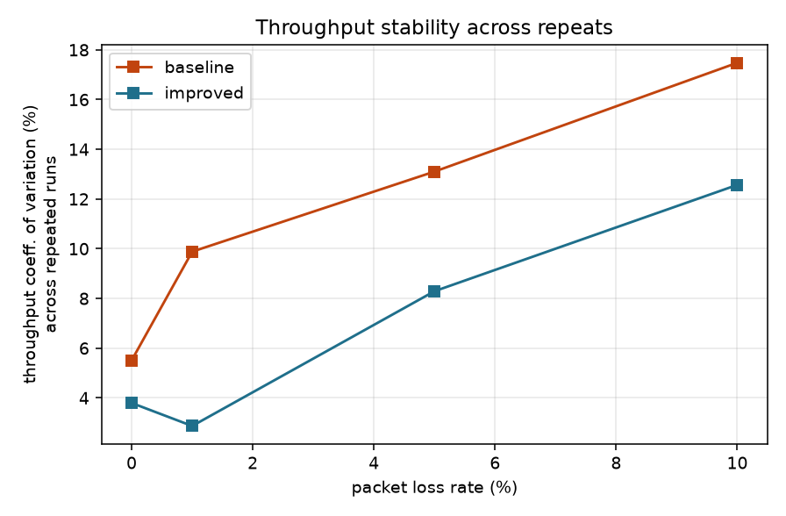
Figure 5 — Run-to-run throughput variability (coefficient of variation)
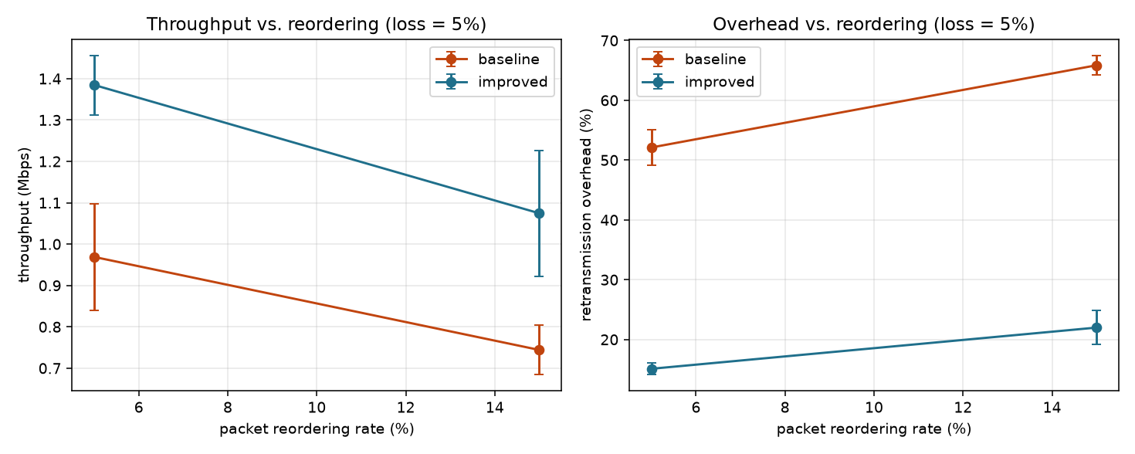
Figure 6 — Effect of packet reordering at 5% loss

Discussion on Results

Comparison with the existing work (UDT)
UDT (Gu & Grossman, 2007) targets high-speed, high-bandwidth-delay-product links with low loss. Its Go-Back-N-style loss handling and timer-driven retransmission are adequate there, but the results show the cost on lossy links: the UDT-style baseline wastes a large share of its transmissions on redundant retransmissions, because a single loss causes the whole outstanding window to be resent.

Improvement achieved
- Throughput: at 5% loss 1.05 → 1.24 Mbps, and at 10% loss 0.69 → 1.02 Mbps (Table 1).
- Retransmission overhead roughly halves: 31.8% → 14.0% at 5% loss and 47.4% → 21.8% at 10% loss (Table 2, Figure 2).
- No penalty on a clean link: at 0% loss both versions perform alike (1.90 vs 1.97 Mbps) with no retransmissions. At 1% loss the two are statistically tied on throughput (1.73 vs 1.72 Mbps) although the improved version already retransmits about a third as much; the throughput gap opens up from 5% loss upward.
- Reordering: with 5% loss plus 5% / 15% packet reordering the improved version keeps a clear lead (0.97 → 1.38 Mbps and 0.74 → 1.07 Mbps; overhead 52% → 15% and 66% → 22%), because Selective Repeat buffers out-of-order packets while Go-Back-N discards them (Figure 6).
- Stability: run-to-run throughput variance is clearly lower for the improved version (Figure 5), because it does not oscillate through repeated full-window resends.
- Loss burst (0.8 s total outage at 5% background loss, large file): both versions resume as soon as the channel returns, so burst-recovery latency itself is similar. The difference is what follows: the improved version sustains a steadier goodput and finishes in 8.2 s vs. 12.8 s with 14.0% vs. 43.1% overhead (Figure 4).

Why it works
Selective Repeat retransmits only packets that are actually missing, which removes the redundant copies; keeping the in-flight window full while a hole is repaired avoids stalling the pipe. The adaptive RTO tracks the measured round-trip time (about 50 ms here) instead of waiting a fixed 200 ms, so genuine losses are recovered sooner. Congestion control is the same shared DAIMD code in both versions, so the measured gain is attributable to the ARQ and timer changes alone, without affecting fairness/stability of the congestion response.

Limitations and honest caveats
- The improved sender takes more timeouts than the baseline (Table 2): the baseline mostly avoids timers by flooding the window after each NAK, which is exactly the redundancy that costs it throughput. Adaptive-RTO timeouts are cheap backstops rather than a defect.
- Evaluation is on a single machine over loopback with an artificial loss/delay model, not a real WAN; absolute Mbps figures are therefore small and only the relative comparison is meaningful. The baseline is a faithful but simplified, window-based UDT-style implementation (not the original UDT library), and its DAIMD is a window-based analogue of UDT's rate-based algorithm.
- Results are for a 256 KB file; larger transfers (2 MB) showed a larger gap (roughly 2× faster at 10% loss) in validation runs.

Conclusion
Replacing the fixed timer and Go-Back-N recovery of a UDT-style UDP transport with an adaptive RTO and Selective Repeat yields a measurable improvement under loss — higher throughput, about half the retransmission overhead, and more stable behaviour — while matching the baseline on a loss-free link.

