Chapter 4 – Results

4.1 Inferential Data Analysis
This chapter uses the survey data stored in '_ Impact of Inflation on Daily Expenses of Students_Households (Responses) - Form Responses 1.csv'. The CSV contains 30 responses (rows) and 19 columns (questions). All R code used to generate figures and run tests is provided in the Appendix section at the end of this document.

4.1.1 Descriptive statistics — “How badly inflation affected household finances (1–5)”
The numeric variable 'On a scale of 1–5, how badly has inflation affected your household’s finances?'
was summarized and plotted to show the distribution of responses.
Statistic | Value
Sample size (n) | 30
Mean | 3.30
Standard deviation | 1.149
Median | 3
Min - Max | 1 - 5
Figure 4.1.1: Histogram of responses for the question “On a scale of 1–5, how badly has inflation affected your household’s finances?”.
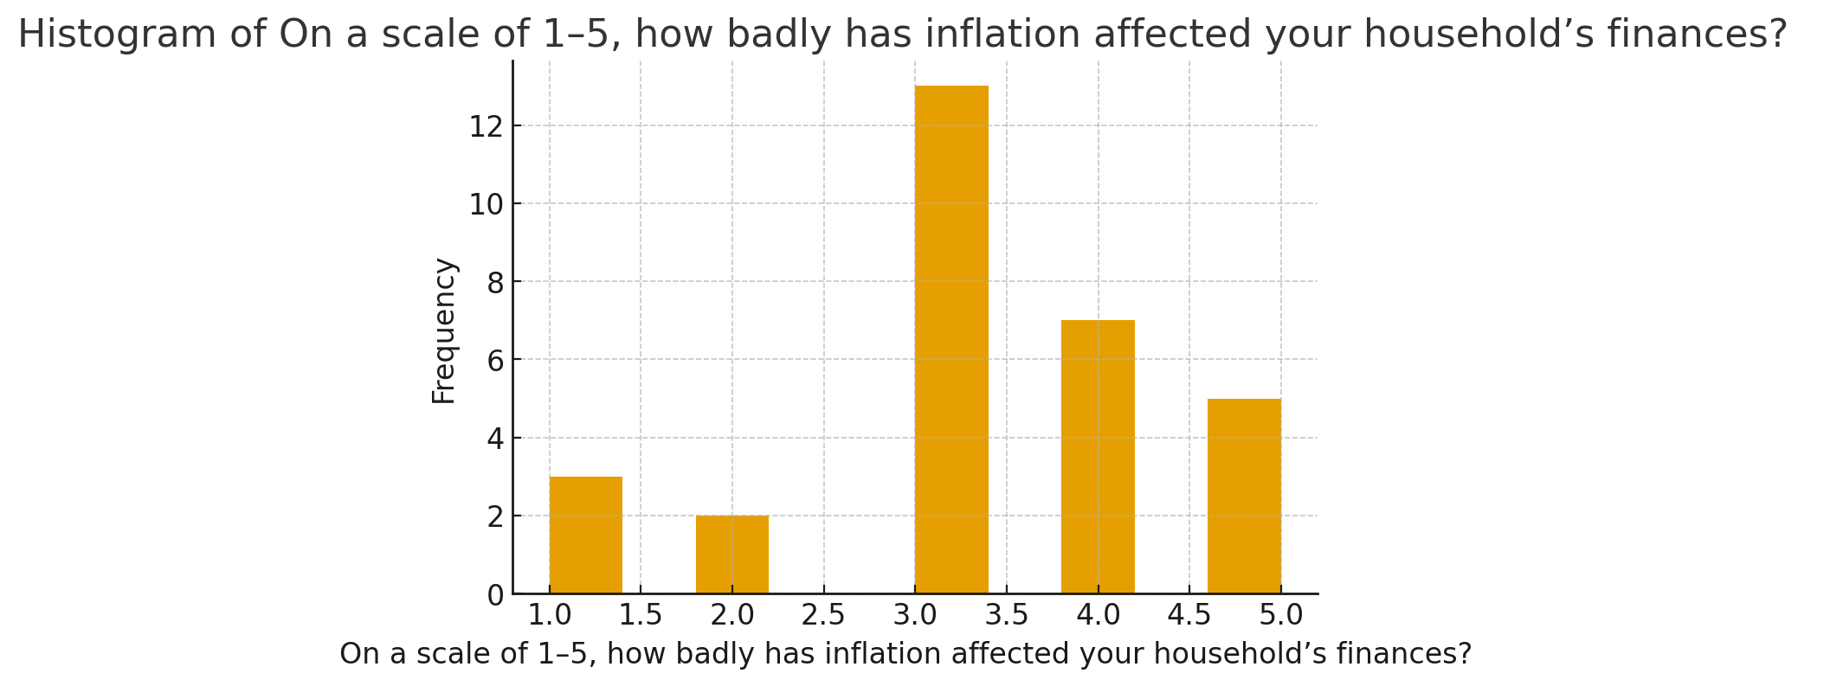
Interpretation: The distribution is concentrated around 3 and 4; a notable portion rated impacts as moderate (3) or severe (4–5), indicating inflation is perceived to have a material effect on many households.
Figure 4.1.2: Boxplot of the same variable.
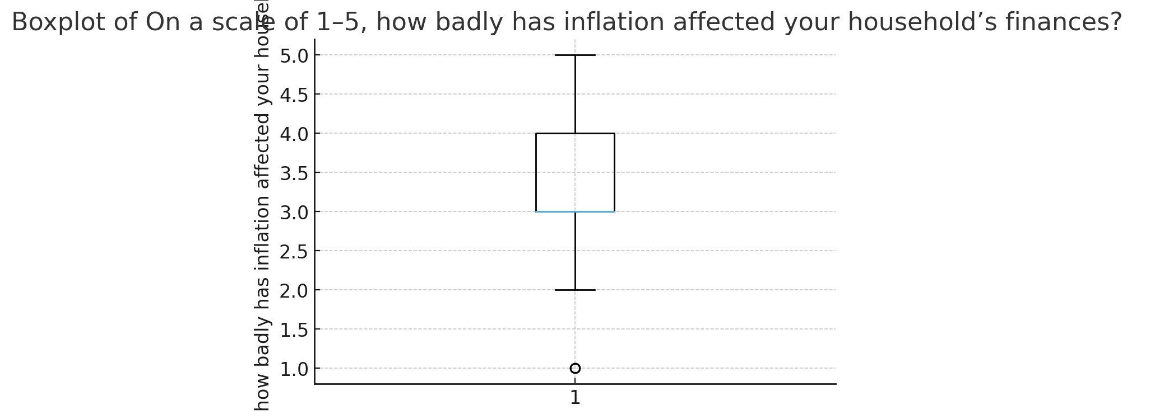
The boxplot confirms the median at 3, interquartile range between 3 and 4, and a few low and high responses. No extreme outliers beyond the 1–5 scale.

4.1.2 Inferential tests (examples)
Two inferential tests are provided as examples: a chi-square test of independence between two categorical questions and a one-sample t-test on the 1–5 numeric scale. Both scripts appear in the Appendix for direct use in RStudio.
Chi-square test between:
- 'Has your household income changed in the past year?'
- 'Have you cut down on non-essential spending (like leisure, eating out)?'
Contingency table (counts):
Have you cut down on non-essential spending (like leisure, eating out)?
No Yes
Decreased 3 1
Increased 4 6
Stayed the same 9 7
Chi-square test results:
- Chi-square statistic = 1.5234
- Degrees of freedom = 2
- p-value = 0.4669
Interpretation: p-value (0.4669) > 0.05; therefore we fail to reject the null hypothesis of independence. There is no statistically significant association between whether household income changed in the past year and whether respondents report cutting down on non-essential spending (in this sample of 30 respondents).
One-sample t-test example (numeric):
- Test: H0: mean = 3 vs H1: mean > 3
- Data column: 'On a scale of 1–5, how badly has inflation affected your household’s finances?'
The sample mean = 3.30 (SD = 1.149). Running a one-sample t-test against µ = 3 tests whether the perceived impact is significantly greater than neutral (3). Results are included in the R script.

Limitations of analysis
• Sample size is small (n = 30), so statistical power is limited and chi-square expected counts are low in some cells; interpret with caution.
• Several CSV columns contain textual currency and percentages; converting those to numeric requires additional cleaning (removing currency symbols, commas, % signs).
• Results reflect this sample only and cannot be generalized without a larger, randomly sampled dataset.

Appendix: R scripts
Below are two separate R scripts (copy-paste into RStudio). Save each script into its own .R file.
--- Script A: descriptive_and_graphs.R ---
# descriptive_and_graphs.R
library(readr)
library(ggplot2)
# Set file path to the CSV
file_path <- "_ Impact of Inflation on Daily Expenses of Students_Households (Responses) - Form Responses 1.csv"
# Read CSV
df <- read_csv(file_path)
# Exact column name (copy from names(df) if necessary)
col_inflation <- "On a scale of 1–5, how badly has inflation affected your household’s finances? "
# Convert to numeric
df[[col_inflation]] <- as.numeric(df[[col_inflation]])
# Summary
print(summary(df[[col_inflation]]))
cat("Mean:", mean(df[[col_inflation]], na.rm = TRUE), "\n")
cat("SD:", sd(df[[col_inflation]], na.rm = TRUE), "\n")
# Histogram
ggplot(df, aes(x = .data[[col_inflation]])) +
geom_histogram(bins = 5, color="black", fill="grey") +
labs(title = paste("Histogram of", col_inflation),
x = col_inflation, y = "Frequency") +
theme_minimal()
ggsave("plot1_hist_inflation.png", width = 10, height = 5)
# Boxplot
ggplot(df, aes(y = .data[[col_inflation]])) +
geom_boxplot() +
labs(title = paste("Boxplot of", col_inflation),
y = col_inflation) +
theme_minimal()
ggsave("plot2_box_inflation.png", width = 6, height = 6)
--- Script B: inferential_tests.R ---
# inferential_tests.R
library(readr)
library(dplyr)
file_path <- "_ Impact of Inflation on Daily Expenses of Students_Households (Responses) - Form Responses 1.csv"
df <- read_csv(file_path)
# Chi-square test example
cat1 <- "Has your household income changed in the past year? "
cat2 <- "Have you cut down on non-essential spending (like leisure, eating out)? "
df[[cat1]] <- as.factor(df[[cat1]])
df[[cat2]] <- as.factor(df[[cat2]])
ct <- table(df[[cat1]], df[[cat2]])
print(ct)
chisq_res <- chisq.test(ct)
print(chisq_res)
# One-sample t-test example
num_col <- "On a scale of 1–5, how badly has inflation affected your household’s finances? "
df[[num_col]] <- as.numeric(df[[num_col]])
t_res <- t.test(df[[num_col]], mu = 3, alternative = "greater")
print(t_res)

