Companion D — Diagrams
Status: v1.0 — Reading Edition (rev. 8) | Drafted: 2026-05-30
Source markdown: ./decision-provenance-standard-v1.0-companion-D-diagrams.md

Decision Provenance Standard™ v1.0 — Companion D: Diagrams
Status: Companion to the Decision Provenance Standard v1.0 (rev. 8). Explanatory, non-normative. Faithful to substrate: v5.1.0 (re-verify on any standard revision).
These figures are explanatory aids, not normative. The text of the Standard is the contract; every figure here illustrates a section of that text. Where a figure and the normative text appear to differ, the text governs. Captions and cross-references use "as shown in" / "illustrated by," never "as required by." Every state name, transition label, field name, enum value, signal name, and controlled-vocabulary chip rendered in these figures is a verbatim protected conformance token — rendered with exact case, hyphens, and underscores.

Notation Key
The figure set uses one consistent visual language. Learn it once; it holds across all eight figures.
Notation | Meaning
Rounded rectangle | A state or a step
Double border | Terminal / irreversible state (e.g., Charter closed, record affirmed + sealed), or a binding attestation — marked by border weight, never by color alone
Solid arrow | A transition
Dashed arrow | A conditional / edge-case transition, or a one-way pointer
Accent (a single desaturated blue, plus heavier stroke) | The one load-bearing element of a figure — comprehension does not depend on the color; the heavier stroke carries the same signal in grayscale
Monospace text | A literal field name, enum value, or signal token (e.g., mode_declaration, dispatch_mode, affirmed, seal_hash)

Color is never the only signal. Every distinction is carried by shape, border style, stroke weight, or label, so the figures remain fully legible in grayscale and to screen-reader and print-only readers.

List of Figures
Figure | Title | Illustrates
Figure 3-1 | Charter Lifecycle State Machine | §3.3
Figure 3-2 | Mode Dispatch Grammar and the Embedded-Mode-2 Edge Case | §3.4 / §4.4 / §4.7
Figure 4-1 | Article 50 Disclosure-Metadata Flow | §4.6.2 / §4.6.3
Figure 4-2 | Mode-Drift Four-Layer Composed Mitigation | §4.8.1
Figure 4-3 | Emission-Cadence by Semantic Class | §4.8.2
Figure 5-1 | Decision-Record State Machine: Two Distinct State Families | §5.1 / §6.2
Figure 6-1 | Artifact-Set Relationship Map | §3 / §5 / §6 / §7 (orientation)
Figure 7-1 | The Three Conformance Levels: Cumulative Criteria | §7.2 / §7.3 / §7.4

Figure 3-1 — Charter Lifecycle State Machine
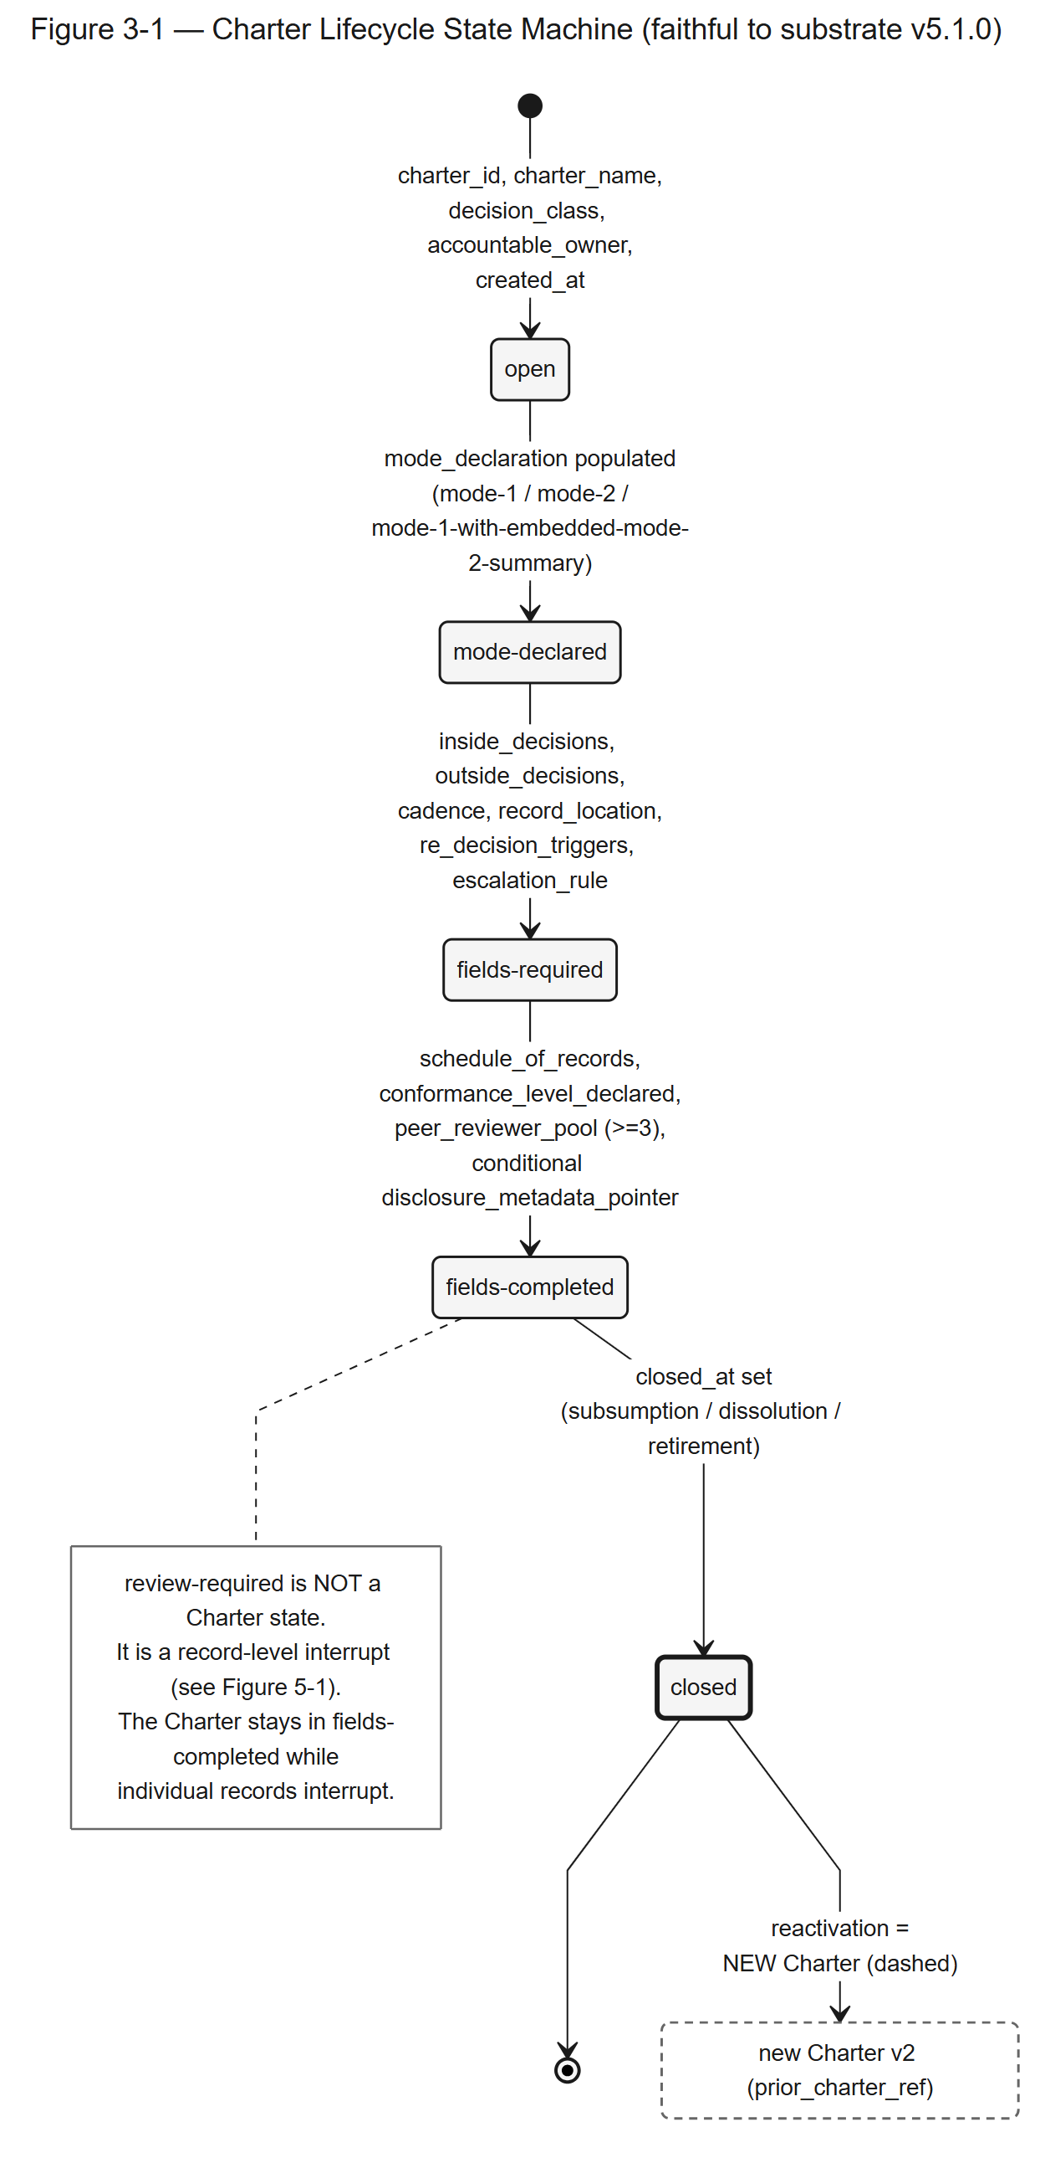
Figure 3-1 — Charter Lifecycle State Machine. A forward-only state machine in which each transition is gated by a named set of Charter fields; closed is terminal and reactivation creates a new Charter.
Full description. The Charter lifecycle is a forward-only state machine with five states: open, mode-declared, fields-required, fields-completed, and closed. Each transition requires a named set of Charter fields to be populated before it can be crossed: creation into open requires charter_id, charter_name, decision_class, accountable_owner, and created_at; open to mode-declared requires mode_declaration populated with one of mode-1, mode-2, or mode-1-with-embedded-mode-2-summary; mode-declared to fields-required requires inside_decisions, outside_decisions, cadence, record_location, re_decision_triggers (at least one outcome and one market trigger), and escalation_rule; fields-required to fields-completed requires schedule_of_records, conformance_level_declared, a peer_reviewer_pool of at least three named reviewers, and a conditional disclosure_metadata_pointer when the mode is mode-2 or mode-1-with-embedded-mode-2-summary; fields-completed to closed requires closed_at to be set on subsumption, dissolution, or explicit retirement. The closed state is terminal; a closed Charter cannot return to a prior state. Reactivation creates a new Charter carrying a prior_charter_ref back-pointer, shown as a dashed off-ramp from closed to a separate "new Charter v2" node, not a back-edge into any prior state. The review-required interrupt is deliberately absent here: it is a record-level state, not a Charter-level state (see Figure 5-1).
Illustrates §3.3.

Figure 3-2 — Mode Dispatch Grammar and the Embedded-Mode-2 Edge Case
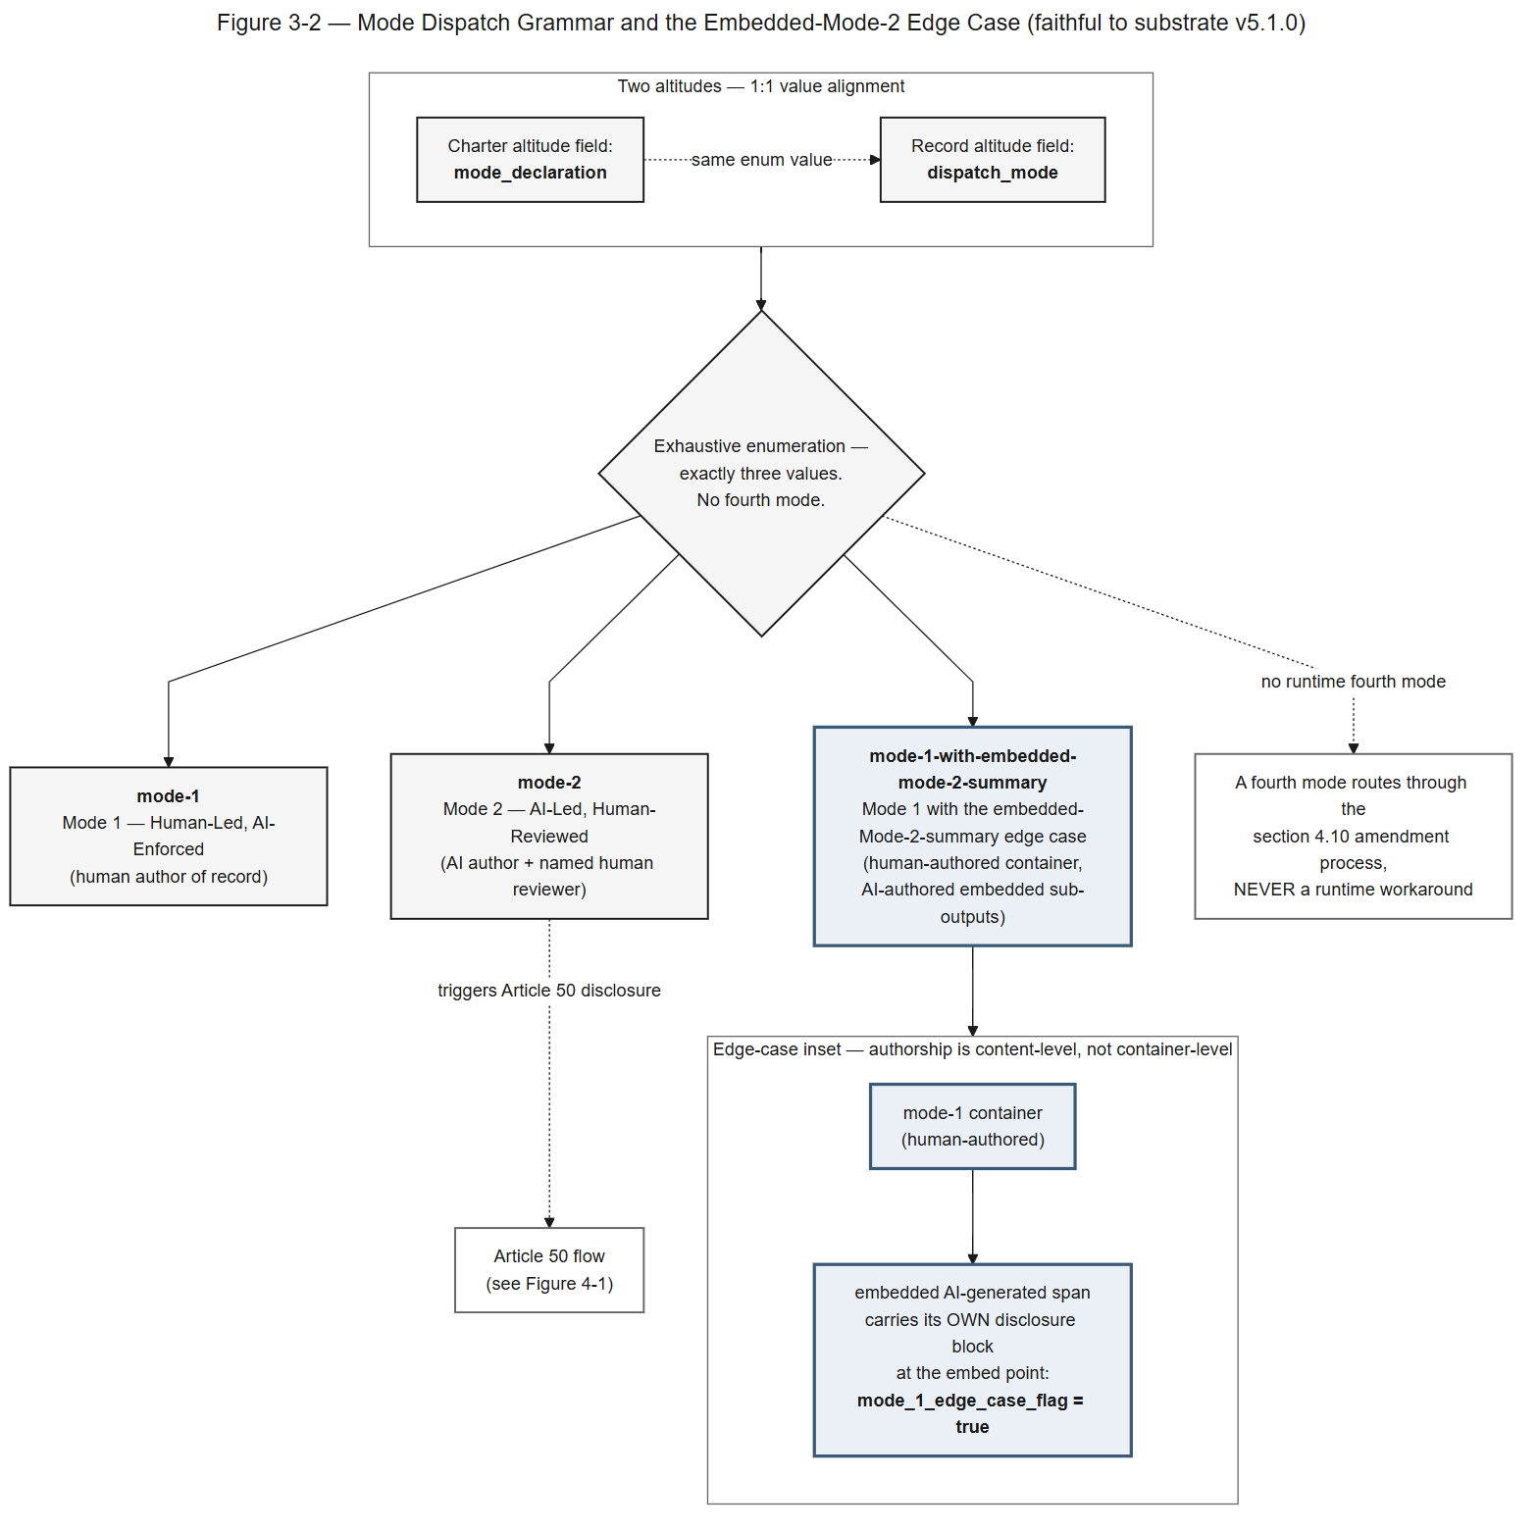
Figure 3-2 — Mode Dispatch Grammar and the Embedded-Mode-2 Edge Case. Mode is declared at two altitudes that align one-to-one, drawn from an exhaustive three-value enumeration; the third value handles content-level embedded authorship.
Full description. Mode is declared at two altitudes that align one-to-one: the Charter field mode_declaration and the decision-record field dispatch_mode. The enumeration is exhaustive with exactly three values: mode-1 (Mode 1 — Human-Led, AI-Enforced), mode-2 (Mode 2 — AI-Led, Human-Reviewed), and mode-1-with-embedded-mode-2-summary (Mode 1 with the embedded-Mode-2-summary edge case). A mode-2 record triggers the Article 50 disclosure flow (Figure 4-1). The third value handles the edge case where a human-authored mode-1 container holds an AI-authored embedded span; authorship is judged at the content level, not the container level, so that embedded span carries its own disclosure block at the embed point with mode_1_edge_case_flag set to true. No fourth mode exists; adding one routes through the §4.10 amendment process, never a runtime workaround. The three token families are distinct and rendered verbatim: mode-declared is a Charter state, mode_declaration and dispatch_mode are fields, and mode-1 / mode-2 / mode-1-with-embedded-mode-2-summary are enum values.
Illustrates §3.4, §4.4, §4.7.

Figure 4-1 — Article 50 Disclosure-Metadata Flow
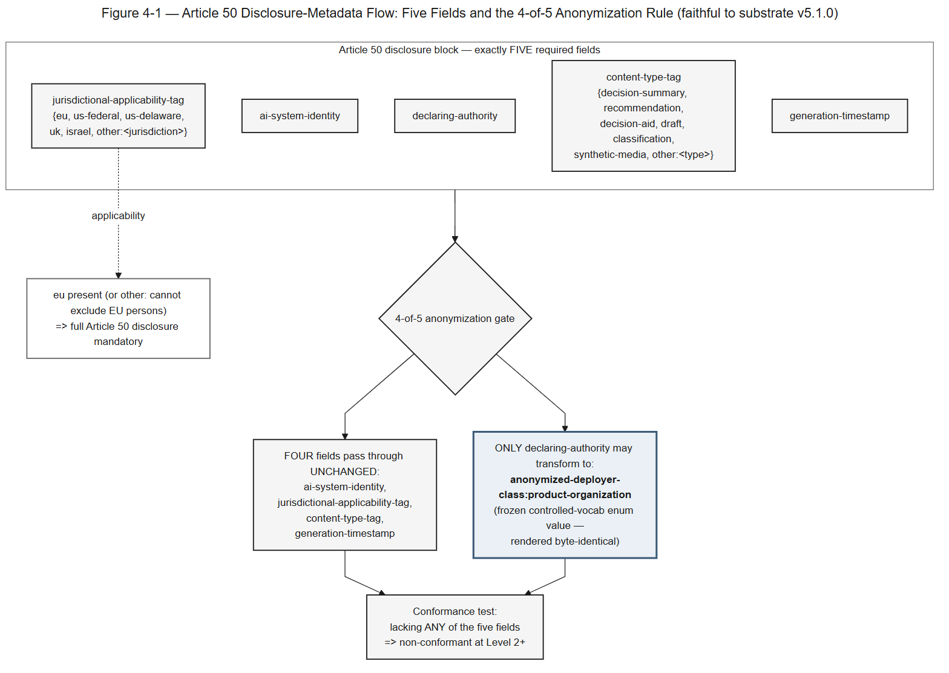
Figure 4-1 — Article 50 Disclosure-Metadata Flow. The disclosure block has exactly five required fields; under the 4-of-5 anonymization rule, four survive unchanged and only declaring-authority may transform.
Full description. The Article 50 disclosure block has exactly five required fields: declaring-authority, ai-system-identity, jurisdictional-applicability-tag, content-type-tag, and generation-timestamp. Two fields carry controlled vocabularies: jurisdictional-applicability-tag takes a value from {eu, us-federal, us-delaware, uk, israel, other:<jurisdiction>} — and when eu is present, or an other: value cannot exclude EU persons, full Article 50 disclosure is mandatory; content-type-tag takes a value from {decision-summary, recommendation, decision-aid, draft, classification, synthetic-media, other:<type>}. Under the four-of-five anonymization rule, four fields survive anonymization unchanged and only declaring-authority may transform to the value anonymized-deployer-class:product-organization. That value is a frozen controlled-vocabulary enum token and is rendered byte-identical; it contains the substring "product-organization" but is not framing text. Lacking any of the five fields makes the record non-conformant at Level 2 or above.
Illustrates §4.6.2, §4.6.3.

Figure 4-2 — Mode-Drift Four-Layer Composed Mitigation
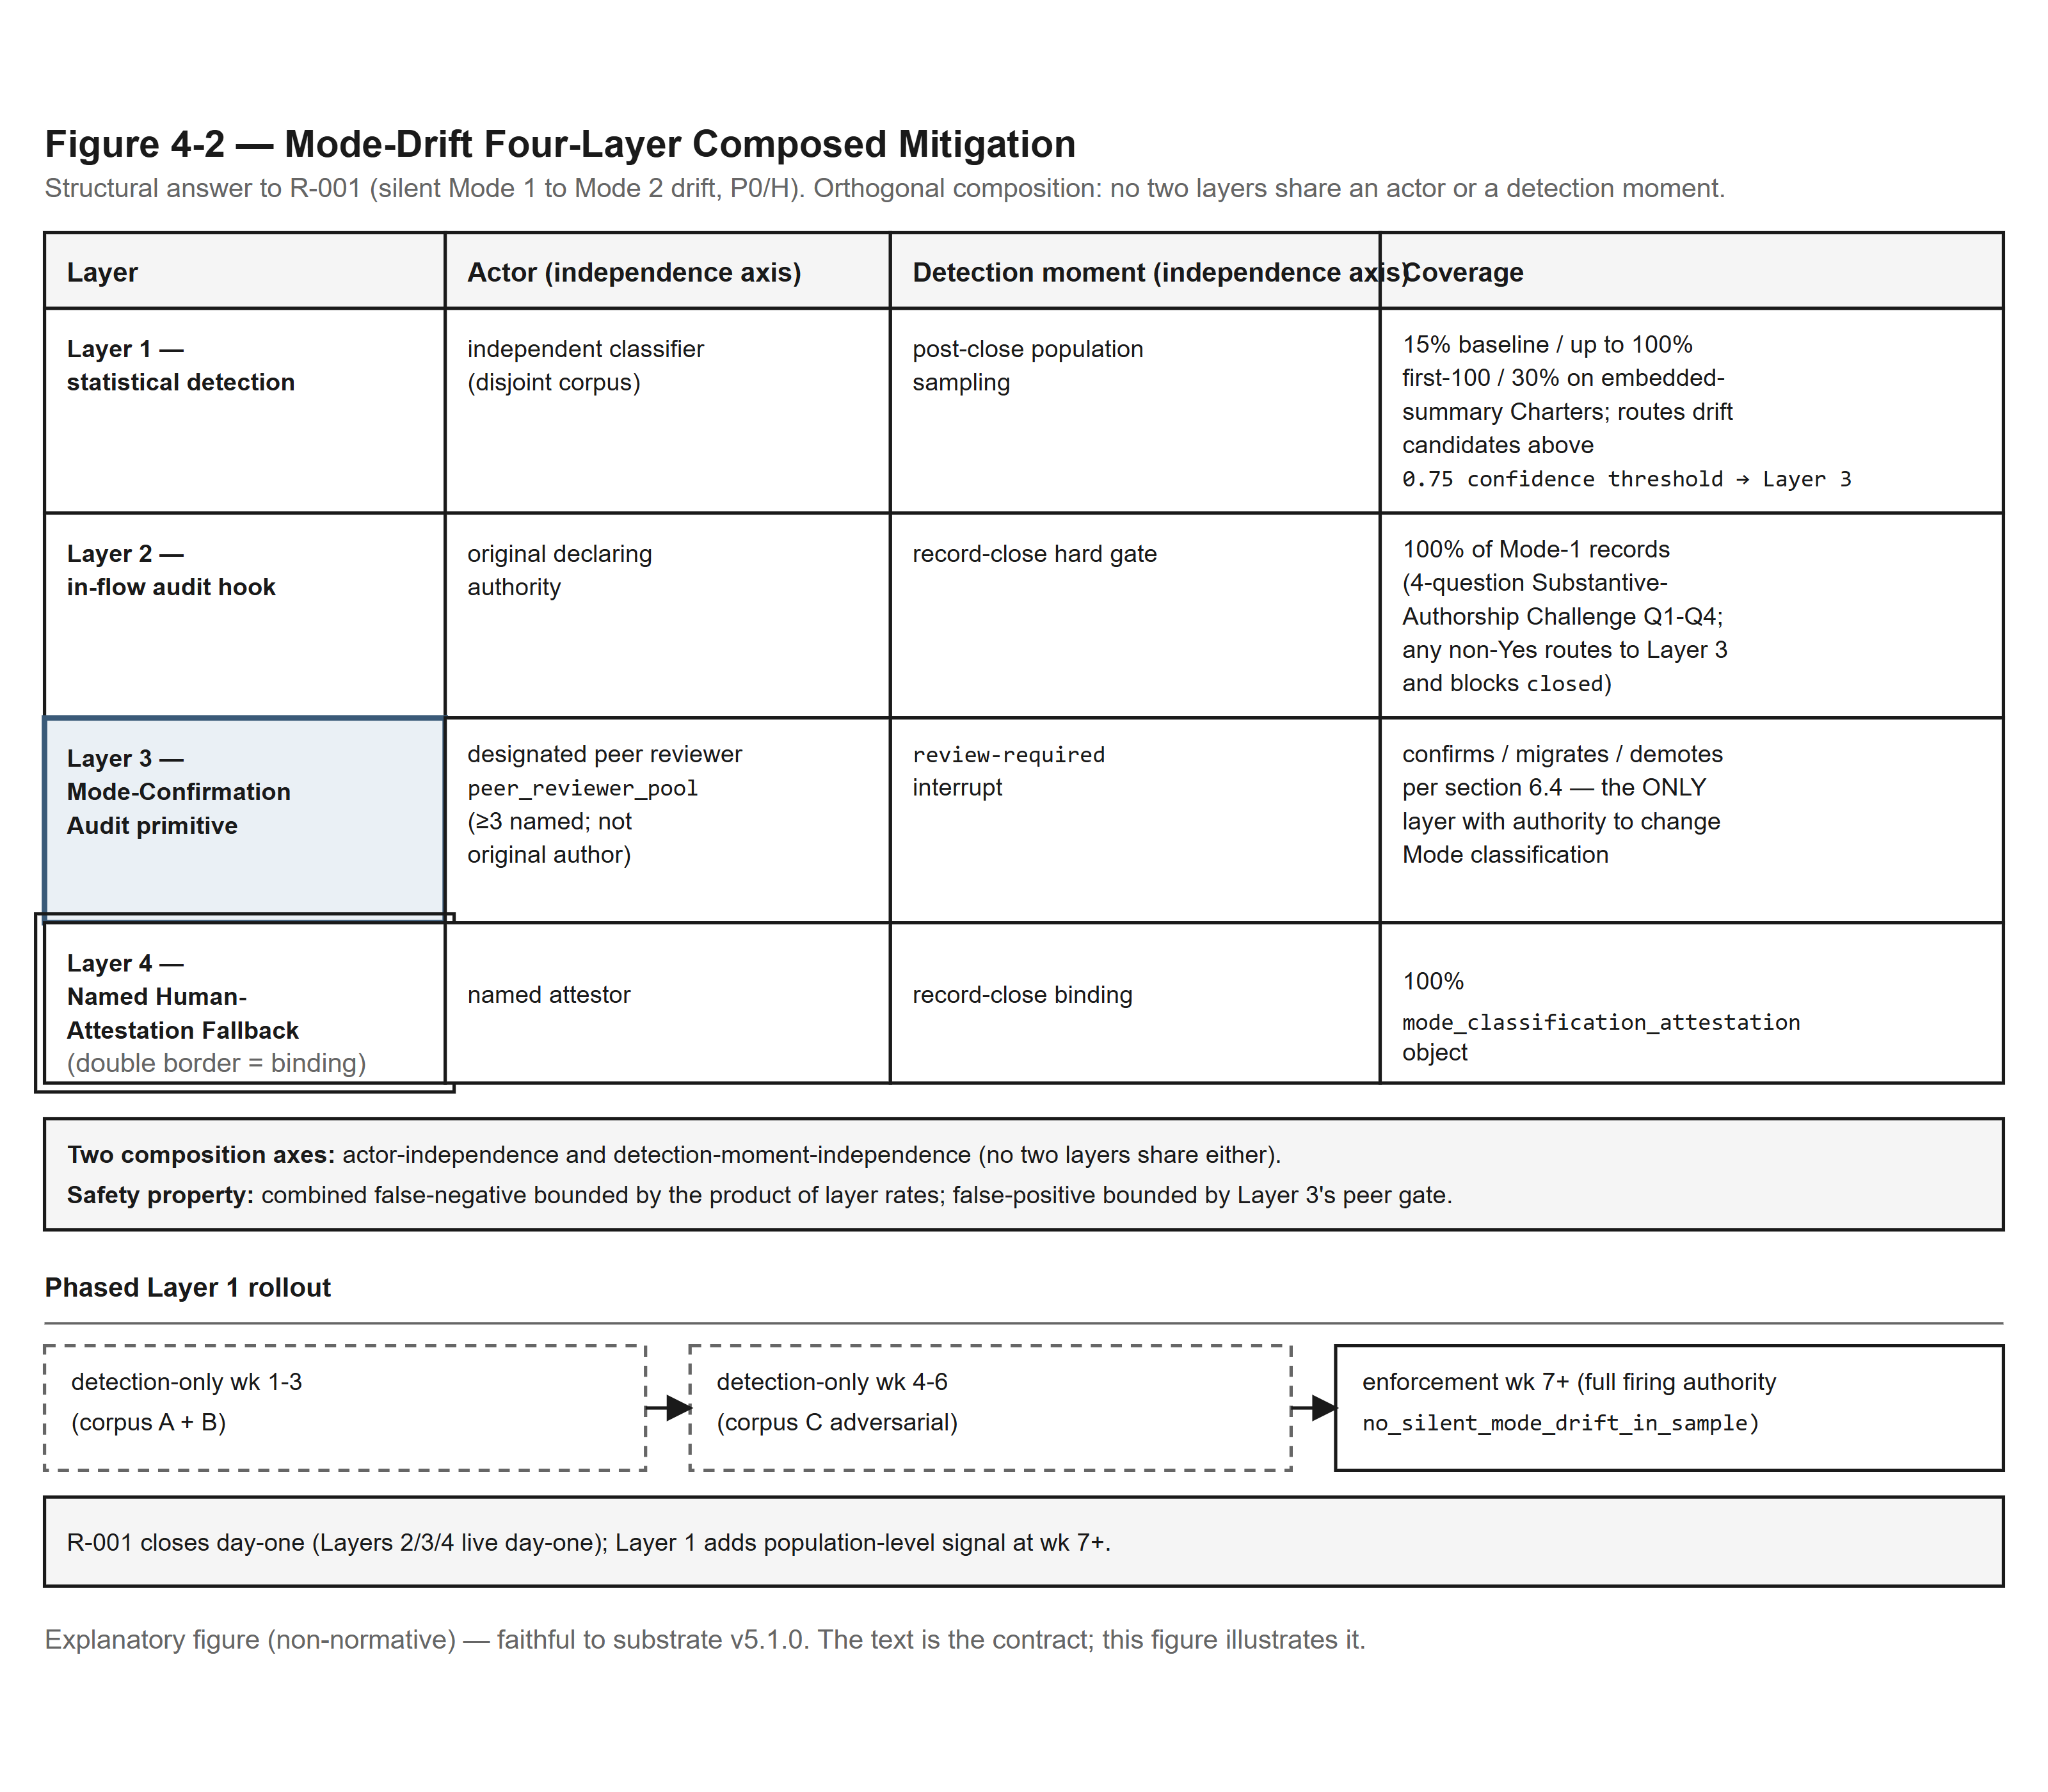
Figure 4-2 — Mode-Drift Four-Layer Composed Mitigation. Four orthogonal mitigation layers — no two sharing an actor or a detection moment — plus a phased Layer 1 rollout, structurally closing R-001.
Full description. The Mode-Drift mitigation composes four orthogonal layers, no two sharing an actor or a detection moment. Layer 1, statistical detection, is run by an independent classifier on a disjoint corpus at a post-close population-sampling moment; its coverage is a 15% baseline, up to 100% on the first hundred records, and 30% on embedded-summary Charters, and it routes drift candidates above the 0.75 confidence threshold to Layer 3. Layer 2, the in-flow audit hook, is run by the original declaring authority as a record-close hard gate, covering 100 percent of Mode-1 records through a four-question Substantive-Authorship Challenge (Q1–Q4); any non-Yes answer routes to Layer 3 and blocks closed. Layer 3, the Mode-Confirmation Audit primitive, is run by a designated peer reviewer drawn from the peer_reviewer_pool (at least three named, not the original author) at the review-required interrupt; it confirms, migrates, or demotes per §6.4 and is the only layer with authority to change Mode classification. Layer 4, the Named Human-Attestation Fallback, is bound at record close by a named attestor at 100 percent coverage through the mode_classification_attestation object. The two composition axes are actor-independence and detection-moment-independence; the combined false-negative is bounded by the product of layer rates and the false-positive is bounded by Layer 3's peer gate. Layer 1 rolls out in phases: detection-only in weeks 1–3 (corpus A + B), detection-only in weeks 4–6 (corpus C adversarial), and enforcement from week 7 onward with full firing authority for no_silent_mode_drift_in_sample. R-001 closes on day one because Layers 2, 3, and 4 are live on day one; Layer 1 adds population-level signal from week 7.
Illustrates §4.8.1.

Figure 4-3 — Emission-Cadence by Semantic Class
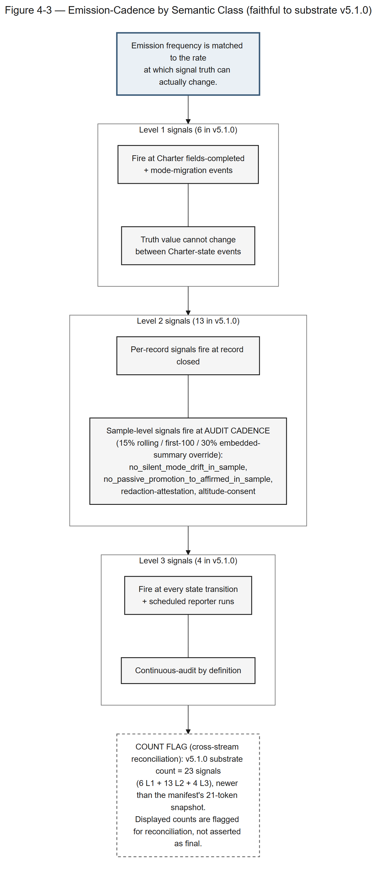
Figure 4-3 — Emission-Cadence by Semantic Class. Signal emission frequency is matched to the rate at which each signal's truth can actually change.
Full description. Conformance signals fire on a cadence matched to how fast their truth can change. The six Level 1 signals fire at Charter fields-completed and mode-migration events, because their truth value cannot change between Charter-state events. The thirteen Level 2 signals split into per-record signals that fire at record closed and sample-level signals — no_silent_mode_drift_in_sample, no_passive_promotion_to_affirmed_in_sample, redaction-attestation, and altitude-consent — that fire on an audit cadence of 15% rolling with first-100 and 30%-embedded-summary overrides. The four Level 3 signals fire at every state transition and on scheduled reporter runs, being continuously auditable by definition. The displayed v5.1.0 substrate count is 23 signals (6 Level 1 + 13 Level 2 + 4 Level 3); this count is newer than the manifest's 21-token snapshot and is flagged for cross-stream reconciliation rather than asserted as final.
Illustrates §4.8.2.

Figure 5-1 — Decision-Record State Machine: Two Distinct State Families
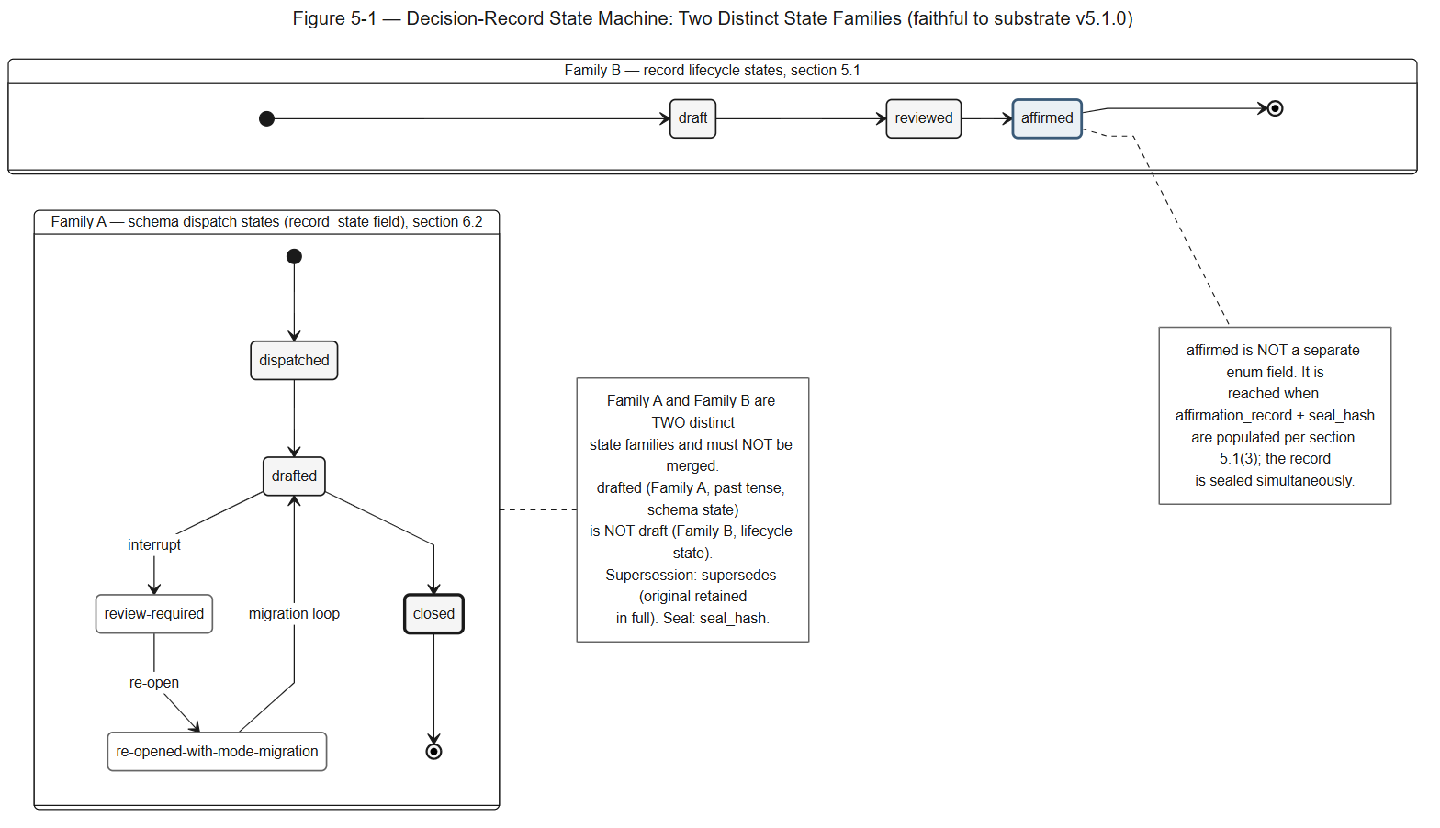
Figure 5-1 — Decision-Record State Machine: Two Distinct State Families. A decision record carries two deliberately distinct state families — schema dispatch and record lifecycle — that must not be conflated.
Full description. A decision record carries two deliberately distinct state families that must not be conflated, drawn as two separate lanes. Family A is the schema dispatch workflow carried on the record_state field: dispatched, then drafted, then closed, with a review-required interrupt branching off drafted and a re-opened-with-mode-migration path that loops from review-required back to drafted. This is the only place review-required legitimately appears; it is not a Charter state (contrast Figure 3-1). Family B is the record lifecycle, rendered as a separate track: draft, then reviewed, then affirmed. Family B is not a separate enum field — affirmed is reached when affirmation_record and seal_hash are populated per §5.1(3), and the record is sealed simultaneously. The past-tense schema state drafted (Family A) is distinct from the lifecycle state draft (Family B); conflating them is a conformance defect. Supersession is via supersedes, with the original retained in full; sealing is via seal_hash.
Illustrates §5.1, §6.2.

Figure 6-1 — Artifact-Set Relationship Map
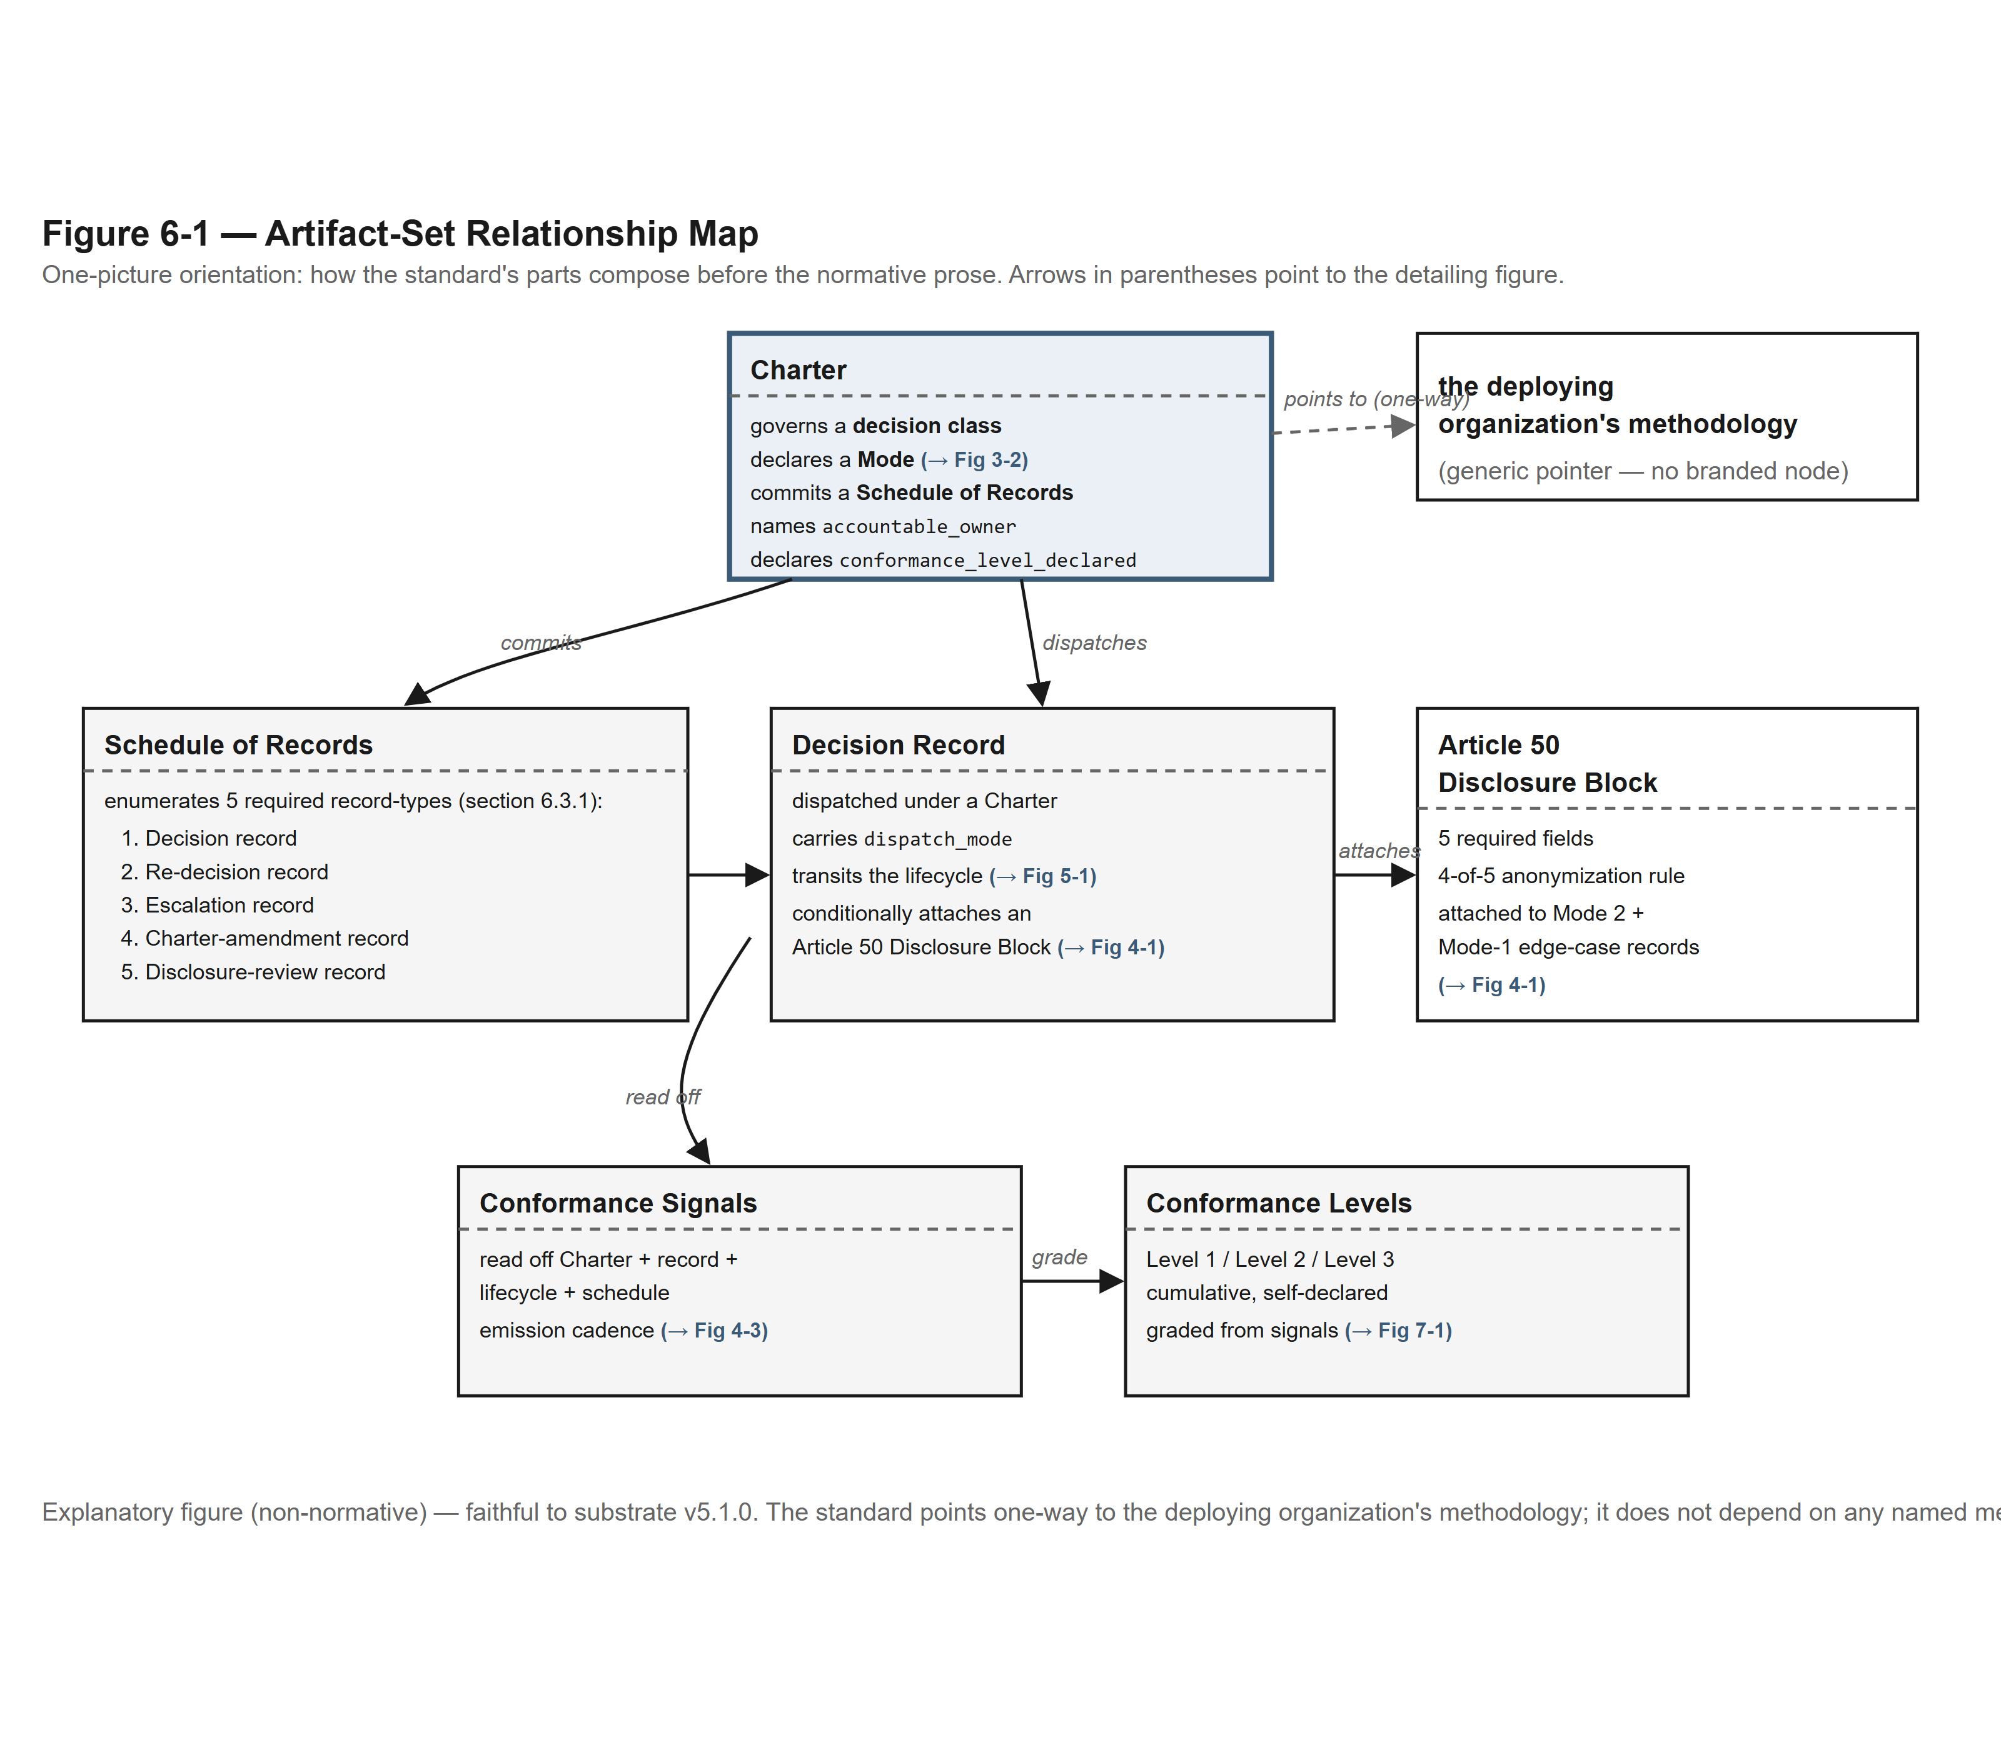
Figure 6-1 — Artifact-Set Relationship Map. A one-picture orientation showing how the standard's artifacts compose before the reader reaches the normative prose.
Full description. This orientation map shows how the standard's artifacts compose. A Charter governs a decision class, declares a Mode (Figure 3-2), commits a Schedule of Records, names an accountable_owner, and declares a conformance_level_declared. The Schedule of Records enumerates five required record types: Decision record, Re-decision record, Escalation record, Charter-amendment record, and Disclosure-review record (§6.3.1). A Decision Record is dispatched under a Charter, carries a dispatch_mode, transits the record lifecycle (Figure 5-1), and conditionally attaches an Article 50 Disclosure Block (Figure 4-1) on Mode 2 and Mode-1 edge-case records. Conformance Signals are read off the Charter, record, lifecycle, and schedule (Figure 4-3) and grade the Conformance Levels (Figure 7-1). The standard points one-way, via a dashed neutral pointer, to the deploying organization's methodology; it does not depend on any named methodology and carries no branded node.
Illustrates §3, §5, §6, §7 (orientation).

Figure 7-1 — The Three Conformance Levels: Cumulative Criteria
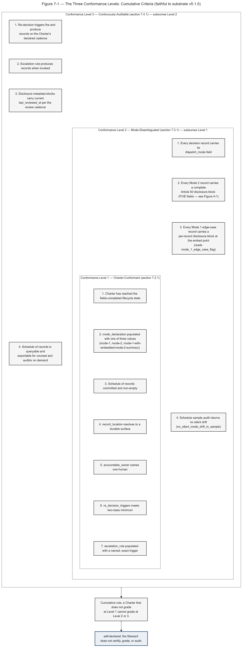
Figure 7-1 — The Three Conformance Levels: Cumulative Criteria. Three cumulative conformance levels drawn as nested bands; all are self-declared and the Steward does not certify, grade, or audit.
Full description. The three conformance levels are cumulative, drawn as nested bands with Level 1 innermost. Level 1, Charter-Conformant (§7.2.1), has seven structural criteria: the Charter has reached the fields-completed lifecycle state; mode_declaration is populated with one of the three enumerated values (mode-1, mode-2, mode-1-with-embedded-mode-2-summary); the schedule of records is committed and non-empty; record_location resolves to a durable surface; accountable_owner names one human; re_decision_triggers meets the two-class minimum; and escalation_rule is populated with a named, exact trigger. Level 2, Mode-Disambiguated (§7.3.1), subsumes Level 1 and adds four record-discipline criteria: every decision record carries its dispatch_mode field; every Mode 2 record carries a complete Article 50 disclosure block of five fields (Figure 4-1); every Mode 1 edge-case record carries a per-record disclosure block at the embed point reading mode_1_edge_case_flag; and the schedule-of-records sample audit returns no silent drift findings (no_silent_mode_drift_in_sample). Level 3, Continuously Auditable (§7.4.1), subsumes Level 2 and adds four criteria: re-decision triggers fire and produce records on the declared cadence; the escalation rule produces records when invoked; disclosure metadata blocks carry a current last_reviewed_at per the review cadence; and the schedule of records is queryable and exportable for counsel and auditor review on demand. A Charter that does not grade at Level 1 cannot grade at Level 2 or 3. All levels are self-declared; the Steward does not certify, grade, or audit.
Illustrates §7.2, §7.3, §7.4.

End of Companion D.

