Aerobatics Principles

Marco “Blackbird” Merli

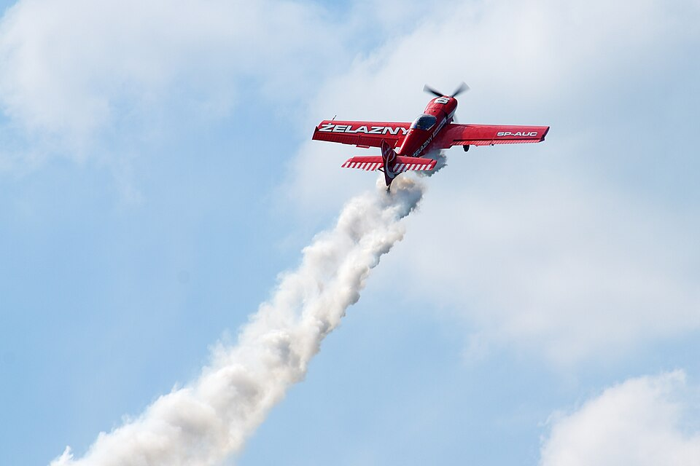

Table of Contents

Disclaimer 3
License 3
Change Log 4
Principles 5
Mindset 5
Energy Management 5
Instruments 6
Horizon 6
Angle of Attack 7
Load Factor 8
Controls 10
Pitch 10
Ailerons 10
Rudder 10
Parameters 11
The Box 12
Exercises 13
Lines 13
Rolls 13
Turns 14
Accelerated Stall Recovery 15
Stall 15
Spin Recovery 16
Freestyle 16
Figures 17
Ailerons-Roll 17
Slow-Roll 17
Barrel-Roll 18
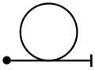 Inside-Loop 18
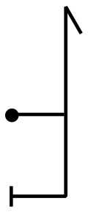Hammer-Head 19
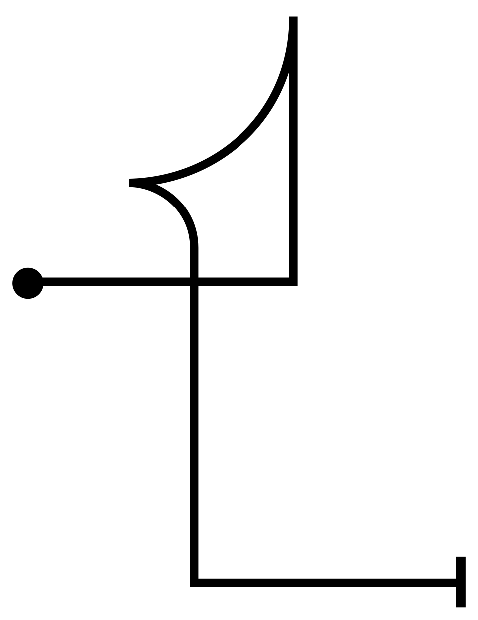 Tail-Slide 19
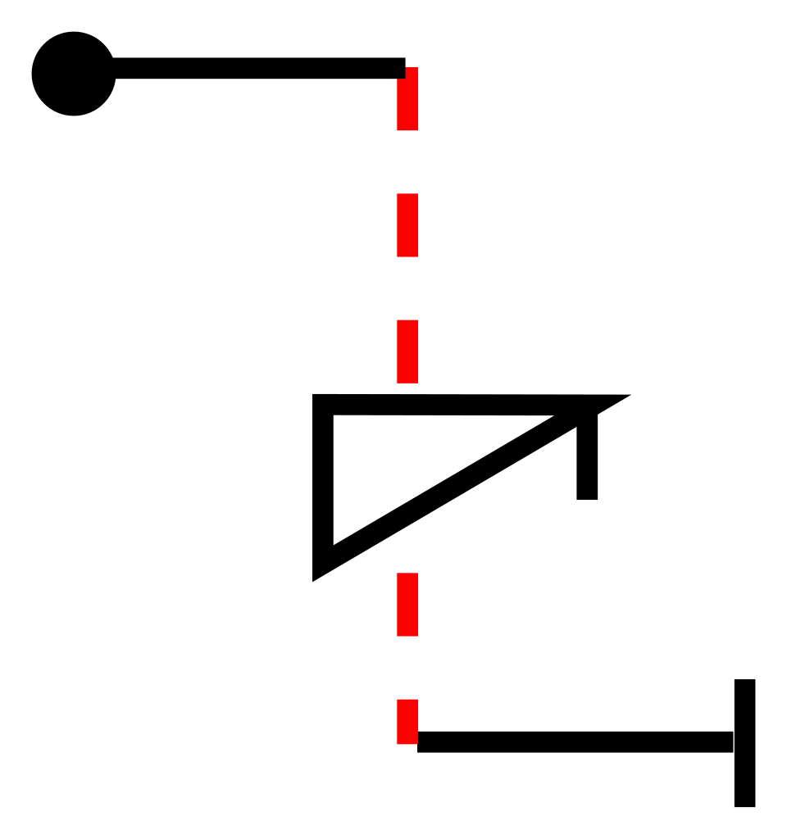 Spin 19
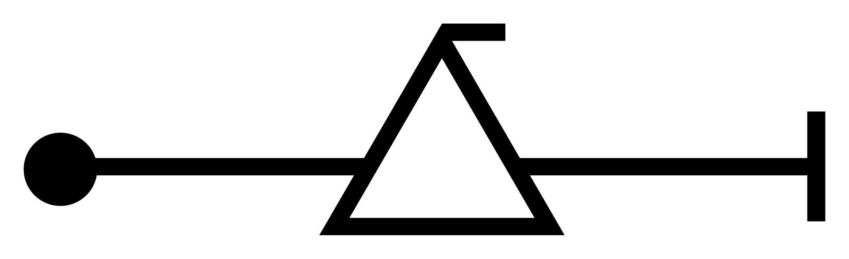 Snap-Roll 20
Glossary 21
External links 22
Bibliography 22
Simulator 22
Software 22
Credits 23

Disclaimer
This publication is intended exclusively for educational and entertainment purposes within the context of flight simulation. All techniques, manoeuvres, procedures, and recommendations described herein are designed for use in virtual environments only.

Under no circumstances should the content of this book be interpreted as instruction, guidance, or authorization for performing aerobatic manoeuvres in real-world aviation. Aerobatic flight in actual aircraft requires formal training, certification, adherence to aviation regulations, and strict safety procedures under the supervision of qualified instructors. Nothing in this book replaces that training, and nothing in it replaces the flight manual of any aircraft, real or simulated.

The author assumes no responsibility or liability for any injuries, damages, losses, or legal consequences, direct or indirect, that may arise from the use or the misuse of the information provided in this book, including but not limited to attempts to replicate described manoeuvres in real-world flight operations.

The content is provided “as is”, without warranty of any kind, either express or implied. Although it has been prepared with care, the author makes no representation as to its accuracy, completeness or fitness for any particular purpose, and accepts no obligation to keep it up to date. Where anything written here differs from the flight manual of the aircraft being flown, real or simulated, the flight manual always prevails.

This publication is independent. It is not affiliated with, endorsed by, or otherwise connected to any aircraft manufacturer, simulation software developer, aviation authority, or aerobatic federation, association or display team. Aircraft designations, product names and organisation names are used for identification and reference purposes only, and remain the property of their respective owners. This book is distributed free of charge. The terms under which it may be copied, translated and redistributed are set out in the License section that follows.

By using this material, the reader acknowledges and agrees to apply all the information solely within a flight simulation environment, and accepts full responsibility for any use outside this intended scope. Readers who do not accept these terms should not use this material.

License
© 2026 Marco “Blackbird” Merli.

This work is licensed under a Creative Commons Attribution-NonCommercial-ShareAlike 4.0 International License (CC BY-NC-SA 4.0). The full text of the licence is available at https://creativecommons.org/licenses/by-nc-sa/4.0/

You are free to share this work - to copy and redistribute it in any medium or format - and to adapt it - to remix, transform and build upon it, including translating it into other languages - under the following terms:

- Attribution: You must give appropriate credit to the author, provide a link to the licence, and indicate whether any changes were made. You may do so in any reasonable manner, but not in any way that suggests the author endorses you or your use;
- NonCommercial: You may not use this work for commercial purposes;
- ShareAlike: If you remix, transform or build upon this work, you must distribute your contribution under the same licence as the original.

Translations and adaptations are welcome under these terms. If you produce one, please make clear that it is a derived version and not the original edition, and please carry the Disclaimer and this License over into it unaltered. For any use falling outside this licence, including any commercial use, please contact the author.

Change Log

v1 | Marco Merli | First release

Principles
This book introduces the principles behind aerobatic flight, providing a framework for understanding how an aircraft moves through space, how energy is managed and transformed, and how a pilot maintains precise control well beyond the normal flight envelope.

The study and practice of aerobatics can be aimed at performing increasingly difficult aerobatic sequences, but they are equally valuable for any pilot who wants to develop better aircraft control in unusual attitudes. They also provide a solid foundation for military Air Combat Manoeuvres, such as those known collectively as the Dogfight. Peacetime aerobatics have drawn a lot of inspiration from the Basic Fighter Manoeuvres developed during wartime, with the difference that the “fight” is decided by competition scores rather than by bullets fired into the aircraft fuselage.

Aerobatics is a lot of fun and certainly rewarding, but also dangerous. Always remember to keep safety margins before beginning any manoeuvre, and carefully take into account the meteorological conditions, which shall be strictly within VMC - Visual Meteorological Conditions - as required for flight under VFR - Visual Flight Rules.

Mindset
From the outside, performing aerobatics may look like a rodeo, but, on the contrary, from the pilot's point of view it should feel like a dance: sometimes made of energetic figures (for example, the Snap-Roll), other times as delicate as a falling leaf (for example, the Tail-Slide).

The pilot's mindset combines precision, discipline, mental calmness, and continuous awareness of energy, limits and spatial orientation. Precision is about executing perfect geometries, with control accurate to the millimetre. Discipline is about respecting the parameters and the limits even when the aircraft would still allow more. Calmness is crucial to manage the high workload compressed into a short time during manoeuvres. Orientation is about constantly knowing where the ground is, which direction is up and which is down, and which phase of the manoeuvre you are in. Since each manoeuvre leads into the next, it is essential to maintain mental clarity, to think ahead and anticipate what will come next. For example, before entering a loop, you are already thinking about exit speed and alignment.

Finally, “Confidence without overConfidence” is the key. Confidence is what you need to perform each manoeuvre properly, while overconfidence is what instead puts you in danger.

Energy Management
The plane deals with three forms of energy:

- Kinetic Energy: due to motion - the speed;
- Potential Energy: due to height above the ground - the altitude;
- Chemical Energy: stored in the fuel tanks and converted into thrust by the engine.

The “sum” of these energies is the Total Energy of the plane at every moment of the flight. The Kinetic and Potential Energies can be directly converted into one another, by spending one to increase the other.

For example, climbing exchanges speed for altitude, while descending does the opposite. Thrust, produced from Chemical Energy, is used to increase the Total Energy, but the conversion cannot be reversed: kinetic energy cannot be turned back into fuel.

Drag bleeds energy away and shall always be considered together with the others. It comes in two forms. Induced drag is the price paid to produce lift: it therefore grows with the square of the Load Factor and falls as speed increases. Parasitic drag is generated by the shape of the airframe and grows with the square of the speed. The two work against each other, which is why total drag is at a minimum at one particular speed and rises on either side of it.

In short, the Throttle primarily governs the rate at which Total Energy is gained or lost, while the Elevator mainly redistributes kinetic and potential energy, with secondary effects on total energy through induced drag.
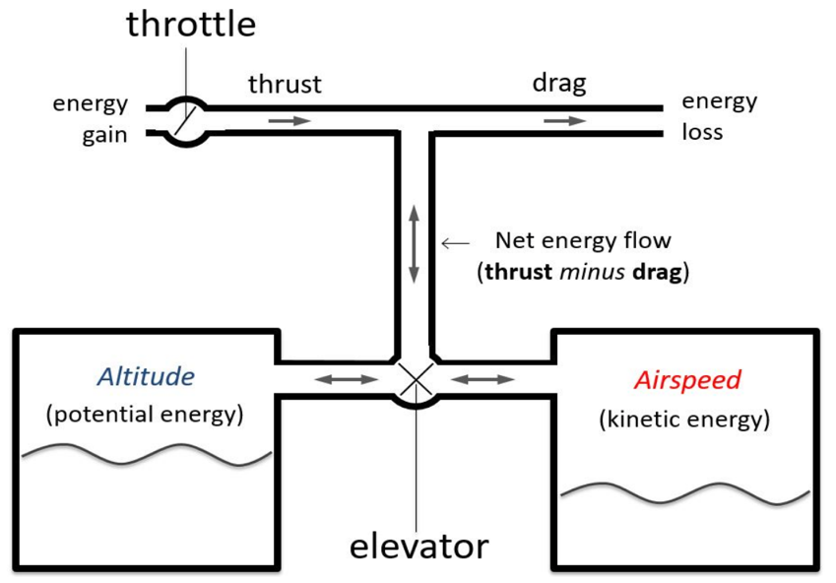

Instruments
As with every plane in the world, instruments are essential for flight, and aerobatics is no exception. However, some important instruments are not located in the cockpit, but around you. During aerobatic manoeuvres, things change quickly, very quickly! Fixating on the cockpit is not only a limitation in performance but can also become a safety hazard when performing complex manoeuvres at low altitude.

The airspeed and altitude can be roughly estimated by visual clues, by observing the ground: the speed by looking at how fast the ground moves beneath you, and the altitude by evaluating the distance to the ground. Heading, in turn, can be checked by aligning with lines on the ground, such as a runway, a road, a river and the like, taking into account the wind drift. The attitude of the plane can be evaluated using the true horizon.

But these visual clues never replace the instruments, which provide precise numbers instead of a rough estimate. You must cross-check with the instruments constantly, to confirm or correct the evaluation made visually. This becomes crucial when executing manoeuvres that demand solid and precise parameters, to avoid ground impact, stall or any other unsafe condition.

Horizon
While the Attitude Indicator accurately shows the pitch and roll of the aircraft, including the angle values, the true horizon is a much more prominent and visible “instrument”. The airframe, in relation to the true horizon, can be effectively used to evaluate pitch and roll.
Every plane, and aerobatic ones in particular, has well-known reference points on the airframe that, when aligned with the horizon, communicate specific attitude angles.

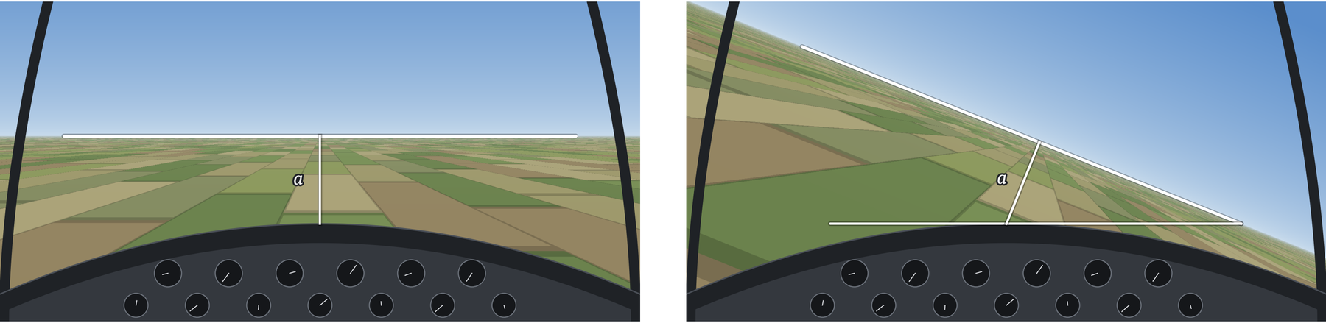

You can use the alignment of the nose with the horizon to evaluate pitch, especially to achieve levelled flight. But when the change in pitch is significant (≥45°), move your head sideways and use the alignment of the wing with the horizon to evaluate the angle. For more precise control, most aerobatic planes have references on the wing tips - aerobatic sights - to help in this assessment, usually including 45° and 90° reference marks.

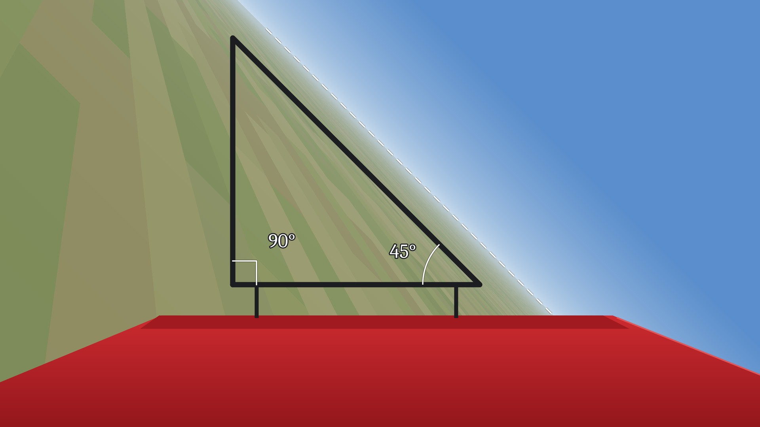

Angle of Attack
The Angle of Attack (AoA), the angle, measured in degrees, between the chord line of an aircraft's wing and the oncoming relative wind, is one of the most important concepts to always keep in mind. It determines whether the wing is still flying - the airflow is “attached” to the surface of the wing - or is in a stall condition - the flow is detached and turbulent. Note that the AoA is not the pitch attitude of the aircraft: a wing can stall at any attitude and at any airspeed.

The stall in aerobatics is not your enemy at all; some figures require you to induce a controlled stall (such as the Spin and the Snap-Roll). However, the stall becomes your number one enemy when it occurs in unwanted conditions.

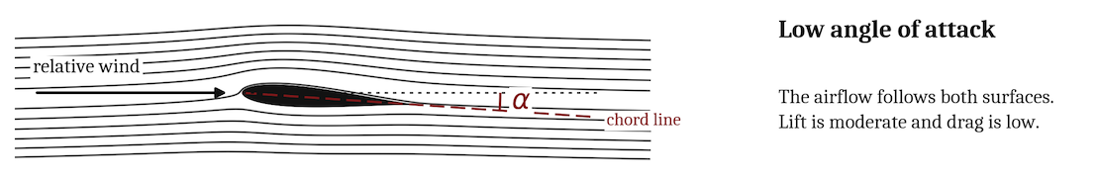
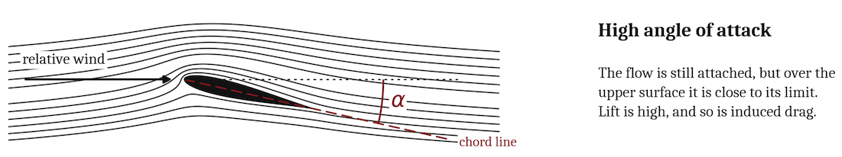

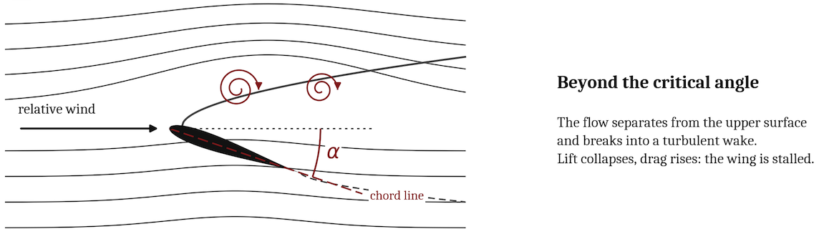

Unlike military and civil jets, an AoA indicator is usually not fitted to aerobatic planes, although modern extreme aerobatic types often have one. For every plane in the world, buffeting - the airframe shaking that occurs near or beyond the stall - is one of the most important “instruments” for aircraft control when reaching the limits. It announces the stall slightly in advance and can be used as an approximation of an AoA indicator.

Load Factor
The Load Factor, measured in G, is the ratio of the total aerodynamic force acting on an aircraft to its actual weight. Increasing the Load Factor raises the stall speed above its nominal 1 G value (Vs): the stall speed grows with the square root of the Load Factor, so at 4 G it is twice the 1 G figure. It also increases the induced drag, and it does so with the square of the Load Factor, which is why energy bleeds away so quickly in hard manoeuvring flight.

For this reason, a Load Factor around 0 G is usually the best condition to accelerate the plane as quickly as possible, since the induced drag falls to almost nothing - the parasitic drag does not. In any case, this is a huge simplification for the sake of clarity, because the actual behaviour depends largely on the shape of the airframe, the type and power of the engine, and many other factors.

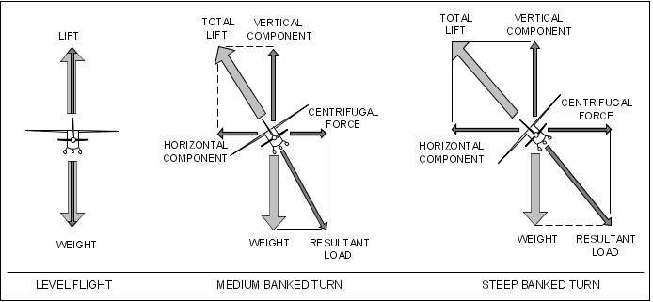

Now you meet a new kind of stall: the Accelerated Stall. This occurs when the plane exceeds its critical Angle of Attack (AoA) while operating under an increased Load Factor, when the wings are required to generate extra lift to manoeuvre. Because the wing is already operating at a higher AoA to sustain the Load Factor, any additional pull on the controls will rapidly push it past its critical angle.

Note that this can happen at any airspeed, including well above the nominal Vs. The Accelerated Stall must be carefully taken into account in aerobatics, since it is generally violent and can put the aircraft in a condition where it exceeds its own limits - some figures require manoeuvring under high Load Factor and high AoA, such as the Schneider.

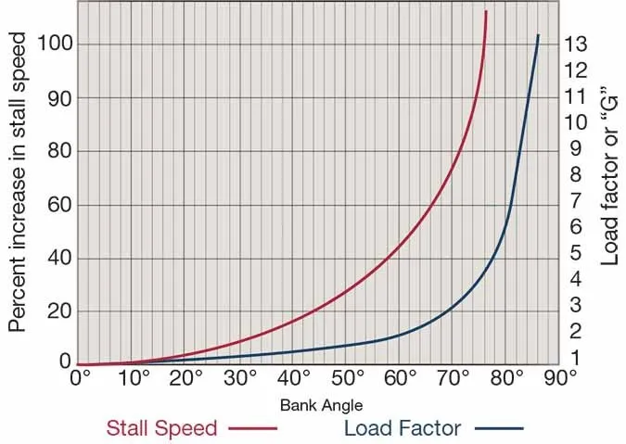

For both the pilot and the aircraft, positive accelerations are much more manageable than negative ones. Therefore, special care must be taken when performing manoeuvres involving negative G, and manoeuvring margins are typically more restrictive when pushing than when pulling.

The engine has a say in this too: under negative G a piston engine with a conventional fuel and oil system will starve and stop, and a jet with no inverted-flight provision will flame out for the same reason. A compressor stall is a different failure, driven by disturbed intake flow at high angle of attack or in heavy sideslip rather than by negative G itself. The airframe is not the only thing with a limit.

The limit is often the pilot rather than the airframe. Under sustained positive G the blood drains from the head, producing first a loss of peripheral vision (grey-out), then a complete loss of vision (black-out) and finally loss of consciousness (G-LOC). Under negative G the opposite happens and blood is forced towards the head, producing the red-out, which is far less tolerable and sets in at much lower values. A rapid transition from negative to positive G - the push-pull effect - lowers tolerance further still.

Structural and physiological limits differ enormously from one aircraft to another, and knowing the exact figures for the machine you are flying is not optional: it is part of knowing how to fly it, and the aircraft manual is the only authority on the subject.

Controls
Performing aerobatics does not necessarily involve using full control deflection, as one might think, even though the aircraft is usually capable of extreme manoeuvres. It is instead about using the appropriate inputs to perform a well-known manoeuvre.

Pitch
The pitch control does far more than just define whether the plane is climbing or descending: it governs the Load Factor, by changing the AoA and therefore the lift. The lower the airspeed, the more input is required, because control effectiveness and response are reduced; the higher the airspeed, the less input is required to obtain the same Load Factor.

For that reason, it is generally uncommon to use full Elevator in aerobatic figures. It must be modulated to set the desired, or the maximum sustainable, Load Factor. In Steep Turns, it also determines the Turn Rate and the Turn Radius.

This leads to one of the most useful concepts in the whole discipline: the corner speed, the speed at which the aircraft reaches its maximum lift and its structural limit at the same moment, and therefore delivers the highest instantaneous turn rate and the smallest instantaneous turn radius it is capable of. Below the corner speed you are limited by the wing, and pulling harder only stalls you; above it you are limited by the structure, and pulling harder only breaks something.

Ailerons
Ailerons are the primary roll control, while the Rudder assists through yaw-roll coupling and coordination. During aerobatic manoeuvres, the Ailerons are usually the only control to be applied fully, in order to maximize the roll rate.

However, this also depends on the plane: an Extra 330, for example, has an insane roll rate, so the pilot rarely uses full Aileron. Finally, some figures require slow roll rates, such as the Slow-Roll, as the name suggests.

When the roll has reached the desired bank angle, especially if it was flown with full deflection, it is common on old and slow planes to do a “check” when neutralizing the control. It consists of a very small and quick application of opposite Aileron, after the stick has come back to neutral, to stop the roll firmly. Modern and precise aerobatic planes, however, do not need the check, because it would cause the plane to start rolling in the opposite direction, even with a small application of the control.

Rudder
The Rudder is, in common parlance, the most underestimated control among novice pilots, used primarily for taxiing or for landing in a crosswind. On the contrary, it is an essential control, especially at low speed. In near-stall conditions, when a wing starts to drop, the first action is always to reduce the AoA; the Rudder is then the control that stops the yaw accompanying the drop, and it must be used to stop that yaw rather than to lever the wing back up. What must be avoided is the instinctive use of opposite aileron, which increases the AoA of the already stalling wing and aggravates the asymmetry.

In post-stall conditions, the Rudder often remains more effective than the ailerons, since it is not mounted on the stalled wings, and it is therefore crucial in stall recovery manoeuvres. This advantage is not unconditional, though: in a developed spin the Rudder can end up shielded by the wake of the stalled wing and by the horizontal tail, losing a good part of its authority. That is precisely why several aircraft have their own specific spin recovery procedure instead of the generic one.

Since it has considerable authority over the yaw of the plane, it shall be applied carefully, because it can lead to exceeding the structural limits of the airframe, causing, in the worst case, the separation of the Rudder itself. In addition, aerobatic planes have a very large Rudder surface, to make possible those figures that require a great deal of yaw. The application of the Rudder shall be, in most cases, progressive and never slammed. Only some figures allow rapid full Rudder - kicking the Rudder - because they are executed at very low speed, such as the Hammer-Head.

One caution deserves particular emphasis: the structural protection offered by the manoeuvring speed (Va) applies to a single full deflection, not to alternating ones. A rapid sequence of full right Rudder followed by full left Rudder can generate side loads well beyond the design values, even below Va, and has caused the loss of the vertical tail in real accidents. Kick the Rudder once, deliberately; never saw it from side to side.

Parameters
One keyword related to aerobatics is “parameters”, which refers to the set of flight values that must be satisfied before starting, and after completing, a manoeuvre. These are usually:

- The airspeed (IAS), measured in knots or metric units, to ensure the plane has sufficient energy to complete the manoeuvre, and enough not to stall on completion;
- The height above the ground (AGL), measured in feet or metric units, to ensure the plane has sufficient ground clearance to complete the manoeuvre without hitting the surface;
- Attitude angles (pitch, roll and yaw), measured in degrees, to place the aircraft in a specific plane of motion before starting the manoeuvre, or to achieve it on completion;
- Power setting, usually defined as MAP and/or RPM for propeller planes, or as % N1/N2 and/or Exhaust Gas Temperature (EGT) for jet planes, strictly correlated with energy management during the manoeuvre;
- The entry and exit headings, measured in degrees, because every figure hands over to the next one and an alignment error at the exit is inherited by the whole remainder of the sequence;
- Aircraft configuration, rarely relevant on pure aerobatic planes, which can include Flaps setting, Airbrake extension, and so on.

Parameters must be law for the pilot, as they represent the contract that ensures the safe completion of a manoeuvre. They are generally included in the aircraft manual, along with an explanation of the manoeuvre itself, and are carefully tested to guarantee a certain safety tolerance. Deliberately altering these parameters can place the pilot and/or the aircraft in a dangerous situation and, in extreme cases, cause structural damage to the airframe, detachment of control surfaces, exceeding of the pilot's physiological limits and, ultimately, death.

Parameters are not only about the entry. Every manoeuvre must be flown with its exit already in mind, because the exit of one figure is the entry of the next: the speed, the height and the heading you arrive with are the ones you will have to work with. Just as important is the minimum recovery altitude - the height at which, if the figure is not developing as planned, you stop trying to save it and simply recover. Deciding that number before the manoeuvre, rather than during it, is what turns a list of parameters into an actual safety net.

The Box
Competition aerobatics is flown inside a defined volume of airspace known as the box: conventionally a square of 1,000 by 1,000 metres in plan, with a lower and an upper limit, and with markers on the ground so that the pilot can see where its boundaries are. Leaving it costs points; in a display, it can cost a great deal more.

What matters here is not the competition rule but the habit it teaches. Before every session you should declare your own box, and above all its floor - the hard deck, the altitude below which you do not descend for any reason whatsoever. If a figure is not finished by the time you reach it, the figure is abandoned and the aircraft is recovered. The hard deck is not a target to be approached; it is a surface as solid as the ground itself. Of all the parameters in this chapter it is the one that will save you most often, precisely because it is the only one that does not depend on how well the manoeuvre is going.

Exercises

These exercises are designed to warm up before practising manoeuvres in sequences. The goal is to refresh your feel for the flight envelope and to reactivate muscle memory for the controls. Repeat each step until you feel confident and completely relaxed during the execution, and can execute it in exactly the same way every time.

These exercises can also be useful to explore a new plane, to let her tell you who she is, by discovering her flight envelope. They can also be an entry point for novices to familiarize themselves with aerobatics, before starting to learn and perform well-known figures.

Regarding rolls, in aerobatic sequences the direction of roll is usually at the pilot's discretion. However, don't limit yourself to a single direction just because it is more comfortable to manage. Especially during training, practise the same manoeuvre in both roll directions.

Lines
The lines come first. Handling the pitch properly is crucial before adding roll into the mix. The goal of this exercise is to manage progressively higher pitch angles while keeping speed and acceleration under control.

Maintain an altitude of at least 4,000 feet (~1,200 m) above the ground: the vertical down line consumes height very quickly, and this is the exercise where you are most likely to find out just how quickly. Keep the airspeed within the green arc of the ASI wherever possible, and treat Vne as an absolute limit that is never to be approached, by using an appropriate amount of pitch input and by managing the throttle, especially on the 90° down line. Keep the Load Factor well inside the positive and negative limits of the aircraft. Use Ailerons and Rudder only to restore levelled wings before moving to the next set of manoeuvres, or for safety reasons.

- AFT (~+1,000 ft/min) | LVL | FWD (~-1,000 ft/min) | LVL
- 45° AFT | LVL | 45° FWD | LVL
- 90° AFT | LVL | 90° FWD | LVL
- 45° AFT | 135° AFT | 225° AFT | LVL

Note that the last line is, in effect, a loop flown as a diamond: straight segments joined by corners, instead of one continuous circle. It is an excellent way to verify that your pitch control is precise before attempting a proper Inside-Loop, where the same rotation has to be flown as a perfect curve.

Rolls
Keep the nose well above the horizon before starting each sequence, and set an appropriate amount of throttle to support the climbing attitude. This exercise deliberately uses the Ailerons alone: Elevator and Rudder are not to be used, unless for safety reasons. That is exactly why you begin with a pronounced nose-up attitude - with no Rudder to hold the nose up at high bank angles and no Elevator to raise it, the pitch you set before starting is the only thing that pays for the drop that follows.

When you reach the desired bank angle, always stop firmly and hold it for a moment, to show that the bank achieved is intentional, before moving on to the next angle.

- LEFT (<30° bank) | LVL | RIGHT (<30° bank) | LVL
- LEFT FULL 45° | LVL | RIGHT FULL 45° | LVL
- LEFT FULL 90° | LVL | RIGHT FULL 90° | LVL
- LEFT FULL 45° | LEFT FULL 90° | RIGHT FULL 45° | LVL
- LEFT FULL 180° | LVL | RIGHT FULL 180° | LVL
- FULL 45° | FULL 90° | FULL 135° | FULL 180° | FULL 225° | FULL 270° | FULL 315° | LVL

Turns
Making steep turns at high Load Factor and bank angle requires putting all the controls together in a coordinated manner. The goal of this exercise is to be comfortable with prolonged sustained turns while keeping the turn level.

Start at a safe altitude and at a speed close to the manoeuvring speed (Va), which is the highest speed at which a single full deflection of one control can be applied without overstressing the airframe, and in any case below Vne.

To roll, use full Aileron both to start and to stop the roll; the bank angle is usually somewhere between 60° and 80° - this is aircraft dependent. Keep in mind what those degrees cost: in a level turn the Load Factor is the inverse of the cosine of the bank angle, so 60° of bank already means 2 G, and beyond 70° the curve rises very steeply - the last few degrees are by far the most expensive.

Accordingly, and immediately, pitch aft to set the Turn Rate/Radius by imposing a constant Load Factor. Use the Ailerons to keep flight levelled: if plane is diving reduce slightly the bank, if climbing increment a bit the bank. Use the horizon to evaluate the pitch attitude, and a reference line on the ground (a runway, a road, a river, etc.) to maintain awareness of the degrees of turn completed.

Do not intentionally cause an accelerated stall. Evaluate the right parameters to keep speed and Load Factor constant during the turn, without exceeding the limits. Use small Aileron corrections to maintain a level plane of motion. In case an accelerated stall occurs, immediately interrupt the exercise, unload the pitch (push) to reduce the Load Factor, and execute the recovery described below.

- FULL LEFT | 180° turn | LVL
- FULL LEFT | 360° turn | LVL
- FULL LEFT | 90° turn | LVL
- FULL LEFT | 270° turn | LVL

Accelerated Stall Recovery
The accelerated stall is the failure mode of this exercise, so it is worth knowing the recovery before you need it. Here the order of the actions matters even more than their individual content.

First, unload: relax the back pressure until the wing is flying again. This is the only action that actually ends the stall, and nothing else works until it has been done. Second, reduce power if the nose has fallen well below the horizon, so that the recovery does not turn into an overspeed. Third, roll the wings level: pulling while still banked tightens the turn instead of raising the nose, and buys you a second stall rather than a recovery. Only then, fourth, recover the pitch progressively, respecting the buffet - a hurried pull at this point will stall the wing again, this time with less height available.

Stall
Managing the stall is vital for aerobatics, since some figures require you to induce it and to recover from it. The goal of this exercise is to become familiar with the stall, and to learn the clues that announce it. It also lets you practise at very low speed, where the plane becomes sluggish and requires fine control inputs. In this condition, the Rudder is your best ally.

Bring the airspeed close to, but above, the stall speed in level flight (Vs), where light buffeting starts to occur. Adjust the trim to keep the flight level and set the throttle accordingly. Maintain an altitude of at least 4,000 feet (~1,200 m) above the ground: this is the most delicate exercise of the set, precisely because its purpose is to live on the edge of the stall without ever crossing it. An aerobatic aircraft will usually recover from the first turn of a spin very quickly, but the height needed to notice, decide and act is not negligible. Use the AoA indicator, if you have one, or the buffeting clues, to anticipate and avoid the stall.

It is worth practising the stall both with power applied and with the engine at idle, because the two behave differently. At idle the stall is gentler, the nose tends to drop more or less straight ahead, and the recovery is largely a matter of reducing the AoA. With power applied the wing stalls at a lower indicated speed and more abruptly, and on a single-engine propeller aircraft torque, slipstream and P-factor tend to drop one wing, turning a symmetric stall into an incipient spin. Which wing drops depends on the direction of propeller rotation, so check it for the type you are flying rather than assuming it: the two aerobatic types most used in simulation turn in opposite directions. Since this exercise asks you to hold level flight close to the stall with the throttle set accordingly, the power-on case is the one you will meet first.

Do not intentionally stall or spin the plane. In the circle and racetrack patterns, keep the turn coordinated and never use the Rudder to tighten it: at this speed that is the classic way to drop the inner wing and enter a spin. If a stall is about to occur, pitch down to reduce the AoA and use opposite Rudder promptly to stop the wing drop; add throttle to gain some extra speed. If a spin develops, immediately interrupt the exercise and execute the spin recovery manoeuvre described below.

- LVL
- CIRCLE RIGHT/LEFT LVL
- RACETRACK RIGHT/LEFT LVL

Spin Recovery
A spin is an autorotation: one wing is stalled more deeply than the other, and the aircraft will keep rotating until that condition is broken. The generic recovery manoeuvre is short enough to be remembered under stress, and the order of the actions is not negotiable.

Power to idle, because thrust and slipstream feed the rotation. Ailerons neutral - this is the one most often got wrong, since the instinctive attempt to lift the dropping wing with Aileron only deepens its stall and accelerates the rotation. Full Rudder against the direction of rotation, and held there. Stick progressively forward, to unstall the wing: the rotation will stop, often abruptly. As soon as it stops, Rudder back to neutral, otherwise you will simply enter a spin the other way. Then recover from the resulting dive progressively, watching the airspeed and the Load Factor, and avoiding a secondary accelerated stall.

One thing has to happen before any of this: you must know which way the aircraft is actually yawing, and in an inverted spin that is easier to get wrong than it sounds. Looking up through the canopy for a ground reference puts the terrain behind the axis of rotation, and its apparent motion then suggests a rotation opposite to the real one. A pilot who trusts that impression applies the rudder on the wrong side, which does not merely fail to stop the spin - it sustains it. Take the yaw reference ahead of the axis of rotation, looking out past the nose rather than over your head, and confirm the direction before touching the pedals. Diagnosing the rotation wrongly makes a perfectly correct procedure useless.

This is the generic procedure. Every aircraft has its own, and where the two differ, the aircraft manual always wins - some types require the controls in a specific sequence, or have inverted and flat spin modes that behave differently.

Freestyle
You can combine parts of the previous exercises to practise everything in one go. Be aware that Freestyle does not mean putting random moves together and seeing what happens. That is the recipe for crashing the plane.

You can, for example, pitch 45° UP, then roll FULL LEFT 90°, and then pull a 270° sustained turn: you have just created a figure - the Cloverleaf, in this case, a manoeuvre of military origin. Similarly, you can pitch 90° UP, then roll FULL LEFT 180°, then fly half a loop over the top while inverted, which brings you onto a vertical down line, then roll FULL LEFT 180° again, and finally level off - this is a variant of the Humpty Bump. Both are given here purely as examples of how the building blocks combine.

Before starting the manoeuvre, you must have a clear picture in mind of all the steps you want to perform, so as to evaluate in advance the minimum safe parameters - such as, but not limited to, the initial speed and the ground clearance - and to ensure you can complete that manoeuvre as planned, in a safe manner.

Figures
This section is not intended to explain every manoeuvre in detail; for that, the reference must always be the aircraft manual, which, along with the explanation, reports all the parameters for that plane. Rather, the objective here is to share some considerations and hints.

To be able to learn and execute all the manoeuvres in the Aerobatic Catalogue, you should be familiar with the Aresti notation, a universal set of graphic elements that describes a manoeuvre with all its details. References are given in the External Links section.

During an aerobatic sequence, it is essential to take the wind into account, as it causes the aircraft to drift downwind. It is therefore necessary to adjust the manoeuvre slightly to compensate for the drift, in proportion to the strength of the wind.

Ailerons-Roll
This is one of the basic aerobatic manoeuvres, and it can be flown as a complete roll (360°) or as a partial and/or stepped one. To execute it at its best, it is important to stop firmly and hold for a moment when you reach the desired bank angle, to highlight that it is intentional. It is also crucial to avoid any input of Elevator and/or Rudder, so that it does not degenerate into a kind of Barrel-Roll.

Since the Elevator stays neutral, the nose will drop through the roll: start with the nose slightly above the horizon, so that you finish close to level flight. Flown this way it is properly an Ailerons-Roll, and it is not a figure of the Aerobatic Catalogue: the catalogue figure that looks similar from the ground is the Slow-Roll, described next.

Slow-Roll
The Slow-Roll is the roll of the Aerobatic Catalogue, and it is a considerably more demanding figure than the Ailerons-Roll, despite looking almost the same from the ground. The difference is the flight path: the aircraft must roll about its longitudinal axis while the nose stays on a perfectly straight line, and the roll rate must remain constant throughout.

Holding that line requires continuous work on all three controls, which is precisely the opposite of the Ailerons-Roll. Approaching 90° of bank, the wing produces almost no vertical lift, so the nose has to be held up with top Rudder, the amount peaking exactly at knife-edge. Through the inverted portion the Rudder is released and the stick is progressively pushed forward, since an inverted wing needs forward Elevator to sustain level flight. Coming through 270° the Rudder is applied on the other side, and the aircraft is rolled out level with the nose exactly where it started.

This is why the Slow-Roll deserves practice of its own: the coordination it teaches - top rudder at knife-edge, forward stick when inverted - is the same coordination required by every figure containing a rolling element along a line, and it does not come from simply rolling faster.

Barrel-Roll
Although this is not a standard figure in the Aerobatic Catalogue, the Barrel-Roll - in which the plane follows a helical path around a reference point - is a manoeuvre you should certainly master. In Italian it is known as the Tonneau a Botte, from the French tonneau, meaning barrel.

To achieve the perfect geometry, you have to find the right blend of pitch and roll. You can start blending the stick when the roll reaches 135° of bank (or 225°, depending on the direction), but keep in mind that the two axes may not have the same control authority, so you must adapt the input on the stick to balance pitch against roll. You can use a cloud in the sky as the reference point, to check that you really are flying a helical path around it.

As already mentioned, this figure is not standard in the Aerobatic Catalogue for solo flight, but it is very common in military formation aerobatics, flown at close range between the aircraft.

Inside-Loop
The loop is one of the main figures associated with aerobatics. While it is quite easy to achieve if you follow the parameters, the goal is to draw a perfect geometric circle. To do so, it is important to manage the yaw induced by torque, slipstream and gyroscopic effects during all the phases, and, when you reach the top, to unload the pitch accordingly. Over the top, look out to the wing tip to keep the wings level: up there the nose is of little use as a reference.

The name Inside-Loop distinguishes it from the Outside-Loop, which describes the same circle in the opposite sense: the pilot sits on the outside of the curve, the figure is flown under negative G with forward stick, and it is considerably more demanding for both aircraft and pilot. Everything that follows refers to the inside version.

Two errors are common enough to deserve a name. The first is pulling too hard on the entry: the bottom of the figure becomes tight while the top stays wide, and the loop comes out shaped like an egg rather than a circle. The second is failing to unload over the top, where the airspeed is at its lowest and the wing has the least to give: holding the same back pressure there squeezes the upper part of the circle and, in the worst case, produces a stall or an unwanted snap exactly where you have the least control authority.

There is a simple way to grade your own loop, and it needs no judge: a correct loop ends at the altitude and on the heading at which it began. Both halves are informative. Coming out low means the circle was not closed - usually because the entry was too tight or the top was flown too wide - and coming out off heading means the yaw was never fully controlled through the vertical. Note that full throttle throughout tends to leave you below the entry altitude, so the exit check is also a check on how you managed the power.

The loop must be mastered at least in its simple form, because, when performing intermediate and especially advanced sequences, additional manoeuvres are inserted in between, generally the Snap-Roll. In addition, it is also the basis for the half loops, such as the Split-S and the Immelmann.

Hammer-Head
When performing the 90° upward rotation, unwanted yaw and roll may develop. The gyroscopic effect acts while the nose is being pitched up, since precession only appears when there is an angular rate; once the vertical line is established, what remains is engine torque and propeller slipstream, no longer masked by the aerodynamic loads present at higher Load Factor. You have to correct them with Rudder and Ailerons, checking the slip-skid indicator - the ball.

Finding the right airspeed to initiate the yaw turn is crucial. If you are still too fast, the plane will not turn; if too slow, it will fall away in a stall. This is why the figure is also known as the Stall-Turn, although the name is a misnomer: in a correctly flown Hammer-Head the wing never stalls, and the rotation is produced by the Rudder while there is still enough airflow over it. By the way, this manoeuvre is also known as the Fieseler.

When executing the yaw turn, you may use full Rudder - kicking the Rudder - while adding opposite Ailerons to compensate for the roll induced by the Rudder, and a little forward or aft stick to counter the gyroscopic pitching moment generated by the yaw.

Tail-Slide
The Tail-Slide is known in Italian as the Scampanata. Unlike the Hammer-Head, the aim here is to let the airspeed decay all the way to zero on the vertical up-line, so that the aircraft slides backwards along its own path before pivoting nose-down. The tricky part is to hold the controls firmly during the slide, because the reversed airflow will try to slam them, and to apply the right amount of forward or aft stick only once the aircraft has actually stopped, in order to command the direction of the pivot.

Aerobatic catalogues distinguish two variants, judged as different figures: the canopy-up slide, in which the aircraft pivots with the cockpit on the outside of the movement, and the wheels-up slide, in which it pivots the other way. Which of the two you obtain is decided precisely by that stick input - which is why it has to be deliberate, and not a reaction.

Spin
The Spin is one of the fundamentals of aerobatics, and you will find it in practically every sequence. The tricky part is to determine the right moment to enter it, by kicking the Rudder while bringing the stick fully aft. As with most aerobatic figures, this depends on the type of plane; in any case, a good starting point is when the airframe begins to shake with light buffeting.

The figure described in Aresti notation always indicates the number of rotations to be performed. Note that the rotation can be 360° or less, so you can exit on a different heading, usually linked to the next figure in the sequence. It is essential to limit the number of rotations to what the notation indicates (usually a maximum of two complete turns). While the spin is developing, each revolution tends to increase the rate of rotation, until it settles into a steady autorotation; by then the attitude is flatter, the recovery takes longer, and the height it costs has grown accordingly.

The recovery has already been described among the exercises, but it is worth repeating here, because this is the part that has to be automatic: power to idle, Ailerons neutral, full Rudder against the direction of rotation, stick progressively forward until the rotation stops, then Rudder back to neutral and a progressive pull out of the dive, avoiding a secondary accelerated stall. Ailerons neutral is the item most often forgotten, and the one that most reliably makes matters worse. And, as always, the aircraft manual takes precedence over any generic procedure.

Snap-Roll
When you are able to perform a decent Snap-Roll (also known as the Flick-Roll, or Frullino in Italian), you have reached the intermediate level. In aerobatic sequences, the Snap-Roll is usually performed inside another figure, which makes it even more challenging - for example, on the top of a Loop.

A Snap-Roll is, in essence, a spin flown along a horizontal flight path. To induce it, the wings must be taken past the critical AoA so quickly that a sudden stall occurs, with the Rudder applied almost at the same instant to produce the yaw that makes the two wings stall by different amounts; the resulting autorotation rolls the aircraft about its longitudinal axis while it continues along its line. For these reasons, only the Elevator and the Rudder are necessary to perform a pure Snap-Roll. However, it is very common to add some amount of Aileron to help the execution, especially when exiting. Using the Ailerons will alter the geometry of the Snap-Roll, producing a slightly different figure.

One warning about limits. The Snap-Roll is among the most severe figures for the airframe, because it combines a high Load Factor with a sudden asymmetric stall. Almost every aerobatic aircraft has a maximum snap entry speed published in its manual, typically well below the manoeuvring speed, and exceeding it is an efficient way to overload the wing. This is also why the Snap-Roll sits comfortably on top of a Loop, where the speed is at its lowest, and why the same figure flown on a fast horizontal line is an entirely different proposition.

Glossary
The following abbreviations and terms are used throughout this book. Where a value or a limit is mentioned, the aircraft manual always takes precedence.

Term | Meaning
AGL | Above Ground Level. Height measured from the terrain directly below the aircraft, as opposed to altitude measured from sea level.
AoA | Angle of Attack. The angle between the chord line of the wing and the oncoming relative wind; it determines whether the wing is flying or stalled.
Aresti | The standard graphic notation used to describe aerobatic figures, and the catalogue of figures built on it.
ASI | Airspeed Indicator. The instrument showing the indicated airspeed, with its coloured arcs marking the operating ranges.
BFM | Basic Fighter Manoeuvres. The set of military manoeuvres from which a large part of modern aerobatics derives.
EGT | Exhaust Gas Temperature. Engine parameter used to set and monitor power on jet aircraft.
G | Unit of Load Factor, expressing the ratio between the total aerodynamic force acting on the aircraft and its weight.
G-LOC | G-induced Loss Of Consciousness. Loss of consciousness caused by sustained positive acceleration.
Hard deck | The minimum altitude declared before the flight, below which no manoeuvre is continued for any reason.
IAS | Indicated Airspeed. The speed read on the instrument; it is the reference for both stall and structural limits.
MAP | Manifold Absolute Pressure. Engine parameter used to set power on piston aircraft.
N1 / N2 | Rotational speeds of the low-pressure and high-pressure spools of a jet engine, expressed as a percentage.
RPM | Revolutions Per Minute. Rotational speed of the engine or of the propeller.
Va | Manoeuvring Speed. The highest speed at which a single full control deflection can be applied without exceeding the structural limits.
VFR | Visual Flight Rules. The set of rules under which flight is conducted by outside visual reference.
VMC | Visual Meteorological Conditions. The meteorological conditions that allow flight under VFR.
Vne | Never Exceed Speed. The absolute speed limit of the airframe.
Vs | Stall Speed. The speed at which the wing stalls in level flight at 1 G.

External links

Bibliography
- Airplane Flying Handbook
- IAC - Aerobatic Figures - Brian Howard
- Aresti Made Simple - Barry Wegman
- Aresti Catalogue - FAI
- Competition Aerobatics - Wikipedia

Simulator
- DCS World (Freeware)
- DCS: Christen Eagle II (Payware)
- DCS: MB-339 (Payware)
- DCS: Yak-52 (Payware)

Software
- OpenAero - Aresti Designer (Freeware)

Credits
Every image in this book is either original work prepared for it, or material in the public domain or released under a free licence. Nothing is used without a licence that permits it.

- Cover photograph. “Zlin 50LS SP-AUC (Żelazny 6)”, Kuba Bożanowski from Warsaw, Poland, via Wikimedia Commons, licensed under Creative Commons Attribution 2.0 Generic (CC BY 2.0, https://creativecommons.org/licenses/by/2.0/), available at https://en.wikipedia.org/wiki/File:Zlin_50LS_SP-AUC_(%C5%BBelazny_6)_(3603508043).jpg
- Energy reservoir diagram, in Energy Management. Figure 4-3 of the FAA Airplane Flying Handbook, FAA-H-8083-3C, published by the Federal Aviation Administration. As a work of the United States federal government, it is in the public domain.
- Cockpit horizon illustration, in Horizon. Original artwork prepared for this book.
- Wing tip sight illustration, in Horizon. Original artwork prepared for this book.
- The load factor chart and the lift components diagram, in Load Factor, it is a diagram from the FAA Flight Training Handbook, published by the Federal Aviation Administration. As a work of the United States federal government, it is in the public domain.
- Angle of attack diagram, in Angle of Attack. Original artwork prepared for this book. The two attached-flow panels are a potential-flow solution obtained by mapping the flow past a circle through the Joukowski transform with the Kutta condition applied, so the streamlines shown are the computed ones; the separated panel is a constructed illustration, since potential flow cannot represent a stall.
- Aresti symbols, beside the figure headings. Drawn in the Aresti notation, the standard graphic system used to describe aerobatic figures. See the External links section for references on the notation and on the catalogue.

The typefaces used in this document are not embedded in it. Readers who open the editable source without them installed will see the text set in a substitute face; the layout of the PDF edition is unaffected.

