Android Fundamentals Project Description

**MTPL -** Motor third party liability insurance

MTPL is obligatory for all car owners in the European Union. The standard MTPL insurance is valid for 6 or 12 months.

**Problem:**

Every car owner has to remember the end date for a series of car related events, like car insurance, and renew them before the expiration date.

**Proposed Solution:**

Design an app that facilitates car events management along with a reminder system to notify the user about events that need attention.

* The app can check the car insurance’s validity in the [romanian national insurance database](http://www.asfromania.ro/consumatori/baza-de-date-cedam/interogare-polite-rca) and add reminders for that event.
* A user can manage all sorts of events, he can manage car details and events.
* Each added event is saved in the app’s local database and has associated a reminder on a specific date when the user’s attention should be required by a system notification.
* Besides the notification, the reminder system includes the ability to add calendar entries from each car event.
* The app will show all managed events in a timeline view, sorted by the expiration date.

**Details and technical specifications**

**Architecture**

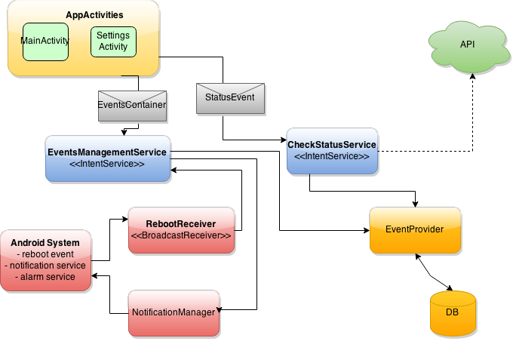

* **StatusEvent -** container for a car event that carrier data like start/end date, event name and description
* **EventsContainer** - Aggregates multiple events and specifies an action to be done for each event
* **EventsManagementService** - responsible to modify events and (re)schedule reminders
* **CheckStatusService -**  responsible to check insurance validity against the national database using a web service that wraps data in JSON format
* **RebootReceiver** - catches broadcast events and reschedules reminders for events

**Mock views**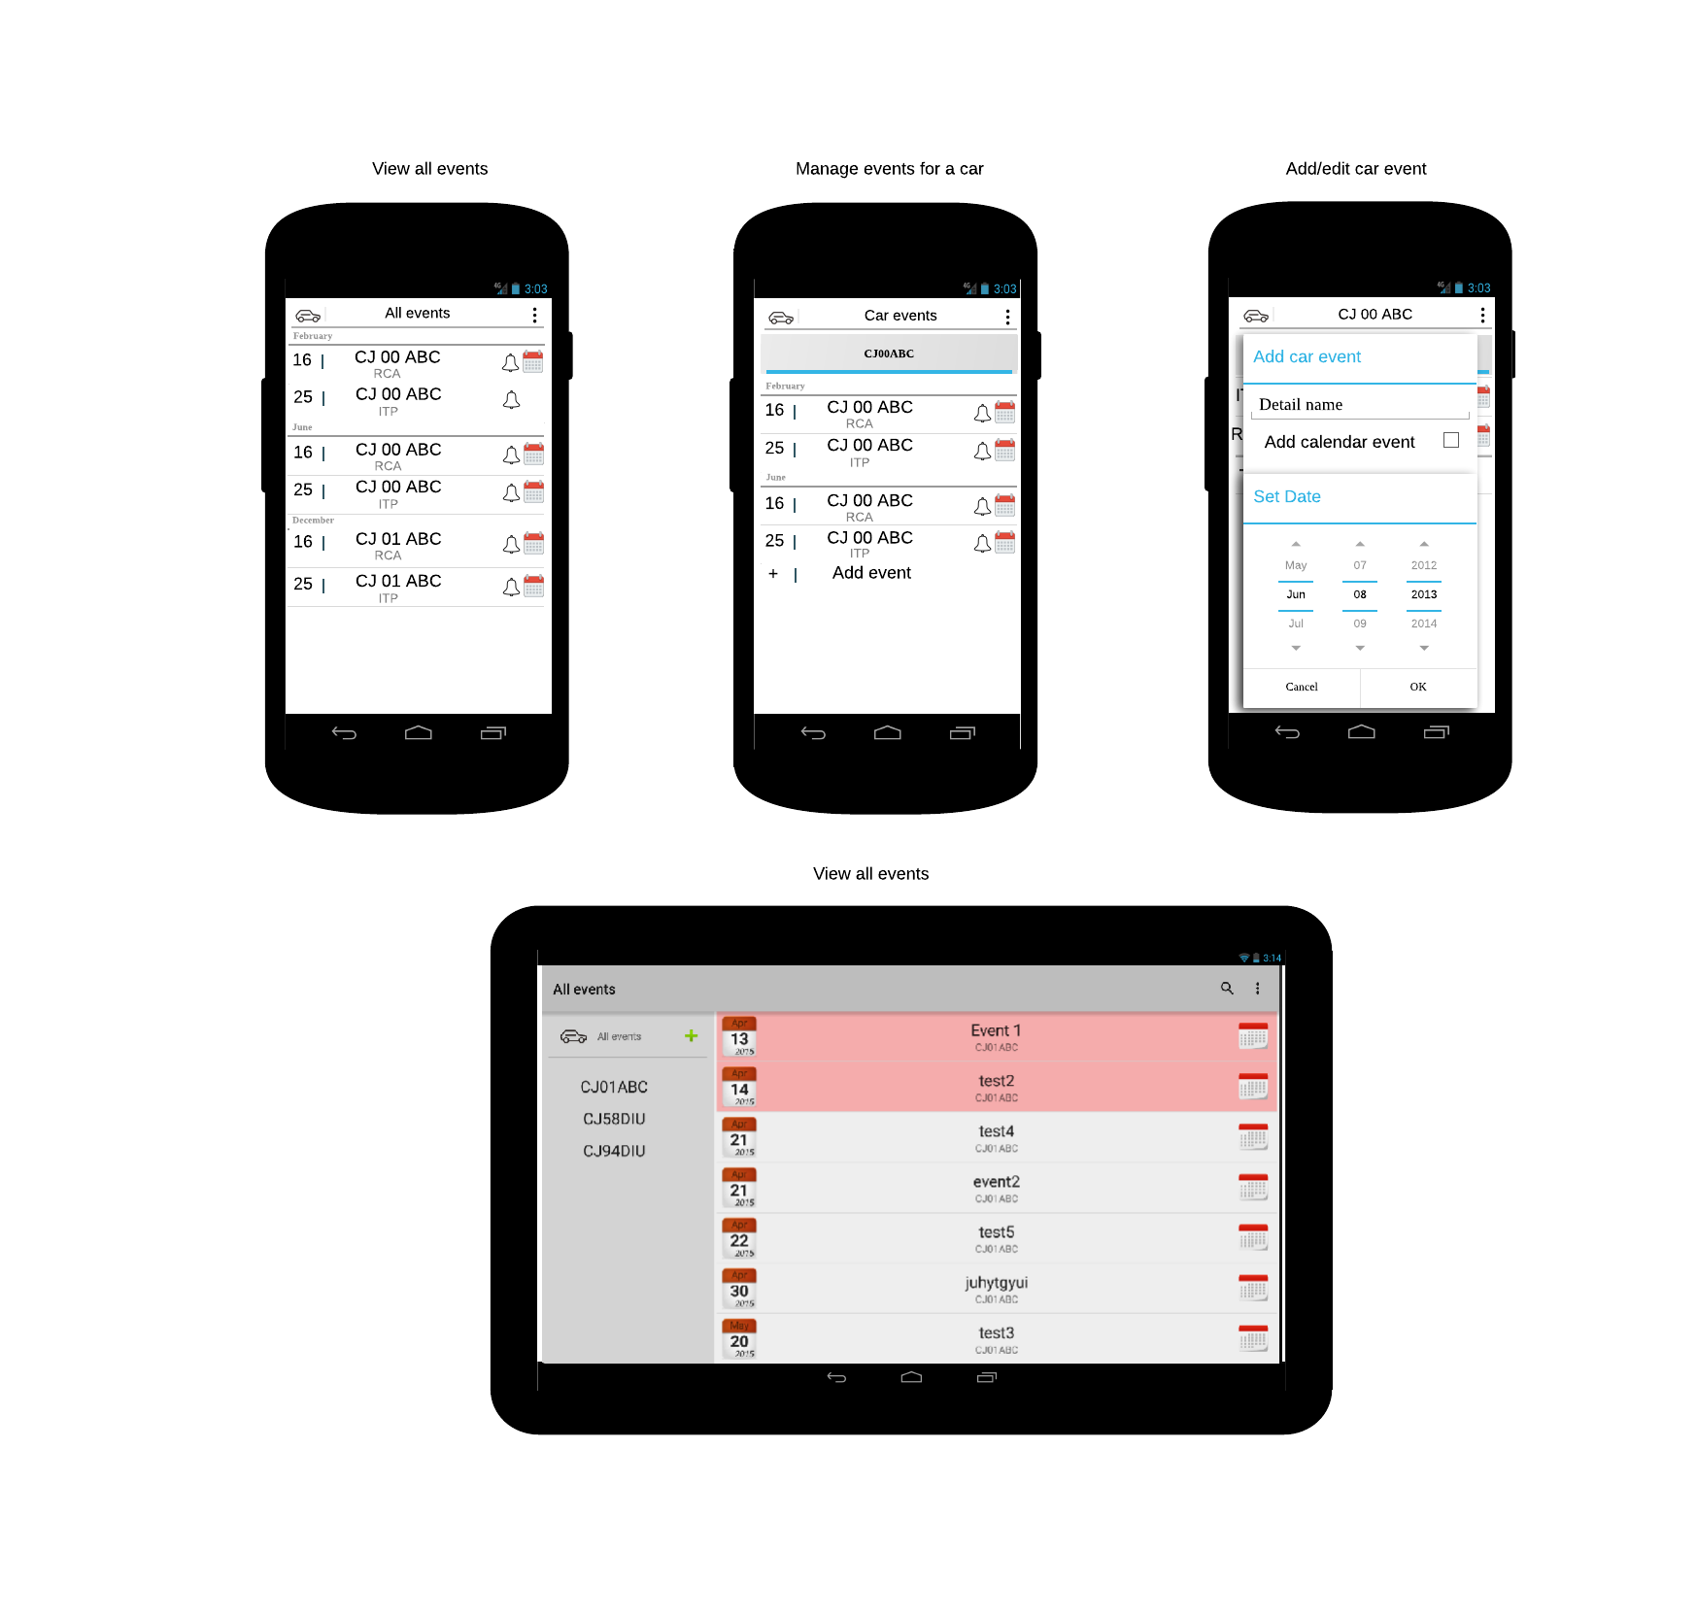

**Implementation details**

**Examples**

* Show all events

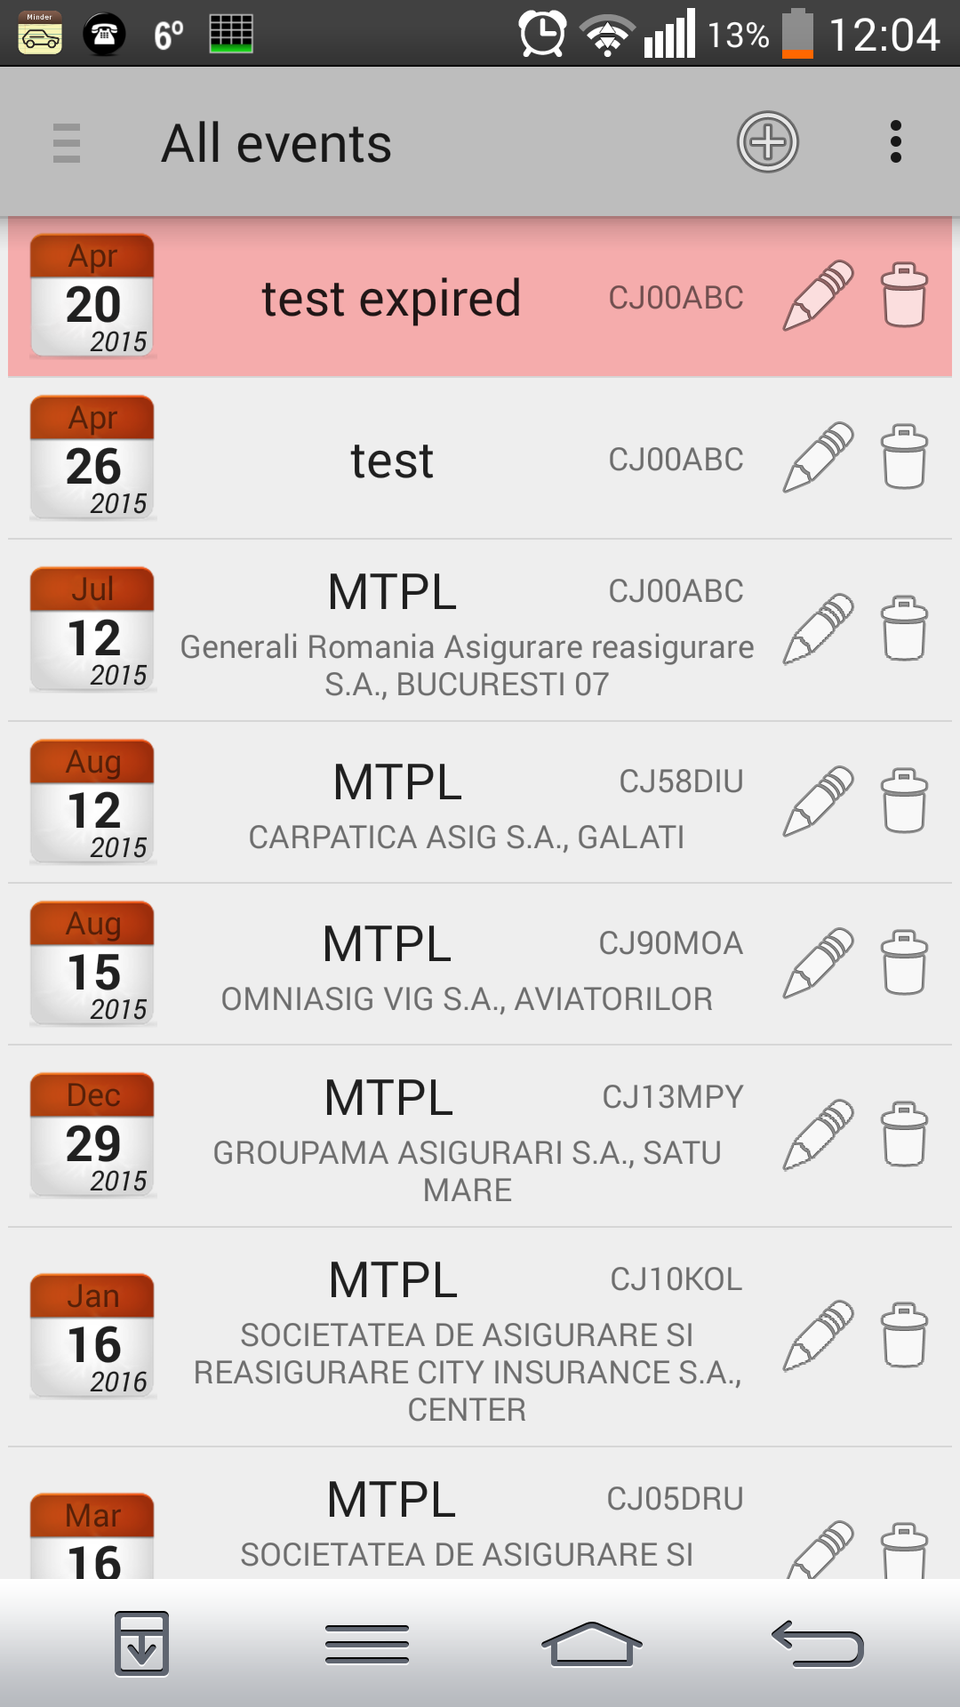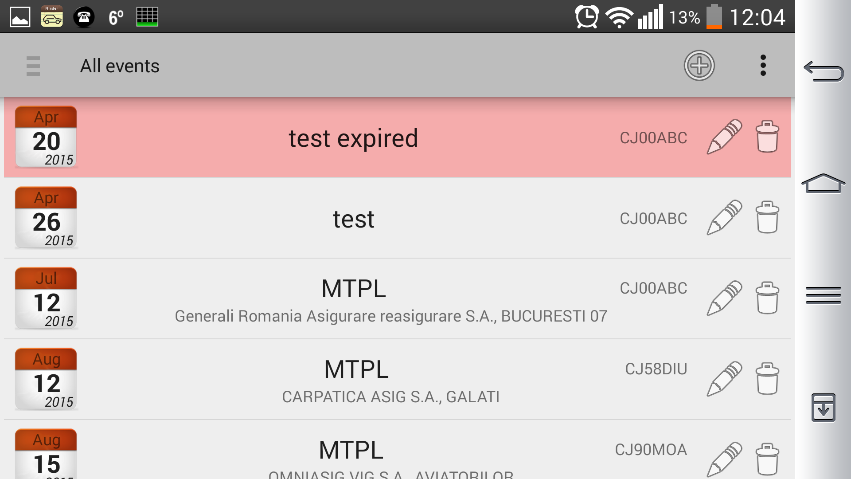

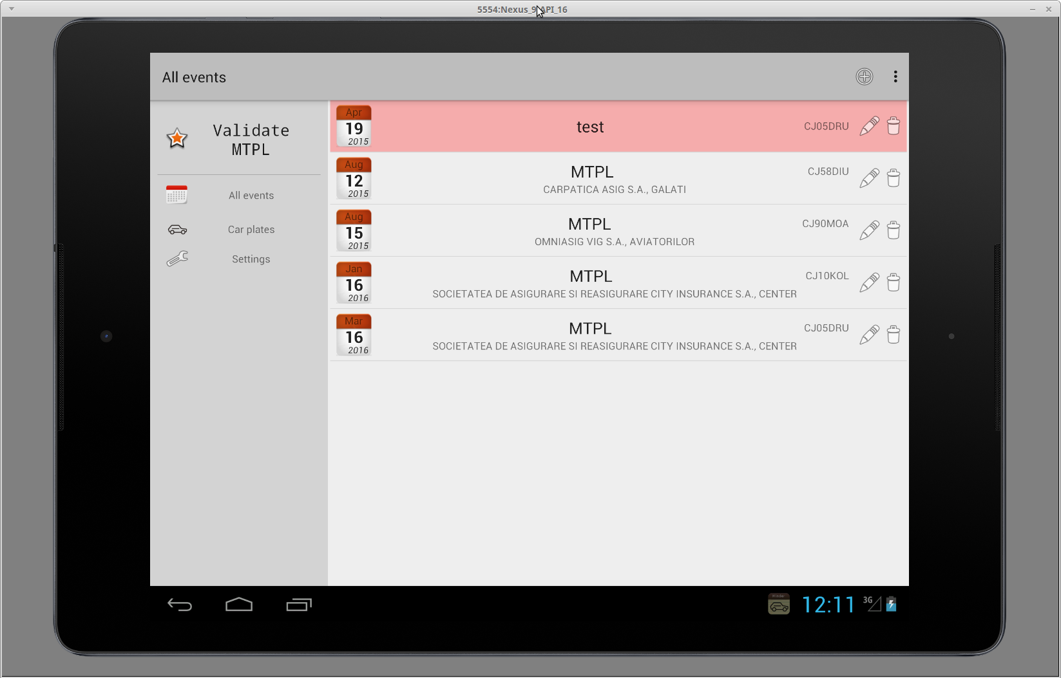

* Online validity check

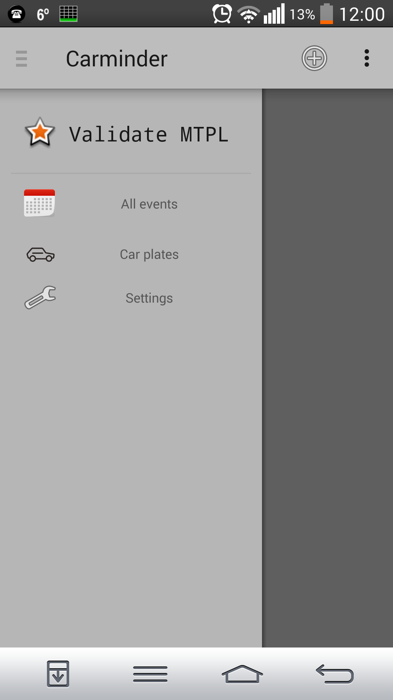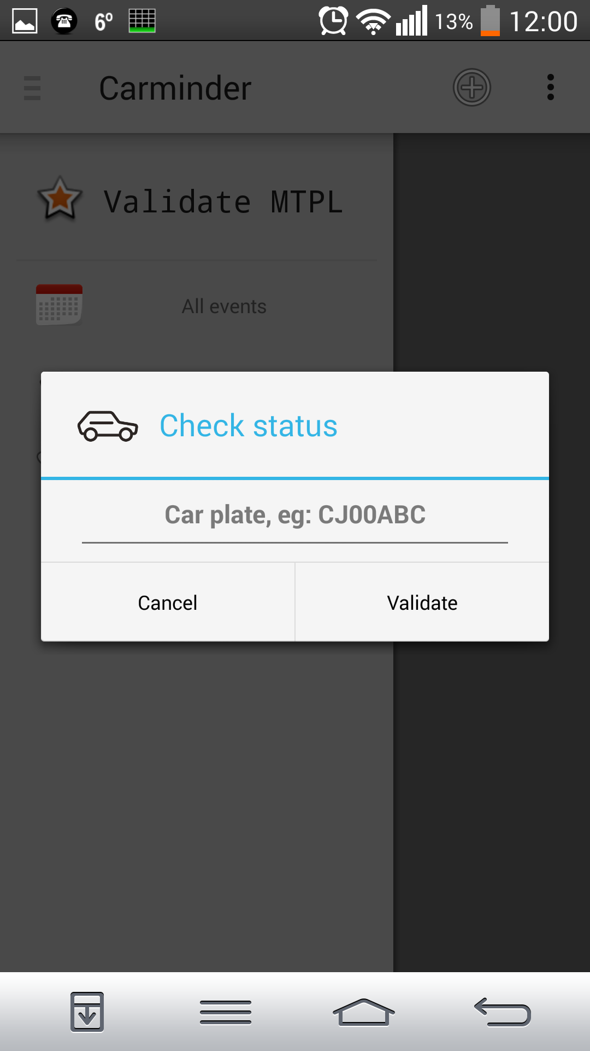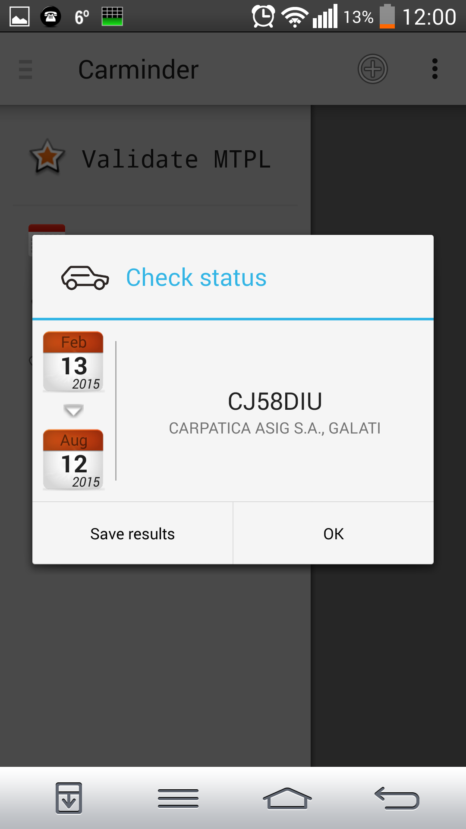

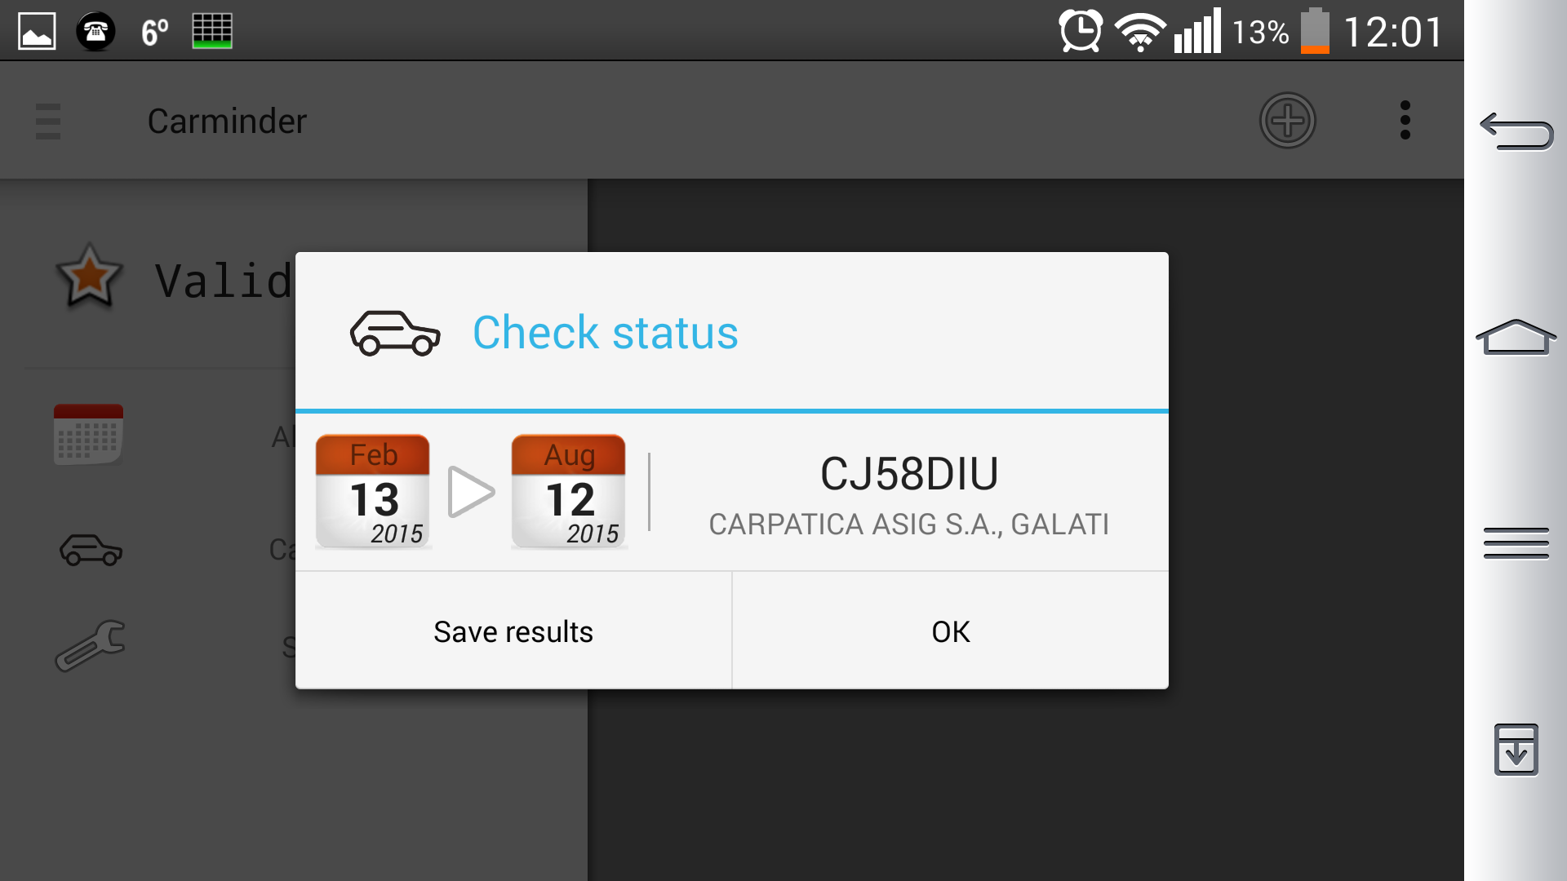

* Manage car events

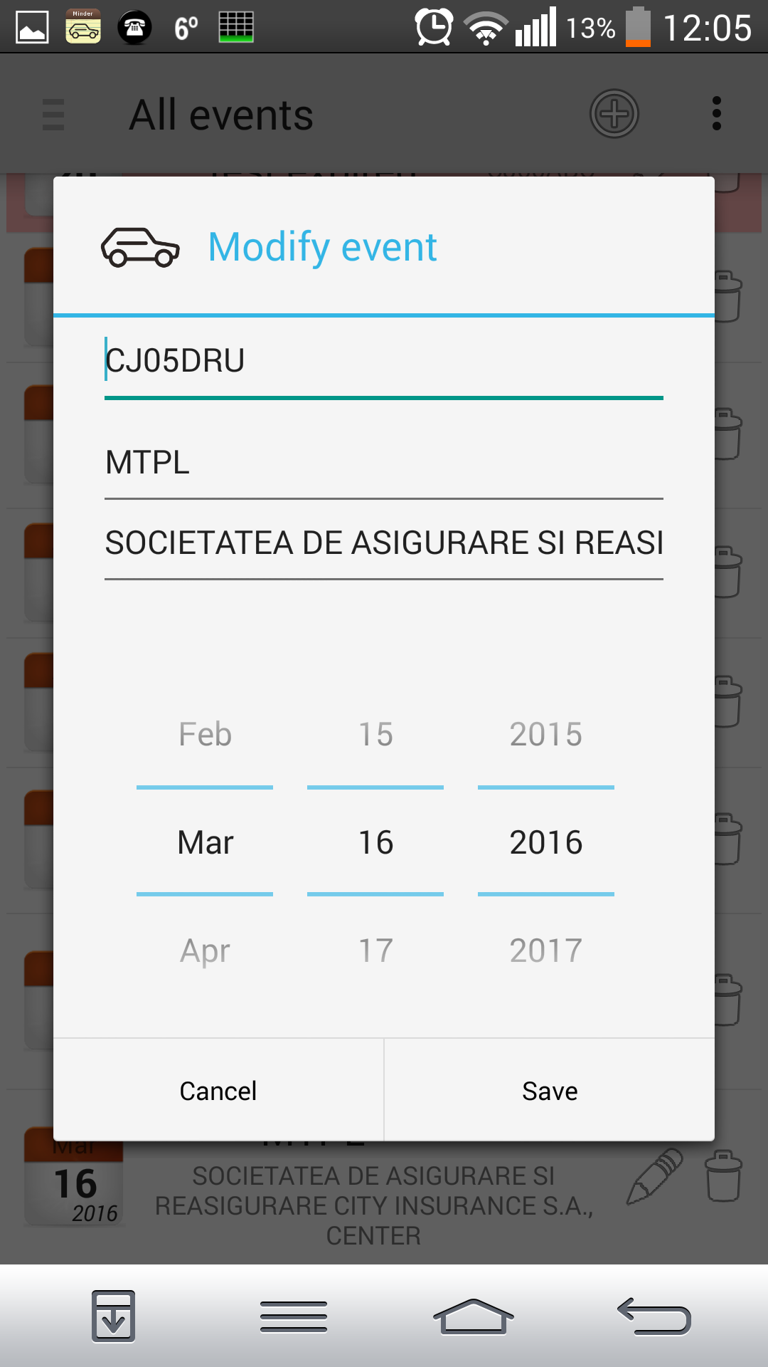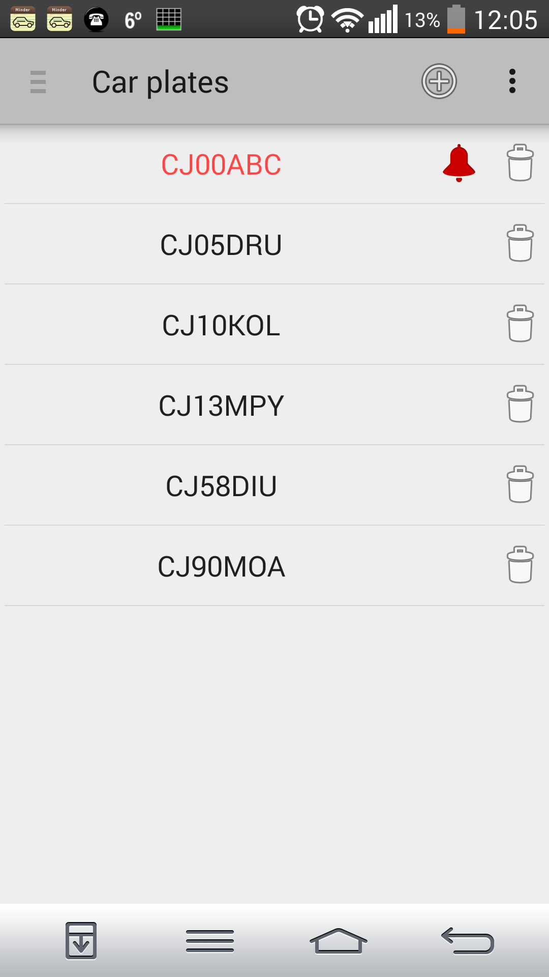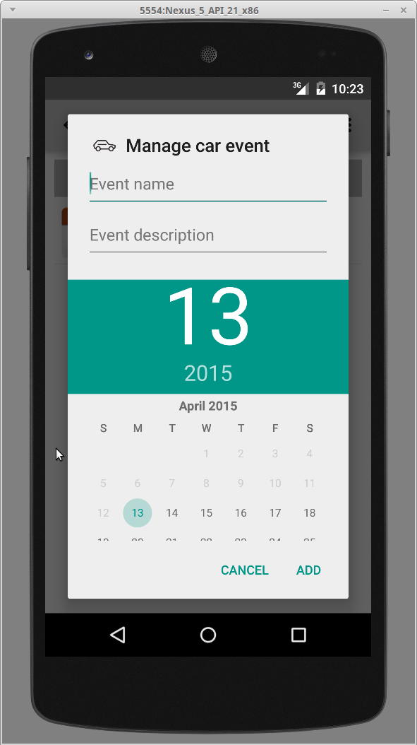

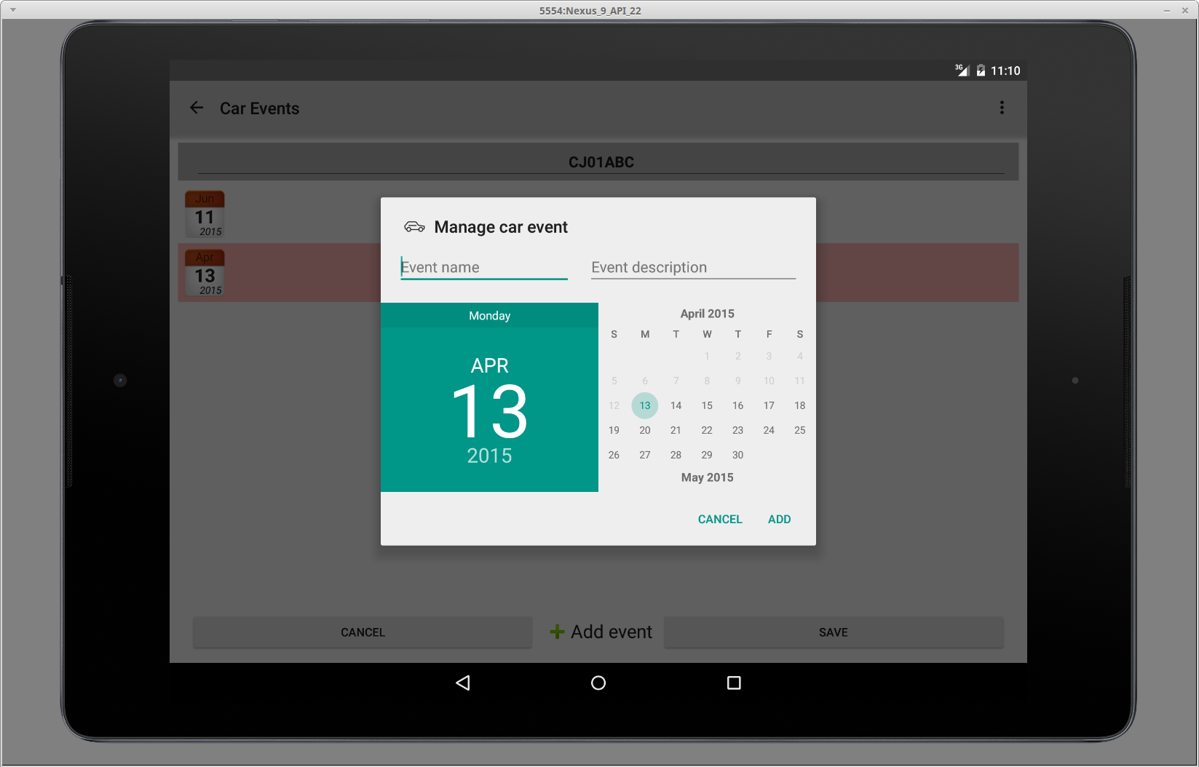

* Alerts for events which require user attention

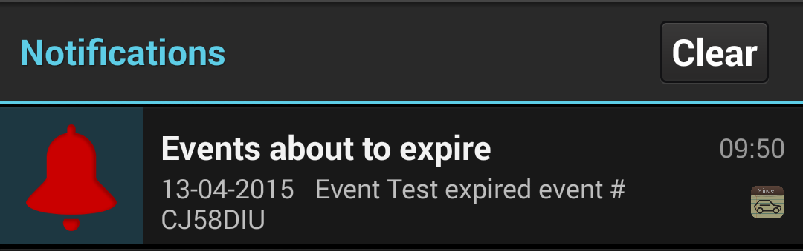

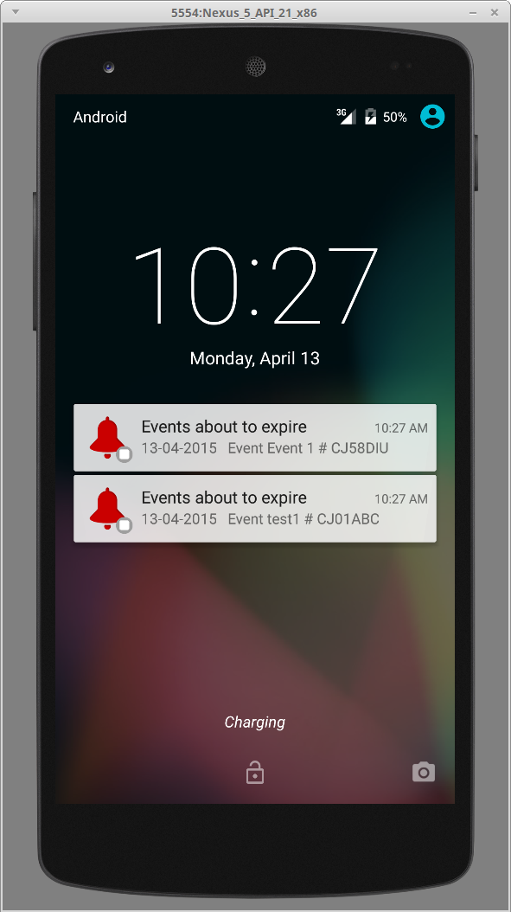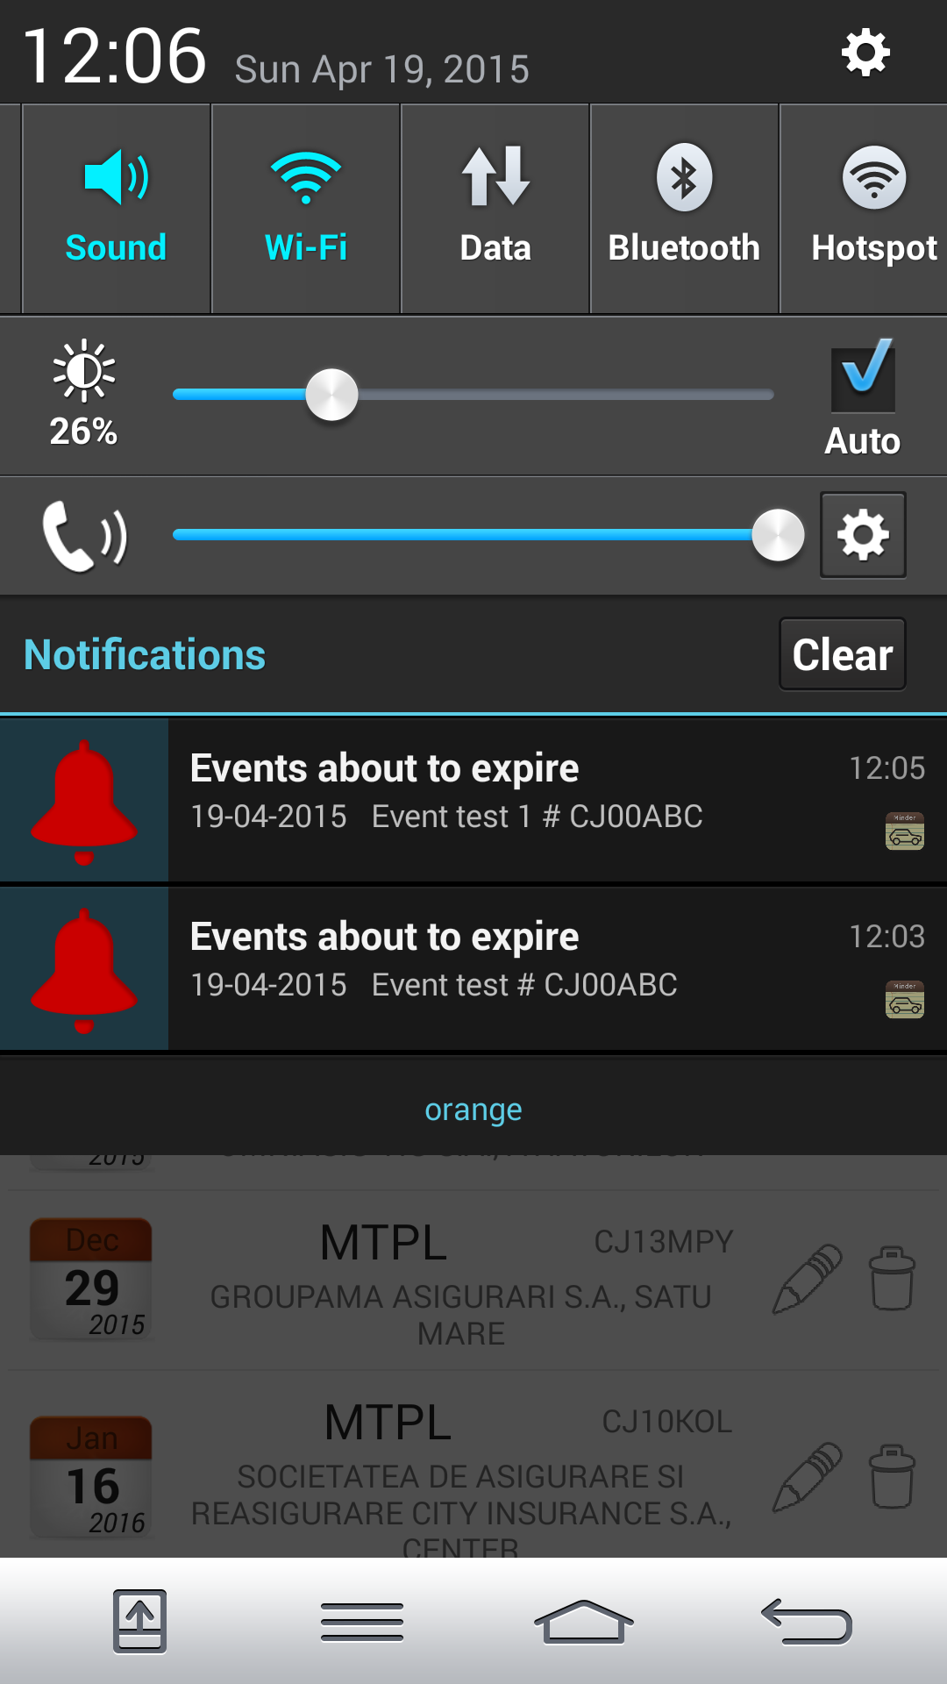

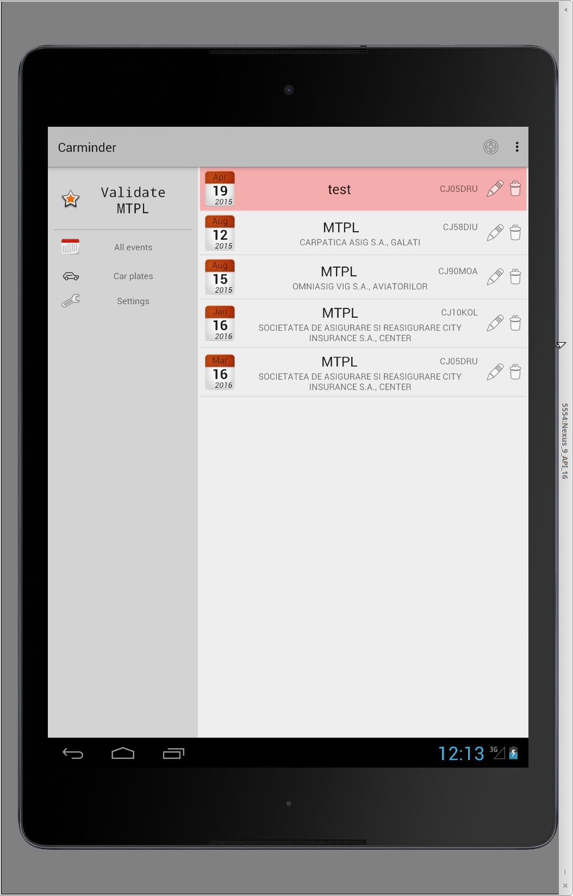

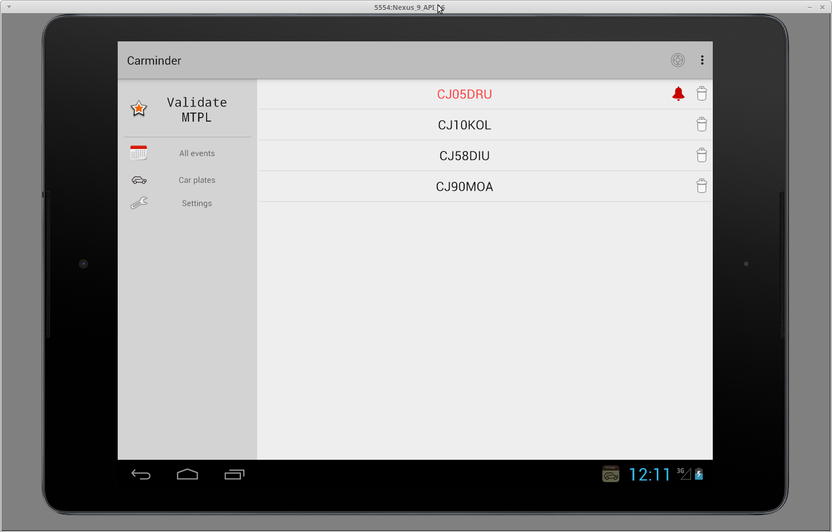

* Settings

