YOH KAWANO, PhD
ykawano@reitaku-u.ac.jp
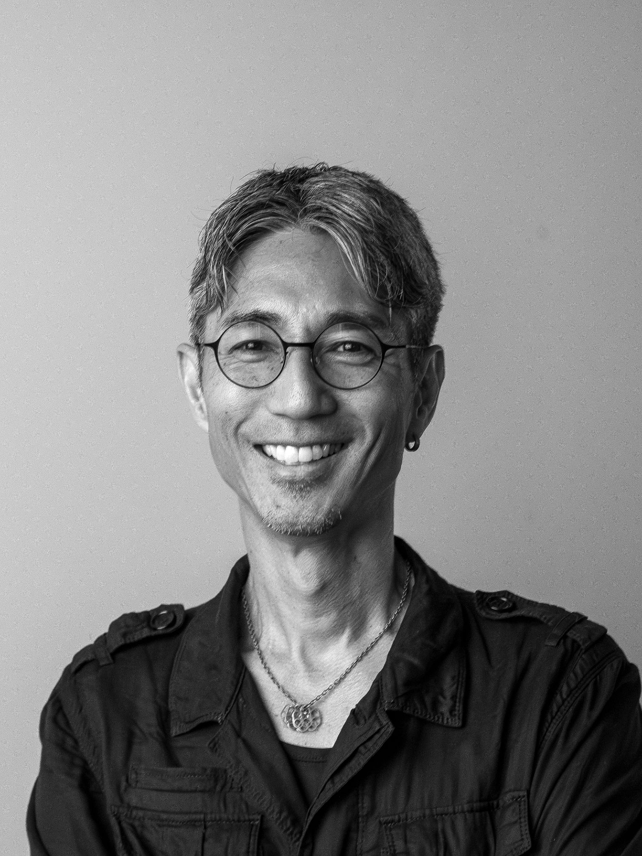
Yoh Kawano is a professor, documentary filmmaker, designer, and researcher whose work is driven by a passion for helping students realize their creative potential and make meaningful contributions to society. Having lived and worked across many countries, he believes academia is most meaningful when it enriches people’s lives by creating opportunities for collaboration, creative exploration, and meaningful engagement with communities. Yoh is a Professor in Reitaku University’s Faculty of Engineering, where he leads interdisciplinary, project-based learning that brings together design, storytelling, technology, and community engagement, while also serving as Vice Director of the International Center.
Before joining Reitaku University, Yoh spent approximately twenty-five years at the University of California, Los Angeles (UCLA), where he led research, teaching, and public-engagement initiatives in geographic information systems, digital mapping, and the urban humanities. At UCLA, he helped develop the Urban Humanities Initiative and founded the International Humanitarian Mapathon, bringing together students, researchers, artists, and communities through collaborative projects exploring place, culture, and humanitarian response.
Today, Yoh’s work focuses on memory cultures and immersive narratives of place, investigating how maps, film, interactive media, and emerging technologies can preserve, interpret, and communicate lived experience. His current projects include Memory Mapping, an initiative that preserves and explores personal memories through interactive three-dimensional landscapes, and Kashiwa After Dark, an urban ethnography that explores the rhythms, identities, and social negotiations of youth culture in public space through spatial visualization. Together, these projects explore how memory, identity, and place can be experienced through immersive forms of storytelling.
Yoh co-authored HyperCities: Thick Mapping in the Digital Humanities (Harvard University Press, 2014), a foundational text in spatial digital humanities, and directed the documentary Human Error (2019), examining the Fukushima nuclear disaster through the experiences of displaced residents. His latest documentary, Airi (2026), explores silence, memory, dialogue, identity, and the enduring human impact of disaster, and has since been screened internationally, resonating deeply with audiences across cultures. Yoh holds a PhD and MA in Urban Planning from UCLA and a BA in Sociology from International Christian University (ICU), Tokyo.

EDUCATION
University of California, Los Angeles - Los Angeles, CA
2015 - 2020
PhD in Urban Planning
Dissertation Title: “Human Error and Human Healing in a Risk Society: The Forgotten Narratives of Fukushima”
Professor Abel Valenzuela, Co-Chair
Professor Anastasia Loukaitou-Sideris, Co-Chair

University of California, Los Angeles - Los Angeles, CA
1995 – 1997
Master of Arts in Urban Planning

International Christian University - Tokyo, Japan
1990 – 1994
Bachelor of Arts in Sociology

ACADEMIC EMPLOYMENT

Reitaku University, Faculty of Engineering
2024
Professor

2022
Associate Professor

UCLA Office of Advanced Research Computing
2007 – 2022
Research Technology Group, Senior Computational Scientist, Spatial Data Visualization

UCLA Urban Planning Department
2011 - 2022
Adjunct Professor

UCLA Center for Digital Humanities

2011 - 2022

Adjunct Professor

UCLA Urban Humanities
2012 - 2016
Steering Committee Member and Affiliated Faculty

UCLA Center for Neighborhood Knowledge
1997 – 2007
Director of Information Technology

PUBLICATIONS

Book:

Presner, Todd, David Shepard, and Yoh Kawano. 2013. HyperCities: Thick Mapping in the Digital Humanities. Harvard University Press.

Refereed Journal Articles:

Schouten, Andrew, Yoh Kawano. 2023. “COVID-19 and the demand for transit access: Residential real estate prices in the Tokyo metropolitan area.” ​​Journal of Transport Geography, Volume 114.

Kawano, Yoh, Andrew Schouten. 2023. “New spaces and new places: The growth and spatial expansion of flexible offices in Tokyo.” ​​CSIS Discussion paper, The University of Tokyo, No.179.

Kawano, Yoh. 2020.Narratives of a Non-urban Humanity (short essay). Urban Humanities: New Practices for Reimagining the City. MIT Press..

Hirano, Katsuya, Yoshihiro Amaya, and Yoh Kawano. 2018. “‘Save the Town’: Insolvable Dilemmas of Fukushima’s ‘Return Policy.’” The Asia-Pacific Journal: Japan Focus 16 (3).

Hirano, Katsuya, Yoshihiro Amaya, and Yoh Kawano. 2017. “Reconstruction Disaster: The Human Implications of Japan’s Forced Return Policy in Fukushima.” The Asia-Pacific Journal Japan Focus 15 (7).

Kawano, Yoh, Arfakhashad Munaim, Jun Goto, Yugo Shobugawa, and Makoto Naito. “Sensing Space: Augmenting Scientific Data with Spatial Ethnography.” GeoHumanities 2, no. 2 (July 2, 2016): 485–508.

Kawano, Yoh, David Shepard, and Yugo Shobugawa.2012. “A Map for the Future: Measuring Radiation Levels in Fukushima, Japan”

Goto, Jun, Yugo Shobugawa, Yoh Kawano, Yoshihiro Amaya, Takuji Izumikawa, Yoshinori Katsuragi, Tomohiro Shiiya, et al. 2016. “Development of a Portable Gamma-Ray Survey System for the Measurement of Air Dose Rates.” In Proceedings of International Symposium on Radiation Detectors and Their Uses (ISRD2016). Journal of the Physical Society of Japan.

Non-Refereed Articles:

Kawano, Yoh (2014). Golden Gai, Shinjuku’s Intimate Public. In Shin-Shinjuku: New Tokyo, Again. UCLA Urban Humanities Initiative.

Presner, Todd, David Shepard, and Yoh Kawano.2011. “Mapping voices that fell the Mubarak regime,” Geospatial Today.

FILMS
Airi. Director Yoh Kawano. 2026.

Human Error. Director Yoh Kawano. 2019.

Metamorphosis. Director Jun Hori. Producer Yoh Kawano. 8bitNews, 2013.

SELECTED PRESENTATIONS

Panelist: gLOCAL 2022-Asian Development Bank (invited)

June 2, 2022
“Using GIS for Evaluating in Context of Fragility, Conflict, and Violence”

Keynote Speaker: Los Angeles County GIS Day (invited)

November 13, 2021
“Human Error and the Narratives of the People”

Crossing Borders: Past and Future of Japanese Studies in the Global Age, Prague, Czech Republic (invited)
October 10, 2019
“Human Error” film screening and panelist on 8 years On: Scholars' Efforts to Reclaim Culture after the Great East Japan Earthquake

Urban Humanities Initiative, UCLA (invited)
May 25, 2019
“_plan” an urban humanities exhibition and symposium
Respondent for panel on “Mapping the Plan”

Loyola Marymount University (invited)
April 24, 2019
Guest lecturer in Transpacific Japan course

Midwest Conference on Asian Affairs (MCAA), Minnesota [invited]
October 20, 2018
“Human Error” selected as the feature film in the session “Nuclear Asia: Prospects for Peace”

PhD Seminar, Riga Stradins University, Latvia (invited)
November 28, 2018
“Human Error” screening and Q&A

Association for Asian Studies (AAS), Washington DC (invited)
March 24, 2018
Film Expo “Remembered Asia, Transformed Futures”
“Human Error” film screening and panelist

University of California Riverside (invited)
March 10, 2018
Lessons From Fukushima Nuclear Disaster
“Human Error” selected as the feature film to commemorate the anniversary of the Japan disasters

Tokyo Electric Power Company (TEPCO), Tokyo, Japan (invited)
December 15, 2017
“Human Error” film screening in front of 100 TEPCO executives followed by a talk and Q&A session, reflecting on the impact that the disaster has had on the affected communities.

Futabaya Ryokan, Fukushima, Japan
July 2, 2017
Community Center inside Evacuation Zone
“Human Error” film screening and discussion with affected community members

Symposium on Ecology and Japan, UC Irvine (invited)
June 15, 2017
“Human Error” film screening and panelist

UCLA Trans-Pacific Workshop, Los Angeles
June 10, 2017
“Human Error” film screening and panelist

Niigata University, Japan
June 26, 2016
Bishamon International Symposium
“Supporting Fukushima: Current Activities and Future Outlooks”

University of California, Santa Cruz (invited)
November 4, 2016
From Concept to Project: A Digital Mapping Workshop

UCLA: Design Knowledge, Los Angeles
November 15, 2015
Making Urban Humanities

Cal Poly University, San Luis Obispo (invited)
February 14, 2014
Measuring Radiation Levels: A Twitter Experiment

Harvard University, Boston
January 24, 2013
Opportunities and Challenges of Participatory Digital Archives: Lessons from the March 11, 2011 Great Eastern Japan Disaster

2012 IEEE Global Humanitarian Technology Conference
October 22, 2012
A Map for the Future: Measuring Radiation Levels in Fukushima, Japan

ESRI User Conference, San Diego
July 24, 2012
A Map for the Future: Mapping Radiation in Fukushima, Japan

UCLA DIYDays, Los Angeles
October 28, 2011
How do you tell a story with a million tweets?

TEDx UCLA, Los Angeles
June 28, 2011
Minding, Mining, Mending, Mapping
“Can Twitter Save Lives?”

Harvard CGA Conference, Boston
August 14, 2011
Geospatial Collaboration - New Common Ground
“Between Social Media and GIS: Mapping Revolutions, History, and Catastrophe”

UNIVERSITY COURSES TAUGHT

UI/UX Design (Reitaku University)
2025 Spring

Introduction to Statistics (Reitaku University)
2025 Spring

GIS (Reitaku University)
2025 Spring

自主企画ゼミナールC (Reitaku University)
2025 Spring

初年次セミナーA (Reitaku University)
2025 Spring

2年次セミナーA (Reitaku University)
2025 Spring

Reitaku Engineer A (Reitaku University)
2024 Fall

Programming (Reitaku University)
2024 Fall

Statistics B (Reitaku University)
2024 Fall

初年次セミナーB (Reitaku University)
2024 Fall

SDGsと道徳 (Reitaku University)
2024 Fall

自主企画ゼミナールB (Reitaku University)
2024 Fall

Introduction to Statistics (Reitaku University)
2024 Spring

GIS (Reitaku University)
2024 Spring

自主企画ゼミナール (Reitaku University)
2024 Spring

初年次セミナーA (Reitaku University)
2024 Spring

Statistics B (Reitaku University)
2023 Fall

GIS (Reitaku University)
2023 Fall

Programming (Reitaku University)
2022 Fall

Econometrics B (Reitaku University)
2022 Fall

Introduction to Statistics (Reitaku University)
2022 Fall

Web GIS: Introduction to Digital Mapping (Digital Humanities DH151)
2022 Spring (Total enrollment: 30)

Introduction to GIS and Spatial Data Science (Urban Planning UP206A)
2022 Winter (Total enrollment: 30)

Introduction to GIS and Spatial Data Science (Urban Planning UP206A)
2021 Fall (Total enrollment: 28)

Web GIS: Introduction to Digital Mapping (Digital Humanities DH151)
2021 Spring (Total enrollment: 30)

Coding for Humanists (Digital Humanities DH140)
2020 Winter (Total enrollment: 30)

Introduction to GIS and Spatial Data Science (Urban Planning UP206A)
2020 Winter (Total enrollment: 30)

Introduction to GIS and Spatial Data Science (Urban Planning UP206A)
2020 Fall (Total enrollment: 26)

Urban Humanities Summer Institute (Arch&UD M295, Urban Planning M295, Digital Humanities DH250)
2014 Summer Session C (Total enrollment: 26)

Advanced GIS (Urban Planning M206B, Public Policy M224B)
2014 Spring (Total enrollment: 31)

Urban Humanities Summer Institute (Arch&UD M404, Urban Planning M404, Digital Humanities DH250)
2013 Summer Session C (Total enrollment: 21)

Advanced GIS (Urban Planning M206B, Public Policy M224B)
2013 Spring (Total enrollment: 25)

Geographic Information Systems (Urban Planning M206A, Public Policy M224A)
2012 Winter (Total enrollment: 17)

Geographic Information Systems (Urban Planning M206A, Public Policy 191A/M224A)
2012 Fall (Total enrollment: 19)

Advanced GIS (Urban Planning M206B, Public Policy M224B)
2012 Spring (Total enrollment: 17)

Geographic Information Systems (Urban Planning M206A, Public Policy M224A)
2011 Winter (Total enrollment: 16)

Advanced GIS (Urban Planning M206B, Public Policy M224B)
2011 Spring (Total enrollment: 33)

Geographic Information Systems (Urban Planning M206A, Public Policy 191A/M224A)
2010 Winter (Total enrollment: 19)

Advanced GIS (Urban Planning M206B, Public Policy M224B)
2006 Spring (Total enrollment: 20)

Geographic Information Systems (Urban Planning M206A)
2006 Summer Session C (Total enrollment: 13)

Geographic Information Systems (Urban Planning M206A)
2007 Summer Session C (Total enrollment: 9)

Special Topics: Planning Methods (Urban Planning UP229)
2001 Spring (Total enrollment: 9)

SELECTED RESEARCH PROJECTS

Million Dollar Hoods (PI: Professor Kelly Lytle Hernandez)
2016-present
Funding from: Haynes Foundation, California Endowment
Technologies used: PostGreSQL, Leaflet, Python, Carto
Built on partnerships with community based organizations, this interactive web-based portal provides unprecedented public access to jail data in Los Angeles to identify patterns of incarceration throughout the county.
http://milliondollarhoods.org

The Urban Displacement Project (PIs Professors Karen Chapple and Anastasia Loukaitou-Sideris)
2016-2018
Funding from: California Air Resources Board, California Endowment
Technologies used: Carto
A research and action initiative of UC Berkeley, UCLA, community based organizations, regional planning agencies, and the State of California’s Air Resources Board. The project aims to understand the nature of gentrification and displacement in the Bay Area and Southern California.
http://www.urbandisplacement.org/

Bishamon
2012-present
Technologies used: Google Maps API
This interactive web mapping portal displays measures of airborne radiation in and around the city spaces that surround the Fukushima nuclear power plant. A time function allows citizens to gage the level of risk over time in their communities. This project is made possible through a partnership between UCLA, Niigata University, and Minamisoma City. The website now serves as an official portal for Minamisoma City’s post-disaster risk assessment plans.
http://bishamon.org

HyperCities (PI: Professor Todd Presner)
2008-2014
Funding from: MacArthur Foundation, Haynes Foundation, Google, The National Endowment for the Humanities (NEH)
Technologies used: Google Maps API, Google Earth API
A collaborative research and educational platform for traveling back in time to explore the historical layers of city spaces in an interactive, hypermedia environment.
http://hypercities.com

Ancient Egyptian Architecture Online (PI: Professor Willeke Wendrich)
2014
Funding from: Deutsche Forschungsgemeinschaft (DFG), The National Endowment for the Humanities (NEH)
Technologies used: ArcGIS Server
A joint collaboration between the German Archaeological Institute in Cairo (DAIK) and UCLA to provide vetted and standardized architectural drawings of a selection of ancient Egyptian buildings.
http://drupaldev.aegaron.ucla.edu/

NKLA/NKCA (PI: Professor Neal Richman)
1998-2006
Funding from: U.S. Department of Commerce, Technology Opportunities Program (TOP)
Technologies used: ArcIMS, MS SQL Server, Cold Fusion
The neighborhood knowledge Los Angeles and California projects were initiated in the late-90’s to address neighborhood disinvestment and slum-housing. By making property level data accessible to the public, the project provided early warning indicators for signs of neighborhood deterioration. Through community outreach and training, citizens were encouraged to take matters into their own hands for their community development efforts. NKLA showed how technology can help connect neighborhoods across large, multiethnic areas and give residents a role in the policy-making process

LILA (PI: Alan Toy)
2002-2006
Funding from: California Endowment, County of Los Angeles, City of Los Angeles, Microsoft
A consumer-directed and regionally focused online project to benefit people with disabilities living in Los Angeles County. LILA uses a GIS-based (Geographic Information Systems - a map formatting tool), interactive information resource database, created by local residents with disabilities using their personal "expert knowledge" to identify and map local independent living resources. Through collaborations with local governments and private non-profit community service agencies, the LILA information system incorporates a variety of databases relevant to the Los Angeles disability and senior community. These may include the locations of services and programs benefiting people with disabilities, local businesses serving the community, accessibility features of publicly subsidized housing, inclusive recreation programs, independent living resource information, etc.

Healthy City
2004-2007
Funding from: James Irvine Foundation
An easy-to-use online platform for accessing data, creating maps, and working collaboratively. It allows users to theme and filter data, conduct research, and connect with their communities. Beyond providing free access to curated databases of community services and localized data variables, HealthyCity.org offers the ability for users to "tell their own story" by uploading their own data or multimedia to the system.

SELECTED CLASS LECTURES (UCLA)

Digital Methods for Research and Scholarship (Information Science dIS289)
Fall 2018
“Data Visualization and Spatial Thinking”

Introduction to Digital Humanities (Digital Humanities DH101)
Fall 2018
“Qualitative Methods: Extracting Topics from Long Interviews”

Popular Literature and Culture (English 108)
Spring 2018
“Data Visualization and Mapping: Using Palladio to Visualize Data”

Disaster Management and Response (Urban Planning UP232)
Spring 2018
“Spatial Ethnography in Fukushima, Japan”

Urban Humanities Summer Institute
Summer 2017
“Thick Mapping”

WORKSHOPS/EVENTS

Economics Department PhD Seminar, UCLA
Winter 2017
“Spatial Analysis: An Introduction to GIS”
Three day workshop on data concepts, spatial thinking, and spatial analysis for economic PhD students.

Cotsen Institute of Archaeology GIS Workshop, UCLA
Winter 2018
“Spatial Analysis: An Introduction to GIS for Archaeologists”
Two day workshop on data concepts, management, integration into spatial databases, spatial analysis, and map production for archaeological project teams.

GISDay, UCLA
This annual event celebrates the use of spatial thinking and research in real world applications. Beginning in 2017, UCLA and USC joined forces to make GISDay a joint event of a shared spatial speaker series and a humanitarian themed “Mapathon,” partnering with HOT (Humanitarian OpenStreetMap Team) to join in the efforts to digitize disaster struck areas around the world.

GIS Workshop Series, UCLA
In addition to course lectures and specialized workshops, I teach the following workshops on a regular basis:
- Introduction to GIS
- Introduction to Spatial Data
- Getting Started With GIS and Spatial Research: Census data analysis with Python
- Introduction to Data Science with Python
- Introduction to GIS for the Social Sciences
- Introduction to GIS/Spatial Research with Python
- Introduction to Spatial Statistics with Python
- Census Data Analysis and Mapping with Python
- Web Mapping with Google Maps API
- Web Mapping with Leaflet
- Mapping with Social Explorer
- Mapping Open Data: Using LA’s Open Data Portal
- Spatial Statistics: Hot Spot Analysis
- Spatial Statistics: Central Means and Directional Distributions
- Data Visualization with Palladio
- Getting Started with ArcPy
- Introduction to Spatial Analysis
- Introduction to Network Analysis
- Introduction to Python for GIS
- Story Mapping
- Introduction to Carto
- History of Digital Mapping and Beyond
- Research Data Visualization

AWARDS

2024 KAKENHI (Grant-in-Aid for Early-Career Scientists) – Using Spatial Ethnography to Preserve the Legacy and Memory of Survivors from the Fukushima Nuclear Disaster – ¥4,680,000

2019 Dissertation Year Fellowship - $20,000

2018 Sasakawa Graduate Fellowship - $7,000

2017 Urban Humanities Initiative - $2,000

2017 Graduate Summer Research Mentorship Program - $6,000

2016 Graduate Research Mentorship - $20,000

2015 Terasaki Center Graduate Student Fellowship - $7,500

2014 Urban Humanities Initiative Faculty Grant - $6,500
“Spatial Ethnography: Storytelling With Data”

LANGUAGES
English: Native
Japanese: Native
Spanish: Intermediate

