Prepared by: | Larry Zhang
Version: | 1.0
Date: | 5/8/2014
HOPE

Development Environment Setup
Guide

1 Introduction 5
2 JBoss 6
2.1 Installation 6
2.2 Configuration 6
2.3 Test and Run 7
3 Eclipse 8
3.1 Installation 8
3.2 Update Eclipse Plug-ins 8
3.3 Configuration 9
4 Hope Project 23
4.1 Creating the HOPE Project 23
4.1.1 Check out the ‘agweb Project from CVS 23
4.1.2 Configure the ‘agweb Project 30
4.2 Run JBoss within Eclipse (optional) 31
4.3 Deploy the Project as an Exploded Directory 31

Figure 1 Install new software 8
Figure 2 Disable Auto Build 9
Figure 3 Change Compare/Patch Setting 10
Figure 4 Change Build Path via Preferences 11
Figure 5 Java Code Format 12
Figure 6 Change Code Formatter 13
Figure 7 Set Compiler Options: Potential programming problems 14
Figure 8 Compiler Options: Unnecessary code 15
Figure 9 New Server Runtime 16
Figure 10 JBoss Directory 17
Figure 11 Server Runtime Environments 18
Figure 12 Disable auto publish at start 19
Figure 13 CVS Default Text Mode 20
Figure 14 Configure CVS Watch/Edit mode 21
Figure 15 Create New Project 22
Figure 16 Dynamic Web Project 23
Figure 17 Project Name and Settings 24
Figure 18 Content Directory 25
Figure 19 Project Explorer and Java EE Perspective 26
Figure 20 Open Perspective 27
Figure 21 Java Perspective 28
Figure 22 Output directory 29
Figure 23 Show View 30
Figure 24 Buildfile selection 31
Figure 25 Ant View 32

Introduction
The goal of this document is to provide instructions on setting up the development environment.

JBoss
JBoss Application Server must be installed and configured on your development PC to run and debug your code. Make sure you have JDK1.7 installed before you start.

Installation
- Download jboss-as-7.1.1.Final.zip from http://jbossas.jboss.org/downloads
- Unzip the downloaded file on your hard drive. Recommended directory: C:\Tools\. After unzip, JBoss wil be under C:\Tools\ jboss-as-7.1.1.Final

Configuration
- (Optional)Set JAVA_HOME in bin\standalone.conf.bat to JDK1.7 directory. For example,
set “JAVA_HOME=<JDK installation directory>” (e.g., C:\Program Files\Java\jdk1.7.0_55)
- Creating the Self-Signed Certificate: From command prompt type the following command: “keytool -genkey -alias tomcat -keyalg RSA“. This will start a wizard. Use jbssl12 as password. After completing the wizard you will have a keystore file which has the key for encryption. You should be able to find the key file in C:\Documents and Settings\<login name> or just search for the file “.keystore”. Rename this file to jb.keystore and copy it to directory “<JBOSS_HOME>\standalone\configuration”. We will use this location in xml file later
- Modify standalone.xml under <JBOSS_HOME>\standalone\configuration
  - Add <system-properties> after </extensions> tag as follows:

<system-properties>
<property name="org.apache.tomcat.util.http.ServerCookie.FWD_SLASH_IS_SEPARATOR" value="false"/>
</system-properties>

  - Edit the connectors subsystem as below, making sure enable-welcome-root is set to false:

<subsystem xmlns="urn:jboss:domain:web:1.1" default-virtual-server="default-host" native="false">
<connector name="http" protocol="HTTP/1.1" scheme="http" socket-binding="http"/>
<connector name="https" protocol="HTTP/1.1" scheme="https" socket-binding="https" secure="true">
<ssl name="https" password="jbssl12" certificate-key-file="../standalone/configuration/jb.keystore" cipher-suite="SSL_RSA_WITH_RC4_128_MD5, SSL_RSA_WITH_RC4_128_SHA, TLS_KRB5_WITH_RC4_128_MD5, TLS_KRB5_WITH_RC4_128_SHA, TLS_RSA_WITH_AES_128_CBC_SHA, TLS_RSA_WITH_AES_256_CBC_SHA"/>
</connector>
<virtual-server name="default-host" enable-welcome-root="false">
<alias name="localhost"/>
<alias name="example.com"/>
</virtual-server>
</subsystem>

  - Modify the public interface to allow remote access. By default, the server is only accessible via localhost

<interface name="public">
<any-address/>
</interface>

  - Create the data sources for Oracle. Note that the jndi name needs to start with java:/ (TBD: this needs to be modified for MySQL)

<datasource jndi-name="java:/hopeDataSource" pool-name="hopeDataSource" enabled="true" use-java-context="true" use-ccm="true">
<connection-url>jdbc:oracle:thin:@my.host.com:1521:<sid></connection-url>
<driver>oracle</driver>
<pool>
<min-pool-size>0</min-pool-size>
<max-pool-size>20</max-pool-size>
<prefill>false</prefill>
<use-strict-min>false</use-strict-min>
<flush-strategy>FailingConnectionOnly</flush-strategy>
</pool>
<security>
<user-name>xxxx</user-name>
<password>xxxx</password>
</security>
<validation>
<validate-on-match>false</validate-on-match>
<background-validation>false</background-validation>
<use-fast-fail>false</use-fast-fail>
</validation>
</datasource>

  - Using JBoss utility script to add user to mgmt-users.properties under <JBOSS_HOME>\standalone\configuration. Since in JBoss AS 7.1.1, the password is encrypted, this needs to be done via the script

cd <JBOSS_HOME>\bin
add-user.bat (You will be prompted with different options. Hit enter twice to accept defaults)
user: admin
password: agadm1n

  - (TBD) Create MySQL module
  - Rename the default JBoss welcome page. Go to <JBOSS_HOME>\welcome-content. Move index.html to index_jboss.html. This allows our own index.html to be displayed properly

Test and Run
First create a shortcut on your desktop pointing to <JBOSS_HOME>\bin\standalone.bat. Name the shortcut “JBoss”. Double click the desktop icon to start JBoss. The server should start without errors. Type the following URL in browser http://127.0.0.1:9990/console/ to see the local host home page. You can check the data sources and its configurations.

Eclipse
Eclipse is a free IDE for download (www.eclipse.org).

Installation
- Download the zip file eclipse-jee-kepler-SR2-win32.zip for “Eclipse IDE for Java EE Developers” from Eclipse web page. http://www.eclipse.org/downloads/
- Unzip the downloaded file on your hard drive, e.g. C:\Tools
- Create a shortcut on Desktop to launch eclipse.exe.

Update Eclipse Plug-ins
- Start Eclipse. Specify a workspace such as C:\workspace\lanking.
- If necessary, set the proxy (for example, if you are on a company intranet). Click menu ‘Window’->’Preferences’. Go to ‘General->Network Connections’. Change Active Provider to Manual and select HTTP and HTTPS with proxy
- Help>Install New Software. Enter the following in Work with field and click Add… Give it a name.
http://download.jboss.org/jbosstools/updates/development/indigo/
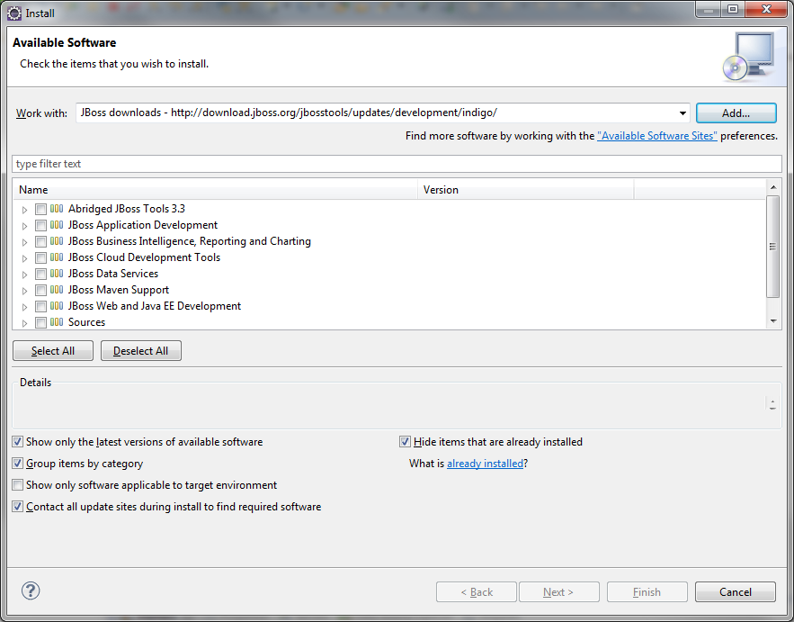
Figure 1 Install new software
- Expand “JBoss Web and Java EE Development” and select “JBossAS Tools”. You only need this plug-in. The other plug-in from JBoss are not needed (except slowing down Eclipse). Click Next, Next …, Finish.

Configuration

- Start Eclipse.
- Open preferences editor. Click menu ‘Window’->’Preferences’.
- Now go through following screens and make sure yours look precisely same.
- Click ‘General->Workspace’ and uncheck ‘Build Automatically’. Check ‘Refresh on access’ and ‘Save automatically before build’.

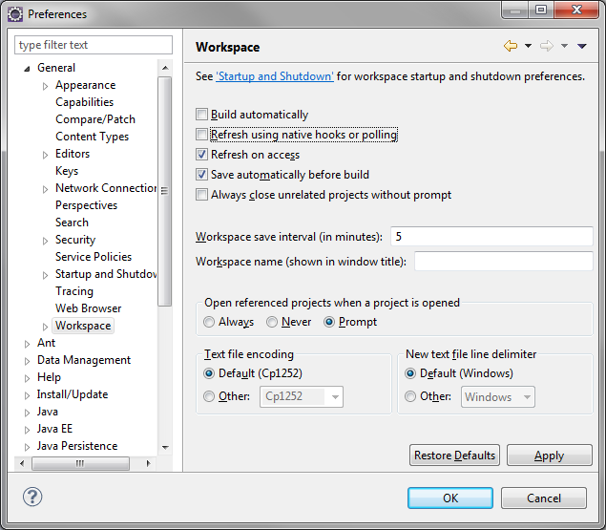
Figure 2 Disable Auto Build

- Fix compare-diff setting. Click ‘General->Compare/patch’. Check ‘Ignore white space’.
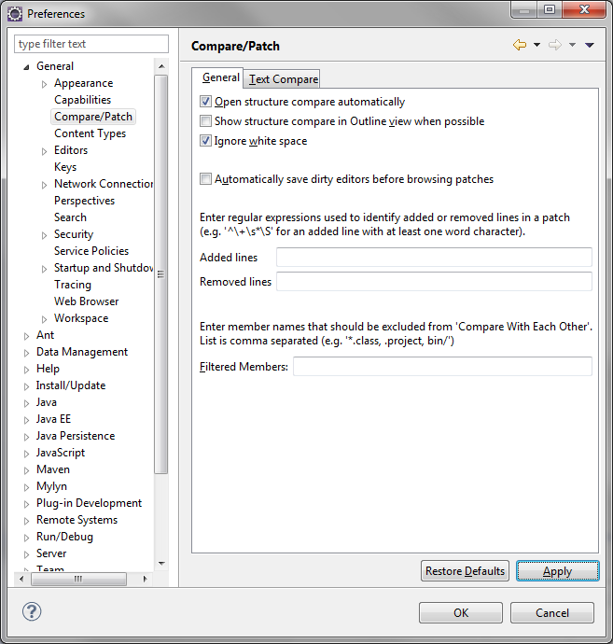
Figure 3 Change Compare/Patch Setting

- Click ‘Java’ -> ‘BuildPath’. Set ‘Source folder name:’ and ‘Output folder name:’ as shown in the figure below.

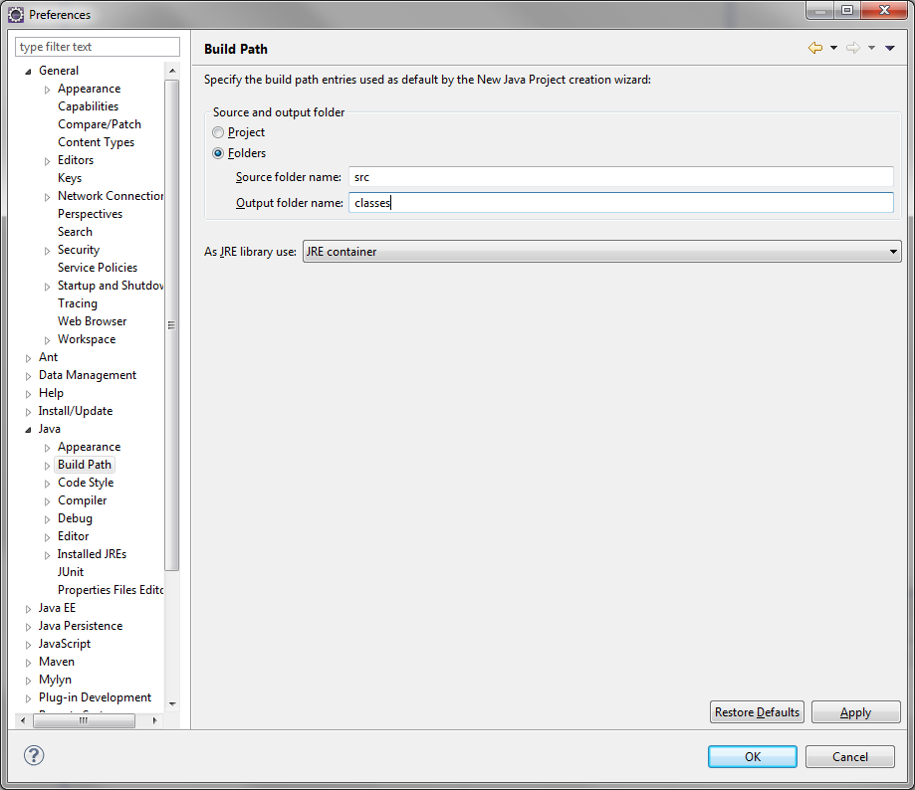
Figure 4 Change Build Path via Preferences

- Click ‘Java’ -> ‘Code Style’ -> ‘Formatter’. Click ‘Edit…’
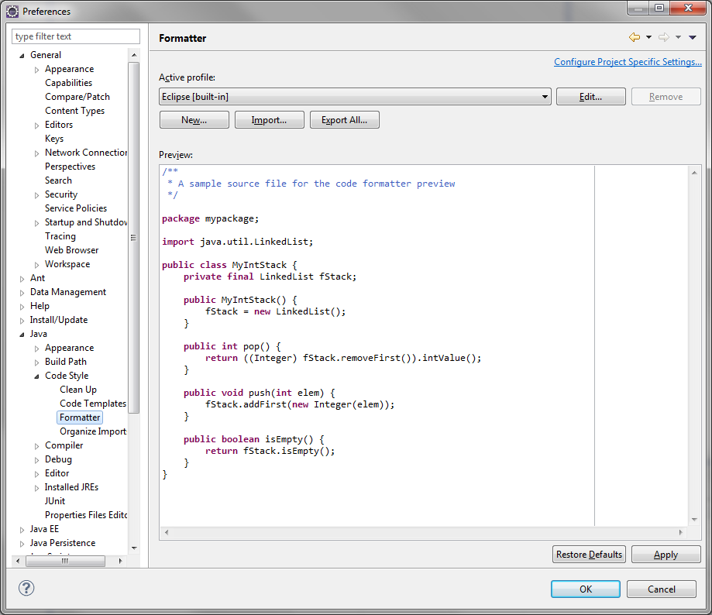
Figure 5 Java Code Format
Change “Tab policy” to “Mixed” and Tab size to 8. Change the Profile name to Eclipse [mixed]

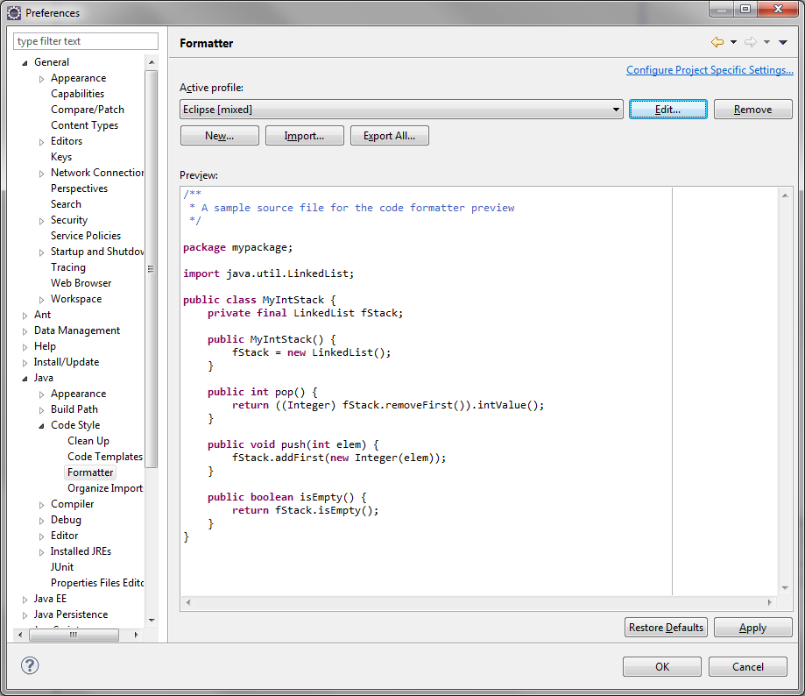
Figure 6 Change Code Formatter

- Click ‘Java’ -> ‘Compiler -> ‘Errors/Warnings’. Make the following suggested changes:

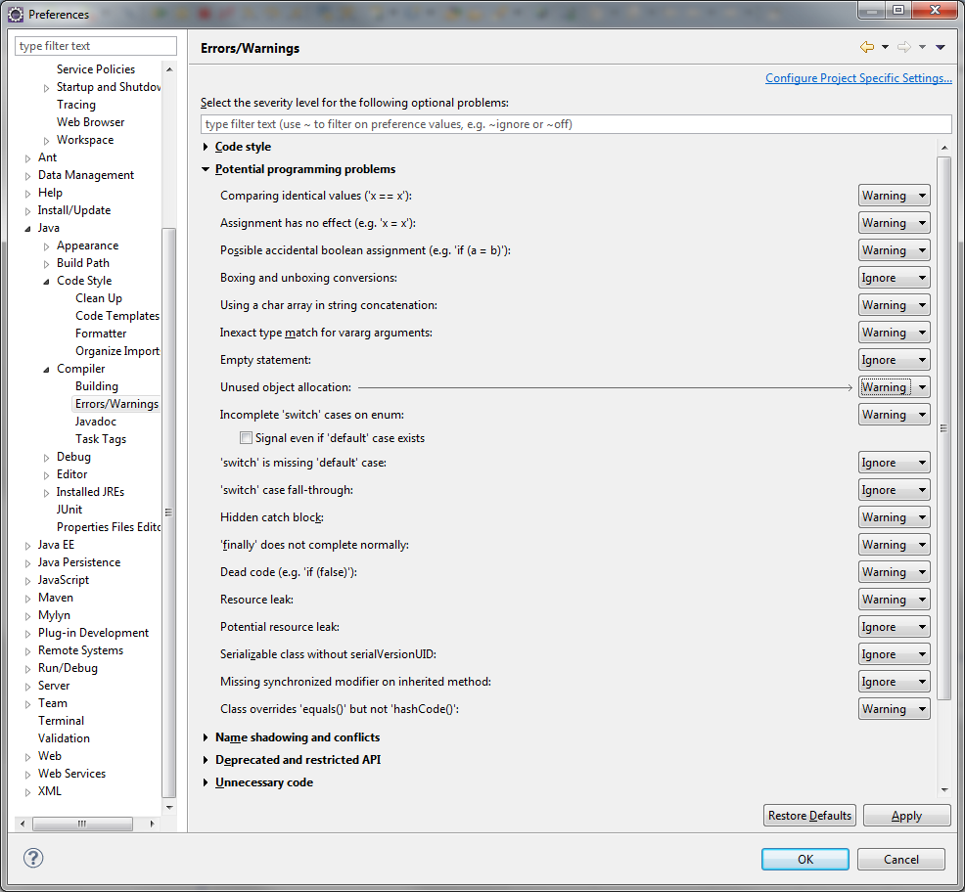
Figure 7 Set Compiler Options: Potential programming problems

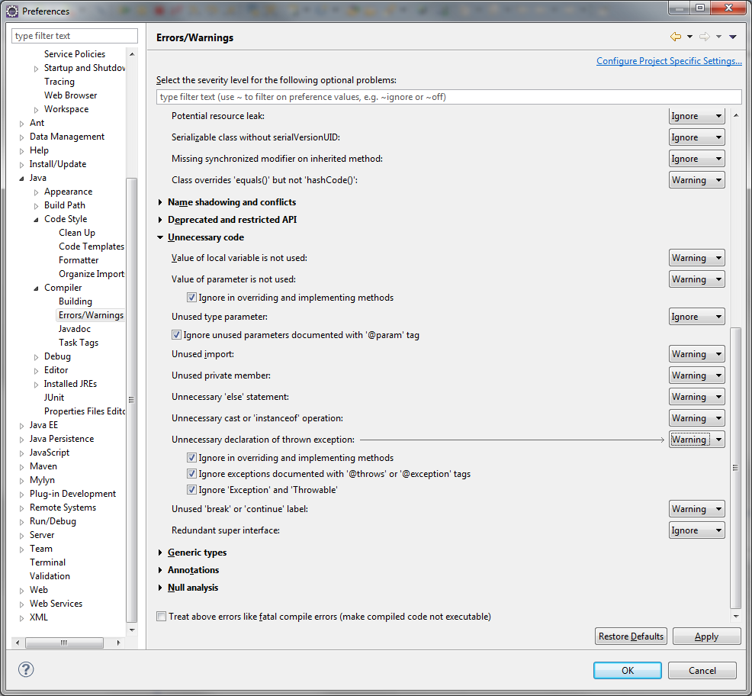
Figure 8 Compiler Options: Unnecessary code

- ‘Server->Installed Runtimes’. Click ‘Add …’. Expand JBoss Community. Select JBoss 7.1 Runtime. Click Next
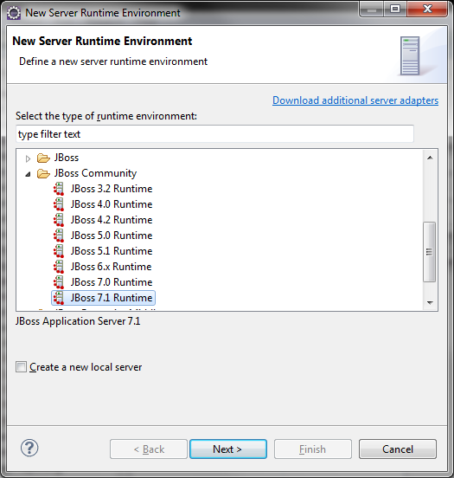
Figure 9 New Server Runtime
- Click Browse… next to Home Directory to find the JBoss directory. Select the correct JRE. Click Finish.
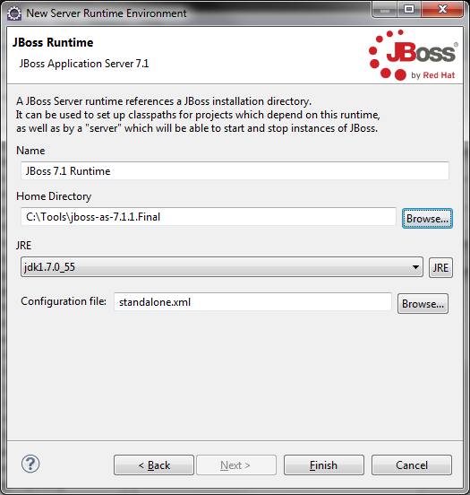
Figure 10 JBoss Directory
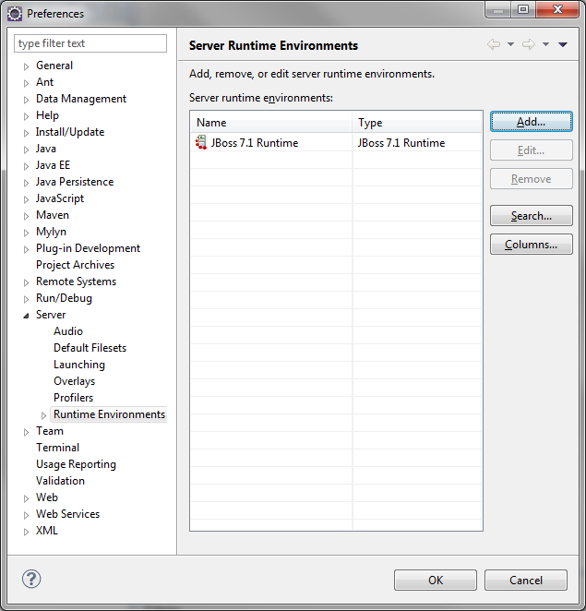
Figure 11 Server Runtime Environments
- (Optional) ‘Server->Launching’. Uncheck ‘Automatically publish when starting servers’ because I want to control when to publish.
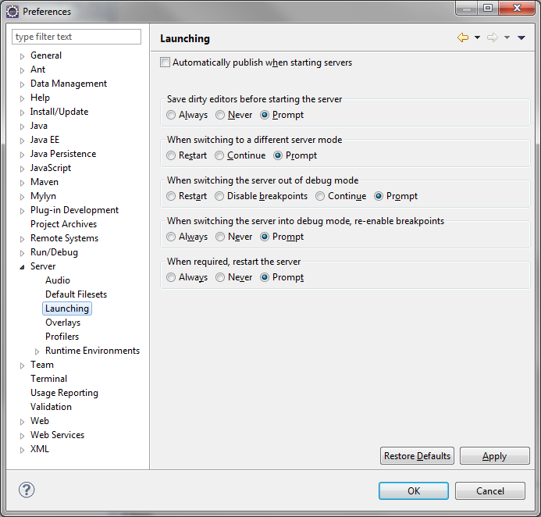
Figure 12 Disable auto publish at start
- (Optional if not using CVS) CVS setup. ‘Team’->’CVS’. Click ‘Files and Folers’ tab. Uncheck ‘Convert text files...’ and ‘Prune empty directories’.

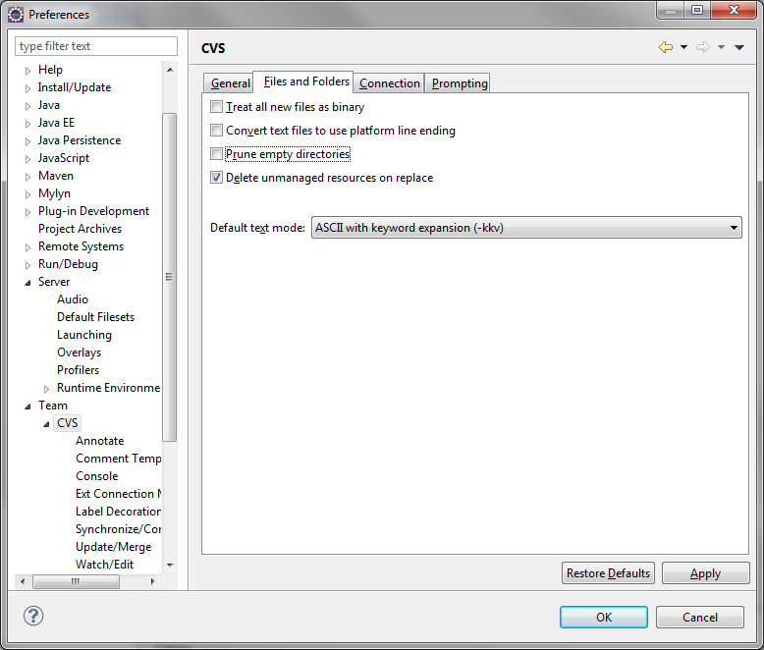
Figure 13 CVS Default Text Mode

- (Optional) Click on Team -> CVS -> Watch/Edit. Check ‘Configure projects to use Watch/Edit on checkout’.

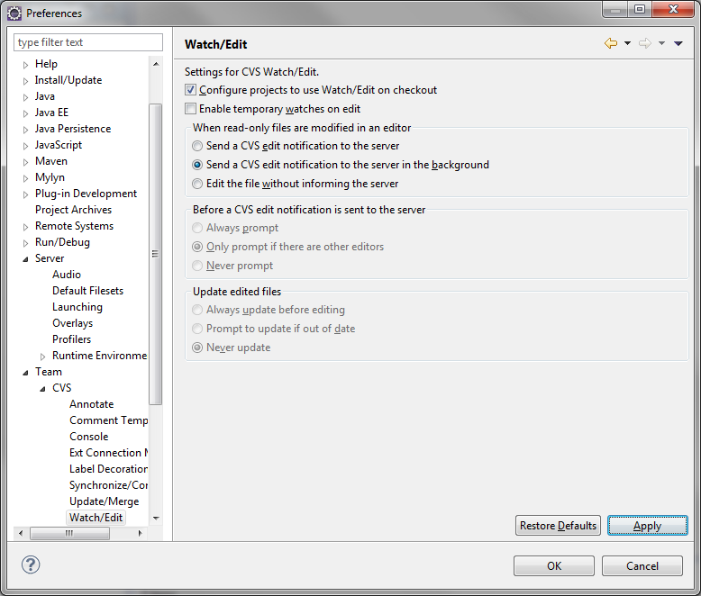
Figure 14 Configure CVS Watch/Edit mode

Hope Project

Creating the HOPE Project
NOTE: This only applies to the person first creating the project. Other developer should create the project from the version control repository.

Check out the ‘agweb Project from CVS
- Select File –> New –> Project.

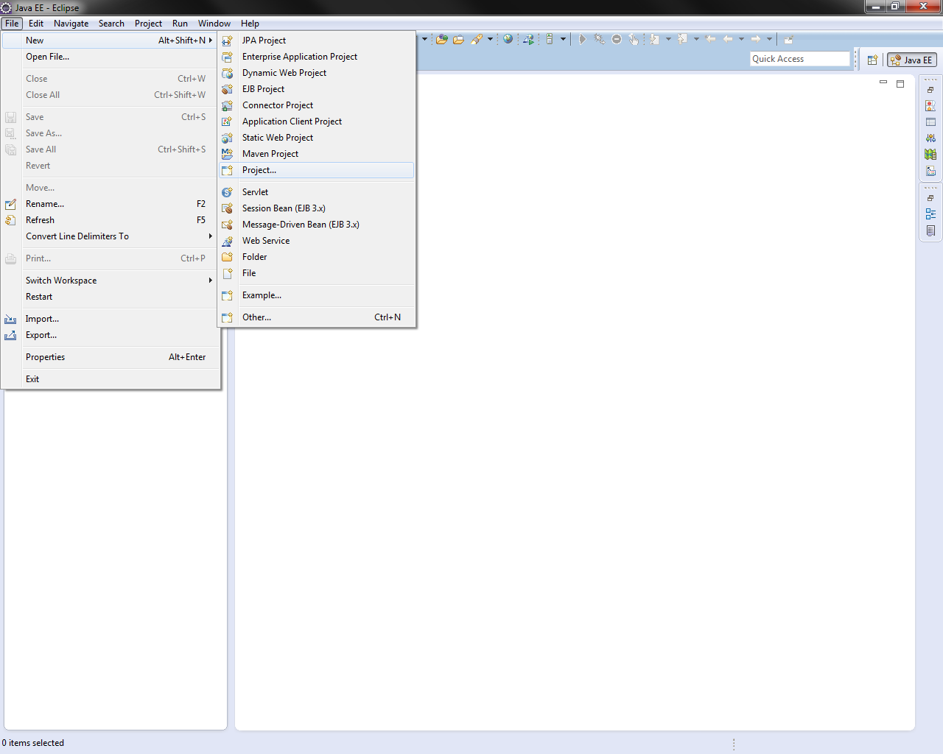
Figure 15 Create New Project
- Expand Web and select Dynamic Web Project.
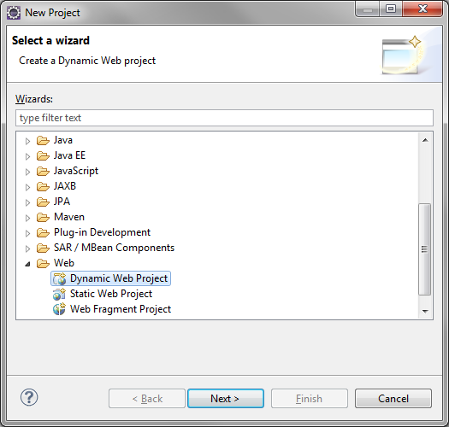
Figure 16 Dynamic Web Project

- Enter hope as the Project name, make sure JBoss 7.1 is selected as the Target Rumetime. Click Next. Click Next again.

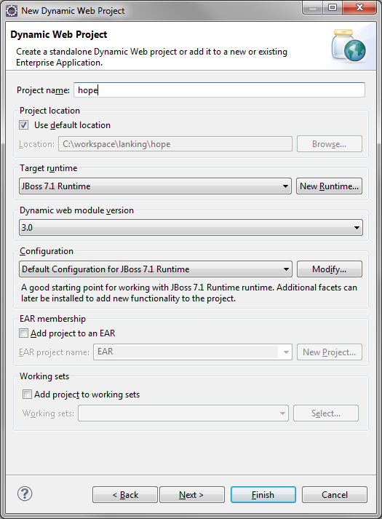
Figure 17 Project Name and Settings

- Change the Content Directory to web. Check “Generate web.xml deployment descriptor”. Click Finish.
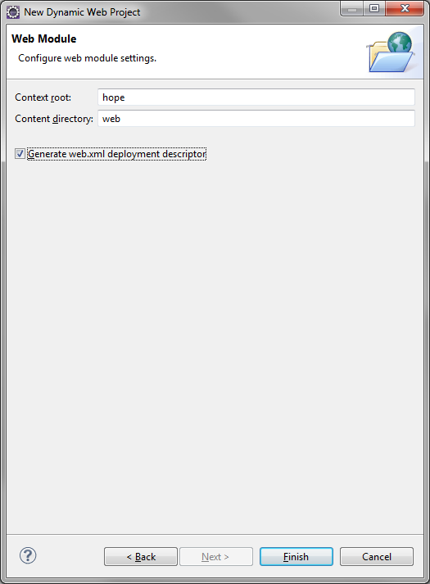
Figure 18 Content Directory
- New project is created and displayed in the Project Explorer. By default, Java EE perspective is used.
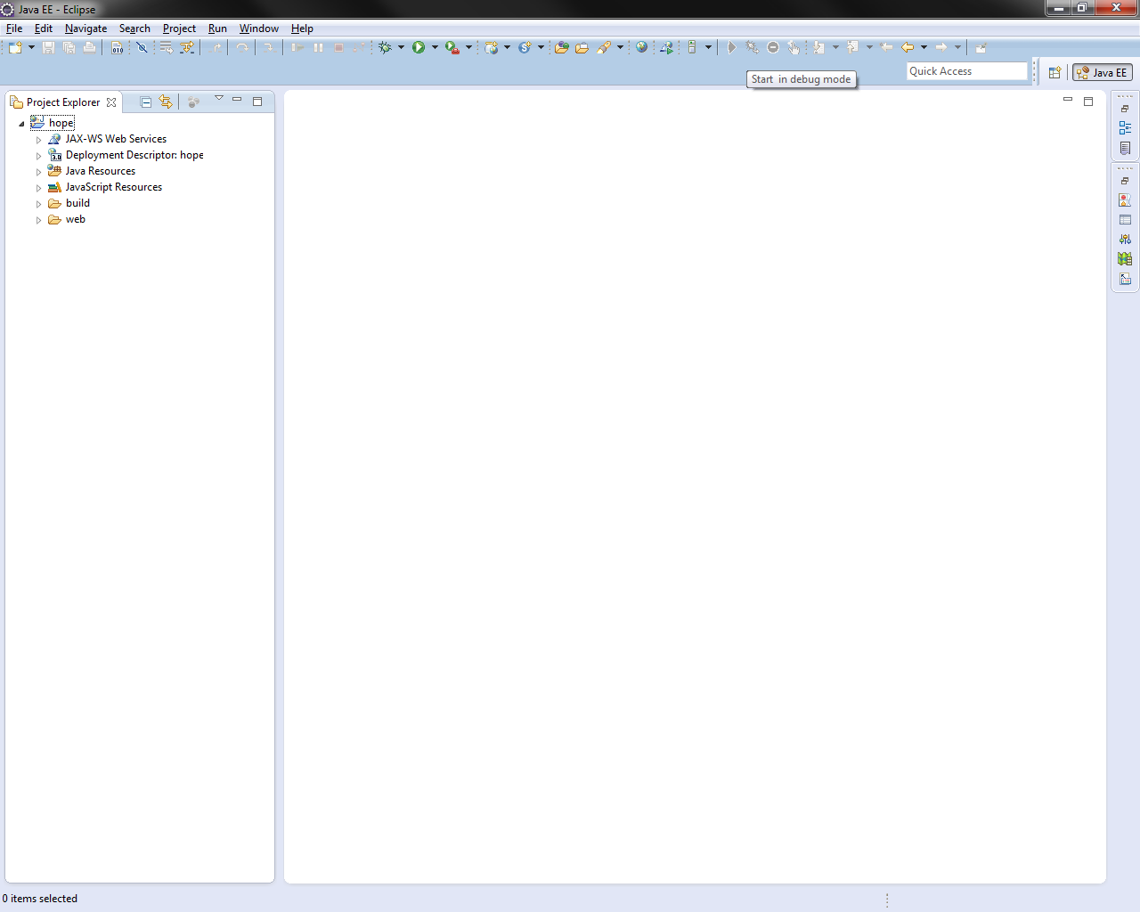
Figure 19 Project Explorer and Java EE Perspective
- (Optional) Close the Java EE perspective and open Java perspective (Window->Open Perspective->Other…). We don’t really need to use Java EE perspective. Java perspective is leaner and quicker.
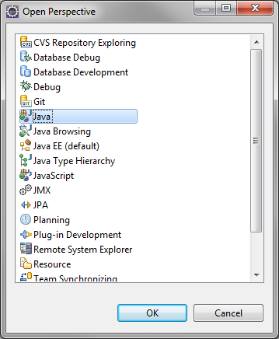
Figure 20 Open Perspective
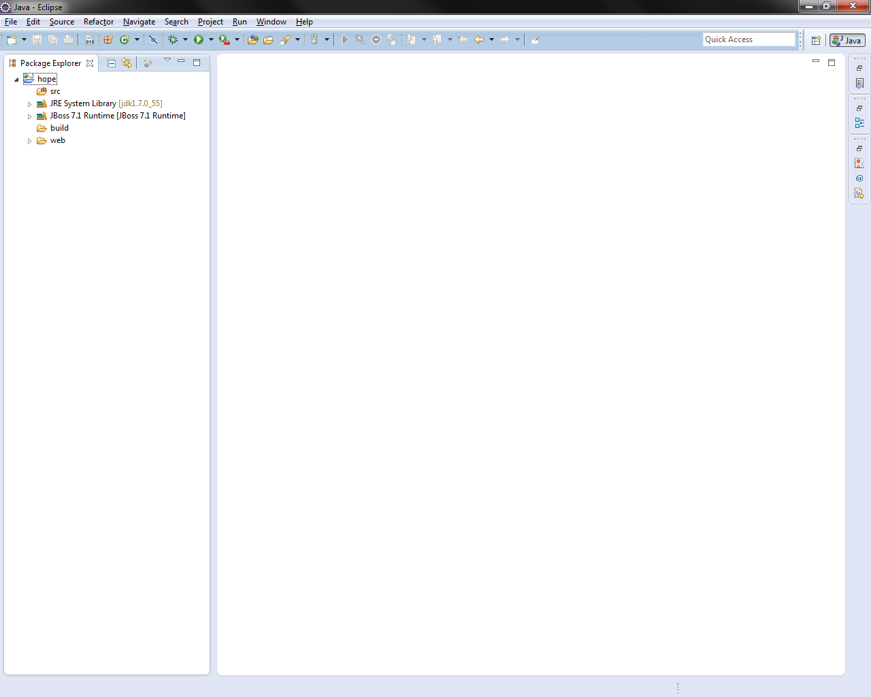
Figure 21 Java Perspective

Configure the ‘hope’ Project

- Right click the hope project and select ‘Properties’
- Select ‘Java Build Path’. Click ‘Source’ tab. Change the Default output folder to hope/web/WEB-INF/classes
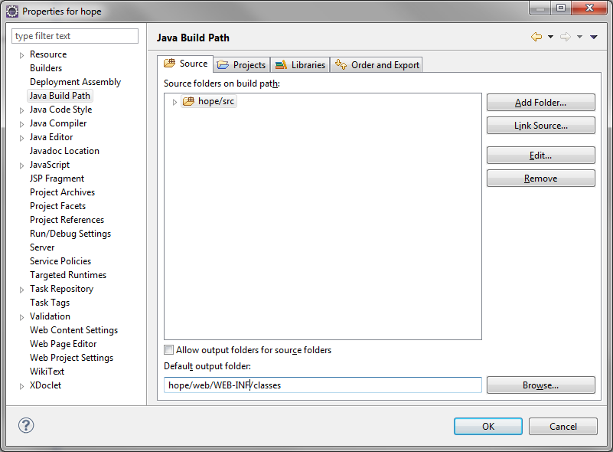
Figure 22 Output directory
- Remove the ‘build’ directory.

Run JBoss within Eclipse (optional)
You can choose to run JBoss within Eclipse. To do this, go to Window->Show View->Server->Servers

Deploy the Project as an Exploded Directory
This is an alternative and much faster way to deploy/redeploy agweb than documented in 4.2
- ‘Window->Show View->Ant’
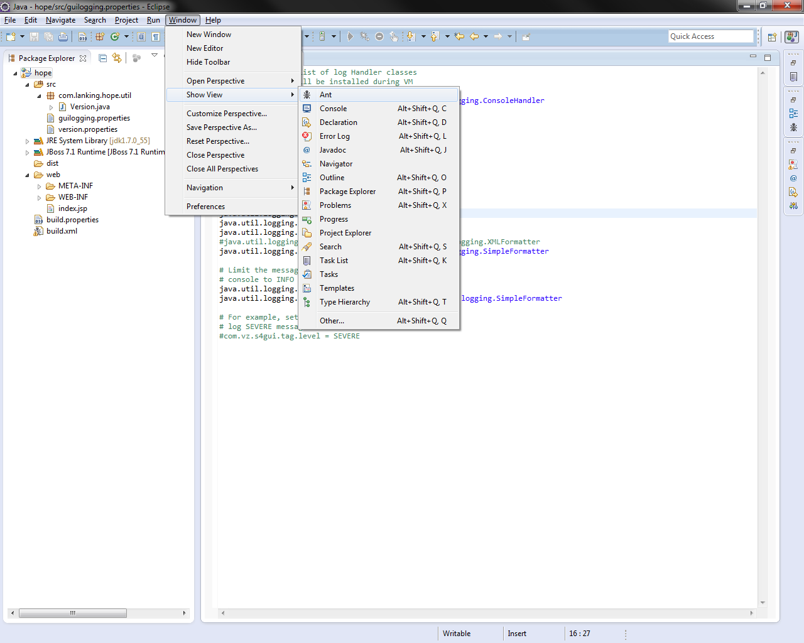
Figure 23 Show View
- In Ant View, click ‘Add Buildfiles’
- Select ‘build.xml’. Note that if your JBoss home directory is different than C:\Tools\jboss-as-7.1.1.Final then you need to modify the build.properties file
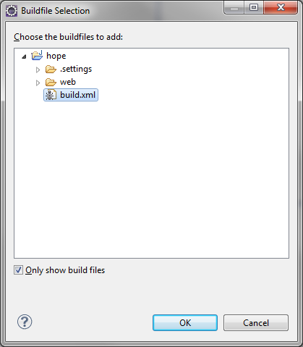
Figure 24 Buildfile selection
- (Optional) Click “Hide Internal Targets” button
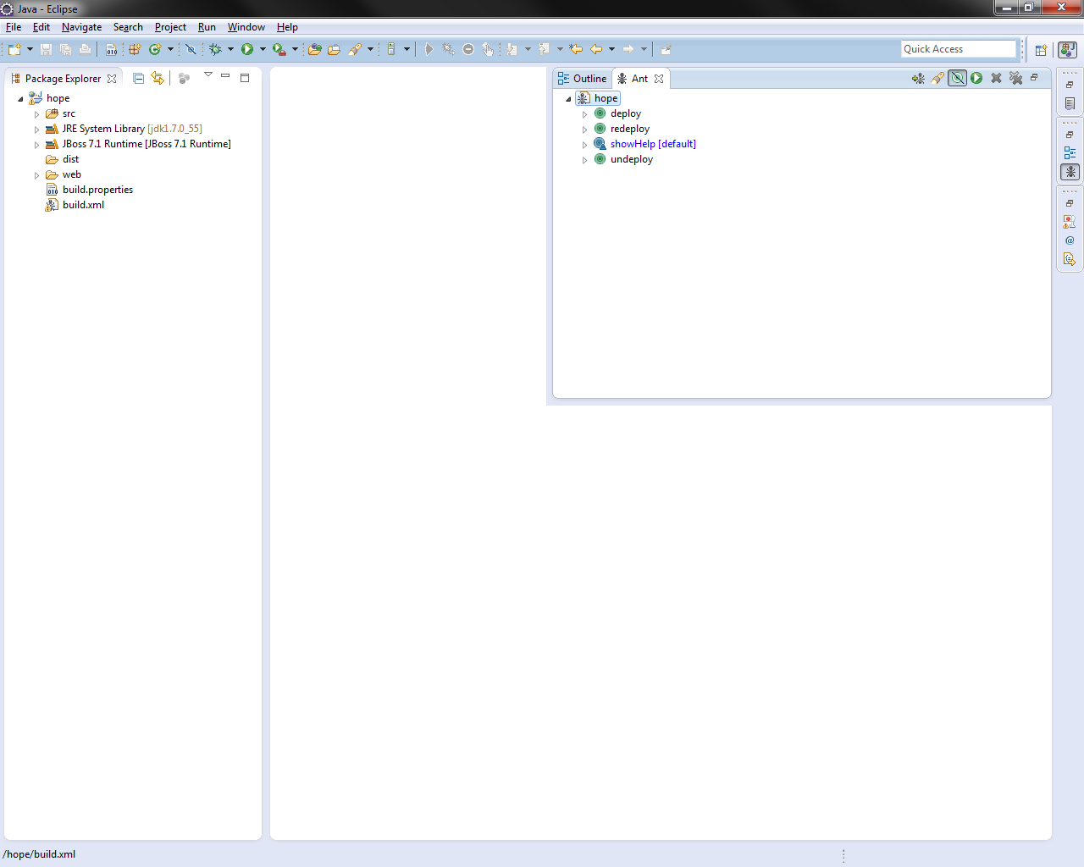
Figure 25 Ant View
- To run a target, select a target in the Ant View and click the ‘Run the Selected Target’ button.

