Quality Management Module


BI Solutions

Panchakumari Marg, Kumaripati

Lalitpur, Nepal

Feature List

Code | Feature | Status | Remarks
QM_Q | Quality Management
QM_Q_001 | Creates Quality Control Points
QM_Q_002 | Check Quality
QM_Q_003 | Alert for new issues on quality
QM_Q_004 | Create quality check team
QM_Q_005 | Create quality alert stages
QM_Q_006 | Create quality tags
QM_RE_001 | Quality Checks
QM_RE_002 | Quality Alerts

Screenshot

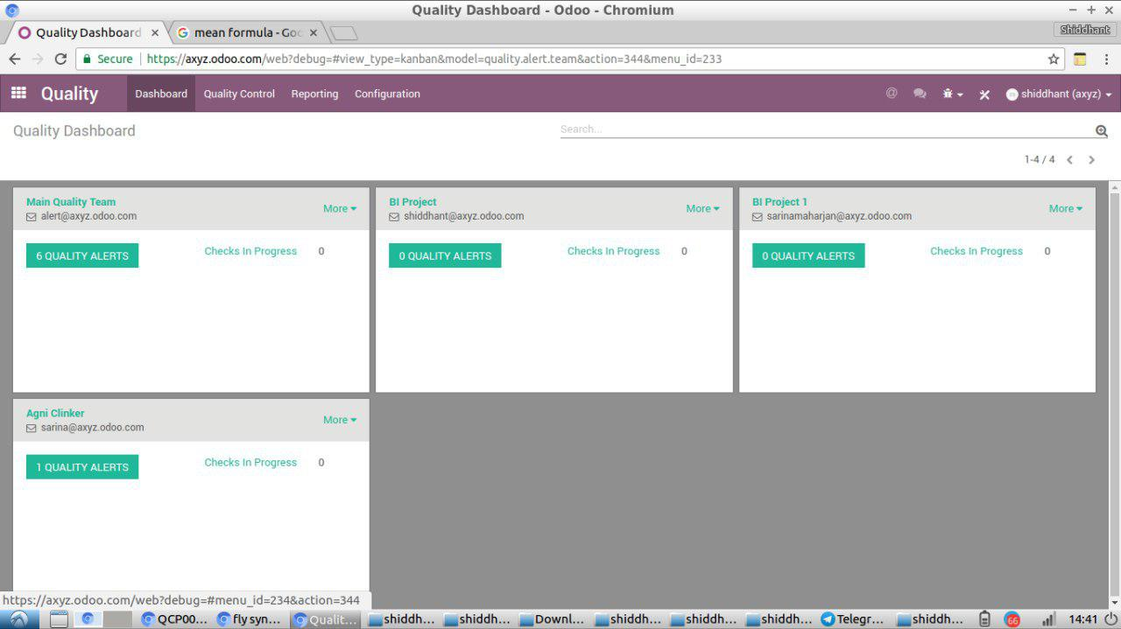
Fig: Dashboard

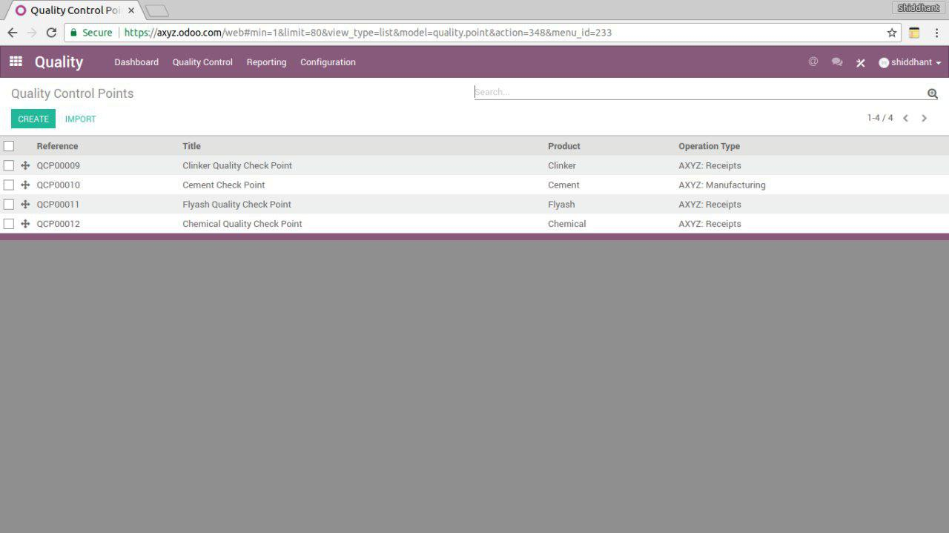

Fig: Quality Control Points Tree

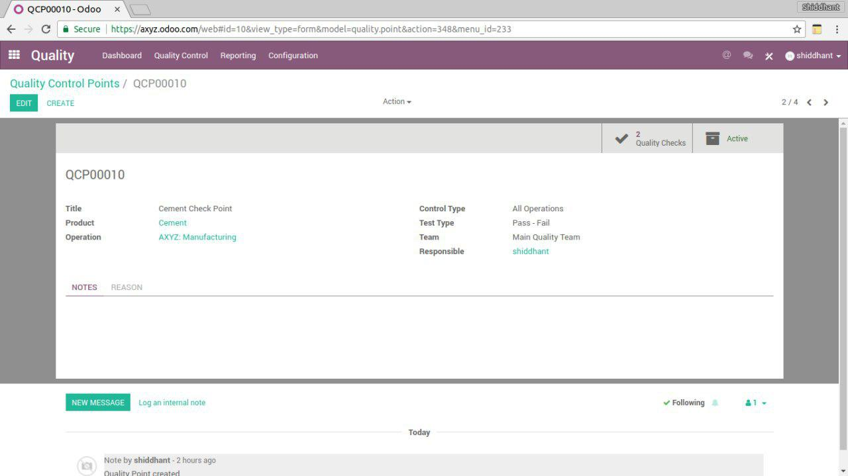
Fig: Quality Control Points Form

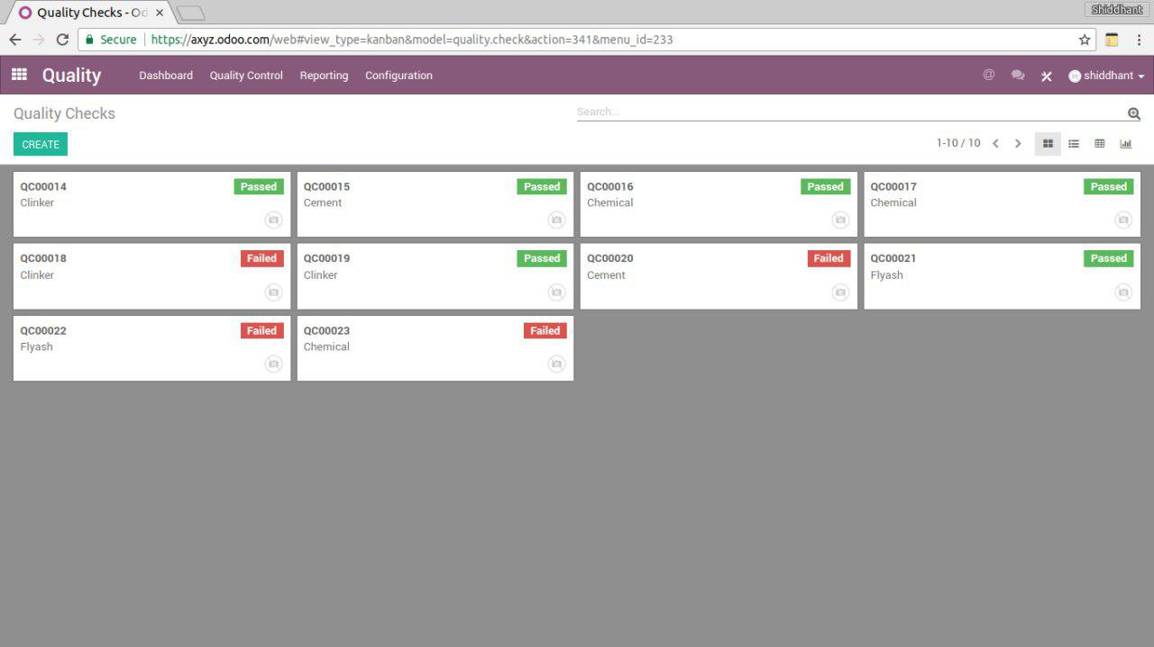

Fig: Quality Check Kanban

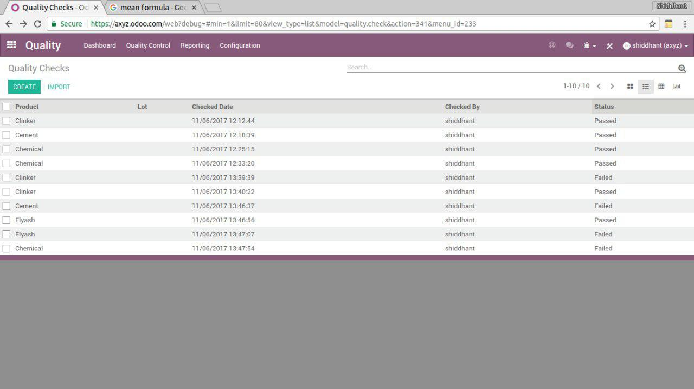
Fig: Quality Checks Tree

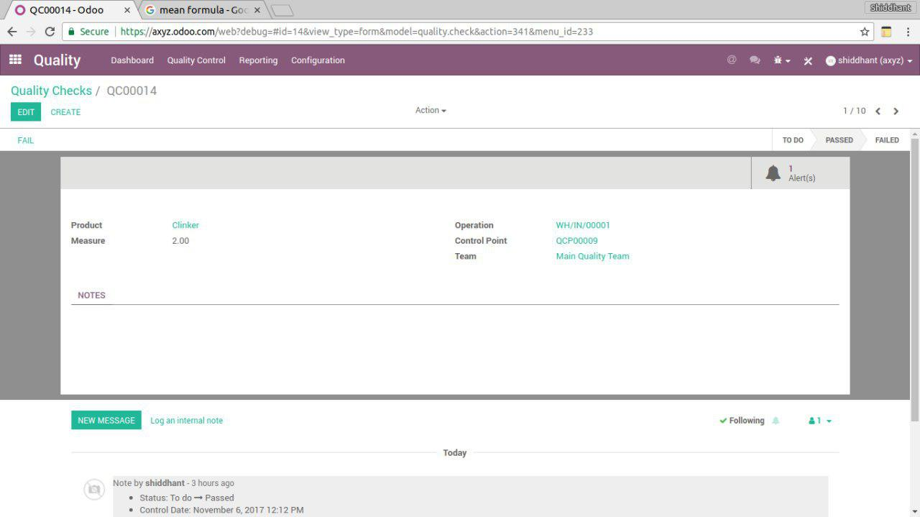
Fig: Quality Checks Form

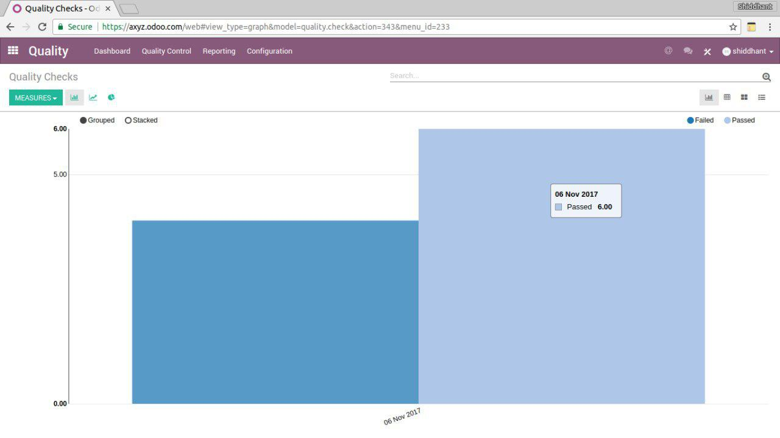
Fig: Quality Check Bar

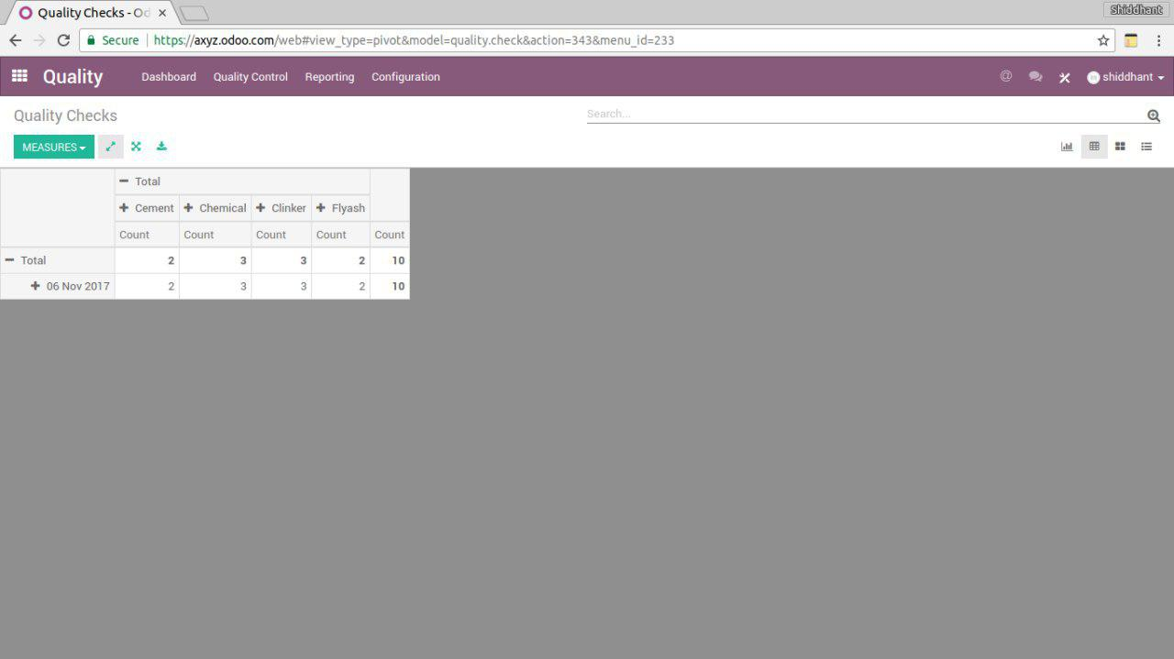

Fig: Quality Checks Pivot

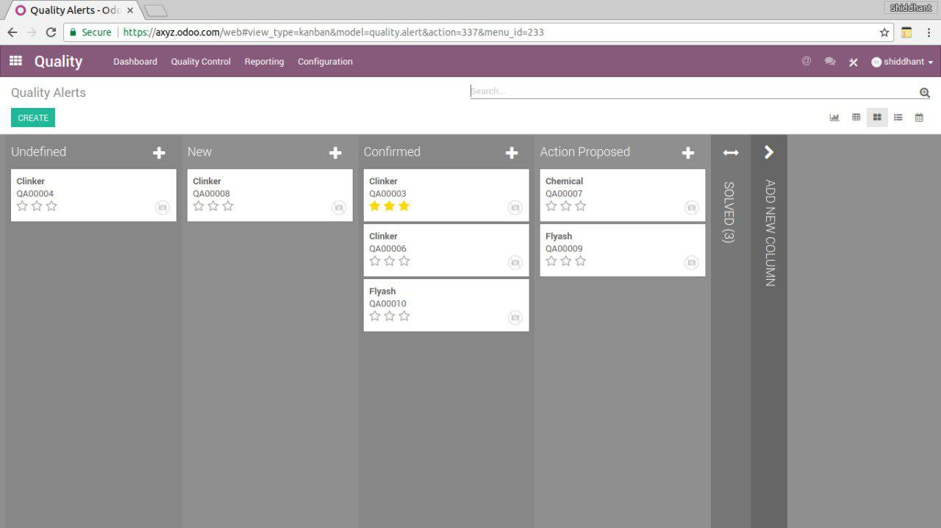
Fig: Quality Alert Kanban

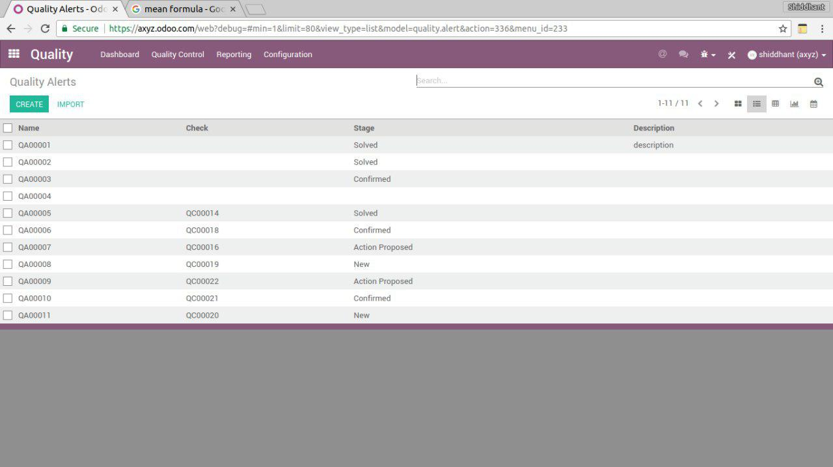
Fig:Quality Alert Tree

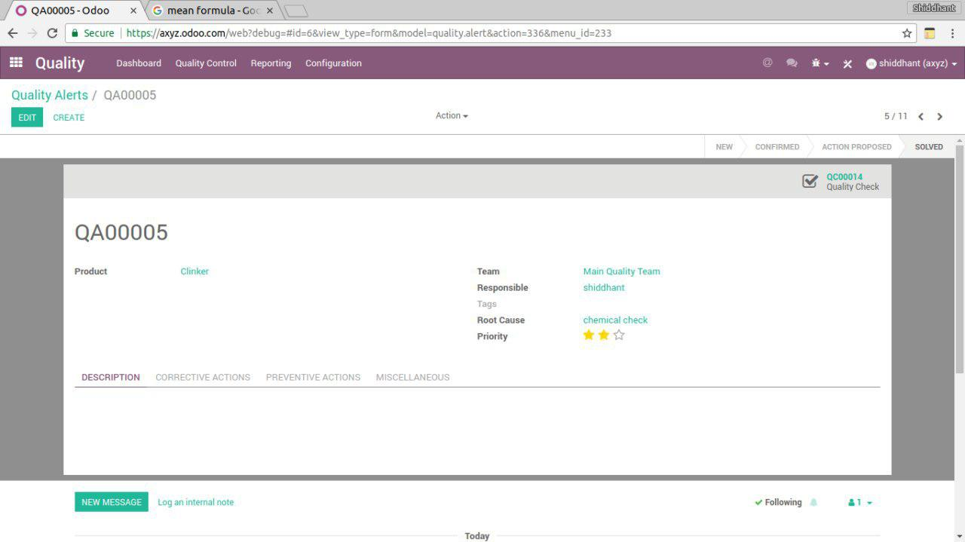
Fig:Quality Alert From

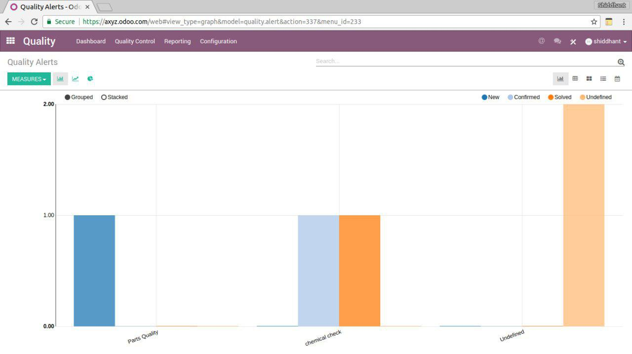
Fig: Quality Alert Bar

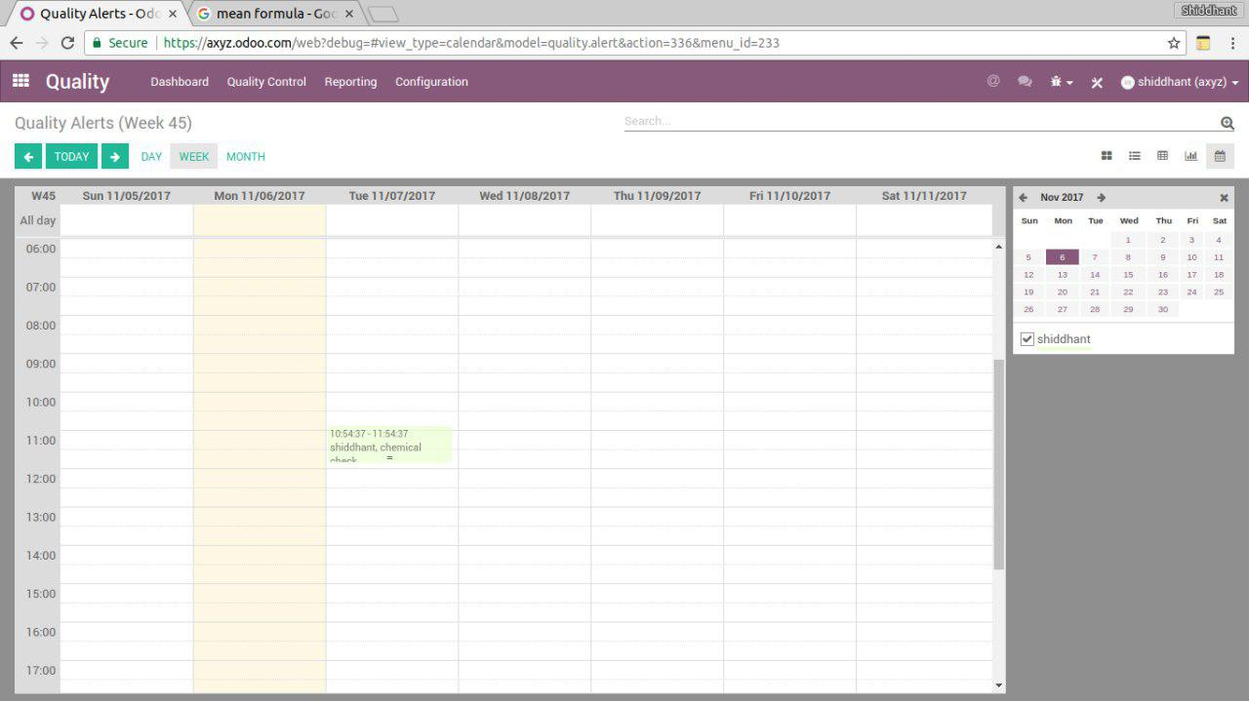
Fig: Quality Alert Calendar

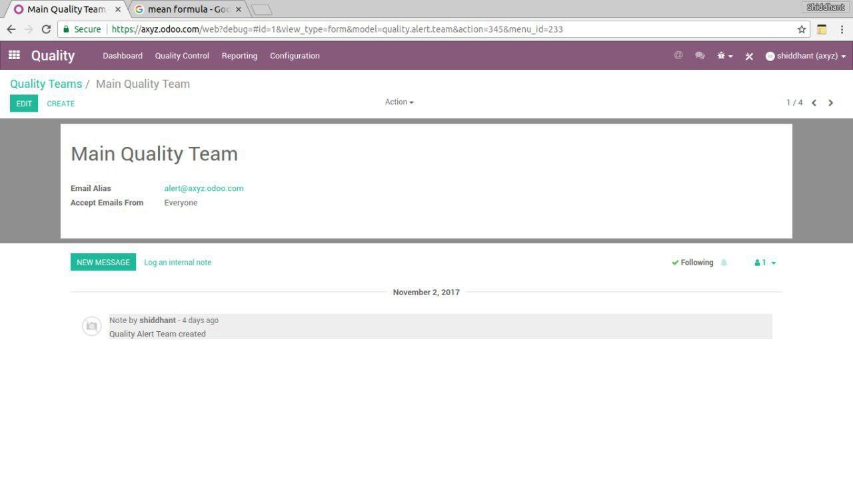
Fig: Quality Team Form

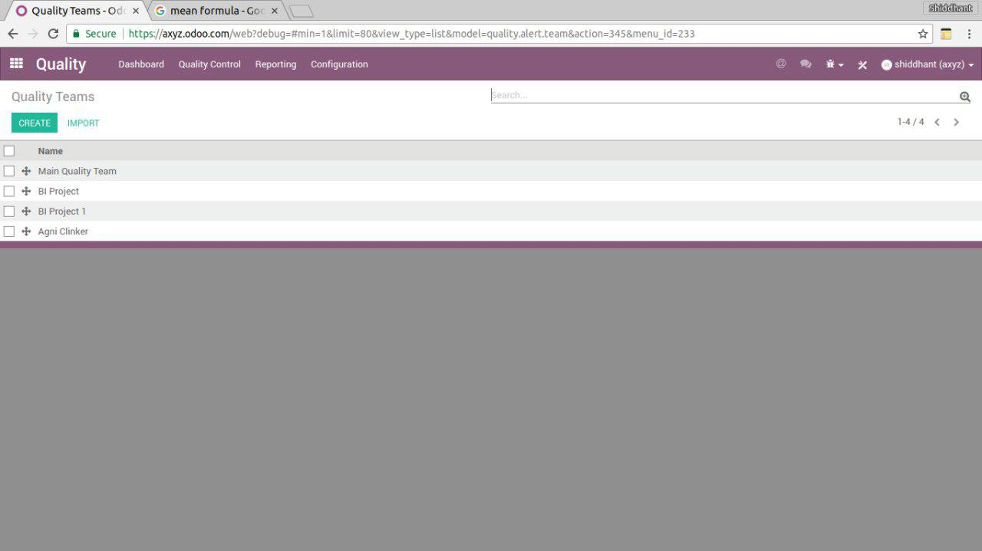
Fig: Quality Team Tree

