Quality Management Module
Odoo Version 8


BI Solutions

Panchakumari Marg, Kumaripati

Lalitpur, Nepal

Feature List
S.N | Module | Feature | Reports
1. | Quality Management System | Create questions for test process(Qualitative and Quantitative) | Provides link to view inspection lines
 |  | Inspection on the basis of different test template
 |  | Specify Test Categories

Screen shot
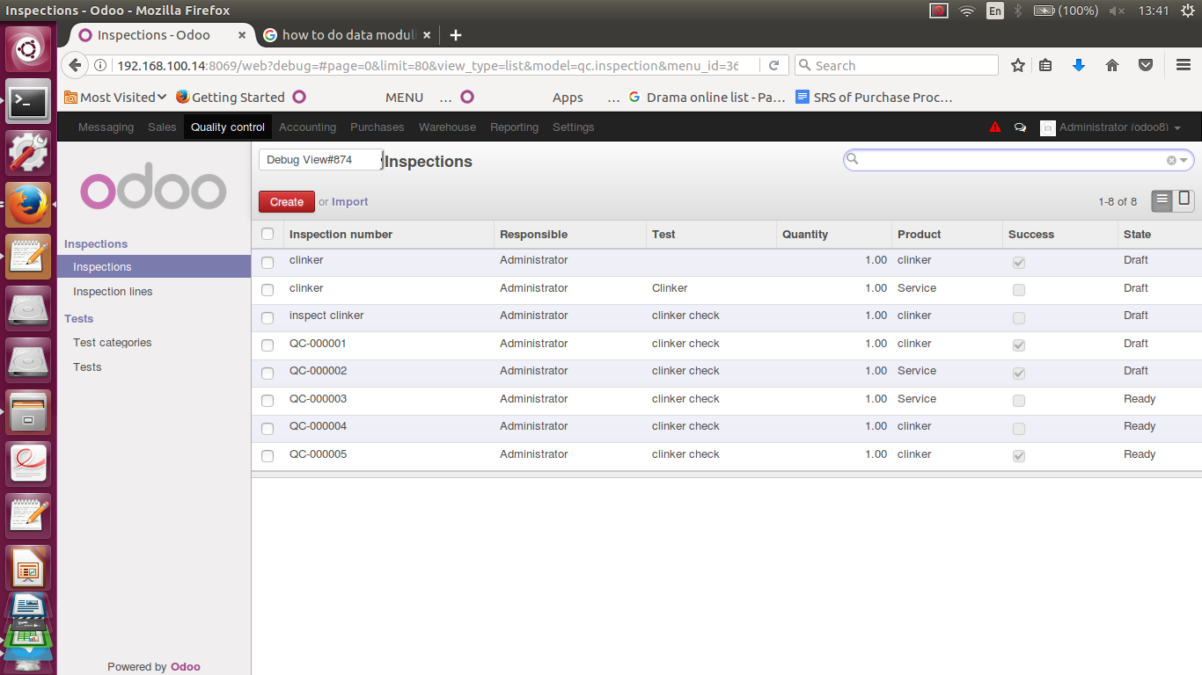
Fig: Inspections Tree View
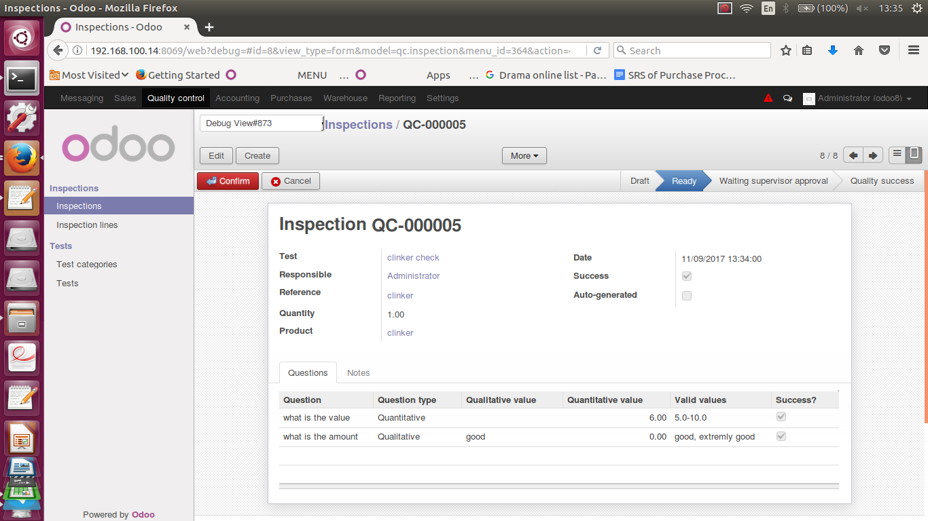
Fig:Inspection Form View
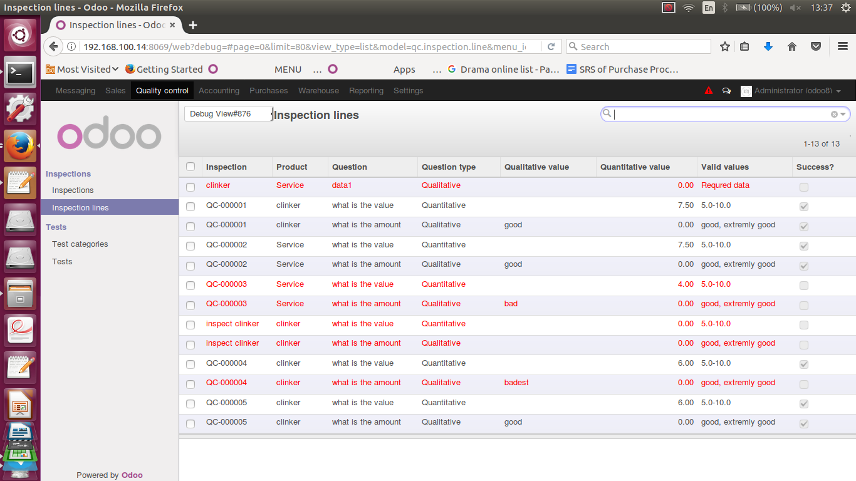
Fig:Inspection Lines Tree

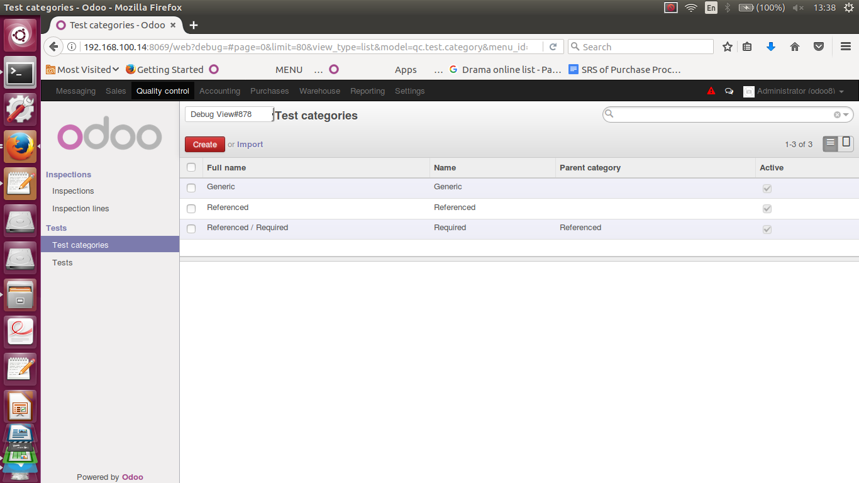
Fig:Test CategoriesView
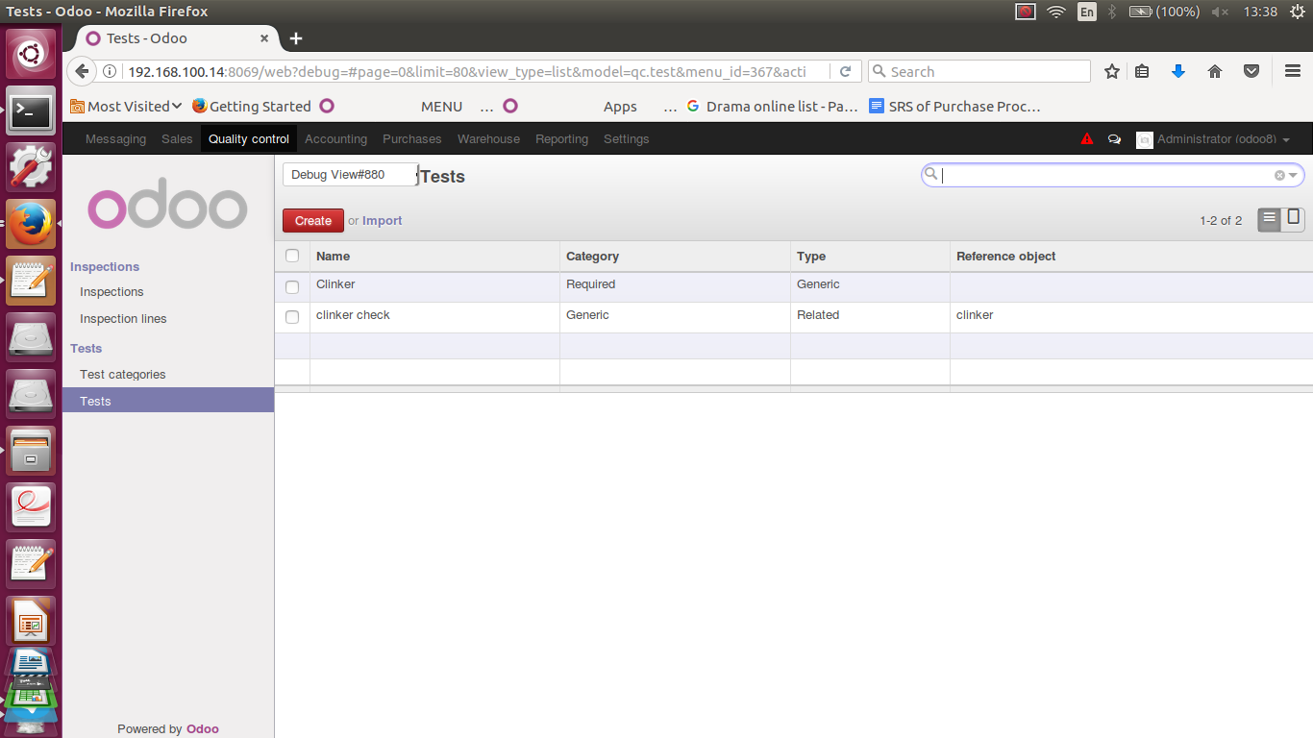
Fig:Test Tree View

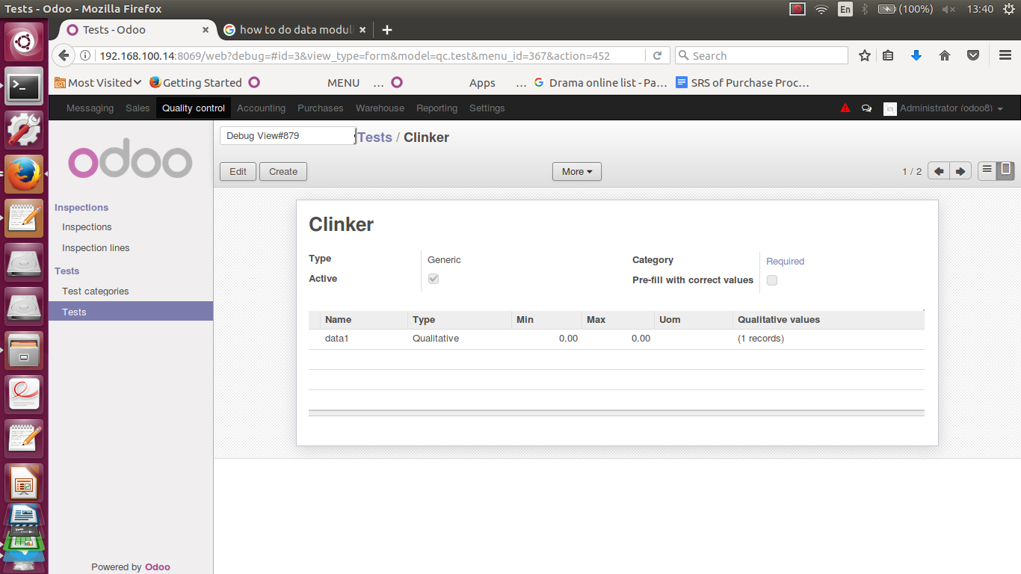
Fig:Tests Form View

