**ABSTRACT**

The project is “Restaurant Billing System” software for monitoring and controlling the transactions in a Restaurant. Restaurant Billing System is a windows application designed to help users maintain and organize Restaurant. The system processes transaction and stores the resulting data. Reports will be generated from these data which help the manager to make appropriate business decisions for the restaurant.

**INDEX**

Title Page no

Abstract i

1. Introduction
2. Requirements
3. Analysis
4. Design
5. Implementation
6. Testing
7. Conclusion
8. **INTRODUCTION**

The project is “Restaurant Billing System” software for monitoring and controlling the transactions in a Restaurant. Restaurant Billing System is a windows application designed to help users maintain and organize Restaurant. The system processes transaction and stores the resulting data. Reports will be generated from these data which help the manager to make appropriate business decisions for the restaurant.

**1.1 Purpose of SIS Project**

The key objectives of the project are to:

Manage the selection and implementation of an appropriate system or systems to meet agreed requirements, through all stages from inception to post-implementation review

* Facilitate the key business processes of the University and its colleges;
* identify and enable process improvement and efficiency
* Allow easy interface to, and seamless integration with, other key systems.
* **1.2 scope**

This billing system focus on the development of an information system that will automate manual transaction in a restaurant.

However, the study has focused on the following:

* The proposed automated system should generate reports of daily and monthly sales including reservation transactions of Beatriz Food and Café.
* It will generate receipt on every transaction inputted to the system.
* The software will display view of calculations of every transaction.
* For security and privacy of the management, the Billing System comply two log-in users with different access level.
* The system will store and recognize customer reservations.
* **Objectives:**

 The researcher aims to create or develop a system that is capable and reliable in the whole transaction flow such as tracking, retrieving and storing data in an appropriate way.

In particular it aims to:

* Provide a database that will store information.
* Develop a system that will lessen process delay in terms of releasing receipts and customer bill.
* Provide summary reports of daily and monthly sales including reservation reports.
* Design system that could accommodate reservation transactions from customers.
* Provide security of two levels of users.

1. **Objectives:**

To create menu .To perform operation on the menu like adding an item to the menu, deleting an item, updating an item etc. These operation can be done only by the administrator .To generate a bill for the customer.

1. **REQUIREMENTS**

2.1 Hardware Requirements:

1. RAM 1GB
2. HARDDISK 80GB
3. PROCESSOR PENTIUM

2.2 Software Requirements:

1. Operating System : Windows XP
2. Turbo C IDE

**3. ANALYSIS PHASE**

**3.1 Introduction**

This whole system is divided into different module.

They are:

For the administrator

* Create menu
* Update an item
* Delete an item
* Add an item
* Display the bill
* Search an item

For the customer

* Search an item
* Generate bill

Add an item module collects the following attributes values from the user

The attributes are item name, item I’d, item cost.

Update item information

This module allows the user to change the item information.

Delete item Information

This module allows the user to delete the user from the database .

View item Database

This module allows the user to view item details.

Print item Information

This module allows the user to print item details.

**4.DESIGN PHASE**

**4.1 ALGORITHM**

STEP 1:Enter your choice.Enter the login and password .

If login=mrecw and password=mrecw goto step 2

Else repeat step 1 .If login is fail for 3 times then exit and goto step 8.

STEP 2: Display the menu to select the options using switch case

1) CREATE 🡪goto step3

2) DELETE 🡪goto step4

3) UPDATE 🡪goto step5

4) DISPLAY 🡪goto step6

5) ADD 🡪goto step7

6) CUSTOMER🡪goto step 8

7) EXIT 🡪goto step 9

STEP 3: call function create() in which the admin can create a new file.goto step 2.

STEP 4: call function delete() in which following information is deleted->item name,item I’d and item cost.. After this call menu() and Goto step 2.

STEP 5:call function update() in which following information is to updated by using following options 1) Item name 🡪goto step 6

2) Item I’d 🡪goto step 7

3) Item cost 🡪goto step 8

After completion call menu() and Goto step 2.

STEP 6: Display item goto step 2

STEP 7: Add item I’d goto step 2

STEP 8: For login as user call customer().

STEP 9: Display the bill of the customer.

STEP 10: Thank you vist again! message is displayed

STEP 11: Exit.

STEP 12: call function display() in which following information is displayed->item name, item I’d, and item cost.. After this call menu() and Goto step 2.

STEP 13: call function print() in which following information is printed in printable format ->item name, item I’d, and item cost. After this call menu() and Goto step 2.

STEP 14: EXIT

4.2 FLOW CHART

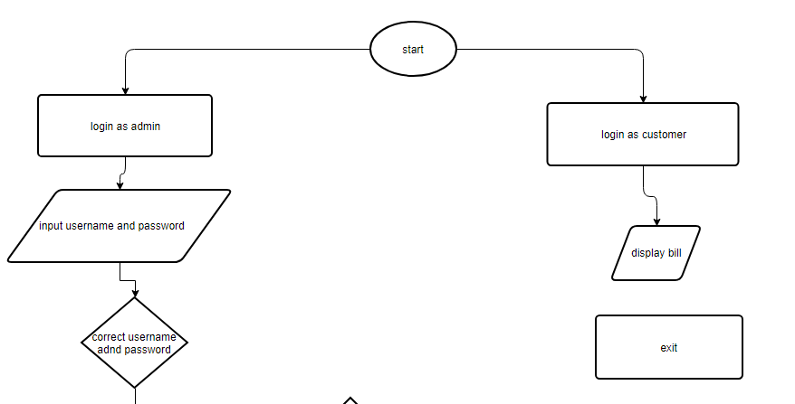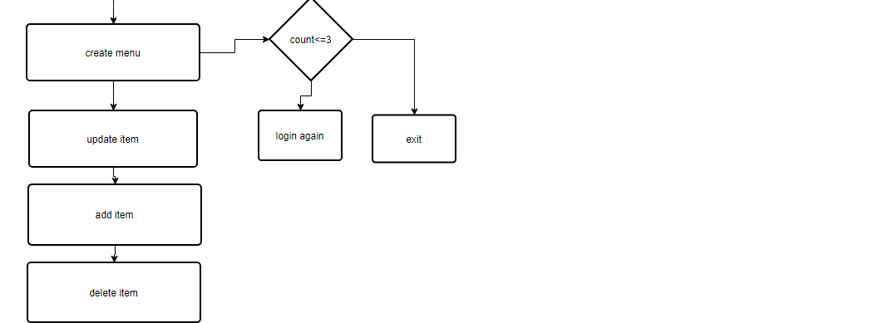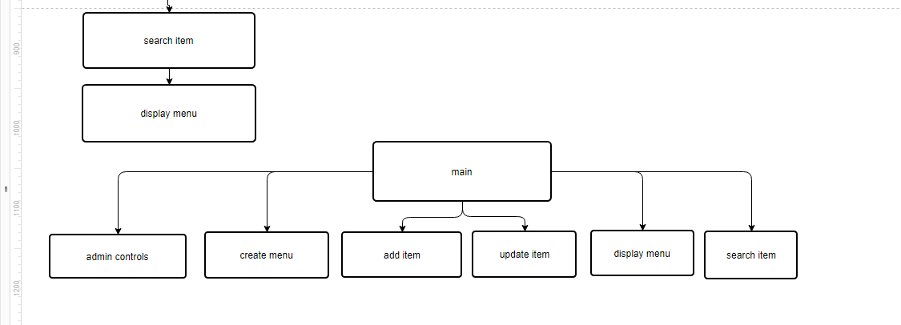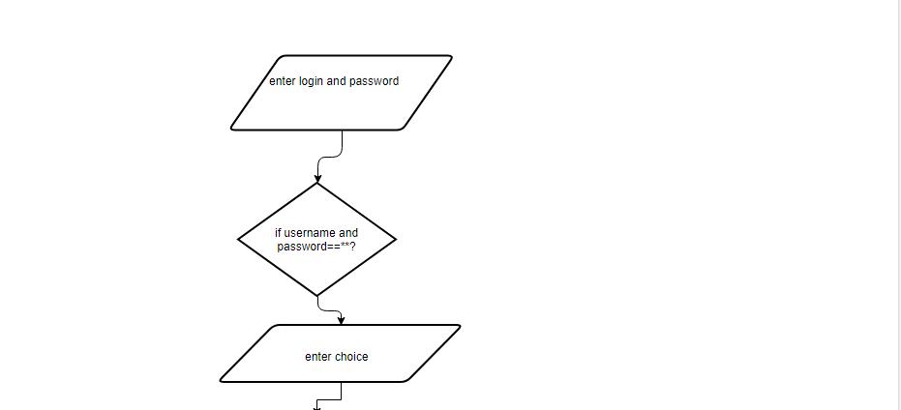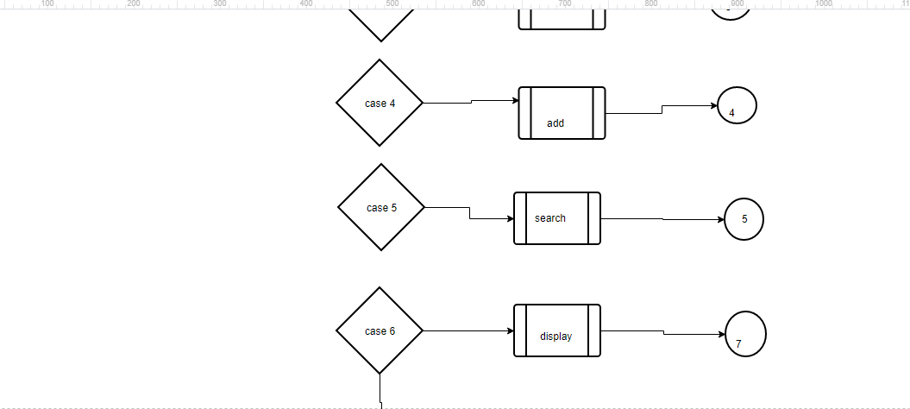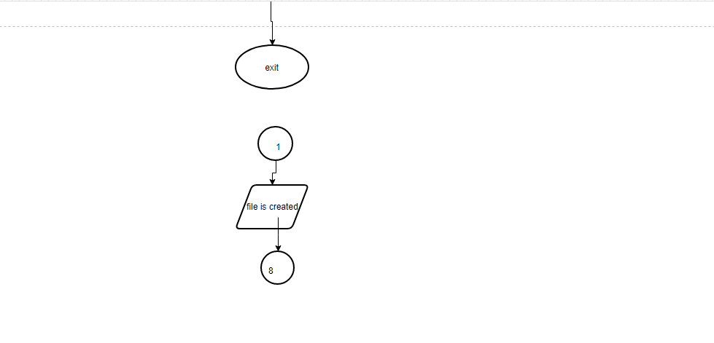

1. **IMPLEMENTATION**

**#include<stdio.h>**

**#include<conio.h>**

**void admin();**

**void admincontrols();**

**void createmenu();**

**void updateitem();**

**void deleteitem();**

**void additem();**

**void customer();**

**void header();**

**void displaymenu();**

**int searchitem(char []);**

**struct item{**

**int id;**

**char name[100];**

**int cost;**

**}rec;**

**char usname[6]="mrecw";**

**char pass[6]="mrecw";**

**int f=0;**

**struct item dl={0};**

**void main()**

**{**

**char role[100];**

**int r=0;**

**clrscr();**

**header();**

**printf("\nEnter 1 to login as admin\n");**

**printf("Enter 2 to login as customer\n");**

**scanf("%d",&r);**

**if(r==1){**

**admin();**

**}**

**else{**

**customer();**

**}**

**getch();**

**}**

**void admin()**

**{**

**char u[100];**

**char p[100];**

**int c=1;**

**printf("Enter username and password");**

**while(c<=3){**

**printf("\nUsername:");**

**scanf("%s",u);**

**printf("Password:");**

**scanf("%s",p);**

**if(strcmp(u,usname)==0 && strcmp(pass,p)==0)**

**{**

**textcolor(GREEN);**

**cprintf("Logged in successfully\n");**

**admincontrols();**

**break;**

**}**

**else{**

**textcolor(RED);**

**cprintf("Incorrect username or password.Please try again");**

**}**

**c+=1;**

**}**

**if(c==3)**

**{**

**textcolor(RED);**

**cprintf("Logging in failed\n");**

**}**

**getch();**

**}**

**void admincontrols()**

**{**

**int choice=0;**

**char itn[100];**

**long int t=0;**

**while(1){**

**textcolor(YELLOW);**

**cprintf("\nEnter your choice\n");**

**printf("\n1.Create menu\n2.Update an item\n3.Delete an item\n4.Add a new item\n5.search for an item\n6.display menu\n7.exit\n");**

**scanf("%d",&choice);**

**switch(choice)**

**{**

**case 1:createmenu();**

**break;**

**case 2:updateitem();**

**break;**

**case 3:deleteitem();**

**break;**

**case 4:additem();**

**break;**

**case 5:printf("Enter the name of the item you want to search : ");**

**scanf("%s",itn);**

**t=searchitem(itn);**

**if(t==-1)**

**printf("Item not found\n");**

**break;**

**case 6:displaymenu();**

**break;**

**case 7:exit(0);**

**break;**

**}**

**}**

**getch();**

**}**

**void customer()**

**{**

**int x,n=1;**

**int z=0;**

**float disc;**

**long int tc=0;**

**float total;**

**char in[100];**

**while(n==1){**

**printf("Enter the item name : ");**

**scanf("%s",in);**

**printf("Enter quantity : ");**

**scanf("%d",&x);**

**z=searchitem(in);**

**if(z==-1)**

**{**

**textcolor(RED);**

**printf("Item is not available.");**

**}**

**else**

**tc+=z*x;**

**printf("Do you want to take more items(1 or 0) : ");**

**scanf("%d",&n);**

**}**

**printf("\n\nYour total bill = %ld\n",tc);**

**disc=tc/10;**

**printf("Discount = %.2f\n",disc);**

**printf("--------------------------\n");**

**total=tc-disc;**

**printf("PAYABLE AMOUNT = %.2f\n",total);**

**printf("\n--------------------------");**

**textcolor(YELLOW);**

**cprintf("\n\nTHANK YOU!VISIT AGAIN!!\n");**

**getch();**

**}**

**void createmenu()**

**{**

**FILE *fp; int num=0;**

**fp=fopen("menu.txt","w");**

**if(fp==NULL)**

**{**

**printf("FILE IS NOT CREATED");**

**}**

**else{**

**textcolor(GREEN);**

**cprintf("One file created successfully\n");**

**}**

**}**

**void updateitem()**

**{**

**FILE *fp;**

**int q;**

**fp=fopen("menu.txt","r+");**

**printf("Enter the item i'd you want to update : ");**

**scanf("%d",&q);**

**while(fread(&rec,sizeof(rec),1,fp)) {**

**if(q==rec.id ){**

**printf("Enter the new cost and name :");**

**scanf("%d %s",&rec.cost,rec.name);**

**printf("Item id = %d\nItem name = %s\nItem cost = %d\n",rec.id,rec.name,rec.cost);**

**fseek(fp,ftell(fp)-sizeof(rec),0);**

**fwrite(&rec,sizeof(rec),1,fp);**

**}**

**}**

**fclose(fp);**

**getch();**

**}**

**void deleteitem()**

**{**

**FILE *fp;**

**int x=0;**

**struct item rec1={-1,"",-1};**

**fp=fopen("menu.txt","r+");**

**if(fp==NULL)**

**{**

**textcolor(RED);**

**cprintf("FILE IS NOT OPENED");**

**exit(0);**

**}**

**printf("ENTER UR ID TO BE DELETED:");**

**scanf("%d",&x);**

**while(fread(&rec,sizeof(rec),1,fp))**

**{**

**if(rec.id==x)**

**{**

**f=1;**

**textcolor(GREEN);**

**cprintf("\n\t\t\tONE RECORD IS DELETED SUCCESSFULLY\n");**

**printf("\nID :%d",rec.id);**

**printf("\nITEM NAME :%s",rec.name);**

**printf("\nCOST:%d",rec.cost);**

**printf("\n\n");**

**getch();**

**fseek(fp,ftell(fp)-sizeof(rec),0);**

**fwrite(&rec1,sizeof(rec),1,fp);**

**}**

**}**

**if(f==0){**

**textcolor(RED);**

**cprintf("NO ITEMS TO BE DELETED");**

**}**

**fclose(fp);**

**getch();**

**}**

**void additem()**

**{**

**FILE *fp;**

**fp=fopen("menu.txt","a");**

**printf("Enter the item name\n");**

**scanf("%s",rec.name);**

**printf("Enter the item id\n");**

**scanf("%d",&rec.id);**

**printf("Enter the item cost\n");**

**scanf("%d",&rec.cost);**

**fwrite(&rec,1,sizeof(rec),fp);**

**fclose(fp);**

**}**

**int searchitem(char s[])**

**{**

**FILE *fp;**

**fp=fopen("menu.txt","r");**

**while(fread(&rec,sizeof(rec),1,fp)) {**

**if(strcmp(rec.name,s)==0 ) {**

**printf("Item id = %d\nItem name = %s\nItem cost = %d\n",rec.id,rec.name,rec.cost);**

**return (rec.cost);**

**}**

**}**

**fclose(fp);**

**return -1;**

**getch();**

**}**

**void header()**

**{**

**clrscr();**

**gotoxy(20,5);**

**textcolor(GREEN);**

**cprintf("**********************************");**

**gotoxy(25,6);**

**textcolor(WHITE);**

**cprintf("RESTAURANT BILLING SYSTEM");**

**gotoxy(20,7);**

**textcolor(GREEN);**

**cprintf("**********************************");**

**}**

**void displaymenu()**

**{**

**FILE *fp;**

**fp=fopen("menu.txt","r");**

**if(fp==NULL)**

**{**

**textcolor(RED);**

**cprintf("MENU IS NOT OPENED");**

**exit(0);**

**}**

**while(fread(&rec,sizeof(rec),1,fp))**

**{**

**f=1;**

**if(rec.id!=-1){**

**printf("\nID :%d",rec.id);**

**printf("\nITEM NAME :%s",rec.name);**

**printf("\nITEM COST :%d",rec.cost);**

**printf("\n\n");**

**}**

**}**

**if(f==0){**

**textcolor(RED);**

**printf("\n\n\t\t\tNO ITEMS IN THE MENU");**

**}**

**fclose(fp);**

**getch();**

**}**

1. CONCLUSION

This Restaurant billing System project will serve as a useful approach to data base dialog box to update add, advanced search options for the authorized person. It serves as a helpful approach for the users. It reduces the time taken by the user to add, update, delete, view & search the information.

Thus the project is the user friendly approach